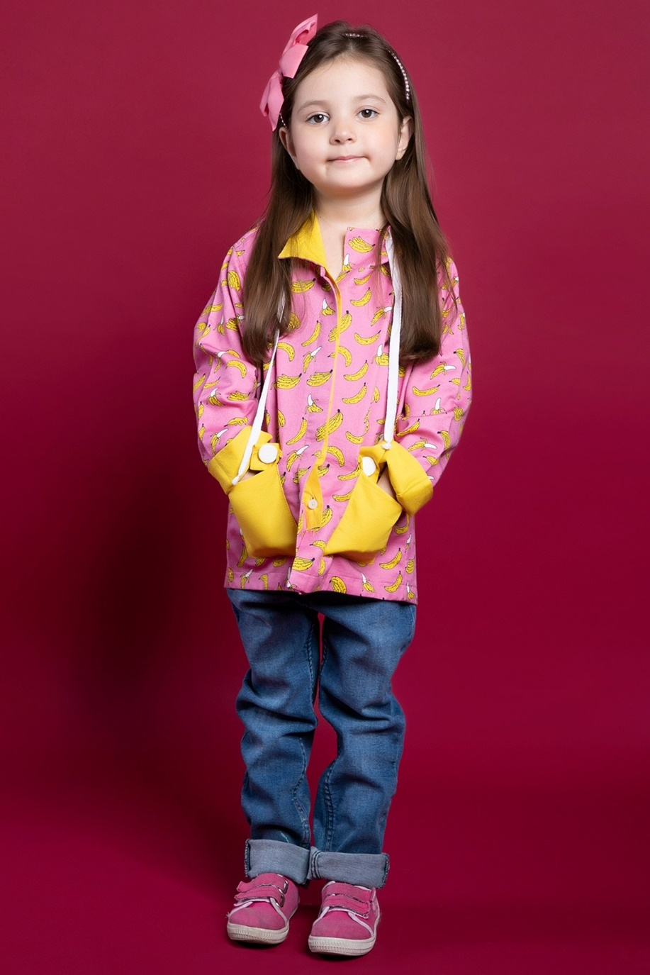**PRODUCT DISCRIPTION:**

Elevate your child's style with this charming two-piece suit. Designed with youthful sophistication in mind, this ensemble is perfect for formal occasions and special events. Crafted from high-quality fabric, the suit features a timeless design that exudes elegance and refinement. Now available in a delightful pink color, adding a touch of vibrancy to your child's wardrobe.

**PRODUCT DETAIL:**

* Classic Two-Piece Suit for Kids
* Slim Fit Design
* Premium Quality Fabric
* Notch Lapel
* Matching Jeans with Flat Front