**PRODUCT DESCRIPTION:**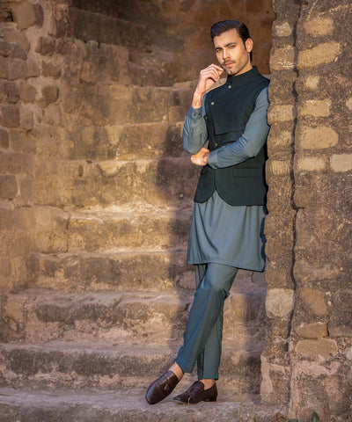

This classic grey suit exudes sophistication and style. Crafted from premium quality fabric, the suit features subtle pinstripes that add a touch of elegance to its design. The waistcoat is tailored with precision, boasting a modern slim fit silhouette that accentuates the wearer's physique. Paired with matching trousers, this ensemble is perfect for formal occasions and professional settings.

**PRODUCT DETAIL:**

* Grey Pinstripe Suit
* Single-Breasted Waistcoat
* Slim Fit Design
* Premium Quality Fabric
* Notch Lapel
* Three-button Closure
* Jetted Pockets
* Adjustable Back Strap
* Matching Trousers with Flat Front
* Button and Hook Closure