|  |  |
| --- | --- |
|  | LAB TASK 01 |
|  |  |
|  | NAME: MST AYESHA SIDDIKA  ID: 1712935642  Course: CSE311L |

1. Display the employee last name, job ID, and start date of employees hired between February 20, 1998, and May 1, 1998. Order the query in ascending order by start date.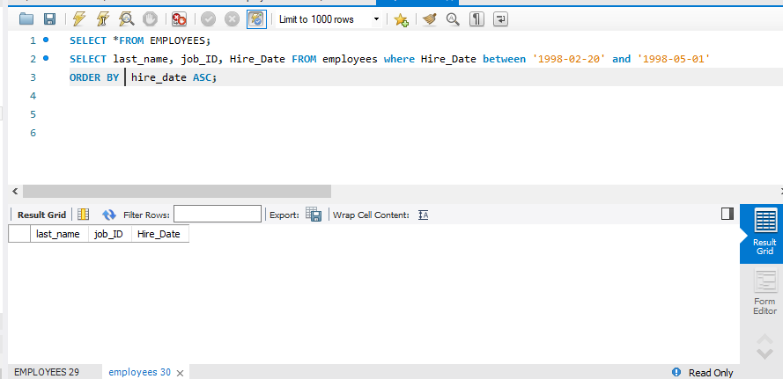
2. Display the last name and department number of all employees in departments 20 and 50 in alphabetical order by name. 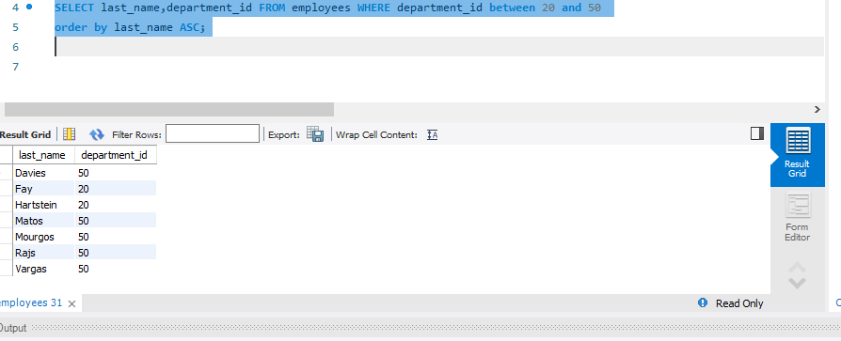

Lecture2.

1. Display the last name and hire date of every employee who was hired in 1994.(1994 doesn’t match to any employee that’s why I use 2007).
2. 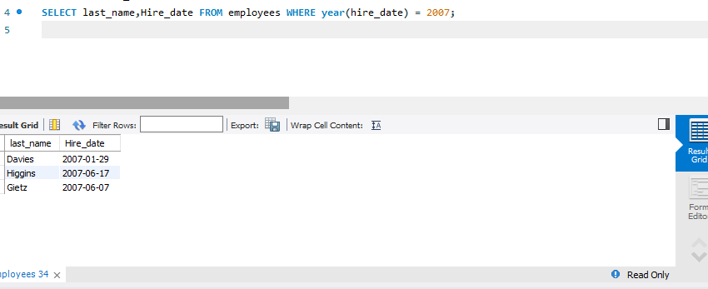

2. Display the last name, salary, and commission for all employees who earn commissions. Sort data in descending order of salary and commissions Title.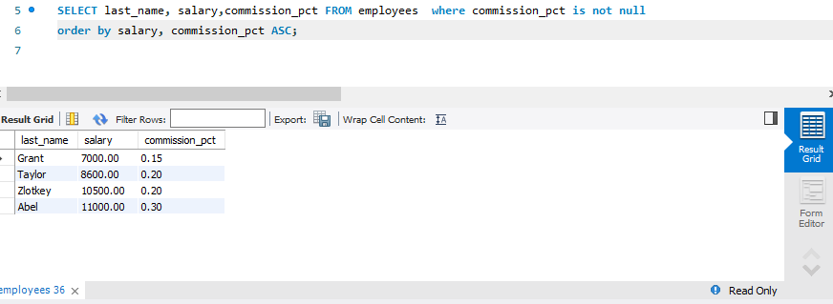

3. Display the last name of all employees who have an a and an e in their last name.

