

**Q1**

COMPARISON OF SORTING ALGORITHMS

Dr. Maryam Bashir

Design and Analysis of Algorithms (CS-B)

FAST National University

**By**

Ayesha Tahreem Aamir (14L-4473)

8th March 2017

Contents

Runtime Environment 2

Experiment 3

Plot 1: Random data 3

Plot 2: Sorted Data 3

Plot 3: Almost sorted 3

Plot 4: Sorted Data in reverse 3

# Runtime Environment

|  |  |
| --- | --- |
| System | 64-bit Operating System, x64-based processor |
| Processor | Intel® Core™ i3-4500U CPU @ 1.70GHz 1.70 GHz |
| RAM | 8.00 GB |
| Language | C++ |
| IDE | Microsoft Visual Studio 2015 |
| Compiler | Visual C++ 14.0 |

# Experiment

## Plot 1: Random data

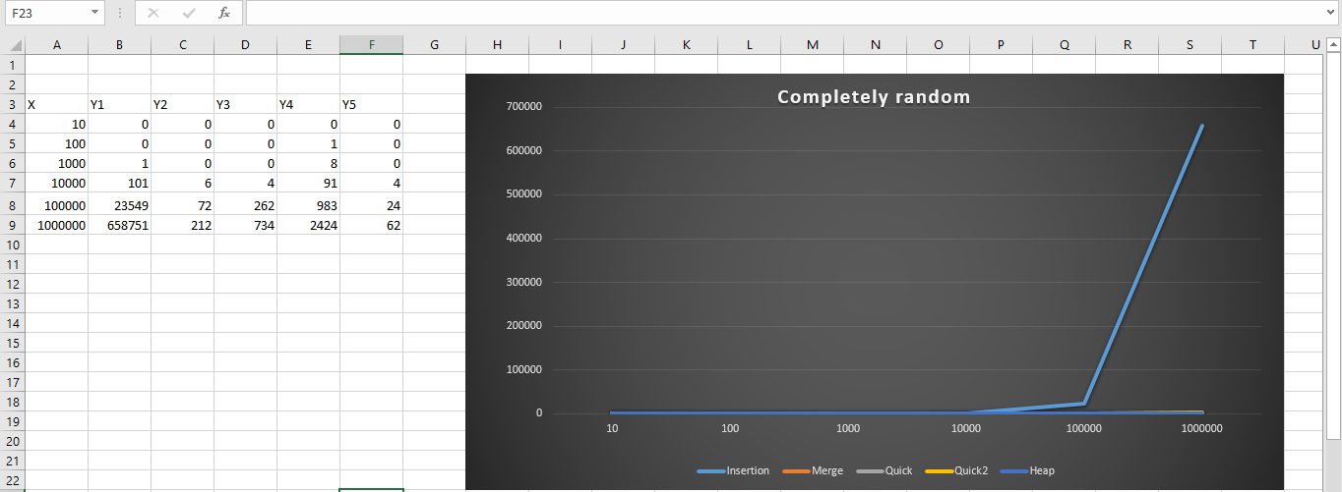

## Plot 2: Sorted Data

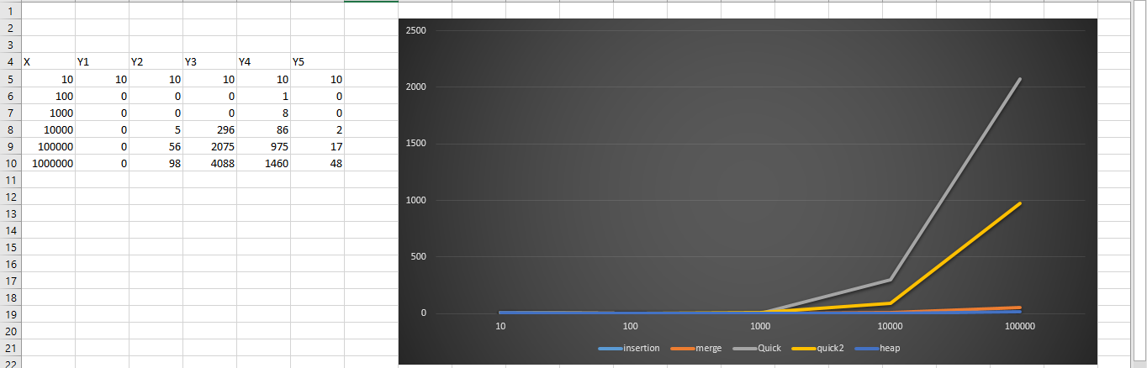

## Plot 3: Almost sorted

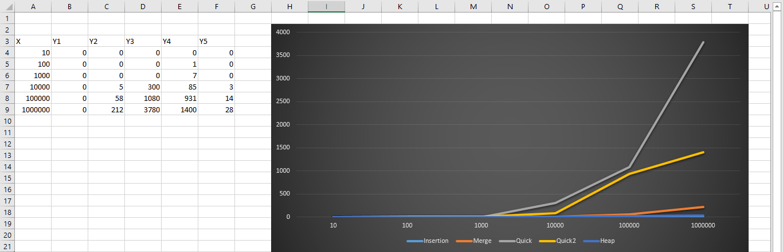

## Plot 4: Sorted Data in reverse

