INTERNSHIP REPORT
Machine-Learning Air Quality Classification
From public data to a desktop application: dataset selection, modelling decisions, calibration and a generalization study
Prepared by | Ayesha Tariq
Project | Development of Machine Learning Based Air Quality Classification Application
Programme | BS Computer Science
Institute | IT and Software Development Lab
Organisation | ASCEND Tower
Supervisor | Raza Ali
Internship period | 8 weeks
Code repository | https://github.com/ayeshatariqq/AI-Based-AQI-Classification

Contents
Abstract 3
1. Introduction 3
2. Literature Review 4
3. Dataset Selection 5
4. Data Preprocessing 7
5. Exploratory Analysis and Feature Engineering 10
6. Train / Validation / Test Split 11
7. Baseline Models 12
8. Ensemble Models 13
9. Handling Class Imbalance with SMOTE 15
10. Tuning, Calibration and Final Evaluation 16
11. The Desktop Application 18
12. Generalization Study 21
13. Limitations 25
14. Conclusion and Future Work 26
References 26
Appendix A. Repository and Reproducibility 27
Appendix B. Decision Log 28

Abstract
This report documents an eight-week internship project that built a machine-learning classifier for the air-quality category of a city-day (Good to Severe, following India’s CPCB scheme) from daily pollutant readings, and packaged it as a desktop application. Starting from a review of eight recent studies, I selected a public Indian city-level dataset (26 cities, 2015–2020) and cleaned it with decisions driven by why values were missing rather than by fixed thresholds. I designed a per-city chronological train/validation/test split, then built a ladder of models: Logistic Regression, Decision Tree and KNN baselines (best macro F1 0.692), then Random Forest and XGBoost (0.782), SMOTE for class imbalance, randomized hyperparameter search and probability calibration.
The final model reaches 82.7% accuracy and 0.791 macro F1 on a held-out test set. A generalization study on two unseen datasets showed that a six-pollutant version of the model transfers well to a new Indian city, Pune (82.6% accuracy), once carbon monoxide and ozone are defined consistently, but degrades on Beijing (71.4%), where ozone rather than particulate matter often sets the AQI — a regime almost absent from the training data. Every decision, including the mistakes found and corrected along the way, is recorded so that a future developer can reproduce and extend the work.

1. Introduction

1.1 Background and motivation
Air pollution has become a major public-health concern in South Asia, where several of the world’s most polluted cities are found (Gul & Khan, 2020). Reference-grade monitoring stations are expensive to install and maintain, so coverage is thin, particularly in developing countries (Ahmed et al., 2022). Even where measurements exist, a table of pollutant concentrations is hard for a non-specialist to interpret. National air quality indices solve this by converting several pollutant readings into a single category with a plain-language meaning. This project asks a practical question: given one day’s pollutant readings for a city, how reliably can a machine-learning model assign the correct AQI category, and can that be offered as a tool anyone can run?

1.2 Objectives
- Build a reliable classifier for the six CPCB categories (Good, Satisfactory, Moderate, Poor, Very Poor, Severe) from publicly available data.
- Justify every decision. Each choice — dataset, cleaning rule, split, metric, model — is explained with the alternatives that were considered, so a future researcher can challenge or extend it.
- Deliver a working desktop application that classifies a single reading or a whole CSV file and communicates uncertainty honestly.
- Test generalization. Measure how the model behaves on data from a city and a country it has never seen, and find out why it succeeds or fails.

1.3 Deliverables
- A trained, tuned and calibrated model with its preprocessing artifacts (saved with joblib).
- The desktop application Aether (and the earlier Tkinter prototype that preceded it).
- Two notebooks: model development, and the generalization study.
- The public code repository: https://github.com/ayeshatariqq/AI-Based-AQI-Classification
- This report and a short stand-alone summary of it.

1.4 Plan and where each part is covered
The internship followed an eight-week plan. Table 1 maps each stage of the plan to the chapters of this report.
Table 1. Internship plan and report structure.
Week | Plan | Covered in
1 | Onboarding and research: literature review, candidate datasets | Chapters 2–3
2 | Data collection and preprocessing | Chapter 4
3 | Exploratory analysis, feature engineering, train/validation/test split | Chapters 5–6
4 | Baseline model development and evaluation pipeline | Chapter 7
5 | Model improvement and tuning: ensembles, imbalance, calibration | Chapters 8–10
6 | Validation, including generalization to other datasets | Chapter 12
7 | Desktop application | Chapter 11
8 | Integration and final report | Chapters 13–14, appendices

1.5 A note on how to read this report
Chapters 3–10 follow the order in which the work was done. Where I made a mistake and later corrected it — a flawed data split (Chapter 6), three columns that crept back into the feature set (Chapter 8), and a calibration step that quietly degraded the model (Chapter 10) — I describe the mistake as well as the fix, because the reasoning is at least as useful to a successor as the final result. Appendix B condenses all major decisions into one table.

2. Literature Review
I reviewed eight recent studies, chosen to cover four things: tabular AQI classification (the task closest to mine), the treatment of class imbalance, deep-learning alternatives, and work set in Pakistan. Each was logged in a tracker recording its data, features, models, results, limitations and relevance. Table 2 summarizes them.
Table 2. Summary of the eight studies reviewed.
Study | Setting and data | Best model and result | What it taught this project
Jayadi et al. (2024) | Jakarta; 4,383 daily samples; 3 imbalanced classes | Decision Tree, 99% accuracy (no resampling used); SVM (RBF) 98% | Trees are strong baselines on tabular pollutant data, even when imbalanced
Saminathan & Malathy (2023) | Beijing, 12 stations, hourly, 2013–2017 (UCI); imbalanced PM2.5 classes (4–34% each) | Random Forest + SMOTE, 92.5% (RF alone 87.9%) | SMOTE gives a large gain on imbalanced AQI classes; use per-class accuracy
Gupta et al. (2023) | Four Indian cities from the same Kaggle dataset used here | Random Forest or CatBoost led in every city, ahead of SVR; SMOTE helped every model in every city (+6–24%) | Ensembles on this dataset family; quantify SMOTE per class
Méndez et al. (2023) | Survey of 155 papers, 2011–2021 | No single winner; LSTM and MLP most used; deep models beat regression in over 60% of comparisons | Pollutant features matter most, then weather; report several metrics, not one
Soontornpipit et al. (2024) | Bangkok, hourly PM2.5 and meteorological data | LSTM (R² 0.94) over LASSO, Ridge, XGBoost; classification accuracy 0.907 | Gains from added complexity can be small: all four models within about 2% accuracy
Ahmed et al. (2022) | Karachi; 1,001 sky photographs with AQI labels | AQE-Net (ResNet18 + attention), 70.1% vs SVM 56.2% | Image-only estimation is feasible but far less accurate than pollutant data
Gul & Khan (2020) | Lahore (1,500 samples, 2017–2019) and Beijing | LSTM: 95.0% Lahore, 98.95% Beijing | Pakistani data exist but are small; tune hyperparameters systematically
Ahmad et al. (2025) | Lahore; 30 sensors, 2,401 grid cells, 12 days | Graph neural network, MAPE about 28% | Sparse sensing is a real constraint; spatial deep models are heavy

2.1 Themes across the studies
- Tree-based and ensemble models are consistently strong on tabular pollutant data. A Decision Tree reached 99% in Jakarta; Random Forest led in Beijing, and Random Forest or CatBoost led in all four Indian cities.
- Class imbalance is the recurring obstacle, and SMOTE the common remedy. In Beijing it lifted Random Forest from 87.9% to 92.5%; in India it improved all three models in all four cities. (The Jakarta study used no resampling and still reached 99% with a tree.)
- Deep sequence models win when the problem is a time series. An LSTM was best in Bangkok and reached 95–99% in Lahore and Beijing, but such models need a forecasting framing and consecutive observations as input.
- Image-based and spatial methods are promising complements, not replacements. The Karachi image model topped out at 70.1%; the Lahore graph model needed satellite, road, population and green-space layers.
- Pakistani data are scarce. The Pakistani studies rest on 1,001 photographs, 1,500 daily samples, or a 12-day window.

2.2 How the review shaped the project
Four design choices follow directly. First, the model ladder (simple baselines, then ensembles) mirrors the consensus that trees and ensembles suit tabular data, and I kept a baseline so that any gain could be measured. Second, class imbalance was expected from the start, so I planned SMOTE and per-class metrics rather than accuracy alone. Third, because Pakistani data were too small or too awkward to extract, I chose the large Indian dataset used by Gupta et al., which also made my results loosely comparable to published work. Fourth, I noticed that most studies evaluate on held-out rows from the same stations they trained on. Very few test a trained model on a different city or country; this gap motivated the generalization study in Chapter 12.

3. Dataset Selection

3.1 Requirements
A dataset had to be (i) real, not synthetic; (ii) public, so that the work is reproducible; (iii) rich enough to contain the pollutants that enter an AQI; (iv) labelled with AQI categories, or detailed enough to derive them; (v) large enough to give every category some examples; and (vi) clean enough to leave most of the eight weeks for modelling rather than data extraction.

3.2 Candidates considered
Table 3. Datasets considered in Week 2.
Candidate | Strengths | Why not (or why yes)
Islamabad air quality (Kaggle; scraped from Pakistan EPA reports, 2019–2023) | Local; real | Extracted from PDFs; the pollutants listed are limited to PM2.5, SO2 and NO2 plus weather, with no PM10, CO or O3. Not used.
Pakistan EPA / Punjab EPD daily reports | Authoritative, multi-pollutant | PDF only, with many “sensor not operating” gaps; would have required building an extraction pipeline. Not used.
Synthetic air-quality sets on Kaggle | Clean, ready to model | Synthetic data cannot support claims about real conditions. Not used.
Beijing multi-site (UCI) | Large, clean, hourly, six pollutants | No AQI labels; different country. Kept for the generalization test (Chapter 12).
India city-level daily data (Kaggle) | Real; 26 cities; pollutants plus AQI and category; same family as Gupta et al. | Chosen.

3.3 Why the Indian dataset
The Kaggle collection Air Quality Data in India (2015–2020) is derived from the Central Pollution Control Board (CPCB) monitoring network. It offers real measurements for 26 cities, every pollutant that enters the CPCB index, a pre-computed AQI value and a six-level category (AQI_Bucket) that I could use directly as the label. It has been used in published work (Gupta et al., 2023), and its categories follow the CPCB bands used across South Asia, so the problem it poses is the same one a Pakistani user would face. Its weakness is that it is Indian, not Pakistani. I accepted that trade-off deliberately: a slightly less local but clean dataset leaves time for modelling, whereas a perfectly local but messy one would not. The generalization study (Chapter 12) later tests how much of the model carries over to other settings.

3.4 What the download contains, and which file I used
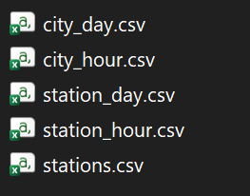
Figure 1. The five files in the downloaded dataset.
The download contains five files: city_day and city_hour (city-level, daily and hourly), station_day and station_hour (station-level) and stations (a lookup table). I used city_day.csv: one row per city per day, 29,531 rows and 16 columns, covering 1 January 2015 to 1 July 2020. The project’s question is city-level, and station-level files would add joins, uneven station histories and a far larger row count without improving the answer. The hourly city file was set aside until Chapter 12, where it turned out to be essential.
Coverage is uneven. Six cities report from January 2015 (2,009 days each), but others begin in 2017, 2018 or 2019, and Aizawl has only 113 days. This unevenness matters for the cleaning rules (Chapter 4) and the split design (Chapter 6).

Decision. Use the Indian city-level daily file with the dataset’s own six-level category as the target. Reason: real, labelled, multi-city, precedented in the literature, and clean enough to leave most of the time for modelling.

4. Data Preprocessing
The raw file is far from model-ready. The guiding principle in this chapter is that missing values are not one problem but several, and the right treatment depends on why a value is missing. A blanket rule such as “drop any column above 50% missing” would have been quick and wrong.

4.1 Auditing the missing values
Table 4. Share of missing values per column in city_day.csv.
Column | Missing | Treatment
Xylene | 61.3% | Dropped
PM10 | 37.7% | Kept; handled by dropping cities (Section 4.3)
NH3 | 35.0% | Dropped
Toluene | 27.2% | Dropped
Benzene | 19.0% | Dropped
AQI, AQI_Bucket | 15.9% | Rows without a label removed
PM2.5, NOx, O3, SO2, NO2, NO | 12.1–15.6% | Filled within each city (Section 4.4)
CO | 7.0% | Filled within each city

4.2 Columns dropped
Xylene, Toluene and Benzene are volatile organic compounds. They are not part of the standard AQI sub-index calculation, and between 19% and 61% of their values are missing, so they were dropped. NH3 (ammonia) is a secondary AQI pollutant with 35% missing; as shown next, its gaps were structural, so no imputation could be trusted, and it was dropped too.

4.3 PM10: a missing-data problem that is really a city problem
PM10 is one of the two dominant drivers of AQI, so discarding it would cost the model real information. A flat 37.7% missing rate looked alarming, so I broke it down by city. The pattern was not random: a handful of cities were missing PM10 for most or all of their history, while every other city was below 24%.
Table 5. Cities with structurally missing PM10 and NH3.
City | PM10 missing | NH3 missing
Lucknow | 100.0% | 50.0%
Patna | 89.7% | 89.7%
Chennai | 85.0% | 23.0%
Ahmedabad | 79.7% | 100.0%
Mumbai | 62.0% | 80.3%
Gurugram | 55.9% | 92.9%
Highest among the remaining cities (Jorapokhar) | 23.5% | 31.5%

A sensor that failed for a few days leaves scattered gaps; a sensor that was never installed leaves a column that is empty for years. These are different problems. Forward-filling an empty column would invent data that never existed. So I kept the PM10 column and removed the six cities where it was structurally absent (Ahmedabad, Chennai, Gurugram, Lucknow, Mumbai, Patna), leaving 20 cities and 17,958 rows. Losing Mumbai is a real cost, but the alternatives were worse: dropping PM10 for everyone, or fabricating most of the PM10 history for six cities.

4.4 Filling the remaining gaps
For the remaining pollutants (PM2.5, PM10, NO, NO2, NOx, CO, SO2, O3), missing rates of 7–16% are consistent with ordinary sensor downtime. I forward-filled and then back-filled within each city’s own time series. Pollution is strongly autocorrelated from one day to the next, so a neighbouring day in the same city is a far better estimate than a global mean, and filling within a city prevents values leaking between cities. Rows still lacking a label (AQI or its category) were then removed, since a row without a label cannot support supervised learning; this left 16,052 rows. One residual gap remained: 107 training rows in a city with no ozone readings at all cannot be filled by neighbouring days; these are given the training-set median, computed on the training data only so that nothing about the validation or test sets leaks in.

4.5 Outliers: kept, deliberately
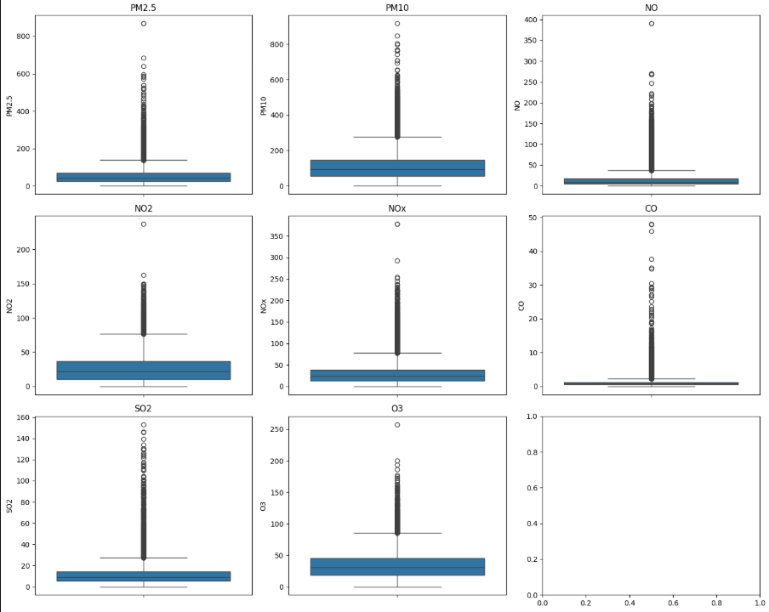
Figure 2. Distribution of each pollutant after cleaning. Every pollutant has a long right tail.
Every pollutant is strongly right-skewed with a long tail of extreme values (Figure 2). The mechanical response would be to cap or delete them. I did not, because I asked what those values are: severe pollution days — post-harvest burning, winter inversions, festival fireworks — and those are exactly the days that define the Poor, Very Poor and Severe classes. Removing them would have deleted the thing the model exists to detect. This also fits the chosen model family: tree-based methods split on thresholds and do not assume a bell-shaped distribution, so they cope with skewed data where a linear or distance-based model would not.

4.6 The target and its imbalance
The target is AQI_Bucket, the dataset’s six-level CPCB category. I chose a six-class formulation over a binary safe/unsafe split because the finer labels were already present and validated, and because a tool meant to communicate severity should distinguish Poor from Severe.
Table 6. Class distribution after cleaning (16,052 city-days).
Category | AQI range | Days | Share
Satisfactory | 51–100 | 6,051 | 37.7%
Moderate | 101–200 | 6,003 | 37.4%
Poor | 201–300 | 1,500 | 9.3%
Good | 0–50 | 1,266 | 7.9%
Very Poor | 301–400 | 917 | 5.7%
Severe | 401–500 | 315 | 2.0%

The imbalance is severe: Severe is about 2% of the data. This is the same problem the literature review highlighted, and it shapes the choice of evaluation metric (Chapter 7) and the use of SMOTE (Chapter 9).

Decisions. Drop Xylene, Toluene, Benzene and NH3. Keep PM10 and drop the six cities where it is structurally missing. Fill the rest within each city. Keep the outliers. Use the six-class category as the target.

5. Exploratory Analysis and Feature Engineering
Exploratory analysis is only useful if it changes a later decision. Each finding below is tied to one.

5.1 Correlations
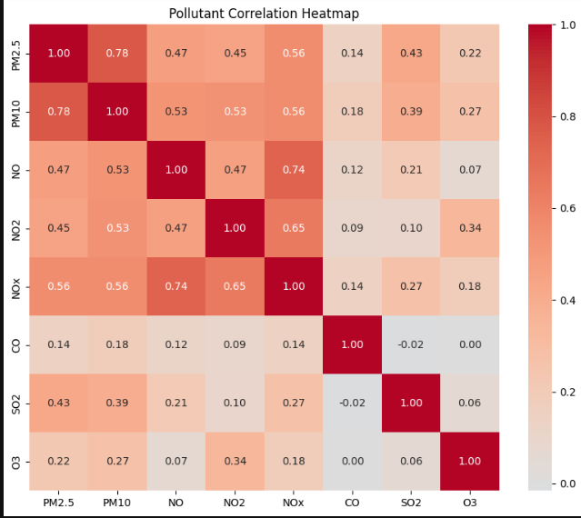 | 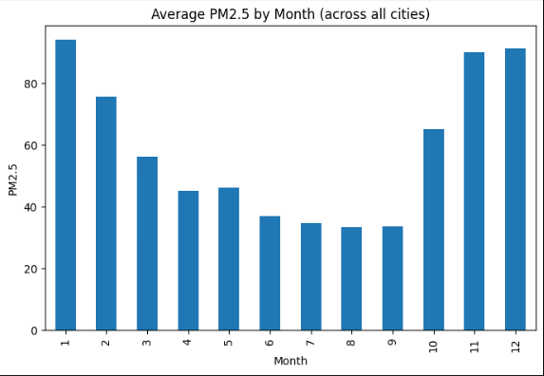
Figure 3. Left: pairwise correlation of the eight pollutants. Right: average PM2.5 by calendar month across all cities.
PM2.5 and PM10 correlate at 0.78, as expected, since PM2.5 is a subset of the PM10 size range, but each still carries its own information at category boundaries. NO, NO2 and NOx correlate at 0.47–0.74 because NOx is chemically the sum of the other two. CO, SO2 and O3 are weakly correlated with everything else, so they bring independent information. The NOx redundancy was noted but not acted on: tree models consider one feature at a time and are largely insensitive to it, so I kept all three and used feature importance afterwards (Chapter 8) to check whether NOx earned its place.

5.2 Seasonality
Average PM2.5 follows a strong annual cycle (right panel of Figure 3): about 90–95 µg/m³ from November to January, falling to about 33–37 µg/m³ between June and September. This is the North Indian winter-smog pattern, commonly attributed to temperature inversions that trap pollutants near the ground and to post-harvest crop-residue burning. A signal this large should not be left for the model to rediscover from a raw month number, so I added a categorical Season feature: Winter (December–February), Summer (March–May), Monsoon (June–September) and Post-Monsoon (October–November). The month itself is kept as well, for finer resolution.

5.3 Encoding and the final feature set
City and Season were one-hot encoded with the first category dropped, to avoid a redundant column. Aizawl and Monsoon are therefore the implicit baseline categories, represented by all-zero indicators. This detail matters later: the desktop application must reproduce exactly the same encoding, which it does by reindexing every input to the saved list of training columns. The final feature set has 31 columns: eight pollutants, Month, 19 city indicators and three season indicators.

5.4 What I did not engineer
I did not add lagged features (yesterday’s AQI) even though pollution is autocorrelated. The application takes a single day’s readings, so a model that needs yesterday’s values could not be used there. The dataset also contains no meteorological variables, which the literature suggests would help; this is listed as future work.

Decisions. Keep all pollutants (redundancy handled by the model family and checked via importance). Add Season. One-hot encode City and Season with a baseline category. No lag features, so the model works on a single day’s input.

6. Train / Validation / Test Split

6.1 Why not a random split
Today’s pollution in a city is highly correlated with yesterday’s. A random split would place neighbouring days in both training and test sets, so the model would be tested on days almost identical to ones it had memorized, and the score would be inflated. Splitting by time avoids this: the model learns from earlier data and is tested on later data, as it would be in use.

6.2 The first attempt, and what was wrong with it
My first split used one global date cut: train before 2019 (7,821 rows), validate on 2019 (4,901) and test on 2020 (3,330). It ran without errors and produced numbers. Only when I counted cities did the problem appear. Because cities started reporting at different times, the training set contained only 12 of the 20 cities, while the test set contained all 20. Eight cities were being tested without having been seen. The test also covered only January to July 2020, missing October to December — the highest-pollution months. The split was answering the wrong question: it blended “does the model generalize forward in time?” with “does it handle cities it has barely seen?”.

6.3 The fix
I split within each city’s own timeline: the first 70% of each city’s days for training, the next 15% for validation and the last 15% for testing. This keeps the property that matters (no future data in training) while ensuring that all 20 cities appear in all three sets. The sizes are 11,227 training, 2,410 validation and 2,415 test rows.

6.4 Consequences and ground rules
- The last 15% of each city is a different slice of time from the 15% before it, so class mix differs between validation and test (for example 184 Good days in validation against 367 in test, and 276 Poor against 88). I treat this as part of real-world drift, not a bug.
- Rare classes are small in the test set (27 Severe days, 51 Very Poor), so their metrics can move by several points on a single day’s prediction.
- Anything that learns from data (scaling, median filling, SMOTE, hyperparameter search) is fitted on the training set only. The test set is used once, at the end.

Decision. Chronological split within each city (70/15/15). Lesson: a pipeline that runs without error is not evidence that it answers the right question — check what a split actually does to the data.

7. Baseline Models

7.1 Why start simple
A score of “82% accuracy” means nothing without a reference: it might be impressive, or a five-line model might have reached 80%. Baselines exist to answer one question — is the extra complexity earning its keep? I deliberately applied no imbalance handling at this stage, so that the baseline is an honest, unmodified reference and any later gain can be attributed to the technique that produced it.

7.2 The three baselines
I chose three classifiers that approach the problem in structurally different ways, so that the comparison is informative rather than redundant. Logistic Regression draws linear boundaries between classes; it is fast, interpretable and the standard first benchmark. A Decision Tree learns rule-based, non-linear splits and is the building block of the ensembles planned next, so it previews how trees behave on this data. K-Nearest Neighbors (k = 5) classifies a day by the labels of the most similar days, testing whether similarity between readings alone is a strong predictor. Logistic Regression and KNN need comparable feature scales, so features were standardized with a scaler fitted on the training set only; the tree needs no scaling.

7.3 One evaluation pipeline, and why macro F1
A single function evaluated every model in this report identically: accuracy, macro and weighted F1, per-class precision and recall, and a confusion matrix. I use macro F1 as the primary metric. Accuracy can look good on imbalanced data simply by performing well on the common classes: a forecaster who always predicts “sunny” is right 90% of the time and useless on the days that matter. Macro F1 averages the F1 of every class with equal weight, so a model that ignores Severe (2% of the data) is penalized as heavily as one that ignores Moderate (37%).

7.4 Results
Table 7. Baseline performance on the validation set.
Model | Accuracy | Macro F1 | Weighted F1
Logistic Regression | 0.749 | 0.692 | 0.740
Decision Tree (no depth limit) | 0.730 | 0.668 | 0.729
K-Nearest Neighbors (k = 5) | 0.681 | 0.646 | 0.678

These baselines were run on the final, corrected 31-column feature set. They were first run before the three leaked columns were removed (Section 8.4) and then repeated, so that every model in this report is compared on the same features. The change was small for Logistic Regression (macro F1 0.693 to 0.692) and the tree (0.674 to 0.668), but KNN improved from 0.616 to 0.646 once the heavily imputed columns were gone, consistent with distance-based methods being sensitive to noisy dimensions.
Logistic Regression was the strongest baseline. This was not what the literature led me to expect, and the reason is instructive. The Decision Tree had no depth limit, so it grew until it fitted the training data almost perfectly — memorizing noise, which shows up as weaker performance on unseen days. The problem is the configuration, not the model family: when I later constrained the same tree to a depth of ten, it improved markedly (Chapter 8). KNN performed worst. With City and Season one-hot encoded the feature space has more than thirty dimensions, most of them sparse 0/1 indicators, and distance-based methods degrade when most dimensions carry little signal.
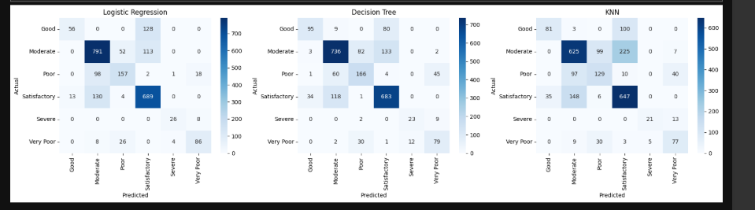
Figure 4. Validation confusion matrices for Logistic Regression, Decision Tree and KNN (rows: true class; columns: predicted class). First-run version; counts differ by a few days from the corrected run in Table 7.
The confusion matrices show a pattern that held for every model in this project: mistakes fall between neighbouring categories (Good called Satisfactory; Satisfactory called Moderate) and almost never between distant ones. Logistic Regression, for instance, called 127 of 184 Good days Satisfactory, yet it never confused Good with Severe. This means that even the weakest baseline had learned the severity ordering of the problem; the errors are of imprecision, not confusion. It also showed that rare classes were not hopeless: Logistic Regression already recovered 76% of Severe days with no help from imbalance handling.

Decision. Report macro F1 (with per-class recall) as the primary metric. Treat Logistic Regression as the baseline to beat.

8. Ensemble Models

8.1 The idea
A single decision tree has no way of checking its own mistakes, which is why it overfits. A Random Forest trains many trees, each on a different random sample of rows and features, and averages their votes; individual errors tend to cancel. XGBoost goes further: it builds trees one after another, and each new tree is trained specifically to correct the errors of the trees before it, like a team in which each new member covers the previous member’s weak spots. The literature review reported these methods winning on comparable data (Saminathan & Malathy, 2023; Gupta et al., 2023), so the question was whether that held here.

8.2 Models and settings
I trained a depth-constrained Decision Tree (maximum depth 10, at least 20 samples per leaf), a Random Forest (200 trees, maximum depth 15) and XGBoost (200 trees, depth 6, learning rate 0.1). These are common starting values for tabular problems of this size, chosen mainly to control the overfitting seen in the unconstrained tree. They were not optimized yet; systematic tuning came afterwards (Chapter 10).

8.3 Results
Table 8. Ensemble performance on the validation set (corrected 31-column feature set).
Model | Accuracy | Macro F1 | Weighted F1
XGBoost | 0.816 | 0.782 | 0.815
Random Forest | 0.809 | 0.768 | 0.805
Decision Tree (depth ≤ 10) | 0.784 | 0.738 | 0.782

All three beat every baseline. Constraining the tree alone lifted its macro F1 from 0.668 to 0.738, confirming that the baseline’s weakness was overfitting. XGBoost was best, improving macro F1 by 0.090 over Logistic Regression, consistent with the pattern in the literature.

8.4 Feature importance, and three columns that should not have been there
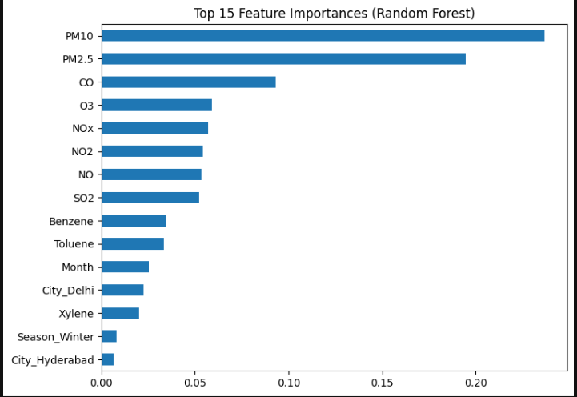 | 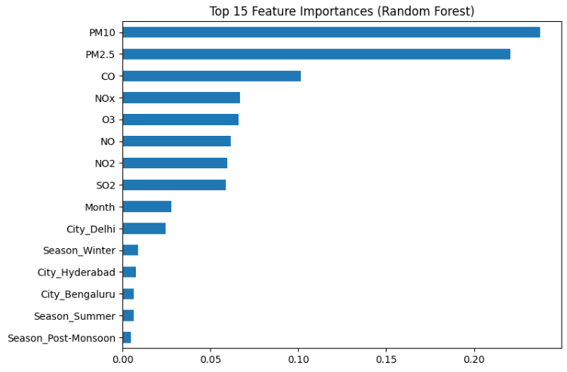
Figure 5. Random Forest feature importance. Left: first run, in which Benzene, Toluene and Xylene still appear. Right: after the columns were removed.
The importance chart is a sanity check as well as an explanation. In the first run (left panel) Benzene, Toluene and Xylene appeared among the top features, even though I had dropped them in Chapter 4. They had come back into the feature set — most likely because the train/validation/test splits were built from a version of the dataframe made before the columns were removed. Nothing crashed; the code simply gave slightly wrong results. I removed the columns explicitly before the split and retrained the ensembles. The effect was small for XGBoost (macro F1 0.787 to 0.782) and the tree (unchanged), but Random Forest improved from 0.743 to 0.768, so the heavily imputed columns had been mildly harmful, not helpful.
In the corrected chart (right panel), PM10 (about 0.24) and PM2.5 (about 0.22) dominate, followed by CO (about 0.10) and then NOx, O3, NO, NO2 and SO2 at 0.06–0.07 each. City and Season indicators contribute little individually. This agrees with how AQI is actually computed from pollutant sub-indices, which is reassuring: the model is learning a physically sensible relationship. It also answers the question from Chapter 5: NOx earns a place comparable to NO2, so there was no reason to drop it.

Decisions. XGBoost becomes the lead model. Always inspect the final feature list and importances before trusting a result. The baselines were repeated on the corrected feature set (Section 7.4).

9. Handling Class Imbalance with SMOTE

9.1 The problem
The training set holds 4,333 Moderate days but only 254 Severe ones, as shown below. A model trained on this distribution is rewarded for getting the common classes right and has few examples from which to learn what a Severe day looks like.
Table 9. Class counts in the training set before and after SMOTE.
Class | Training days before SMOTE | After SMOTE
Moderate | 4,333 | 4,333
Satisfactory | 4,047 | 4,333
Poor | 1,136 | 4,333
Very Poor | 742 | 4,333
Good | 715 | 4,333
Severe | 254 | 4,333

9.2 What SMOTE does
SMOTE (Synthetic Minority Over-sampling Technique) does not just copy minority-class rows. It picks a minority example, finds its five nearest minority neighbours, and creates a new synthetic example at a random point on the line between them. The model therefore sees more varied examples of rare classes. It was applied to the training set only: validation and test sets keep their real class distribution, since they must measure performance on the data the model will meet in practice.

9.3 Result
Table 10. Effect of SMOTE on XGBoost (validation set).
Class | Recall (no SMOTE) | Recall (SMOTE) | Precision (no SMOTE) | Precision (SMOTE)
Good | 0.61 | 0.79 | 0.87 | 0.72
Satisfactory | 0.88 | 0.84 | 0.80 | 0.82
Moderate | 0.83 | 0.78 | 0.86 | 0.87
Poor | 0.74 | 0.79 | 0.72 | 0.64
Very Poor | 0.73 | 0.69 | 0.77 | 0.78
Severe | 0.79 | 0.94 | 0.84 | 0.82
Accuracy / macro F1 | 0.816 / 0.782 | 0.802 / 0.787

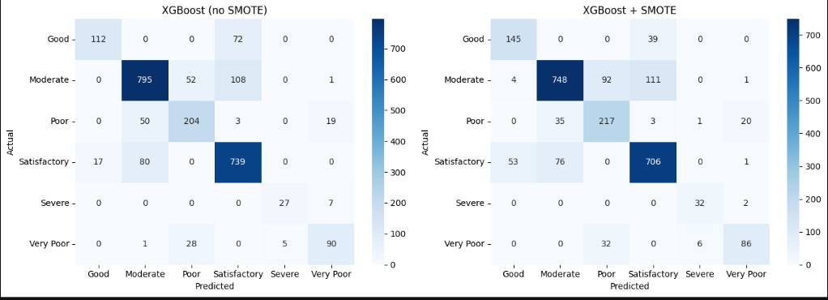
Figure 6. Validation confusion matrices for XGBoost without (left) and with (right) SMOTE.
The aggregate change is small: accuracy fell by 1.4 points and macro F1 rose by 0.5. The detail is what matters. Recall on Good rose from 0.61 to 0.79 (112 to 145 of 184 days) and, more importantly, recall on Severe rose from 0.79 to 0.94, so the model now misses 2 of 34 Severe days instead of 7. The price is paid by the common classes: Satisfactory days wrongly called Good rose from 17 to 53, and Poor precision fell from 0.72 to 0.64. Even the new errors stay between neighbouring categories, as before.
I judged this trade acceptable, and I would defend it on practical grounds. In an air-quality tool, failing to flag a Severe day is a far costlier mistake than an occasional false alarm on a Moderate one. Accuracy alone would have hidden this improvement and counted it as a loss.

Decision. Keep SMOTE (training data only). Judge models by macro F1 and minority-class recall, with accuracy reported for completeness.

10. Tuning, Calibration and Final Evaluation

10.1 Hyperparameter search
The Week 5 plan called for systematic tuning, so I replaced the hand-picked XGBoost settings with a randomized search over six hyperparameters (Table 11): 30 random combinations, each scored with stratified 5-fold cross-validation (150 model fits) on macro F1.
Table 11. XGBoost search space and the best combination found.
Hyperparameter | Values searched | Best
n_estimators | 100, 200, 300, 400 | 200
max_depth | 4, 6, 8, 10 | 10
learning_rate | 0.01, 0.05, 0.1, 0.2 | 0.01
subsample | 0.6, 0.8, 1.0 | 0.6
colsample_bytree | 0.6, 0.8, 1.0 | 1.0
min_child_weight | 1, 3, 5 | 1

There is a subtlety in doing this with SMOTE. If the training data are oversampled before cross-validation, a synthetic point derived from one real example can land in a different fold from that example, leaking information and inflating the score. I therefore put SMOTE inside the cross-validation pipeline, so that it is refitted on each fold’s training portion only and never touches the fold being scored.
The best combination reached a cross-validated macro F1 of 0.767 and, scored on the validation set, macro F1 0.806 (accuracy 0.809) — a clear step up from 0.787 before tuning. The cross-validation score is lower than the validation score probably because each fold’s model trains on only four-fifths of the training data; it is useful for comparing candidates with each other, not as an absolute estimate.

10.2 Calibration
A classifier’s predicted probabilities are not automatically trustworthy: tree ensembles tend to be over-confident, so a stated “90%” need not mean the model is right nine times in ten. Because the application shows the probability to a user, this is a correctness issue. I calibrated the model with isotonic regression, which learns a mapping from raw scores to observed frequencies and changes how confident the model says it is without changing which class it picks.
The first attempt went wrong in an instructive way. Calibrating the earlier, untuned model with scikit-learn’s default three-fold mode did no harm (validation macro F1 0.787 to 0.794). Repeating the same call on the tuned model degraded it: validation macro F1 fell to 0.792 and the test macro F1 was only 0.781. The cause is that this mode does not merely rescale probabilities. It refits three fresh clones of the whole pipeline — SMOTE included — on two-thirds of the data each and averages them, so the decision boundary itself changes. The tuned model (depth 10, learning rate 0.01) was more sensitive to training-set size than the untuned one. The fix is the pre-fitted mode, which calibrates the already trained model’s outputs on a separate set (here the validation set) without refitting anything.

10.3 Final evaluation on the test set
With tuning and calibration settled, I evaluated once on the untouched test set: accuracy 0.827, macro F1 0.791, weighted F1 0.828 on 2,415 days.
Table 12. Final model, held-out test set (accuracy 0.827, macro F1 0.791).
Class | Precision | Recall | F1 | Test days
Good | 0.78 | 0.80 | 0.79 | 367
Satisfactory | 0.89 | 0.81 | 0.85 | 1,168
Moderate | 0.80 | 0.89 | 0.84 | 714
Poor | 0.67 | 0.66 | 0.66 | 88
Very Poor | 0.72 | 0.82 | 0.77 | 51
Severe | 0.82 | 0.85 | 0.84 | 27

Severe has only 27 test days, so its figures can move several points on one prediction. The model is deliberately a little generous with Good (recall 0.80, precision 0.78) and strongest on the large Moderate and Satisfactory classes.

10.4 The whole progression
Table 13. Cumulative improvement across the modelling pipeline.
Stage | Evaluated on | Macro F1
Baseline: Logistic Regression | Validation | 0.692
XGBoost | Validation | 0.782
+ SMOTE | Validation | 0.787
+ Hyperparameter tuning | Validation | 0.806
+ Calibration (final model) | Test (used once) | 0.791

On the validation set, macro F1 rose from 0.692 to 0.806 (0.114). The final row is on a different set and should not be compared directly with the others: the test set has a different class mix (88 Poor days against 276 in validation). What it does show is that the gains were not an artefact of repeatedly tuning against validation — the test figure is of the same order, not a collapse.

Decisions. Tune with SMOTE inside the cross-validation folds. Calibrate in pre-fitted mode so that confidence changes and predictions do not. Touch the test set once. Final model: XGBoost + SMOTE, tuned and calibrated — 82.7% accuracy, macro F1 0.791.

11. The Desktop Application

11.1 Requirements
The model is only useful if someone can run it. The application had to (i) classify a single day’s readings and a whole CSV file, (ii) show how confident the model is rather than a bare label, (iii) run on an ordinary desktop without a server or internet connection, as specified in the project plan, and (iv) never silently guess: a reading it cannot classify should be flagged, not invented.

11.2 From notebook to application
The notebook saves six artifacts with joblib: the calibrated model (xgb_aqi_model.pkl), the label encoder, the ordered list of the 31 training columns, the list of pollutants, the list of supported cities and the list of seasons. The application loads these and contains a single prediction engine that mirrors the notebook’s preprocessing exactly: it derives the season from the month, one-hot encodes city and season, and reindexes the result to the saved training columns, filling absent columns with zero. That last step reproduces the baseline categories (Aizawl, Monsoon) dropped in Chapter 5. Mismatched preprocessing between training and use is one of the most common silent failures in deployed models, so single readings, batch files and the history view all go through this one code path.

11.3 First prototype (Tkinter)
The first version was a minimal Tkinter window with two tabs, manual entry and batch CSV, showing the predicted category and one confidence number (Figure 7). It proved that the saved artifacts worked end to end. It also exposed a limitation: a single confidence figure hides whether a prediction is a clear call or a close one. The second version (Figure 8) added a bar chart of the probability of every category.
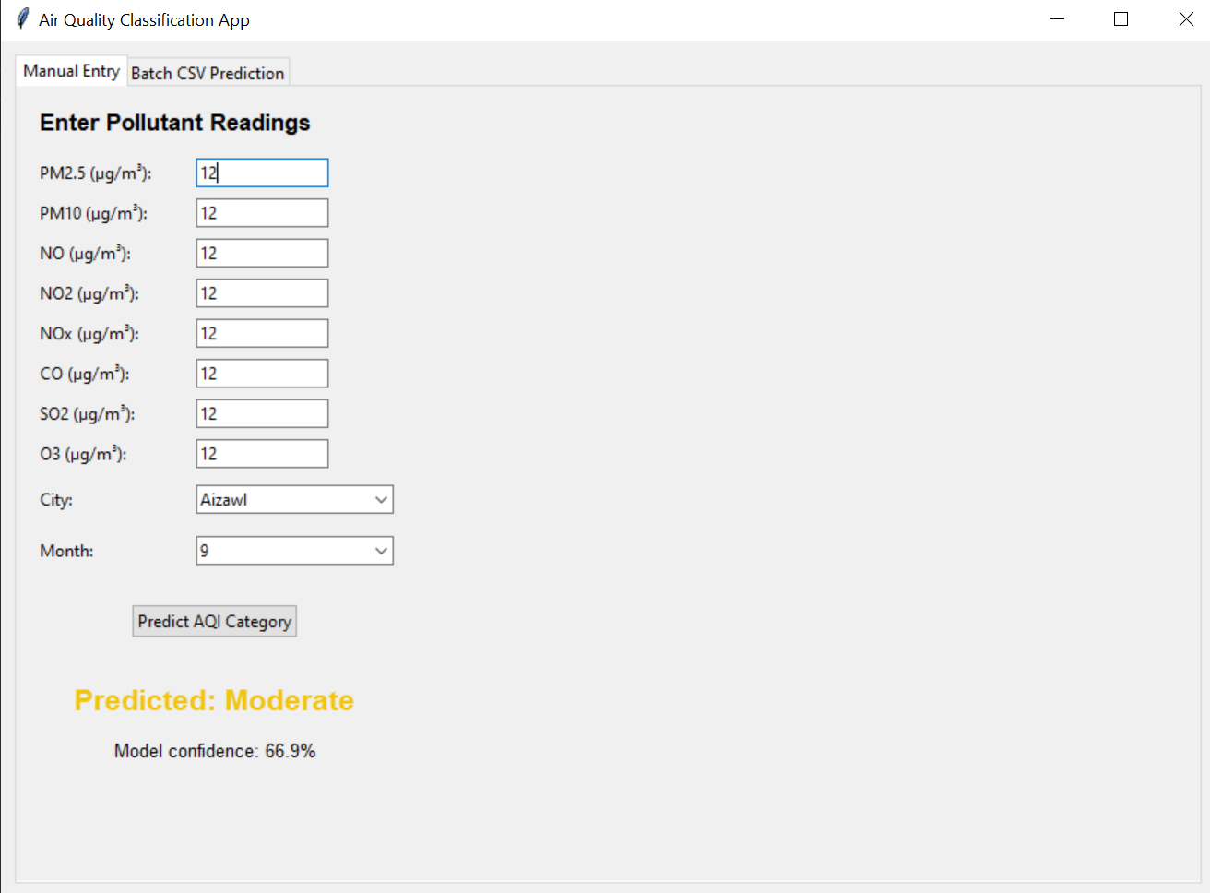
Figure 7. First prototype: manual entry with a single confidence value (raw model output).
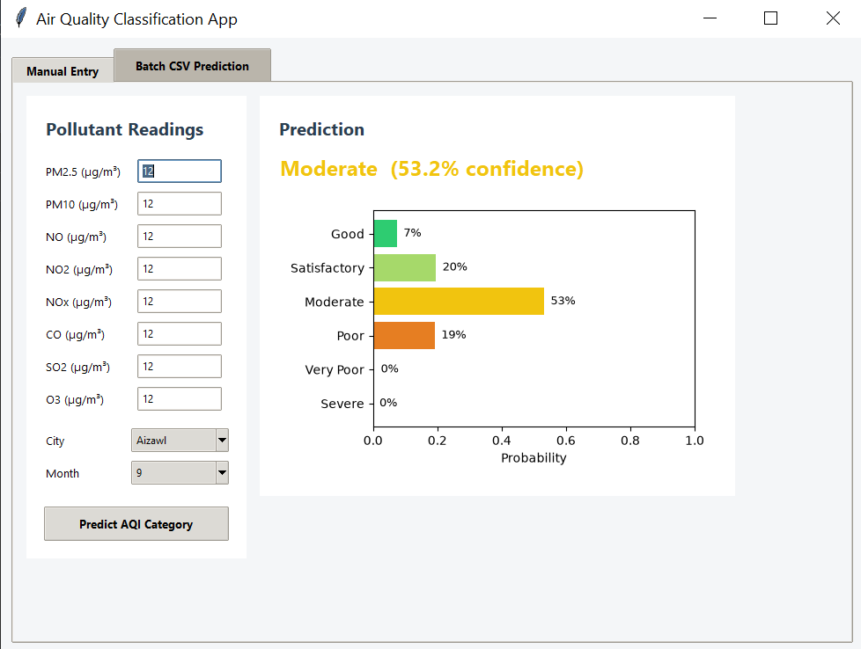 | 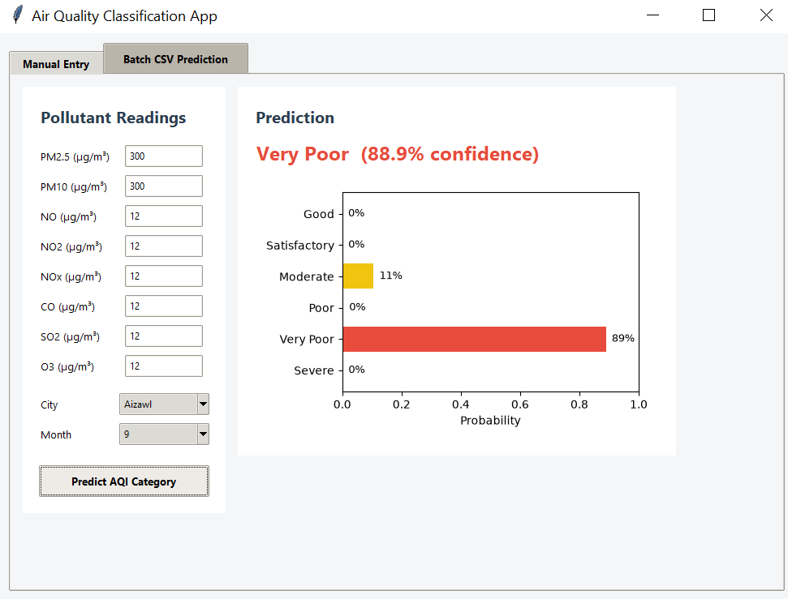
Figure 8. Second prototype with the full probability chart. Left: a borderline input. Right: PM2.5 and PM10 both 300.
The two prototypes also made the effect of calibration visible. The same input (all eight readings equal to 12) produced “Moderate, 66.9%” with the raw model and “Moderate, 53.2%” after calibration, with the chart showing why: Satisfactory (20%) and Poor (19%) were both plausible. By contrast, PM2.5 and PM10 of 300 gave “Very Poor, 88.9%” with almost all the remaining probability on Moderate. A model whose confidence is low on ambiguous inputs and high on clear ones is behaving as it should. The prototype also contained a mistake that the final version corrects: every input was labelled µg/m³, although CO in the training data is in mg/m³, so a user could have entered a value a thousand times too large.

11.4 The final application: Aether
The final application, Aether, is a native desktop program written with PySide6 (Qt). It has four views.
- Single reading. Eight pollutant readings, a city and a month. Each field shows its unit (CO in mg/m³, everything else in µg/m³) and the form states that inputs must be daily averages. The result shows the category, its AQI range, the calibrated confidence, a plain-language health message and the probability of every category. A borderline notice appears when confidence is below 60% or the runner-up category has at least 25%. Three illustrative presets (a clean day, a moderate winter day, a heavy smog episode) let a new user try the tool.
- Batch analysis. A CSV is opened by dialog or by drag-and-drop, and a template with the required columns can be saved from the app. Results are shown in a sortable table that can be filtered by category or searched by city, with a category breakdown and an Export button. Rows that cannot be classified are kept, marked Skipped, and given a reason: city not supported, invalid date or month, missing or non-numeric reading, or negative reading. A banner summarizes how many rows were skipped and why.
- History. Every single-reading analysis is saved between launches and can be exported or cleared.
- About the model. A model card (model name, held-out test accuracy and macro F1, training data), a legend of the six categories with their health messages, a statement of limitations and the list of supported cities.
[Insert screenshot: Aether, Single reading view, with a result displayed (for example the “Moderate winter day” preset)]
Figure 9. Aether, Single reading view, with a result displayed (for example the “Moderate winter day” preset)
[Insert screenshot: Aether, Batch analysis view after loading a CSV, showing the results table, category breakdown and a skipped row]
Figure 10. Aether, Batch analysis view after loading a CSV, showing the results table, category breakdown and a skipped row
[Insert screenshot: Aether, History view]
Figure 11. Aether, History view
[Insert screenshot: Aether, About the model view (model card and limitations)]
Figure 12. Aether, About the model view (model card and limitations)

11.5 Design decisions
- One engine for every path, so that a single reading, a batch file and a history entry can never be classified differently.
- Skip with a reason instead of guessing. A missing reading is never treated as zero; a city the model was not trained on is refused rather than silently mapped to the baseline city.
- Uncertainty is part of the answer. The probability chart and the borderline notice exist because the model’s mistakes are between neighbouring categories (Chapter 7); users should see when a reading is close to a boundary.
- Limitations are shown in the product, not only in this report: the model is trained on Indian cities, expects daily averages, and is a classifier, not a health advisory.
- Muted, earth-toned category colours rather than a traffic-light scheme, and bundled fonts (Cormorant Garamond and Montserrat, open licence) so that the application looks the same on every machine. A build script produces a standalone Windows executable.

Decision. Ship the full calibrated model (31 features) behind a single prediction engine, and make its limits visible in the interface. The generalization findings in Chapter 12 are the main input for refining those limit statements.

12. Generalization Study

12.1 The question, and an important caveat about which model is tested
The test set in Chapter 10 comes from the same 20 cities and years as the training data, so it cannot say how the model behaves elsewhere. The final phase of the internship asked: does the model hold up on a city and a country it has never seen, and if not, why?
Two practical problems shaped the design. The external datasets do not contain NO or NOx, and the shipped model uses one-hot indicators for 20 specific cities that an external city does not have. I therefore tested a six-pollutant sibling of the final model (PM2.5, PM10, NO2, SO2, CO, O3), with the same tuned hyperparameters and SMOTE on the training data only. On the Indian test set it scores 80.9% accuracy (macro F1 0.772), a little below the full model’s 82.7%, partly because it lacks the extra features and partly because it is uncalibrated. The generalization results below are therefore evidence about this sibling model and the approach, not a direct measurement of the model inside Aether. Chapter 13 returns to this.

12.2 The external datasets
Table 14. The two external datasets.
 | Pune, India | Beijing, China
Source | Daily air quality and pollutant data for Pune (Mendeley Data), city-average file | UCI Multi-Site Air-Quality Data: 12 stations, hourly
Period | 2,022 city-average days from March 2018; 276 days have all six pollutants and sub-indices (Feb 2025–Jan 2026) | 1 Mar 2013 – 28 Feb 2017; 420,768 hourly rows; 1,453 complete days
Labels | Pune’s own CPCB-method AQI, rounded to whole numbers and binned with the Indian bands | Computed by me with CPCB breakpoints (Section 12.7); no official categories exist in the files
Class counts | Moderate 106, Satisfactory 81, Good 76, Poor 6, Severe 5, Very Poor 2 | Moderate 447, Satisfactory 369, Very Poor 332, Poor 246, Severe 45, Good 14
What it tests | A new Indian city, six years later | A different country, climate and pollution mix

Pune was kept only on days where all six pollutants and all six sub-indices were reported. Pune’s AQI is the maximum of its sub-indices, so on days with some pollutants missing it reflects only part of the picture and would not be comparable to a label built from all six. O3, CO and SO2 are about 83% missing in the file, so filling them would have meant inventing most of the data; I dropped incomplete days instead. Beijing was a natural second test because it is used in two of the reviewed studies (Saminathan & Malathy, 2023; Gul & Khan, 2020) and offers hourly data. Both datasets were checked for unit consistency before any scores were computed: CO is in mg/m³ in the Indian data and in µg/m³ in Beijing (converted), and the medians of the other pollutants are of the same order.

12.3 First result: Pune, and a shifted ruler
On Pune the six-pollutant model reached 72.5% accuracy, against 80.9% on the Indian test set. The shape of the errors was more revealing than the drop. 99.6% of predictions (275 of 276) were within one category of the label, so the model had the severity ordering right. But 69 of its 76 errors (91%) were the model calling a day one step more polluted than its label. Like a ruler that reads one notch high, the ordering is right and the whole scale is shifted. Accuracy on the three well-populated classes (Good, Satisfactory, Moderate) was an F1 of 0.77. The three rare Pune classes have only 13 days between them and are not reliable to score.
A clue was already in the data. Compared with the training cities, Pune was cleaner on four pollutants (median PM2.5 26 against 49, PM10 63 against 96, NO2 19 against 22, SO2 4.4 against 9.2) yet higher on two: CO (1.25 against 0.89 mg/m³) and O3 (43 against 31 µg/m³).

12.4 Diagnosis by elimination
Two suspects could push predictions upwards: SMOTE (which nudges a model towards higher classes) and CO/O3. Four variants separated them (table below).
Table 15. Ablations on Pune. “Too high” means the model called the day more polluted than its label.
Variant | India test accuracy | Pune accuracy | Pune F1 (3 main classes) | Pune errors that are “too high”
A: six pollutants + SMOTE (reference) | 0.809 | 0.725 | 0.772 | 91%
B: six pollutants, no SMOTE | 0.824 | 0.714 | 0.710 | 87%
C: no CO/O3, with SMOTE | 0.733 | 0.743 | 0.751 | 28%
D: no CO/O3, no SMOTE | 0.745 | 0.569 | 0.470 | 69%

- SMOTE is not the cause. Removing it barely changes the share of upward errors (91% to 87%), and SMOTE actually helps Pune’s F1 (0.71 to 0.77).
- The shift lives in CO and O3. Removing them cuts the upward errors to 28%.
- But removing them is not a fix. It costs about 8 points of accuracy on the Indian data and flips the bias the other way, because Pune’s labels do depend on CO and O3. Variant D is an outlier that I treated as a diagnostic arm, not a candidate model.

12.5 The cause: the same name, two different measurements
Pune reports CO and O3 as the daily maximum of rolling 8-hour averages, the convention used in the CPCB index. The Indian dataset’s documentation does not say how its daily CO and O3 were computed, so I tested it directly. For Delhi, I computed both versions from the hourly file and compared each to the value in city_day.csv.
Table 16. Which definition does the Indian data use? (Delhi.)
Pollutant | Days compared | Median gap: file vs daily mean | Median gap: file vs 8-hour maximum
CO (mg/m³) | 2,005 | 0.002 | 0.474
O3 (µg/m³) | 1,924 | 0.002 | 19.257

The file matches the daily mean almost exactly and is far from the 8-hour maximum. The training features were daily means; Pune’s were 8-hour maxima. Ozone peaks in the afternoon, so its 8-hour maximum runs well above its daily mean. To a model trained on means, a Pune day therefore looked more polluted than it was, which is exactly the upward shift observed. I checked only Delhi, on the assumption that one pipeline produced every city.

12.6 The fix: harmonize the definitions
I rebuilt CO and O3 in the training data as daily maxima of 8-hour means, using the hourly city file I had set aside in Chapter 3, kept everything else identical, and retrained. Pune accuracy rose from 72.5% to 82.6%, and Indian test accuracy from 80.9% to 82.1%, so nothing was lost at home. In the run that first showed the effect, upward errors fell from 69 to 28 while downward errors rose only from 7 to 18, a roughly balanced split that chance could produce, and the F1 on the three main classes rose from 0.77 to 0.87. Indian accuracy also improved slightly, which fits the idea that the labels themselves follow 8-hour maxima. One caution: Pune was used to find this problem, so its post-fix score is a post-diagnosis number, not a blind test. The change followed documented definitions and was a single change with no tuning against Pune, but a genuinely untouched check was needed. Beijing is that check.

12.7 Beijing: the untouched test

Labels and how far to trust them
Beijing has no AQI labels, so I wrote a calculator: for each pollutant, a sub-index interpolated within CPCB’s concentration bands, and the AQI is the largest sub-index. I validated it first on Pune, where the answer key exists: median gaps from Pune’s own sub-indices were 0.07 or less for PM2.5, PM10, NO2, SO2 and O3 and 1.2 for CO (whose bands are narrow), and the category matched on all 276 days. That check covers mostly Good to Moderate days, so I also compared the calculator with the Indian dataset’s own labels. Agreement was lower than I hoped: 73.7% with daily-mean CO/O3 and 78.4% with 8-hour maxima on days where every pollutant was genuinely measured. The 8-hour version agreeing better is further evidence that the dataset’s labels use 8-hour maxima; the remaining disagreement was not resolved and ran in both directions. So Beijing’s labels are my calculation, not official categories, and the numbers below should be read with that caution.

Results
The harmonized model was frozen and scored on Beijing without any change. For comparison, the daily-mean model (A) was given the same Beijing features, replicating the Pune diagnosis on data that had not been used to find it.
Table 17. Beijing, frozen models. Good (14 days) is not scored separately.
Model on Beijing (1,453 days) | Accuracy | Within one category | F1 (5 classes with ≥ 30 days) | Days called too high | Days called too low
E: harmonized (frozen) | 0.714 | 0.959 | 0.728 | 60 | 355
A: daily-mean model | 0.641 | 0.975 | 0.686 | 207 | 314

Two things follow. First, the diagnosis replicates: given identical Beijing inputs, the model trained on daily means is 7 points worse and calls 147 more days too high than the harmonized model. Second, Beijing has its own problem on top: even the harmonized model errs mostly in the low direction (355 of its 415 errors), mainly Moderate days called Satisfactory (121) and Very Poor days called Poor (99). About 4% of days are two or more categories off, including 35 Very Poor days called Moderate or Satisfactory. For a health-oriented tool, under-calling is the more serious direction.

Where does it fail?
Grouping Beijing days by the pollutant that sets the label gave the clearest result of the study.
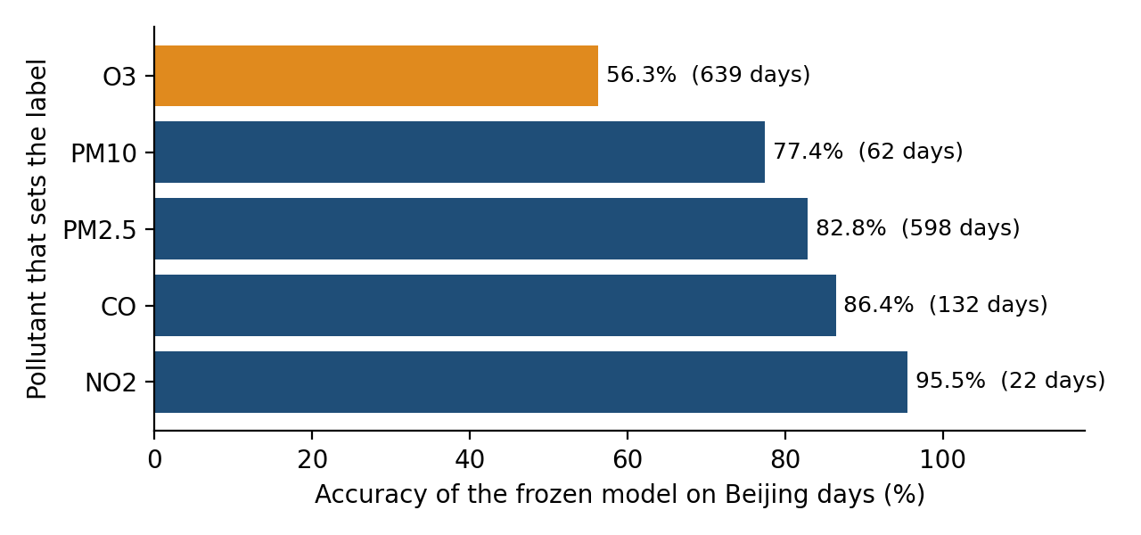
Figure 13. Accuracy of the frozen harmonized model on Beijing, grouped by which pollutant sets the label.
On the 814 days where the label is set by something other than ozone, accuracy is 83.3%, matching the Indian test set (82%) and Pune (83%). Where ozone sets the label (639 days, 44% of Beijing), accuracy drops to 56.3%. The training data explain why: only 14 of 11,227 Indian training days have ozone driving a Poor-or-worse label, against 193 of 1,453 Beijing days. Beijing’s 90th-percentile ozone (198 µg/m³) is above India’s 99th (149). Tree models cannot predict beyond the range they have seen, so in this regime its predictions are unreliable. This is a coverage limit of the training data, not something more tuning would fix.
I tested an alternative explanation and rejected it. Beijing’s PM10-to-PM2.5 ratio is much lower than India’s (median 1.4 against 2.1), which could in principle make the model read PM-driven days as milder. But PM2.5-driven Beijing days are predicted well (82.8%, only 12% under-called), so the particle mix is not the main problem. Two caveats remain: ozone-driven days are mostly summer days, so regime and season are entangled; and the labels on those days rest on ozone breakpoints that the Pune check validated only at low values.

12.8 Summary of the study
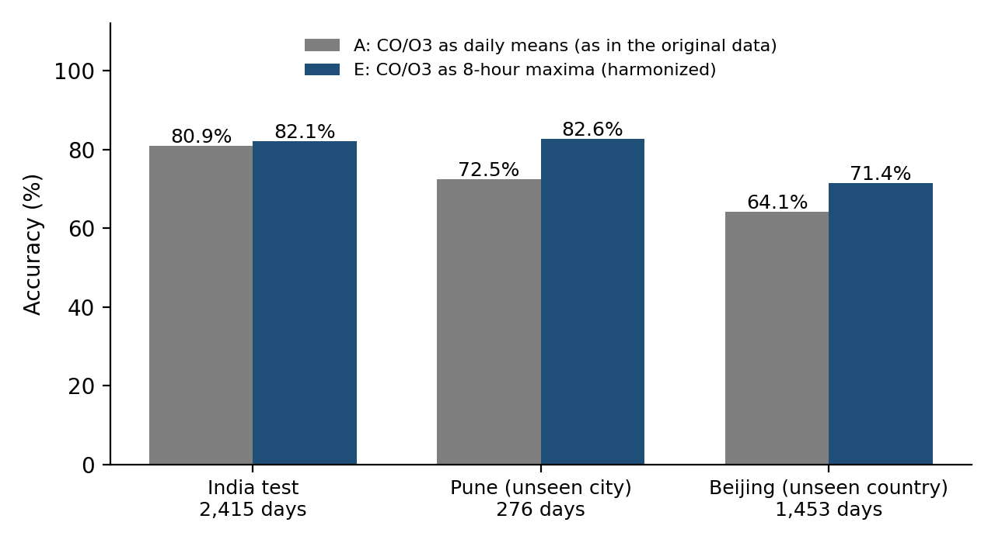
Figure 14. Accuracy of the daily-mean (A) and harmonized (E) six-pollutant models on the Indian test set, Pune and Beijing.
Table 18. Accuracy across datasets.
Dataset | Days | Model A (daily-mean CO/O3) | Model E (8-hour-max CO/O3)
India test (20 cities) | 2,415 | 0.809 | 0.821
Pune (unseen city; post-diagnosis) | 276 | 0.725 | 0.826
Beijing (unseen country; untouched) | 1,453 | 0.641 | 0.714
Beijing, days not set by ozone | 814 | 0.763 | 0.833
Beijing, days set by ozone | 639 | 0.487 | 0.563

- Within the regime it was trained on, the approach generalizes. About 83% accuracy on a new Indian city and on Beijing days not driven by ozone, with errors almost always one category.
- Feature definitions matter as much as models. One mislabelled convention (daily mean vs 8-hour maximum) cost about ten points on Pune and was found by testing hypotheses, not by tuning.
- The model fails where its training data are empty. Ozone-driven high-AQI days are almost absent from the Indian data, and accuracy there falls to 56%, with many days under-called by one or more categories.

Conclusions. (1) Harmonize CO and O3 as 8-hour maxima if the model is retrained for use outside the original data. (2) State in the application that results are least reliable when ozone, rather than particulate matter, drives the AQI. (3) Treat the Beijing numbers as indicative rather than definitive, since its labels are computed.

13. Limitations and Lessons Learned

13.1 Limitations
- One training dataset, one country. The shipped model reflects Indian monitoring, Indian cities and 2015–2020. Its city indicators tie it to 20 named cities, and it cannot score a new city without retraining.
- The shipped model was not directly validated externally. The generalization evidence comes from a six-pollutant sibling model. A natural next step is to ship the harmonized six-pollutant model.
- Daily averages only. CO and O3 must be entered as daily means to match the shipped model, whereas regulatory indices use 8-hour maxima.
- Label noise. The dataset’s labels are only 74–78% reproducible from the pollutant columns by a plain CPCB calculation, and the cause was not established.
- Small rare classes. Severe has 27 test days and 5 Pune days; individual per-class figures are noisy.
- No weather or time structure. The data contain no meteorology, and the model treats every day independently.
- Computed labels for Beijing, and a validation of the calculator that covers few upper-band days.

14. Conclusion and Future Work
The project delivered what it set out to: a documented pipeline from public data to a calibrated six-category classifier (82.7% accuracy, macro F1 0.791 on a held-out test set), a desktop application that communicates uncertainty and refuses to guess, and a generalization study that located both the strengths and the boundary of the approach. Its most useful results are arguably the least expected ones: that a feature-definition mismatch, not model quality, explained the first failure, and that the model’s weakness is a specific, nameable regime rather than diffuse error.
Natural extensions, roughly in order of value:
- Retrain and ship the harmonized model (six pollutants, 8-hour-maximum CO/O3, calibrated), which removes the dependence on specific cities and was validated on two external datasets.
- Add ozone-driven high-AQI days to the training data, from other regions or from Pakistani monitoring data, and re-test on Beijing’s ozone days.
- Resolve the label-agreement gap by establishing exactly how the Indian dataset’s AQI was computed.
- Add meteorological and time features, and consider a sequence model if consecutive days are available as input.
- Collect Pakistani data (for example Punjab EPD reports) with a proper extraction pipeline, giving a locally relevant test set.
- Show a data-range warning in the application when an input lies outside the range seen in training.

References
Ahmad, O., Khalid, Z., Tahir, M. & Uppal, M. (2025). Spatiotemporal air quality mapping in urban areas using sparse sensor data, satellite imagery, meteorological factors, and spatial features. arXiv:2501.11270.
Ahmed, M., Shen, Y., Ahmed, M., Xiao, Z., Cheng, P., Ali, N., Ghaffar, A. & Ali, S. (2022). AQE-Net: A deep learning model for estimating air quality of Karachi city from mobile images. Remote Sensing, 14(22), 5732. https://doi.org/10.3390/rs14225732
Central Pollution Control Board, India. National Air Quality Index: categories and concentration breakpoints.
Gul, S. & Khan, G. M. (2020). Forecasting hazard level of air pollutants using LSTM’s. AIAI 2020, IFIP AICT 584, 143–153. https://doi.org/10.1007/978-3-030-49186-4_13
Gupta, [remaining authors] (2023). Prediction of air quality index using machine learning techniques: a comparative analysis. Journal of Environmental and Public Health.
Jayadi, [remaining authors] (2024). AQI classification for imbalanced data using machine learning. Sistemasi.
Méndez, M., Merayo, M. G. & Núñez, M. (2023). Machine learning algorithms to forecast air quality: a survey. Artificial Intelligence Review.
Rao, R. Air Quality Data in India (2015–2020). Kaggle dataset.
Saminathan, S. & Malathy, C. (2023). Ensemble-based classification approach for PM2.5 concentration forecasting using meteorological data. Frontiers in Big Data.
Soontornpipit, [remaining authors] (2024). PM2.5 prediction and air quality classification using machine learning. Thai Journal of Mathematics.
[Authors] Daily air quality index and pollutant concentrations for Pune, India. Mendeley Data. https://data.mendeley.com/datasets/y6p778djzj/1
UCI Machine Learning Repository. Beijing Multi-Site Air-Quality Data. https://archive.ics.uci.edu/dataset/501/beijingmultisiteairqualitydata

Appendix A. Repository and Reproducibility
All code is in the public repository https://github.com/ayeshatariqq/AI-Based-AQI-Classification. At the time of writing it contains the following.
Table 19. Repository contents.
Item | Purpose
model_training.ipynb | Data cleaning, EDA, split, baselines, ensembles, SMOTE, tuning, calibration and final test evaluation
data/ | Input data folder (city_day.csv and the other files of the Kaggle download)
models/ | Saved artifacts: calibrated model, label encoder, training columns, pollutant list, city list, season list
app.py | Desktop application code

To add before submission: the generalization notebook, the Aether application folder (with its README and build script), and a README describing how to run everything.
[Insert screenshot: The GitHub repository page]
Figure 15. The GitHub repository page

A.1 Environment
The work was done in Python 3.12 with pandas, NumPy, scikit-learn, imbalanced-learn (SMOTE), XGBoost, joblib and Matplotlib; the Aether application additionally uses PySide6. Random seeds are fixed (42) wherever a random process is involved.

A.2 Reproducing the results
- Download the Kaggle dataset Air Quality Data in India (2015–2020) into data/. Run model_training.ipynb from top to bottom to reproduce Chapters 4–10 and to regenerate the six artifacts in models/.
- For the generalization study, add the Pune files to data/pune/ and the 12 Beijing station files (PRSA_Data_*.csv) to data/beijing/, then run the generalization notebook top to bottom. It reads only the raw files, not the processed splits.
- Run the application and point it at the models/ folder, or build the executable with the provided script.
The datasets are not redistributed with the repository; each is available from the sources listed in the references and is subject to its own licence.

Appendix B. Decision Log
Each row records a decision, the alternatives considered, the choice and the reason. It is intended as a quick reference for anyone extending the project.
Table 20. Summary of decisions.
Decision | Alternatives | Choice | Reason (chapter)
Dataset | Islamabad scrape; Punjab EPD PDFs; synthetic; Beijing; India | India city-level (Kaggle) | Real, labelled, multi-city, precedented (3)
Granularity | Station-level; hourly; city-daily | City-daily | Matches the question; no joins (3)
Xylene, Toluene, Benzene | Impute; keep; drop | Drop | Not in AQI sub-index; 19–61% missing (4)
NH3 | Impute; keep; drop | Drop | Structurally missing in many cities (4)
PM10 | Drop column; impute; drop cities | Drop 6 cities | Core AQI driver; absent for years in those cities (4)
Remaining gaps | Global mean; interpolate; within-city fill | Within-city forward/back fill | Autocorrelation; no cross-city leakage (4)
Outliers | Cap; remove; keep | Keep | They are real severe days (4)
Target | Binary; six-class | Six-class category | Labels present; communicates severity (4)
Features | Lags; weather; season | Season, month, one-hot city | Seasonal signal in EDA; single-day input (5)
Split | Random; global date; per-city time | Per-city chronological 70/15/15 | No leakage; all cities in every set (6)
Metric | Accuracy; macro F1 | Macro F1 + per-class recall | Imbalance; cost of errors (7)
Lead model | LR, DT, KNN, RF, XGBoost | XGBoost | Best validation macro F1 (8)
Imbalance | Class weights; SMOTE | SMOTE, training only | Severe recall 0.79 to 0.94 (9)
Tuning | Grid; randomized | Randomized, SMOTE inside CV | Cost; avoids fold leakage (10)
Calibration | None; isotonic 3-fold; isotonic pre-fitted | Isotonic, pre-fitted | 3-fold refit changed the boundary (10)
Application | Web; Tkinter; PySide6 | Tkinter prototype, then PySide6 (Aether) | Desktop requirement; polish (11)
Model for external tests | Full model; six-pollutant model | Six-pollutant model | External data lack NO/NOx and cities (12)
CO/O3 definition | Daily mean; 8-hour maximum | 8-hour maximum for external use | Matches CPCB and Pune; +10 points on Pune (12)
Beijing labels | None official; CPCB calculator | Calculator, validated on Pune | Only option; documented caveats (12)

