PROJECT SUMMARY
Machine-Learning Air Quality Classification
Ayesha Tariq | IT and Software Development Lab, ASCEND Tower | Supervisor: Raza Ali | Code: https://github.com/ayeshatariqq/AI-Based-AQI-Classification

1. The project in brief
Over an eight-week internship I asked a practical question: given one day’s pollutant readings for a city, how reliably can a machine-learning model assign the correct air-quality category (Good, Satisfactory, Moderate, Poor, Very Poor, Severe, following India’s CPCB scheme), and can the answer be offered as a tool anyone can run? The work produced a documented pipeline from public data to a calibrated classifier, a desktop application (Aether), and a study of how well the model carries over to other cities and countries.
Headline results. The final model (XGBoost with SMOTE, tuned and calibrated) reaches 82.7% accuracy and macro F1 0.791 on a held-out test set of 2,415 city-days. A six-pollutant version scores 82.6% on an unseen Indian city (Pune) and 71.4% on Beijing, where accuracy is 83% on days not driven by ozone but only 56% on days where ozone sets the AQI — a regime almost absent from the training data.

2. Literature and dataset
I reviewed eight recent studies (Jakarta, Beijing, four Indian cities, Bangkok, Karachi, Lahore and a global survey). Three lessons shaped the design: tree-based and ensemble models are consistently strong on tabular pollutant data; class imbalance is the recurring obstacle, with SMOTE the common remedy; and Pakistani datasets are small or hard to extract (1,001 photographs, 1,500 daily samples, PDF reports). I therefore chose the public Kaggle dataset Air Quality Data in India (2015–2020): real measurements for 26 cities, every CPCB pollutant, and a pre-computed six-level category used as the label. It has precedent in the literature. Islamabad scrapes, Punjab EPD PDFs and synthetic sets were rejected. I used the city-level daily file (29,531 rows) because the question is city-level; station-level and hourly files add complexity without improving the answer.

3. Preparing the data
The guiding principle was to ask why a value is missing before deciding what to do. Xylene, Toluene, Benzene and NH3 were dropped (outside the AQI calculation, or 19–61% missing). PM10, a core AQI driver, was 38% missing, but a per-city breakdown showed it was structurally absent in six cities (Lucknow, Patna, Chennai, Ahmedabad, Mumbai, Gurugram), so I removed those cities rather than the column or fabricating the data, leaving 20 cities. Remaining gaps (7–16%) were filled within each city’s own time series, and 16,052 labelled rows remained. Outliers were kept: they are real severe-pollution days, the very ones the model must detect. The classes are imbalanced (Severe is 2%). Features are the eight pollutants, month, a Season variable motivated by the strong winter-smog cycle, and one-hot city and season: 31 columns.
My first train/test split used a single date cutoff and looked fine, but counting cities showed the training set held only 12 of 20 cities while the test set held all 20. I replaced it with a chronological 70/15/15 split within each city (11,227 / 2,410 / 2,415 rows), so every city appears in every set and no future data leaks into training. Anything that learns from data is fitted on the training set only, and the test set is used once.

4. Models and results
I used macro F1 as the main metric, because accuracy can look good on imbalanced data while ignoring the rare, most important classes. The models formed a ladder, each step justified by the one before.
Table 1. From baseline to final model.
Stage | Model and change | Macro F1 | Set
Baselines | Logistic Regression (best); Decision Tree 0.668; KNN 0.646 | 0.692 | Validation
Ensembles | XGBoost (Random Forest 0.768; depth-limited tree 0.738) | 0.782 | Validation
Imbalance | + SMOTE (training only): Severe recall 0.79 to 0.94 | 0.787 | Validation
Tuning | + randomized search, 150 fits, SMOTE inside the CV folds | 0.806 | Validation
Final | + isotonic calibration (pre-fitted); accuracy 0.827 | 0.791 | Test, once

Table 2. Per-class results of the final model (accuracy 0.827, macro F1 0.791).
Final model, test set | Precision | Recall | Test days
Good | 0.78 | 0.80 | 367
Satisfactory | 0.89 | 0.81 | 1,168
Moderate | 0.80 | 0.89 | 714
Poor | 0.67 | 0.66 | 88
Very Poor | 0.72 | 0.82 | 51
Severe | 0.82 | 0.85 | 27

Three decisions are worth noting. SMOTE cost 1.4 points of accuracy but raised recall on the rarest, most consequential class, a trade I judge right for a health tool. The unconstrained Decision Tree lost to Logistic Regression because it overfitted, not because trees suit the data poorly: a depth limit alone added 0.07 macro F1. Calibration must be done in pre-fitted mode: the default three-fold mode refits clones of the model and quietly degraded it (test macro F1 0.781). I also caught two silent errors by inspecting outputs rather than trusting clean runs: the flawed split above, and three dropped columns that had crept back into the features, found through the feature-importance chart. Across every model the errors fall between neighbouring categories almost always, so the model keeps the severity ordering even when it is wrong.

5. The desktop application
A first Tkinter prototype showed the saved model working end to end and led to a probability chart for every category, which made calibration visible: a borderline input gave “Moderate, 53%” with Satisfactory and Poor both plausible, while PM2.5 = PM10 = 300 gave “Very Poor, 89%”. The final application, Aether (PySide6), has four views: single reading, batch CSV analysis, history and a model card. One prediction engine, mirroring the training preprocessing exactly, serves every view. The app never guesses: unsupported cities, bad dates and missing or negative readings are skipped with a stated reason. It shows health guidance, a notice when a result is borderline, its own limitations, and ships with a build script for a standalone Windows executable.

6. Does it generalize?
The test set shares cities and years with the training data, so I tested on two unseen datasets: Pune (a new Indian city, 276 fully measured days in 2025–26) and Beijing (a different country, 1,453 days, with labels I computed using CPCB breakpoints, validated against Pune’s own labels). Because these lack NO/NOx and the model has city indicators, I tested a six-pollutant sibling of the final model with the same hyperparameters. This means the results below are evidence about the approach, not a direct test of the model inside Aether.
On Pune the first result was 72.5% accuracy, with 99.6% of predictions within one category, but 91% of errors called the day one step too polluted, like a ruler reading one notch high. Ablations ruled out SMOTE and pointed to CO and O3. A check on Delhi found the cause: in the Indian data CO and O3 are daily means, whereas Pune (and the official index) use daily maxima of 8-hour averages. The same column names measured different things. Rebuilding the training features with the 8-hour definition fixed it.
Table 3. Accuracy across datasets.
Test set | Days | Daily-mean CO/O3 | 8-hour-max CO/O3
India test (20 cities) | 2,415 | 0.809 | 0.821
Pune (unseen city) | 276 | 0.725 | 0.826
Beijing (unseen country) | 1,453 | 0.641 | 0.714
Beijing, days not set by ozone | 814 | 0.763 | 0.833
Beijing, days set by ozone | 639 | 0.487 | 0.563

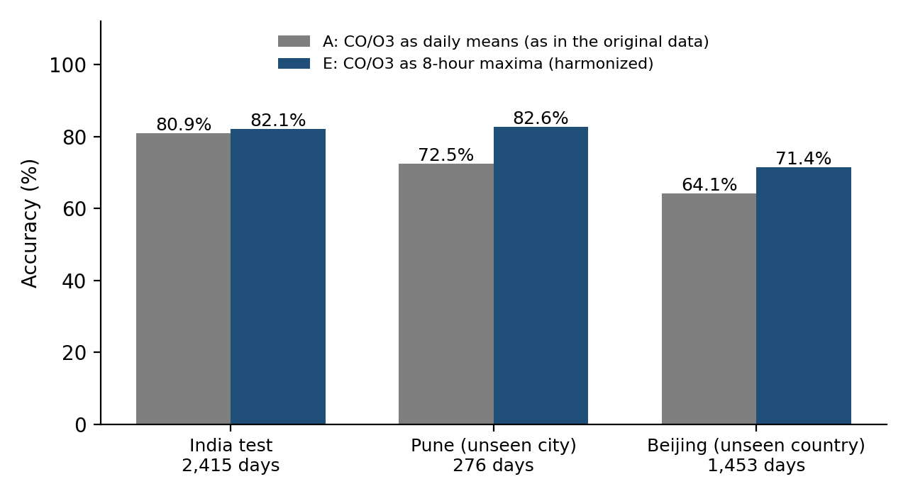 | 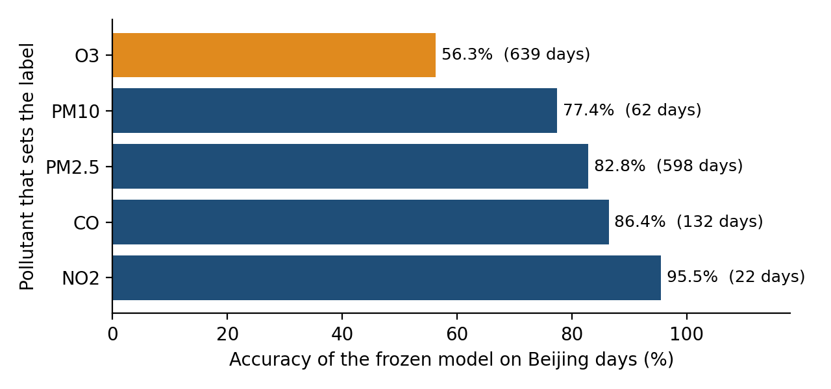
Figure 1. Left: accuracy of the daily-mean (A) and harmonized (E) models by dataset. Right: frozen model on Beijing, by the pollutant that sets the label.
Beijing, untouched during diagnosis, replicated the effect (the daily-mean model was 7 points worse) and revealed the model’s real boundary: only 14 of 11,227 Indian training days have ozone driving a Poor-or-worse label, against 193 of Beijing’s 1,453, and tree models cannot predict beyond the range they have seen. I tested a second explanation (a different particle mix) and rejected it. The caveat is that Beijing’s labels are my calculation, which matched the Indian dataset’s own labels only 74–78% of the time.

7. Key decisions at a glance
Table 4. The main decisions and their reasons.
Decision | Choice | Why
Dataset | India city-level daily data (Kaggle) | Real, labelled, multi-city, precedented in the literature
Missing PM10 | Drop six cities, keep the column | Structural gaps; PM10 is a core AQI pollutant
Outliers | Keep | They are real severe days; trees tolerate skew
Split | Chronological within each city | No leakage; every city in every set
Metric | Macro F1 and per-class recall | Imbalance; missing a Severe day costs most
Imbalance | SMOTE on training data only | Severe recall 0.79 to 0.94
Tuning | Randomized search, SMOTE inside CV | Avoids leakage between folds
Calibration | Isotonic, pre-fitted | Honest confidence without changing predictions
Application | One engine; skip with a reason | Never silently guess
Use outside India | CO/O3 as 8-hour maxima | About +10 points of accuracy on Pune

8. Limitations and next steps
- One training source. The model reflects Indian monitoring from 2015–2020, and its city indicators tie it to 20 named cities; the shipped model itself was not directly tested externally.
- Daily-average inputs, and no weather or time structure. Rare classes are small (27 Severe test days), so their metrics are noisy.
- Next: ship the harmonized six-pollutant model; add ozone-driven high-AQI days from other regions or Pakistani monitoring data; establish exactly how the Indian dataset’s AQI was computed; add meteorological features; show a data-range warning in the app.
The main lesson is that a pipeline that runs is not a pipeline that is right. The three largest problems found (the split, the leaked columns, the CO/O3 definitions) all ran without error, and each was caught only by asking whether the output made sense. The full 28-page report documents every decision, alternative and result.

