INTRODUCTION

INTRODUCTION
Medicinal plants have been used as important sources of therapeutic agents in traditional systems of medicine for the management of various health conditions. The therapeutic potential of medicinal plants is mainly associated with the presence of diverse biologically active phytoconstituents, particularly secondary metabolites such as flavonoids, phenolic compounds, alkaloids, tannins, saponins, terpenoids and glycosides. These constituents may contribute to several biological activities, including antioxidant and anti-inflammatory effects. The increasing scientific interest in medicinal plants has therefore encouraged the systematic investigation of their phytochemical composition and pharmacological properties, with the aim of identifying plant-derived substances possessing potential therapeutic value.
Cardiospermum halicacabum Linn., commonly known as balloon vine, is an herbaceous climber belonging to the family Sapindaceae. It is widely distributed in tropical and subtropical regions and is used in various traditional systems of medicine. Different parts of the plant, including the leaves, roots, stems and seeds, have been used traditionally for several ailments such as rheumatism, abdominal pain, skin disorders, cough, nervous disorders and other inflammatory conditions. The broad traditional use of the plant, together with its reported biological activities, has led to increasing scientific interest in its phytochemical composition and pharmacological potential.
Cardiospermum halicacabum has been investigated for its phytochemical composition, and different studies have reported the presence of several groups of bioactive constituents. Reported constituents include phenolic compounds, phenolic acids, flavonoids and flavonoid glycosides, along with other classes of secondary metabolites. More detailed analytical studies have identified compounds such as chlorogenic acid, caffeic acid, p-coumaric acid, luteolin-7-O-glucuronide, apigenin-7-O-glucuronide and chrysoeriol in different parts of the plant. The presence of these phytoconstituents provides a basis for investigating the biological activities associated with C. halicacabum.
The pharmacological potential of Cardiospermum halicacabum has been investigated in several experimental studies. Reported activities include antioxidant, anti-inflammatory, anti-arthritic, antidiabetic, antimicrobial, antiulcer, anxiolytic, antidiarrhoeal, nephroprotective and hepatoprotective effects. Among these activities, the antioxidant and anti-inflammatory properties are particularly relevant because oxidative stress and inflammatory processes are involved in the development of several pathological conditions. However, although a broad range of pharmacological effects has been reported, the specific bioactive constituents and mechanisms responsible for many of these effects have not yet been completely established.
The antioxidant activity of Cardiospermum halicacabum has been demonstrated in experimental investigations, and this activity has been associated with its phenolic and flavonoid constituents. In one study, an ethanolic extract of C. halicacabum showed free-radical-scavenging activity in DPPH and ABTS assays and contained identifiable phenolic compounds, including luteolin 7-O-glucuronide, apigenin 7-O-glucuronide and chrysoeriol derivatives. These findings are important to the present research because antioxidant activity may be relevant when investigating the protective effects of plant extracts against experimentally induced cellular or tissue injury.
The liver is one of the major organs involved in the metabolism, biotransformation and elimination of endogenous and exogenous substances and is therefore particularly vulnerable to injury caused by various chemical and environmental factors. Liver injury may involve disturbances in cellular metabolism, oxidative stress, inflammation and changes in biochemical functions. Because oxidative stress and related cellular damage can contribute to the progression of hepatic injury, the search for substances with antioxidant and protective properties has become an important area of pharmacological research. Medicinal plants containing phenolic and flavonoid constituents are consequently being investigated for their potential role in protecting hepatic cells against experimentally induced injury.
Cardiospermum halicacabum has also been investigated for its potential hepatoprotective activity. Experimental research has evaluated the hepatoprotective effect of an ethanolic extract of C. halicacabum in a chemically induced liver-injury model and reported improvement in several biochemical, oxidative and histopathological parameters. The same investigation also demonstrated free-radical-scavenging activity of the extract and identified phenolic constituents in the extract, suggesting that its protective effects may be associated, at least in part, with its antioxidant and phenolic components. These findings provide a scientific basis for further investigation of C. halicacabum in relation to hepatic protection.
Cardiospermum halicacabum has also been investigated for its potential hepatoprotective activity. Experimental research has evaluated the hepatoprotective effect of an ethanolic extract of C. halicacabum in a chemically induced liver-injury model and reported improvement in several biochemical, oxidative and histopathological parameters. The same investigation also demonstrated free-radical-scavenging activity of the extract and identified phenolic constituents in the extract, suggesting that its protective effects may be associated, at least in part, with its antioxidant and phenolic components. These findings provide a scientific basis for further investigation of C. halicacabum in relation to hepatic protection.
The liver performs several essential functions, including metabolism of nutrients, biotransformation of drugs and other foreign substances, synthesis of important proteins, and regulation of various physiological processes. Because of its continuous exposure to endogenous and exogenous substances, the liver may be affected by different toxic and pathological factors. Hepatic injury can involve alterations in cellular and biochemical functions and may be associated with oxidative stress, lipid peroxidation and inflammatory responses. Therefore, identification of natural products capable of supporting hepatic protection has become an important area of pharmacological research.
Cardiospermum halicacabum has therefore emerged as a plant of interest for studies on hepatic protection because both its phytochemical composition and its reported antioxidant properties provide a plausible basis for further investigation. In particular, the presence of phenolic and flavonoid constituents is of interest because these compounds may contribute to protection against oxidative damage. Previous experimental work has reported hepatoprotective effects of an ethanolic extract of C. halicacabum in a carbon tetrachloride-induced liver injury model, together with antioxidant activity and improvement of biochemical and histopathological alterations. These findings support continued investigation of the plant using appropriate experimental models and standardized procedures.
Hepatotoxicity refers to liver injury caused by exposure to various toxic substances, drugs, chemicals, infections, metabolic disturbances and other harmful factors. The liver’s central role in the metabolism and biotransformation of xenobiotics makes it particularly susceptible to toxic injury. Hepatic damage may be associated with oxidative stress, lipid peroxidation, inflammation, disruption of cellular membranes and alterations in normal liver function. The increasing incidence of liver injury associated with different toxic and therapeutic agents has consequently created a need for effective hepatoprotective agents, particularly those obtained from natural sources.
The search for hepatoprotective agents from medicinal plants has received considerable attention because many plants contain naturally occurring bioactive compounds with antioxidant and anti-inflammatory properties. Phenolic compounds and flavonoids, in particular, have been investigated for their ability to counteract oxidative processes and protect biological tissues from damage. The presence of such constituents in Cardiospermum halicacabum, together with its reported antioxidant and hepatoprotective activities, makes the plant a promising candidate for further pharmacological investigation. Further experimental evaluation is therefore necessary to establish its protective potential under defined experimental conditions.
In view of the traditional medicinal use of Cardiospermum halicacabum, its reported phytochemical constituents, antioxidant and anti-inflammatory properties, and the previously described hepatoprotective potential, further systematic evaluation of the plant is warranted. Investigation of its hepatoprotective activity may help to provide additional scientific evidence for its medicinal significance and may contribute to the identification of plant-derived preparations with potential protective effects against hepatic injury. The present study was therefore undertaken to investigate the hepatoprotective potential of C. halicacabum using an appropriate in-vitro experimental approach and to assess its activity under the selected experimental conditions.
The phytochemical constituents present in a medicinal plant may play an important role in determining its biological and pharmacological effects. Preliminary phytochemical screening is therefore an important initial step in the investigation of a plant extract, as it provides information regarding the major classes of secondary metabolites present in the extract. Such information can be useful for correlating the phytochemical profile of Cardiospermum halicacabum with its reported biological activities and for providing a basis for further investigation of its therapeutic potential.
The biological effects of Cardiospermum halicacabum have been associated with the presence of diverse phytoconstituents reported in different parts and extracts of the plant. Phenolic and flavonoid compounds are of particular interest because of their reported antioxidant properties, while other classes of secondary metabolites may also contribute to the overall pharmacological activity of the plant. Therefore, characterization of the phytochemical constituents together with evaluation of the biological activity can provide a more comprehensive understanding of the therapeutic potential of C. halicacabum.
Considering the traditional use of Cardiospermum halicacabum, its documented phytochemical constituents and its reported pharmacological activities, the plant represents a suitable candidate for further experimental investigation. A systematic study combining preliminary phytochemical evaluation with assessment of hepatoprotective potential may provide useful evidence regarding the relationship between the constituents of the plant and its biological effects. The present investigation is therefore intended to contribute to the scientific evaluation of C. halicacabum and to provide further evidence regarding its potential as a plant-derived hepatoprotective agent.

OBJECTIVES

OBJECTIVES
➢ To evaluate the hepatoprotective activity of Cardiospermum halicacabum extract
○ To evaluate the protective effect of Cardiospermum halicacabum extract against CCl₄-induced hepatic injury under the selected experimental conditions.
➢ To compare the efficacy with a standard hepatoprotective agent
○ To compare the hepatoprotective effect of Cardiospermum halicacabum extract with the standard drug Liv.52.
➢ To determine the dose-dependent effect
○ To assess the hepatoprotective activity of two selected doses of Cardiospermum halicacabum extract, namely 500 mg and 1 g.
➢ To assess the effect against CCl₄-induced hepatic injury
○ To evaluate the protective effect of the plant extract in the presence of CCl₄-induced hepatic injury.
➢ To compare the experimental groups with the control
○ To compare the response of the extract-treated groups with the CCl₄-treated and control groups under the selected experimental conditions.
➢ To correlate the activity with phytochemical constituents
○ To correlate the observed hepatoprotective potential of the extract with the phytoconstituents identified during preliminary phytochemical screening.
➢ To establish a foundation for further research
○ To generate preliminary data for further investigation of the hepatoprotective potential of Cardiospermum halicacabum.

REVIEW OF
LITERATURE

PLANT DESCRIPTION
Taxonomy
- Kingdom: Plantae
- Subkingdom: Viridiplantae
- Infrakingdom: Streptophyta
- Superdivision: Embryophyta
- Division: Tracheophyta
- Subdivision: Spermatophytina
- Class: Magnoliopsida
- Superorder: Rosanae
- Order: Sapindales
- Family: Sapindaceae
- Genus: Cardiospermum
- Species: Cardiospermum halicacabum L.
Vernacular names
- English: Balloon Vein, Heart’s Pea
- Sanskrit: Indravalli, Sakralata
- Hindi: Kapalphoti, Kanphuti
- Bengali: Lataphatkari
- Marathi: Kakumardanika, Shibjal
- Gujarati: Ghisdoda
- Telugu: Ekkudutige, Buddakakara
- Tamil: Mudukattan
- Kannada: Agniballi
- Malayalam: Karuttakunni
Habitat and Distribution
Cardiospermum halicacabum, commonly known as balloon vine, belongs to the family Sapindaceae. The genus Cardiospermum comprises about 17 species occurring as shrubs, subshrubs, climbers and erect plants. Most of the species occur in tropical and subtropical regions, while a few are adapted to arid conditions. The species are distributed in regions including Brazil, Argentina, Paraguay and Mexico. Cardiospermum halicacabum is distributed in Europe and Asia and is regarded as native to South and Central America. It is present in China and India and is widely used for medicinal purposes. In China, it is reported as a common weed occurring in grasslands, forest areas and cultivated areas.
The plant is a woody perennial and branching herbaceous climber which grows up to approximately 10 feet. Different parts of the plant have traditionally been used for stiffness of limbs, snake bite and rheumatism. In Ayurveda and folk medicine, the plant is used for fever, lumbago and earache. It has also been described as having stomachic, rubefacient and diuretic uses.
Geographical Distribution
Cardiospermum halicacabum is widely distributed in tropical and subtropical regions. The species is reported from Brazil, Argentina, Paraguay, and Mexico and is regarded as native to South and Central America. It is also distributed in Europe and Asia, where it may occur as either a native or alien species. In Asia, the plant is reported from China and India. In China, it occurs commonly as a weed in grasslands, forest areas, and cultivated areas. In India, the plant is widely used for medicinal purposes and is also consumed as a green leafy vegetable, particularly in southern regions.
The geographical occurrence of Cardiospermum halicacabum reflects its adaptation to warm climatic conditions. The plant is particularly associated with tropical and subtropical environments, where suitable climatic conditions support its growth and naturalization. Its broad occurrence in different regions has also contributed to its recognition as a medicinal plant in various traditional systems.
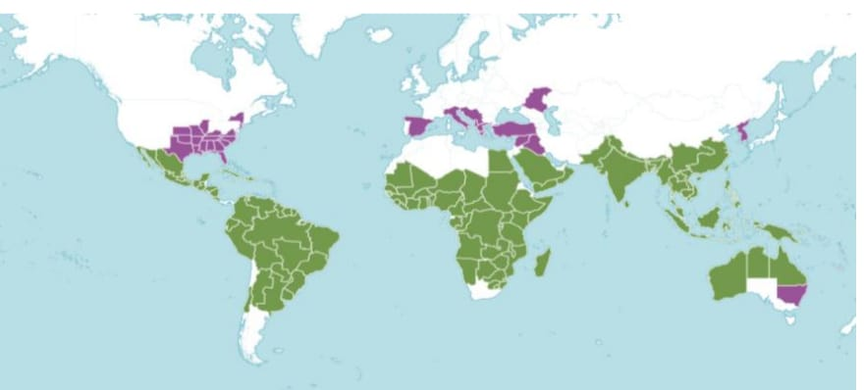
FIG 1 Global distribution of Cardiospermum halicacabum L. Green: Native range. Purple: Introduced and naturalized regions. Source: POWO/Kew Science
Leaves
Cardiospermum halicacabum is an herbaceous vine with bi-ternate leaves. The leaflets are ovate-lanceolate, glabrous, with a smooth surface and dentate margins. The leaves are approximately 3–5 cm long and 1.5–2 cm wide.
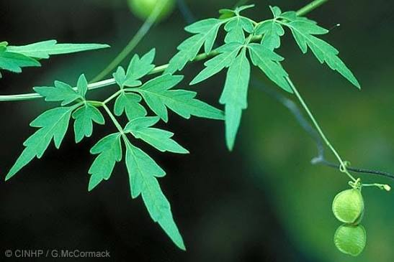
FIG 2 Leaves of Caediospermun halicacabum

Flowers
The flowers of Cardiospermum halicacabum are tetramerous and irregular, with 2+2 sepals and 2+2 equal petals. The flower possesses eight unequal stamens, a tricarpellary ovary with one ovule in each carpel, and a trifid stigma
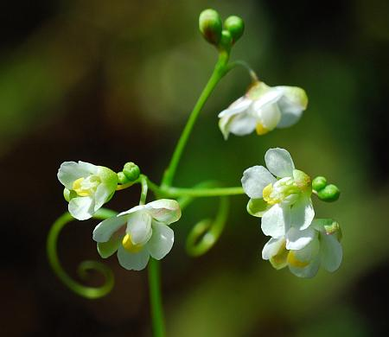
FIG 3 Flowers of Cardiospermum helicacabum
Fruit
The fruit of Cardiospermum halicacabum is globose and develops as a winged, inflated capsule.
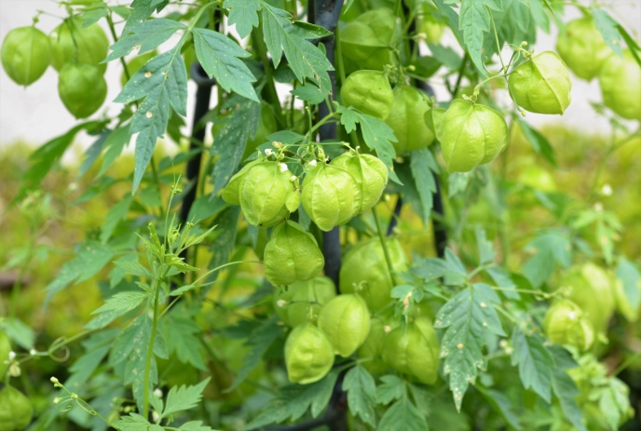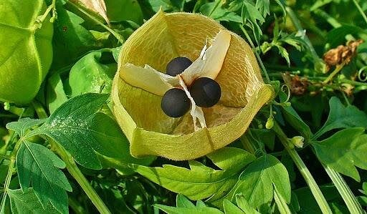
FIG 4 Friuts of Cardiospermun helicacabum

Stem
The stem of Cardiospermum halicacabum is green in colour and measures approximately 0.2–0.3 cm in width. The petiole is about 1.5–2.5 cm long
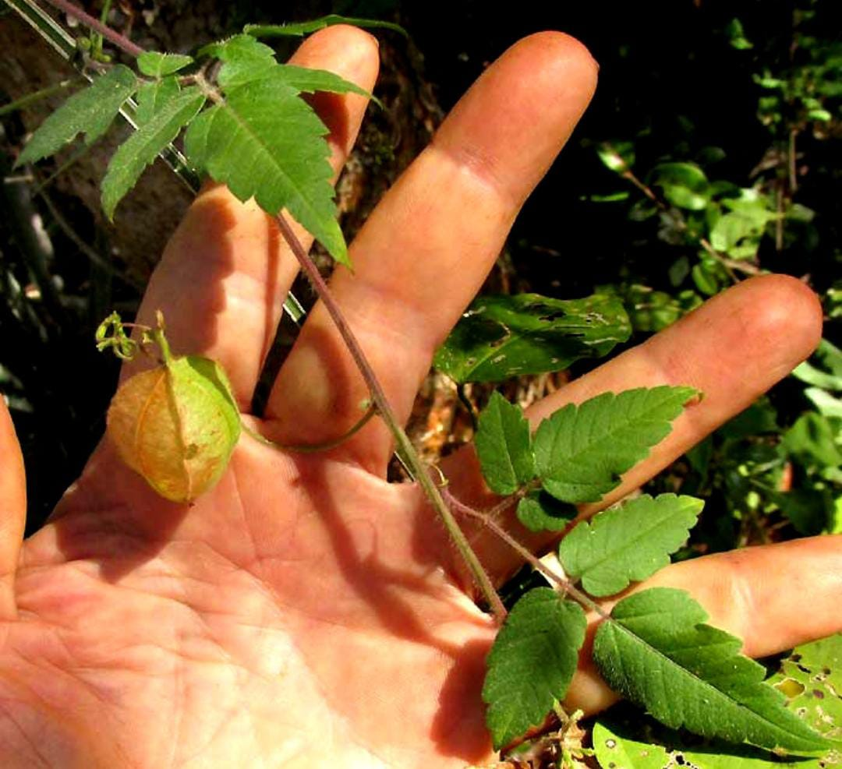
FIG 5 Stem of Cardiospermum helicacabum
Seeds
The seeds of Cardiospermum halicacabum are black in colour and characteristically heart-shaped. They are enclosed within the inflated, balloon-like capsule
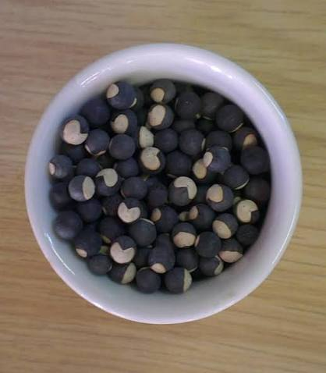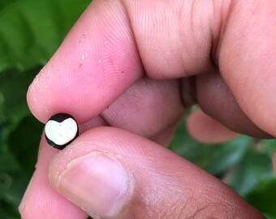
FIG 6 Seeds of Cardiospermum helicacabum

PHYTOCHEMICAL CONSTITUENTS
Cardiospermum halicacabum contains a diverse range of phytochemical constituents. Preliminary phytochemical investigations have reported the presence of carbohydrates, proteins, tannins, saponins, flavonoids, lipids, alkaloids, steroids and glycosides. FT-IR analysis of the ethanolic leaf extract has also indicated the presence of alcohols, phenols, alkynes, flavonoids, alkanes and aliphatic esters. GC-MS analysis has further identified several compounds, including caryophyllene, neophytadiene, phytol, benzene acetic acid, β-sitosterol, oleic acid, stearic acid, linoleic acid, arachidic acid and flavonoid glycosides.
CARBOHYDRATES AND PROTEINS
Carbohydrates and proteins have been reported among the major phytochemical constituents of Cardiospermum halicacabum. Their presence contributes to the overall chemical and nutritional profile of the plant
ALKALOIDS
Preliminary phytochemical analysis of Cardiospermum halicacabum has reported the presence of alkaloids among its secondary metabolites. Alkaloids form an important part of the phytochemical profile of the plant and may contribute to its overall biological activity
FLAVONOIDS
Flavonoids have been reported in Cardiospermum halicacabum during preliminary phytochemical investigations. Quantitative studies have reported flavonoid concentrations ranging from 27.833 ± 0.412 to 139.261 ± 0.412 mg quercetin equivalent/g in different extracts. Several flavonoid derivatives, including apigenin-7-O-glucuronide, chrysoeriol-7-O-glucuronide and luteolin-7-O-glucuronide, have also been identified
POLYPHENOLS
Phenolic compounds are reported among the phytochemical constituents of Cardiospermum halicacabum. The reported phenolic concentration in extracts ranges
from 29.697 ± 0.232 to 187.372 ± 0.615 mg pyrogallol equivalent/g. Phenolic constituents are of particular interest because of their association with the biological and antioxidant properties reported for the plant
TANNINS
Tannins have been detected during preliminary phytochemical analysis of Cardiospermum halicacabum. They occur together with other reported secondary metabolites such as flavonoids, alkaloids and saponins, contributing to the diverse phytochemical profile of the plant.
SAPONINS
Saponins are reported among the phytochemical constituents of Cardiospermum halicacabum. The presence of saponins has also been associated with the characteristic foam formation when the plant material is agitated with water, which has contributed to its traditional use as a cleansing material.
STEROIDS AND TERPENOIDS
Steroids and terpenoid constituents have been reported in Cardiospermum halicacabum. β-Sitosterol and β-sitosterol glycosides have been identified among the compounds reported from the plant, while the plant has also been described as being rich in triterpenoid constituents.
LIPIDS AND FATTY ACIDS
Lipids and several fatty acids have been reported from Cardiospermum halicacabum. Identified fatty acid constituents include oleic acid, linoleic acid, stearic acid and arachidic acid, while GC-MS analysis has also reported compounds such as hexadecenoic acid and octadecanoic acid.
REPORTED ACTIVITIES ON CARDIOSPERMUM HALICACABUM
Cardiospermum halicacabum has been investigated for a wide range of pharmacological activities. Reported studies have demonstrated antioxidant, anti-inflammatory, antiviral, antifilarial, antimalarial, antibacterial, anxiolytic, anti-arthritic, antiparasitic, anticancer,
antidiarrhoeal, antifungal, antipyretic, anti-sickling and adulticidal activities. These findings provide scientific support for the diverse traditional medicinal applications of the plant.
Reported pharmacological activities
- Antioxidant activity
- Anti-inflammatory activity
- Antiviral activity
- Antifilarial activity
- Antimalarial activity
- Antibacterial activity
- Anxiolytic activity
- Anti-arthritic activity
- Antiparasitic activity
- Anticancer activity
- Antidiarrhoeal activity
- Antifungal activity
- Antipyretic activity
- Anti-sickling activity
- Adulticidal activity

REVIEW OF LITERATURE:
Gaziano R et al. (2018)
Gaziano R et al. investigated the antifungal activity of Cardiospermum halicacabum against Trichophyton rubrum. Different concentrations of the plant extract were tested in vitro, and the interaction between active constituents of C. halicacabum and fungal Hsp90 was also investigated computationally. The extract showed distinct antifungal activity at higher concentrations of 250 and 500 µg/ml. Rutin and luteolin were identified as potential Hsp90 interactors and individually exhibited antifungal effects, although their activity was lower than that of the total plant extract. The study suggested that C. halicacabum possesses substantial fungistatic activity against T. rubrum and that interaction with fungal Hsp90 may contribute to its antifungal effect
Vijayakumari K et al. (2017)
Vijayakumari K et al. evaluated the anti-ulcer activity of the ethanolic extract of Cardiospermum halicacabum using an indomethacin-induced gastric ulcer model in male Wistar rats. The ethanolic extract was administered orally at doses of 200 and 400 mg/kg, while omeprazole at 10 mg/kg/day was used as the standard drug. The extract produced a significant dose-dependent reduction in gastric mucosal damage and ulcer index in the treated animals. The study suggested that the anti-ulcer activity of C. halicacabum may be associated with phytoconstituents such as phenols, flavonoids, saponins, tannins and caffeic acid
Peiris LDC et al. (2015)
Peiris LDC et al. evaluated the effects of the aqueous leaf extract of Cardiospermum halicacabum on fertility in male rats. The study reported that administration of the aqueous leaf extract produced a dose-dependent increase in sperm count and sperm motility and increased serum testosterone levels. The study also reported a hepatoprotective effect of the aqueous leaf extract without evidence of renal toxicity. These findings demonstrated the biological activity of C. halicacabum and provided important evidence for its protective effect, supporting further investigation of the plant for hepatoprotective applications
Mohaddesi B et al. (2015)
Mohaddesi B et al. investigated the anticancer potential of different seed extracts of Cardiospermum halicacabum against human colorectal, breast and skin cancer cell lines. Various seed extracts were prepared by Soxhlet extraction and their cytotoxic effects were evaluated using the Sulforhodamine B assay, with doxorubicin used as the standard drug. The n-hexane seed extract showed pronounced cytotoxic activity against the MCF-7 breast cancer cell line, while the other extracts demonstrated comparatively lower activity against the tested cell lines. The study indicated that C. halicacabum seeds contain biologically active constituents with potential anticancer activity
Aishwarya V et al. (2014)
Aishwarya V et al. investigated the in-vitro antioxidant and anticancer activities of Cardiospermum halicacabum. Different extracts of the plant were evaluated for their biological effects, including antioxidant and cytotoxic activities. The study reported antioxidant potential of the extracts and demonstrated anticancer activity against the tested cancer cell line, with the chloroform extract showing higher activity than the ethanolic extract against Ehrlich Ascites Carcinoma cells. The findings suggested that the pharmacological effects of C. halicacabum may be associated with its bioactive phytoconstituents and supported further investigation of the plant.
Prakash KC et al. (2014)
Prakash KC et al. investigated the antidiarrhoeal activity of Cardiospermum halicacabum and Dodonea viscosa using aqueous and alcoholic leaf extracts. The antidiarrhoeal activity was evaluated using experimental models including castor oil-induced diarrhoea and charcoal meal propulsion. Treatment with the extracts reduced the rate of defecation and the amount of moist faeces and also decreased intestinal oedema in the treated animals. The study concluded that the extracts of C. halicacabum possessed potential antidiarrhoeal activity

Huang M-H et al. (2011)
Huang M-H et al. investigated the antioxidant and anti-inflammatory properties of Cardiospermum halicacabum and its reference compounds using ex-vivo and in-vivo experimental approaches. The study evaluated the ability of the plant extract to inhibit inflammatory responses and influence antioxidant defence mechanisms. The extract prevented carrageenan-induced paw oedema and increased the activities of antioxidant enzymes including glutathione peroxidase, superoxide dismutase and catalase in liver tissue. The findings demonstrated the antioxidant and anti-inflammatory potential of C. halicacabum and suggested that its biological activity may be associated with enhancement of antioxidant defence and reduction of inflammatory responses.
Murugan K et al. (2011)
Murugan K et al. investigated the antiviral activity of Cardiospermum halicacabum extract against the coinfecting agents human immunodeficiency virus (HIV) and hepatitis B virus (HBV). The antiviral potential of different plant constituents was investigated using assays for HIV-1 reverse transcriptase and hepatitis B surface antigen. Methanolic extract containing several constituents showed inhibition of HBsAg and HIV reverse transcriptase activity. The study reported suppression of HBsAg and HIV-RT and suggested that the bioactive principles of C. halicacabum could be investigated further for controlling HIV and HBV coinfection
Kumar E et al. (2008)
Kumar E et al. investigated the anti-arthritic property of the ethanolic leaf extract of Cardiospermum halicacabum. The study evaluated the pharmacological effects of the ethanolic leaf extract in experimental models related to inflammation and arthritis. The extract demonstrated anti-arthritic activity and supported the traditional use of C. halicacabum in inflammatory and rheumatic conditions. The findings indicated that the ethanolic leaf extract possesses significant pharmacological potential and warrants further investigation for its therapeutic effects

Kumaran A et al. (2006)
Kumaran A et al. investigated the antioxidant activity of the methanol extract of Cardiospermum halicacabum. The antioxidant potential was evaluated using several in-vitro models, including DPPH radical scavenging, β-carotene-linoleate model system, reducing power, nitric oxide and superoxide scavenging and iron-ion chelating activity. The methanolic extract showed significant inhibition in the β-carotene-linoleate model and concentration-dependent DPPH radical inhibition. It also demonstrated reducing power, nitric oxide scavenging, superoxide scavenging and ferrous-ion chelating activities. The study established the antioxidant potential of C. halicacabum and suggested that its antioxidant constituents may contribute to its pharmacological effects.

METHODOLOGY

METHODOLOGY
CHEMICALS USED
- Methanol
- Dulbecco’s Modified Eagle Medium (DMEM)
- Carbon tetrachloride (CCl₄)
- Fetal bovine serum (FBS)
- Phosphate-buffered saline (PBS)
- Trypsin-EDTA
- Antibiotic-antimycotic solution
- Distilled water
- Molisch’s reagent
- Concentrated sulphuric acid
- Phytochemical screening
- Fehling’s solution A
- Fehling’s solution B
- Dragendorff’s reagent
- Sodium hydroxide
- Dilute hydrochloric acid
- Ferric chloride solution
- Chloroform
- Ninhydrin reagent
- Copper sulphate solution
- Sodium bicarbonate solution
- Ammonia solution
- Trypan blue
- MTT reagent
- Liv.52
- Soxhlet apparatus
- Heating mantle
- Round-bottom flask
- Condenser
- Extraction thimble
- Electronic weighing balance
- Grinder
- Beakers
- Measuring cylinders
- Test tubes
- Test tube stand
- Pipettes
- Micropipettes
- Glass rod
- Filter paper
- Funnel
- Water bath
- Centrifuge
- UV–Visible spectrophotometer
- Laminar airflow cabinet
- CO₂ incubator
- Inverted microscope
- Refrigerator
- Autoclave
COLLECTION OF PLANT MATERIAL
The fruits and seeds of Cardiospermum halicacabum were collected from Kyadigere, Karnataka, India. The collected plant material was carefully selected and cleaned to remove adhering dirt and other unwanted materials.

DRYING OF PLANT MATERIAL
The collected fruits and seeds were dried under suitable conditions to remove moisture. The dried plant material was then powdered using a suitable grinder and stored appropriately until further use.
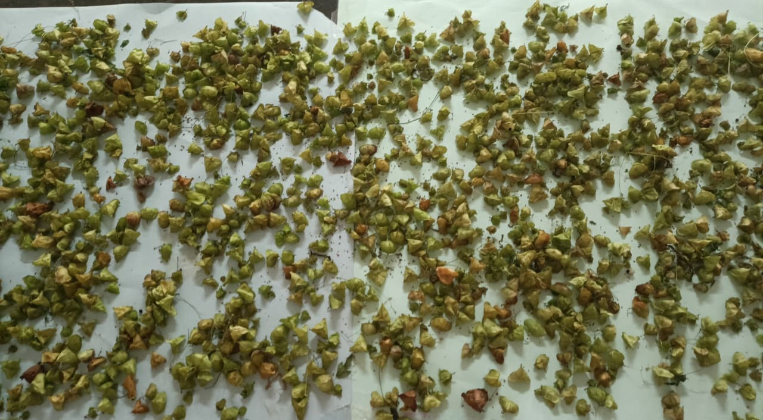
FIG 7 Dried Cardiospermun helicacabum
PREPARATION OF PLANT EXTRACT
The dried fruits and seeds of Cardiospermum halicacabum were separately powdered using a suitable grinder. About 50 g of powdered plant material was extracted with methanol using a Soxhlet apparatus. The extraction was carried out three times to facilitate the extraction of phytoconstituents. The resulting extracts were collected, and the solvent was allowed to evaporate. The crude extracts obtained from both plant parts were then used for preliminary phytochemical screening and evaluation of in-vitro hepatoprotective activity.

PRELIMINARY PHYTOCHEMICAL SCREENING
1. Tests for Carbohydrates
a) Molisch’s Test
To the extract, 1 ml of alpha-naphthol solution was added, and concentrated sulphuric acid was carefully added along the sides of the test tube. Purple or reddish-violet colour at the junction of the two liquids revealed the presence of carbohydrates.
b) Fehling’s Test
To the extract, equal quantities of Fehling’s solutions A and B were added, and the mixture was heated. Formation of a brick-red precipitate indicated the presence of reducing sugars.
c) Benedict’s Test
To 5 ml of Benedict’s reagent, the extract was added, boiled for two minutes, and allowed to cool. Formation of a red precipitate indicated the presence of reducing sugars.
2. Tests for Alkaloids
a) Dragendorff’s Test
To 1 ml of the extract in a test tube, a few drops of Dragendorff’s reagent were added, and the colour developed was observed. Appearance of an orange colour indicated the presence of alkaloids.
b) Wagner’s Test
To the extract, 2 ml of Wagner’s reagent was added. Formation of a reddish-brown precipitate indicated the presence of alkaloids.
c) Mayer’s Test
To the extract, 2 ml of Mayer’s reagent was added. Formation of a dull-white precipitate indicated the presence of alkaloids.
3. Test for Saponins
To 1 ml of the extract, 5 ml of distilled water was added, and the test tube was shaken vigorously. Formation of persistent foam indicated the presence of saponins.
4. Tests for Tannins
a) Ferric Chloride Test
The crude extract was mixed with 1 ml of 5% ferric chloride solution. Formation of a dark-blue or greenish-black colour indicated the presence of tannins.
b) Lead Acetate Test
The extract was mixed with basic lead acetate solution. Formation of a white precipitate indicated the presence of tannins.
5. Test for Coumarins
To 1 ml of the extract, 1 ml of 10% sodium hydroxide solution was added. Formation of a yellow colour indicated the presence of coumarins.
6. Tests for Flavonoids
a) Shinoda Test
The crude extract was mixed with a few fragments of magnesium ribbon, and concentrated hydrochloric acid was added dropwise. Appearance of a pink or scarlet colour indicated the presence of flavonoids.
b) Alkaline Reagent Test
The crude extract was mixed with 2 ml of 10% sodium hydroxide solution. A few drops of dilute acid were then added. Formation of an intense yellow colour that became colourless after the addition of dilute acid indicated the presence of flavonoids.

7. Tests for Proteins and Amino Acids
a) Millon’s Test
The crude extract was mixed with 2 ml of Millon’s reagent and gently heated. Formation of a white precipitate that turned red upon heating indicated the presence of proteins.
b) Ninhydrin Test
The crude extract was boiled with 2 ml of 0.2% ninhydrin solution. Appearance of a violet colour indicated the presence of amino acids and certain proteins.
8. Tests for Phenols
a) Ferric Chloride Test
A few drops of neutral ferric chloride solution were added to the aqueous or alcoholic solution of the extract. Appearance of a violet, blue, green, or red colour indicated the presence of phenolic compounds.
b) Liebermann’s Test
The sample was treated with sodium nitrite and concentrated sulphuric acid, diluted with water, and made alkaline using sodium hydroxide solution. Development of a deep-green or blue colour indicated the presence of phenolic compounds.
c) Bromine Water Test
Bromine water was added to the solution of the extract. Formation of a white precipitate of 2,4,6-tribromophenol indicated the presence of phenolic compounds.
9. Tests for Steroids
The crude extract was mixed with 2 ml of chloroform, and concentrated sulphuric acid was carefully added along the side of the test tube. Formation of a red colour in the lower chloroform layer indicated the presence of steroids..In another test, the crude extract was mixed with 2 ml of chloroform, followed by the addition of 2 ml each of concentrated
sulphuric acid and acetic acid. Development of a greenish colour indicated the presence of steroids.
10. Test for Terpenoids
The crude extract was dissolved in 2 ml of chloroform and evaporated to dryness. To this, 2 ml of concentrated sulphuric acid was added, and the mixture was heated for approximately two minutes. Development of a greyish colour indicated the presence of terpenoids.
11. Tests for Glycosides
a) Liebermann’s Test
The crude extract was mixed with 2 ml each of chloroform and acetic acid. The mixture was cooled in ice, and concentrated sulphuric acid was carefully added. A colour change from violet to blue to green indicated the presence of a steroidal nucleus associated with certain glycosides.
b) Salkowski’s Test
The crude extract was mixed with 2 ml of chloroform. Then, 2 ml of concentrated sulphuric acid was carefully added, and the mixture was shaken gently. Formation of a reddish-brown colour indicated the presence of a steroidal ring.
c) Keller–Kiliani Test
The crude extract was mixed with 2 ml of glacial acetic acid containing 1–2 drops of 2% ferric chloride solution. The mixture was carefully added to another test tube containing 2 ml of concentrated sulphuric acid. Formation of a brown ring at the interface indicated the presence of cardiac glycosides.

IN-VITRO HEPATOPROTECTIVE ACTIVITY
Goat liver was obtained from Chitradurga, Karnataka, India, for the evaluation of in-vitro hepatoprotective activity. Approximately 1 g of goat liver was taken for each experimental group and processed using a laboratory stirrer.
The methanolic extract of fruits and seeds of Cardiospermum halicacabum was evaluated at three different concentrations: 1 g, 500 mg, and 250 mg. Liv.52 was used as the standard drug, and carbon tetrachloride (CCl₄) was used as the hepatotoxic agent. Dulbecco’s Modified Eagle Medium (DMEM) was used in the experimental preparation.
Six experimental groups were prepared, including the three extract concentrations, the standard-drug group, the CCl₄ group, and the control group. A volume of 1 ml of DMEM was added to each group, and 0.5 ml of CCl₄ was added to all groups except the control group. Liv.52 was added to the standard-drug group.
After preparation, the samples were subjected to centrifugation and left for three days according to the laboratory procedure. The absorbance of each group was then measured using a UV–Visible spectrophotometer at a wavelength of 540 nm. Three readings were recorded for each group, and the mean absorbance was calculated.

RESULTS

