User personas:

User personas are fictional, realistic, representations of your ideal users. They are created to help product teams understand and empathize with the different types of people who will use their product or service. **Personas** are based on user research and data, and they help teams make informed design decisions by focusing on user needs and behaviors.

**UX personas Do:**

* Capture your user research in a digestible, visual format
* Build user empathy and make sure the design process prioritises the target audience’s needs
* Steer, inform and justify design decisions
* Enable others to understand who you’re designing for

**Created User Personas:**

UX personas are typically comprised of a combination of text and images representing a “typical” user of your product. This means a UX persona will include:

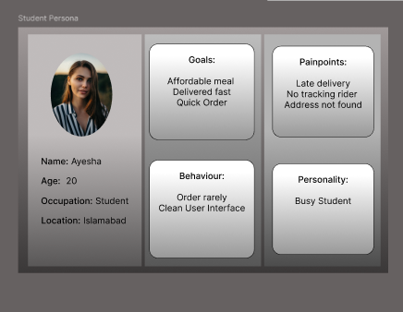

* The persona’s name
* An image (e.g. an illustration, avatar, photo or stock image)
* Demographic information such as your persona’s age, gender, family/living situation, employment status and anything else that’s relevant to your product or problem space
* Their needs and goals in relation to your product
* A summary of their challenges, frustrations and pain points in relation to your product or problem space
* Quotes from real users whom the persona should represent

**UX Research:**

1. Conduct Research:

· **Surveys or interviews** with potential users.

1. *Food delivery App Survey form link:*

<https://docs.google.com/forms/d/e/1FAIpQLSfDDst7JXjnVgutE2yUTItdV--9m8Vo8o9HrM9IjuTU4DtpIQ/viewform?usp=header>

1. Responder Link:

<https://docs.google.com/forms/d/e/1FAIpQLSfDDst7JXjnVgutE2yUTItdV--9m8Vo8o9HrM9IjuTU4DtpIQ/viewform?usp=header>

· **Online reviews** of existing apps

1. FoodPanda (4.6 out of 5)

Point1: Worst Customer Services

Point 2: No Rider contact information.

Point 3: No Chat Feature.

1. OPTP(4.6 out of 5)

Point 1:Address issue[main]

Point 2: App order issue [hang or stuck while entering home address]

1. Dastak (3.3 out of 5)

Point 1 : bad services

Point 2: Not good UI

1. KFC (4.5 out of 5)

Point 1: worst experience in ios

Point 2: Online payment option problem

1. Cheezious (4.7 out of 5)

Point 1 : Late order

Point 2: App crashing when high traffic not good ux

Common point: customer Services, payment and adress problem, rider information

| **App** | **Rating (Google Play)** | **Noted Weaknesses** |
| --- | --- | --- |
| Foodpanda | ⭐ 4.6 | Customer service, no rider contact, no chat support |
| OPTP | ⭐ 4.6 | Address input issues, app hangs during order |
| Dastak | ⭐ 3.3 | Poor service, outdated UI |
| KFC App | ⭐ 4.5 | iOS app issues, online payment errors |
| Cheezious | ⭐ 4.7 | Late delivery, app crashes in peak hours |

**Competitor analysis**

**Competitor Analysis between KFC and Cheezious**

1. **Feature Comparison Table:**

| **Feature / Criteria** | **KFC App** | **Cheezious App** |
| --- | --- | --- |
| App Rating (App store) | 4.5 | 4.7 |
| Performance (Stability) | iOS issues | crashes in traffic |
| Order Tracking | Basic/unclear | Poor feedback on status |
| Payment Options | Payment fails sometimes | Multiple options (JazzCash, card, COD) |
| Customer Support | Slow | No live chat or instant help |
| Delivery Speed | Moderate | Often late |
| UX Design | Clean layout | Cluttered, confusing flow |
| Targeted Deals / Discounts | App-only deals | Student/family combos |

1. **Opportunity for new app**

| **Gap in KFC & Cheezious** | **New App Can Offer** |
| --- | --- |
| No real-time tracking | Add live map tracking |
| No rider contact info | Show rider name + chat/call button |
| Late or cold delivery | Add a **“Delivery Quality Rating”** to track rider performance |
| Bad UX on one platform | Focus on **consistent UI/UX for all devices** |

New APP need:

* Real-time tracking
* Better UX
* Chat support
* Rider visibility

1. Identify user segment

Segment based on ;

1. Name
2. Age
3. Occupation
4. location
5. Personality traits (goals)
6. Frustrations( pain points)
7. behaviour(app name, food type,How often used app, order timming)
8. Student:
9. Working Professional
10. Business owner





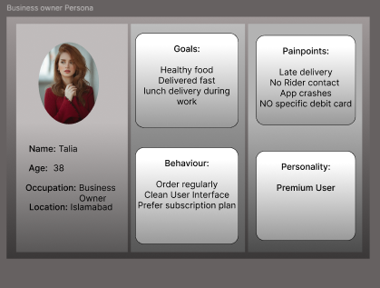

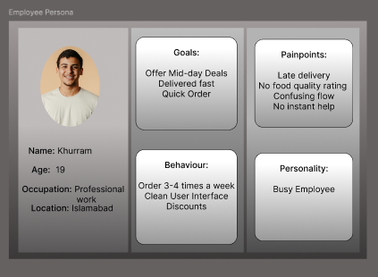

**User journey**

User journey maps and customer experience maps are visual tools that help understand how users interact with a product or service. User journey maps focus on the steps a user takes to achieve a specific goal, while customer experience maps offer a broader view of all interactions a customer has with a brand. Both help identify pain points and opportunities for improvement in user experience.

User Journey (Cheezious App)

Overall App journey Assume

FOR Create information

| **Step** | **User Action** | **User Thought** | **Pain Point** | **Improvement Opportunity** |
| --- | --- | --- | --- | --- |
| **1. Opens App** | Taps the app icon on phone | “Let me quickly order something” | App crashes or freezes during peak hours | Improve server capacity during high traffic |
| **2. Browses Menu** | Scrolls through menu categories | “What combos are available today?” | Cluttered layout, no visual hierarchy | Use better spacing, categorization, and large icons |
| **3. Selects Item** | Clicks on a burger combo | “Does this come with a drink?” | Poor product description or unclear info | Add clear descriptions with images and item options |
| **4. Adds to Cart** | Taps "Add to Cart" | “I’ll add fries too” | No quantity or customization option | Let users edit quantity or add extras inline |
| **5. Checkout** | Proceeds to checkout page | “Hope the address I used last time is saved” | Manual address entry every time | Add address-saving or auto-suggestion (Google Maps) |
| **6. Payment** | Selects JazzCash | “Hope it goes through” | Payment fails sometimes, no error message | Provide clear error/success feedback, allow retries |
| **7. Order Tracking** | Waits for order | “Where’s my food?” | No live tracking, no rider contact info | Add rider map, contact/chat support |
| **8. Delivery** | Receives cold food after 45 minutes | “It’s too late and cold” | Late delivery, no ETA or delay alert | Show estimated delivery time, enable delivery rating |
| **9. Feedback** | Wants to leave a review | “They should know about the delay” | No direct feedback or issue reporting in app | Add quick feedback screen with delivery rating |

***Major Painpoint in cheezious App***

| **Area** | **Pain Point** | **Suggested Fix** |
| --- | --- | --- |
| Performance | App crashes during high traffic | Backend optimization or traffic load balancing |
| UX/UI | Cluttered food menu, poor layout | Use clean spacing, icons, categories |
| Checkout | No saved address, manual entry | Auto-fill + Google Maps integration |
| Tracking | No live order tracking or rider info | Add map + rider name/contact/chat |
| Delivery | Late delivery with no status updates | Show ETA, send real-time delay notifications |

*Refine Screens for Cheezious App*

1. Splash Screen
2. Login/Signup/Guest login
3. Home Screen (Add reorder button)
4. Explore (Menu + Best seller sections+ Add friends/family/couple deals)
5. My Favourites
6. Cart
7. Checkout (confirm address through map)
8. Apply voucher
9. Payment
10. Order confirmation (auto all info to track order page)
11. Track order (Add new screen rider info + chat option+ map )
12. Deliver order(real time delay notification due to some conditions)
13. Saved Address
14. Order History
15. Review/feedback order

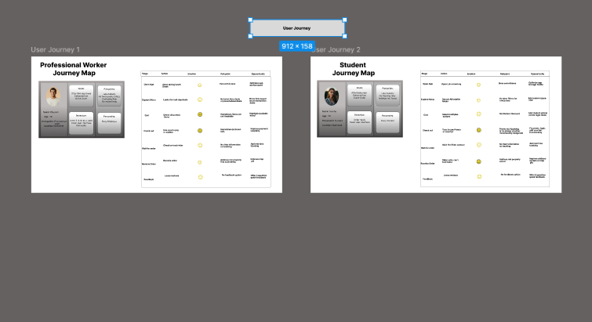

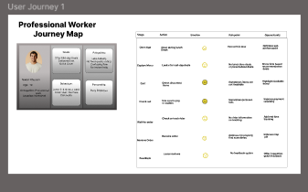

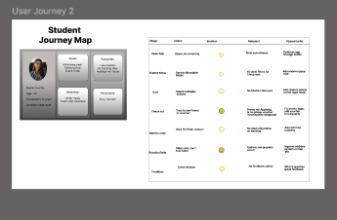

A **customer journey map** takes a broader view, tracking the entire customer lifecycle, from awareness through post-purchase. Customer journey maps cover every brand touchpoint across all channels, not just product interactions.

***Customer Experience Map — Student Persona***

| **Step** | **User Goal** | **Touchpoints** | **Emotion** | **Pain Point** | **Backstage Support** | **Opportunity** |
| --- | --- | --- | --- | --- | --- | --- |
| Open App | Open quickly and smoothly | App icon, splash screen | Frustrated | Crashes during peak hours | App performance, server load | Optimize app to handle high traffic |
| Login/Guest | Start ordering immediately | Guest login | Pleased | None | User session | Continue without full signup |
| Explore | Find cheap deals or quick snacks | Menu screen, student combo banner | Excited | Too many items, overwhelming | Menu | Filter for “Student Deals” |
| Cart | Review and finalize order | Cart screen | Neutral | Can’t add extra sauce | Cart logic | Add customization options |
| Checkout | Enter address easily | Map + address input | Annoyed | Manual typing every time | Location API | Save last used address |
| Payment | Use JazzCash securely | Payment screen | Nervous | Payment failed before | JazzCash API | Show retry button, success feedback |
| Track Order | Know where rider is | Map tracker, status page | Confused | No rider name/chat | Dispatch + GPS system | Add live map + rider info |
| Delivery | Get food hot and on time | Rider, delivery time | Angry | Late and cold food | Logistics coordination | ETA updates + “Delivery Quality” feedback |
| Feedback | Rate and share experience | Feedback screen | Neutral | No reward, no follow-up | Review logging system | Offer points or discounts for feedback |

### Grab grub food App and prototyping:

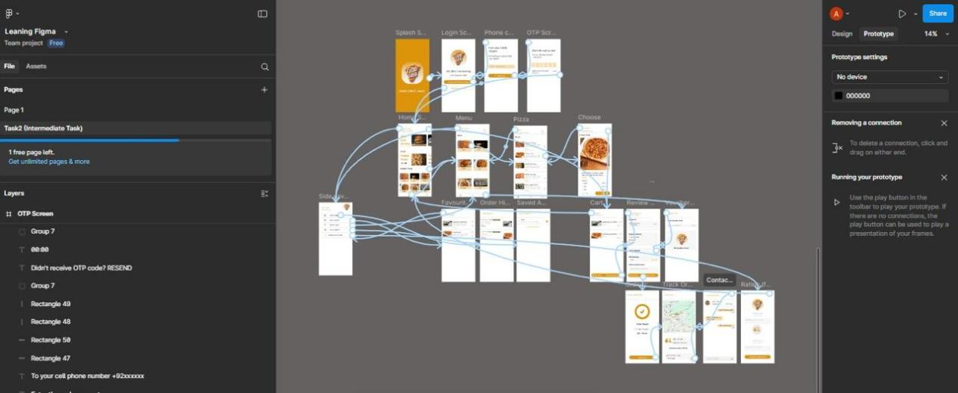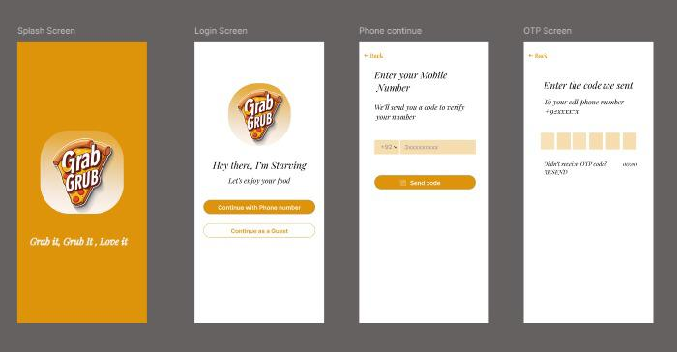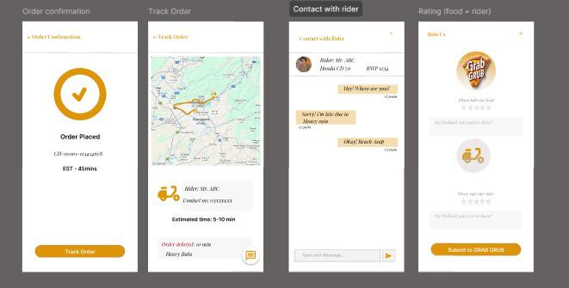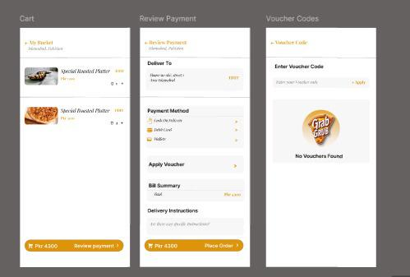

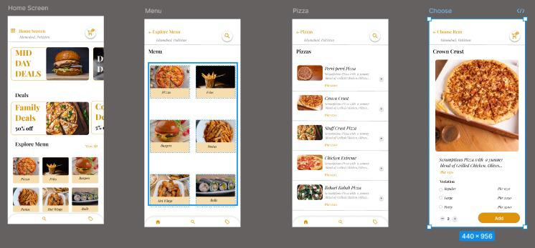

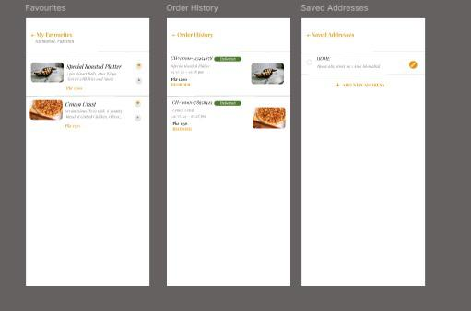

For further understanding

Figma link : https://www.figma.com/proto/Uwy28VmNMEzER5PpukrXkW/Leaning-Figma?node-id=52-24&t=d4MMV78tKyNKPVbF-1