Software Requirements Specification

for

ArguMind
Multi-Agent Debate System

Version 1.0

Prepared by Muhammad Ayesh (K230593),
Anumta (K230777), Muhammad Hammad (I230544)

FAST-NUCES, Karachi

Spring 2026



Copyright © 1999 by Karl E. Wiegers. Permission is granted to use, modify, and distribute this document.

Table of Contents
Table of Contents | ii
Revision History | ii
1. Introduction | 1
1.1 Purpose | 1
1.2 Document Conventions | 1
1.3 Intended Audience and Reading Suggestions | 1
1.4 Product Scope | 1
1.5 References | 2
2. Overall Description | 2
2.1 Product Perspective | 2
2.2 Product Functions | 2
2.3 User Classes and Characteristics | 3
2.4 Operating Environment | 3
2.5 Design and Implementation Constraints | 3
2.6 User Documentation | 3
2.7 Assumptions and Dependencies | 3
3. External Interface Requirements | 4
3.1 User Interfaces | 4
3.2 Hardware Interfaces | 4
3.3 Software Interfaces | 4
3.4 Communications Interfaces | 4
4. System Features | 5
4.1 Topic Submission and Debate Initiation | 5
4.2 Multi-Agent Debate Pipeline | 5
4.3 Pattern-Based Turn Ordering | 6
4.4 Judgment and Verdict Generation | 6
4.5 Debate Transcript and Summary | 7
5. Other Nonfunctional Requirements | 7
5.1 Performance Requirements | 7
5.2 Safety Requirements | 7
5.3 Security Requirements | 7
5.4 Software Quality Attributes | 8
5.5 Business Rules | 8
6. Other Requirements | 8
Appendix A: Glossary | 8
Appendix B: Analysis Models | 9
Appendix C: To Be Determined List | 9

Revision History
Name | Date | Reason For Changes | Version
initial | Spring 2026 | Initial SRS submission | 1.0

1. Introduction

1.1 Purpose
This document specifies the software requirements for ArguMind, a multi-agent AI debate system developed as the Software Engineering course project at FAST-NUCES Karachi, Spring 2026. ArguMind addresses the limitation of single large language model (LLM) responses by orchestrating four specialized AI agents that argue, challenge, analyze, and fact-check a given topic across multiple structured rounds, producing a more balanced and rigorous final verdict.

This SRS covers the complete system as currently implemented and planned for the Week 15 final submission. It is valid for the system version hosted at the project GitHub repository.

1.2 Document Conventions
All functional requirements are labeled with unique identifiers in the format REQ-XXX. Priority levels are High, Medium, or Low. Higher-level requirements inherit priority from their parent section unless explicitly overridden. Sections marked TBD will be completed before the Week 15 final submission. Code-level identifiers are written in monospace (e.g., DebateState, build_llm).

1.3 Intended Audience and Reading Suggestions
This document is written for the course instructor and evaluators assessing the SE rubric. Developers on the team should begin with Section 2 for the product overview and Section 4 for detailed functional requirements. Evaluators should refer to Section 4 for technical depth, Section 5 for nonfunctional requirements, and Appendix B for UML diagrams. The architectural patterns discussion appears in Section 2.1 and Section 4.

1.4 Product Scope
ArguMind is a web-based application that accepts a debate topic from the user and orchestrates a structured multi-agent debate. Four specialized AI agents (Proponent, Critic, Analyst, Fact-checker) argue across configurable rounds managed by a LangGraph state machine. A fifth agent, the Judge, evaluates the completed transcript and produces a scored verdict. The frontend streams the debate in real time and presents a final summary card.

The system is self-contained and does not depend on any existing enterprise platform. Its primary goal is to demonstrate that multi-agent debate produces measurably better reasoning quality than a single LLM response on the same topic.

1.5 References
- Russell, S. and Norvig, P. (2022). Artificial Intelligence: A Modern Approach, 4th Edition. Prentice Hall.
- IEEE Std 830-1998. IEEE Recommended Practice for Software Requirements Specifications.
- LangGraph Documentation. https://langchain-ai.github.io/langgraph/
- FastAPI Documentation. https://fastapi.tiangolo.com/
- Next.js 14 Documentation. https://nextjs.org/docs
- LangChain Documentation. https://python.langchain.com/

2. Overall Description

2.1 Product Perspective
ArguMind is a new, self-contained product with no external system dependencies beyond third-party LLM APIs. The system consists of two loosely coupled components: a Python FastAPI backend that owns all agent logic and orchestration, and a Next.js 14 frontend that handles user interaction and real-time display.

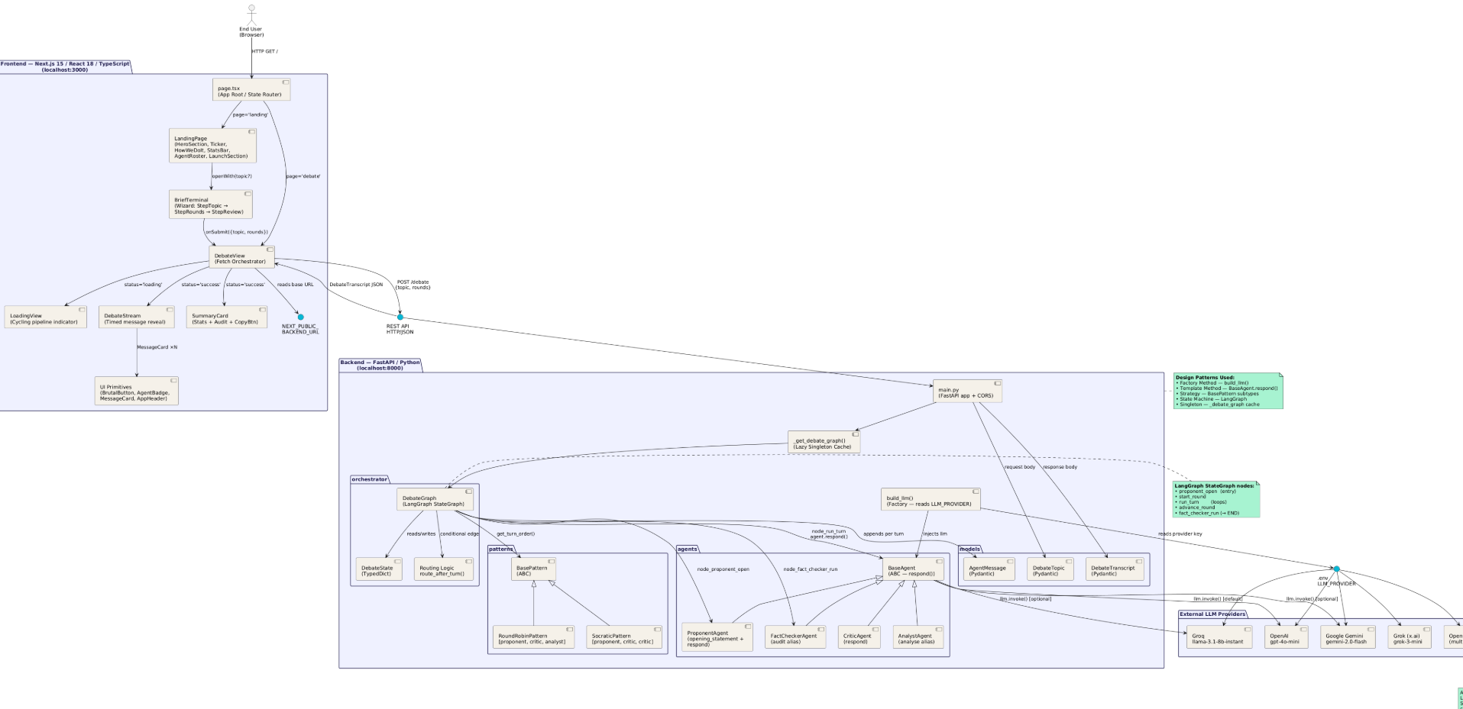
Figure 1: Architecture/Component Diagram

The system applies three architectural patterns from the Software Engineering course curriculum. The Layered Architecture is visible in the separation of the frontend presentation layer, the FastAPI application layer, the LangGraph orchestration layer, and the external LLM provider layer. The Pipe and Filter pattern is realized directly in the debate pipeline, where each agent (Proponent, Critic, Analyst, Fact-checker) acts as a discrete filter that reads the current transcript and appends its output. The Client-Server pattern describes the relationship between the Next.js browser client and the FastAPI server.

At the code level, three design patterns are explicitly implemented. The Strategy pattern is realized through the BasePattern abstract class and its concrete implementations RoundRobinPattern and SocraticPattern, which allow the turn-ordering algorithm to be swapped without modifying the orchestrator. The Observer pattern is realized through the agent notification and SSE streaming architecture. The Factory pattern is realized through the build_llm() function in base.py, which constructs the correct LLM provider instance based on the LLM_PROVIDER environment variable, hiding instantiation details from all agent classes.

2.2 Product Functions
The major functions of the system are:

- Topic submission: the user enters a debate topic and selects the number of rounds via the web interface.
- Opening statement: the ProponentAgent generates a one-time opening argument for the topic before the first round begins.
- Multi-round debate: the orchestrator executes N rounds, each consisting of turns by the Proponent, Critic, and Analyst in an order determined by the active BasePattern implementation.
- Fact-checking: after all debate rounds complete, the FactCheckerAgent audits the full transcript and labels every factual claim as SUPPORTED, UNSUPPORTED, or UNVERIFIABLE.
- Judgment: the JudgeAgent evaluates the completed transcript and returns scores (accuracy, balance, depth, reasoning_quality each 1-10), a winner, and a one-sentence verdict.
- Real-time display: the frontend polls the backend for the completed debate result and animates messages into the transcript view sequentially.
- Summary display: a summary card shows total messages, rounds, active agents, the fact-checker audit, the judge scores, and the winner.

2.3 User Classes and Characteristics
End User: submits topics and reads results via the web interface. No technical knowledge required. Expects a response within a reasonable wait time.

Developer / Team Member: accesses the backend directly for testing and debugging. Requires Python and Node.js familiarity. May switch LLM providers via environment variables.

Evaluator / Instructor: reads the SRS and reviews the codebase. Expects clear mapping from requirements to implementation.

2.4 Operating Environment
The backend requires Python 3.10 or later with all packages listed in requirements.txt installed. It runs on any machine with internet access for LLM API calls. The frontend requires Node.js 18 or later. The system has been developed and tested on Windows and can run on any platform supporting Python and Node.js. The default LLM provider is OpenAI GPT-4o-mini; the build_llm() factory supports Gemini, Grok, Groq, and OpenRouter as alternative providers via environment variables.

2.5 Design and Implementation Constraints
- The backend must use FastAPI as the web framework.
- Agent orchestration must use LangGraph StateGraph.
- All agents must inherit from BaseAgent and use the respond() method interface.
- Turn ordering must be implemented through the BasePattern interface to support pattern swapping.
- The LLM provider must be configurable via environment variables without code changes; build_llm() handles this.
- All API keys must be stored in .env and never committed to the repository.
- The frontend must be implemented in Next.js 14 with TypeScript.

2.6 User Documentation
A README.md at the repository root documents: environment setup, .env.example variable descriptions, backend startup (uvicorn main:app --reload), frontend startup (npm run dev), and a description of supported LLM providers. No additional user manual is planned for the prototype.

2.7 Assumptions and Dependencies
- It is assumed that a valid API key for at least one supported LLM provider is available and set in the .env file.
- It is assumed that the LLM provider's API is reachable from the deployment environment.
- The system depends on the OpenAI Python SDK, LangChain, LangGraph, and LangChain provider packages as listed in requirements.txt.
- The system depends on LangGraph maintaining backward-compatible StateGraph APIs.
- If the LLM provider is unreachable, BaseAgent.respond() returns a fallback string and allows the pipeline to continue rather than raising an exception.

3. External Interface Requirements

3.1 User Interfaces
The user interface is a web application rendered in any modern browser. It consists of the following screens:

Landing Page (LandingPage.tsx): contains a topic input field, a round selector, and two call-to-action buttons to start the debate. Also displays an agent roster, a how-it-works section, and a statistics bar.

Loading View (LoadingView.tsx): shown while the backend processes the debate. Cycles through the four agent names with a status message indicating which agent is currently working. This is a visual simulation of pipeline progress, as the current architecture returns the complete result rather than streaming individual agent messages.

Debate Stream (DebateStream.tsx): once the backend returns, messages are animated into view one at a time at 600ms intervals. Messages are grouped by round with a round header badge. Each message shows the agent role badge and message content.

Summary Card (SummaryCard.tsx): shown after all messages have appeared. Displays total message count, round count, active agent count, the final fact-checker audit, the judge verdict including winner and one-sentence explanation, and the four quality scores displayed as large numerals.

3.2 Hardware Interfaces
No dedicated hardware interfaces. The system runs on standard server and desktop hardware. Minimum recommended specification for the development environment: 8 GB RAM, dual-core CPU, stable internet connection for LLM API calls.

3.3 Software Interfaces

Interface | Description
OpenAI API | Default LLM provider. Called via langchain-openai ChatOpenAI. Model: gpt-4o-mini.
Gemini API | Alternative provider via langchain-google-genai ChatGoogleGenerativeAI. Model: gemini-2.0-flash.
Groq API | Alternative provider via ChatOpenAI with custom base_url. Model: llama-3.1-8b-instant.
Grok (xAI) API | Alternative provider via ChatOpenAI with custom base_url pointing to api.x.ai/v1.
OpenRouter API | Alternative provider via ChatOpenAI with custom base_url. Model: meta-llama/llama-3.1-8b-instruct:free.
LangGraph | StateGraph-based orchestration of agent nodes and conditional routing edges.
FastAPI | Python web framework serving the REST API on port 8000 by default.
Next.js 14 | React framework serving the frontend on port 3000 by default.

3.4 Communications Interfaces
The frontend communicates with the backend via a single REST endpoint: POST /debate at http://localhost:8000/debate (configurable via the NEXT_PUBLIC_BACKEND_URL environment variable). The request body is JSON with fields topic (string) and rounds (integer). The response is a JSON DebateTranscript object containing the topic, a messages array, and a judgment object. All communication is over HTTP in development and should be served over HTTPS in production.

The current implementation uses a synchronous request-response model rather than SSE streaming. The frontend displays a loading animation while awaiting the complete response, then animates messages client-side using a 600ms interval timer.

4. System Features

4.1 Topic Submission and Debate Initiation

4.1.1 Description and Priority
High priority. The user submits a topic string and selects the number of debate rounds via the web interface. The system validates the input and sends it to the backend POST /debate endpoint.

4.1.2 Stimulus / Response Sequences
Stimulus: User enters a topic and clicks a debate button. Response: Frontend sends POST /debate with the topic and rounds. Loading view is shown. On success, DebateView transitions to DebateStream. On failure, an error card is shown with the server error message and a retry option.

4.1.3 Functional Requirements
REQ-001: The system shall accept a POST /debate request with a topic string and a rounds integer.
REQ-002: The system shall return a DebateTranscript response containing the topic, a messages list, and a judgment object.
REQ-003: If the LLM provider is unreachable, the backend shall return a partial transcript with fallback messages rather than a 502 error, ensuring the pipeline always completes.
REQ-004: The frontend shall display an error card with the server error message and a retry button if the /debate endpoint returns a non-200 response.

4.2 Multi-Agent Debate Pipeline

4.2.1 Description and Priority
High priority. The core feature of the system. A LangGraph StateGraph orchestrates five agent nodes. Each agent reads the current transcript as its context and appends its response. The state machine determines turn order and round progression.

4.2.2 Agent Descriptions

Agent | Class | Role
Proponent | ProponentAgent | Argues FOR the topic. Generates an opening statement and rebuts the Critic in each subsequent round. Responds in 3-5 sentences.
Critic | CriticAgent | Dismantles the pro-topic case. Quotes the Proponent's most recent claim verbatim, then attacks its logical flaws or missing evidence. Never argues for the topic.
Analyst | AnalystAgent | Neutral observer. Surfaces the strongest arguments from both sides and flags logical gaps or unaddressed nuances. Does not declare a winner.
Fact-checker | FactCheckerAgent | Audits every factual claim in the full transcript after all rounds complete. Labels each claim SUPPORTED, UNSUPPORTED, or UNVERIFIABLE. Presents output as a numbered list.
Judge | JudgeAgent | Evaluates the completed transcript and returns a structured JSON judgment with scores and a winner. Runs once after the fact-checker.

4.2.3 Pipeline Flow
The debate_graph.py module defines the LangGraph StateGraph with the following node sequence:

- proponent_open node: ProponentAgent.opening_statement() is called once. Appends an AgentMessage with round=0.
- start_round node: retrieves the ordered agent list from the active BasePattern implementation and resets the turn index.
- run_turn node: the current agent in turn_order responds. Appends its AgentMessage and increments current_turn_idx.
- route_after_turn conditional edge: if more turns remain in the round, returns to run_turn. If the last round is complete, routes to fact_checker_run. Otherwise routes to advance_round.
- advance_round node: increments current_round and returns to start_round.
- fact_checker_run node: FactCheckerAgent.audit() is called on the full transcript. Appends its AgentMessage. Routes to END.

Note: The JudgeAgent is invoked separately in main.py after the graph completes. The /debate endpoint calls run_debate() from the graph, then calls judge_agent.judge() on the returned transcript to populate the judgment field of the DebateTranscript response.
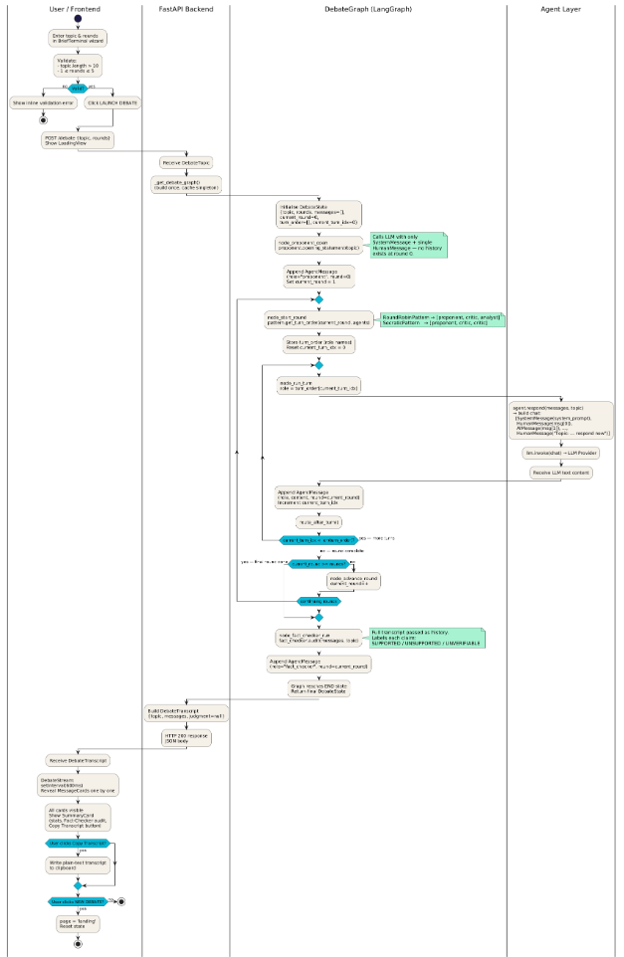
Figure 2: LangGraph State Flow

4.2.4 Functional Requirements
REQ-005: The ProponentAgent shall generate an opening statement before the first round begins.
REQ-006: Each agent shall receive the full debate transcript as context before producing its response.
REQ-007: The debate shall run for exactly N rounds where N is the value supplied by the user in the request body.
REQ-008: The FactCheckerAgent shall run exactly once, after all debate rounds complete.
REQ-009: Each AgentMessage shall record the agent role, message content, and round number.

4.3 Pattern-Based Turn Ordering

4.3.1 Description and Priority
High priority. The Strategy design pattern governs how agents are ordered within each round. The BasePattern abstract class defines the get_turn_order(round_num, agents) interface. Concrete implementations can be swapped without modifying the orchestrator.

4.3.2 Implemented Patterns
RoundRobinPattern (round_robin.py): returns agents in fixed order [Proponent, Critic, Analyst] regardless of round number. This is the default pattern.

SocraticPattern (socratic.py): an alternative ordering strategy for future use. Allows the turn sequence to vary by round number, enabling more dynamic debate structures.

4.3.3 Functional Requirements
REQ-010: The orchestrator shall determine agent turn order by calling the active BasePattern.get_turn_order() method at the start of each round.
REQ-011: Changing the active pattern shall not require modifying the orchestrator or any agent class.

4.4 Judgment and Verdict Generation

4.4.1 Description and Priority
High priority. After the debate pipeline completes, the JudgeAgent evaluates the full transcript and produces a structured verdict.

4.4.2 Judgment Schema
The JudgeAgent is instructed to return a JSON object with exactly these keys: accuracy (integer 1-10), balance (integer 1-10), depth (integer 1-10), reasoning_quality (integer 1-10), winner ("proponent" or "critic"), verdict (one-sentence string). The JudgeAgent.judge() method strips markdown code fences if the model wraps its output, then parses the JSON. On parse failure or provider error, it returns a default fallback object with all scores set to 0.

4.4.3 Functional Requirements
REQ-012: The JudgeAgent shall receive the full transcript formatted as [Round N] ROLE: content lines.
REQ-013: The judgment object shall contain accuracy, balance, depth, reasoning_quality, winner, and verdict fields.
REQ-014: On JSON parse failure, the system shall return a fallback judgment with all scores set to 0 and a verdict explaining the failure, rather than raising an exception.

4.5 Debate Transcript and Summary

4.5.1 Description and Priority
Medium priority. The frontend displays the full debate transcript with round groupings and a summary card with statistics, the fact-checker audit, and the judge verdict.

4.5.2 Functional Requirements
REQ-015: The frontend shall animate messages into the transcript at 600ms intervals.
REQ-016: Messages shall be grouped by round number with a visible round header.
REQ-017: The summary card shall display total message count, number of rounds, number of active agents, the final fact-checker message, and the judge verdict with all four scores.
REQ-018: The user shall be able to copy the full transcript to the clipboard as plain text.
REQ-019: The user shall be able to start a new debate from the summary card without navigating away.

5. Other Nonfunctional Requirements

5.1 Performance Requirements
The backend shall return a complete DebateTranscript for a 3-round debate within 60 seconds under normal network conditions. This is primarily bounded by LLM API latency, which is outside the system's direct control. The frontend shall begin displaying messages within 1 second of receiving the response. The system shall handle at least 5 concurrent debate requests in the demo environment without crashing.

5.2 Safety Requirements
Not applicable. This is an academic prototype with no safety-critical operations. The system does not store user-submitted topics persistently and does not handle personally identifiable information.

5.3 Security Requirements
All LLM API keys shall be stored in the .env file and never committed to the repository. The .env file is listed in .gitignore. The CORS middleware in main.py currently allows all origins (allow_origins=["*"]) for development convenience. Before any public deployment, this should be restricted to the known frontend origin. No authentication or authorization layer is implemented in the prototype.

5.4 Software Quality Attributes
Maintainability: the BaseAgent abstract class ensures all agents share a consistent interface. Adding a new agent requires only creating a new class that extends BaseAgent with a system_prompt, without modifying the orchestrator. The BasePattern interface allows new turn-ordering strategies to be added without touching existing code.

Portability: the build_llm() factory allows the system to run on any of five LLM providers by changing a single environment variable. This makes the system portable across environments where different API keys are available.

Robustness: both BaseAgent.respond() and JudgeAgent.judge() catch all exceptions and return fallback strings or objects rather than propagating errors. The debate pipeline always completes and returns a usable transcript even if provider calls fail.

Testability: each agent is independently testable by mocking the LLM and asserting on the returned string. The orchestrator is testable with mocked agent.respond() calls. Tests are located in backend/tests/.

5.5 Business Rules
Only one debate can be active per browser session at a time. The number of rounds must be a positive integer; the frontend enforces this before submitting. The Fact-checker always speaks last, after all debate rounds, and its message is always labeled round equal to the final debate round. The Judge does not participate in the debate rounds and only evaluates the completed transcript.

6. Other Requirements
The GitHub repository must be public and the link submitted with the final report. The codebase must include a README with environment setup instructions, a description of supported LLM providers, and backend and frontend startup commands. The .env.example file must document all required and optional environment variables with explanatory comments.

Appendix A: Glossary
Term | Definition
Agent | An autonomous software component with a defined role and a system prompt, powered by an LLM.
BaseAgent | Abstract Python class in agents/base.py that all debate agents inherit from. Defines the respond() method.
BasePattern | Abstract Python class in patterns/base_pattern.py that defines the get_turn_order() interface for the Strategy pattern.
DebateState | TypedDict defining the state passed between LangGraph nodes: topic, rounds, messages, current_round, turn_order, current_turn_idx.
DebateTranscript | Pydantic response model returned by POST /debate: contains topic, messages list, and judgment object.
build_llm() | Factory function in agents/base.py that constructs the correct LangChain chat model based on the LLM_PROVIDER environment variable.
LangGraph | Library for building stateful multi-agent workflows as directed graphs.
StateGraph | LangGraph class used to define the debate pipeline as a directed graph of nodes and edges.
RoundRobinPattern | Concrete BasePattern implementation that returns agents in fixed order: Proponent, Critic, Analyst.
SocraticPattern | Alternative BasePattern implementation with a different turn-ordering strategy.
GPT-4o-mini | Default OpenAI model used for all agent reasoning.
SRS | Software Requirements Specification. This document.

Appendix B: Analysis Models
The following UML diagrams are included in the diagrams/ folder of the project repository as SVG files. They should be inserted here in the final submission.

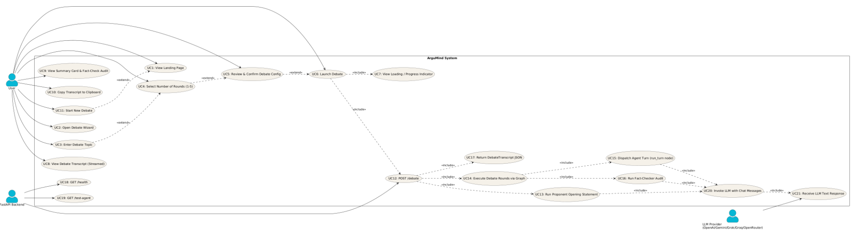
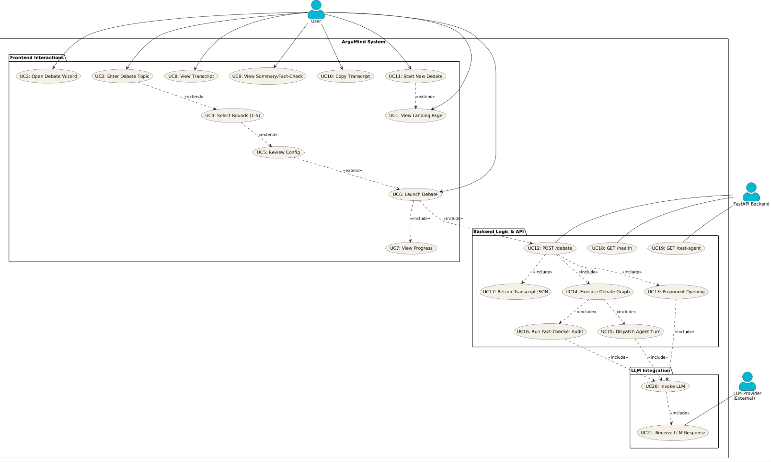
Figure B.1 — Use Case Diagram

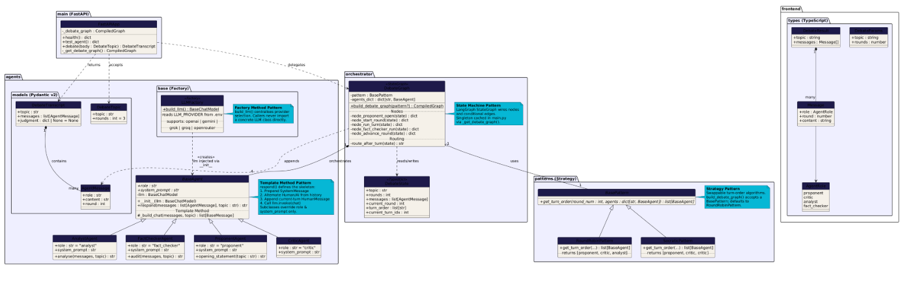
Figure B.2 — Class Diagram

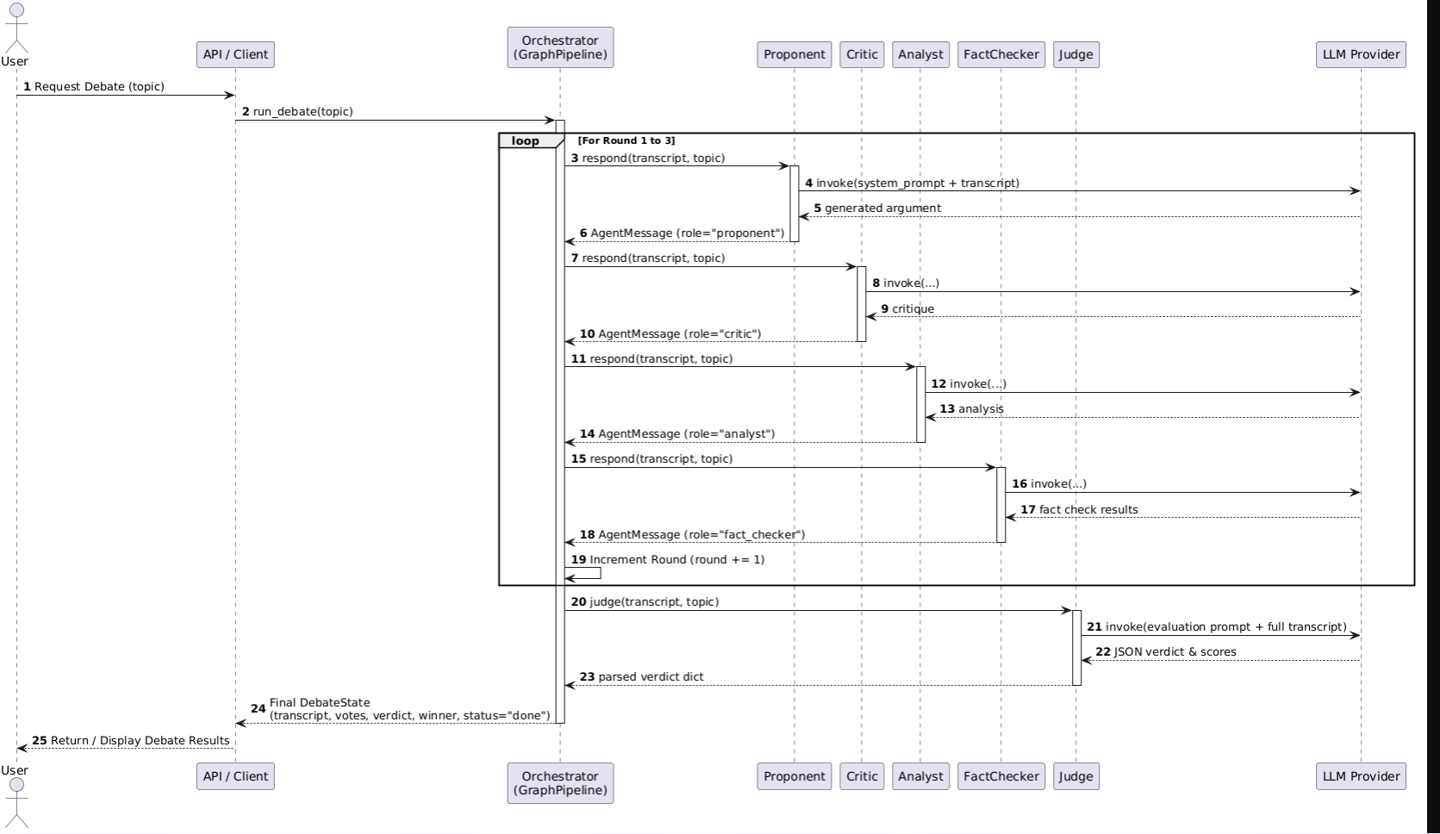
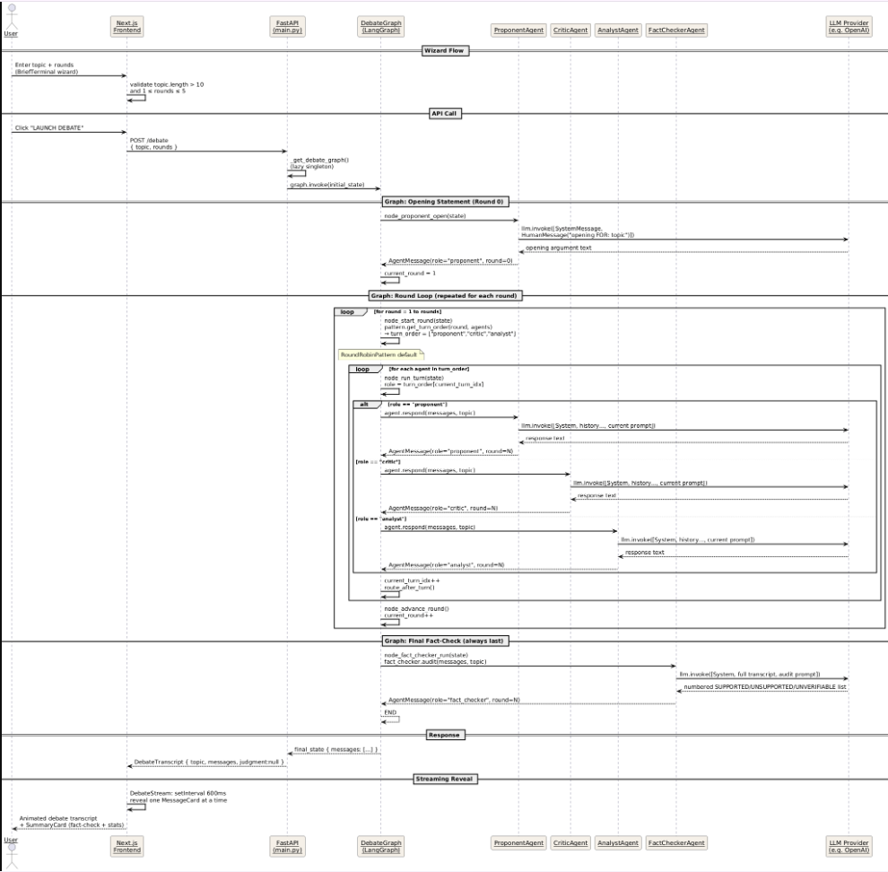
Figure B.3 — Sequence Diagram

Appendix C: To Be Determined List
TBD # | Description | Target Resolution
TBD-1 | Insert final UML diagram images into Appendix B | Week 14
TBD-2 | Unit and integration test results to be documented in SRS Section 4 | Week 14
TBD-3 | Performance comparison experiment: multi-agent vs single LLM across 10 topics with bar chart | Week 13
TBD-4 | CORS origins to be restricted to known frontend URL before deployment | Week 15

