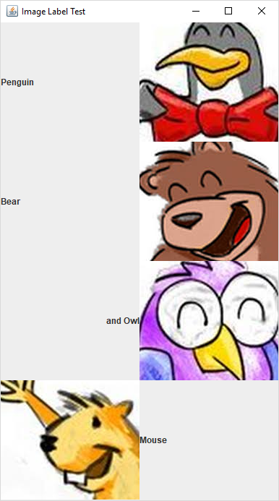

**import** java.awt.GridLayout;

**import** java.awt.event.*;

**import** javax.swing.*;

**public** **class** LabelImage {

**public** **static** **void** main(String[] args) {

JFrame frame = **new** JFrame();

frame.setTitle("Image Label Test");

JLabel label1 = **new** JLabel("Penguin"); //left aligned

JLabel label2 = **new** JLabel("Bear", SwingConstants.***LEFT***);

JLabel label3 = **new** JLabel();

label3.setText("and Owl");//assigning text to label3

label3.setHorizontalAlignment(SwingConstants.***RIGHT***);//set alignment

Icon icon = **new** ImageIcon("images1.jfif");//create image icon

JLabel label4 = **new** JLabel(icon);//create image label

Icon icon2 = **new** ImageIcon("images2.jfif");//create image icon

JLabel label5 = **new** JLabel(icon2);//create image label

Icon icon3 = **new** ImageIcon("images3.jfif");//create image icon

JLabel label6 = **new** JLabel(icon3);//create image label

Icon icon4 = **new** ImageIcon("images4.jfif");//create image icon

JLabel label7 = **new** JLabel(icon4);//create image label

JLabel label8 = **new** JLabel("Mouse"); //left aligned

frame.getContentPane().setLayout(**new** GridLayout(4,2));

frame.getContentPane().add(label1);

frame.getContentPane().add(label5);

frame.getContentPane().add(label2);

frame.getContentPane().add(label6);

frame.getContentPane().add(label3);

frame.getContentPane().add(label7);

frame.getContentPane().add(label4);

frame.getContentPane().add(label8);

frame.setSize(400,700); //frame.pack();

frame.setDefaultCloseOperation( JFrame.***EXIT_ON_CLOSE*** );

frame.setVisible(**true**);

}

}

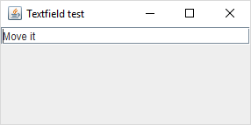

**import** java.awt.BorderLayout;

**import** java.awt.Container;

**import** java.awt.event.ActionEvent;

**import** java.awt.event.ActionListener;

**import** javax.swing.*;

**public** **class** TextBoxEg **extends** JFrame **implements** ActionListener {

JTextField txt;

TextBoxEg()

{

setTitle("Textfield test");

setDefaultCloseOperation( JFrame.***EXIT_ON_CLOSE*** );

setSize(300, 150);

setLocation(100,200);

txt=**new** JTextField("Move it");

Container c = getContentPane(); // unnecessary in 5.0+

c.add(txt,BorderLayout.***NORTH***);

txt.addActionListener(**this**);

txt.setHorizontalAlignment(JTextField.***LEFT***);

**this**.setVisible(**true**);

}

**public** **static** **void** main(String[] args) {

**new** TextBoxEg();

}

@Override

**public** **void** actionPerformed(ActionEvent e) {

**if**(e.getSource()==txt)

{

**if**(txt.getHorizontalAlignment()==JTextField.***LEFT***)

txt.setHorizontalAlignment(JTextField.***CENTER***);

**else** **if**(txt.getHorizontalAlignment()==JTextField.***RIGHT***)

txt.setHorizontalAlignment(JTextField.***LEFT***);

**else** **if**(txt.getHorizontalAlignment()==JTextField.***CENTER***)

txt.setHorizontalAlignment(JTextField.***RIGHT***);

}

}

}

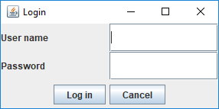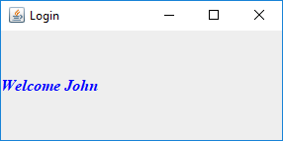

**import** java.awt.BorderLayout;

**import** java.awt.Container;

**import** java.awt.GridLayout;

**import** java.awt.event.ActionEvent;

**import** java.awt.event.ActionListener;

**import** javax.swing.JButton;

**import** javax.swing.JFrame;

**import** javax.swing.JLabel;

**import** javax.swing.JPanel;

**import** javax.swing.JPasswordField;

**import** javax.swing.JTextField;

**public** **class** LoginEg **extends** JFrame **implements** ActionListener{

JLabel lblUser, lblPwd;

JTextField txtUser;

JPasswordField txtPwd;

JButton btnLogin,btnCancel;

LoginEg()

{ setTitle("Login");

setDefaultCloseOperation( JFrame.***EXIT_ON_CLOSE*** );

setSize(300, 150);

setLocation(100,200);

txtUser=**new** JTextField(20);

txtPwd=**new** JPasswordField(20);

txtPwd.setEchoChar('*');

lblUser=**new** JLabel("User name");

lblPwd=**new** JLabel("Password");

btnLogin=**new** JButton("Log in");

btnCancel=**new** JButton("Cancel");

Container c = getContentPane();

JPanel p1=**new** JPanel();

p1.setLayout(**new** GridLayout(2,2));

p1.add(lblUser);

p1.add(txtUser);

p1.add(lblPwd);

p1.add(txtPwd);

JPanel p2=**new** JPanel();

p2.add(btnLogin);

p2.add(btnCancel);

c.add(p1,BorderLayout.***CENTER***);

c.add(p2,BorderLayout.***SOUTH***);

btnLogin.addActionListener(**this**);

btnCancel.addActionListener(**this**);

**this**.setVisible(**true**);

}

**public** **static** **void** main(String[] args) {

**new** LoginEg();

}

@Override

**public** **void** actionPerformed(ActionEvent e) {

**if**(e.getSource()==btnLogin)

{ String name=txtUser.getText();

String pwd=**new** String(txtPwd.getPassword());

**if**(name.equals("John")&&pwd.equals("123"))

{

Home.*name*=txtUser.getText();

**new** Home();

**this**.dispose();

}

}

**else**

{

txtUser.setText("");

txtPwd.setText("");

}

}

}

**import** java.awt.BorderLayout;

**import** java.awt.Color;

**import** java.awt.Container;

**import** java.awt.Font;

**import** java.awt.event.ActionEvent;

**import** java.awt.event.ActionListener;

**import** javax.swing.JFrame;

**import** javax.swing.JLabel;

**import** javax.swing.JOptionPane;

**public** **class** Home **extends** JFrame{

**static** String *name*;

JLabel lblName;

Home()

{

setTitle("Login");

setDefaultCloseOperation( JFrame.***EXIT_ON_CLOSE*** );

setSize(300, 150);

setLocation(100,200);

lblName=**new** JLabel();

lblName.setText("Welcome "+*name*);

lblName.setFont(**new** Font("Times New Roman",Font.***BOLD***+Font.***ITALIC***,16));

lblName.setForeground(Color.***BLUE***);

Container c = getContentPane();

c.add(lblName);

**this**.setVisible(**true**);

}

}