**Assignment IV**

Database

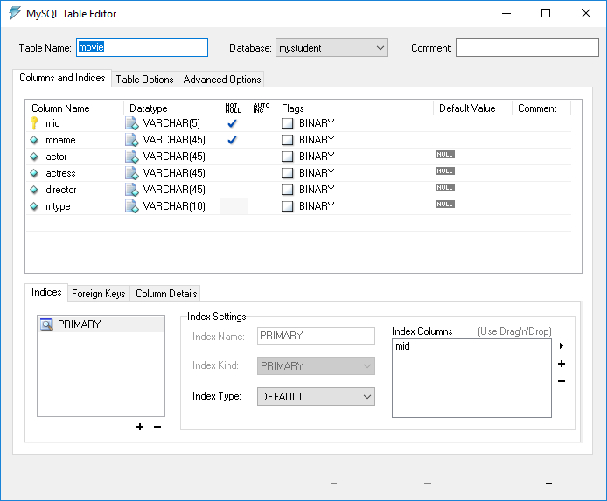

Form Load

If there is no data in database, movie id must be shown as “m-001”. If there is a movie record, it will show as “m-002”. It means movie id must be auto id.

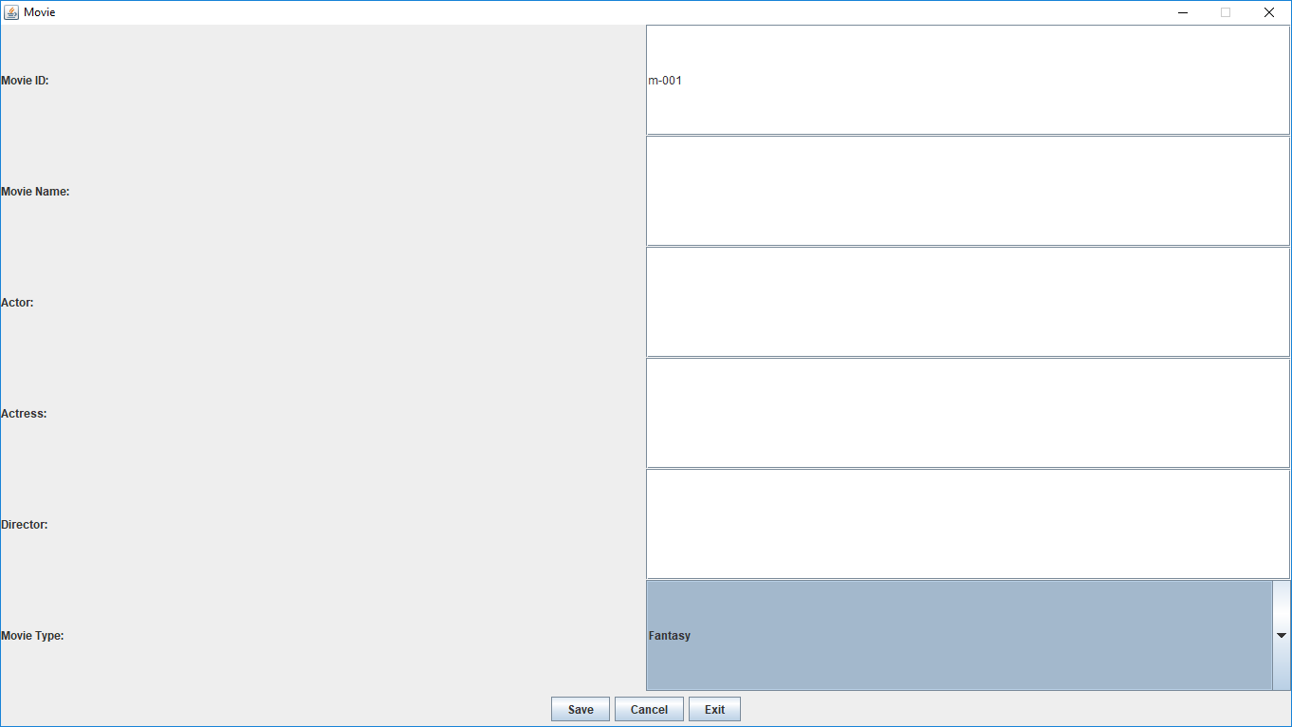

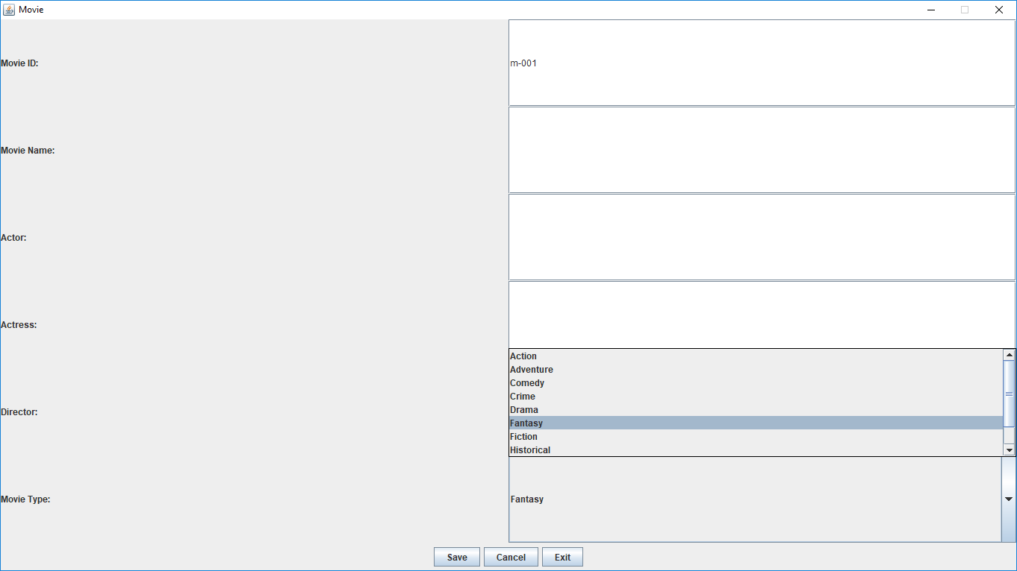

When user clicks “Save” button, all data should be saved. And then movie id will appear with new number.

