**Assignment 2**

**Create form design as shown in following figure.**

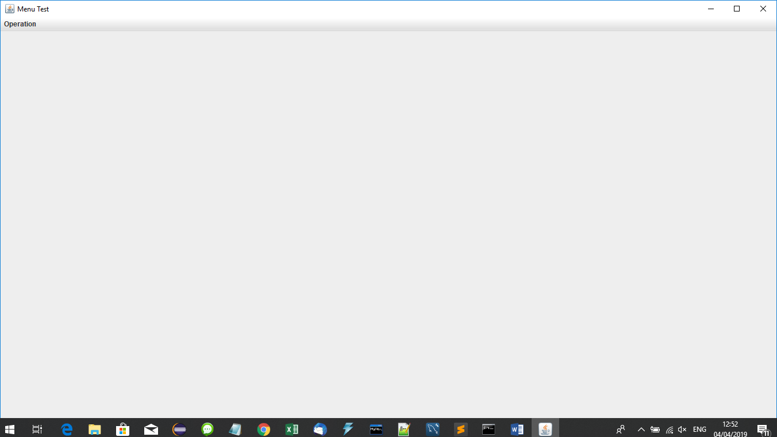

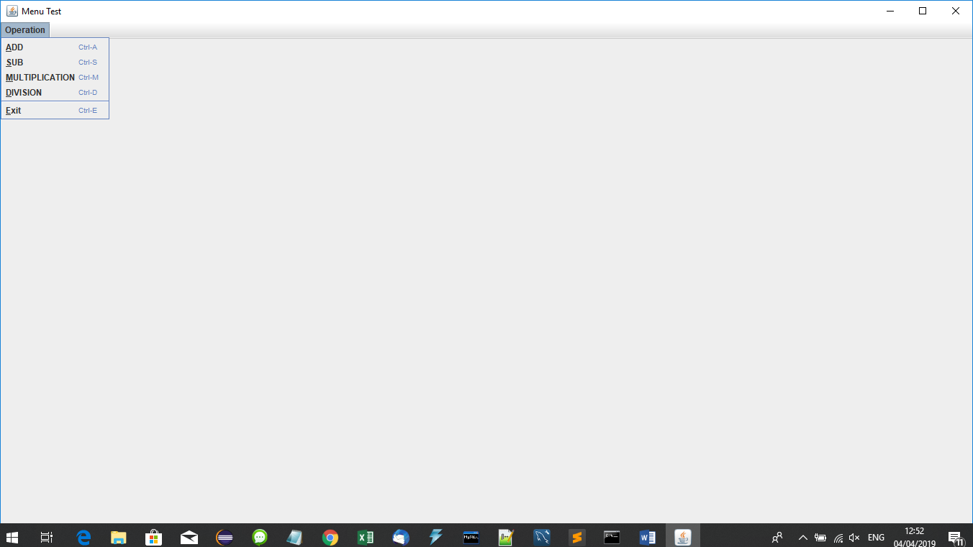

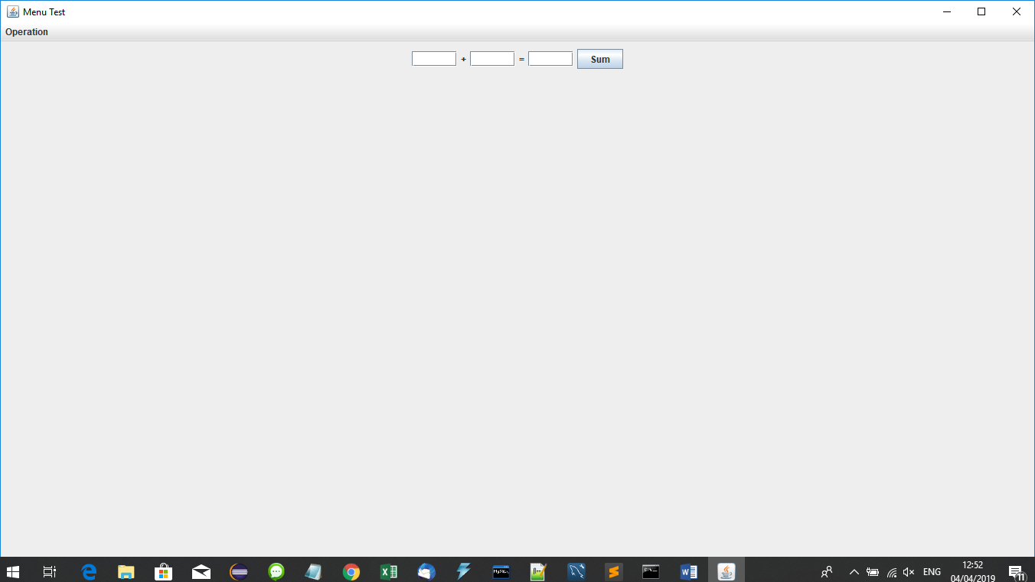

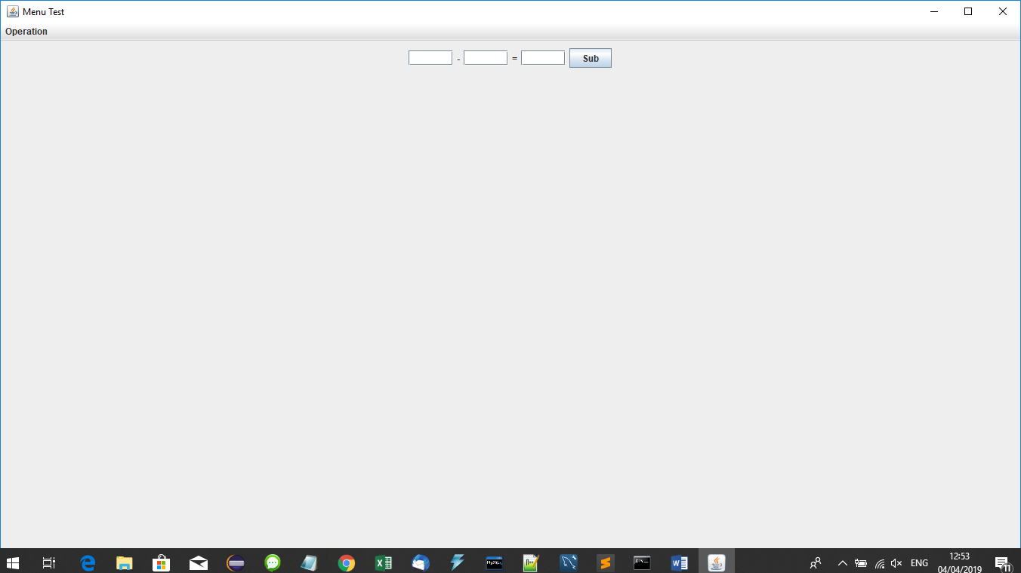

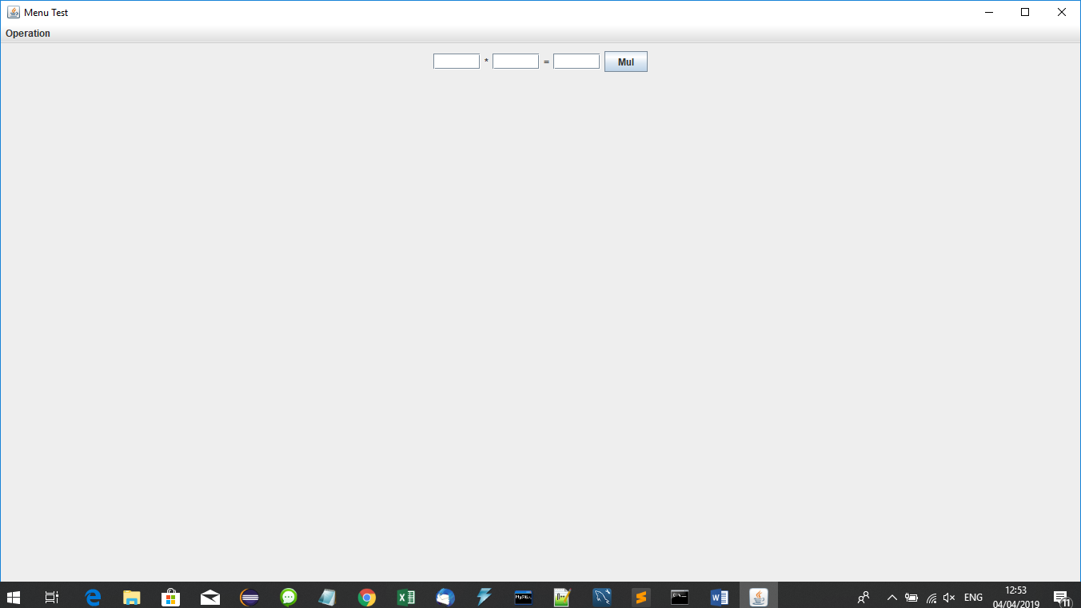

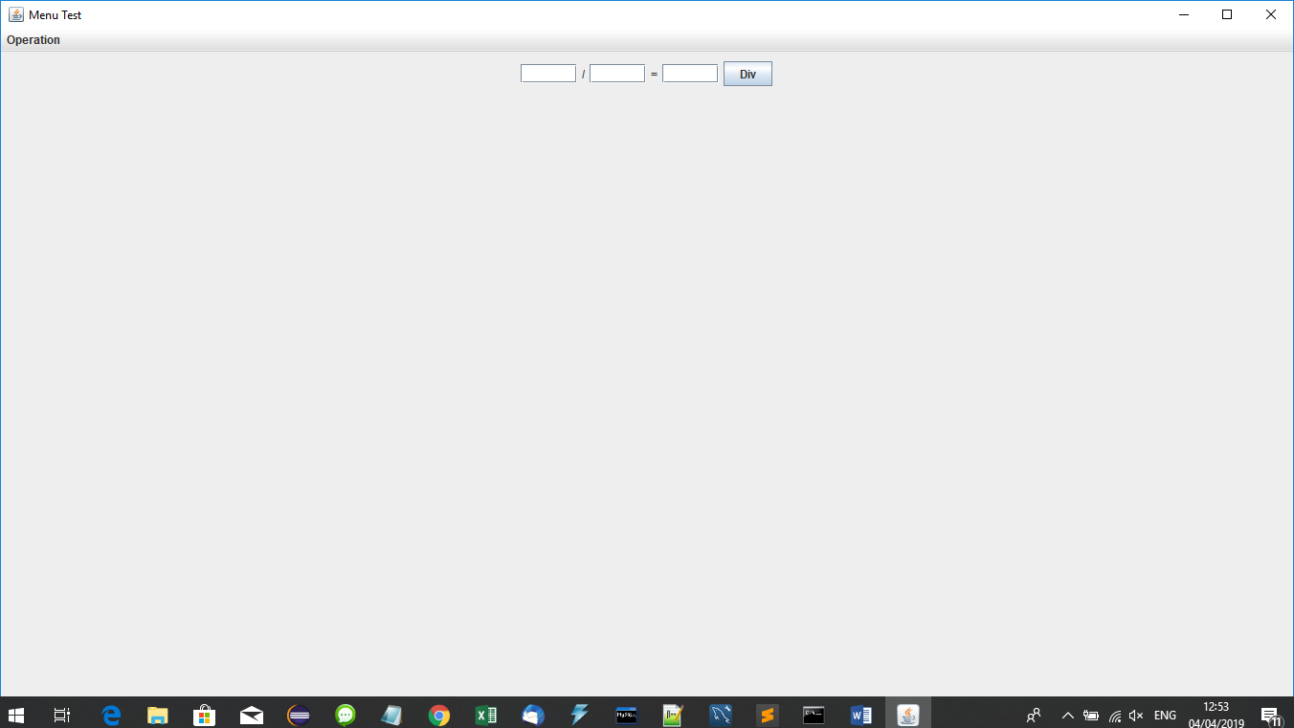

**Tasks to do**

1. **Use setting for following codes:**

setTitle("Menu Test");

Dimension d=Toolkit.*getDefaultToolkit*().getScreenSize();

setSize((**int**)d.getWidth(),(**int**)d.getHeight());

setLocationRelativeTo(**null**);

**int** x=(**int**)((d.getWidth()-**this**.getWidth()))/2;

**int** y=(**int**)((d.getHeight()-**this**.getHeight()))/2;

setLocation(x,y);

setDefaultCloseOperation(JFrame.***EXIT_ON_CLOSE***);

1. **Form Load🡪 Show Menu Only**
2. **When user click Add menu item, show addition panel.**
3. **When user click Sub menu item, show subtration panel.**
4. **When user click Multiplication menu item, show multiplication panel.**
5. **When user click Division menu item, show division panel.**
6. **When user click exit menu item, close this application.**
7. **When user click Sum button, show the result of two numbers addition in result textfield.**
8. **When user click Sum button, show the result of two numbers addition in result textfield.**
9. **When user click Sub button, show the result of two numbers subtraction in result textfield.**
10. **When user click Mul button, show the result of two numbers multiplication in result textfield.**
11. **When user click Div button, show the result of two numbers division in result textfield.**

**Mail to me include java file.**

|  |  |
| --- | --- |
|  | [htetmyetaung@brycenmyanmar.com.mm](mailto:htetmyetaung@brycenmyanmar.com.mm) |

**Last Date: 10/4/2019 Weds**

**Try your best.**

**Thank you.**