**Assignment I**

**Create form design as shown in following figure.**

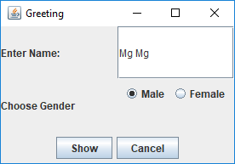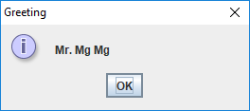

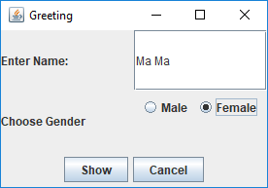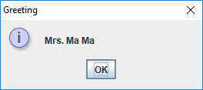

**Tasks to do**

1. **Use setting for following codes:**

setSize(290,200);

setLocation(200,200);

setDefaultCloseOperation(***EXIT_ON_CLOSE***);

1. **In form load, Select Male Radio Button and Name textfield must be black.**
2. **When user click “Show” button, if Male is selected,**

**Show the message 🡪 “Mr.[user entered name]”, otherwise**

**Show the message 🡪 “Mrs.[user entered name]”**

1. **When user click “Cancel” button, clear textfield and check Male radio button.**

**And then fill the following Check List after coding is completely developed.**

|  |  |
| --- | --- |
| **Topic** | **Correct or Not (〇　または　✕ )** |
| 1. **Form Design** |  |
| 1. **Form Load Event** |  |
| 1. **Show Button Click, Male is selected** |  |
| 1. **Show Button Click, Female is selected** |  |
| 1. **Cancel button click** |  |

**Mail to me include java file and write check list in mail(optional).**

|  |  |
| --- | --- |
|  | [htetmyetaung@brycenmyanmar.com.mm](mailto:htetmyetaung@brycenmyanmar.com.mm) |

**Last Date: 4/4/2018 Weds**

**Try your best.**

**Thank you.**