**First Create student table in mystudent [db] as follow:**

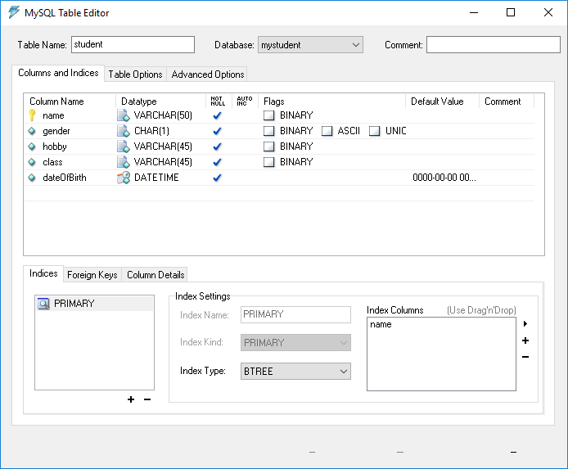

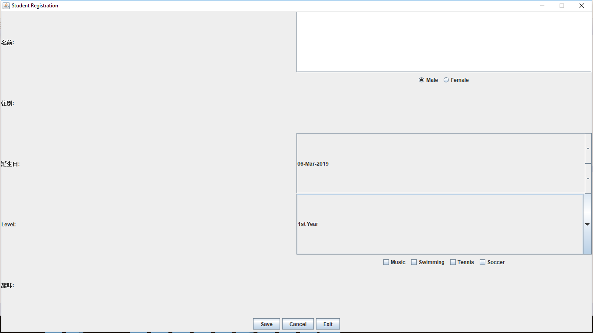

**import** java.awt.BorderLayout;

**import** java.awt.Dimension;

**import** java.awt.GridLayout;

**import** java.awt.Toolkit;

**import** java.awt.event.ActionEvent;

**import** java.awt.event.ActionListener;

**import** java.sql.Connection;

**import** java.util.Calendar;

**import** java.util.Date;

**import** javax.swing.ButtonGroup;

**import** javax.swing.JButton;

**import** javax.swing.JCheckBox;

**import** javax.swing.JComboBox;

**import** javax.swing.JFrame;

**import** javax.swing.JLabel;

**import** javax.swing.JOptionPane;

**import** javax.swing.JPanel;

**import** javax.swing.JRadioButton;

**import** javax.swing.JSpinner;

**import** javax.swing.JTextField;

**import** javax.swing.SpinnerDateModel;

**import** javax.swing.SpinnerModel;

**import** java.sql.DriverManager;

**import** java.sql.PreparedStatement;

**import** java.sql.SQLException;

**public** **class** Student **extends** JFrame **implements** ActionListener {

JLabel lblName, lblGender, lblHobby, lblBDay,lblClass;

JTextField txtName;

JRadioButton rdoMale,rdoFemale;

JCheckBox chkSwim, chkTennis, chkSoccer, chkMusic;

JSpinner spinner;

JComboBox cboClass;

JButton btnCancel,btnSave, btnExit;

/* Database Begin*/

**static** Connection *conn*;

**static** String *url* = "jdbc:mysql://localhost:3308/***mystudent***";;

**static** String *username* = "nts";

**static** String *password* = "@nts";

**static** String *sql*;

**static** PreparedStatement *stmt*=**null**;

/* Database End*/

Student()

{

**super** ("Student Registration");

Dimension d=Toolkit.*getDefaultToolkit*().getScreenSize();

setSize((**int**)d.getWidth(),(**int**)d.getHeight());

setLocationRelativeTo(**null**);

**int** x=(**int**)((d.getWidth()-**this**.getWidth()))/2;

**int** y=(**int**)((d.getHeight()-**this**.getHeight()))/2;

setLocation(x,y);//Set Position on the screen

setDefaultCloseOperation(JFrame.***EXIT_ON_CLOSE***);

lblName=**new** JLabel("名前:");//namae

lblBDay=**new** JLabel("誕生日:");//tanjoubi

lblClass=**new** JLabel("Level:");

lblGender=**new** JLabel("性別:");//seibetsu

lblHobby=**new** JLabel("趣味:");//shumi

txtName=**new** JTextField(20);

Calendar now = Calendar.*getInstance*();

Calendar earliest = (Calendar)now.clone();

earliest.add( Calendar.***YEAR***, -100 );

Calendar latest = (Calendar)now.clone();

latest.add( Calendar.***YEAR***, 20);

SpinnerModel model = **new** SpinnerDateModel(now.getTime(), earliest.getTime(), latest.getTime(),Calendar.***DATE***);

spinner = **new** JSpinner(model);// Disable the built-in date editor

spinner.setEditor(**new** JSpinner.DefaultEditor(spinner) );

cboClass=**new** JComboBox();

cboClass.addItem("1st Year");

cboClass.addItem("2nd Year");

cboClass.addItem("3rd Year");

cboClass.addItem("4th Year");

cboClass.addItem("Final Year");

rdoMale=**new** JRadioButton("Male",**true**);

rdoFemale=**new** JRadioButton("Female");

ButtonGroup bg=**new** ButtonGroup();

bg.add(rdoFemale);

bg.add(rdoMale);

JPanel pnlRadio=**new** JPanel();

pnlRadio.add(rdoMale);

pnlRadio.add(rdoFemale);

chkMusic=**new** JCheckBox("Music");

chkSwim=**new** JCheckBox("Swimming");

chkTennis=**new** JCheckBox("Tennis");

chkSoccer=**new** JCheckBox("Soccer");

JPanel pnlChk=**new** JPanel();

pnlChk.add(chkMusic);

pnlChk.add(chkSwim);

pnlChk.add(chkTennis);

pnlChk.add(chkSoccer);

btnCancel=**new** JButton("Cancel");

btnExit=**new** JButton("Exit");

btnSave=**new** JButton("Save");

JPanel pnlButton=**new** JPanel();

pnlButton.add(btnSave);

pnlButton.add(btnCancel);

pnlButton.add(btnExit);

btnSave.addActionListener(**this**);

btnCancel.addActionListener(**this**);

btnExit.addActionListener(**this**);

JPanel p1=**new** JPanel();

p1.setLayout(**new** GridLayout(5,2));

p1.add(lblName);

p1.add(txtName);

p1.add(lblGender);

p1.add(pnlRadio);

p1.add(lblBDay);

p1.add(spinner);

p1.add(lblClass);

p1.add(cboClass);

p1.add(lblHobby);

p1.add(pnlChk);

**this**.getContentPane().add(p1,BorderLayout.***CENTER***);

**this**.getContentPane().add(pnlButton,BorderLayout.***SOUTH***);

setVisible(**true**);

setResizable(**false**);

}

**public** **static** **void** main(String[] e) {

**new** Student();

}

@Override

**public** **void** actionPerformed(ActionEvent e) {

**if**(e.getSource()==btnSave)

{ **int** yn=JOptionPane.*showConfirmDialog*(**this**,"Are you sure you want to save","Confirmation",1);

**if**(yn==0) // 0=yes, 1=no, 2=cancel

{

String st="";

String name=txtName.getText();

String gender="";

**if**(rdoMale.isSelected())

{

gender="M";

}

**else**

{

gender="F";

}

String hobby="";

**if**(chkMusic.isSelected())

hobby+="Music ";

**if**(chkSoccer.isSelected())

hobby+="Soccer ";

**if**(chkTennis.isSelected())

hobby+="Tennis ";

**if**(chkSwim.isSelected())

hobby+="Swimming ";

String cl=cboClass.getSelectedItem().toString();

Date d=(Date)spinner.getValue();

java.sql.Date sqlDate = **new** java.sql.Date(d.getTime());

//st=name+"\n"+gender+"\n"+hobby+"\n"+cl+"\n"+d;

//JOptionPane.showMessageDialog(this, st, "Student Information",1);

/* Database Begin*/

*createDB*();

**try** {

//sql="insert into student //values('"+name+"','"+gender+"','"+hobby+"','"+cl+"',"+d+")";

*sql*="insert into student(name,gender,hobby,class,dateOfBirth) values(?,?,?,?,?)";

*stmt* = *conn*.prepareStatement(*sql*);

*stmt*.setString(1,name);//1 specifies the first parameter in the query

*stmt*.setString(2,gender);

*stmt*.setString(3,hobby);

*stmt*.setString(4,cl);

*stmt*.setDate(5,sqlDate);

} **catch** (SQLException e1) {

e1.printStackTrace();

}

**try** {

**int** execute = *stmt*.executeUpdate();

} **catch** (SQLException e1) {

e1.printStackTrace();

}

JOptionPane.*showMessageDialog*(**this**,"One row has been inserted","Information",1);

/* Database End*/

}

}

**else** **if** (e.getActionCommand().equals("Cancel"))

{

txtName.setText("");

rdoMale.setSelected(**true**);

rdoFemale.setSelected(**false**);

cboClass.setSelectedIndex(0);

chkMusic.setSelected(**false**);

chkSoccer.setSelected(**false**);

chkSwim.setSelected(**false**);

chkTennis.setSelected(**false**);

}

**else**

{

System.*exit*(0);

}

}

/* Database Begin*/

**static** **void** createDB()

{

**try**{

Class.*forName* ("com.mysql.jdbc.Driver");

*conn* = DriverManager.*getConnection* (*url*, *username*, *password*);

}

**catch**(Exception e)

{

System.***out***.println("connection error");

}

}

/* Database End*/

}

(please download it from Java Learning Channel)



**How to add external jar?**

* Right Click on Project🡪Build Path 🡪 Configure Build Path

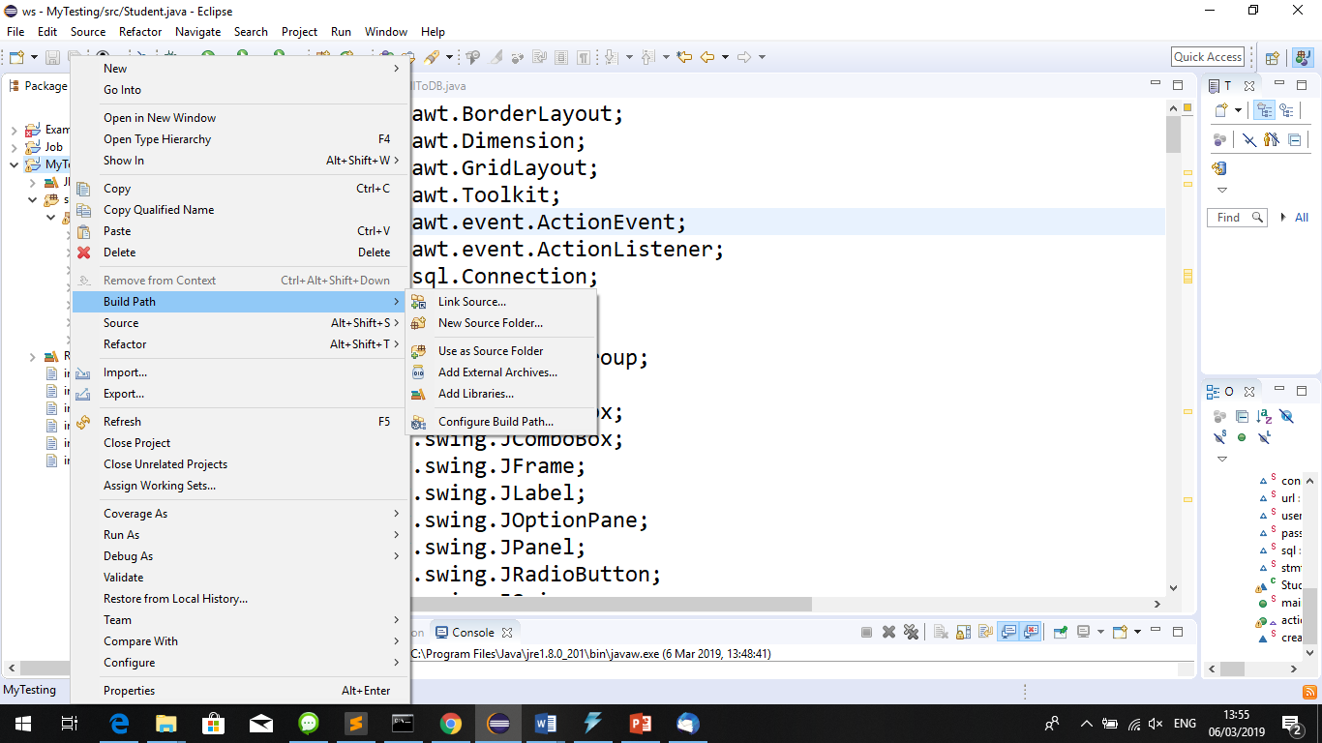

* Add External JARs

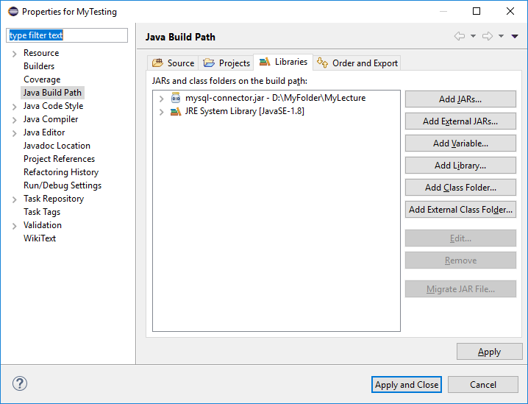

Choose from your mysql-connector.jar

