**MVC**

1. MODEL class ---MVC_Model
2. VIEW class --- MVC_View
3. CONTROLLER class ---MVC_Controller
4. Intialize all above three classes in Main Method class ---GlobelMVC

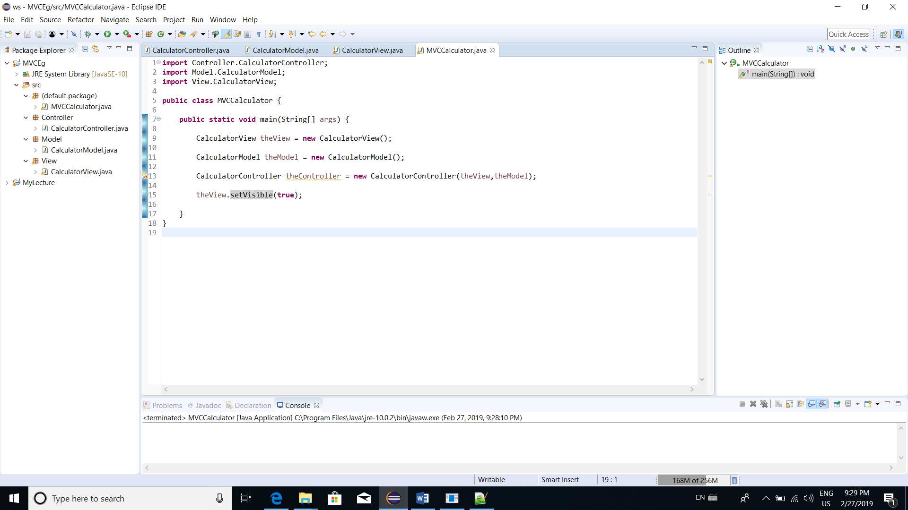

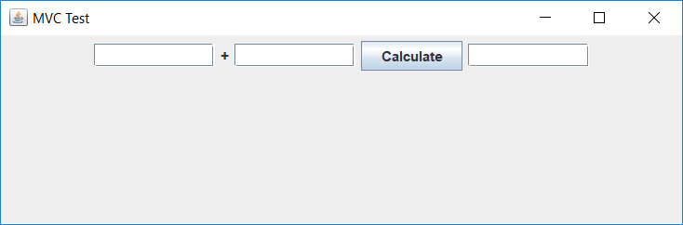

**import** Controller.CalculatorController;

**import** Model.CalculatorModel;

**import** View.CalculatorView;

**public** **class** MVCCalculator {

**public** **static** **void** main(String[] args) {

CalculatorView theView = **new** CalculatorView();

CalculatorModel theModel = **new** CalculatorModel();

CalculatorController theController = **new** CalculatorController(theView,theModel);

theView.setVisible(**true**);

}

}

**package** View;

**import** java.awt.Dimension;

**import** java.awt.Toolkit;

**import** java.awt.event.ActionListener;

**import** javax.swing.*;

**public** **class** CalculatorView **extends** JFrame{

**private** JTextField txtNum1;

**private** JLabel lblAdd;

**private** JTextField txtNum2;

**private** JButton btnCal;

**private** JTextField txtSum;

**public** CalculatorView(){

**super** ("MVC Test");

setSize(600,200);

Dimension d=Toolkit.*getDefaultToolkit*().getScreenSize();

**int** x=(**int**)((d.getWidth()-**this**.getWidth()))/2;

**int** y=(**int**)((d.getHeight()-**this**.getHeight()))/2;

setLocation(x,y);//Set Position on the screen

setDefaultCloseOperation(JFrame.***EXIT_ON_CLOSE***);

// Sets up the view and adds the components

txtNum1 = **new** JTextField(10);

lblAdd = **new** JLabel("+");

txtNum2 = **new** JTextField(10);

btnCal = **new** JButton("Calculate");

txtSum = **new** JTextField(10);

JPanel calcPanel = **new** JPanel();

calcPanel.add(txtNum1);

calcPanel.add(lblAdd);

calcPanel.add(txtNum2);

calcPanel.add(btnCal);

calcPanel.add(txtSum);

**this**.add(calcPanel);

}

**public** **int** getFirstNumber(){

**return** Integer.*parseInt*(txtNum1.getText());

}

**public** **int** getSecondNumber(){

**return** Integer.*parseInt*(txtNum2.getText());

}

**public** **int** getSum(){

**return** Integer.*parseInt*(txtSum.getText());

}

**public** **void** setCalcSolution(**int** solution){

txtSum.setText(Integer.*toString*(solution));

}

// If the calculateButton is clicked execute a method

// in the Controller named actionPerformed

**public** **void** addCalculateListener(ActionListener listenForCalcButton){

btnCal.addActionListener(listenForCalcButton);

}

**public** **void** displayErrorMessage(String errorMessage){

JOptionPane.*showMessageDialog*(**this**, errorMessage);

}

}

**package** Model;

**public** **class** CalculatorModel {

// Holds the value of the sum of the numbers

// entered in the view

**private** **int** sum;

**public** **void** addTwoNumbers(**int** firstNumber, **int** secondNumber){

sum = firstNumber + secondNumber;

}

**public** **int** getCalculationValue(){

**return** sum;

}

}

**package** Controller;

**import** java.awt.event.ActionEvent;

**import** java.awt.event.ActionListener;

**import** Model.CalculatorModel;

**import** View.CalculatorView;

// The Controller coordinates interactions

// between the View and Model

**public** **class** CalculatorController {

**private** CalculatorView theView;

**private** CalculatorModel theModel;

**public** CalculatorController(CalculatorView theView, CalculatorModel theModel)

{

**this**.theView = theView;

**this**.theModel = theModel;

// Tell the View that when ever the calculate button

// is clicked to execute the actionPerformed method

// in the CalculateListener inner class

**this**.theView.addCalculateListener(**new** CalculateListener());

}

**class** CalculateListener **implements** ActionListener{

**public** **void** actionPerformed(ActionEvent e) {

**int** num1, num2 = 0;

// Surround interactions with the view with

// a try block in case numbers weren't

// properly entered

**try**{

num1 = theView.getFirstNumber();

num2 = theView.getSecondNumber();

theModel.addTwoNumbers(num1, num2);

theView.setCalcSolution(theModel.getCalculationValue());

}

**catch**(NumberFormatException ex){

System.***out***.println(ex);

theView.displayErrorMessage("You Need to Enter 2 Integers");

}

}

}

}

**List Box**

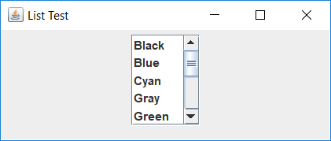

**import** java.awt.*;

**import** javax.swing.*;

**import** javax.swing.event.*;

**import** java.awt.event.*;

**public** **class** ListTest **extends** JFrame

{ **private** JList colorList;

**private** Container c;

**private** String colorName[ ] = {"Black", "Blue", "Cyan", "Gray", "Green", "Megenta",

"Orange","Pink", "Red", "White", "Yellow"};

**private** Color colors[ ] = { Color.***black***, Color.***blue***, Color.***cyan***, Color.***gray***, Color.***green***,

Color.***magenta***, Color.***orange***, Color.***pink***, Color.***red***, Color.***white***, Color.***yellow***};

**public** ListTest()

{ **super** ("List Test" );

c=getContentPane();

c.setLayout (**new** FlowLayout());

colorList = **new** JList(colorName);

colorList.setVisibleRowCount(5);

colorList.setSelectionMode( ListSelectionModel.***SINGLE_SELECTION***);

c.add (**new** JScrollPane (colorList) );

colorList.addListSelectionListener (**new** ListSelectionListener()

{

**public** **void** valueChanged (ListSelectionEvent e)

{ c.setBackground ( colors[ colorList.getSelectedIndex()]);

}

});

setSize(350, 150);

~~show~~();

}

**public** **static** **void** main(String args[ ])

{ ListTest app = **new** ListTest();

app.addWindowListener(**new** WindowAdapter(){

**public** **void** windowClosing(WindowEvent e)

{ System.*exit* (0); }

});

}

}