**MENU**

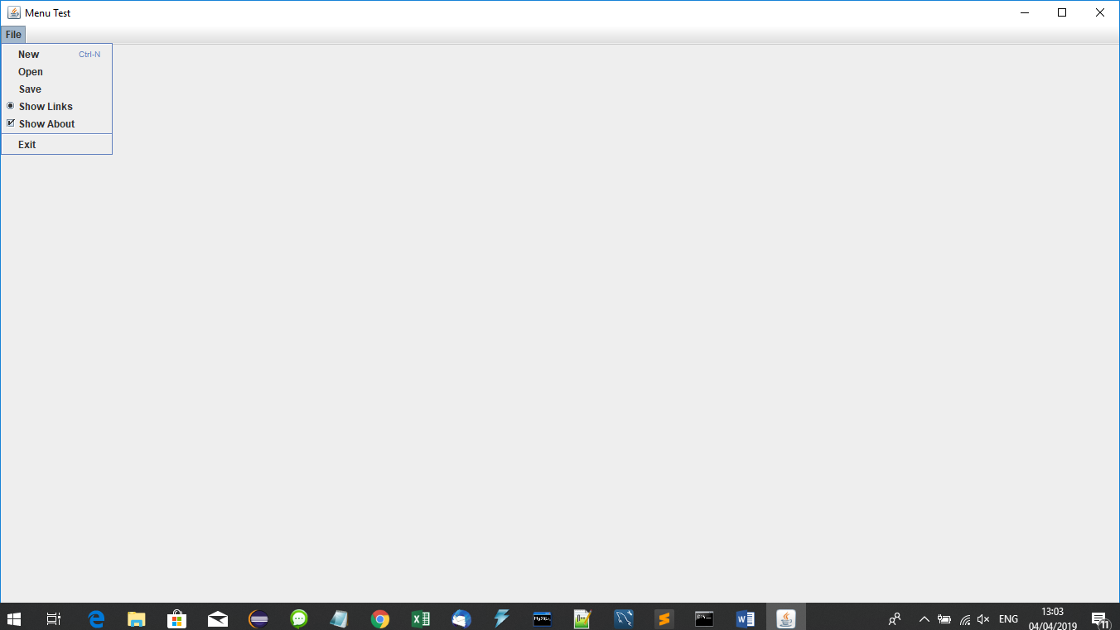

import java.awt.Container;

import java.awt.Dimension;

import java.awt.Toolkit;

import java.awt.event.ActionEvent;

import java.awt.event.ActionListener;

import java.awt.event.KeyEvent;

import javax.swing.JButton;

import javax.swing.JCheckBoxMenuItem;

import javax.swing.JFrame;

import javax.swing.JLabel;

import javax.swing.JMenu;

import javax.swing.JMenuBar;

import javax.swing.JMenuItem;

import javax.swing.JOptionPane;

import javax.swing.JPanel;

import javax.swing.JRadioButtonMenuItem;

import javax.swing.JTextField;

import javax.swing.KeyStroke;

public class menuTest extends JFrame implements ActionListener{

JMenuBar mb;

JMenu menuFile;

JMenuItem menuitemNew,menuitemOpen,menuitemSave,menuitemExit;

menuTest()

{ setTitle("Menu Test");

Dimension d=Toolkit.getDefaultToolkit().getScreenSize();

setSize((int)d.getWidth(),(int)d.getHeight());

//setExtendedState(JFrame.MAXIMIZED_BOTH);

//setUndecorated(true);

setLocationRelativeTo(null);

int x=(int)((d.getWidth()-this.getWidth()))/2;

int y=(int)((d.getHeight()-this.getHeight()))/2;

setLocation(x,y);//Set Position on the screen

setDefaultCloseOperation(JFrame.EXIT_ON_CLOSE);

mb=new JMenuBar();

menuFile=new JMenu("File");

menuitemNew=new JMenuItem("New");

menuitemOpen=new JMenuItem("Open");

menuitemSave=new JMenuItem("Save");

menuitemExit=new JMenuItem("Exit");

menuitemNew.setMnemonic(KeyEvent.VK_B);

menuitemNew.setAccelerator(KeyStroke.getKeyStroke(

KeyEvent.VK_N, ActionEvent.CTRL_MASK));

JRadioButtonMenuItem showLinksMenu = new JRadioButtonMenuItem(

"Show Links", true);

JCheckBoxMenuItem showWindowMenu = new JCheckBoxMenuItem(

"Show About", true);

mb.add(menuFile);

menuFile.add(menuitemNew);

menuFile.add(menuitemOpen);

menuFile.add(menuitemSave);

menuFile.add(showLinksMenu);

menuFile.add(showWindowMenu);

menuFile.addSeparator();

menuFile.add(menuitemExit);

this.setJMenuBar(mb);

menuitemNew.addActionListener(this);

menuitemOpen.addActionListener(this);

menuitemSave.addActionListener(this);

menuitemExit.addActionListener(this);

setVisible(true);

}

public static void main(String[] args) {

new menuTest();

}

@Override

public void actionPerformed(ActionEvent e) {

if(e.getSource()==menuitemNew)

{

//new Student();

//this.dispose();

JOptionPane.showMessageDialog(this,"New","Information", 1);

}

else if(e.getSource()==menuitemOpen)

{

JOptionPane.showMessageDialog(this,"Open","Information", 1);

}

else if(e.getSource()==menuitemSave)

{

JOptionPane.showMessageDialog(this,"Save","Information", 1);

}

else if(e.getSource()==menuitemExit)

{

System.exit(0);

}

}

}