**REVISION**

**Button and Background Color**

**Create a frame with layout design and should include 6 buttons and a label. You should use border layout and JPanel. If user clicks the yellow button, the label should be changed to yellow and others also.**

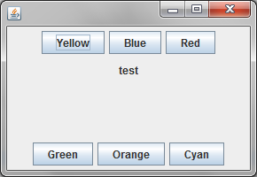

**import** java.awt.BorderLayout;

**import** java.awt.Color;

**import** java.awt.Container;

**import** java.awt.event.ActionEvent;

**import** java.awt.event.ActionListener;

**import** javax.swing.JButton;

**import** javax.swing.JFrame;

**import** javax.swing.JLabel;

**import** javax.swing.JPanel;

**public** **class** ButtonAndBgColor **extends** JFrame **implements** ActionListener{

JButton b1=**new** JButton("Yellow");

JButton b2=**new** JButton("Blue");

JButton b3=**new** JButton("Red");

JButton b4=**new** JButton("Green");

JButton b5=**new** JButton("Orange");

JButton b6=**new** JButton("Cyan");

JLabel lbl=**new** JLabel("test");

JPanel p1,p2,p3;

**public** ButtonAndBgColor()

{

**this**.setSize(290,200);

p1=**new** JPanel();

p1.add(b1);

p1.add(b2);

p1.add(b3);

p3=**new** JPanel();

p3.add(lbl);

p2=**new** JPanel();

p2.add(b4);

p2.add(b5);

p2.add(b6);

Container c=**this**.getContentPane();

c.add(p1,BorderLayout.***NORTH***);

c.add(p2,BorderLayout.***SOUTH***);

c.add(p3,BorderLayout.***CENTER***);

**this**.setDefaultCloseOperation(JFrame.***EXIT_ON_CLOSE***);

**this**.setVisible(**true**);

b1.addActionListener(**this**);

b2.addActionListener(**this**);

b3.addActionListener(**this**);

b4.addActionListener(**this**);

b5.addActionListener(**this**);

b6.addActionListener(**this**);

}

**public** **static** **void** main(String args[])

{

**new** ButtonAndBgColor();

}

@Override

**public** **void** actionPerformed(ActionEvent e) {

**if**(e.getSource()==b1)

{

p1.setBackground(Color.***YELLOW***);

p2.setBackground(Color.***YELLOW***);

p3.setBackground(Color.***YELLOW***);

}

**else** **if**(e.getSource()==b2)

{

p1.setBackground(Color.***BLUE***);

p2.setBackground(Color.***BLUE***);

p3.setBackground(Color.***BLUE***);

}

**else** **if**(e.getSource()==b3)

{

p1.setBackground(Color.***RED***);

p2.setBackground(Color.***RED***);

p3.setBackground(Color.***RED***);

}

**else** **if**(e.getSource()==b4)

{

p1.setBackground(Color.***GREEN***);

p2.setBackground(Color.***GREEN***);

p3.setBackground(Color.***GREEN***);

}

**else** **if**(e.getSource()==b5)

{

p1.setBackground(Color.***ORANGE***);

p2.setBackground(Color.***ORANGE***);

p3.setBackground(Color.***ORANGE***);

}

**else** **if**(e.getSource()==b6)

{

p1.setBackground(Color.***CYAN***);

p2.setBackground(Color.***CYAN***);

p3.setBackground(Color.***CYAN***);

}

}

}

**Radio Button**

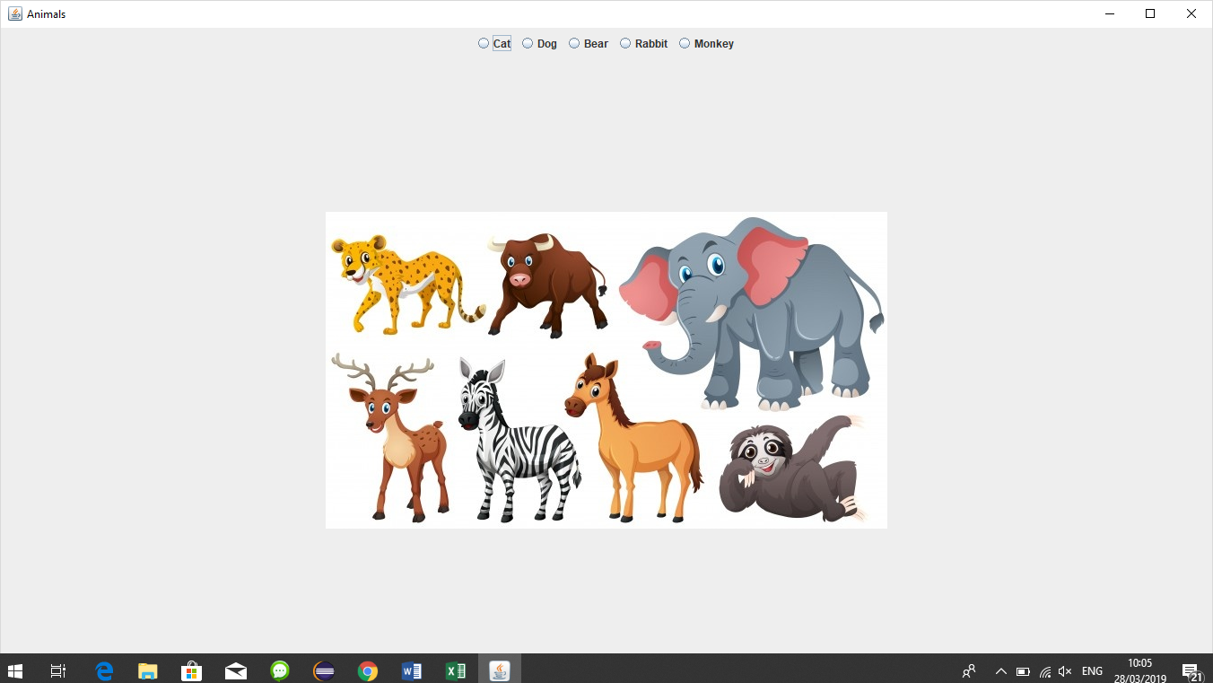

**import** java.awt.*;

**import** java.awt.event.*;

**import** javax.swing.*;

**public** **class** AnimalWithRadio **extends** JFrame **implements** ActionListener {

JRadioButton rdoCat = **new** JRadioButton("Cat");

JRadioButton rdoDog = **new** JRadioButton("Dog");

JRadioButton rdoRabbit = **new** JRadioButton("Rabbit");

JRadioButton rdoBear = **new** JRadioButton("Bear");

JRadioButton rdoMonkey = **new** JRadioButton("Monkey");

ButtonGroup group = **new** ButtonGroup();

JLabel lbl = **new** JLabel(**new** ImageIcon("./animals/logo.jpg"));

**public** AnimalWithRadio()

{ **super**("Animals");

Dimension d=Toolkit.*getDefaultToolkit*().getScreenSize();

setSize((**int**)d.getWidth(),(**int**)d.getHeight());

//setExtendedState(JFrame.MAXIMIZED_BOTH);

//setUndecorated(true);

setLocationRelativeTo(**null**);

**int** x=(**int**)((d.getWidth()-**this**.getWidth()))/2;

**int** y=(**int**)((d.getHeight()-**this**.getHeight()))/2;

setLocation(x,y);//Set Position on the screen

**this**.setDefaultCloseOperation(JFrame.***EXIT_ON_CLOSE***);

JPanel p= **new** JPanel();

p.add(rdoCat);

p.add(rdoDog);

p.add(rdoBear);

p.add(rdoRabbit);

p.add(rdoMonkey);

group.add(rdoCat);

group.add(rdoDog);

group.add(rdoBear);

group.add(rdoRabbit);

group.add(rdoMonkey);

Container c= **this**.getContentPane();

c.add(p, BorderLayout.***NORTH***);

c.add(lbl);

rdoCat.addActionListener(**this**);

rdoDog.addActionListener(**this**);

rdoBear.addActionListener(**this**);

rdoRabbit.addActionListener(**this**);

rdoMonkey.addActionListener(**this**);

**this**.setVisible(**true**);

}

**public** **static** **void** main(String[] args) {

**new** AnimalWithRadio();

}

**public** **void** actionPerformed(ActionEvent e) {

Object obj = e.getSource();

**if**(obj == rdoCat)

{

lbl.setIcon(**new** ImageIcon("./animals/cat.jpg"));

}**else** **if**(obj == rdoDog)

{

lbl.setIcon(**new** ImageIcon("./animals/dog.jfif"));

}**else** **if**(obj == rdoBear)

{

lbl.setIcon(**new** ImageIcon("./animals/bear.jfif"));

}**else** **if**(obj == rdoRabbit)

{

lbl.setIcon(**new** ImageIcon("./animals/rabbit.jpg"));

}**else** **if**(obj == rdoMonkey)

{

lbl.setIcon(**new** ImageIcon("./animals/monkey.jfif"));

}

}

}

**Note**

Copy and paste Animals folder in your project