**Test I**

**Create form design as shown in following figure.**

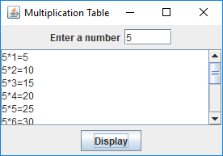

**Tasks to do**

1. **Develop setting for above design:**
2. **When user click Display menu item, show the multiplication table of user entered number in text area (1 to 12).**

**For e.g. if user entered 5, then show**

**5*1=5**

**5*2=10**

**5*3=15**

**5*4=20**

**5*5=25**

**5*6=30**

**5*7=35**

**5*8=40**

**5*9=45**

**5*10=50**

**5*11=55**

**5*12=60**

**Try your best.**

**Thank you.**

**Test 2**

**Create form design as shown in following figure.**

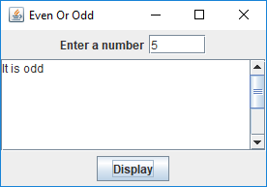

**Tasks to do**

1. **Develop setting for above design:**
2. **When user click Display menu item, show the text “It is odd” if user entered odd number, otherwise show the text “It is even”.**

**Try your best.**

**Thank you.**