**SELECT**

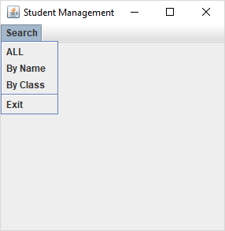 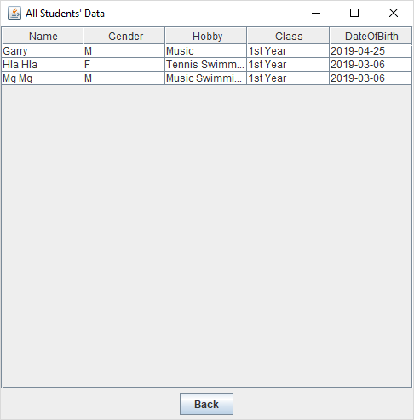

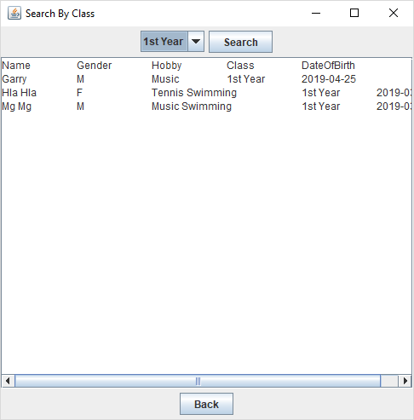

1. When user clicks “All” Menu Item, call [All students’ data] form and then display all information. In this form, when user clicks “Back” button, show [Student Management] form.
2. When user clicks “By Class” Menu Item, call [Search By Class] form. When user clicks Search Button and then display information associated with selected data. In this form, when user clicks “Back” button, show [Student Management] form.
3. When user clicks “Exit” Menu Item, close this application.
4. It is an assignment to do. It is the same process as [Search by class] form.



Enter Name

G

Name

When user clicks “Search button” and type an initial character or all characters in Name Text field, show information in the text area associated with begins entered character for name.

**Implementation**

StudentManagement.java

import java.awt.Dimension;

import java.awt.Toolkit;

import java.awt.event.ActionEvent;

import java.awt.event.ActionListener;

import javax.swing.JFrame;

import javax.swing.JMenu;

import javax.swing.JMenuBar;

import javax.swing.JMenuItem;

public class StudentManagement extends JFrame implements ActionListener{

JMenuBar mb;

JMenu mnSearch;

JMenuItem mniSearchAll, mniByName,mniByAddress,mniExit;

StudentManagement(){

setSize(300,300);

setTitle("Student Management");

Dimension d=Toolkit.getDefaultToolkit().getScreenSize();

int x=(int)((d.getWidth()-this.getWidth()))/2;

int y=(int)((d.getHeight()-this.getHeight()))/2;

setLocation(x,y);

setDefaultCloseOperation(EXIT_ON_CLOSE);

mb = new JMenuBar();

mnSearch=new JMenu("Search");

mniSearchAll=new JMenuItem("ALL");

mniByName=new JMenuItem("By Name");

mniByAddress=new JMenuItem("By Class");

mniExit=new JMenuItem("Exit");

mb.add(mnSearch);

mnSearch.add(mniSearchAll);

mnSearch.add(mniByName);

mnSearch.add(mniByAddress);

mnSearch.addSeparator();

mnSearch.add(mniExit);

this.setJMenuBar(mb);

mniSearchAll.addActionListener(this);

mniByName.addActionListener(this);

mniByAddress.addActionListener(this);

mniExit.addActionListener(this);

setVisible(true);

}

public static void main(String[] args) {

new StudentManagement();

}

@Override

public void actionPerformed(ActionEvent e) {

if(e.getSource()==mniSearchAll)

{

new SearchAll();

this.dispose();

}

else if(e.getSource()==mniExit)

{

System.exit(0);

}

else if(e.getSource()==mniByAddress)

{

new SearchByClass();

this.dispose();

}

}

}

SearchAll.java

**import** java.awt.BorderLayout;

**import** java.awt.Dimension;

**import** java.awt.Toolkit;

**import** java.awt.event.ActionEvent;

**import** java.awt.event.ActionListener;

**import** java.sql.Connection;

**import** java.sql.DriverManager;

**import** java.sql.ResultSet;

**import** java.sql.ResultSetMetaData;

**import** java.sql.SQLException;

**import** java.sql.Statement;

**import** javax.swing.JButton;

**import** javax.swing.JFrame;

**import** javax.swing.JPanel;

**import** javax.swing.JScrollPane;

**import** javax.swing.JTable;

**import** javax.swing.table.DefaultTableModel;

**public** **class** SearchAll **extends** JFrame **implements** ActionListener{

JButton btnBack;

Connection conn;

String username = "nts";

String password = "@nts";

String url="jdbc:mysql://localhost:3308/mystudent";

SearchAll()

{

setSize(500,500);

setTitle("All Students' Data");

Dimension d=Toolkit.*getDefaultToolkit*().getScreenSize();

**int** x=(**int**)((d.getWidth()-**this**.getWidth()))/2;

**int** y=(**int**)((d.getHeight()-**this**.getHeight()))/2;

setLocation(x,y);

setDefaultCloseOperation(***EXIT_ON_CLOSE***);

createDB();

Statement st;

JTable t1 = **null** ;

**try** {

st = conn.createStatement();

String query="select * from student";

ResultSet rs = st.executeQuery(query);

DefaultTableModel dtm = **new** DefaultTableModel();

ResultSetMetaData meta = rs.getMetaData();

**int** numberOfColumns = meta.getColumnCount();

rs.last();

**int** noOfRow=rs.getRow();

Object [][] rowData = **new** Object[noOfRow][numberOfColumns];

rs.beforeFirst();

**int** i=0;

**while** (rs.next())

{rowData[i][0] = rs.getString("name");

rowData[i][1] = rs.getString("gender");

rowData[i][2] = rs.getString("hobby")+"";

rowData[i][3] = rs.getString("class");

rowData[i][4] =rs.getDate("dateOfBirth");

i++;

}

String[] columnNames = {"Name","Gender","Hobby","Class","DateOfBirth"};

t1 = **new** JTable(rowData,columnNames);

st.close();

conn.close();

} **catch** (SQLException e) {

// **TODO** Auto-generated catch block

e.printStackTrace();

}

JScrollPane scrollpane = **new** JScrollPane(t1);

getContentPane().add(scrollpane, BorderLayout.***CENTER***);

btnBack=**new** JButton("Back");

JPanel p=**new** JPanel();

p.add(btnBack);

getContentPane().add(p, BorderLayout.***SOUTH***);

btnBack.addActionListener(**this**);

**this**.setVisible(**true**);

}

**void** createDB()

{ **try**{

Class.*forName* ("com.mysql.jdbc.Driver");

conn = DriverManager.*getConnection* (url, username, password);

}

**catch**(Exception e)

{ System.***out***.println("connection error");

}

}

@Override

**public** **void** actionPerformed(ActionEvent e) {

**if**(e.getSource()==btnBack)

{

**new** StudentManagement();

**this**.dispose();

}

}

}

import java.awt.BorderLayout;

import java.awt.Dimension;

import java.awt.Toolkit;

import java.awt.event.ActionEvent;

import java.awt.event.ActionListener;

import java.sql.Connection;

import java.sql.DriverManager;

import java.sql.PreparedStatement;

import java.sql.ResultSet;

import java.sql.SQLException;

import java.sql.Statement;

import javax.swing.JButton;

import javax.swing.JComboBox;

import javax.swing.JFrame;

import javax.swing.JPanel;

import javax.swing.JScrollPane;

import javax.swing.JTextArea;

public class SearchByClass extends JFrame implements ActionListener {

JButton btnBack,btnSearch;

JComboBox cboClass;

JTextArea area;

Connection conn;

String username = "nts";

String password = "@nts";

String url="jdbc:mysql://localhost:3308/mystudent";

JScrollPane scrollpane;

SearchByClass()

{

setSize(500,500);

setTitle("Search By Class");

Dimension d=Toolkit.getDefaultToolkit().getScreenSize();

int x=(int)((d.getWidth()-this.getWidth()))/2;

int y=(int)((d.getHeight()-this.getHeight()))/2;

setLocation(x,y);

setDefaultCloseOperation(EXIT_ON_CLOSE);

btnSearch=new JButton("Search");

cboClass=new JComboBox();

area=new JTextArea(5,40);

createDB();

Statement st;

try {

st = conn.createStatement();

String query="select distinct(class) from student";

ResultSet rs = st.executeQuery(query);

while (rs.next())

{

cboClass.addItem(rs.getString(1));

}

}

catch (SQLException e) {

e.printStackTrace();

}

JPanel p1=new JPanel();

p1.add(cboClass);

p1.add(btnSearch);

getContentPane().add(p1, BorderLayout.NORTH);

btnSearch.addActionListener(this);

cboClass.setSelectedIndex(0);

btnBack=new JButton("Back");

JPanel p2=new JPanel();

p2.add(btnBack);

getContentPane().add(p2, BorderLayout.SOUTH);

btnBack.addActionListener(this);

PreparedStatement stmt2 = null;

try {

String query="select * from student where class=?";

stmt2 = conn.prepareStatement(query);

stmt2.setString(1,cboClass.getSelectedItem().toString());

ResultSet rs = stmt2.executeQuery();

String s="Name\tGender\tHobby\tClass\tDateOfBirth\n";

while (rs.next())

{

s+= rs.getString("name")+"\t";

s+= rs.getString("gender")+"\t";

s+= rs.getString("hobby")+"\t";

s+= rs.getString("class")+"\t";

s+= rs.getDate("dateOfBirth")+"\n";

}

area.setText(s);

stmt2.close();

conn.close();

} catch (SQLException e) {

e.printStackTrace();

}

scrollpane = new JScrollPane(area);

getContentPane().add(scrollpane, BorderLayout.CENTER);

this.setVisible(true);

}

void createDB()

{

try{

Class.forName ("com.mysql.jdbc.Driver");

conn = DriverManager.getConnection (url, username, password);

}

catch(Exception e)

{

System.out.println("connection error");

}

}

@Override

public void actionPerformed(ActionEvent e) {

if(e.getSource()==btnBack)

{

new StudentManagement();

this.dispose();

}

else if(e.getSource()==btnSearch)

{

createDB();

PreparedStatement stmt2 = null;

try {

String query="select * from student where class=?";

stmt2 = conn.prepareStatement(query);

stmt2.setString(1,cboClass.getSelectedItem().toString());

ResultSet rs = stmt2.executeQuery();

String s="Name\tGender\tHobby\tClass\t\tDateOfBirth\n";

while (rs.next())

{

s+= rs.getString("name")+"\t";

s+= rs.getString("gender")+"\t";

s+= rs.getString("hobby")+"\t";

s+= rs.getString("class")+"\t";

s+= rs.getDate("dateOfBirth")+"\n";

}

area.setText(s);

stmt2.close();

conn.close();

} catch (SQLException e1) {

e1.printStackTrace();

}

}

}

}