📊 Statistical Sample Generator and Analyzer
This project:
- Aims to clarify Large Number Law by generating and analyzing statistical samples from normal distributions
- Provides tools for generating and analyzing data, including visualization and regression analysis
- Accepts parameters for the population size, the number of samples, the number of graphs to generate, the degree of the polynomial to use for regression, and the folders to save output CSV files and graphs in

📊 GITHUB
https://github.com/ayezza/generate_samples

🔍 Features
- Generate random population samples with configurable sizes
- Analyze sample distributions with various statistical metrics
- Generate visualizations including:
  - Individual population analysis (4 graphs per population)
    - Sample distribution histograms
    - Box plots
    - Normal distribution fitting
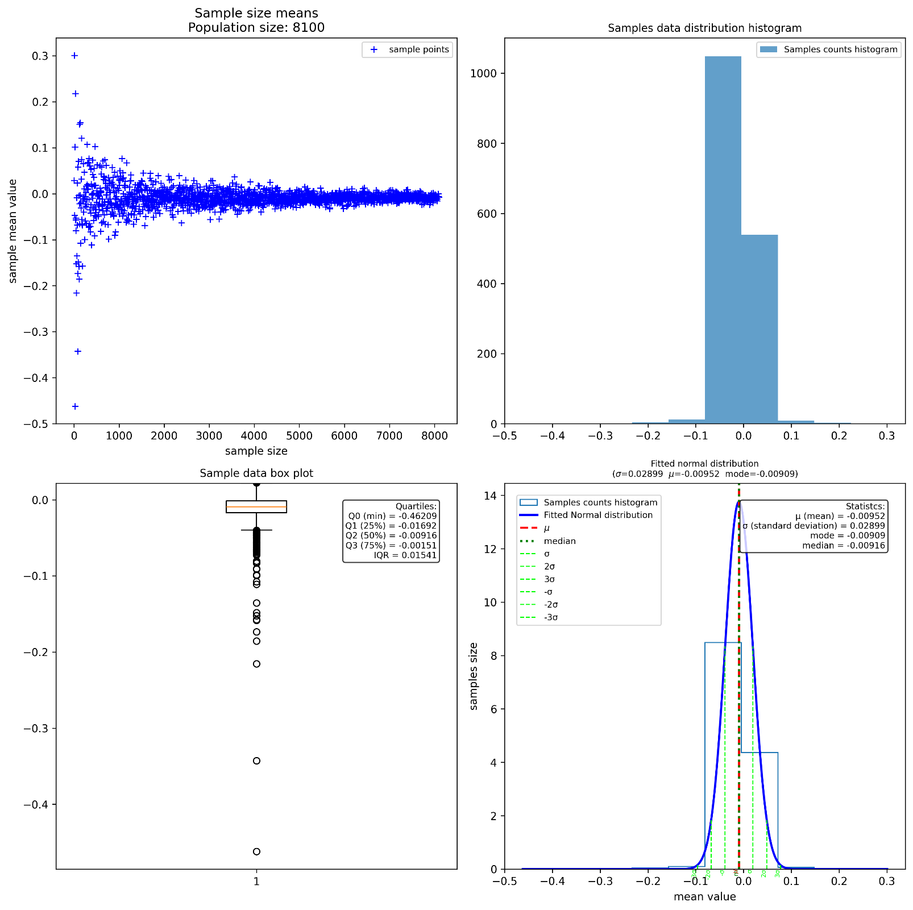
  - Combined population analysis
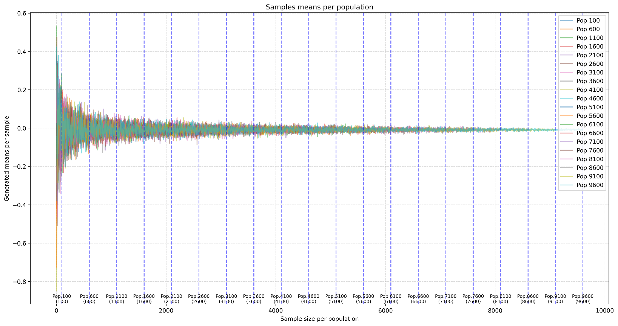
  - Linear and polynomial regression
- Export results to CSV files
- Statistical analysis including:
  - Mean, median, mode
  - Standard deviation
  - Distribution parameters
  - Confidence intervals

🛠️ Installation
- Create a virtual environment:
python -m venv venv
- Activate the virtual environment:
- Windows:
venv\Scripts\activate
- Unix/MacOS:
source venv/bin/activate
- Install dependencies:
pip install numpy pandas scipy sympy matplotlib numpy_financial

📂 Directory Structure
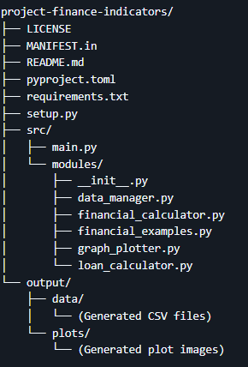

📚 Usage

Basic Execution
python main.py

Command Line Arguments for table amortization generation
python main.py --rate <loan rate in %> --n_periods <number of periods> --principal <loan principal> --when <'begin' or 'end'>
Arguments:
rate: Annual interest rate as % value (ex: 6 for 6%)
n_periods: Number of loan periods (in months or years)
principal: Loan principal
when: When payments are made (begin or end)

Example:
python main.py --rate 6 --n_periods 48 --principal 100000 --when 'end'

Command line arguments for examples execution
python main.py --examples

Available Examples
The main.py file contains several practical examples:
- example_1_1_1_1: Solving complex financial equations
- example_1_1_1: Calculating IRR, MIRR, and payback periods
- example_5_1: Project comparison using NPV
- example_7_2: Generating amortization tables

Output Structure
- Graphs: Saved in ./output/graphs with timestamps
- Data: Exported as CSV in ./output/data with timestamps
- Console: Detailed display of calculations and results

📊 Visualization Examples
- Cumulative cash flow evolution
- NPV/IRR project comparisons
- Amortization tables with payment breakdowns
- Break-even points and recovery periods

🤝 Contributing
Contributions are welcome! Please feel free to submit a Pull Request.

✍️ Author
Abdel YEZZA, Ph.D

📄 License
This code is completely free and can be modified without any restriction.

