ALGORITHME COMBINATOIRE DE SELECTION DES PROFILS : MCAP, TOPSIS et HONGROIS
Par : Abdel YEZZA, Ph.D
Date : Oct. 2025

Sommaire
🚀TOPSIS Profile Selection System 2
🚀Overview 3
🚀General functional schema 3
Scenario 1: Ranking Profiles for Each Activity 4
Using: Profile Assignment System (MCAP) + TOPSIS 4
Scenario 2: Optimal One-to-One Assignment 6
Using: MCAP + TOPSIS + Hungarian Method 6
🔄 Key Differences Between Scenarios 7
🧩 How the Algorithms Complement Each Other 7
🔄 Features 7
Installation 8
Prerequisites 8
Install Dependencies 8
Quick Start 8
1. Basic Usage (Default Configuration) 8
2. Custom Threshold 8
3. Single Activity Processing 8
4. Verbose Mode with Visualizations 8
5. Custom Weight Strategy 8
6. Custom Input Files 8
Configuration 9
Input Data Format 10
Profiles CSV (data/input/profiles.csv) 10
Activities CSV (data/input/activities.csv) 10
How It Works 10
1. Skill Transformation 10
2. TOPSIS Algorithm 10
3. Ranking 11
Sample Output 11
4. Command-Line Options 13
5. Weight Strategies 14
1. Uniform Weights (Default) 14
2. Requirement-Based Weights 14
3. Custom Weights 14
6. TOPSIS Formulas 14
Standard Formula (Default) 14
Variant Formula 14
7. Usage Examples 15
Example 1: Find Best Backend Developer 15
Example 2: Adjust Threshold for Different Standards 15
Example 3: Generate Complete Report with Visualizations 15
API Usage (Python) 16
Real examples 16
Example 1: standard TOPSIS 16
Example 2: variant TOPSIS 18
Example 3: HUNGARIAN assignment constraint (1-to-1 assignement) & proximity_formula = variant 19
References 21
TOPSIS Algorithm 21
Multi-Criteria Decision Analysis 21
License 21
Contributing 21
Author 21

🚀TOPSIS Profile Selection System
A comprehensive system for profile evaluation and ranking, but not only, combining 3 algorithms :
- The Profile-Activity Matching method
- The TOPSIS (Technique for Order Preference by Similarity to Ideal Solution) algorithm
- Optionally, the HUNGARIAN algorithm

with configurable skill-level thresholds and many other options and features as you will discover below.
Author: Abdel YEZZA, Ph.D, 2025

🚀Overview
This project combines two powerful concepts and optionally Hungarian algorithm:
- Profile-Activity Matching: Matching profiles to activities based on competencies - see my article: Profile Assignment System (MCAP) - Abdel YEZZA (Ph.D), 2025
- TOPSIS Algorithm - Multi-criteria decision analysis for ranking - see my article: TOPSIS Algorithm Implementation - Abdel YEZZA (Ph.D), 2025
The system uses a configurable threshold to determine how skills are evaluated:
- Skills >= Threshold: Treated as Beneficial criteria (higher is better)
- Skills < Threshold: Treated as Non-Beneficial criteria (lower is acceptable)
This approach allows flexible evaluation where some skills are critical (must be maximized) while others are optional (don’t penalize lack of proficiency).

🚀General functional schema
PROFILES
- Profile_1
- Profile_2
- Profile_3
- …
ACTIVITIES
- Activity_1
- Activity _2
- Activity _3
- …
SKILLS
- Skill_1
- Skill _2
- Skill _3
- …
REQUIRED
AQUIRED
?
Constraint?
Each profile → ONE activity
Each activity → ONE profile

YES
NO
Apply algorithms:
- MCAP
- TOPSIS
Apply algorithms:
- MCAP
- TOPSIS
- Hungarian

Let’s illustrate this general schema by some scenarios:

Scenario 1: Ranking Profiles for Each Activity

Using: Profile Assignment System (MCAP) + TOPSIS
INPUT:
┌─────────────┐ ┌──────────────────┐
│ Profiles │ │ Activities │
│ │ │ │
│ • Dev1 │ │ • Backend Dev │
│ • Dev2 │ │ • Frontend Dev │
│ • Dev3 │ │ • Team Lead │
│ • ... │ │ • ... │
└─────────────┘ └──────────────────┘
AQUIRED REQUIRED
------- --------
│ │
│ ┌───────────┐ │
└──────>│ Skills │<─────┘
│ │
│ • Python │
│ • Java │
│ • SQL │
│ • ... │
└───────────┘
STEP 1: Profile Assignment System (MCAP)
┌────────────────────────────────────────────────────┐
│ Skill Transformation Based on Threshold │
│ │
│ For each activity requirement: │
│ • If skill level >= Threshold (e.g., 3.0) │
│ → Mark as BENEFICIAL (higher is better) │
│ • If skill level < Threshold │
│ → Mark as NON-BENEFICIAL (lower is acceptable) │
│ │
│ Example: Backend Dev needs Python=5, Leadership=2 │
│ With threshold=3.0: │
│ • Python (5≥3): BENEFICIAL → maximize │
│ • Leadership (2<3): NON-BENEFICIAL → minimize │
└────────────────────────────────────────────────────┘
│
▼
STEP 2: TOPSIS Algorithm
┌───────────────────────────────────────────────────┐
│ Multi-Criteria Decision Analysis │
│ │
│ 1. Normalize profile skills (make comparable) │
│ 2. Apply weights (importance of each skill) │
│ 3. Find IDEAL profile (best in all skills) │
│ 4. Find WORST profile (worst in all skills) │
│ 5. Calculate how close each profile is to IDEAL │
│ │
│ Result: Proximity Score (0 to 1) │
│ • 1.0 = Perfect match │
│ • 0.0 = Worst match │
└───────────────────────────────────────────────────┘
│
▼
OUTPUT: Ranked List for Each Activity
┌──────────────────────────────────────────────────┐
│ Backend Development: │
│ 1. Dev10 (Score: 0.95) ⭐ Best match │
│ 2. Dev7 (Score: 0.87) │
│ 3. Dev1 (Score: 0.82) │
│ ... │
│ │
│ Frontend Development: │
│ 1. Dev2 (Score: 0.91) ⭐ Best match │
│ 2. Dev5 (Score: 0.85) │
│ ... │
└──────────────────────────────────────────────────┘
Use Case:
- You have multiple activities and want to know the best candidates for each
- You need to see all qualified profiles ranked by suitability
- Helps in decision-making when you have flexibility in assignments

Scenario 2: Optimal One-to-One Assignment

Using: MCAP + TOPSIS + Hungarian Method
INPUT: Same as Scenario 1
│
▼
STEPS 1-2: Same as Scenario 1 (MCAP + TOPSIS)
┌────────────────────────────────────────────────────┐
│ Create Compatibility Matrix │
│ │
│ Backend Frontend TeamLead │
│ Dev1 0.82 0.91 0.65 │
│ Dev2 0.75 0.85 0.70 │
│ Dev3 0.90 0.60 0.88 │
│ │
│ Each cell = TOPSIS proximity score │
└────────────────────────────────────────────────────┘
│
▼
STEP 3: Hungarian Algorithm (Optimal Assignment)
┌────────────────────────────────────────────────────┐
│ Find the BEST overall assignment │
│ │
│ Constraint: Each profile → ONE activity │
│ Each activity → ONE profile │
│ │
│ Goal: Maximize total satisfaction │
│ │
│ Algorithm finds optimal pairing considering │
│ all possibilities simultaneously │
└────────────────────────────────────────────────────┘
│
▼
OUTPUT: Optimal Assignments
┌────────────────────────────────────────────────────┐
│ Optimal Assignments: │
│ │
│ Dev1 → Frontend Development (0.91) │
│ Dev2 → Team Lead (0.70) │
│ Dev3 → Backend Development (0.90) │
│ │
│ Total Score: 2.51 (best possible combination) │
└────────────────────────────────────────────────────┘
Use Case:
- You need to assign exactly ONE profile to each activity
- No profile can be assigned to multiple activities
- You want the globally optimal solution, not just individual bests
- Example: Assigning team members to project roles

🔄 Key Differences Between Scenarios
Aspect | Scenario 1 (Ranking) | Scenario 2 (Optimal Assignment)
Output | Ranked list per activity | One-to-one assignments
Flexibility | Multiple candidates per activity | One profile per activity
Optimization | Individual activity level | Global level
Algorithms | MCAP + TOPSIS | MCAP + TOPSIS + Hungarian
When to Use | Exploring felexibiliy options | Final assignments

🧩 How the Algorithms Complement Each Other
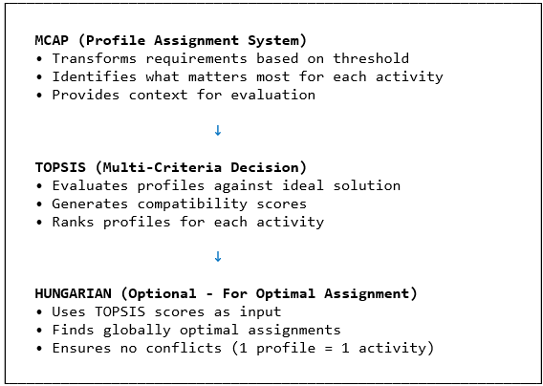

🔄 Features
- Configurable Threshold System: (min_threshold to max_threshold with threshold values) - see config.json file at threshold_settings key
- Multiple Weight Strategies: (uniform, requirement-based, custom)
- Two TOPSIS Proximity Formulas: (standard and variant) - the standard case uses the TOPSIS standard formulas, whereas variant uses a different function already normalized and more disparate than the standard
- Comprehensive Visualizations: (heatmaps, bar charts, radar plots and distance analysis)
- The heatmap graph gives clear and comprehensive ranking and proximity values allowing to choose among the top-ranked profiles.
- Flexible Input Formats: (CSV files with profiles and activities)
- Command-Line Interface: with simple and extensive options
- Detailed Results Export: (rankings, matrices, analysis reports)

Installation

Prerequisites
- Python 3.8 or higher
- pip package manager

Install Dependencies
cd .\topsis_profiles_selection
pip install -r requirements.txt

Quick Start

1. Basic Usage (Default Configuration)
python main.py
This will:
- Load profiles and activities from data/input/
- Use threshold = 3.0 (configurable between 0-5) by default or custom values
- Apply uniform weights to all skills by default
- Generate rankings for all activities
- Save results to data/output/

2. Custom Threshold
python main.py --threshold 3.5

3. Single Activity Processing
python main.py --activity "Backend_Development"

4. Verbose Mode with Visualizations
python main.py -v --viz

5. Custom Weight Strategy
python main.py --weight-strategy requirement_based

6. Custom Input Files
python main.py --profiles data/input/profiles.csv --activities data/input/activities.csv

Configuration
This option allows to customize all input parameters in one JSON configuration file. You don’t have to remember all command-line options.
Edit config.json to customize:
{
"project_name": "TOPSIS Profile Selection System",
"description": "Profile selection using TOPSIS algorithm with configurable skill threshold",
"version": "1.0.0",
"author": "Abdel YEZZA (Ph.D)",

"data": {
"profiles_file": "data/input/profiles.csv",
"activities_file": "data/input/activities.csv",
"output_dir": "data/output"
},

"topsis_settings": {
"proximity_formula_options": ["standard", "variant"],
"proximity_formula": "variant",
"proximity_formula_description": {
"standard": "S*[i] = E-[i] / (E+[i] + E-[i]) - Values between 0 and 1",
"variant": "S*[i] = E-[i] / E+[i] - Better discrimination, normalized to [0,1]"
}
},

"threshold_settings": {
"threshold": 3.0,
"min_threshold": 0.0,
"max_threshold": 5.0,
"description": "Skill levels >= threshold are treated as beneficial (maximize), < threshold as non-beneficial (minimize)"
},

"weight_settings": {
"strategy": "uniform",
"strategy_options": ["uniform", "requirement_based", "custom"],
"strategy_descriptions": {
"uniform": "All skills have equal weight",
"requirement_based": "Weights proportional to required skill levels",
"custom": "User-defined weights for each skill"
},
"custom_weights": null
},

"output_settings": {
"top_n_profiles": 3,
"save_detailed_results": true,
"generate_visualizations": true,
"verbose": false
},

"visualization_settings": {
"chart_types": ["bar", "radar", "heatmap"],
"figure_format": "png",
"figure_dpi": 300
},

"assignment_settings": {
"enable_optimal_assignment": false,
"assignment_method": "auto",
"assignment_method_options": ["auto", "hungarian", "greedy"],
"assignment_method_descriptions": {
"auto": "Automatically select Hungarian (if dimensions match) or Greedy approach",
"hungarian": "Use Hungarian Algorithm for optimal 1-to-1 assignment (requires equal number of profiles and activities)",
"greedy": "Use Greedy approach for best-effort assignment (works with any dimensions)"
},
"generate_assignment_heatmap": true
}
}
The assignment_method: Options are "auto", "hungarian", or "greedy"
- auto: Automatically selects Hungarian if dimensions match, otherwise uses Greedy. This option should be the default assignment method in general.
- hungarian: Forces Hungarian Algorithm (requires equal number of profiles and activities). This algorithm is O($n^{3}$) complexity order.
- greedy: Uses greedy best-effort assignment (works with any dimensions). This is a fast algorithm using local optimisation by iterating over activities to assign all of them. It is fast, O($n^{2}\log{n}$) complexity order.

The table below summarizes the 3 options:
Feature | Auto | Greedy algorithm | Hungarian algorithm
Optimality | Depends | Sub-optimal | Globally optimal
Dimension Requirement | Any | Any | Must be equal ($n×n$)
Complexity | Depends | O$(n^{2}\log{n})$ | O$(n^{3})$
Use Case | Default | Unequal dimensions | Equal dimensions
Total Score | Varies | May be lower | Maximum possible

Input Data Format
Make sure that input csv values are in the intervall [min_threshold, max_threshold].

Profiles CSV (data/input/profiles.csv)
Profile,Python,Java,SQL,Communication,Leadership
Dev1,5,3,4,4,2
Dev2,4,5,3,5,4
Dev3,3,2,5,3,3
- First column: Profile names/IDs
- Other columns: Skill levels (0-5 scale or any other scale)

Activities CSV (data/input/activities.csv)
Activity,Python,Java,SQL,Communication,Leadership
Backend_Development,5,4,5,3,2
Frontend_Development,3,5,2,4,2
Team_Lead,3,3,3,5,5
- First column: Activity names
- Other columns: Required skill levels (same skills as profiles)
- Important: Skill columns must match between profiles and activities

How It Works

1. Skill Transformation
For each activity, required skill levels are analyzed:
Example:
- Backend Development requires Python=5, Leadership=2
- Python (5 >= 3): Beneficial criterion → Higher Python skills preferred
- Leadership (2 < 3): Non-beneficial criterion → Lower Leadership acceptable

2. TOPSIS Algorithm
The system applies TOPSIS in 5 steps:
- Normalize the decision matrix (profiles × skills)
- Apply weights to normalized values
- Determine ideal solutions (best and worst)
- Calculate distances from each profile to ideal solutions
- Calculate proximity coefficients (higher = better match)

3. Ranking
Profiles are ranked by proximity coefficient (0 to 1): - 1.0 = Perfect match with ideal solution - 0.0 = Closest to worst solution
NOTE: if using variant proximity formula, the perfect match is always 1, which facilitates detecting the best choice.

Sample Output
Case: standard proximity formula
================================================================================
Best Profile for Each Activity
================================================================================
Activity Best Profile Coefficient
--------------------------------------------------------------------------------
Backend_Development Profile_10 0.750578
Frontend_Development Profile_1 0.672916
Team_Lead Profile_14 0.659264
Data_Engineer Profile_1 0.703770
DevOps_Engineer Profile_4 0.718717
...
================================================================================
================================================================================
RANKING MATRIX - Top 3 Profiles per Activity
================================================================================
Activity Rank 1 Rank 2 Rank 3
Backend_Development Profile_10 (0.7506) Profile_7 (0.7153) Profile_1 (0.6702)
Frontend_Development Profile_1 (0.6729) Profile_2 (0.6305) Profile_7 (0.6281)
Team_Lead Profile_14 (0.6593) Profile_9 (0.6236) Profile_12 (0.6116)
Data_Engineer Profile_1 (0.7038) Profile_10 (0.6652) Profile_7 (0.6460)
DevOps_Engineer Profile_4 (0.7187) Profile_10 (0.6542) Profile_14 (0.6458)
...
Case: variant proximity formula
================================================================================
Best Profile for Each Activity
================================================================================
Activity Best Profile Coefficient
--------------------------------------------------------------------------------
Backend_Development Profile_10 1.000000
Frontend_Development Profile_1 1.000000
Team_Lead Profile_14 1.000000
Data_Engineer Profile_1 1.000000
DevOps_Engineer Profile_4 1.000000
...
================================================================================
================================================================================
RANKING MATRIX - Top 3 Profiles per Activity
================================================================================
Activity Rank 1 Rank 2 Rank 3
Backend_Development Profile_10 (1.0000) Profile_7 (0.8348) Profile_1 (0.6754)
Frontend_Development Profile_1 (1.0000) Profile_2 (0.8295) Profile_7 (0.8207)
Team_Lead Profile_14 (1.0000) Profile_9 (0.8564) Profile_12 (0.8140)
Data_Engineer Profile_1 (1.0000) Profile_10 (0.8361) Profile_7 (0.7681)
DevOps_Engineer Profile_4 (1.0000) Profile_10 (0.7404) Profile_14 (0.7137)
...

4. Command-Line Options
All options are optional. The config.json parameters are loaded first and replaced if any parameter is passed on the command-line.
usage: main.py [-h] [-c CONFIG] [--profiles PROFILES] [--activities ACTIVITIES]
[--threshold THRESHOLD] [--min-threshold MIN_THRESHOLD]
[--max-threshold MAX_THRESHOLD] [--activity ACTIVITY]
[--weight-strategy {uniform,requirement_based}]
[--proximity-formula {standard,variant}]
[-v] [--viz] [-o OUTPUT]
[--assignment] [--assignment-method {auto,hungarian,greedy}]
Options:
-h, --help Show help message
-c, --config Configuration file path
--profiles Profiles CSV file path
--activities Activities CSV file path
--threshold Skill level threshold (default: 3.0)
--min-threshold Minimum skill level (default: 0.0)
--max-threshold Maximum skill level (default: 5.0)
--activity Process only specific activity
--weight-strategy Weight generation strategy
--proximity-formula TOPSIS proximity formula
-v, --verbose Enable verbose output
--viz, --visualize Generate visualizations
-o, --output Output directory
--assignment Enable optimal assignment (Hungarian/Greedy)
--assignment-method {auto,hungarian,greedy}
Assignment method (overrides config)
Examples:
# Use default configuration, the most simple
python main.py

# Use custom configuration
python main.py -c my_config.json

# Override threshold
python main.py --threshold 3.5

# Process single activity
python main.py --activity "Backend_Development"

# Use custom input files
python main.py --profiles data/my_profiles.csv --activities data/my_activities.csv

# Verbose mode with visualizations
python main.py -v --viz

# Use different weight strategy
python main.py --weight-strategy requirement_based

# Enable optimal assignment with Hungarian/Greedy algorithm
python main.py --assignment

# Force Hungarian algorithm (requires activities/profiles CSV equal dimensions)
python main.py --assignment --assignment-method hungarian

# Use greedy assignment approach
python main.py --assignment --assignment-method greedy

5. Weight Strategies

1. Uniform Weights (Default)
All skills have equal importance as for example:
weights = [0.1, 0.1, 0.1, ..., 0.1]

2. Requirement-Based Weights
Skills with higher required levels get higher weights:
weights proportional to required_levels

3. Custom Weights
Define specific weights in config.json:
{
"weight_settings": {
"strategy": "custom",
"custom_weights": [0.3, 0.2, 0.2, 0.1, 0.1, 0.1]
}
}
In this example, weights are all normalized since their sum is 1.

6. TOPSIS Formulas

Standard Formula (Default)
$$S^{*}=\frac{E^{-}}{{\left(E^{+}+E^{-}\right) }^{ }}$$
- Values between 0 and 1
- Easier to interpret
- Smaller differences between alternatives

Variant Formula
$$S^{*}= \left\{\begin{aligned}\frac{E^{-}}{E^{+}} for E^{+}≠0 \\ \\ \frac{E^{-}}{{ \max_{i}⁡(E_{i}^{+}}^{ })} for E^{+}=0 \end{aligned}\right.$$
Where:
- E- = Distance to worst ideal solution
- E+ = Distance to best ideal solution
- max(E+) = Maximum distance to best across all alternatives
Characteristics:
- Better discrimination between alternatives
- Handles edge cases when distance to best is zero
- No normalization required
- Higher values indicate better match
- Ranking results are the same as in the case of the standard formula

7. Usage Examples

Example 1: Find Best Backend Developer
python main.py --activity "Backend_Development" -v
This will show detailed analysis of which profiles best match the backend development requirements.

Example 2: Adjust Threshold for Different Standards
# Strict evaluation (threshold = 4.0)
python main.py --threshold 4.0
# Lenient evaluation (threshold = 2.5)
python main.py --threshold 2.5
Higher thresholds mean more skills are treated as “must have” (beneficial).

Example 3: Generate Complete Report with Visualizations
python main.py -v --viz --output reports/analysis_2025

API Usage (Python)
from pathlib import Path
import sys
sys.path.insert(0, 'src')
from core.profile_processor import ProfileProcessor, load_profiles_from_csv, load_activities_from_csv
# Load data
profiles_df = load_profiles_from_csv('data/input/profiles.csv')
activities_df = load_activities_from_csv('data/input/activities.csv')
# Create processor
processor = ProfileProcessor(
profiles_df=profiles_df,
activities_df=activities_df,
threshold=3.0,
min_threshold=0.0,
max_threshold=5.0,
proximity_formula='standard'
)
# Process all activities
results = processor.process_all_activities(
weight_strategy='uniform',
verbose=True
)
# Get specific activity results
backend_results = processor.results['Backend_Development']
best_profile = backend_results['best_alternative']
print(f"Best profile for Backend Development: {best_profile}")
# Save results
processor.save_results(Path('data/output'))

Real examples

Example 1: standard TOPSIS
Activities.csv
Profile | Python | Java | SQL | Communication | Leadership | Problem_Solving | Teamwork | Project_Management | Data_Analysis | Cloud_Computing
Profile_1 | 5 | 3 | 4 | 4 | 2 | 5 | 4 | 2 | 3 | 4
Profile_2 | 4 | 5 | 3 | 5 | 4 | 4 | 5 | 3 | 2 | 3
Profile_3 | 3 | 2 | 5 | 3 | 3 | 4 | 3 | 2 | 5 | 2
Profile_4 | 5 | 4 | 5 | 4 | 4 | 5 | 4 | 4 | 4 | 5
Profile_5 | 2 | 3 | 2 | 5 | 5 | 3 | 5 | 5 | 2 | 1
Profile_6 | 4 | 4 | 4 | 3 | 3 | 4 | 4 | 3 | 4 | 4
Profile_7 | 5 | 5 | 4 | 2 | 2 | 5 | 3 | 1 | 5 | 5
Profile_8 | 3 | 4 | 5 | 4 | 3 | 4 | 4 | 3 | 4 | 3
Profile_9 | 4 | 3 | 3 | 5 | 5 | 3 | 5 | 4 | 3 | 2
Profile_10 | 5 | 5 | 5 | 3 | 2 | 5 | 3 | 2 | 5 | 5
Profile_11 | 2 | 2 | 3 | 4 | 4 | 3 | 4 | 4 | 3 | 2
Profile_12 | 3 | 4 | 4 | 5 | 4 | 4 | 5 | 4 | 3 | 3
Profile_13 | 4 | 3 | 5 | 3 | 3 | 5 | 3 | 3 | 5 | 4
Profile_14 | 5 | 4 | 4 | 4 | 5 | 4 | 4 | 5 | 4 | 4
Profile_15 | 3 | 5 | 3 | 4 | 3 | 3 | 4 | 3 | 4 | 5
Profiles.csv
Activity | Python | Java | SQL | Communication | Leadership | Problem_Solving | Teamwork | Project_Management | Data_Analysis | Cloud_Computing
Backend_Development | 5 | 4 | 5 | 3 | 2 | 5 | 3 | 2 | 4 | 5
Frontend_Development | 3 | 5 | 2 | 4 | 2 | 4 | 4 | 2 | 2 | 3
Team_Lead | 3 | 3 | 3 | 5 | 5 | 4 | 5 | 5 | 3 | 2
Data_Engineer | 5 | 2 | 5 | 3 | 2 | 5 | 3 | 2 | 5 | 4
DevOps_Engineer | 4 | 3 | 3 | 3 | 2 | 4 | 3 | 3 | 3 | 5
Project_Manager | 2 | 2 | 2 | 5 | 5 | 4 | 5 | 5 | 2 | 2
Full_Stack_Developer | 4 | 4 | 4 | 4 | 3 | 4 | 4 | 3 | 3 | 4
Database_Admin | 3 | 2 | 5 | 3 | 2 | 4 | 3 | 2 | 4 | 3
Cloud_Architect | 4 | 3 | 3 | 3 | 2 | 5 | 3 | 3 | 4 | 5
Tech_Lead | 4 | 4 | 4 | 5 | 5 | 5 | 5 | 5 | 4 | 4
Output:
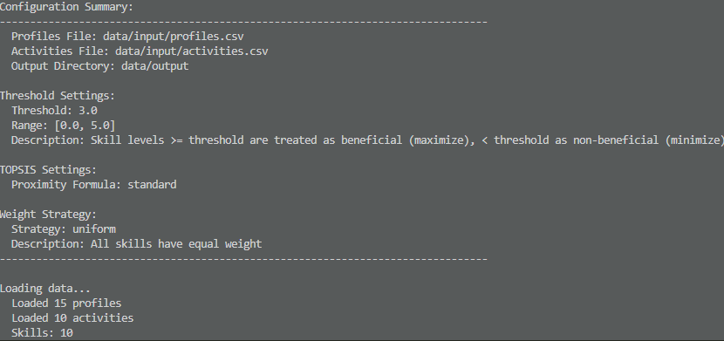
…
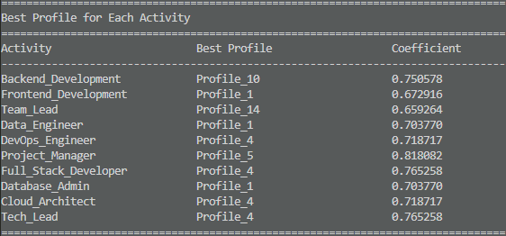

================================================================================
PROCESS COMPLETED SUCCESSFULLY
================================================================================
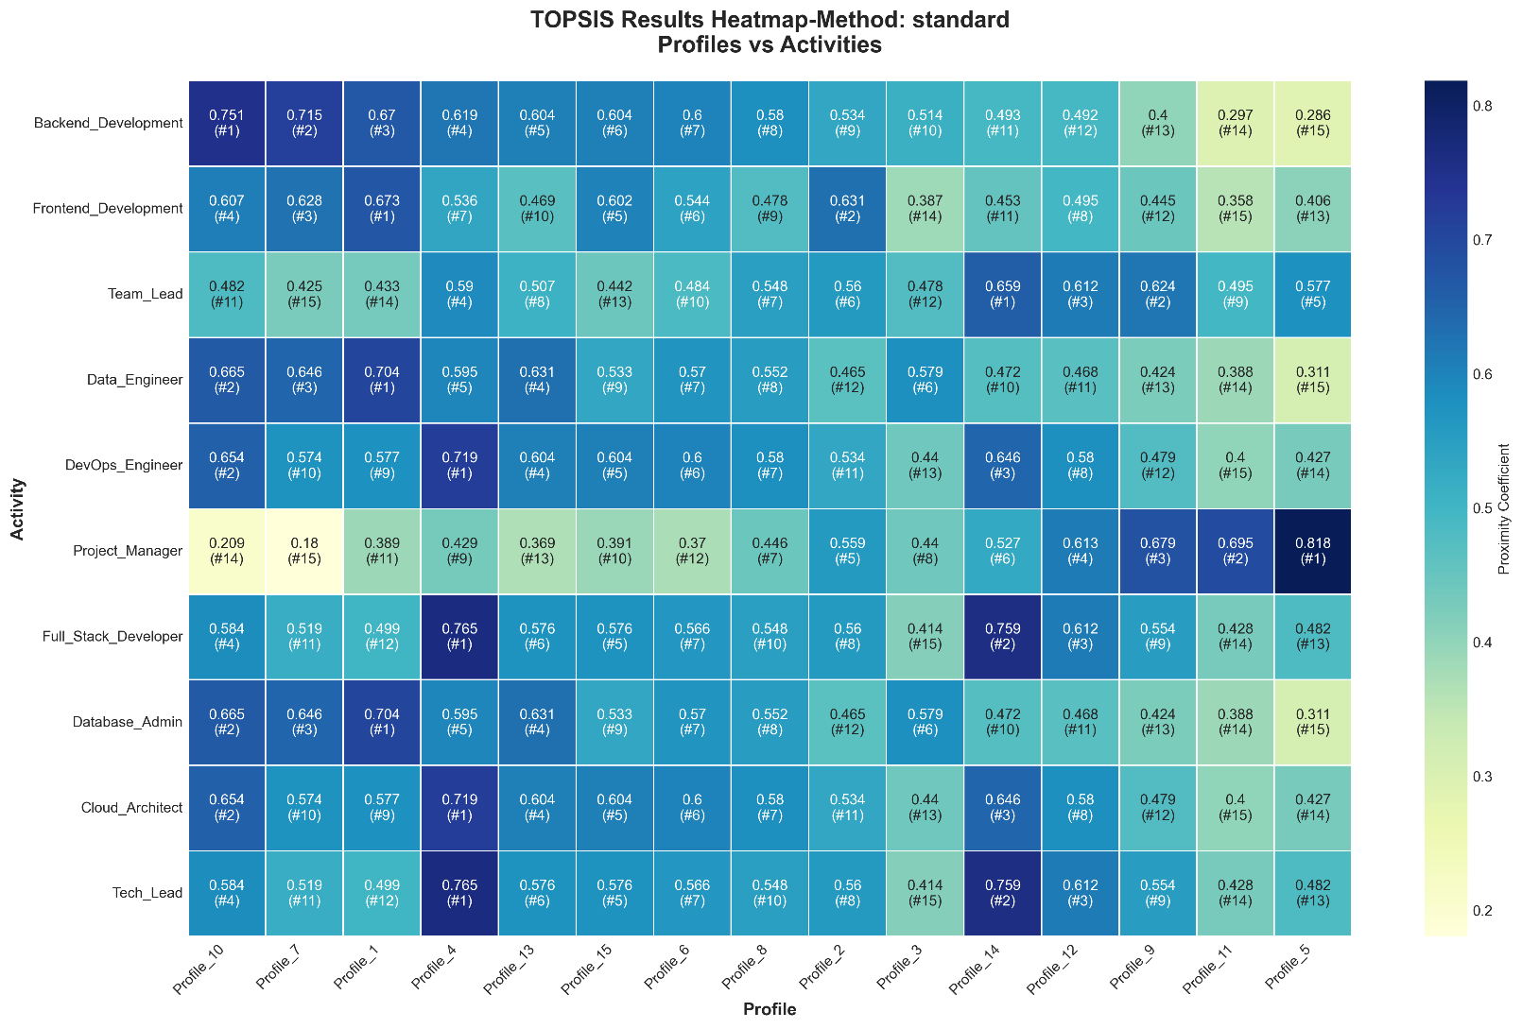
By changing the proximity_formula='standard' to proximity_formula='variant' we obtain the same assignment matrix easier to identify optimal assignments by spotting the 1’s:

Example 2: variant TOPSIS
The same as example 1 by changing the proximity_formula to variant:
"topsis_settings": {
"proximity_formula_options": ["standard", "variant"],
"proximity_formula": "variant",
…
}
},
…

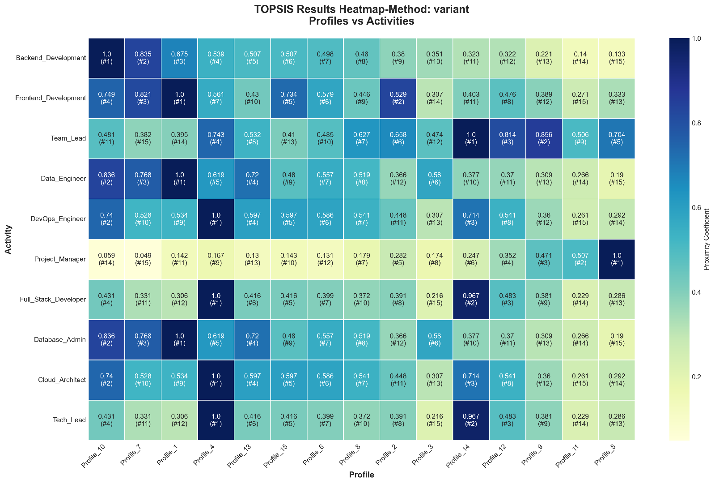
In both examples 1, 2 a profile may be assigned to more than one activity even if profiles count is greater than activities count. Nevertheless, This can give recruiters and employers more leeway in choosing from the full range of profiles, not just the best ones!

Example 3: HUNGARIAN assignment constraint (1-to-1 assignement) & proximity_formula = variant
In this case, the number of activities must be the same as the number of profiles (=10):
Activities_2.csv
Profile | Python | Java | SQL | Communication | Leadership | Problem_Solving | Teamwork | Project_Management | Data_Analysis | Cloud_Computing
Profile_1 | 5 | 4 | 5 | 3 | 2 | 5 | 3 | 2 | 4 | 5
Profile_2 | 3 | 5 | 2 | 4 | 2 | 4 | 4 | 2 | 2 | 3
Profile_3 | 3 | 3 | 3 | 5 | 5 | 4 | 5 | 5 | 3 | 2
Profile_4 | 5 | 2 | 5 | 3 | 2 | 5 | 3 | 2 | 5 | 4
Profile_5 | 4 | 3 | 3 | 3 | 2 | 4 | 3 | 3 | 3 | 5
Profile_6 | 2 | 2 | 2 | 5 | 5 | 4 | 5 | 5 | 2 | 2
Profile_7 | 4 | 4 | 4 | 4 | 3 | 4 | 4 | 3 | 3 | 4
Profile_8 | 3 | 2 | 5 | 3 | 2 | 4 | 3 | 2 | 4 | 3
Profile_9 | 4 | 3 | 3 | 3 | 2 | 5 | 3 | 3 | 4 | 5
Profile_10 | 4 | 4 | 4 | 5 | 5 | 5 | 5 | 5 | 4 | 4
Profiles_2.csv
Activity | Python | Java | SQL | Communication | Leadership | Problem_Solving | Teamwork | Project_Management | Data_Analysis | Cloud_Computing
Backend_Development | 5 | 3 | 4 | 4 | 2 | 5 | 4 | 2 | 3 | 4
Frontend_Development | 4 | 5 | 3 | 5 | 4 | 4 | 5 | 3 | 2 | 3
Team_Lead | 3 | 2 | 5 | 3 | 3 | 4 | 3 | 2 | 5 | 2
Data_Engineer | 5 | 4 | 5 | 4 | 4 | 5 | 4 | 4 | 4 | 5
DevOps_Engineer | 2 | 3 | 2 | 5 | 5 | 3 | 5 | 5 | 2 | 1
Project_Manager | 4 | 4 | 4 | 3 | 3 | 4 | 4 | 3 | 4 | 4
Full_Stack_Developer | 5 | 5 | 4 | 2 | 2 | 5 | 3 | 1 | 5 | 5
Database_Admin | 3 | 4 | 5 | 4 | 3 | 4 | 4 | 3 | 4 | 3
Cloud_Architect | 4 | 3 | 3 | 5 | 5 | 3 | 5 | 4 | 3 | 2
Tech_Lead | 5 | 5 | 5 | 3 | 2 | 5 | 3 | 2 | 5 | 5
Command-line:
We obtain the following assignment represented by a heatmap graph:
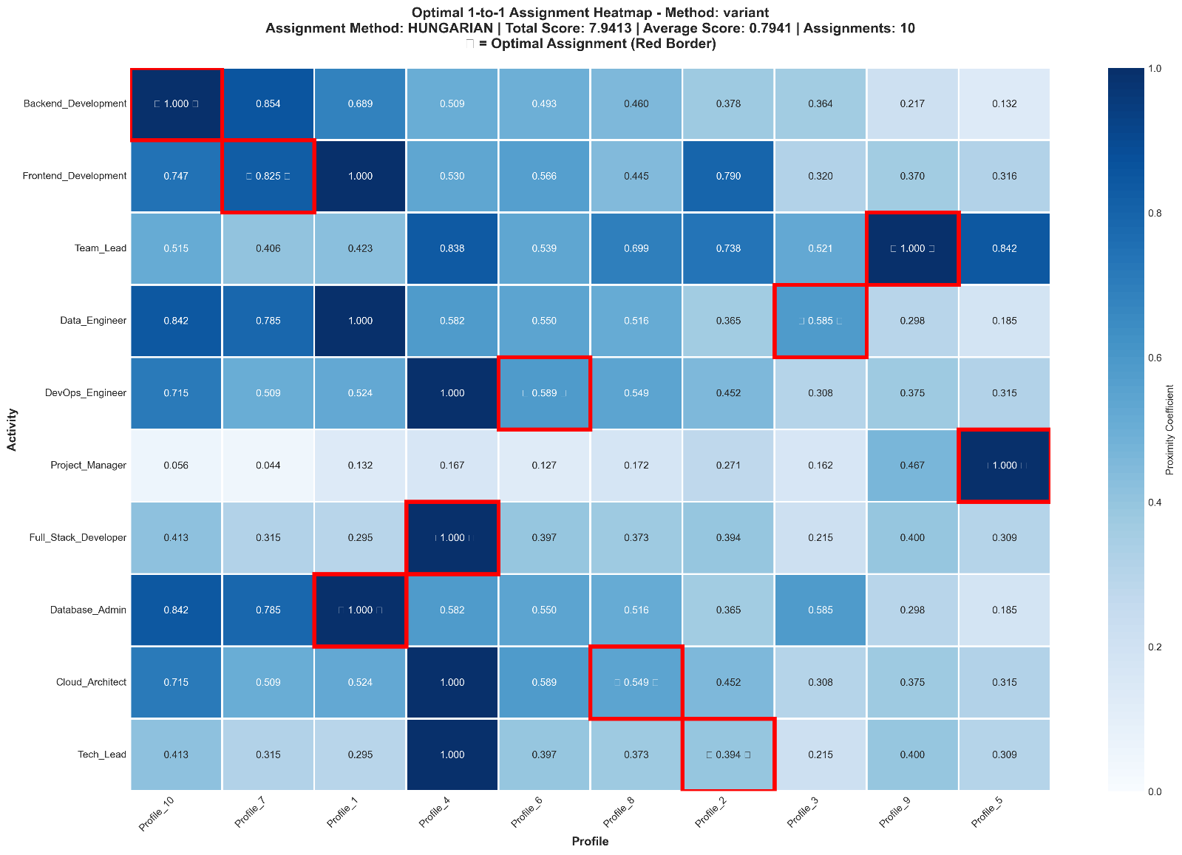
We note that even a profile has 1 as a proximity factor, he/she is not automatically assigned to the corresponding activity as for example: Profile_7 is affected to Frontend_Development activity with a proximity factor of .825<1.0 even if profile_1 has 1 as proximity factor for the same activity.
NOTE: The HUNGARIAN assignment matrix is not necessarily the same in the standard proximity_formula as in the variant case. Applying standard and variant proximity_formulas gives the following conclusions:
- Different Score Ranges:
  - Standard: [0.173, 0.825] - more compressed range
  - Variant: [0.044, 1.000] - wider range with better discrimination
- Different Total Optimization Scores:
  - Standard: 6.633 (average: 0.663)
  - Variant: 7.941 (average: 0.794)
  - Difference: 1.309 points!

References

TOPSIS Algorithm
- Hwang, C.L., & Yoon, K. (1981). Multiple Attribute Decision Making: Methods and Applications. Springer-Verlag.
- Yoon, K.P., & Hwang, C.L. (1995). Multiple Attribute Decision Making: An Introduction. SAGE Publications.

Multi-Criteria Decision Analysis
- Triantaphyllou, E. (2000). Multi-criteria Decision Making Methods: A Comparative Study. Kluwer Academic Publishers.

License
This project combines concepts from: - Profile Assignment System (MCAP) - Abdel YEZZA (Ph.D), 2025 - TOPSIS Algorithm Implementation - Abdel YEZZA (Ph.D), 2025

Contributing
For issues, suggestions, or contributions, please contact the author.

Author
Abdel YEZZA, Ph.D
Version: 1.0.0 Last Updated: 2025

