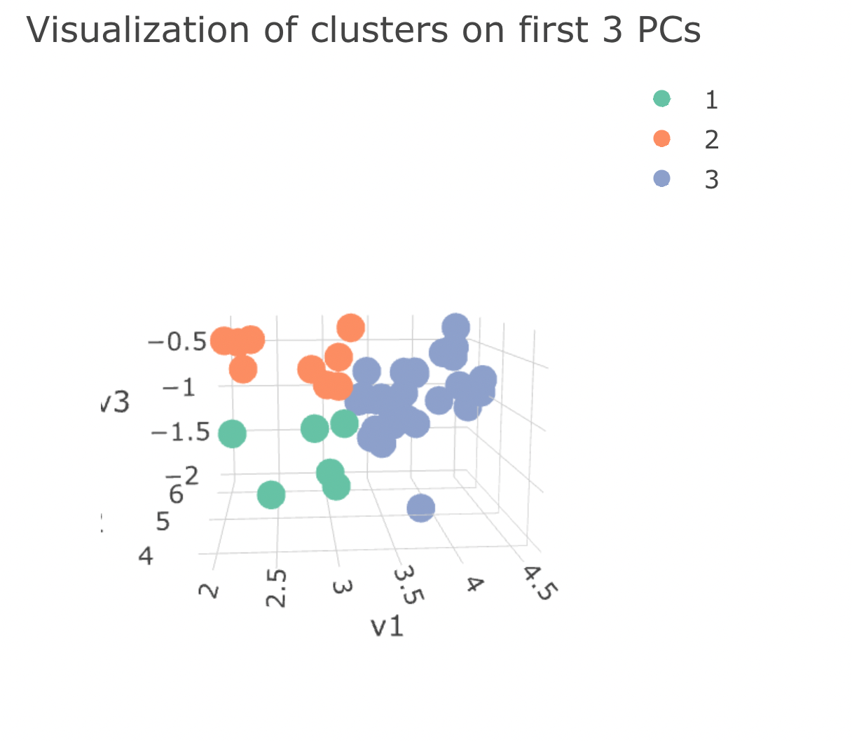

1 2 3

9 13 22

1 2 3

0.8384393 0.9033264 0.8334394

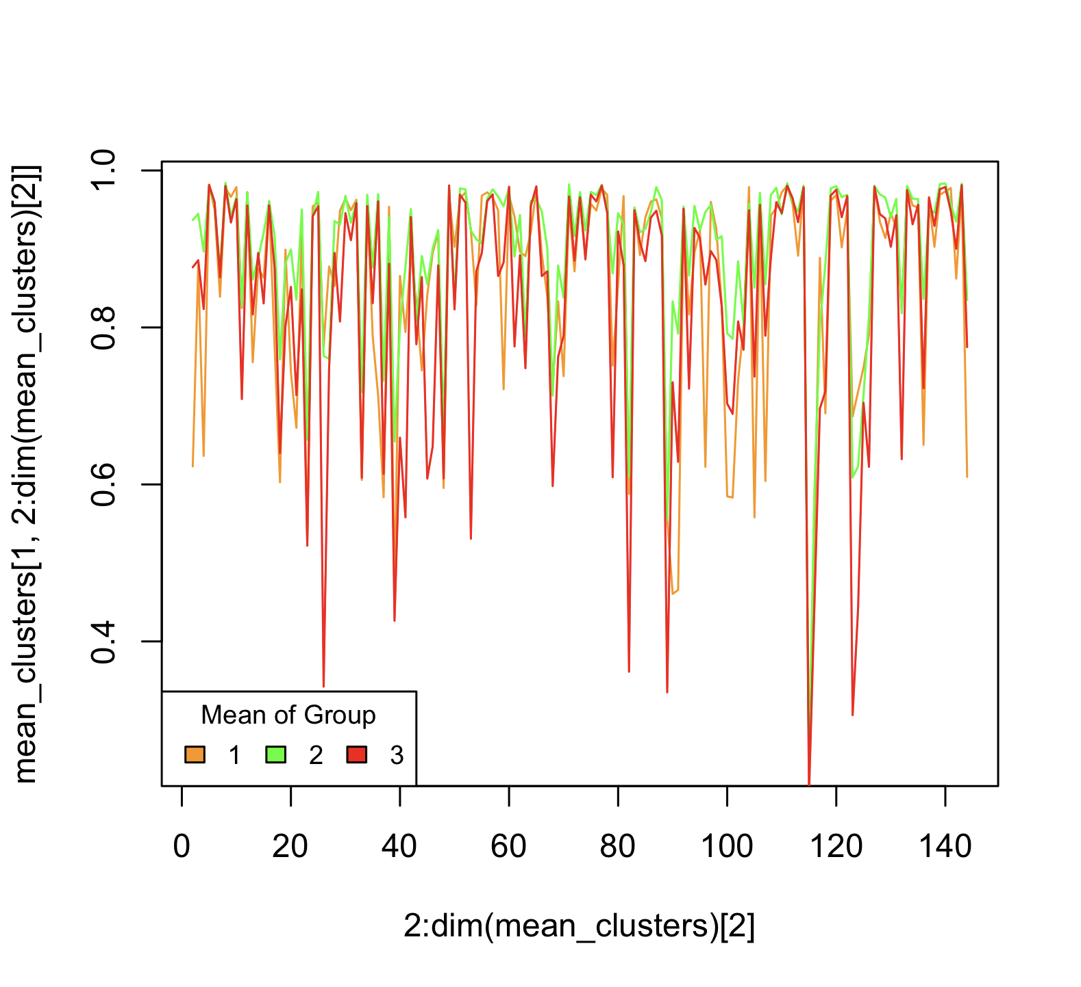

Group 2 with the highest mean

While 3 and 1 depends on the treatment

sum(mean_clusters[1,2:dim(mean_clusters)[2]]>mean_clusters[3,2:dim(mean_clusters)[2]])

[1] 74

Afatinib-2 AKTinhibitorVIII-1 AKTinhibitorVIII-2 Avagacestat-1

1 FALSE FALSE FALSE TRUE

Avagacestat-2 AZD6482-1 Bicalutamide-1 BMS-536924-2 CHIR-99021-1 JQ1-1

1 FALSE FALSE FALSE TRUE TRUE TRUE

PLX-4720-2 UNC0638-1 UNC0638-2 5-Fluorouracil Alectinib Amuvatinib

1 TRUE FALSE FALSE TRUE TRUE FALSE

AR-42 AS601245 AS605240 AT-7519 BAY-61-3606 Belinostat Bexarotene

1 FALSE TRUE FALSE FALSE TRUE TRUE TRUE

BIX02189 Bleomycin Bleomycin50uM BMS-345541 BMS-754807 Bryostatin1

1 TRUE TRUE TRUE FALSE TRUE TRUE

BX-912 Cabozantinib CAY10603 CCT007093 CP466722 CP724714 CUDC-101

1 TRUE TRUE FALSE TRUE FALSE FALSE FALSE

CX-5461 Dacinostat DMOG Doxorubicin EHT-1864 Embelin Enzastaurin

1 TRUE TRUE TRUE TRUE FALSE TRUE FALSE

EpothiloneB Etoposide Fedratinib FH535 FMK Foretinib FR-180204

1 TRUE TRUE TRUE FALSE FALSE TRUE FALSE

FTI-277 Gemcitabine GenentechCpd10 GSK1070916 GSK1904529A GSK429286A

1 TRUE TRUE FALSE TRUE TRUE FALSE

GSK650394 GSK690693 GW-2580 HG6-64-1 I-BET-762 ICL1100013 Idelalisib

1 TRUE FALSE FALSE TRUE TRUE TRUE FALSE

IOX2 IPA-3 IspinesibMesylate JNK-9L JQ12 JW-7-24-1 KIN001-236

1 FALSE TRUE FALSE TRUE TRUE FALSE FALSE

KIN001-244 KIN001-260 KIN001-266 KIN001-270 LFM-A13 Linifanib

1 FALSE FALSE TRUE FALSE FALSE FALSE

Linsitinib Luminespib Masitinib Midostaurin Mitomycin-C MPS-1-IN-1

1 TRUE TRUE FALSE TRUE TRUE TRUE

NG-25 NPK76-II-72-1 NSC-207895 NSC-87877 NVP-BHG712 ObatoclaxMesylate

1 FALSE TRUE TRUE TRUE TRUE TRUE

Omipalisib OSI-027 OSI-930 OSU-03012 PAC-1 Pazopanib Pelitinib

1 FALSE FALSE FALSE TRUE FALSE TRUE FALSE

PF-562271 PFI-1 PHA-793887 Phenformin PI-103 PIK-93 Piperlongumine

1 TRUE TRUE TRUE FALSE FALSE FALSE TRUE

Ponatinib QL-X-138 QL-XI-92 QL-XII-47 QS11 Quizartinib rTRAIL

1 TRUE FALSE FALSE FALSE TRUE FALSE TRUE

Ruxolitinib SB505124 SB52334 Selisistat Sepantroniumbromide Shikonin

1 TRUE FALSE FALSE TRUE TRUE TRUE

SN-38 SNX-2112 STF-62247 T0901317 TAK-715 Tamoxifen Thapsigargin

1 TRUE FALSE FALSE FALSE FALSE FALSE TRUE

THZ-2-102-1 THZ-2-49 Tipifarnib Tivozanib TL-1-85 TL-2-105 TPCA-1

1 TRUE TRUE TRUE TRUE FALSE FALSE TRUE

TubastatinA Vinorelbine VNLG124 VX-11e WHI-P97 WZ3105 XAV939 XMD13-2

1 FALSE TRUE TRUE TRUE FALSE FALSE FALSE FALSE

XMD14-99 XMD15-27 Y-39983 YM201636 Zibotentan ZSTK474

1 FALSE FALSE TRUE FALSE FALSE FALSE

> colnames(data_5)[which(mean_clusters[1,2:dim(mean_clusters)[2]]>mean_clusters[3,2:dim(mean_clusters)[2]])]

[1] "Avagacestat-1" "BMS-536924-2" "CHIR-99021-1"

[4] "JQ1-1" "PLX-4720-2" "5-Fluorouracil"

[7] "Alectinib" "AS601245" "BAY-61-3606"

[10] "Belinostat" "Bexarotene" "BIX02189"

[13] "Bleomycin" "Bleomycin50uM" "BMS-754807"

[16] "Bryostatin1" "BX-912" "Cabozantinib"

[19] "CCT007093" "CX-5461" "Dacinostat"

[22] "DMOG" "Doxorubicin" "Embelin"

[25] "EpothiloneB" "Etoposide" "Fedratinib"

[28] "Foretinib" "FTI-277" "Gemcitabine"

[31] "GSK1070916" "GSK1904529A" "GSK650394"

[34] "HG6-64-1" "I-BET-762" "ICL1100013"

[37] "IPA-3" "JNK-9L" "JQ12"

[40] "KIN001-266" "Linsitinib" "Luminespib"

[43] "Midostaurin" "Mitomycin-C" "MPS-1-IN-1"

[46] "NPK76-II-72-1" "NSC-207895" "NSC-87877"

[49] "NVP-BHG712" "ObatoclaxMesylate" "OSU-03012"

[52] "Pazopanib" "PF-562271" "PFI-1"

[55] "PHA-793887" "Piperlongumine" "Ponatinib"

[58] "QS11" "rTRAIL" "Ruxolitinib"

[61] "Selisistat" "Sepantroniumbromide" "Shikonin"

[64] "SN-38" "Thapsigargin" "THZ-2-102-1"

[67] "THZ-2-49" "Tipifarnib" "Tivozanib"

[70] "TPCA-1" "Vinorelbine" "VNLG124"

[73] "VX-11e" "Y-39983"