Aygün Bayır

Student No: 161044119

Gebze Technical University Engineering Faculty –

Computer Engineering

CONDITIONAL PROBABILITY

MATH 118 – Probability and Statistics

Contents

What is Conditional Probability? 2

Key Takeaways 2

Understanding Conditional Probability 2

Conditional Probability Formula 3

Another Example of Conditional Probability 3

Independent Events 3

Dependent Events 4

Notation 5

Finding Hidden Data 5

Conditional Probability vs. Joint Probability and Marginal Probability 6

Bayes' Theorem 6

What Is Bayes' Theorem? 7

Understanding Bayes' Theorem 7

Formula For Bayes' Theorem 8

References 9

# What is Conditional Probability?

Conditional probability is defined as the likelihood of an event or outcome occurring, based on the occurrence of a previous event or outcome. Conditional probability is calculated by multiplying the probability of the preceding event by the updated probability of the succeeding, or conditional, event.

For example:

* Event A is that an individual applying for college will be accepted. There is an 80% chance that this individual will be accepted to college.
* Event B is that this individual will be given dormitory housing. Dormitory housing will only be provided for 60% of all of the accepted students.
* P (Accepted and dormitory housing) = P (Dormitory Housing | Accepted) P (Accepted) = (0.60)*(0.80) = 0.48.

A conditional probability would look at these two events in relationship with one another, such as the probability that you are both accepted to college, *and*you are provided with dormitory housing.

Conditional probability can be contrasted with unconditional probability. Unconditional probability refers to the likelihood that an event will take place irrespective of whether any other events have taken place or any other conditions are present.

# Key Takeaways

* Conditional probability refers to the chances that some outcome occurs given that another event has also occurred.
* It is often stated as the probability of B given A and is written as P(B|A), where the probability of B depends on that of A happening.
* Conditional probability can be contrasted with unconditional probability.

# Understanding Conditional Probability

As previously stated, conditional probabilities are contingent on a previous result. It also makes a number of assumptions. For example, suppose you are drawing three marbles—red, blue, and green—from a bag. Each marble has an equal chance of being drawn. What is the conditional probability of drawing the red marble after already drawing the blue one?

First, the probability of drawing a blue marble is about 33% because it is one possible outcome out of three. Assuming this first event occurs, there will be two marbles remaining, with each having a 50% chance of being drawn. So the chance of drawing a blue marble after already drawing a red marble would be about 16.5% (33% x 50%).

As another example to provide further insight into this concept, consider that a fair die has been rolled and you are asked to give the probability that it was a five. There are six equally likely outcomes, so your answer is 1/6. But imagine if before you answer, you get extra information that the number rolled was odd. Since there are only three odd numbers that are possible, one of which is five, you would certainly revise your estimate for the likelihood that a five was rolled from 1/6 to 1/3.

This *revised* probability that an event *A* has occurred, considering the additional information that another event *B* has definitely occurred on this trial of the experiment, is called the *conditional probability of* *A* *given* *B* and is denoted by P(A|B).

# Conditional Probability Formula

P(B|A) = P(A and B) / P(A)

Or:

P(B|A) = P(A∩B) / P(A)

# Another Example of Conditional Probability

As another example, suppose a student is applying for admission to a university and hopes to receive an academic scholarship. The school to which they are applying accepts 100 of every 1,000 applicants (10%) and awards academic scholarships to 10 of every 500 students who are accepted (2%). Of the scholarship recipients, 50% of them also receive university stipends for books, meals, and housing. For our ambitious student, the chance of them being accepted then receiving a scholarship is .2% (.1 x .02). The chance of them being accepted, receiving the scholarship, then also receiving a stipend for books, etc. is .1% (.1 x .02 x .5).

# Independent Events

Events can be "Independent", meaning each event is not affected by any other events.

Example: Tossing a coin.



Each toss of a coin is a perfect isolated thing.

What it did in the past will not affect the current toss.

The chance is simply 1-in-2, or 50%, just like ANY toss of the coin.

So each toss is an **Independent Event**.

# Dependent Events

But events can also be "dependent" ... which means they can be affected by previous events ...

Example: Marbles in a Bag

2 blue and 3 red marbles are in a bag.

What are the chances of getting a blue marble?

The chance is 2 in 5

But after taking one out the chances change!

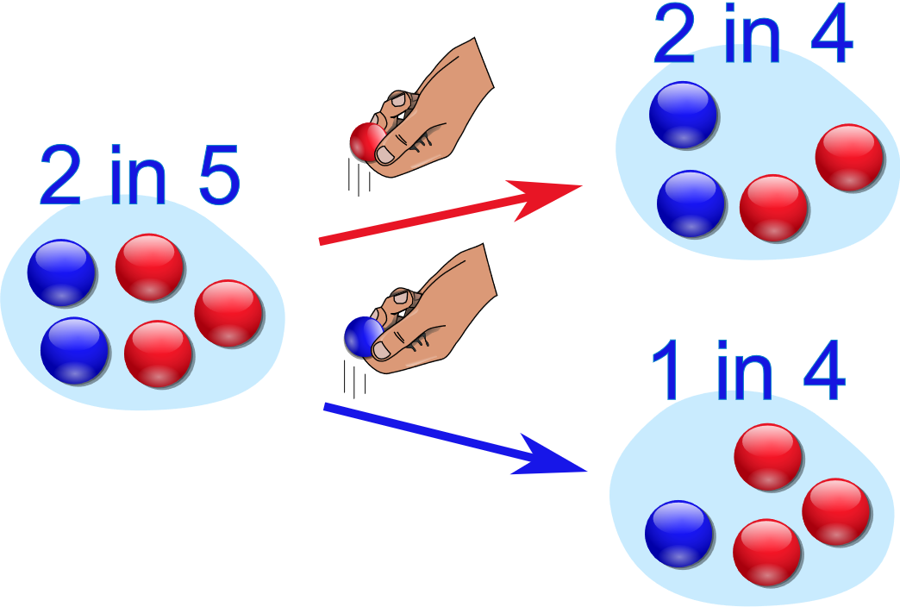

So the next time:



if we got a red marble before, then the chance of a blue marble next is 2 in 4



if we got a blue marble before, then the chance of a blue marble next is 1 in 4

# Notation

* P(A) means "Probability Of Event A"
* P(B|A) means "Event B **given** Event A"

In other words, event A has already happened, now what is the chance of event B?

P(B|A) is also called the "Conditional Probability" of B given A.

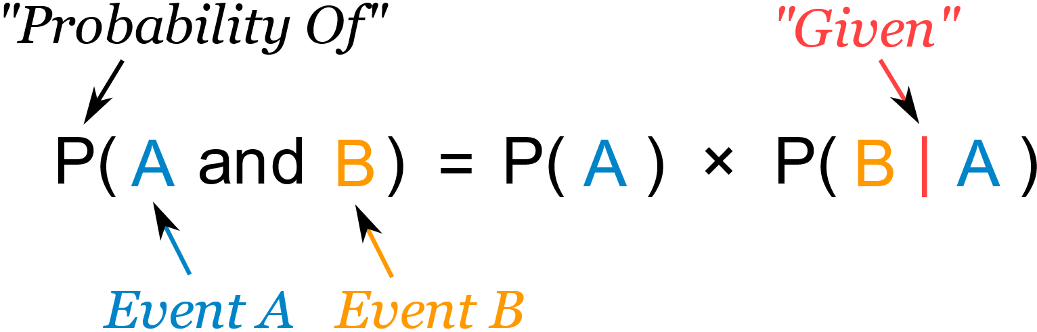

*"Probability of****event A and event B****equals  
the probability of****event A****times the probability of****event B given event A****"*

# Finding Hidden Data

Using Algebra we can also "change the subject" of the formula, like this:

|  |  |  |
| --- | --- | --- |
| Start with: |  | P(A and B) = P(A) x P(B|A) |
| Swap sides: |  | P(A) x P(B|A) = P(A and B) |
| Divide by P(A): |  | P(B|A) = P(A and B) / P(A) |

And we have another useful formula:

metin içeren bir resim

Açıklama otomatik olarak oluşturuldu

*"The probability of****event B given event A****equals  
the probability of****event A and event B****divided by the probability of****event A***

Example: Ice Cream

70% of your friends like Chocolate, and 35% like Chocolate AND like Strawberry.

What percent of those who like Chocolate also like Strawberry?

P(Strawberry|Chocolate) = P(Chocolate and Strawberry) / P(Chocolate)

0,35 / 0,7 = 50%

50% of your friends who like Chocolate also like Strawberry

# Conditional Probability vs. Joint Probability and Marginal Probability

**Conditional probability**: p(A|B) is the probability of event A occurring, given that event B occurs. Example: given that you drew a red card, what’s the probability that it’s a four (p(four|red))=2/26=1/13. So out of the 26 red cards (given a red card), there are two fours so 2/26=1/13.

**Marginal probability**: the probability of an event occurring (p(A)), it may be thought of as an unconditional probability. It is not conditioned on another event. Example: the probability that a card drawn is red (p(red) = 0.5). Another example: the probability that a card drawn is a 4 (p(four)=1/13).

**Joint probability**: p(A and B). The probability of event A **and** event B occurring. It is the probability of the intersection of two or more events. The probability of the intersection of A and B may be written p(A ∩ B). Example: the probability that a card is a four and red =p(four and red) = 2/52=1/26. (There are two red fours in a deck of 52, the 4 of hearts and the 4 of diamonds).

# Bayes' Theorem

Bayes' theorem, named after 18th-century British mathematician Thomas Bayes, is a mathematical formula for determining conditional probability. The theorem provides a way to revise existing predictions or theories (update probabilities) given new or additional evidence. In finance, Bayes' theorem can be used to rate the risk of lending money to potential borrowers.

Bayes' theorem is also called Bayes' Rule or Bayes' Law and is the foundation of the field of Bayesian statistics. This set of rules of probability allows one to update their predictions of events occurring based on new information that has been received, making for better and more dynamic estimates.

# What Is Bayes' Theorem?

Bayes' theorem, named after 18th-century British mathematician Thomas Bayes, is a mathematical formula for determining conditional probability. Conditional probability is the likelihood of an outcome occurring, based on a previous outcome occurring. Bayes' theorem provides a way to revise existing predictions or theories (update probabilities) given new or additional evidence. In finance, Bayes' theorem can be used to rate the risk of lending money to potential borrowers.

Bayes' theorem is also called Bayes' Rule or Bayes' Law and is the foundation of the field of Bayesian statistics.

* Bayes' theorem allows you to update predicted probabilities of an event by incorporating new information.
* Bayes' theorem was named after 18th-century mathematician Thomas Bayes.
* It is often employed in finance in updating risk evaluation.

# Understanding Bayes' Theorem

Applications of the theorem are widespread and not limited to the financial realm. As an example, Bayes' theorem can be used to determine the accuracy of medical test results by taking into consideration how likely any given person is to have a disease and the general accuracy of the test. Bayes' theorem relies on incorporating prior probability distributions in order to generate posterior probabilities. Prior probability, in Bayesian statistical inference, is the probability of an event before new data is collected. This is the best rational assessment of the probability of an outcome based on the current knowledge before an experiment is performed. Posterior probability is the revised probability of an event occurring after taking into consideration new information. Posterior probability is calculated by updating the prior probability by using Bayes' theorem. In statistical terms, the posterior probability is the probability of event A occurring given that event B has occurred.

Bayes' theorem thus gives the probability of an event based on new information that is, or may be related, to that event. The formula can also be used to see how the probability of an event occurring is affected by hypothetical new information, supposing the new information will turn out to be true. For instance, say a single card is drawn from a complete deck of 52 cards. The probability that the card is a king is four divided by 52, which equals 1/13 or approximately 7.69%. Remember that there are four kings in the deck. Now, suppose it is revealed that the selected card is a face card. The probability the selected card is a king, given it is a face card, is four divided by 12, or approximately 33.3%, as there are 12 face cards in a deck.

# Formula For Bayes' Theorem

*P*(*A*∣*B*) = *P*(*A*⋂*B*) / *P*(*B*) ​= *P*(*A*)⋅*P*(*B*∣*A*)​ / P(B)

where:

*P*(*A*)= The probability of A occurring

*P*(*B*)= The probability of B occurring

*P*(*A*∣*B*)=The probability of A given B

*P*(*B*∣*A*)= The probability of B given A

*P*(*A*⋂*B*))= The probability of both A and B occurring​

# References

<https://www.investopedia.com/terms/c/conditional_probability.asp>

<https://www.mathsisfun.com/data/probability-events-conditional.html>

<https://www.investopedia.com/terms/b/bayes-theorem.asp>