
Group Members: Almir Ayham & Mohasin Nawaz
Subject: database theory
Department: BSSE (B)
Semester: 4th
Assigned To: Sir Ali Hassan
Milestone | Version | Date | Remarks
ERD & DB Schema | 1.0 | 26-04-2026
Normalization | 1.1 | 17-5-2026

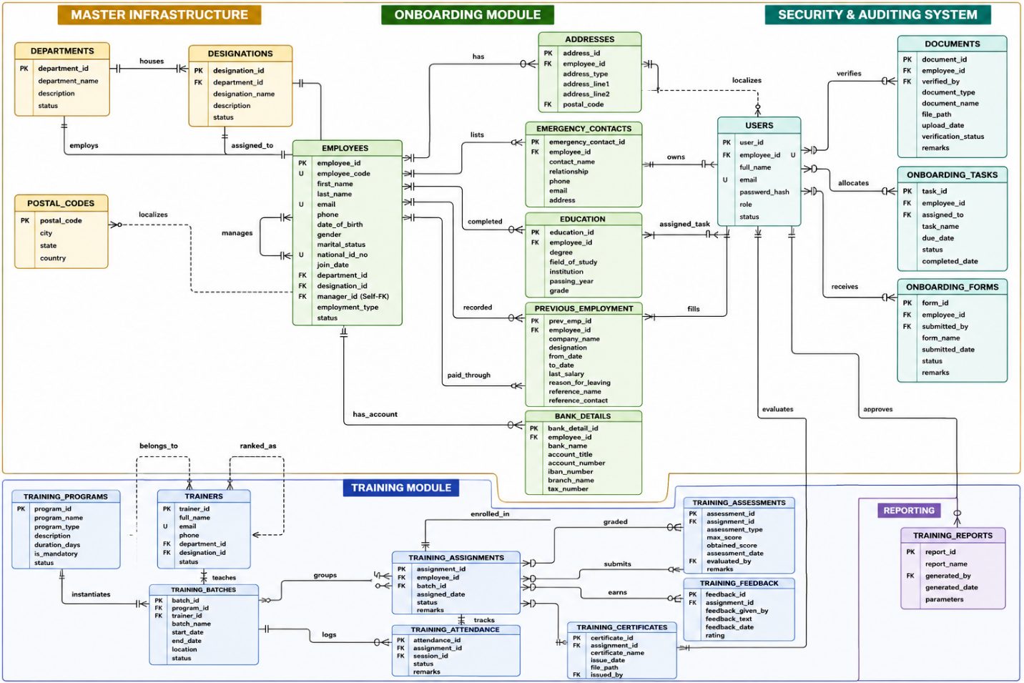
Description:
Onboarding Module (Green Tables)
- DEPARTMENTS
  - Normalization Form Applied: 1NF
  - Justification: Configured as a baseline master lookup entity. It fulfills 1NF by ensuring all attributes like department names and statuses are atomic and hold indivisible values.
- DESIGNATIONS
  - Normalization Form Applied: 3NF
  - Justification: Optimized for 3NF by utilizing a foreign key reference (department_id) linking back to the master department infrastructure. This removes any descriptive department text duplication and safeguards the table against update anomalies.
- POSTAL_CODES (Brand New Table Extracted)
  - Normalization Form Applied: 3NF
  - Justification: Specifically designed to target and eliminate a hidden transitive dependency from your original address format where $\text{address\_id} \rightarrow \text{postal\_code} \rightarrow \text{city, state, country}$. Moving these location elements here ensures non-prime attributes rely strictly on the primary key.
- EMPLOYEES
  - Normalization Form Applied: 1NF
  - Justification: Enforces strict 1NF rules by stripping out all potential repeating arrays or multi-valued fields (such as lists of previous jobs, degrees, or documents). These are decoupled into independent tables to maintain atomicity.
- ADDRESSES
  - Normalization Form Applied: 3NF
  - Justification: Upgraded to 3NF by removing the unnormalized city, state, and country text fields. The table now relies exclusively on a clean foreign key pointer to POSTAL_CODES.
- EMERGENCY_CONTACTS
  - Normalization Form Applied: 1NF
  - Justification: Solves a 1NF repeating group violation. By isolating contacts here, an employee can easily have multiple emergency contacts without forcing the central employee rows to repeat their data.
- EDUCATION
  - Normalization Form Applied: 1NF
  - Justification: Applied 1NF to handle an employee's multi-valued academic history milestones (e.g., holding both a Matric/O-Level and an Intermediate/A-Level degree) safely in separate atomic entries.
- PREVIOUS_EMPLOYMENT
  - Normalization Form Applied: 1NF
  - Justification: Resolves 1NF requirements for multi-valued historical work logs. It isolates multiple past job roles into distinct rows linked back to a single candidate.
- BANK_DETAILS
  - Normalization Form Applied: 1NF
  - Justification: Isolates financial data structures cleanly away from the primary employee profile to satisfy 1NF, ensuring each record tracks an atomic account entity wrapper.
- ONBOARDING_TASKS
  - Normalization Form Applied: 3NF
  - Justification: Tailored for 3NF by using a clean foreign key relationship (assigned_to pointing to the USERS table). This tracks task allocations dynamically without copying over names or emails.
- ONBOARDING_FORMS
  - Normalization Form Applied: 3NF
  - Justification: Fixed transitive loopholes by linking form submissions directly to a user ID via the submitted_by foreign key. The form entry remains completely independent of changing user details.

Training Module (Blue Tables)
- TRAINING_PROGRAMS
  - Normalization Form Applied: 1NF
  - Justification: Establishes an atomic catalog baseline for course parameters, keeping basic course details completely isolated from changing batch execution timelines.
- TRAINERS
  - Normalization Form Applied: 3NF
  - Justification: Upgraded to 3NF. The original blueprint stored the trainer's department and designation as hardcoded text. These were refactored into normalized foreign keys (department_id, designation_id) pointing back to your core master tables.
- TRAINING_BATCHES
  - Normalization Form Applied: 1NF
  - Justification: Operates as a cleanly isolated entity mapping batch iterations. It avoids embedding raw details about the program or instructor, keeping attributes completely atomic.
- TRAINING_ASSIGNMENTS
  - Normalization Form Applied: 3NF
  - Justification: Upgraded to 3NF by completely stripping out the start_date and end_date fields. Because those dates are functionally determined by the batch schedule itself, keeping them here created a transitive dependency flaw ($\text{assignment\_id} \rightarrow \text{batch\_id} \rightarrow \text{start\_date}$).
- TRAINING_SESSIONS
  - Normalization Form Applied: 1NF
  - Justification: Breaks down training schedules into distinct calendar events to satisfy 1NF, making sure macro-level timelines are divided into atomic, date-specific rows.
- TRAINING_ATTENDANCE
  - Normalization Form Applied: 1NF
  - Justification: Corrects a severe 1NF risk. Instead of appending multiple present employee IDs as an array into a single text cell for a session, it tracks a single atomic attendance status per row.
- TRAINING_ASSESSMENTS
  - Normalization Form Applied: 3NF
  - Justification: Achieves 3NF by utilizing the evaluated_by foreign key linking straight to the USERS access domain, which prevents grading records from holding duplicated evaluator details.
- TRAINING_FEEDBACK
  - Normalization Form Applied: 1NF
  - Justification: Houses specific survey logs atomically. All rating fields and feedback statements depend purely on the primary key without embedding complex nested data structures.
- TRAINING_CERTIFICATES
  - Normalization Form Applied: 3NF
  - Justification: Satisfies 3NF rules by ensuring the issuing authority metadata tracks uniquely to a user identifier via issued_by without relying on repeated text blocks.

System & Reporting Tables
- USERS
  - Normalization Form Applied: 3NF
  - Justification: Configured to enforce 3NF rules across application layers. It relies on a UNIQUE foreign key for employee_id to build a clean 1:1 security account layer for employees without duplicating core personnel information.
- TRAINING_REPORTS
  - Normalization Form Applied: 1NF
  - Justification: Fulfills 1NF requirements by packaging runtime configuration options into single, atomic metadata parameters mapped directly to the report ID wrapper.

