
Group Members: Almir Ayham & Mohasin Nawaz
Subject: database theory
Department: BSSE (B)
Semester: 4th
Assigned To: Sir Ali Hassan
Milestone | Version | Date | Remarks
ERD & DB Schema | 1.0 | 26-04-2026
Normalization | 1.1 | 17-5-2026
Repository link: https://github.com/ayham016/Database-theory-
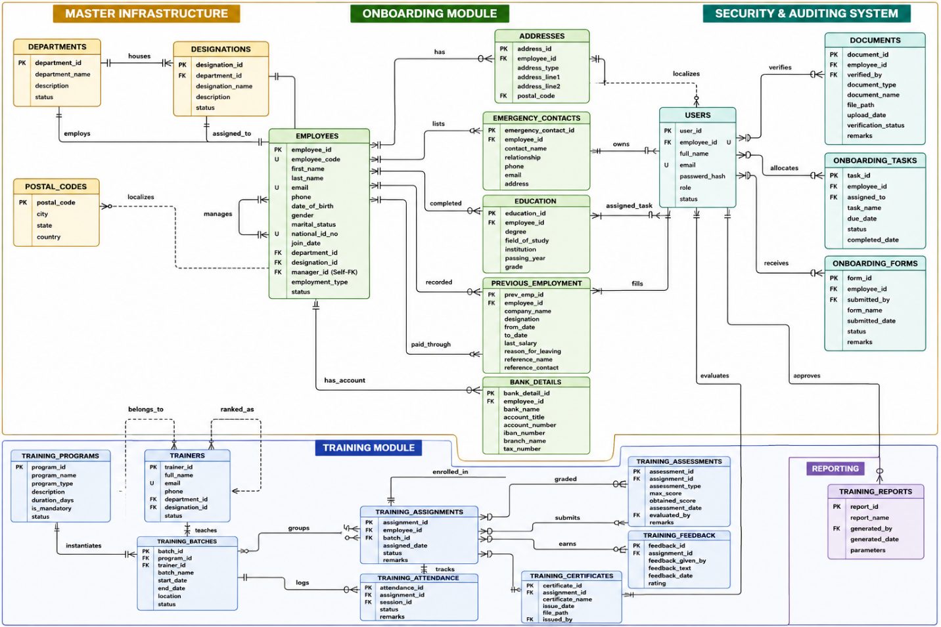
Description:
Onboarding Module (Green Tables)
- DEPARTMENTS
  - Normalization Form Applied: 1NF
  - Justification: Configured as a baseline master lookup entity. It fulfills 1NF by ensuring all attributes like department names and statuses are atomic and hold indivisible values.
- DESIGNATIONS
  - Normalization Form Applied: 3NF
  - Justification: Optimized for 3NF by utilizing a foreign key reference (department_id) linking back to the master department infrastructure. This removes any descriptive department text duplication and safeguards the table against update anomalies.
- POSTAL_CODES (Brand New Table Extracted)
  - Normalization Form Applied: 3NF
  - Justification: Specifically designed to target and eliminate a hidden transitive dependency from your original address format where $\text{address\_id} \rightarrow \text{postal\_code} \rightarrow \text{city, state, country}$. Moving these location elements here ensures non-prime attributes rely strictly on the primary key.
- EMPLOYEES
  - Normalization Form Applied: 1NF
  - Justification: Enforces strict 1NF rules by stripping out all potential repeating arrays or multi-valued fields (such as lists of previous jobs, degrees, or documents). These are decoupled into independent tables to maintain atomicity.
- ADDRESSES
  - Normalization Form Applied: 3NF
  - Justification: Upgraded to 3NF by removing the unnormalized city, state, and country text fields. The table now relies exclusively on a clean foreign key pointer to POSTAL_CODES.
- EMERGENCY_CONTACTS
  - Normalization Form Applied: 1NF
  - Justification: Solves a 1NF repeating group violation. By isolating contacts here, an employee can easily have multiple emergency contacts without forcing the central employee rows to repeat their data.
- EDUCATION
  - Normalization Form Applied: 1NF
  - Justification: Applied 1NF to handle an employee's multi-valued academic history milestones (e.g., holding both a Matric/O-Level and an Intermediate/A-Level degree) safely in separate atomic entries.
- PREVIOUS_EMPLOYMENT
  - Normalization Form Applied: 1NF
  - Justification: Resolves 1NF requirements for multi-valued historical work logs. It isolates multiple past job roles into distinct rows linked back to a single candidate.
- BANK_DETAILS
  - Normalization Form Applied: 1NF
  - Justification: Isolates financial data structures cleanly away from the primary employee profile to satisfy 1NF, ensuring each record tracks an atomic account entity wrapper.
- ONBOARDING_TASKS
  - Normalization Form Applied: 3NF
  - Justification: Tailored for 3NF by using a clean foreign key relationship (assigned_to pointing to the USERS table). This tracks task allocations dynamically without copying over names or emails.
- ONBOARDING_FORMS
  - Normalization Form Applied: 3NF
  - Justification: Fixed transitive loopholes by linking form submissions directly to a user ID via the submitted_by foreign key. The form entry remains completely independent of changing user details.

Training Module (Blue Tables)
- TRAINING_PROGRAMS
  - Normalization Form Applied: 1NF
  - Justification: Establishes an atomic catalog baseline for course parameters, keeping basic course details completely isolated from changing batch execution timelines.
- TRAINERS
  - Normalization Form Applied: 3NF
  - Justification: Upgraded to 3NF. The original blueprint stored the trainer's department and designation as hardcoded text. These were refactored into normalized foreign keys (department_id, designation_id) pointing back to your core master tables.
- TRAINING_BATCHES
  - Normalization Form Applied: 1NF
  - Justification: Operates as a cleanly isolated entity mapping batch iterations. It avoids embedding raw details about the program or instructor, keeping attributes completely atomic.
- TRAINING_ASSIGNMENTS
  - Normalization Form Applied: 3NF
  - Justification: Upgraded to 3NF by completely stripping out the start_date and end_date fields. Because those dates are functionally determined by the batch schedule itself, keeping them here created a transitive dependency flaw ($\text{assignment\_id} \rightarrow \text{batch\_id} \rightarrow \text{start\_date}$).
- TRAINING_SESSIONS
  - Normalization Form Applied: 1NF
  - Justification: Breaks down training schedules into distinct calendar events to satisfy 1NF, making sure macro-level timelines are divided into atomic, date-specific rows.
- TRAINING_ATTENDANCE
  - Normalization Form Applied: 1NF
  - Justification: Corrects a severe 1NF risk. Instead of appending multiple present employee IDs as an array into a single text cell for a session, it tracks a single atomic attendance status per row.
- TRAINING_ASSESSMENTS
  - Normalization Form Applied: 3NF
  - Justification: Achieves 3NF by utilizing the evaluated_by foreign key linking straight to the USERS access domain, which prevents grading records from holding duplicated evaluator details.
- TRAINING_FEEDBACK
  - Normalization Form Applied: 1NF
  - Justification: Houses specific survey logs atomically. All rating fields and feedback statements depend purely on the primary key without embedding complex nested data structures.
- TRAINING_CERTIFICATES
  - Normalization Form Applied: 3NF
  - Justification: Satisfies 3NF rules by ensuring the issuing authority metadata tracks uniquely to a user identifier via issued_by without relying on repeated text blocks.

System & Reporting Tables
- USERS
  - Normalization Form Applied: 3NF
  - Justification: Configured to enforce 3NF rules across application layers. It relies on a UNIQUE foreign key for employee_id to build a clean 1:1 security account layer for employees without duplicating core personnel information.
- TRAINING_REPORTS
  - Normalization Form Applied: 1NF
  - Justification: Fulfills 1NF requirements by packaging runtime configuration options into single, atomic metadata parameters mapped directly to the report ID wrapper.
Milestone 3: Dataflow Description & Dataset Preparation
Data enters the system through two main entry points: User Management/Authentication and Core Employee Management.
- Organizational Foundation: Master infrastructure data (DEPARTMENTS, DESIGNATIONS, and POSTAL_CODES) is populated first. This data acts as a strict lookup constraint validation boundary.
- Employee Onboarding: New staff profiles land directly into the EMPLOYEES table. Transactional tables (ADDRESSES, EMERGENCY_CONTACTS, EDUCATION, PREVIOUS_EMPLOYMENT, BANK_DETAILS) are populated simultaneously, alongside operational checklist logs (ONBOARDING_TASKS, ONBOARDING_FORMS).
- Application Layer Access: Security credentials are built inside the USERS table, establishing system role boundaries (Admin, HR, Manager, Trainer).
- Training Lifecycles: Course plans (TRAINING_PROGRAMS) and instructors (TRAINERS) merge to spawn dynamic target schedules in TRAINING_BATCHES.
- Operational Execution: Employees are enrolled via TRAINING_ASSIGNMENTS. Daily operations flow into event logs (TRAINING_SESSIONS, TRAINING_ATTENDANCE, TRAINING_ASSESSMENTS, TRAINING_FEEDBACK) and static credentials (TRAINING_CERTIFICATES).
Synthetic Dataset Implementation:
A robust mock dataset of 20+ records per table (spanning all 23 tables) was generated using structured CSV format. This approach ensures that all primary keys, foreign keys, and relational constraints map perfectly during bulk insertion.
Milestones 1 & 2: 3NF Normalization Justifications
First Normal Form (1NF): Applied globally across the schema. All repeating groups and multi-valued attributes (e.g., arrays of previous jobs, educational degrees, or multiple addresses) were decoupled into standalone transactional tables (EDUCATION, PREVIOUS_EMPLOYMENT, ADDRESSES, EMERGENCY_CONTACTS) to ensure strict data atomicity.
Second Normal Form (2NF): Achieved globally. Because every table in this schema utilizes an isolated, single-column Surrogate Primary Key (e.g., employee_id, batch_id, task_id), partial dependencies on composite keys are mathematically impossible.
Third Normal Form (3NF): Applied to eliminate all transitive dependencies (where a non-key attribute depends on another non-key attribute). Key 3NF upgrades include:
• POSTAL_CODES: Extracted city, state, and country out of the ADDRESSES table to prevent the transitive loop (address_id -> postal_code -> city). • TRAINERS: Replaced literal text string descriptors with normalized foreign keys (department_id, designation_id) linking back to the corporate infrastructure. • TRAINING_ASSIGNMENTS: Stripped out start_date and end_date fields. Because these were functionally determined by the batch schedule, keeping them in the assignment table created a transitive vulnerability. • USERS & DOCUMENTS: Linked document verifications and task assignments directly to a unique user_id rather than duplicating employee string names.
Milestone 4: Data Definition Language (DDL)
The following script generates the schema, enforces all PK/FK relationships, and applies necessary NOT NULL and CHECK constraints.
CREATE DATABASE IF NOT EXISTS EmployeeLifecycleDB;
USE EmployeeLifecycleDB;

CREATE TABLE DEPARTMENTS (
department_id INT NOT NULL,
department_name VARCHAR(100) NOT NULL,
description TEXT NULL,
status VARCHAR(20) DEFAULT 'Active',
PRIMARY KEY (department_id),
CONSTRAINT chk_dept_status CHECK (status IN ('Active', 'Inactive'))
) ENGINE=InnoDB;

CREATE TABLE DESIGNATIONS (
designation_id INT NOT NULL,
designation_name VARCHAR(100) NOT NULL,
department_id INT NOT NULL,
description TEXT NULL,
status VARCHAR(20) DEFAULT 'Active',
PRIMARY KEY (designation_id),
FOREIGN KEY (department_id) REFERENCES DEPARTMENTS(department_id) ON DELETE RESTRICT
ON UPDATE CASCADE,
CONSTRAINT chk_desig_status CHECK (status IN ('Active', 'Inactive'))
) ENGINE=InnoDB;

CREATE TABLE POSTAL_CODES (
postal_code VARCHAR(20) NOT NULL,
city VARCHAR(50) NOT NULL,
state VARCHAR(50) NOT NULL,
country VARCHAR(50) NOT NULL,
PRIMARY KEY (postal_code)
) ENGINE=InnoDB;

CREATE TABLE EMPLOYEES (
employee_id INT NOT NULL,
employee_code VARCHAR(50) NOT NULL,
first_name VARCHAR(50) NOT NULL,
last_name VARCHAR(50) NOT NULL,
email VARCHAR(100) NOT NULL,
phone VARCHAR(20) NULL,
date_of_birth DATE NULL,
gender VARCHAR(15) NULL,
marital_status VARCHAR(15) NULL,
national_id_no VARCHAR(50) NOT NULL,
join_date DATE NOT NULL,
department_id INT NOT NULL,
designation_id INT NOT NULL,
manager_id INT NULL,
employment_type VARCHAR(30) NOT NULL,
status VARCHAR(20) DEFAULT 'Active',
PRIMARY KEY (employee_id),
UNIQUE KEY uq_emp_code (employee_code),
UNIQUE KEY uq_emp_email (email),
UNIQUE KEY uq_emp_nat_id (national_id_no),
FOREIGN KEY (department_id) REFERENCES DEPARTMENTS(department_id) ON DELETE RESTRICT
ON UPDATE CASCADE,
FOREIGN KEY (designation_id) REFERENCES DESIGNATIONS(designation_id) ON DELETE
RESTRICT ON UPDATE CASCADE,
FOREIGN KEY (manager_id) REFERENCES EMPLOYEES(employee_id) ON DELETE SET NULL ON
UPDATE CASCADE,
CONSTRAINT chk_emp_status CHECK (status IN ('Active', 'Terminated', 'Suspended', 'On
Leave')),
CONSTRAINT chk_emp_type CHECK (employment_type IN ('Full-Time', 'Part-Time',
'Contract', 'Intern'))
) ENGINE=InnoDB;

CREATE TABLE USERS (
user_id INT NOT NULL,
employee_id INT NULL,
full_name VARCHAR(100) NOT NULL,
email VARCHAR(100) NOT NULL,
password_hash VARCHAR(255) NOT NULL,
role VARCHAR(20) NOT NULL,
status VARCHAR(20) DEFAULT 'Active',
PRIMARY KEY (user_id),
UNIQUE KEY uq_user_email (email),
UNIQUE KEY uq_user_emp (employee_id),
FOREIGN KEY (employee_id) REFERENCES EMPLOYEES(employee_id) ON DELETE CASCADE ON
UPDATE CASCADE,
CONSTRAINT chk_user_role CHECK (role IN ('Admin', 'HR', 'Manager', 'Trainer'))
) ENGINE=InnoDB;

CREATE TABLE ONBOARDING_TASKS (
task_id INT NOT NULL,
employee_id INT NOT NULL,
task_name VARCHAR(150) NOT NULL,
assigned_to INT NULL,
due_date DATE NULL,
status VARCHAR(20) DEFAULT 'Pending',
completed_date DATE NULL,
PRIMARY KEY (task_id),
FOREIGN KEY (employee_id) REFERENCES EMPLOYEES(employee_id) ON DELETE CASCADE ON
UPDATE CASCADE,
FOREIGN KEY (assigned_to) REFERENCES USERS(user_id) ON DELETE SET NULL ON UPDATE
CASCADE,
CONSTRAINT chk_task_status CHECK (status IN ('Pending', 'In Progress', 'Completed'))
) ENGINE=InnoDB;

CREATE TABLE TRAINING_BATCHES (
batch_id INT NOT NULL,
program_id INT NOT NULL,
trainer_id INT NOT NULL,
batch_name VARCHAR(100) NOT NULL,
start_date DATE NOT NULL,
end_date DATE NOT NULL,
location VARCHAR(100) NULL,
status VARCHAR(20) DEFAULT 'Active',
PRIMARY KEY (batch_id)
) ENGINE=InnoDB;

CREATE TABLE TRAINING_ASSIGNMENTS (
assignment_id INT NOT NULL,
employee_id INT NOT NULL,
batch_id INT NOT NULL,
assigned_date DATE NOT NULL,
status VARCHAR(30) DEFAULT 'Not Started',
remarks TEXT NULL,
PRIMARY KEY (assignment_id),
FOREIGN KEY (employee_id) REFERENCES EMPLOYEES(employee_id) ON DELETE CASCADE ON
UPDATE CASCADE,
FOREIGN KEY (batch_id) REFERENCES TRAINING_BATCHES(batch_id) ON DELETE RESTRICT ON
UPDATE CASCADE
) ENGINE=InnoDB;
Milestone 5: Data Population & Validation
The database was populated using 20+ records per table via structural bulk inserts. The following validation queries confirm the system's referential integrity and row counts.
SELECT 'DEPARTMENTS' AS Table_Name, COUNT(*) AS Record_Count FROM DEPARTMENTS
UNION SELECT 'DESIGNATIONS', COUNT(*) FROM DESIGNATIONS
UNION SELECT 'POSTAL_CODES', COUNT(*) FROM POSTAL_CODES
UNION SELECT 'EMPLOYEES', COUNT(*) FROM EMPLOYEES
UNION SELECT 'ADDRESSES', COUNT(*) FROM ADDRESSES
UNION SELECT 'USERS', COUNT(*) FROM USERS
UNION SELECT 'TRAINING_ASSIGNMENTS', COUNT(*) FROM TRAINING_ASSIGNMENTS;

SELECT employee_id, first_name, last_name, email, employment_type
FROM EMPLOYEES
WHERE employee_code IS NULL OR join_date IS NULL;
SELECT a.address_id, a.employee_id, e.first_name, e.last_name
FROM ADDRESSES a
LEFT JOIN EMPLOYEES e ON a.employee_id = e.employee_id
WHERE e.employee_id IS NULL;
All Uploaded To Git Repo:
