RAHC-LoRA: Reward-Aware Hessian-Free Consolidation for Continual Reinforcement Learning in LLMs
by
Ayhan Arash Tasin (24241122)
Afiah Tabassum Mou (22299142)
Pushpita Gosh (22299024)
Fauzia Abida Raida (23301149)
Nihad Hasan Niloy (24241124)

A thesis submitted to the Department of Computer Science and Engineering
in partial fulfillment of the requirements for the degree of
B.Sc. in Computer Science and Engineering
Department of Computer Science and Engineering
BRAC University
[Month] 2026
© 2026. BRAC University
All rights reserved.

Declaration
It is hereby declared that
- The thesis submitted is our own original work while completing degree at BRAC University.
- The thesis does not contain material previously published or written by a third party, except where this is appropriately cited through full and accurate referencing.
- The thesis does not contain material which has been accepted, or submitted, for any other degree or diploma at a university or other institution.
- We have acknowledged all main sources of help.
Student's Full Name & Signature:
______________________  Ayhan Arash Tasin  24241122 | ______________________  Afiah Tabassum Mou  22299142
______________________  Pushpita Gosh  22299024 | ______________________  Fauzia Abida Raida  23301149
______________________
Nihad Hasan Niloy
24241124

Approval
The thesis titled "RAHC-LoRA: Reward-Aware Hessian-Free Consolidation for Continual Reinforcement Learning in LLMs" submitted by
- Ayhan Arash Tasin (24241122)
- Afiah Tabassum Mou (22299142)
- Pushpita Gosh (22299024)
- Fauzia Abida Raida (23301149)
- Nihad Hasan Niloy (24241124)
of [Semester], 2026 has been accepted as satisfactory in partial fulfillment of the requirement for the degree of B.Sc. in Computer Science and Engineering on [Date].
Examining Committee:
Supervisor: (Member)
______________________________
Mr. Md. Tanzim Reza
Senior Lecturer
Department of Computer Science and Engineering
BRAC University
Thesis Coordinator: (Member)
______________________________
Dr. Md. Golam Rabiul Alam
Professor
Department of Computer Science and Engineering
BRAC University
Head of Department: (Chair)
______________________________
Sadia Hamid Kazi, PhD
Chairperson and Associate Professor
Department of Computer Science and Engineering
BRAC University

Abstract
Reinforcement learning (RL) with verifiable rewards is now a standard way to improve the reasoning of large language models (LLMs), and low-rank adaptation (LoRA) makes it affordable on one consumer GPU. When a single shared LoRA policy is trained on a sequence of tasks, however, updates for a new task can overwrite earlier skills. This is catastrophic forgetting. Building on our P1 review, this P2 thesis proposes RAHC-LoRA (Reward-Aware Hessian-Free Consolidation for LoRA) and builds the platform needed to test it.
RAHC-LoRA keeps one frozen backbone and one shared adapter. It protects the effective update ΔW = (α/r)BA, which is invariant to LoRA's rescaling symmetry. It estimates Hessian-free importance from the clipped-advantage RL gradient and the observed optimizer step, and stores it as rank-one factors. A fixed-budget anchor memory with a compact top-k KL preserves old behaviour, while a detached layer-conflict gate and a dual KL controller set the protection strength.
We implemented a reproducible platform with four verifiable tasks, network-isolated code execution, the official IFEval scorer, full performance matrices, atomic checkpoints, and 59 tests. On it we built standard RL-LoRA and a direct HLoRA-to-RL baseline and ran eight GPU pilots with Qwen2.5-0.5B/1.5B-Instruct. Standard RL-LoRA forgot −1.30 to +3.12 points, below the 10-point threshold our protocol requires, so the task stream must be redesigned. On ARC-Challenge → GSM8K, HLoRA-RL did not reduce forgetting (3.12 versus 3.12 points) but reached higher GSM8K accuracy (32.8% versus 3.1%, n = 64; McNemar p = 3.8 × 10⁻⁶; one seed). Its softmax layer weights collapsed onto one of 112 modules, and the runs diverged from the second GSM8K update, so this gain cannot yet be attributed to consolidation. Dense importance needed 616.6 MB against 1.09 MB for the planned rank-one state. These results provide a validated testbed, a calibrated baseline, and concrete design corrections for the final thesis.
Keywords: Catastrophic Forgetting; Continual Reinforcement Learning; Large Language Models; Low-Rank Adaptation (LoRA); Group Relative Policy Optimization (GRPO); Parameter Consolidation; Synaptic Intelligence; Knowledge Distillation; Stability-Plasticity Trade-off; Reproducible Machine Learning.

Acknowledgement
First and foremost, we thank Almighty Allah for His blessings, which allowed us to complete this stage of our thesis. We are deeply grateful to our supervisor, Mr. Md. Tanzim Reza, for his guidance, patience, and constructive feedback throughout P1 and P2. We thank the thesis coordination panel and the faculty of the Department of Computer Science and Engineering, BRAC University, for their support. Finally, we thank our families and friends for their constant encouragement.

Table of Contents

(Right-click the table and choose Update Field if page numbers are not shown.)

List of Figures
Figure 1.1 Research roadmap from the P1 literature review to the final study.
Figure 2.1 Evaluation protocol.
Figure 2.2 Taxonomy of forgetting-mitigation strategies reviewed in this chapter and the strands that RAHC-LoRA combines.
Figure 3.1 Work plan.
Figure 4.1 Architecture of RAHC-LoRA.
Figure 4.2 Gauge invariance.
Figure 4.3 Current-task learning pipeline with GRPO and deterministic verifiers, with worked examples of informative and zero-variance groups.
Figure 4.4 Factorized importance and the efficient penalty.
Figure 4.5 Order of operations in one RAHC-LoRA optimizer update, by owning component.
Figure 4.6 Lifecycle of a continual run.
Figure 5.1 Layered software architecture of the rahc_lora package.
Figure 5.2 Data roles and isolation.
Figure 5.3 Security boundary for code rewards.
Figure 5.4 The implemented direct HLoRA-to-RL baseline, with the coefficient collapse observed in the pilots.
Figure 5.5 Run artifacts and checkpoint contract.
Figure 6.1 Performance matrices of the standard RL-LoRA Phase 2 pilots (held-out accuracy, n = 128 per cell).
Figure 6.2 Measured task-1 forgetting of standard RL-LoRA in every stream, compared with the 10-point continuation threshold.
Figure 6.3 Held-out accuracy on ARC-Challenge → GSM8K for RL-LoRA and HLoRA-RL at (a) 100 and (b) 150 updates per task.
Figure 6.4 Training reward (15-update moving mean) for RL-LoRA and HLoRA-RL at (a) 100 and (b) 150 updates per task.
Figure 6.5 Learning-signal diagnostics on the ARC-first runs: batches with positive reward, zero-variance prompt groups, and updates with exactly zero gradient.
Figure 6.6 Fraction of unparseable training responses (15-update moving mean) at 150 updates per task.
Figure 6.7 General-capability suite for the 150-update ARC → GSM8K runs (n = 64 per point, Wilson 95% intervals).
Figure 6.8 WikiText-2 perplexity change from the frozen model after task 1 and task 2 in all eight runs.
Figure 6.9 Dense path-integral importance norms per layer and projection in HLoRA-RL (150 updates per task) after (a) ARC-Challenge and (b) GSM8K.
Figure 6.10 Layer coefficients sorted by importance norm: the implemented softmax of raw norms (one-hot) compared with two non-degenerate normalizations.
Figure 6.11 Magnitude of the consolidation penalty and of the GRPO loss during GSM8K training.
Figure 6.12 (a) Absolute difference of per-step gradient norms between the two 150-update runs; (b) cumulative training reward.
Figure 6.13 Compute profile of all runs: mean time per update, peak GPU memory allocated, and total optimizer time.
Figure 6.14 Persistent state for Qwen2.5-1.5B (log scale): the frozen backbone, dense importance (implemented), the adapter and its reference, and rank-one ...

List of Tables
Table 2.1 Comparison of representative continual-learning and forgetting studies relevant to sequential RL fine-tuning with one shared LoRA adapter.
Table 3.1 Final specifications and requirements of the RAHC-LoRA research platform and their verification status.
Table 3.2 Hardware and software platform recorded in the run manifests.
Table 3.3 Risk register: risks anticipated in the specification, controls, and what was observed during P2.
Table 4.1 Notation used in the RAHC-LoRA formulation.
Table 4.2 Methods compared in the study and the retention components each one enables (all run through the same trainer).
Table 4.3 Planned ablations; each is a configuration switch, never a source edit.
Table 4.4 Default RAHC-LoRA hyperparameters fixed in the specification before any method pilot.
Table 5.1 Pinned datasets, project roles, split sizes, and training rewards.
Table 5.2 Experimental configuration shared by all GPU pilots (values from the resolved run configurations).
Table 5.3 Inventory of the GPU runs analysed in this report (seed 1 in every run).
Table 5.4 Engineering validation evidence (cheap checks before GPU runs).
Table 5.5 Phase-by-phase implementation status established from repository evidence (29 September 2026).
Table 6.1 Standard RL-LoRA pilots: performance matrices and continual metrics (percent; seed 1).
Table 6.2 ARC-Challenge -> GSM8K pilots: held-out accuracy with Wilson 95% intervals (n = 64 per cell) and continual metrics.
Table 6.3 Example-level paired analysis on identical held-out examples: paired bootstrap 95% intervals (10,000 resamples) and exact McNemar tests.
Table 6.4 Training-rollout diagnostics (training data only, never used as held-out evidence).
Table 6.5 General-capability suite for the 150-update ARC -> GSM8K pilots (n = 64 per metric; percent except perplexity).
Table 6.6 Compute and persistent-state cost on the RTX 4070 Ti SUPER (Qwen2.5-1.5B unless noted).
Table 6.7 Summary of findings against the research questions and hypotheses.
Table D.1 Reconciliation of statements in earlier internal reports with the verified run artifacts.

Nomenclature
The following symbols and abbreviations are used in the body of this document.
A[i, j] | Held-out score on task j after training on task i
ADR | Architecture Decision Record
AdamW | Adam optimizer with decoupled weight decay
ARC | AI2 Reasoning Challenge (ARC-Challenge, ARC-Easy)
BF16 / FP32 | Brain floating point 16-bit / IEEE 32-bit floating point
BWT | Backward Transfer
CF | Catastrophic Forgetting
CI | Confidence Interval
CL | Continual Learning
CPO | Continual Policy Optimization
EMA | Exponential Moving Average
EWC | Elastic Weight Consolidation
GEM / A-GEM | (Averaged) Gradient Episodic Memory
GPU / VRAM | Graphics Processing Unit / Video memory
GRPO | Group Relative Policy Optimization
GSM8K | Grade School Math 8K benchmark
HLoRA / HLER | Hierarchical Layer-wise and Element-wise Regularization
HLoRA-RL | Direct transfer of HLoRA to RL (Phase 3 baseline)
IFEval | Instruction-Following Evaluation benchmark
KL | Kullback-Leibler divergence
LLM | Large Language Model
LoRA | Low-Rank Adaptation
MAS | Memory Aware Synapses
MBPP | Mostly Basic Python Programming benchmark
MMLU | Massive Multitask Language Understanding benchmark
PEFT | Parameter-Efficient Fine-Tuning
PPL | Perplexity
PPO | Proximal Policy Optimization
pp | Percentage points
RAHC-LoRA | Reward-Aware Hessian-Free Consolidation for LoRA (proposed method)
RFT | Reinforcement Fine-Tuning
RL | Reinforcement Learning
RLHF | Reinforcement Learning from Human Feedback
RLVR | Reinforcement Learning with Verifiable Rewards
SFT | Supervised Fine-Tuning
SHA-256 | Secure Hash Algorithm, 256-bit
SI | Synaptic Intelligence
ΔW | Effective LoRA update (α/r)BA
λ_f, λ_p | Functional (KL) multiplier and parameter-penalty weight

Chapter 1: Introduction
This chapter introduces the problem studied in this thesis, explains why it matters, and states the research questions, objectives, hypotheses, and contributions of the P2 stage. It closes with a short description of the methodology, the scope and challenges of the work, and the organization of the remaining chapters.

1.1 Background
Large language models (LLMs) built on the Transformer architecture [1] are pre-trained on very large text corpora and then adapted for particular behaviours such as instruction following, mathematical reasoning, or code generation [2], [3]. Adaptation is increasingly done with reinforcement learning (RL). In reinforcement learning from human feedback (RLHF), a policy is optimized against a learned reward model with algorithms such as Proximal Policy Optimization (PPO) [4], [5], [6]. In reinforcement learning with verifiable rewards (RLVR), the reward is computed by a deterministic program: a checker for a final numeric answer, a multiple-choice label, a unit-test suite, or a set of formatting constraints [7], [8]. Group Relative Policy Optimization (GRPO) removes the separate value network of PPO by normalizing rewards within a group of responses sampled for the same prompt [9]. This makes RL post-training of billion-parameter models feasible on a single GPU.
Parameter-efficient fine-tuning (PEFT) makes adaptation cheaper still. Low-Rank Adaptation (LoRA) [10] freezes the pre-trained weight matrix W₀ of each target layer and learns a low-rank update ΔW = (α/r)BA with r much smaller than the layer dimensions. Only the two thin factors A and B are trained, so a 1.5-billion-parameter model can be adapted by training about two million parameters. The adapter can be stored, shared, or swapped cheaply.
Real systems are rarely adapted once. A deployed assistant may first be improved for mathematics, then for science questions, then for code, then for new formatting rules, each time with a new reward and a new dataset. Learning a sequence of tasks with one model is the continual-learning setting [11], [12]. Its best-known failure is catastrophic forgetting: gradient updates for the new task change parameters that were important for earlier tasks, and performance on those tasks collapses [13], [14]. Forgetting has been measured repeatedly in LLM fine-tuning [15], [16], and recent studies show that RL fine-tuning is not immune, even if it tends to forget less than supervised fine-tuning [17], [18], [19].
Our P1 thesis reviewed 24 studies of catastrophic forgetting in LLM fine-tuning. It identified the hierarchical layer-wise and element-wise regularization method (HLoRA/HLER) [20] as one of the most complete regularization approaches, and it concluded that existing methods are rarely designed for sequential RL, for a single shared LoRA adapter, or for strict memory budgets. This P2 thesis turns that conclusion into a concrete method, RAHC-LoRA, and into an experimental platform that can test it rigorously.

1.2 Rationale of the Study
Three developments make continual RL with a shared adapter an important problem.
First, RL post-training is now a main source of reasoning ability in open models [9], [8], [7]. Reward functions and task families change over time, so the same model is trained again and again. If every new RL stage erodes earlier skills, the cost of maintaining a model grows with every update, and users experience regressions they cannot predict.
Second, the popular remedies scale poorly in this setting. Keeping one adapter per task [21], [22] makes storage and routing grow with the number of tasks. Replaying all old data [23] conflicts with privacy, licensing, and compute budgets. Dense importance matrices in the style of Elastic Weight Consolidation (EWC) [24] or Synaptic Intelligence (SI) [25] cost as much memory as the protected weights. For the 112 LoRA target modules of Qwen2.5-1.5B used in this work, a dense importance tensor holds 154.1 million values (616.6 MB in FP32), about 71 times the size of the rank-8 adapter itself.
Third, methods designed for supervised learning do not transfer cleanly to policy gradients. Supervised importance estimates assume a smooth, low-variance loss. In GRPO the gradient is proportional to normalized advantages, it is exactly zero whenever all responses in a group receive the same reward, and it moves the parameters through an adaptive optimizer rather than plain gradient descent [26]. The HLoRA method, for example, derives its importance from a closed-form SGD step on a supervised loss [20]. That derivation does not describe an AdamW update driven by sparse, clipped advantages.
A method that is designed from the start for RL, for one shared adapter, and for a bounded memory budget would make continual RL post-training cheaper and more predictable. Equally important, a rigorous and reproducible platform is needed to find out whether such a method works, including the possibility that it does not.

1.3 Problem Statement
The central problem of this thesis is:
Given a frozen language-model backbone and one shared LoRA policy trained with RL on a sequence of tasks with verifiable rewards, reduce forgetting of earlier tasks while maintaining learning of the current task, under fixed memory and compute budgets.
This problem breaks down into the five sub-problems below.

1.3.1 Problem Statement 1: Forgetting in sequential RL with one shared adapter
Standard RL-LoRA trains the same adapter on every task with no retention mechanism. Nothing prevents the update for task t from overwriting directions that encoded tasks 1 to t−1. The degree of forgetting depends on the task order, the conflict between tasks, and the training budget, and it must be measured, not assumed.

1.3.2 Problem Statement 2: The protected object is ambiguous in LoRA
A LoRA update can be written with many different factor pairs: for any invertible matrix Q, the pair (BQ, Q⁻¹A) gives exactly the same update as (B, A). A penalty that constrains A and B separately therefore punishes harmless reparameterizations and may ignore harmful ones. Importance must be defined on the effective update ΔW.

1.3.3 Problem Statement 3: Importance estimation under policy-gradient noise
Importance that works in supervised learning may fail under sparse, high-variance, clipped policy gradients. An estimator must use the gradient of the real RL objective and the optimizer step that was actually taken. It must also be numerically safe when gradients are exactly zero.

1.3.4 Problem Statement 4: Unbounded persistent state
Dense per-parameter importance, per-task adapters, and unlimited replay buffers all grow with model size or with the number of tasks. A practical method needs persistent retention state that stays bounded: compact importance, one reference adapter, and a fixed-capacity memory.

1.3.5 Problem Statement 5: Protection must adapt to conflict and to behaviour
Parameter penalties protect weights, not behaviour. A small change of weights can change outputs substantially, and a large change can leave them unchanged. Fixed layer coefficients also cannot tell whether the current task actually conflicts with an old one. An effective method needs a behavioural signal and a way to increase protection only where and when the new gradient opposes the old behaviour.

1.4 Research Questions and Objectives

1.4.1 Research questions
The primary research question is:
RQ. Can reward-aware parameter consolidation, combined with old-policy behavioural constraints, reduce catastrophic forgetting during sequential RL fine-tuning of a language model without materially reducing new-task learning?
The secondary questions, fixed in the project specification before any experiment, are:
- Does advantage-aware importance outperform ordinary path-integral importance?
- Is importance on the effective LoRA weight more reliable than importance on the separate factors?
- Does conflict-aware layer protection outperform static layer coefficients?
- How much fixed anchor memory is required?
- How much retention is lost by factorizing the importance matrix?
- Does behavioural KL explain most of the retention benefit, or does parameter consolidation add a measurable improvement?
- Does the method remain effective across task orders and random seeds?

1.4.2 General objective
The general objective is to design, implement, and rigorously evaluate a continual RL method for one shared LoRA policy. The method should reduce forgetting while preserving plasticity, and it should use bounded persistent state.

1.4.3 Specific objectives
- Formulate RAHC-LoRA mathematically: effective-weight importance, rank-one factorization, efficient penalty, anchor KL, conflict gate, and dual controller.
- Build a reproducible continual-RL platform with pinned datasets, strict data isolation, deterministic rewards, isolated code execution, full performance matrices, a general-capability suite, and resumable checkpoints.
- Implement and validate the standard RL-LoRA baseline and the direct HLoRA-to-RL baseline in the same trainer.
- Run pilots that test whether the chosen task streams produce measurable forgetting, and diagnose the behaviour of the direct consolidation baseline.
- Define the baselines, ablations, statistical procedures, and decision rules for the final study, and complete them in the final thesis stage.

1.5 Hypotheses and Success Criteria
The primary hypothesis (H1) is that RAHC-LoRA reduces average forgetting compared with standard RL-LoRA and with the direct HLoRA-to-RL baseline, while keeping competitive final average performance. Average forgetting and final average performance are co-primary outcomes, and both are required: a method that keeps old tasks only by failing to learn new ones is not a success.
Before the full study, a pilot must satisfy a continuation rule. At least one prior task must lose 10 or more percentage points under standard RL-LoRA, RAHC-LoRA must reduce that loss, and current-task reward must fall by no more than 5% relative to standard RL-LoRA. If the baseline does not forget, the task stream is redesigned before any method is judged.
The thesis is successful if it produces a reproducible answer, including a negative one. Acceptable outcomes include that the full method outperforms practical baselines, that behavioural KL explains most of the retention, that factorized importance suffices with little replay, or that the importance estimator fails under policy-gradient noise and so marks the boundary of HLoRA-style consolidation in RL.

1.6 Contributions of this P2 Stage
This report makes the following contributions.
- Method specification. A complete mathematical definition of RAHC-LoRA (Section 4.3). It covers gauge-invariant effective-weight protection, reward-aware Hessian-free importance from the observed optimizer step, a mass-preserving rank-one factorization with a Gram-form penalty, a compact top-k anchor KL, a detached conflict gate, and a bounded dual controller.
- A validated research platform. A typed, configuration-driven codebase with four verifiable tasks, hash-based data isolation and an IFEval overlap audit, a network-disabled Docker sandbox for generated code, the official IFEval scorer, full performance matrices, and atomic SHA-256 checkpoints. It is covered by 59 passing tests and resumes interrupted runs within 10⁻⁷ (Chapter 5).
- Two implemented baselines. Standard RL-LoRA with a project-owned GRPO objective, and a direct HLoRA-to-RL transfer with dense path-integral importance on effective weights and static layer coefficients.
- Pilot evidence. Eight analysed GPU runs (43.2 optimizer hours, not counting the preserved interrupted run) showing that none of six standard RL-LoRA streams reached the 10-point forgetting threshold. The analysis identifies why: reward sparsity, floor effects, and short budgets (Chapter 6).
- Diagnosis of the direct transfer. Paired, example-level analysis of HLoRA-RL against RL-LoRA. HLoRA-RL showed no retention benefit but a significant single-seed plasticity difference. The analysis traces this difference to trajectory divergence and shows that the softmax layer coefficients collapse onto one module, which motivates specific corrections in RAHC-LoRA.

1.7 Methodology in Brief
The work follows a phased research-engineering workflow (Figure 1.1). Each mechanism is added only after the previous stage has a working baseline, tests, and a measurable expected effect.
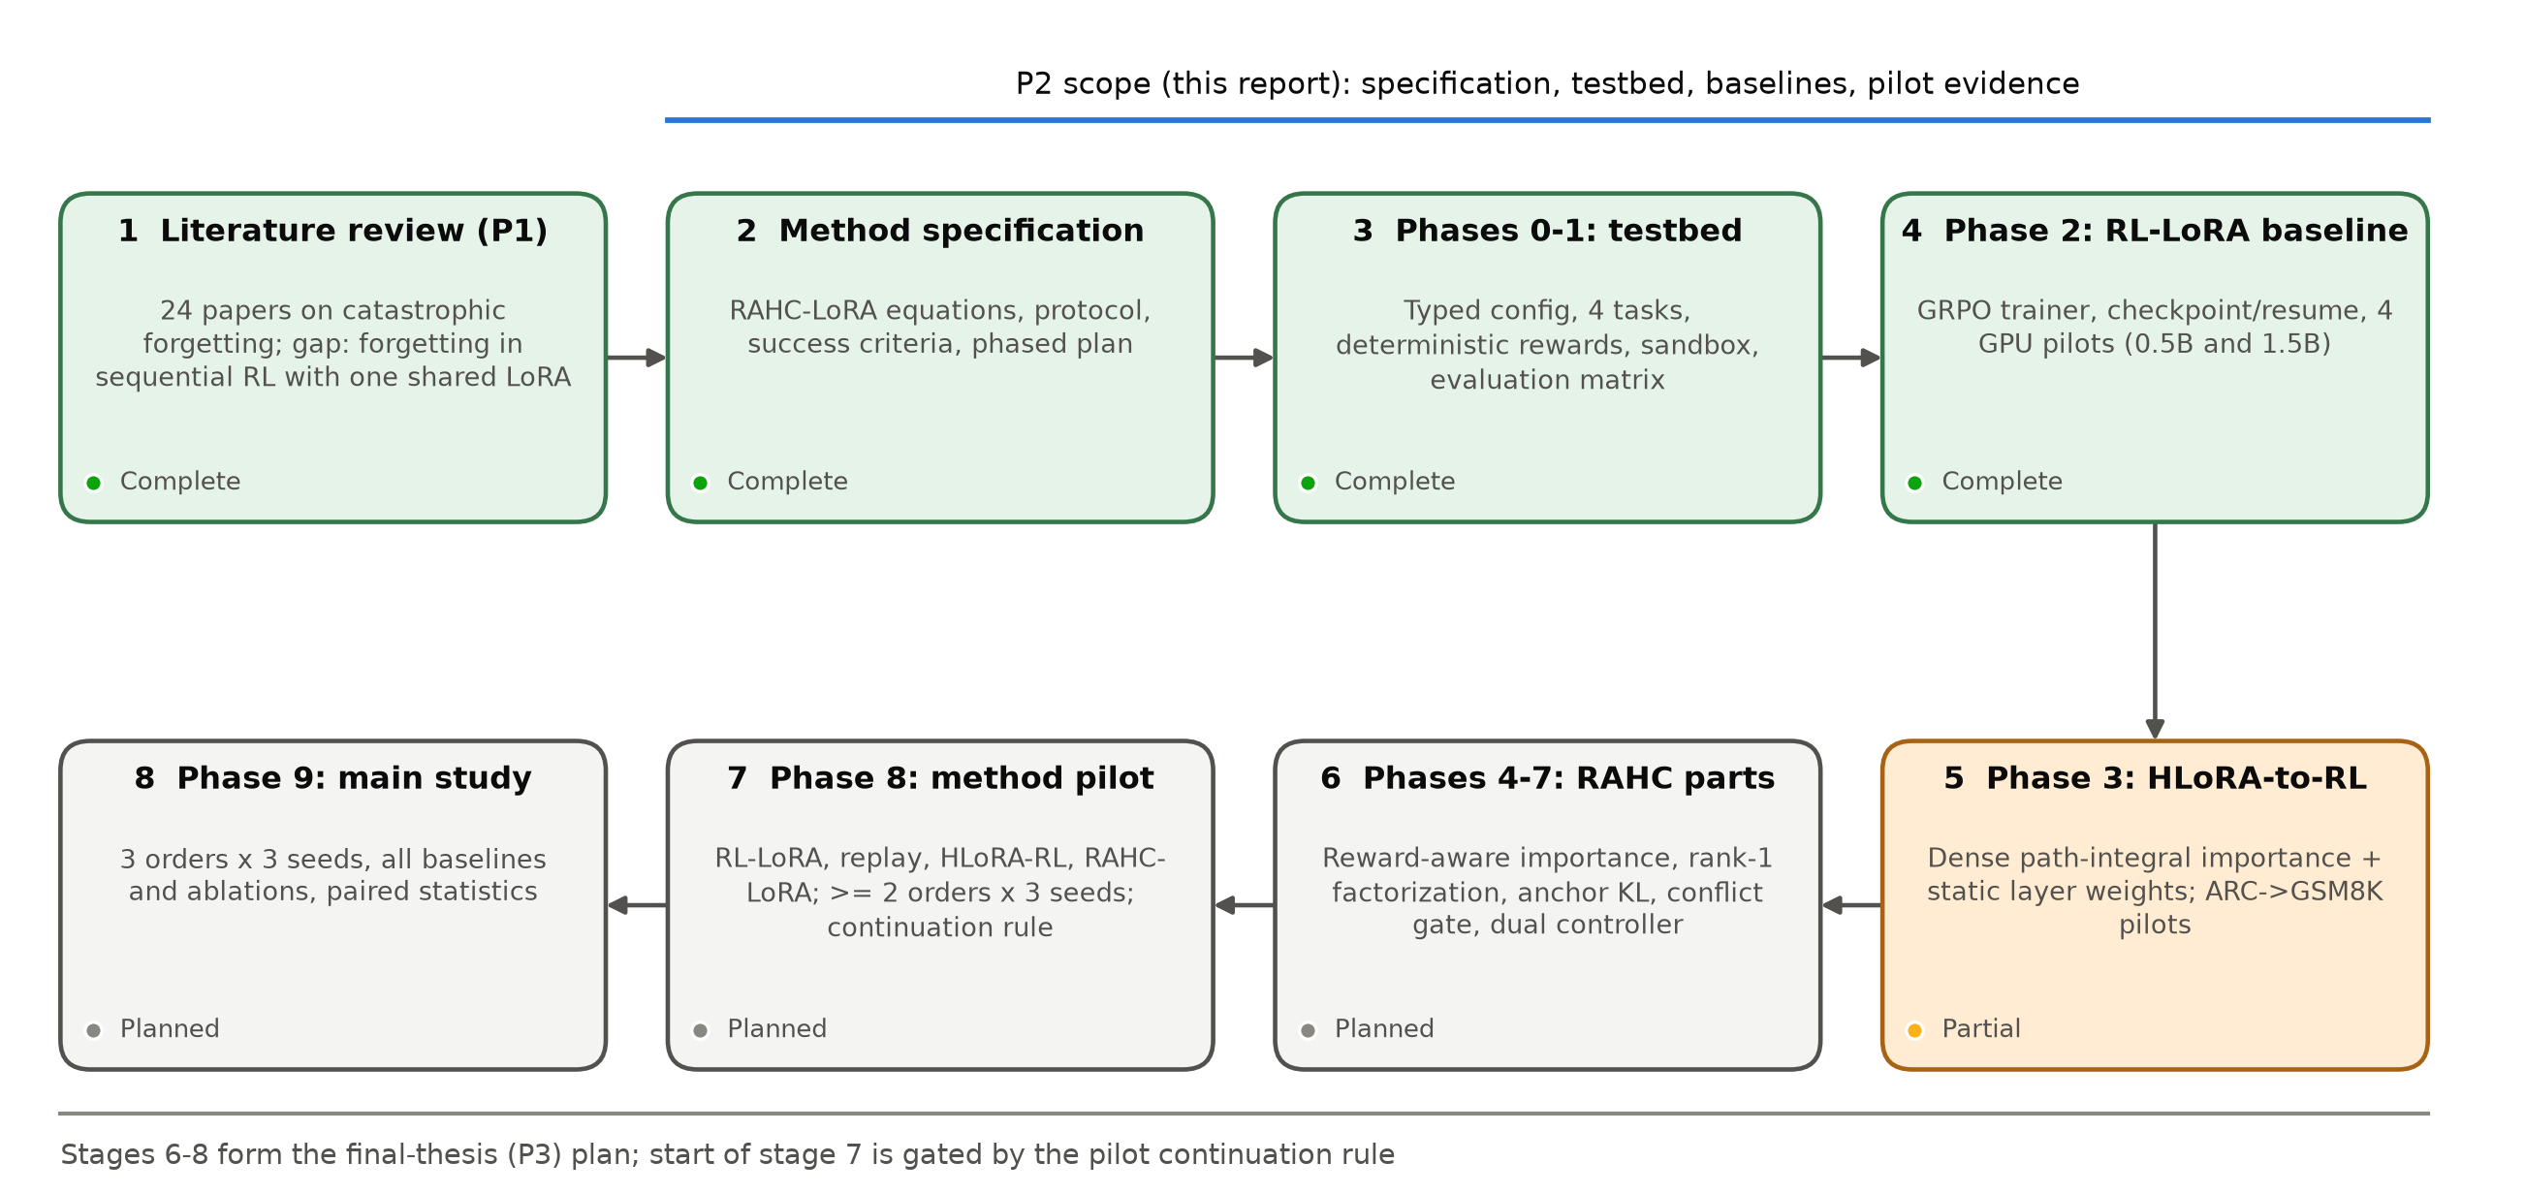
Figure 1.1: Research roadmap from the P1 literature review to the final study. Stages 1-4 are complete, stage 5 is partly complete, and stages 6-8 form the final-thesis plan.
First, the problem, method, and success criteria were written down as an authoritative specification. Second, a testbed was built for data preparation, rewards, evaluation, and continual metrics, with evaluation-only benchmarks isolated from all training roles. Third, a standard RL-LoRA baseline was implemented and piloted on GPU to test whether the chosen streams produce measurable forgetting. Fourth, the direct HLoRA-to-RL baseline was implemented in the same trainer and compared with RL-LoRA on a stream chosen to create more conflict. The remaining RAHC-LoRA components, the multi-seed pilot, and the main study with ablations follow in the final thesis stage.

1.8 Scope and Challenges

1.8.1 What this study covers
- Continual RL post-training of one instruction-tuned causal LLM (0.5B to 1.5B parameters in the pilots; 1B to 3B planned) with a frozen backbone and one shared LoRA adapter.
- Four task families with deterministic verifiable rewards: arithmetic reasoning (GSM8K), science reasoning (ARC-Challenge), Python code generation (MBPP), and verifiable instruction constraints.
- Parameter-level and behaviour-level retention mechanisms, their ablations, and their memory and compute cost.
- Evaluation after every task of all learned tasks and of an evaluation-only general-capability suite.

1.8.2 What this study does not cover
- Training a foundation model from scratch or full-parameter continual fine-tuning.
- Methods that add one adapter per task as the primary approach (they appear only as baselines).
- Unbounded replay of old training data.
- Claims that catastrophic forgetting is solved in general, or state-of-the-art claims from a single task order or seed.

1.8.3 Key challenges
Measuring forgetting at all. Forgetting can only be observed when the first task is learned well and then lost. A task learned to only 2% cannot lose 10 points. The pilots showed that obtaining a clear forgetting signal is itself difficult.
Sparse rewards. With four responses per prompt, many groups receive identical rewards and therefore produce zero gradient. This slows learning and makes importance estimates noisy.
Distinguishing real forgetting from evaluation artefacts. Generative evaluation with strict answer parsing and a fixed token cap can confuse loss of knowledge with loss of answer format [27], [28].
Compute. One 1.5B update with eight rollouts takes about 50 seconds on the available 16 GB GPU, so a 1,000-update pilot takes about 14-17 hours. Multi-seed studies must be budgeted carefully.
Fair comparison. Every method must run through the same trainer with the same data, rewards, budgets, seeds, and generation settings. Otherwise differences could come from the implementation rather than the method.

1.9 Thesis Organization
Chapter 2 reviews the background and related work on LLM fine-tuning, RL for LLMs, continual learning, and forgetting mitigation, and identifies the research gap. Chapter 3 states the requirements, impacts, and constraints of the project, including ethics, risk management, and the work plan. Chapter 4 presents the proposed methodology: the problem formulation, the complete RAHC-LoRA method, the baselines, the ablations, and the evaluation protocol. Chapter 5 describes the implementation and the experimental setup. Chapter 6 reports and discusses the pilot results. Chapter 7 concludes the report and sets out the plan for the final thesis. The appendices contain reproduction commands, configuration listings, example prompts, and a reconciliation of earlier internal reports with the verified artifacts.

Chapter 2: Literature Review
This chapter first introduces the concepts that the rest of the thesis relies on: LLM adaptation with LoRA, RL for LLMs, catastrophic forgetting, and importance-based consolidation. It then reviews existing research grouped by mitigation strategy, with particular attention to work on forgetting during RL fine-tuning, which has grown quickly since our P1 review. The chapter ends with a comparison table and the research gap that motivates RAHC-LoRA.

2.1 Preliminaries

2.1.1 Large language models and adaptation
A decoder-only LLM defines an autoregressive distribution over tokens, π(y|x) = ∏_{j} p(y_{j} | x, y_{<j}), computed by a stack of Transformer layers with self-attention and feed-forward blocks [1], [2]. Each attention block contains the query, key, value, and output projections (q_proj, k_proj, v_proj, o_proj), which are the LoRA targets in this work. Pre-training gives broad knowledge. Adaptation then specializes the model through supervised fine-tuning (SFT) on demonstrations, preference optimization [29], or RL against a reward [3].

2.1.2 Parameter-efficient fine-tuning and LoRA
PEFT methods adapt a frozen model by training a small number of new parameters, for example adapters [30] or low-rank updates [10]. LoRA replaces the output of a target linear layer by
(2.1)

where W₀ is frozen, B is initialized to zero so that training starts from the pre-trained model, and α/r is a fixed scale. Variants change the rank allocation [31], the learning rates of the two factors [32], or decompose the update into magnitude and direction [33]. Two properties of LoRA matter for continual learning. First, LoRA tends to learn less and forget less than full fine-tuning, but it still forgets [34]. Second, the factorization is not unique. For any invertible r×r matrix Q, the pair (BQ, Q⁻¹A) gives the same update, so any quantity defined on A and B separately depends on an arbitrary choice of coordinates. Chapter 4 builds on this observation.

2.1.3 Reinforcement learning for LLMs
In the RL view, a prompt x is a state, a response y is an action sequence sampled from the policy π_{θ}, and a scalar reward r(x, y) scores the response. RLHF-style training maximizes the KL-regularized objective [5], [3]
(2.2)

where π_{ref} is usually the initial model. The policy-gradient theorem [35] gives unbiased but high-variance gradient estimates. PPO [6] reduces variance with a learned value baseline and limits update size with a clipped probability ratio. GRPO [9] samples a group of G responses per prompt and uses the group-normalized reward as the advantage, which removes the value network entirely. With verifiable rewards (RLVR), rewards come from exact checkers rather than a learned reward model [7], [8]. This removes reward-model drift and makes rewards deterministic, which is why this thesis uses RLVR tasks.
An important practical property of GRPO with binary rewards is sparsity. If all G responses for a prompt are wrong, or all are right, the group's rewards have zero variance and every advantage is zero. Such a group contributes no gradient at all. The pilots in Chapter 6 show that this happens for most GSM8K and MBPP groups early in training.

2.1.4 Catastrophic forgetting and the stability-plasticity dilemma
Catastrophic forgetting was first described in connectionist networks trained on sequential tasks [13], [14]. It follows from sharing parameters: the gradient of the new task's loss is unaware of the old task's loss surface, so moving along it can increase the old loss arbitrarily. Continual learning seeks a balance between stability (retaining old skills) and plasticity (acquiring new ones) [11], [12]. Surveys for language models [36], [37], [38] distinguish continual pre-training, continual instruction tuning, and continual alignment. Our setting is continual RL post-training with a fixed task sequence and task boundaries known during training.
Two cautions from recent work matter for evaluation. Spurious forgetting shows that an apparent drop in performance can reflect a loss of task alignment or format rather than of underlying knowledge [27]. Implicit-inference analysis shows that fine-tuning can suppress capabilities that remain recoverable [28]. Evaluations therefore need to be designed carefully: they must parse answers explicitly and document failures, and they must compare against the frozen starting model.

2.1.5 Continual-learning evaluation
The standard protocol records a performance matrix A[i, j], the held-out score on task j after training on task i (Figure 2.1). Average forgetting compares each old task's best earlier score with its final score. Final average performance averages the last row, and backward transfer compares final scores with the score each task had right after it was learned [39], [40]. Reporting only the final row hides whether a method retained old tasks or simply never learned new ones, so the full matrix must be reported.
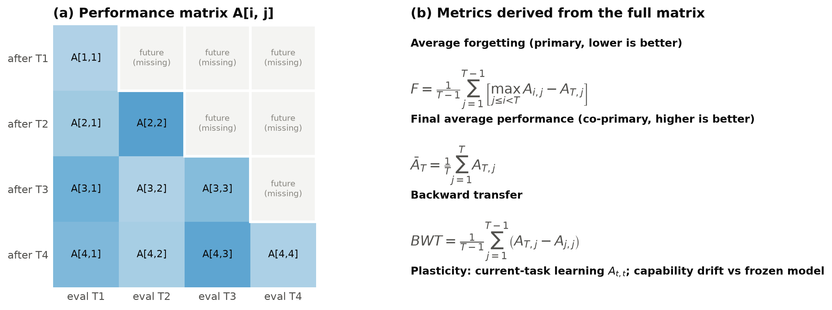
Figure 2.1: Evaluation protocol. (a) The performance matrix A[i, j]: entries above the diagonal refer to tasks not yet learned and are explicitly missing. (b) The metrics derived from the complete matrix.

2.1.6 Importance-based consolidation
Regularization methods add a penalty that keeps parameters important for old tasks near their old values. EWC [24] uses the diagonal Fisher information F as importance:
 | 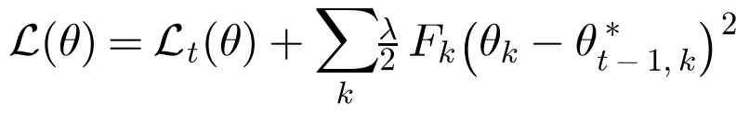 | (2.3)

Synaptic Intelligence [25] estimates importance online as a path integral. Each parameter's contribution to the loss decrease is accumulated along the training trajectory and normalized by its total displacement:
 | 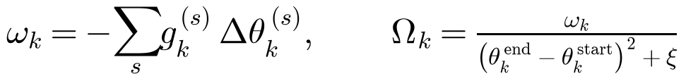 | (2.4)

Memory Aware Synapses [41] measure the sensitivity of the model output instead of the loss. Structured curvature approximations such as Kronecker-factored Laplace approximations [42], [43] trade accuracy for memory. All of these methods avoid computing the full Hessian, which is impossible at LLM scale; in that sense they are Hessian-free, a term borrowed from second-order optimization [44]. The first-order path-integral estimate is the starting point of RAHC-LoRA. However, it was designed for supervised learning with SGD-like updates. Using it in RL requires an explicit definition of which gradient is used (the clipped-advantage RL objective) and which movement is measured (the step the optimizer actually took).

2.2 Review of Existing Research
The literature is organized into six strands, summarized in Figure 2.2.
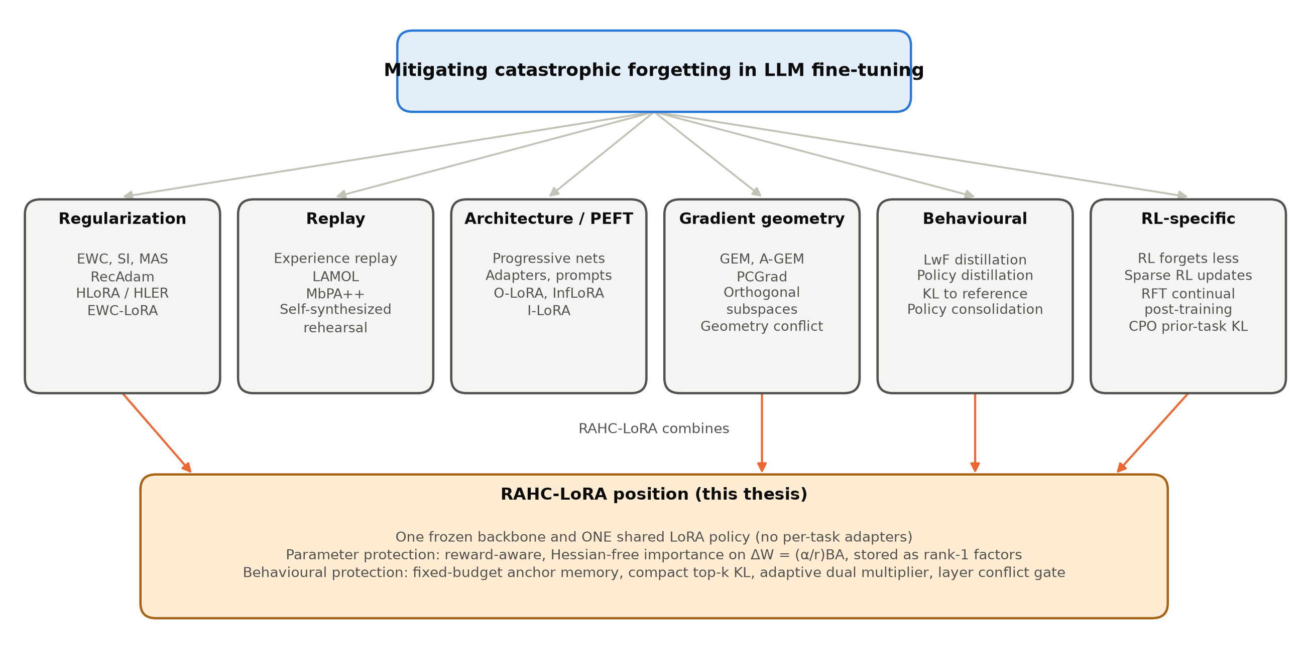
Figure 2.2: Taxonomy of forgetting-mitigation strategies reviewed in this chapter and the strands that RAHC-LoRA combines.

2.2.1 Empirical studies of forgetting in LLMs
Luo et al. [15] measured forgetting of domain knowledge, reasoning, and reading comprehension during continual instruction tuning of models from 1B to 7B parameters. They found that forgetting is common and generally becomes more severe as model size grows in that range. Kalajdzievski [16] reported power-law relationships between the amount of fine-tuning and forgetting, even for LoRA. Scialom et al. [45] showed that instruction-tuned T0 models can continually learn new instructions with a small rehearsal buffer. Gupta et al. [46] studied how learning-rate re-warming affects forgetting during continual pre-training. Together, these studies establish that forgetting in LLMs is real and depends on the task sequence and the training budget. They also show that measured forgetting depends strongly on how evaluation is done [27].

2.2.2 Regularization-based methods
EWC [24], SI [25], and MAS [41] are the canonical parameter-regularization methods. Progress & Compress [47] combines distillation with an online EWC variant and applies it to RL agents. For pre-trained language models, RecAdam [48] gradually pulls fine-tuned weights towards the pre-trained weights with an annealed quadratic penalty.
The method closest to ours is HLoRA/HLER [20]. It computes element-wise parameter importance for preserving general knowledge from a supervised general-domain task. It then adds an importance-weighted regularization loss to the cross-entropy of the new domain task and weights each layer by a softmax of its importance norm. Experiments used The Pile [49] as the general-domain reference and SciQ [50], PiQA [51], and MedMCQA [52] as domain tasks. HLoRA was the main baseline identified in P1. Three aspects limit its direct use in continual RL: its importance derivation assumes a closed-form SGD step on a supervised loss, its importance is dense, and its softmax layer coefficients are static.
Very recently, EWC-LoRA [53] revisited weight regularization for low-rank continual learning. It regularizes a single shared low-rank update with EWC and so keeps storage and inference cost constant. This supports our choice of one shared adapter, but it is supervised and uses Fisher importance without a behavioural term.

2.2.3 Replay and distillation
Experience replay mixes stored old examples into new-task training and is a strong baseline for both supervised and RL continual learning [23]. LAMOL [54] lets the language model generate pseudo-samples of earlier tasks. MbPA++ [55] keeps an episodic memory with sparse replay and adapts locally at inference time. Self-synthesized rehearsal [56] generates rehearsal data with the model itself. Learning without Forgetting [57] and knowledge distillation [58] preserve the old model's outputs rather than its data. This is the principle behind our anchor KL: RAHC-LoRA stores a fixed budget of old training prompts together with compact top-k reference distributions, so it preserves behaviour without replaying rewards or storing full vocabulary distributions.

2.2.4 Parameter-efficient and subspace methods
O-LoRA [21] learns each new task in a LoRA subspace orthogonal to those of earlier tasks. InfLoRA [22] designs the subspace so that new updates do not interfere with old tasks. I-LoRA [59] builds a dual-memory replay framework on interpolations of LoRA parameters. Progressive networks [60] and prompt-based methods add capacity per task. These methods reduce interference effectively, but storage or routing grows with the number of tasks. The primary RAHC-LoRA method deliberately keeps a single shared adapter, and subspace methods appear only as baselines.

2.2.5 Gradient-geometry methods
GEM [39] and A-GEM [40] project the new-task gradient so that the loss on stored examples does not increase. PCGrad [61] removes the conflicting component when two task gradients have negative cosine similarity. These methods motivate our conflict gate, which measures the cosine between the RL gradient and the anchor gradient at the level of each layer's effective weight. The difference is that RAHC-LoRA does not project gradients. It uses the detached conflict to weight a parameter penalty, which is cheaper and keeps the RL gradient unchanged when there is no conflict. Concurrent work on geometry conflict [62] explains forgetting in LLM continual post-training as a geometric incompatibility between the new update and the current model state, which supports conflict-aware protection.

2.2.6 Forgetting in RL fine-tuning of LLMs
Several recent studies ask specifically whether RL forgets. Shenfeld et al. [17] find that the amount of forgetting is predicted by the KL divergence between the fine-tuned and base policies on the new task. They also find that on-policy RL is implicitly biased towards KL-minimal solutions ("RL's Razor") and therefore forgets less than SFT. Lai et al. [18] report that reinforcement fine-tuning mitigates forgetting in continual post-training of a multimodal model and attribute part of this to the scaling of gradients by reward variance. Mukherjee et al. [63] show that RL updates only a small subnetwork of 5-30% of the parameters, which suggests that importance should be sparse and structured. In contrast, Luo et al. [19] show that standard RL still suffers severe forgetting during continual post-training. They trace the failure to a mismatch: the usual KL regularizer is measured on current-task data, whereas forgetting is caused by drift on prior-task distributions. Their remedy is a replay-free KL on the prior-task distribution.
These findings are directly relevant. They predict that RL forgetting may be milder than SFT forgetting, which our pilots confirm (Chapter 6). They also argue that behavioural drift on old-task inputs, not on current prompts, is the quantity to control, which is exactly what our anchor KL measures.
Continual RL outside language modelling has a longer history [64]. Policy consolidation [65] couples a cascade of policies through KL terms. Continual World [66] showed that forgetting and transfer in continual control are sensitive to design choices. That literature also warns that RL results vary strongly across seeds and must be reported with appropriate statistics [67], [68], a caution we follow.

2.2.7 Constrained optimization and KL control
Keeping a policy close to a reference is naturally formulated as a constrained problem: maximize reward subject to a divergence budget [69]. PPO-style RLHF uses a fixed or adaptive KL coefficient [5], and Lagrangian and PID controllers adapt the multiplier to keep a constraint satisfied [70]. RAHC-LoRA applies the same principle to old-task behaviour. A nonnegative dual variable increases when the smoothed anchor KL exceeds its budget and decreases when it is below.

2.3 From P1 to P2
P1 reviewed catastrophic forgetting broadly and selected HLoRA/HLER as the strongest regularization starting point. P2 narrows and deepens this in four ways. It moves from supervised fine-tuning to RL with verifiable rewards, following the trend in LLM post-training. It changes the protected object from individual parameters to the effective LoRA update. It adds recent RL-specific evidence [17], [18], [19], [63], which shows that behavioural drift on old-task inputs is the key quantity. Finally, it moves from reviewing methods to implementing and testing them under a pre-registered protocol. The title of the thesis was updated accordingly.

2.4 Summary of Key Findings and Research Gap
Table 2.1 compares representative methods. Four observations follow.
Table 2.1: Comparison of representative continual-learning and forgetting studies relevant to sequential RL fine-tuning with one shared LoRA adapter.
Ref. | Method / study | Category | Setting | Key mechanism | Gap for our problem
[24] | EWC | Regularization | Supervised; Atari RL | Fisher-weighted quadratic penalty to old weights | Needs Fisher estimate; applied to raw parameters, not LoRA effective update
[25] | Synaptic Intelligence | Regularization | Supervised | Online path integral of gradient x movement | Assumes low-noise gradients; untested with sparse policy gradients
[41] | MAS | Regularization | Supervised | Output-sensitivity importance | Importance ignores reward and advantage
[48] | RecAdam | Regularization | NLP fine-tuning | Annealed pull towards pretrained weights | Single-step transfer, not a task sequence
[20] | HLoRA / HLER | Regularization | Supervised LLM domain tuning | Element-wise importance + softmax layer coefficients | Supervised loss; SGD closed form; dense importance
[53] | EWC-LoRA | Regularization | Low-rank continual learning | EWC on a shared low-rank update | Supervised Fisher; no behavioural anchor
[54] | LAMOL | Replay | Lifelong language learning | Model generates pseudo-samples of old tasks | Pseudo-data quality; supervised
[55] | MbPA++ | Replay / memory | Lifelong language learning | Episodic memory with local adaptation | Memory and inference cost grow
[21] | O-LoRA | PEFT subspace | LLM continual instruction tuning | Orthogonal LoRA subspace per task | Adapter count grows with tasks
[59] | I-LoRA | PEFT + replay | LLM continual fine-tuning | Interpolated dual-memory LoRA | Replay buffer; supervised
[39], [40] | GEM / A-GEM | Gradient projection | Supervised | Project updates to avoid old-loss increase | Hard constraint; needs memory gradients each step
[61] | PCGrad | Gradient surgery | Multi-task | Remove conflicting gradient components | Simultaneous tasks, not sequential
[65] | Policy consolidation | Behavioural | Continual RL (control) | Cascade of policies coupled by KL | Extra policy copies; not LLM
[17] | RL's Razor | Analysis | LLM RL vs SFT | Forgetting tracks KL on new task; RL is KL-minimal | Explains, does not prevent, multi-task RL forgetting
[18] | RFT in continual post-training | Analysis | Multimodal LLM task stream | RFT forgets less; reward variance as implicit regularizer | No explicit retention mechanism
[19] | CPO | Behavioural / KL | Continual RL post-training of VLMs | Replay-free KL on the prior-task distribution | Concurrent; multimodal; no parameter consolidation
[62] | Geometry conflict | Gradient geometry | LLM continual post-training | Forgetting as geometric incompatibility of updates | Concurrent; not LoRA-RL specific
This work | RAHC-LoRA | Hybrid | Sequential verifiable-reward RL, one LoRA | Reward-aware effective-weight importance, rank-1 factors, anchor KL, conflict gate, dual controller | Full method implementation and multi-seed evaluation pending (P3)

- Regularization is memory-heavy or supervised. Dense importance (EWC, SI, MAS, HLoRA) costs as much as the protected weights, and the known importance derivations assume supervised losses and SGD-like updates.
- PEFT continual methods usually grow. Subspace and per-task adapter methods avoid interference by adding capacity, which conflicts with a single shared adapter.
- RL forgetting is real but different. RL forgets less than SFT, updates are sparse, and forgetting is governed by drift on prior-task distributions. The standard current-prompt KL does not measure that drift.
- Few methods combine parameter and behavioural protection adaptively. Gradient-conflict ideas exist for multi-task learning, and KL budgets exist for RLHF, but to our knowledge no method combines conflict-gated effective-weight consolidation, compact old-task KL, and a dual controller for one shared LoRA policy under RL.
Research gap. There is no validated method for continual RL post-training of a single shared LoRA policy that (i) defines importance on the gauge-invariant effective update using the actual RL gradient and optimizer step, (ii) keeps persistent retention state bounded, (iii) protects old behaviour through a fixed-budget memory, and (iv) adapts protection to measured conflict and drift. There is also no reproducible, statistically careful testbed for evaluating such a method in RLVR. RAHC-LoRA and the platform described in this thesis address both needs.

Chapter 3: Requirements, Impacts and Constraints
This chapter states the final specifications of the research platform and the method, the constraints under which they were built, and the societal, environmental, ethical, and economic aspects of the work. It also presents the risk register and the project management plan.

3.1 Final Specifications and Requirements
The deliverable of this thesis is a research instrument, not a product. It must answer the research question reproducibly, including when the answer is negative. The requirements were therefore written as testable statements before implementation, in an authoritative specification. Each requirement is verified by an automated test or by an artifact produced by a run. Table 3.1 lists the requirements and their status at the end of P2.
Table 3.1: Final specifications and requirements of the RAHC-LoRA research platform and their verification status.
ID | Requirement | Type | Verification in repository | Status
R1 | One frozen backbone and exactly one shared LoRA adapter; no per-task adapters | Scientific | Factory and trainer tests: frozen weights bit-identical, only LoRA in optimizer | Met
R2 | Disjoint train / validation / anchor-candidate / test roles; IFEval evaluation-only | Scientific | Hash-ranked splits, manifest duplicate checks, access-denying loaders, overlap audit (0 exact, 0 normalized) | Met
R3 | Deterministic rewards in [0, 1]; documented zero for parse failures | Scientific | Hand-checked accepted, rejected, malformed examples in unit tests | Met
R4 | Generated code executed only in an isolated, network-disabled, resource-limited sandbox | Safety | Docker command test; fail-closed test when Docker unavailable | Met
R5 | Full performance matrix after every task plus capability suite vs frozen model | Evaluation | Mock two-task gate; every GPU run records A[i, j] and 6 capability metrics | Met
R6 | All method components switchable by configuration only | Reproducibility | Hydra method groups; validation forbids hidden retention in rl_lora | Met for implemented components
R7 | Atomic, hashed, resumable checkpoints including retention state | Reproducibility | Resume within 1e-7; SHA-256 validation of all pilot checkpoints | Met
R8 | Fail loudly on non-finite values; no silent fallbacks | Engineering | Finite checks on rewards, advantages, losses, gradients, importance | Met
R9 | Bounded persistent retention state (factorized importance, fixed anchors) | Scientific | Dense importance only in the HLoRA-RL reference baseline | Pending (Phases 5-6)
R10 | Three task orders x three seeds, paired statistics, ablations | Evaluation | Protocol and aggregation specified | Pending (Phases 8-9)
R11 | Consumer single-GPU feasibility (16 GB VRAM) | Constraint | Peak allocation 12.2 GB (RL-LoRA) and 14.1 GB (HLoRA-RL) on Qwen2.5-1.5B | Met

The scientific requirements (R1-R3, R9, R10) protect the validity of conclusions: one shared adapter, strict separation of data roles, deterministic rewards, bounded state, and multi-seed paired statistics. The safety requirement (R4) exists because the policy writes Python code that is executed to compute the MBPP reward. The reproducibility requirements (R5-R8) ensure that every reported number can be traced to a configuration, a data manifest, and a checkpoint. The resource requirement (R11) reflects the hardware actually available to the team, a single consumer GPU.
The platform was built and run on the hardware and software in Table 3.2. Every run manifest records these values automatically, so each result can be tied to its exact environment.
Table 3.2: Hardware and software platform recorded in the run manifests.
Component | Specification
GPU | NVIDIA GeForce RTX 4070 Ti SUPER, 16 GB VRAM, BF16 supported
CPU / OS | Intel64 Family 6 Model 183 (x86-64); Windows 11 Pro (build 26200)
Python / CUDA | Python 3.11.15 (Conda gpu-env), CUDA runtime 12.6
Core libraries | torch 2.13.0+cu126, transformers 4.57.6, peft 0.20.0, trl 0.29.1 (not used for GRPO semantics), accelerate 1.14.0, datasets 4.8.5, hydra-core 1.3.7
Analysis libraries | numpy 2.4.6, pandas 3.0.5, scipy 1.17.1, scikit-learn 1.9.0, pyarrow 25.0.1
Code sandbox | Docker Desktop Linux engine 29.2.1; python:3.11.10-slim-bookworm pinned by digest
Models | Qwen2.5-0.5B-Instruct @ 7ae5576; Qwen2.5-1.5B-Instruct @ 989aa79 (pinned 40-character revisions)
Quality gates | Ruff format and lint, mypy (51 source files), pytest (59 tests, 12.5 s on CPU)

3.2 Design Constraints
Compute. All experiments run on one NVIDIA RTX 4070 Ti SUPER with 16 GB of memory. This bounds the backbone to about 1.5B parameters with BF16 weights, the rollout budget to eight responses per update, and the response length to 128 tokens. One update takes 40-60 seconds (Chapter 6). A 1,000-update two-task pilot therefore takes 14-17 hours, and a full three-order, three-seed, four-task study must be planned in stages.
Memory budget of the method. The primary method may not store a model copy per task, a dense importance matrix per task, or an unlimited replay buffer. It may store one current adapter, one reference adapter, factorized importance vectors, a fixed-capacity anchor memory, and small controller state.
Data. Only permissively licensed public datasets are used. Official IFEval is evaluation-only and may never influence training, anchors, importance, reward design, or tuning. The custom constraint dataset is generated from versioned templates and is checked against IFEval for exact and normalized overlap.
Software. The GRPO objective is implemented inside the project and not delegated to a trainer library, so that a library upgrade cannot silently change the objective. Transformers and PEFT are wrapped behind project-owned interfaces. Precision fallbacks are forbidden: an unsupported precision raises an error.
Scientific process. Task orders, seeds, metrics, and the continuation rule were fixed before any method pilot. Failed or negative runs are preserved. Held-out scores are never used to choose training settings.

3.3 Societal Impact
Continual adaptation is how deployed language models keep up with new domains, tools, and rules. If each update silently erodes earlier skills, users receive regressions, for example a tutoring model whose arithmetic degrades after a coding update. Better retention methods make updates more predictable and reduce the need to retrain from scratch, which lowers the barrier for universities, small companies, and developers in regions such as Bangladesh who cannot afford large clusters. Because the method works with one shared adapter on one consumer GPU, the results are relevant to exactly these users.
There are also risks. Methods that preserve old behaviour also preserve old mistakes and biases, so retention is not automatically beneficial. The method should preserve whatever the evaluation suite measures, and that suite must include safety-relevant behaviour before any deployment. In addition, stronger RL post-training on small models lowers the cost of specializing models for any purpose. Our tasks (arithmetic, science questions, code, formatting constraints) are benign, and we release no new model weights.

3.4 Environmental Impact
Training LLMs consumes electricity. The eight analysed pilots used 43.2 optimizer hours on one GPU with a board power of roughly 285 W. At full load this is below about 15 kWh for the GPU, which is small compared with multi-GPU training runs. PEFT and bounded retention state are themselves efficiency measures: continual adaptation with a 2.2-million-parameter adapter avoids repeated full fine-tuning of 1.5 billion parameters. The protocol also includes a pilot continuation rule, which stops expensive full studies when the benchmark cannot measure the effect of interest. In P2 this rule stopped a multi-seed study that would not have been informative.

3.5 Ethical Issues
Research integrity. The central ethical risk in empirical machine learning is overstating results. Our protocol forbids tuning on test data, requires the full performance matrix, keeps negative and failed runs, and separates statistical significance from practical significance. Earlier internal summaries of this project described single-seed pilots with stronger language than the evidence supports. This thesis corrects those statements against the raw artifacts (Appendix D).
Data. All datasets are public and pinned to exact revisions, with licenses recorded in manifests (MIT, CC-BY-SA-4.0, CC-BY-4.0, Apache-2.0). No personal data are collected, and generated responses are stored only as hashes in the evaluation records.
Safety of generated code. Code written by the policy is untrusted. It runs only inside a Docker container with no network, a read-only root file system, all Linux capabilities dropped, an unprivileged user, and strict CPU, memory, process, time, and output limits. If Docker is unavailable, scoring stops with an error rather than falling back to host execution.
Benchmark contamination. Public benchmarks may have appeared in the backbone's pre-training data. We therefore report changes relative to the frozen starting model as well as absolute scores, and we keep IFEval strictly evaluation-only.

3.6 Standards and Research Practice
The work follows accepted standards of reproducible machine learning. All experimental choices are held in typed configuration and saved with each run; datasets, models, and code dependencies are pinned; and checkpoints are written atomically with SHA-256 manifests. Code quality is enforced with Ruff formatting and linting, mypy type checking, and pytest. Statistical reporting follows guidance for NLP and RL: paired tests on identical examples, confidence intervals, correction for multiple comparisons in ablations, and multiple seeds [71], [67], [68], [72]. Citations follow the IEEE numeric style.

3.7 Risk Management
Table 3.3 lists the main risks identified before implementation, the controls built into the platform, and what actually happened during P2. Three risks materialized and were handled by the controls. The first was the absence of a measurable forgetting signal, handled by the continuation rule. The second was an interrupted 1,000-update run, handled by the verified checkpoint and recovery. The third was host memory pressure from an orphaned monitoring process, detected through the system metrics. A fourth risk, unstable layer coefficients, was observed in a form that was not anticipated: the coefficients were not noisy but completely concentrated on one module. This finding feeds directly into the design of the final method.
Table 3.3: Risk register: risks anticipated in the specification, controls, and what was observed during P2.
Risk | Consequence | Control | Observed in P2
Weak base performance / no forgetting | Retention cannot be measured | Pilot continuation rule (>= 10 pp) | Occurred: all six RL-LoRA streams < 10 pp; stream redesign required
Reward sparsity | Zero advantages, no gradient | Grouped rewards, longer budgets, logging of zero-variance groups | Occurred: 55-87% zero-variance groups on GSM8K and MBPP
Over-consolidation | Old task kept, new task not learned | Co-primary plasticity metric | Not observed; penalty was very small
Baseline mismatch | Unfair comparison | Same trainer, seed, data, budgets, generation | Controlled: task-1 trajectories bit-identical
Dense transient memory | Out-of-memory | CPU-resident dense importance; factorization planned | Peak GPU +1.9 GB; 616.6 MB dense state on CPU
Unstable layer coefficients | Protection concentrated or noisy | Normalization, clipping, static ablation | Occurred: softmax of raw norms became one-hot
Code reward escape | Host compromise | Network-disabled Docker sandbox, fail closed | No incident; sandbox check passed
Long-job interruption | Lost progress | Atomic boundary checkpoints, verified resume | Occurred (order_2, step 918); recovered from step-500 checkpoint
Host memory pressure | Slow or failed steps | System metrics logging | Occurred: orphaned monitor used 22.5 GiB; removed

3.8 Project Management Plan
Figure 3.1 shows the work plan. Completed items are placed at the dates recorded in the repository. The remaining items form a proposed schedule for the final thesis stage, to be confirmed with the supervisor. The critical path runs through the RAHC-LoRA components (Phases 4-7), the multi-seed pilot, and the main study. Each phase has an exit gate: for example, dense and factorized penalties must agree numerically before the factorized method is used, and the pilot must satisfy the continuation rule before the main study is launched.
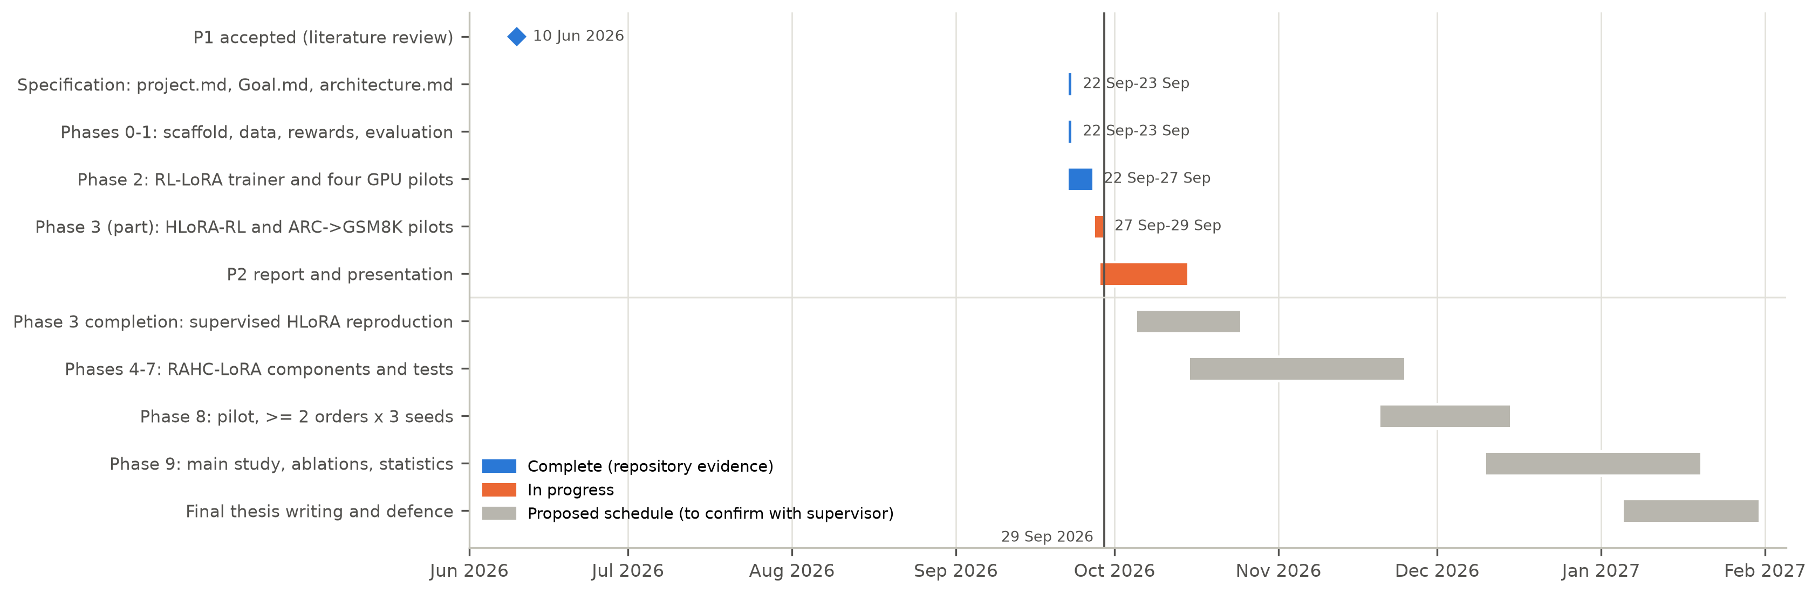
Figure 3.1: Work plan. Completed work is shown at repository dates; the final-thesis phases are a proposed schedule.
The codebase is organized into subsystems that can be owned separately: data and rewards, the RL trainer and checkpointing, the evaluation and capability suite, the consolidation methods, and analysis and writing. [Team to complete: assignment of subsystems to members.] Design decisions are recorded as architecture decision records in the repository, so that anyone who takes over a subsystem inherits its rationale.

3.9 Economic Analysis
The main cost of the project is GPU time on hardware the team already had. A single-GPU workstation of this class costs roughly the price of a few hundred hours of rented data-centre GPU time, and the P2 pilots used about 43 GPU-hours. If rented at a typical public-cloud price of roughly US$0.5-1.0 per hour for a comparable GPU, the P2 compute would have cost less than US$50. The planned main study (three orders, three seeds, several methods, four tasks) needs a few hundred GPU-hours and would cost on the order of a few hundred dollars. All software is open source.
The economic motivation of the method itself is also direct. Retraining a model from scratch for each new task, or storing and serving one adapter per task, costs more than maintaining one shared adapter with bounded retention state. For Qwen2.5-1.5B, the rank-one importance state planned for RAHC-LoRA is 1.09 MB, compared with 616.6 MB for dense importance. That difference decides whether consolidation state fits alongside the model on consumer hardware.

Chapter 4: Proposed Methodology
This chapter presents the complete design of RAHC-LoRA. It begins with the design process and the alternatives considered, formalizes the continual-RL problem, defines each component of the method mathematically, and ends with the baselines, ablations, evaluation protocol, and statistical plan that will be used to test it. Components already implemented are described in Chapter 5, and the chapter marks clearly which parts are specified but not yet implemented.

4.1 Design Process and Methodology Overview

4.1.1 Design objectives
The method was designed to meet five objectives derived from the problem statement (Section 1.3):
- Stability with plasticity: reduce forgetting of earlier tasks without materially reducing learning of the current task.
- One shared policy: a single frozen backbone and one LoRA adapter for all tasks, with no per-task parameters.
- Correct protected object: retention defined on the effective update ΔW, not on the arbitrary LoRA factors.
- Bounded state: persistent retention state independent of the number of tasks and far smaller than dense importance.
- Removable parts: each component switchable by configuration, so its contribution can be measured by ablation.

4.1.2 Alternatives considered
Several designs were considered and rejected for the primary method. Per-task adapters or orthogonal subspaces [21], [22] avoid interference but violate objective 2 and grow with the task count, so they are kept as baselines. Full replay of old rewards needs stored rewards and sandbox executions for old tasks and grows with the stream; a fixed anchor memory of prompts with compact reference distributions is cheaper and does not require re-running old reward functions. Fisher-based importance (EWC) requires sampling and squaring gradients under the current policy, is sensitive to reward sparsity, and does not account for the actual optimizer step. Gradient projection [39], [40] imposes hard constraints that can block learning and requires per-step memory gradients for every protected task. Static softmax layer weights (as in HLoRA) cannot react to whether the current task actually conflicts with the old ones. Our pilots later showed that they can collapse entirely (Section 6.6).
The chosen design combines two complementary protections. Parameter protection resists movement of effective weights that were important for the reward of earlier tasks. Functional protection keeps the policy's output distribution close to its old behaviour on a small memory of old prompts. Protection is scaled up only where the current RL gradient opposes the anchor gradient, and the strength of the behavioural term is controlled to meet an explicit drift budget. Figure 4.1 shows the architecture.
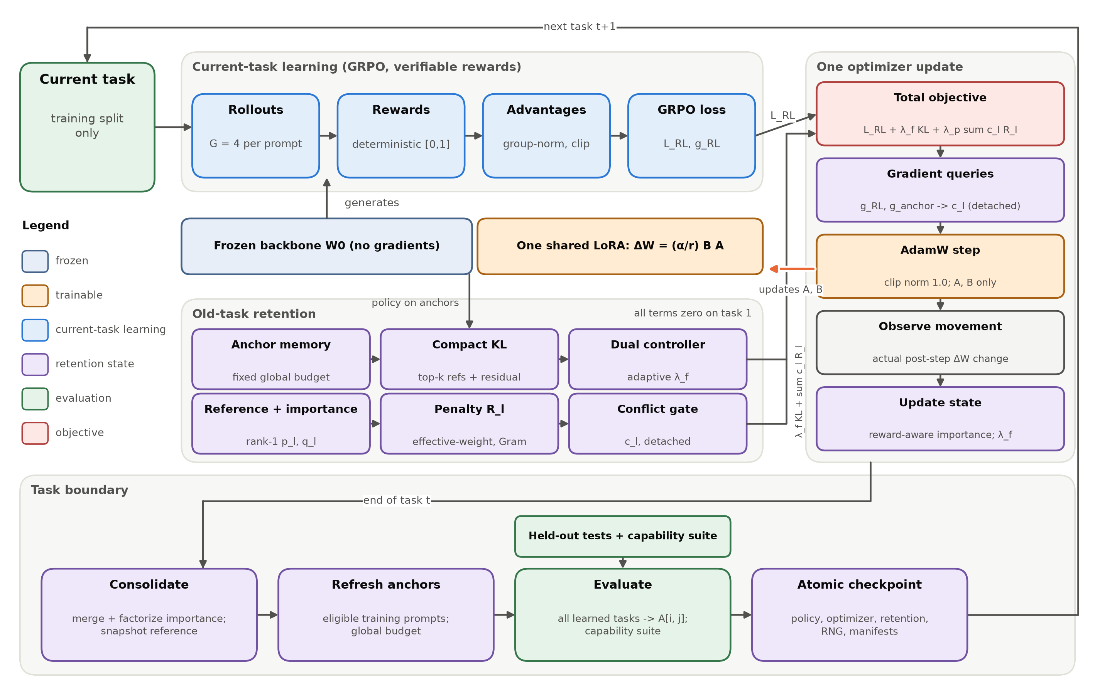
Figure 4.1: Architecture of RAHC-LoRA. One frozen backbone and one shared LoRA adapter serve both current-task learning and old-task retention. Retention terms are zero on the first task. State is consolidated at each task boundary, and the adapter is updated only by the AdamW step.

4.2 Problem Formulation
Table 4.1 summarizes the notation.
Table 4.1: Notation used in the RAHC-LoRA formulation.
Symbol | Meaning
T, t | number of tasks in the stream; index of the current task
W0, l | frozen backbone weight of a target linear layer; index of a protected LoRA module
A_l, B_l, r, α | LoRA down-projection (r x I), up-projection (O x r), rank, scaling numerator
s_l = α / r | LoRA scale (2.0 in all pilots: r = 8, α = 16)
ΔW_l = s_l B_l A_l | effective LoRA update, the protected object
G | responses sampled per prompt (group size, 4 in the pilots)
r_i, Â_i | deterministic reward of response i and its group-normalized advantage
L_RL | clipped GRPO objective of the current task
g_l^RL, g_l^anc | effective-weight gradients of the RL loss and of the anchor KL
δ_l | observed post-step change of ΔW_l
S_l, p_l, q_l | importance matrix and its rank-1 nonnegative row / column factors
R_l | effective-weight consolidation penalty of module l
c_l | detached conflict-aware layer coefficient
L_KL | compact forward KL between stored anchor references and the current policy
λ_f, λ_p | adaptive functional (KL) multiplier and fixed parameter-penalty weight
A[i, j] | held-out score on task j after finishing task i

A task stream is an ordered sequence of T datasets, each split into four disjoint roles:
(4.1)

The policy is the frozen backbone plus one shared set of LoRA factors θ over L protected modules:
 | 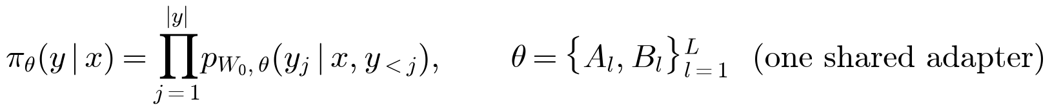 | (4.2)

While training on task t, the learner may access only D_{t}^{train} for RL updates, D_{t}^{val} for tuning, and the anchor candidates of completed tasks, under a fixed global memory budget. Test splits are used only at task boundaries for evaluation. The goal is to maximize the final average performance Ā_{T} while minimizing the average forgetting F, both defined on the full performance matrix (Section 4.6).

4.3 The RAHC-LoRA Method

4.3.1 Effective LoRA weight space and gauge invariance
For each protected module l, RAHC-LoRA defines importance and consolidation on the effective update
 | 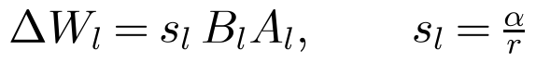 | (4.3)

rather than on A_{l} and B_{l} separately. The reason is the rescaling (gauge) symmetry of the factorization:
(4.4)

Any quantity computed on the factors, such as ‖A − A^{ref}‖² + ‖B − B^{ref}‖², changes under this transformation even though the model is unchanged. A quantity computed on ΔW does not. Figure 4.2 verifies this numerically. For random 64×8 and 8×48 factors, the factor-level penalty varies by more than four orders of magnitude as the rescaling factor k goes from 0.03 to 30, while the effective-weight penalty stays constant to within a relative spread of 3×10⁻¹⁶ (machine precision). The implementation must pass the same invariance test on real LoRA modules.
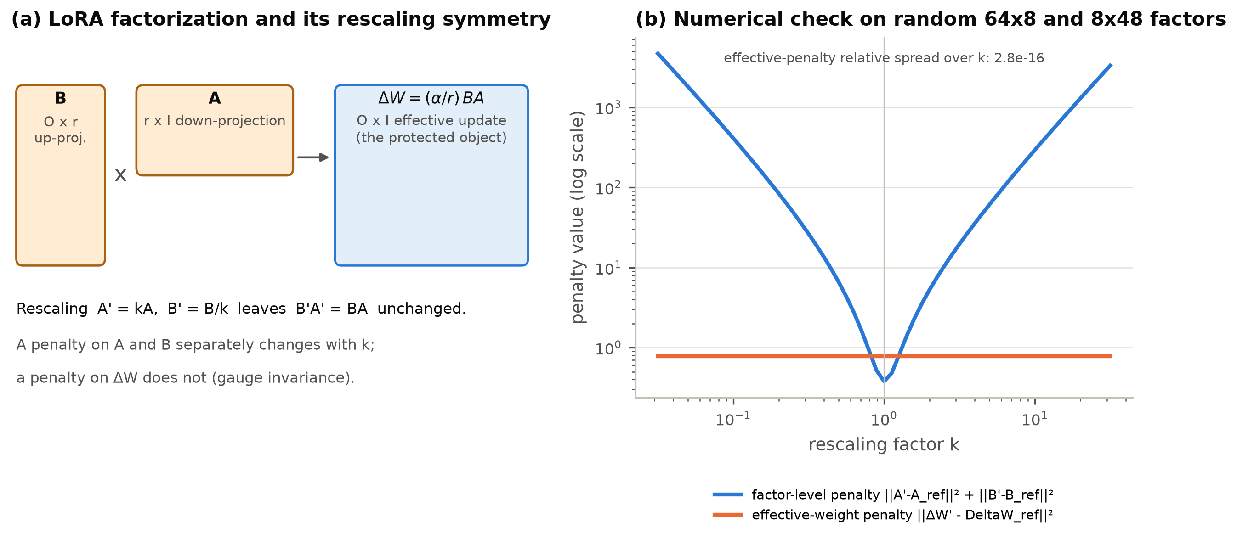
Figure 4.2: Gauge invariance. (a) LoRA factors and the protected effective update. (b) Under the rescaling A′ = kA, B′ = B/k, a factor-level penalty changes by orders of magnitude while the effective-weight penalty is invariant.

4.3.2 Current-task learning with GRPO
The current-task objective is the clipped GRPO loss [9] with verifiable rewards, implemented inside the project with explicitly documented semantics (Figure 4.3). For each prompt, G responses are sampled and scored by a deterministic reward r_{i} ∈ [0, 1]. The advantage is normalized within the group using the population standard deviation and clipped:
(4.5)

The loss is the token-mean clipped surrogate over all valid response tokens:
 | 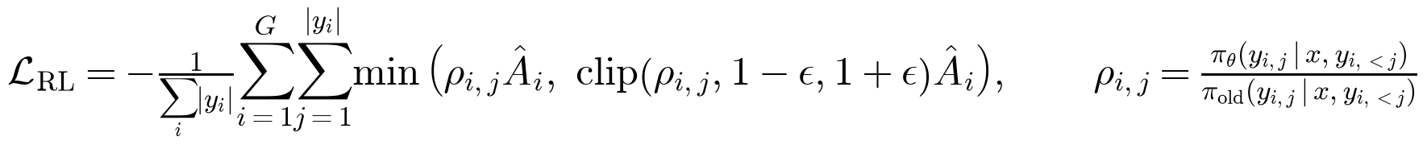 | (4.6)

Two details matter for consolidation. First, a group with identical rewards contributes exactly zero advantage and hence zero gradient. This is logged and never replaced by a heuristic reward. Second, the reference RL-LoRA baseline adds no KL term to the initial policy, since that is a separate baseline (Section 4.4).
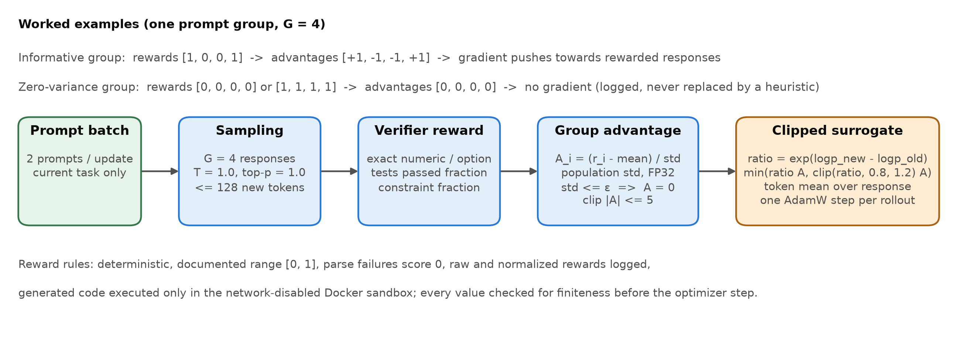
Figure 4.3: Current-task learning pipeline with GRPO and deterministic verifiers, with worked examples of informative and zero-variance groups.

4.3.3 Reward-aware Hessian-free importance
Consider the change of the RL loss when the effective update moves by δ:
(4.7)

Second-order consolidation methods approximate the Hessian H, for example with a diagonal Fisher matrix, which is costly and noisy for policy gradients. Following the path-integral view of SI [25], RAHC-LoRA instead credits each element of ΔW with the loss decrease it actually produced during training. No Hessian or Fisher matrix is computed, which is the sense of "Hessian-free" in the method's name [44]. The first ingredient is the effective-weight gradient of the RL loss, captured at the target layer from its input activations x and output gradients:
 | 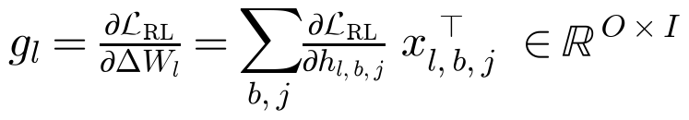 | (4.8)

The second is the movement actually taken by the optimizer, observed after gradient clipping and the AdamW update, not reconstructed from an assumed SGD step:
(4.9)

The per-step raw score keeps only positive contributions, those where the element moved in the direction that reduced the RL loss, and normalizes by the squared movement:
 | 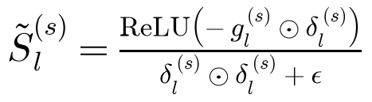 | (4.10)

Scores are robustly clipped at the 99.5th percentile and accumulated with an exponential moving average in FP32:
(4.11)

The estimator is reward-aware because g_{l} is the gradient of the clipped-advantage GRPO objective, not of a likelihood or a supervised loss. Elements that moved to increase the probability of high-advantage responses receive credit in proportion to the reward signal that drove them. Groups with zero reward variance contribute nothing, so importance reflects only informative learning. Any non-finite gradient, movement, or score stops the step with a diagnostic instead of being skipped silently. This is Phase 4 of the implementation plan.

4.3.4 Rank-one factorized importance and efficient penalty
Dense importance S_{l} ∈ ℝ^{O×I} is as large as the module itself. RAHC-LoRA stores only a nonnegative rank-one approximation built from the row and column marginals:
(4.12)

This choice is exact for any importance matrix that is itself an outer product. It preserves the total importance mass exactly and is always nonnegative, and it reduces storage from O·I to O + I values per module:
 | 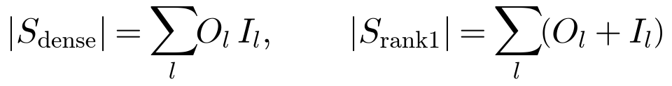 | (4.13)

For the q/k/v/o projections of the 28 layers of Qwen2.5-1.5B, this is 154.1 million versus 272,384 values, a reduction of 566 times. Higher-rank nonnegative factorizations [73] are a possible extension. The factorization module must report reconstruction error, rank correlation with dense importance, storage, and update time on small models. This role is similar to that of Kronecker-factored curvature approximations in second-order methods [43], [42].
At each task boundary the current factors are stored as the reference. The consolidation penalty is defined on the difference of effective updates:
(4.14)

and weights it by the factorized importance:
 | 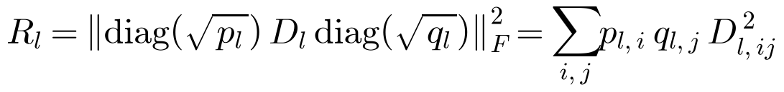 | (4.15)

Materializing D_{l} costs O·I memory. With P = diag(√p_{l}) and Q = diag(√q_{l}), the same value is computed from rank-2r Gram matrices without ever forming D_{l}:
(4.16)

This costs O(r²(O + I)) time and memory per module. Unit tests must confirm that the Gram form equals the dense computation on random matrices. Figure 4.4 illustrates the construction.
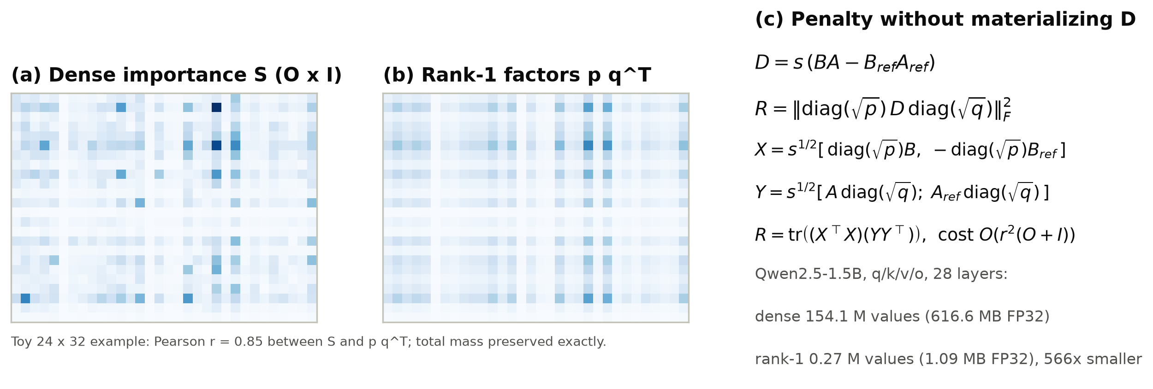
Figure 4.4: Factorized importance and the efficient penalty. (a) A dense nonnegative importance matrix. (b) Its mass-preserving rank-one approximation. (c) The Gram-form penalty and the storage it saves on Qwen2.5-1.5B.

4.3.5 Fixed-budget anchor memory and compact behavioural KL
Parameter penalties protect weights, but the quantity that matters is behaviour on old-task inputs [19]. At each task boundary, RAHC-LoRA selects anchor records from the completed task's anchor-candidate split, which is a subset of its training data and never its test data. Each record stores the prompt, the reference completion tokens, the top-k (k = 32) token log-probabilities of the policy at capture time with the residual probability mass, the reward at capture, a selection hash, and the policy version. One global capacity (512 by default) is shared by all tasks. Selection combines reservoir sampling for temporal fairness [74], task balance, diversity by farthest-first selection when embeddings are available [75], and a mixture of easy, medium, and hard examples by reward stratum.
On an anchor minibatch M_{b}, the behavioural loss is a forward KL over the stored top-k tokens plus one residual bucket:
(4.17)

Only the current-policy probabilities π_{θ} are differentiable, and the references are constants. The compact representation avoids storing full vocabulary distributions (151,936 tokens for Qwen2.5). The anchor KL is logged together with held-out old-task scores, because a low anchor KL alone does not prove that old-task performance is preserved. This is Phase 6.

4.3.6 Conflict-aware layer coefficients
Protection is needed most where the current RL update opposes the old behaviour. For each module, the conflict is the positive part of the negative cosine between the effective RL gradient and the effective anchor-KL gradient:
(4.18)

Aligned or orthogonal gradients give zero conflict, and so does any gradient whose norm is below the threshold τ = 10⁻¹². The conflict is combined with the module's importance mass and normalized across modules:
 | 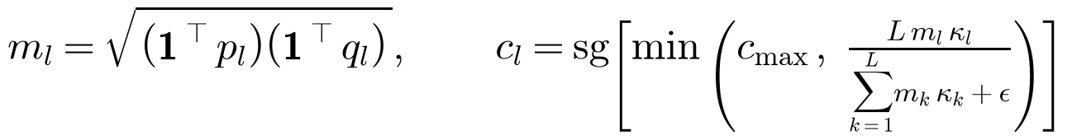 | (4.19)

where sg[·] stops gradients (the coefficient is detached) and c_{max} = 5 bounds the coefficient. The normalization "normalize across layers" in the specification is interpreted as rescaling to a mean of one across the L modules followed by clipping. This is the simplest testable interpretation, and it will be recorded as a design decision. Unlike a softmax of raw importance norms, this normalization cannot collapse onto a single module because of the scale of the norms (Section 6.6). A static-coefficient ablation keeps c_{l} fixed. This is Phase 7.

4.3.7 Adaptive functional-retention controller
The strength of the behavioural term is a nonnegative dual variable [69], [70]. It increases when the smoothed anchor KL exceeds a target budget K* and decreases otherwise:
(4.20)

The defaults are an initial λ_{f} of 0.01, η_{λ} = 0.001, K* = 0.02, β_{K} = 0.95, and λ_{max} = 10. If λ_{f} saturates while the KL stays above budget for a configured number of steps (100), the run stops with a diagnostic instead of continuing in a regime where the constraint cannot be met. A fixed-coefficient ablation disables the controller.

4.3.8 Combined objective and training algorithm
The full objective for task t is
 | 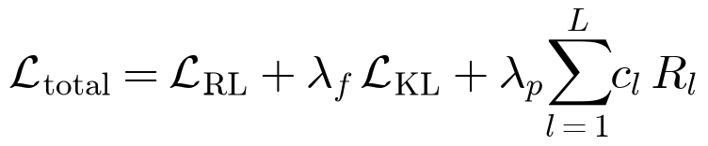 | (4.21)

All retention terms are exactly zero on the first task, because the memory and the consolidated state are empty. The method is therefore identical to standard RL-LoRA on task 1, which the pilots verified bit for bit (Chapter 6). The order of operations within one update is fixed (Figure 4.5). In particular, the importance update uses the movement observed after the optimizer step, and the dual variable is updated outside automatic differentiation. At task boundaries the state is consolidated, evaluated, and checkpointed atomically (Figure 4.6). Algorithm 4.1 summarizes the procedure.
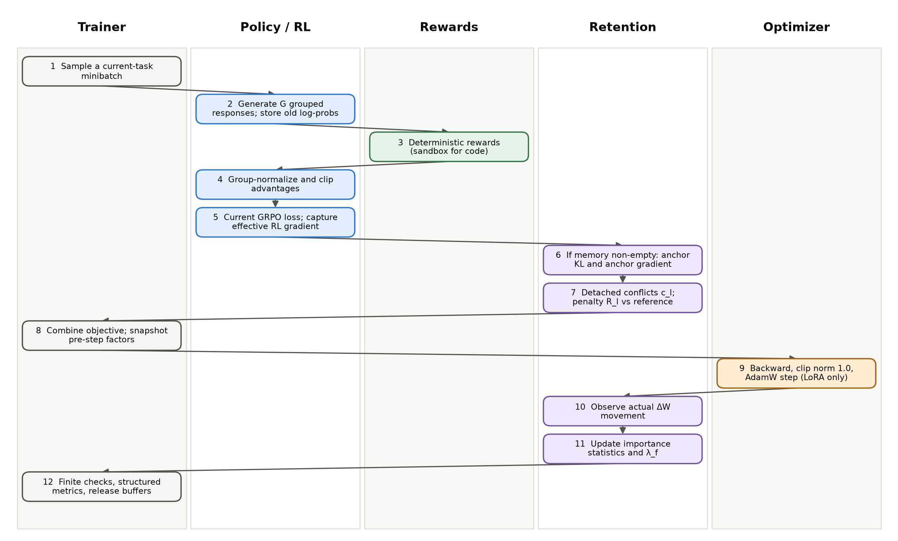
Figure 4.5: Order of operations in one RAHC-LoRA optimizer update, by owning component.
Algorithm 4.1: RAHC-LoRA continual RL training
Input: frozen backbone W0, shared LoRA factors {A_l, B_l}, task stream D_1..D_T, memory budget M
Initialize: empty anchor memory, zero importance factors p_l, q_l, lambda_f <- lambda_0
for t = 1..T:
load only D_t(train); reference <- current LoRA factors (task-start snapshot)
for each update s:
sample 2 prompts, G responses each; compute deterministic rewards
advantages <- group-normalize and clip (zero if group variance <= eps)
L_RL, g_RL <- clipped GRPO loss and effective-weight gradients
if memory not empty:
L_KL, g_anc <- compact top-k KL on an anchor minibatch
c_l <- detached conflict coefficients from g_RL, g_anc, p_l, q_l
R_l <- Gram-form effective-weight penalty vs reference
L_total <- L_RL + lambda_f * L_KL + lambda_p * sum_l c_l * R_l
snapshot DeltaW_l; backward; clip grad norm; AdamW step (LoRA only)
delta_l <- observed change of DeltaW_l
S_l <- EMA of robust-clipped relu(-g_RL * delta_l) / (delta_l^2 + eps)
lambda_f <- clamp(lambda_f + eta * (EMA(L_KL) - K_target), 0, lambda_max)
fail on any non-finite value; log metrics
consolidate: p_l, q_l <- rank-one factors of accumulated importance
store reference factors; add anchors from D_t(anchor), rebalance to budget M
evaluate all learned tasks and the capability suite -> row t of A[i, j]
write atomic checkpoint (policy, optimizer, RNG, retention state, manifests)
Output: one continual LoRA policy, compact retention state, anchor memory, full A[i, j]

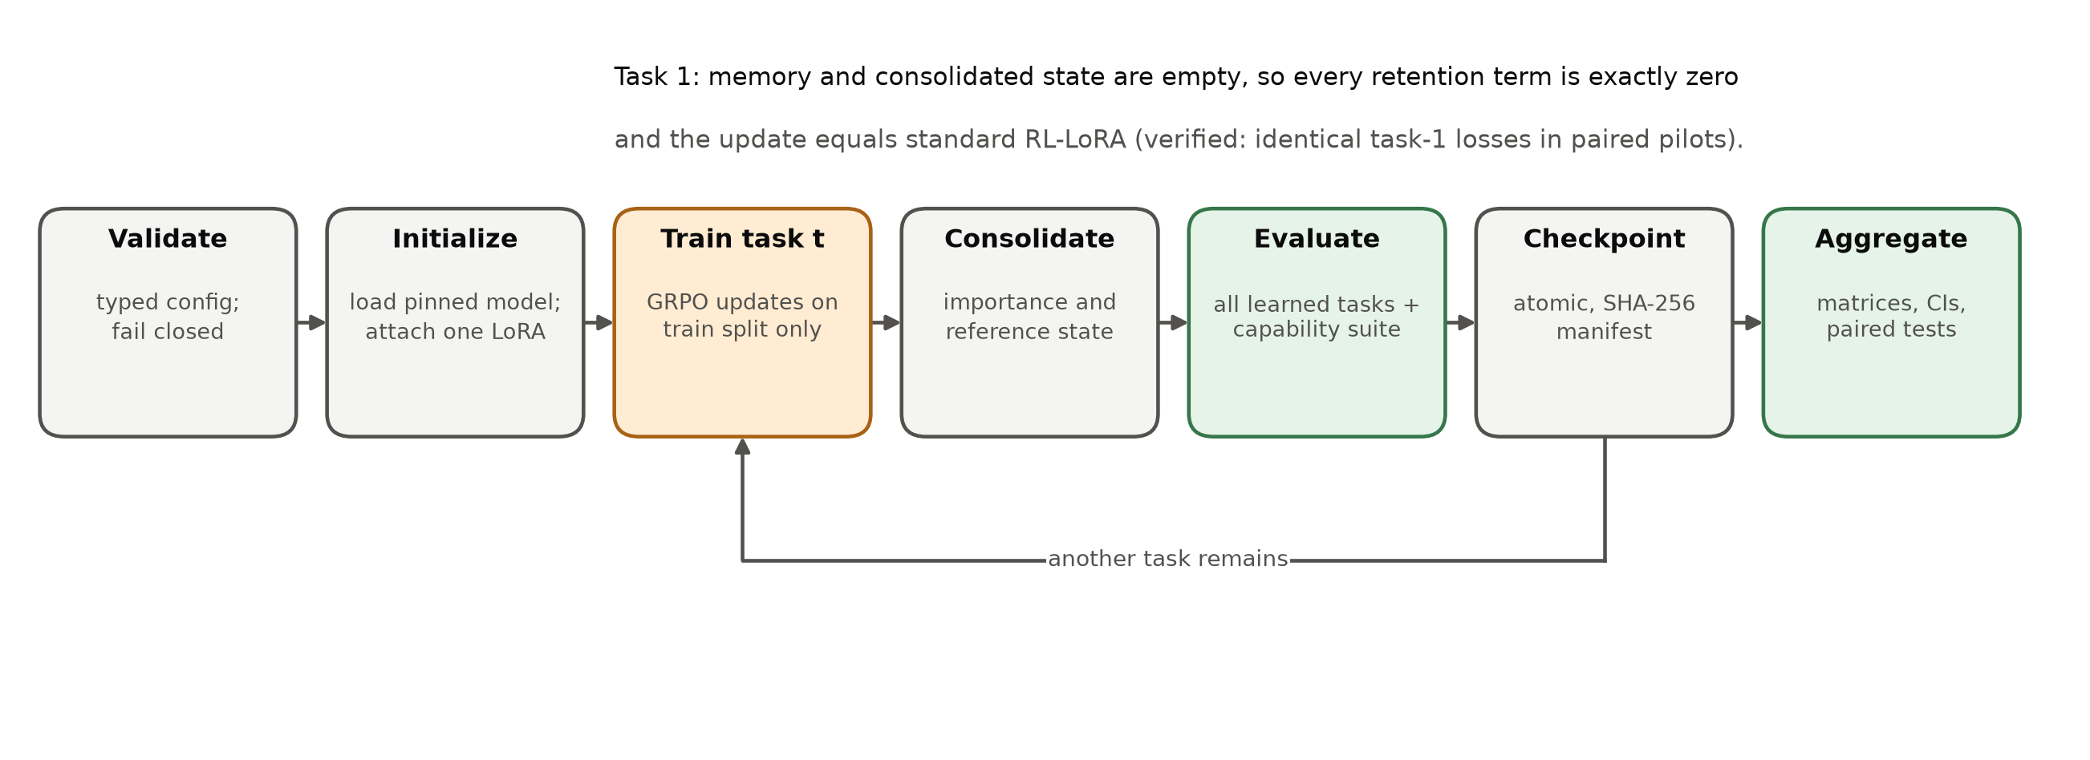
Figure 4.6: Lifecycle of a continual run. On task 1 every retention term is zero, so the update equals standard RL-LoRA.

4.3.9 Computational complexity
Relative to standard RL-LoRA, RAHC-LoRA adds per update one forward and backward pass on the anchor minibatch, two effective-gradient queries per protected module, and the Gram-form penalty. The effective gradient g_{l} = Σ (∂L/∂h) x^{T} is an O×I matrix and is the dominant transient cost. It can be processed module by module ("chunked hooks") so that at most one dense module-sized tensor is resident at a time. Persistent state is two rank-r factor sets (current and reference), O + I importance values per module, and the anchor memory. For 512 anchors with 128 response tokens and top-32 references, the memory holds about 2.1 million token-probability pairs, a few tens of megabytes, independent of the number of tasks.

4.4 Baselines
All methods run through the same trainer and evaluator and differ only in configuration (Table 4.2). They are matched on backbone, LoRA rank and targets, rollout count, optimizer steps, rewards, task order, seed, generation parameters, and memory budget where applicable. Joint multi-task RL is included only as an upper reference and is clearly marked as violating the sequential-data constraint.
Table 4.2: Methods compared in the study and the retention components each one enables (all run through the same trainer).
Method | Param. consolidation | Reward-aware importance | Factorized | Anchor KL | Conflict gate | Dual controller | Status
Standard RL-LoRA | - | - | - | - | - | - | Implemented, piloted
RL-LoRA + KL to initial policy | - | - | - | current prompts | - | - | Planned baseline
Balanced replay (same budget) | - | - | - | replay | - | - | Config stub
EWC-LoRA / SI-LoRA | yes (Fisher / SI) | - | diagnostic | - | - | - | Config stub
HLoRA-RL (direct transfer) | yes (dense SI path) | - | - (dense) | - | - (static softmax) | - | Implemented, piloted
O-LoRA (subspace) | orthogonality | - | - | - | - | - | Planned baseline
RAHC-LoRA (proposed) | yes | yes | rank-1 | yes | yes | yes | Specified; Phases 4-7
Joint multi-task RL | - | - | - | - | - | - | Upper reference (violates sequential data)

4.5 Ablation Design
Each component can be switched off through configuration (Table 4.3). The ablations answer the secondary research questions: whether anchor KL or parameter consolidation carries the effect, what factorization costs, whether reward awareness helps, whether the conflict gate and the dual controller are necessary, how much memory is needed, and whether adapter capacity and gauge invariance matter in practice.
Table 4.3: Planned ablations; each is a configuration switch, never a source edit.
Ablation | Question answered | Configuration switch
Remove anchor KL | Is parameter consolidation sufficient under policy shift? | method.use_anchor_kl=false
Remove parameter consolidation | Does behavioural retention explain the result? | method.use_parameter_consolidation=false
Dense vs factorized importance | What is lost through rank-1 compression? | method.use_factorized_importance
Reward-aware vs ordinary importance | Does advantage information improve importance? | method.use_reward_aware_importance
Remove conflict gate | Does dynamic conflict control improve plasticity? | method.use_conflict_gate=false
Static vs adaptive KL coefficient | Is the dual controller necessary? | method.use_dual_controller=false
Memory 0 / 128 / 512 / 2048 | How much historical behaviour is needed? | method.anchor_memory.capacity
LoRA rank 4 / 8 / 16 | Does adapter capacity change forgetting? | method.lora.rank (α scaled)
Effective-weight vs factor-level penalty | Does rescaling invariance matter in practice? | penalty parameterization flag

4.6 Evaluation Protocol and Metrics
After each task, the evaluator scores every learned task on its held-out test split and records one row of the performance matrix A[i, j]. Cells for tasks not yet learned are stored explicitly as missing, never as zero. The co-primary metrics are average forgetting and final average performance, with backward transfer as a secondary metric:
 | 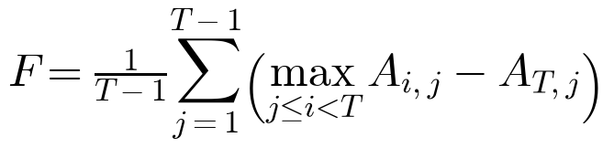 | (4.22)

 | 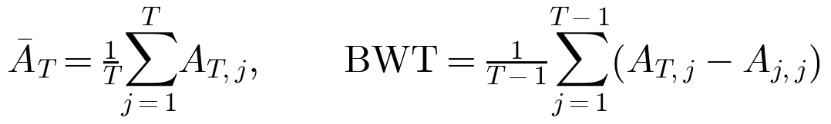 | (4.23)

A fixed general-capability suite is evaluated on the frozen starting model and after every task. It consists of the official IFEval scorer (strict and loose) [76], a fixed four-subject MMLU subset [77], HellaSwag [78], ARC-Easy [79], and WikiText-2 perplexity [80]. Every capability score is reported together with its signed change from the frozen model. Additional diagnostics include current-task learning curves, reward sparsity, parse failures, sampled policy KL, response length and diversity, gradient conflict, importance concentration, the dual multiplier, step time, throughput, and peak CPU and GPU memory.
Statistical plan. The primary analysis pairs methods by seed and task order. For each metric it reports the mean, median, standard deviation, a 95% bootstrap confidence interval [81], and an effect size. Paired comparisons use permutation or Wilcoxon signed-rank tests when the sample is small, and secondary ablations are corrected for the false discovery rate [72]. For single-run pilots, where training-seed variance cannot yet be estimated, we report evaluation-sample uncertainty on the identical held-out examples: Wilson intervals for accuracies [82], paired bootstrap intervals for differences, and exact McNemar tests on discordant pairs [83], [71]:
 | 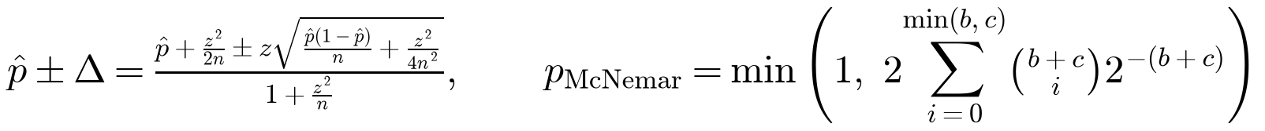 | (4.24)

where b and c are the numbers of examples solved only by the first and only by the second method. These tests do not substitute for multiple seeds [67], [68].
Decision rules. The protocol fixes in advance how results will change the method. If anchor KL alone matches the full method, parameter consolidation is reported as unnecessary. If the conflict gate provides no consistent benefit, factorized importance plus anchor KL becomes the main method. If factorization loses substantial retention, a small factorization rank is tested before compression is abandoned. If no forgetting occurs, the stream is redesigned. If forgetting falls but current-task performance falls materially, the result is reported as over-consolidation.

4.7 Hyperparameters
Table 4.4 lists the default hyperparameters, fixed before any method pilot. They are tuned only on validation splits, never on test results.
Table 4.4: Default RAHC-LoRA hyperparameters fixed in the specification before any method pilot.
Component | Hyperparameter | Default
LoRA | rank / α / dropout / targets | 8 / 16 / 0.0 / q, k, v, o projections (pilots); 8-16 in main study
Importance | EMA beta / epsilon / clip quantile / accumulator | 0.99 / 1e-8 / 0.995 / FP32
Anchor memory | capacity / batch / top-k logits / selection | 512 / 16 / 32 / balanced, diverse reservoir
Conflict gate | zero-norm threshold / coefficient clip | 1e-12 / 5.0
Dual controller | initial λ / dual lr / target KL / EMA / max λ / patience | 0.01 (specification; rahc_lora.yaml currently inherits 0.0 and must be updated) / 0.001 / 0.02 / 0.95 / 10.0 / 100 steps
Parameter penalty | lambda_parameter | 1.0
GRPO | group size / prompts per update / clip ε / advantage clip | 4 / 2 / 0.2 / 5.0
Optimizer | AdamW lr / betas / weight decay / grad-norm clip | 1e-4 / (0.9, 0.999) / 0.0 / 1.0

Chapter 5: Implementation and Experimental Setup
This chapter describes how the methodology was implemented: the software architecture, data collection and preprocessing, rewards and the code sandbox, the policy and GRPO trainer, the direct HLoRA-to-RL baseline, evaluation, checkpointing, and validation. It ends with the configuration of the GPU pilots and the implementation status of every phase.

5.1 System Architecture and Software Design
The platform is a Python 3.11 package, rahc_lora, with a single command-line interface (doctor, prepare-data, train) and typed Hydra configuration. The code follows a strict layered architecture (Figure 5.1). The interface layer only parses configuration and calls package functions. The orchestration layer (the ContinualTrainer, checkpointing, and run artifacts) coordinates components without implementing scientific logic. The domain layer contains the RL objective, consolidation, and evaluation. The adapter layer wraps models, tasks, and rewards, and the infrastructure layer provides validated configuration, atomic file writes, structured logging, manifests, and reproducibility utilities. Dependencies point downward only. Scientific logic such as losses, answer parsing, and forgetting metrics never lives in scripts or notebooks.
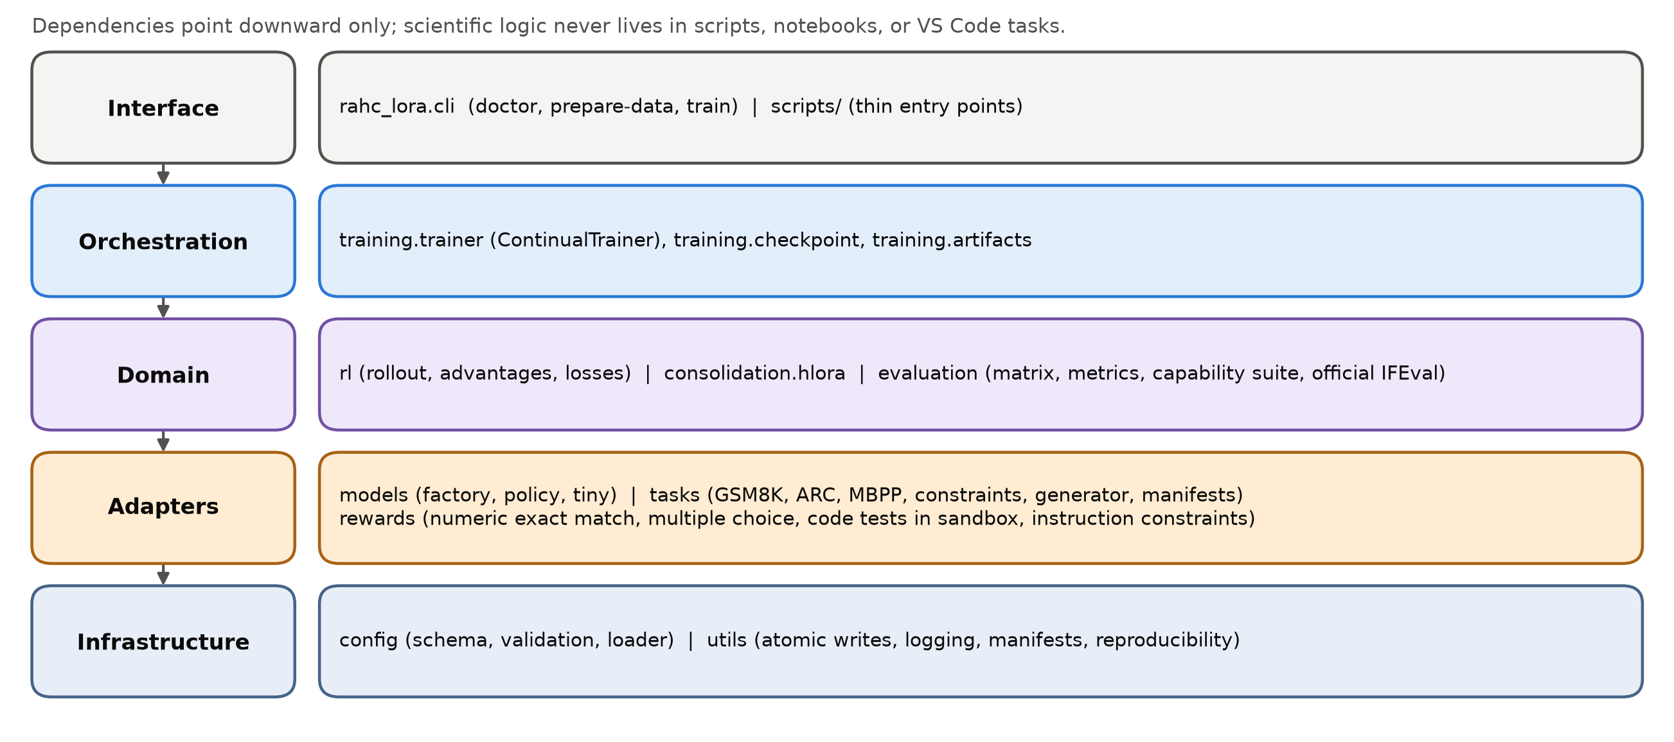
Figure 5.1: Layered software architecture of the rahc_lora package.
Configuration is composed by Hydra from groups (model, task, method, task stream, experiment, rollout, optimizer, scheduler, checkpoint, launcher, and sandbox). It is validated into immutable dataclasses and frozen when a run starts. Validation enforces, for example, that the standard method rl_lora enables no retention component, that model revisions are 40-character commit hashes, and that a requested precision is supported, with no silent fallback. The resolved configuration and its SHA-256 hash are saved with every run and checkpoint.

5.2 Data Collection and Preprocessing

5.2.1 Data sources
The continual-RL stream uses four task families, and the capability suite uses five evaluation-only datasets, all pinned to exact Hugging Face revisions (Table 5.1). GSM8K [84] provides grade-school math word problems with numeric answers. ARC-Challenge [79] provides grade-school science questions with three to five labelled options. MBPP [85], sanitized version, provides Python programming problems with hidden assert-based tests. The custom verifiable-constraints dataset is generated by the project.
Table 5.1: Pinned datasets, project roles, split sizes, and training rewards.
Dataset (revision) | Role | Train | Val. | Anchor cand. | Test / eval | Reward or metric
GSM8K main (740312a) | RL task | 5,979 | 747 | 747 | 1,319 | normalized exact final number
ARC-Challenge (210d026) | RL task | 1,007 | 299 | 112 | 1,172 | exact option label
MBPP sanitized (4bb6404) | RL task | 108 | 43 | 12 | 257 | fraction of hidden tests passed (sandbox)
Custom constraints v1.0.0 | RL task | 32 | 16 | 16 | 16 | fraction of constraints satisfied
IFEval (966cd89) | Evaluation only | - | - | - | 541 | official strict / loose scorer
MMLU, 4 subjects (c30699e) | Evaluation only | - | - | - | 623 | exact option label
HellaSwag (218ec52) | Evaluation only | - | - | - | 10,042 | exact option label
ARC-Easy (210d026) | Evaluation only | - | - | - | 2,376 | exact option label
WikiText-2 raw (b08601e) | Evaluation only | - | - | - | 2,891 | token perplexity (<= 256 tokens)
Note: Custom-constraint prompts: 0 exact and 0 normalized overlaps with the 541 official IFEval prompts. The pilots evaluate the first 64 or 128 examples of each held-out split.

5.2.2 Data cleaning and split construction
Raw records are never modified or committed. Each record receives a stable identifier, the SHA-256 hash of configured immutable identity fields (for example the GSM8K question text or the ARC item ID). Source training records are ranked by the SHA-256 of "split_seed:example_id". This makes role assignment independent of the order in which the provider returns records. Official splits are preserved where they exist. GSM8K has no validation split, so validation (10%) and anchor candidates (10%) are taken from the ranked source training split, and the official test split is the held-out test. ARC-Challenge and MBPP keep their official validation and test splits, and anchor candidates (10%) are removed from the source training split. Every trainable manifest rejects duplicate IDs and duplicate content hashes across roles, and empty roles fail loudly (Figure 5.2).
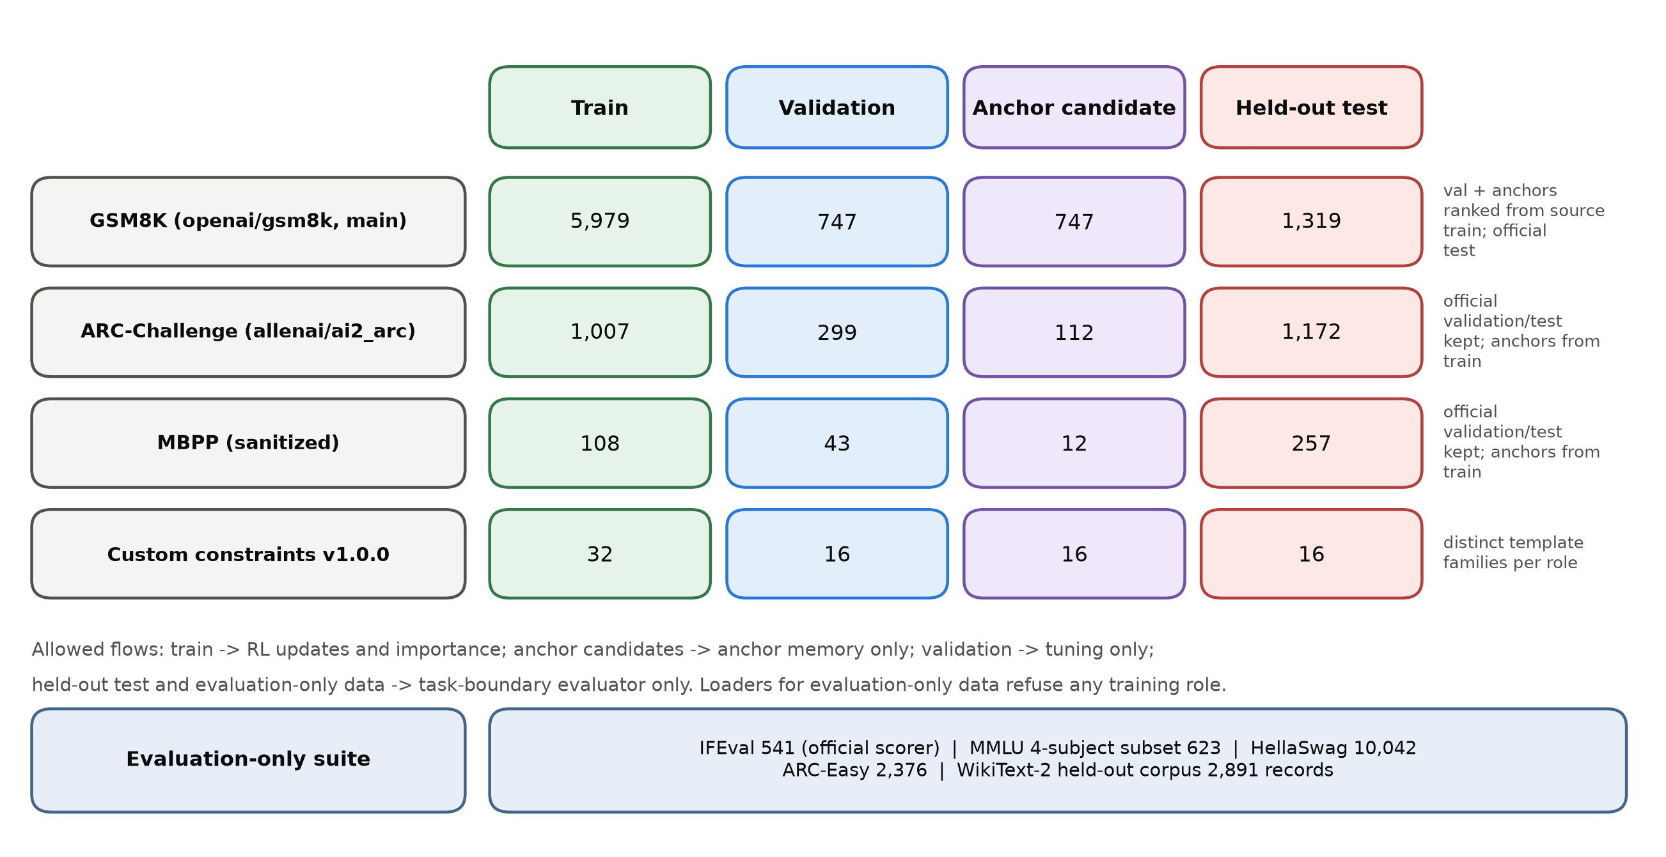
Figure 5.2: Data roles and isolation. Split sizes of the four RL tasks and the evaluation-only suite, with the flows each role is allowed to feed.

5.2.3 Data transformation: prompts and answer formats
Each task formats a fixed, versioned prompt. GSM8K uses "Solve the problem. Give your final numeric answer clearly." followed by the problem. ARC-Challenge uses "Choose the correct option and end with its label." followed by the question and labelled options. MBPP uses "Write a complete Python solution. Return only Python code; do not include tests." followed by the problem; the tests are hidden from the prompt. The capability suite uses "Select the best completion and answer with its label." for MMLU, HellaSwag, and ARC-Easy, and the official IFEval prompts unchanged. Prompts are tokenized with the pinned tokenizer and truncated to 128 tokens.

5.2.4 Custom verifiable-constraint dataset
Official IFEval must remain evaluation-only, so the constraint task uses a separate, generated dataset (version 1.0.0, seed 20260922) of 80 prompts from eight template families. The families are separated by role: topic-keyword-bullets and brief-forbidden-ending for training; summary-sections and JSON-profile for validation; steps-keyword and note-word-range for anchor candidates; and recommendation-bullets and JSON-inventory for test. Constraints include an exact bullet count, keyword counts, forbidden words, required ending phrases, word-count intervals, titled sections, and valid JSON with required fields. The reward is the fraction of constraints satisfied. Before manifests are written, every custom prompt is compared with the 541 official IFEval prompts by exact and aggressively normalized text. The checked-in audit reports zero exact and zero normalized overlaps. Any overlap would abort data preparation.

5.2.5 Summary of preprocessed data
Preparation writes only JSON manifests and the overlap audit. Each manifest records the canonical source, revision, license and citation, source-split mapping, preprocessing, prompt and reward versions, exact role membership IDs, content hashes, and per-example provenance. The run manifest of every GPU run records the SHA-256 fingerprint of each dataset manifest, so any change to the data protocol produces a visibly different run identity.

5.3 Rewards and Isolated Code Execution
All rewards are deterministic functions with a documented range of [0, 1]. Malformed or ambiguous answers receive a documented score of zero rather than a guessed interpretation. The numeric scorer extracts the final number after an explicit marker ("####", "final answer", or "answer") or, failing that, the last number in the response. It converts the number to an exact rational, handling thousands separators, currency symbols, fractions, and percentages, and compares it exactly with the reference. The multiple-choice scorer accepts one unambiguous label after a marker such as "answer:", a bare label, or an exact normalized option text. It rejects responses that name two different labels. Unit tests cover hand-written accepted, rejected, malformed, and normalization-equivalent examples for every scorer.
Generated code is executed only through an isolated Docker runner (Figure 5.3). Each response is written with its hidden tests into a read-only workspace. It runs in a new container from a digest-pinned image with no network, a read-only root file system, all capabilities dropped, no-new-privileges, user 65534, 256 MB of memory with no additional swap, one CPU, 32 processes, CPU-time and file-descriptor limits, a 5-second timeout, and a 64 KiB output cap. The container is removed afterwards. Only the test outcome leaves the sandbox. If the Docker daemon is unavailable, scoring raises an error: there is no host-execution fallback.
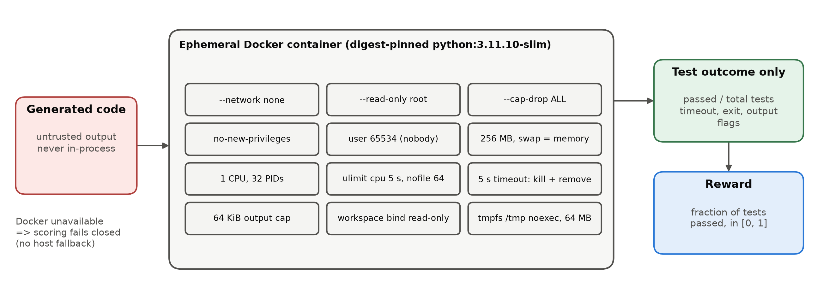
Figure 5.3: Security boundary for code rewards. Generated code runs only in an ephemeral, network-disabled, resource-limited container, and only the test outcome leaves it.

5.4 Policy, Rollouts, and the GRPO Trainer
The model factory loads the pinned causal LM (Qwen2.5-0.5B-Instruct or Qwen2.5-1.5B-Instruct [86]) in explicit BF16 with remote code disabled. It freezes every backbone parameter and attaches exactly one PEFT LoRA adapter (rank 8, α = 16, dropout 0) to the q, k, v, and o projections of every layer. For Qwen2.5-1.5B this gives 2,179,072 trainable parameters. The same closed-form count reproduces the 1,081,344 trainable parameters that the factory reported when loading Qwen2.5-0.5B on CUDA. Only LoRA tensors enter the AdamW optimizer [26], and the adapter is never reset between tasks. A CPU-only tiny model with a byte-level tokenizer shares the same policy interface and is used for deterministic tests.
Each update samples two training prompts by deterministic cycling through the current task's training split. It draws G = 4 responses per prompt with temperature 1.0, top-p 1.0, and at most 128 new tokens, storing the old log-probability of every generated token. Rewards are then normalized within each group in FP32 using the population standard deviation. Groups with a standard deviation at or below 10⁻⁸ receive exactly zero advantage, and advantages are clipped to ±5. The token-mean clipped surrogate (ε = 0.2) is optimized with one AdamW step per rollout, a learning rate of 10⁻⁴, and gradient-norm clipping at 1.0. Rewards, advantages, loss, and gradients are checked for finiteness before the optimizer is allowed to change any parameter. These semantics, which libraries leave open, are fixed in a decision record so that a dependency upgrade cannot change the objective.
Each update logs raw and normalized reward statistics, the number of zero-variance groups, the advantage and ratio clipping fractions, the gradient norm and whether it was clipped, the sampled policy KL (the mean of the old minus new log-probability, a diagnostic of step size), response length and distinct-response fraction, and reward diagnostics. The diagnostics separate parse failures from executed code that failed tests, timeouts, output-limit events, and non-zero exits. System metrics record step time, tokens per second, process memory, and peak GPU allocation.

5.5 Direct HLoRA-to-RL Implementation
The direct HLoRA-to-RL baseline (method hlora_rl) is the Phase 3 reference for consolidation. It transfers the HLoRA idea of element-wise importance with layer coefficients [20] to the shared RL trainer, with two corrections required by RL: importance uses the gradient of the real RL loss, and it uses the movement actually produced by AdamW (Figure 5.4).
During each update, forward hooks on every LoRA target layer capture the input activation (after the configured dropout) and the output gradient. From these the dense effective-weight gradient G_{l} is formed for the forward pass, without reconstructing it from factor gradients. After the optimizer step, the path integral is accumulated with the observed change of the effective update:
(5.1)

At the task boundary, negative path contributions are clamped to zero, the result is normalized by the squared total displacement over the task, and the importance is added to that of earlier tasks. Static layer coefficients are then computed as a softmax over the L2 norms of the module importances:
 | 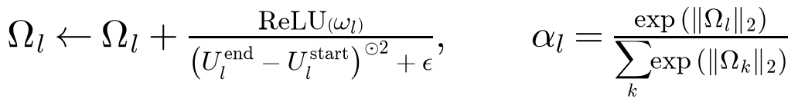 | (5.2)

During the next task, the penalty against the reference effective update is added to the GRPO loss with λ = 1:
 | 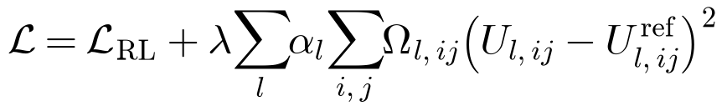 | (5.3)

Importance is stored densely on the CPU in FP32, and dense module-sized transfers happen once per update. The checkpoint stores the reference LoRA factors, the dense importance, and the layer coefficients. Reference effective updates are recomputed from the stored factors. Unit tests check that zero movement gives a zero path contribution, that the penalty against a reference matches a direct computation, and that the state survives serialization exactly. As Chapter 6 shows, this baseline behaves exactly like RL-LoRA on the first task, as required. It also reveals a weakness of the softmax coefficients, which is the main design lesson of P2.
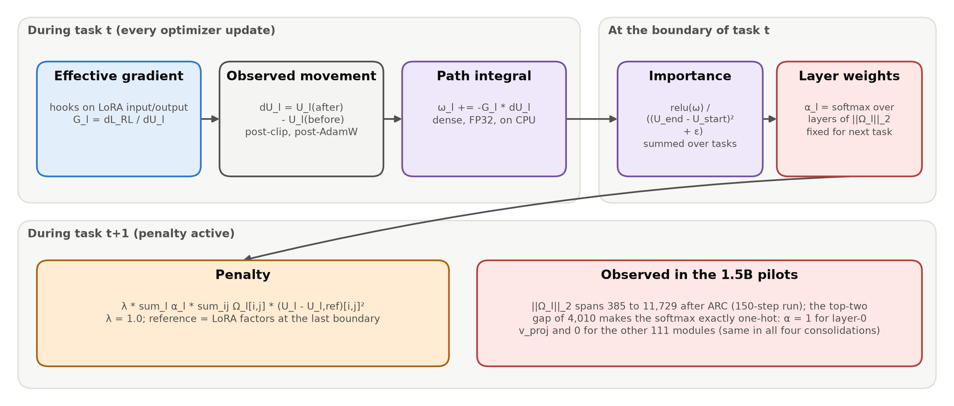
Figure 5.4: The implemented direct HLoRA-to-RL baseline, with the coefficient collapse observed in the pilots.

5.6 Evaluation Implementation
At each task boundary, the evaluator generates greedy responses (at most 64 new tokens) for the held-out test examples of every learned task. It scores them with the task's reward and writes one row of the performance matrix together with per-example records. The records contain example IDs, prompt and response hashes, rewards, and parse status, not raw text. Continual metrics are computed only from a complete matrix. Forward transfer is reported as unavailable unless the corresponding pre-learning cells were evaluated.
The capability suite is evaluated once on the frozen starting policy and after every task, and each score is stored with its signed change from the frozen baseline. IFEval is scored with the official Google Research implementation checked out at a pinned commit. Its four runtime source files and the NLTK punkt_tab resource are verified by digest before use, and there is no approximate fallback scorer. MMLU uses a fixed subset of four subjects (abstract algebra, college computer science, high-school physics, professional medicine). MMLU, HellaSwag, and ARC-Easy are scored by exact option label with the same parser as the training tasks, and perplexity is computed on non-empty WikiText-2 test records truncated to 256 tokens. The pilots evaluate the first 64 or 128 examples of each split and capability, as configured.

5.7 Checkpointing, Artifacts, and Reproducibility
Every run writes a fixed artifact layout (Figure 5.5): the resolved configuration, a schema-validated run manifest (model and tokenizer revisions, command overrides, dependency versions, hardware, and Git state when available), dataset fingerprints, structured learning and system metrics, evaluation records, the performance matrix, capability scores, layer diagnostics, the memory and checkpoint manifests, and a final summary. Checkpoints are written at every task boundary into a new directory, with the size and SHA-256 hash of every file recorded in a manifest. The latest-checkpoint pointer changes only after validation and atomic replacement succeed, and no valid checkpoint is ever overwritten. A checkpoint contains the adapter, optimizer, scheduler, task and step counters, the rollout counter and policy version, the general and rollout RNG states, the performance matrix, the capability history, and the retention state (empty for RL-LoRA, and reference factors, importance, and layer coefficients for HLoRA-RL). Resume rejects any change to the scientific configuration, the model identity, the data fingerprints, or the dependency versions.
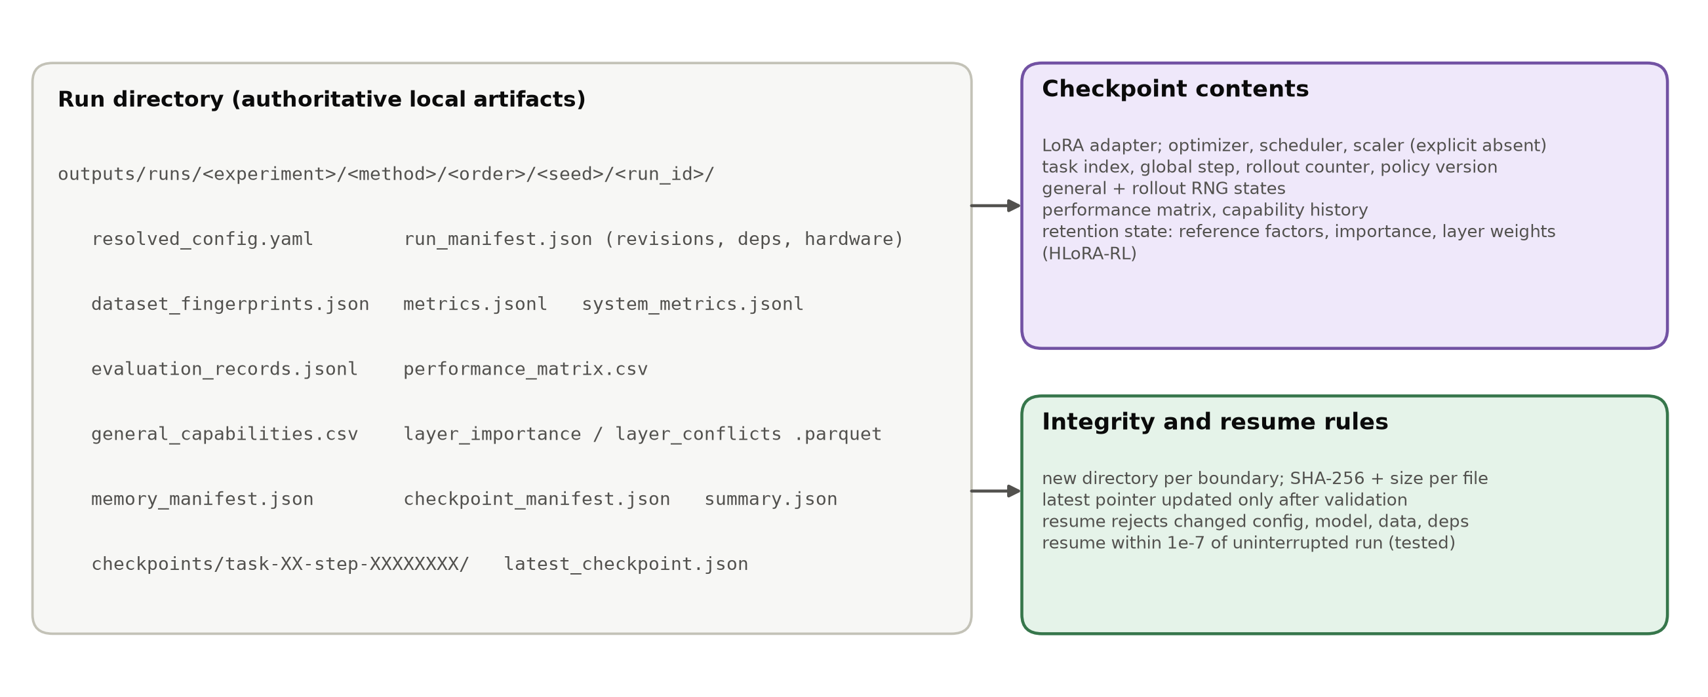
Figure 5.5: Run artifacts and checkpoint contract.
This design proved its value during P2. The 1,000-update MBPP → GSM8K pilot stopped after 918 updates, during GSM8K. Its only resumable checkpoint was the verified task-1 boundary at step 500. A recovery run restored that checkpoint under the identical configuration hash, replayed the remaining 500 GSM8K updates, and completed the final evaluation. Both the source and the recovered checkpoints pass file-membership, size, and hash validation, and the recovery provenance is recorded alongside the artifacts.

5.8 Experimental Setup
All GPU pilots share the configuration in Table 5.2. The stream design proceeded in two stages. Phase 2 tested standard RL-LoRA on the pre-registered order_1 (GSM8K → ARC-Challenge) and order_2 (MBPP → GSM8K) streams at 100 and 500 updates per task, to find out whether the baseline forgets. Because the first task was learned only weakly in these streams (Chapter 6), a stream with a strong first task, ARC-Challenge → GSM8K ("order_arc_first"), was then used to compare RL-LoRA and HLoRA-RL at 100 and 150 updates per task. Runs were executed back to back with identical seeds and settings. Table 5.3 lists every analysed run.
Table 5.2: Experimental configuration shared by all GPU pilots (values from the resolved run configurations).
Setting | Value
Backbone | Qwen2.5-1.5B-Instruct (one 0.5B pilot), BF16, frozen
Adapter | one LoRA, rank 8, α 16 (scale 2.0), dropout 0, q/k/v/o in all layers; 2,179,072 trainable parameters (1.5B)
Rollouts | 2 prompts x G = 4 responses per update (8 rollouts); temperature 1.0, top-p 1.0; <= 128 prompt and <= 128 response tokens
GRPO | population-std group normalization, zero advantage for zero-variance groups, advantage clip 5.0, ratio clip 0.2, one update per rollout
Optimizer | AdamW, lr 1e-4, betas (0.9, 0.999), no weight decay, grad-norm clip 1.0, constant schedule
Budgets | 100 or 500 updates per task (Phase 2); 100 or 150 updates per task (ARC -> GSM8K)
HLoRA-RL | λ = 1.0, epsilon = 1e-8, dense importance on CPU, static softmax layer weights
Evaluation | greedy decoding, <= 64 new tokens; 128 (Phase 2) or 64 (ARC -> GSM8K) held-out examples per task and capability
Seed / orders | seed 1; order_1 (GSM8K -> ARC), order_2 (MBPP -> GSM8K), order_arc_first (ARC -> GSM8K)

Table 5.3: Inventory of the GPU runs analysed in this report (seed 1 in every run).
Label | Model | Order | Updates / task | Eval n | Optimizer hours | Run ID
P2-A RL-LoRA | Qwen2.5-0.5B | GSM8K -> ARC | 100 | 128 | 2.3 | phase2-pilot-gpu-128-20260924
P2-B RL-LoRA | Qwen2.5-1.5B | GSM8K -> ARC | 100 | 128 | 2.8 | phase2-pilot-confirmation-gpu-128-20260924
P2-C RL-LoRA | Qwen2.5-1.5B | GSM8K -> ARC | 500 | 128 | 16.7 | phase2-pilot-duration-500-gpu-128-20260924
P2-D RL-LoRA | Qwen2.5-1.5B | MBPP -> GSM8K | 500 | 128 | 7.3 | phase2-pilot-order2-recovery-20260926
P3-A RL-LoRA | Qwen2.5-1.5B | ARC -> GSM8K | 100 | 64 | 2.8 | phase3-pilot-baseline-arc-gsm-100
P3-A HLoRA-RL | Qwen2.5-1.5B | ARC -> GSM8K | 100 | 64 | 2.9 | phase3-pilot-hlora-arc-gsm-100
P3-B RL-LoRA | Qwen2.5-1.5B | ARC -> GSM8K | 150 | 64 | 4.2 | phase3-scaled-baseline-arc-gsm-150
P3-B HLoRA-RL | Qwen2.5-1.5B | ARC -> GSM8K | 150 | 64 | 4.3 | phase3-scaled-hlora-arc-gsm-150
Note: P2-D optimizer hours cover the 500 recovered GSM8K updates; the preserved source run supplied the MBPP task and its verified step-500 checkpoint.
Two deviations from the initial pilot plan were made using training rollouts only and are documented. First, the training response budget was raised from 32 to 128 tokens after probes at 32 and 64 tokens produced no GSM8K reward. Second, the budget was extended from 100 to 500 updates per task after the 1.5B confirmation pilot showed positive GSM8K reward in only 28 of 100 training batches. Held-out scores were not used to choose either setting.

5.9 Validation and Testing
Following the rule "cheap validation before expensive validation", the platform was validated before any GPU run and re-validated afterwards (Table 5.4). The test suite contains unit tests for splits and manifests, rewards, the constraint generator and IFEval overlap, the sandbox command, GRPO advantages and loss, continual metrics, the capability suite, the official IFEval adapter, and HLoRA importance, together with integration tests for data preparation, mock two-task evaluation, and interrupted training with resume. At the time of writing all 59 tests pass in 12.5 seconds on CPU.
Table 5.4: Engineering validation evidence (cheap checks before GPU runs).
Check | Result
Unit and integration tests | 59 passed in 12.5 s (CPU, Python 3.12 venv); also 56/56 in the CUDA gpu-env at Phase 2
Frozen backbone | synthetic-reward update changes LoRA tensors; every frozen parameter bit-identical
Interrupted resume | adapter and matrix match the uninterrupted run within 1e-7 absolute tolerance
Repeat determinism | two CLI smoke runs match exactly in adapter tensors, events, summary, matrix
First-task equivalence | HLoRA-RL and RL-LoRA losses and gradient norms bit-identical for all task-1 updates
Checkpoint integrity | all files in every pilot checkpoint pass size and SHA-256 validation
Data isolation | custom constraints vs IFEval: 0 exact, 0 normalized overlaps; duplicate IDs and hashes rejected
Sandbox | Docker backend passed a generated-code check; unavailable Docker fails closed
IFEval scorer | pinned google-research checkout and NLTK punkt_tab digest verified; no fallback scorer

5.10 Implementation Status
Table 5.5 summarizes the status of each phase, established from repository evidence rather than from file names. Phases 0-2 are complete. Phase 3 is partly complete: the dense HLoRA-to-RL baseline is implemented and has been piloted, but the separate supervised HLoRA reproduction on SciQ, PiQA, MedMCQA, and a Pile subset has not yet been run. Phases 4-7, the RAHC-LoRA components specified in Chapter 4, have not been started. Their configuration switches exist and are validated, but the trainer currently accepts only the rl_lora and hlora_rl methods. It rejects the others explicitly, so no result in this thesis could come from an unimplemented component.
Table 5.5: Phase-by-phase implementation status established from repository evidence (29 September 2026).
Phase | Deliverable | Status | Evidence
0 | Scaffold, typed Hydra config, CLI, logging, manifests, tooling | Complete | doctor, ruff, mypy, pytest pass
1 | Four task adapters, generator, rewards, sandbox, matrix and metrics | Complete | hand-checked reward tests; mock two-task gate
2 | Standard RL-LoRA GRPO trainer, checkpoint/resume, capability suite | Complete | 4 GPU pilots; resume within 1e-7
3 | Direct HLoRA-to-RL baseline | Partial | dense importance + penalty implemented and piloted; supervised reproduction not yet run
4 | Reward-aware effective-weight importance | Not started | specified (Section 4.3.3)
5 | Rank-1 factorization and Gram-form penalty | Not started | specified (Section 4.3.4)
6 | Fixed anchor memory and compact KL | Not started | specified (Section 4.3.5)
7 | Conflict gate and dual controller | Not started | specified (Section 4.3.6)
8-9 | Method pilot, main study, ablations, statistics | Not started | gated by continuation rule

Chapter 6: Results and Discussion
This chapter reports the results of the eight analysed GPU pilots. All numbers are computed directly from the raw run artifacts by a versioned analysis script. Nothing is copied from earlier summaries, and Appendix D lists where those summaries differed. All pilots use one training seed. Uncertainty statements therefore describe the finite evaluation samples, not seed-to-seed training variance, and no result in this chapter is a test of the full RAHC-LoRA method.

6.1 Overview of Experiments
Two groups of experiments were run. The first group (Phase 2) tested whether standard RL-LoRA forgets on the pre-registered streams: four runs on GSM8K → ARC-Challenge and MBPP → GSM8K with 100 or 500 GRPO updates per task. The second group compared standard RL-LoRA with the direct HLoRA-to-RL baseline on ARC-Challenge → GSM8K, with 100 and 150 updates per task. This stream was chosen after Phase 2 because its first task is learned strongly and therefore can be forgotten, so the comparison is exploratory rather than part of the pre-registered order set.

6.2 Standard RL-LoRA Pilots and the Continuation Rule
Figure 6.1 and Table 6.1 show the performance matrices of the Phase 2 pilots. No stream showed meaningful forgetting. With the 0.5B model and 100 updates per task, GSM8K reached only 1.56% (2/128) and fell to 0.78% (1/128) after ARC-Challenge. With the 1.5B model and 100 updates per task, GSM8K rose from 3.91% (5/128) to 4.69% (6/128) after ARC-Challenge, a small positive backward transfer. Extending training to 500 updates per task raised GSM8K to 18.75% (24/128). After 500 ARC-Challenge updates, which brought ARC-Challenge to 75.78% (97/128), GSM8K still scored 17.19% (22/128), a loss of only two problems or 1.56 points. On MBPP → GSM8K, MBPP reached only 4.95% after 500 updates (a mean fraction of tests passed) and rose slightly to 6.25% after GSM8K.
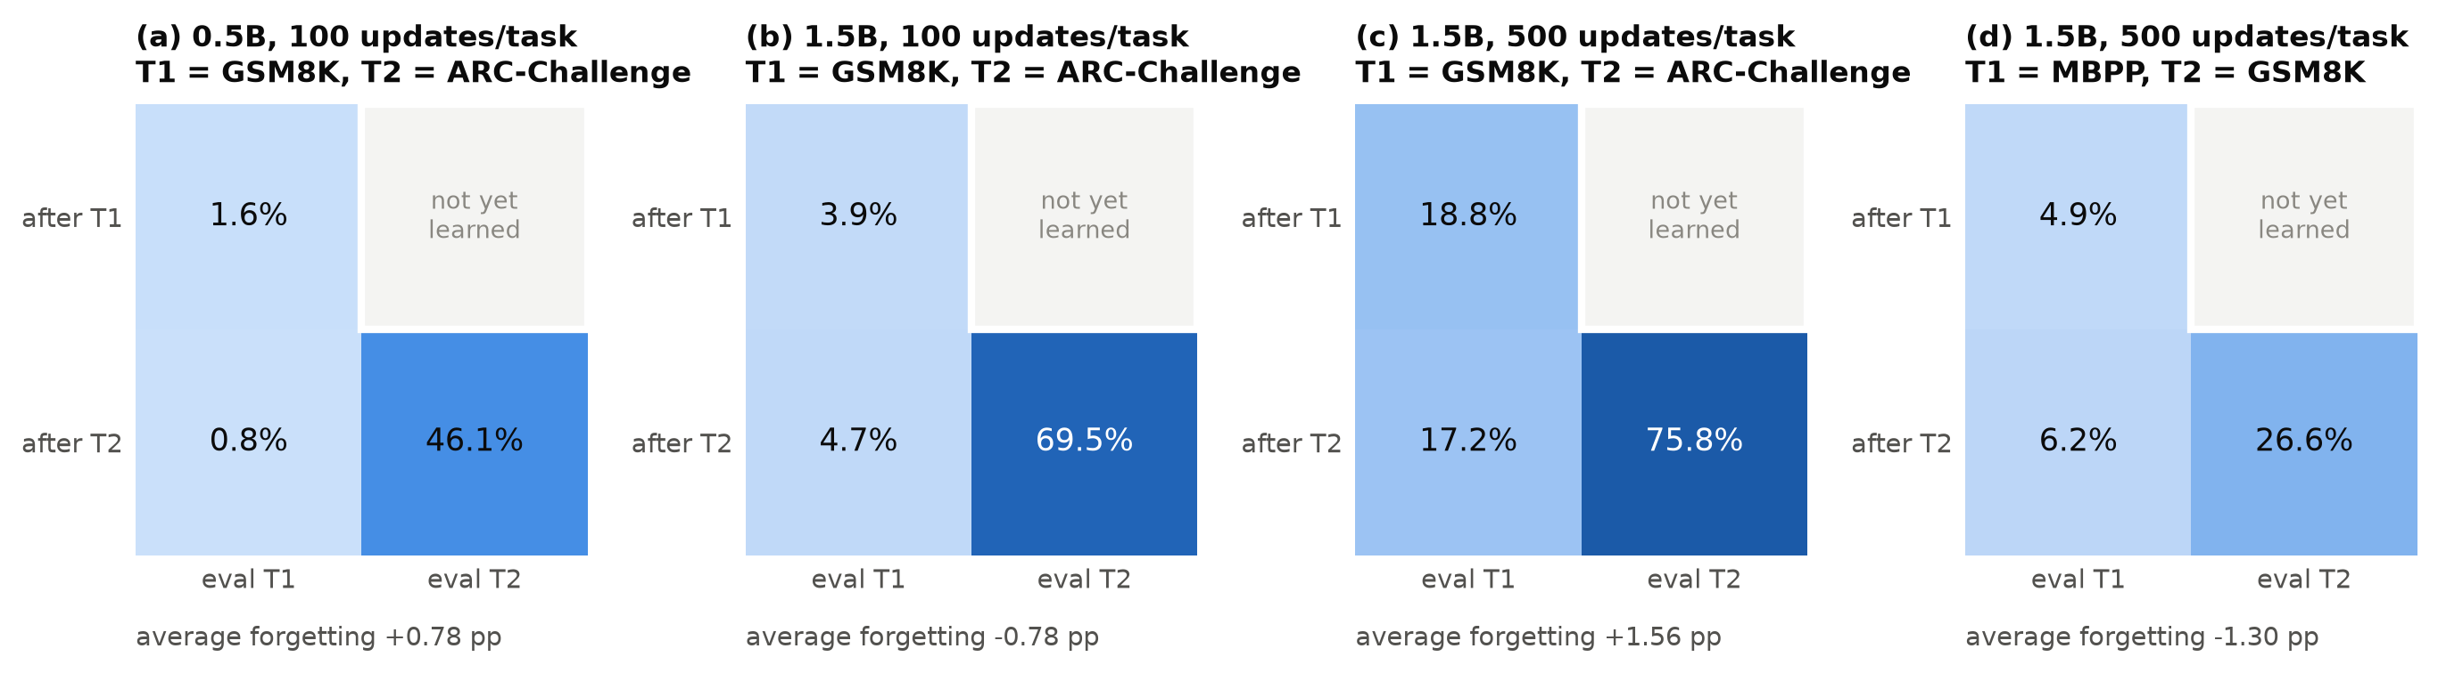
Figure 6.1: Performance matrices of the standard RL-LoRA Phase 2 pilots (held-out accuracy, n = 128 per cell).
Table 6.1: Standard RL-LoRA pilots: performance matrices and continual metrics (percent; seed 1).
Run | T1 after T1 | T1 after T2 | T2 after T2 | Forgetting (pp) | BWT (pp) | Final avg. | Meets 10 pp rule
0.5B GSM8K -> ARC, 100/task | 1.56 | 0.78 | 46.09 | +0.78 | -0.78 | 23.44 | no
1.5B GSM8K -> ARC, 100/task | 3.91 | 4.69 | 69.53 | -0.78 | +0.78 | 37.11 | no
1.5B GSM8K -> ARC, 500/task | 18.75 | 17.19 | 75.78 | +1.56 | -1.56 | 46.48 | no
1.5B MBPP -> GSM8K, 500/task | 4.95 | 6.25 | 26.56 | -1.30 | +1.30 | 16.41 | no
1.5B ARC -> GSM8K, 100/task | 76.56 | 76.56 | 1.56 | +0.00 | +0.00 | 39.06 | no
1.5B ARC -> GSM8K, 150/task | 82.81 | 79.69 | 3.12 | +3.12 | -3.12 | 41.41 | no

The pilot continuation rule requires a loss of at least 10 points on some prior task under standard RL-LoRA. Figure 6.2 places every standard RL-LoRA stream, including the two ARC-first runs, against that threshold. Measured forgetting ranged from −1.30 to +3.12 points. In three streams the first task was learned so weakly that even total collapse could not have produced a 10-point loss (maximum possible losses of 1.6, 3.9, and 4.9 points). In the remaining streams the first task was learned well (18.8%, 76.6%, 82.8%) but lost at most 3.12 points. The continuation rule is therefore not met. Following the protocol, no multi-seed method study was launched on these streams.
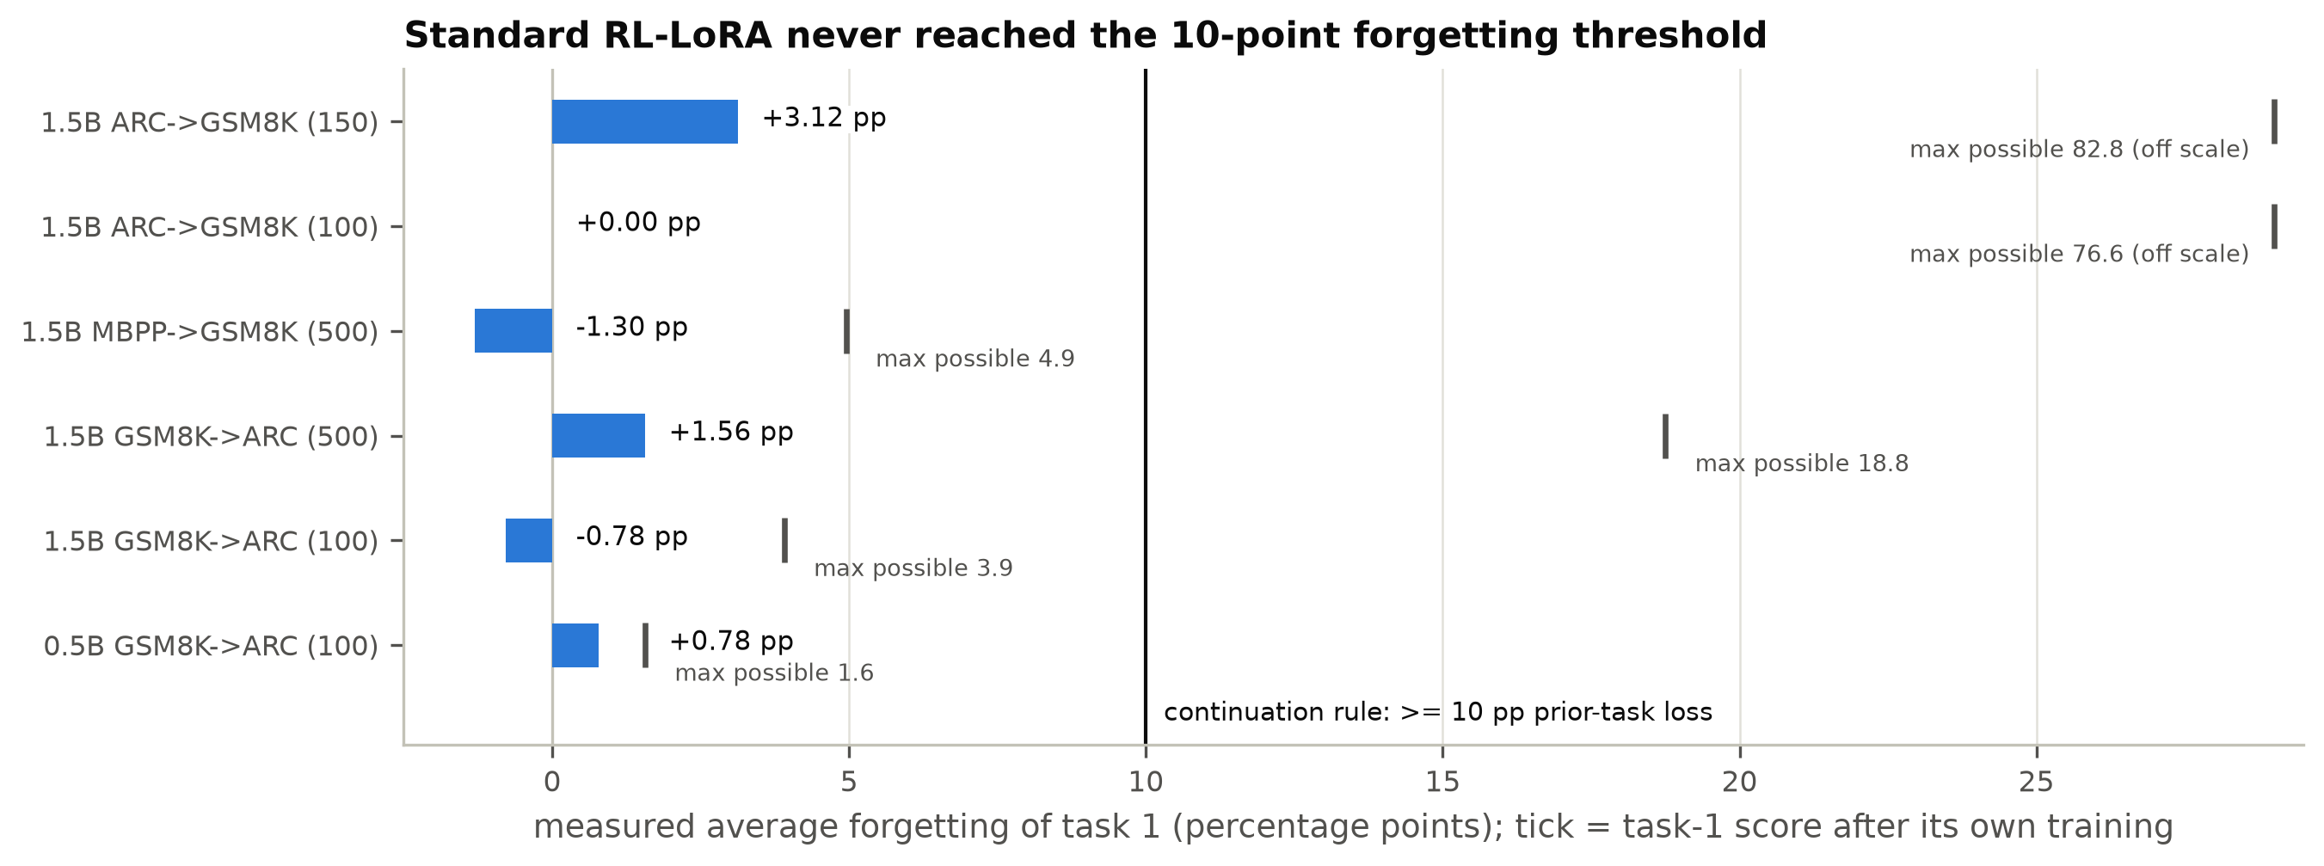
Figure 6.2: Measured task-1 forgetting of standard RL-LoRA in every stream, compared with the 10-point continuation threshold. The tick shows the largest loss that was possible given the task-1 score.

6.3 ARC-Challenge → GSM8K: RL-LoRA versus HLoRA-RL
Figure 6.3 and Table 6.2 compare the two methods on ARC-Challenge → GSM8K. Because the first task carries no retention term, both methods produced identical ARC-Challenge scores after task 1: 76.56% (49/64) at 100 updates and 82.81% (53/64) at 150 updates. After GSM8K training, the ARC-Challenge score of RL-LoRA was unchanged at 100 updates and fell by 3.12 points (two problems) at 150 updates. HLoRA-RL lost 1.56 points at 100 updates and exactly the same 3.12 points at 150 updates. HLoRA-RL did not reduce forgetting in either budget. At 150 updates the two methods even lost the same two ARC-Challenge items, and their correctness on the 64 ARC-Challenge items after task 2 agreed exactly.
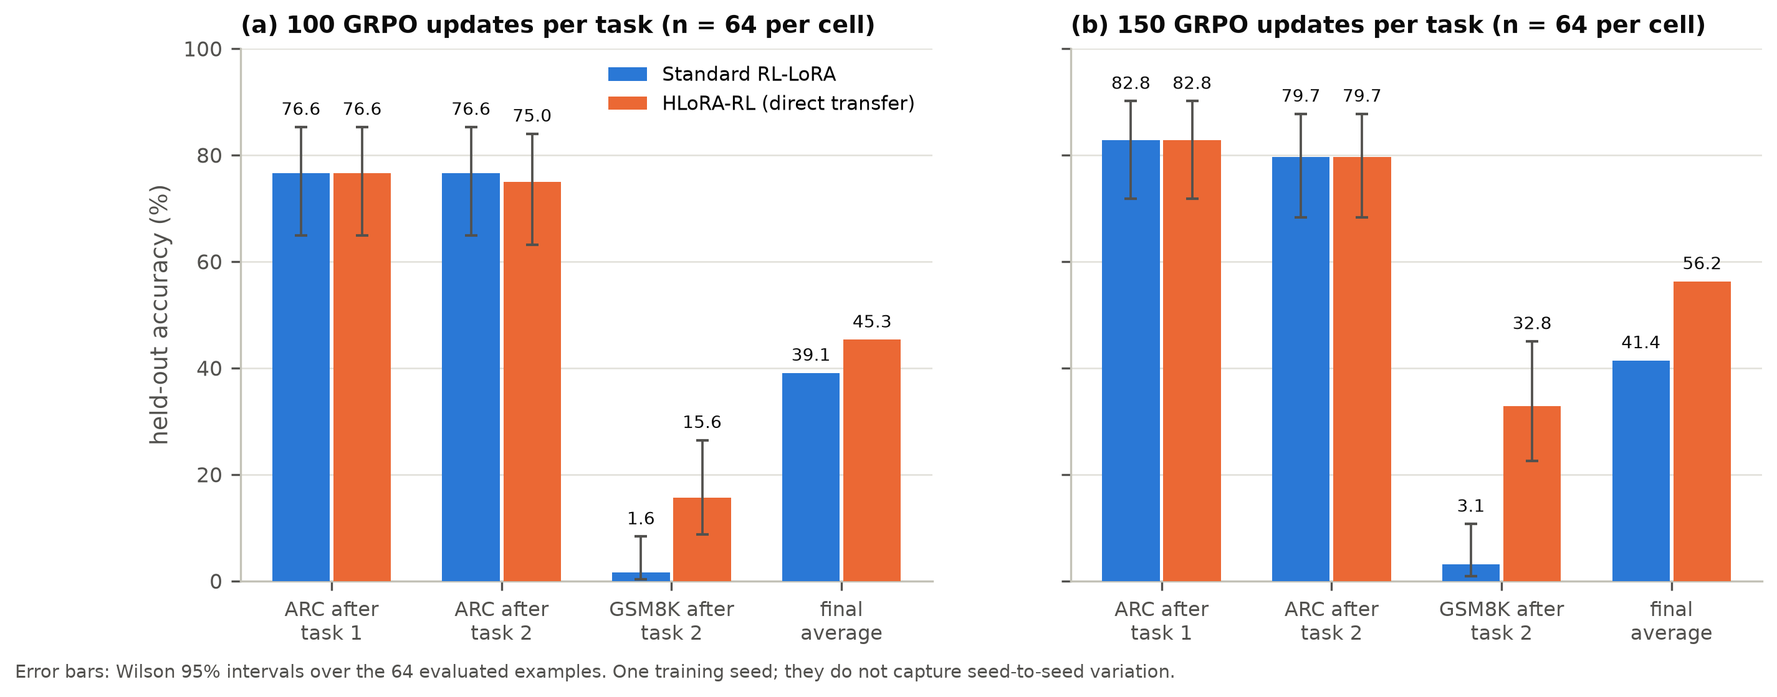
Figure 6.3: Held-out accuracy on ARC-Challenge → GSM8K for RL-LoRA and HLoRA-RL at (a) 100 and (b) 150 updates per task. Error bars are Wilson 95% intervals over 64 examples.
Table 6.2: ARC-Challenge -> GSM8K pilots: held-out accuracy with Wilson 95% intervals (n = 64 per cell) and continual metrics.
Method, budget | ARC after T1 | ARC after T2 | GSM8K after T2 | Forgetting (pp) | Final avg. (%)
RL-LoRA, 100/task | 76.6 [64.9, 85.3] | 76.6 [64.9, 85.3] | 1.6 [0.3, 8.3] | +0.00 | 39.06
HLoRA-RL, 100/task | 76.6 [64.9, 85.3] | 75.0 [63.2, 84.0] | 15.6 [8.7, 26.4] | +1.56 | 45.31
RL-LoRA, 150/task | 82.8 [71.8, 90.1] | 79.7 [68.3, 87.7] | 3.1 [0.9, 10.7] | +3.12 | 41.41
HLoRA-RL, 150/task | 82.8 [71.8, 90.1] | 79.7 [68.3, 87.7] | 32.8 [22.6, 45.0] | +3.12 | 56.25

The methods differed in how well they learned the second task. RL-LoRA reached only 1.56% (1/64) on GSM8K at 100 updates and 3.12% (2/64) at 150 updates. HLoRA-RL reached 15.62% (10/64) and 32.81% (21/64). The final average performance was therefore higher for HLoRA-RL: 45.31% versus 39.06% at 100 updates, and 56.25% versus 41.41% at 150 updates. Table 6.3 analyses the difference on the identical 64 GSM8K problems. At 150 updates, every one of the 19 discordant problems was solved by HLoRA-RL and not by RL-LoRA. The paired bootstrap interval of the difference is [+18.8, +40.6] points and the exact McNemar p-value is 3.8 × 10⁻⁶. At 100 updates, 9 of 9 discordant problems favoured HLoRA-RL (p = 0.0039). The ARC-Challenge forgetting of either method is not distinguishable from zero (McNemar p ≥ 0.5).
Table 6.3: Example-level paired analysis on identical held-out examples: paired bootstrap 95% intervals (10,000 resamples) and exact McNemar tests.
Budget | Comparison | RL-LoRA (%) | HLoRA-RL (%) | Difference (pp) | Bootstrap 95% CI | Discordant (RL only / HLoRA only) | McNemar p
100/task | ARC after T2 | 76.6 | 75.0 | -1.6 | [-4.7, +0.0] | 1 / 0 | 1
100/task | GSM8K after T2 | 1.6 | 15.6 | +14.1 | [+6.2, +23.4] | 0 / 9 | 0.0039
100/task | RL-LoRA ARC forgetting | - | - | +0.0 | [-4.7, +4.7] | 1 lost / 1 gained | 1
100/task | HLoRA-RL ARC forgetting | - | - | +1.6 | [-3.1, +7.8] | 2 lost / 1 gained | 1
150/task | ARC after T2 | 79.7 | 79.7 | +0.0 | [+0.0, +0.0] | 0 / 0 | 1
150/task | GSM8K after T2 | 3.1 | 32.8 | +29.7 | [+18.8, +40.6] | 0 / 19 | 3.8e-06
150/task | RL-LoRA ARC forgetting | - | - | +3.1 | [+0.0, +7.8] | 2 lost / 0 gained | 0.5
150/task | HLoRA-RL ARC forgetting | - | - | +3.1 | [+0.0, +7.8] | 2 lost / 0 gained | 0.5
Note: These tests quantify evaluation-sample uncertainty for a single training seed. They do not measure seed-to-seed training variance, which the protocol requires (three seeds) before any method claim.
These tests show that the GSM8K difference is not an artefact of sampling the 64 evaluation problems. They do not show that the difference is caused by consolidation, or that it would recur with another training seed. Section 6.6 examines the mechanism.

6.4 Training Dynamics and Learning Signal
Figure 6.4 shows the training reward. On ARC-Challenge the curves of the two methods coincide exactly: every loss and gradient norm of the first task is bit-identical, which confirms that the retention machinery is inactive on task 1, as specified. ARC-Challenge training reward rose from about 0.25 to about 0.7. When training switched to GSM8K, reward fell to about 0.02-0.05 within 15 updates and recovered only slowly. At 100 updates the GSM8K training curves of the two methods were nearly indistinguishable, and the mean training reward was even slightly lower for HLoRA-RL (0.050 versus 0.058). At 150 updates the curves stayed close until about global step 270 (GSM8K update 120 of 150), after which HLoRA-RL's training reward rose faster.
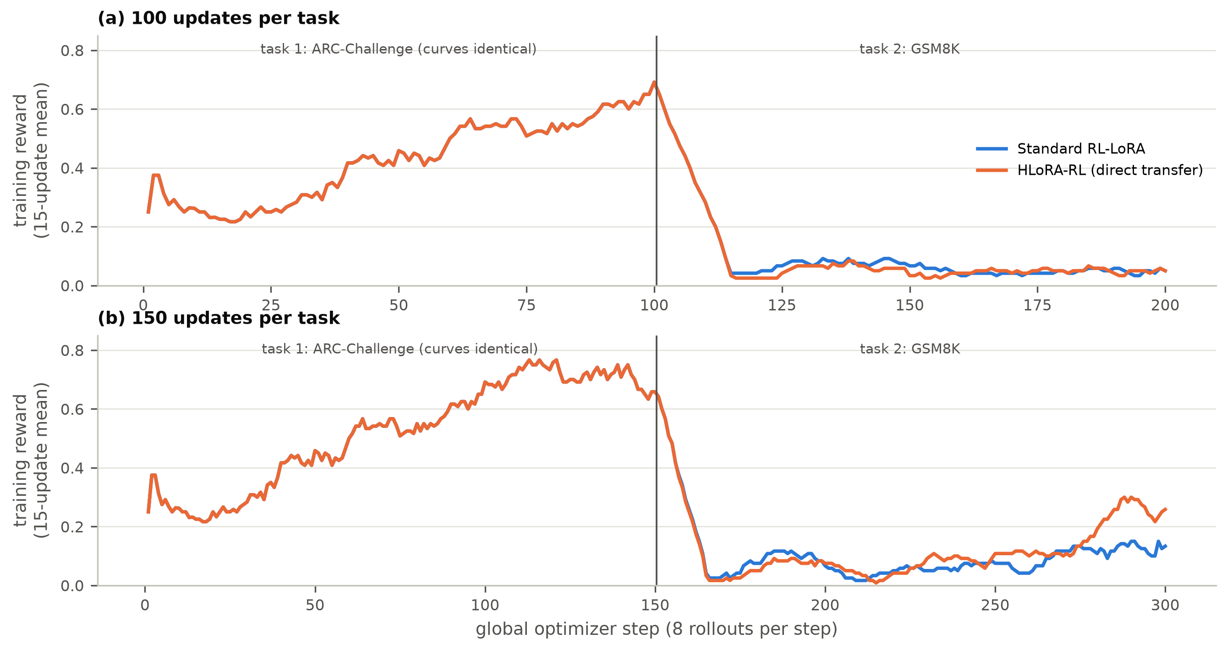
Figure 6.4: Training reward (15-update moving mean) for RL-LoRA and HLoRA-RL at (a) 100 and (b) 150 updates per task. The task-1 curves are identical.
The low GSM8K reward is a sparsity effect (Figure 6.5, Table 6.4). Across the four ARC-first runs, 68-82% of GSM8K prompt groups had identical rewards for all four responses, usually all zero, and therefore produced zero advantage. For RL-LoRA, 61% (100 updates) and 57% (150 updates) of GSM8K updates had an exactly zero gradient. HLoRA-RL had no zero-gradient updates at all: whenever the RL loss vanished (66 and 69 GSM8K updates), the consolidation penalty still produced a small gradient. The same sparsity dominated Phase 2: MBPP had positive reward in only 80 of 500 training batches (16%), and in the 500-update GSM8K → ARC run, 345 of the 500 ARC-Challenge updates had zero gradient, mostly because all four responses in a group were already correct (mean training reward 0.72).
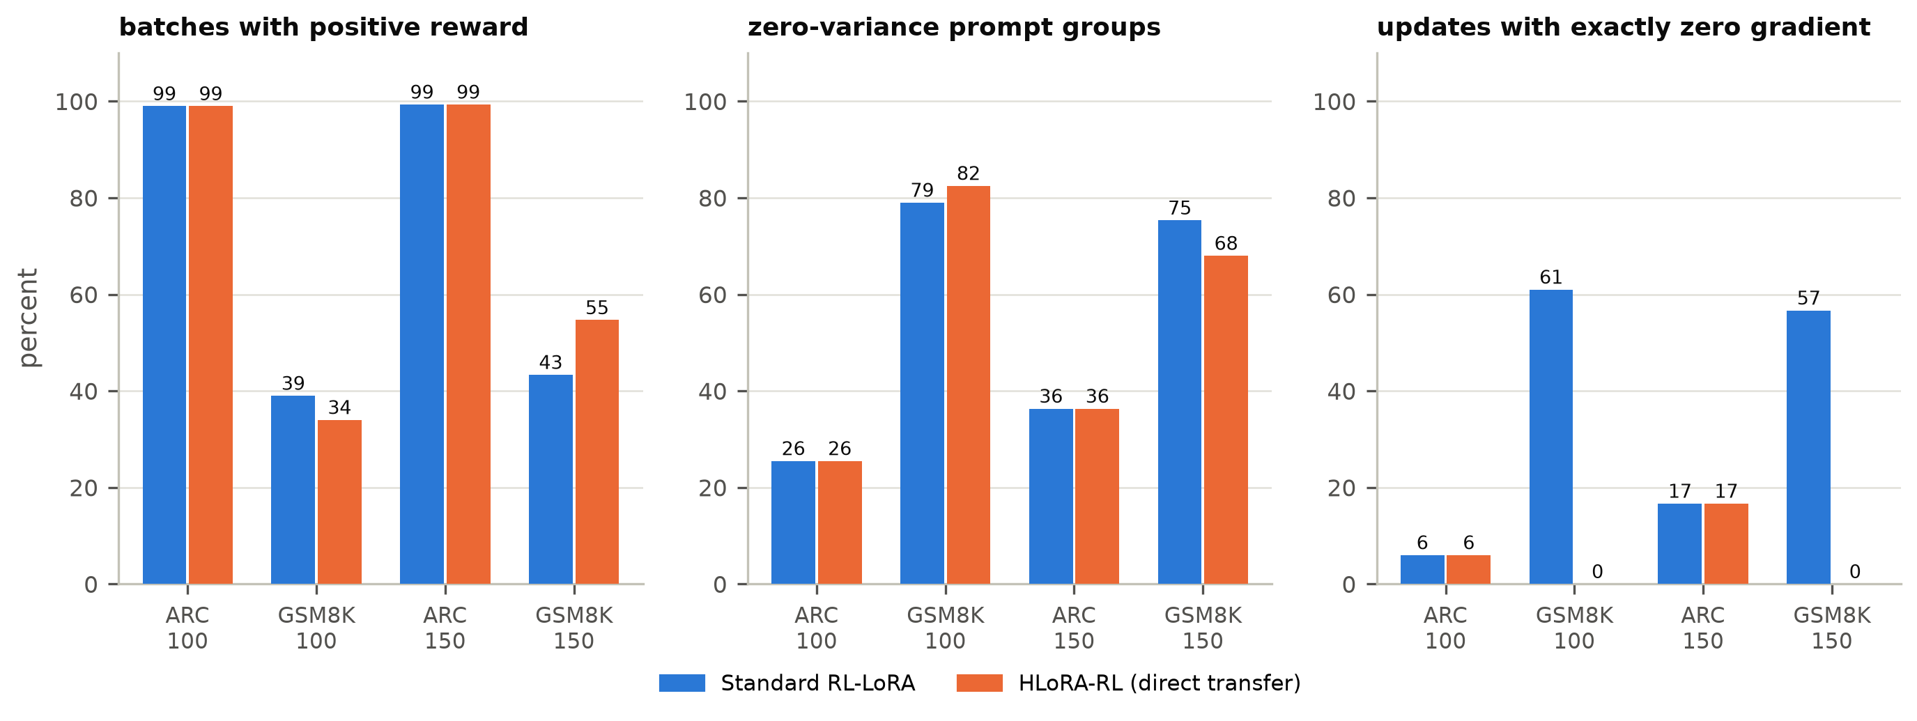
Figure 6.5: Learning-signal diagnostics on the ARC-first runs: batches with positive reward, zero-variance prompt groups, and updates with exactly zero gradient.
Table 6.4: Training-rollout diagnostics (training data only, never used as held-out evidence).
Run | Task | Mean reward | Positive batches | Zero-var. groups (%) | Zero-grad updates | Parse failures (%) | Sampled KL
RL-LoRA, 100/task | ARC | 0.454 | 99/100 | 26 | 6/100 | 38.6 | 0.0011
RL-LoRA, 100/task | GSM8K | 0.058 | 39/100 | 79 | 61/100 | 14.5 | 0.0008
HLoRA-RL, 100/task | ARC | 0.454 | 99/100 | 26 | 6/100 | 38.6 | 0.0011
HLoRA-RL, 100/task | GSM8K | 0.050 | 34/100 | 82 | 0/100 | 16.5 | 0.0006
RL-LoRA, 150/task | ARC | 0.539 | 149/150 | 36 | 25/150 | 29.4 | 0.0011
RL-LoRA, 150/task | GSM8K | 0.079 | 65/150 | 75 | 85/150 | 11.2 | 0.0006
HLoRA-RL, 150/task | ARC | 0.539 | 149/150 | 36 | 25/150 | 29.4 | 0.0011
HLoRA-RL, 150/task | GSM8K | 0.107 | 82/150 | 68 | 0/150 | 11.8 | 0.0006

A substantial part of early learning is learning the answer format. In the first 30 ARC-Challenge updates, 55-60% of sampled responses could not be parsed into an option label; by the end of the task this had fallen to about 10% (Figure 6.6). The sampled policy KL per update remained small (about 0.0006-0.0011 nats per token), consistent with the conservative, clipped updates of GRPO.
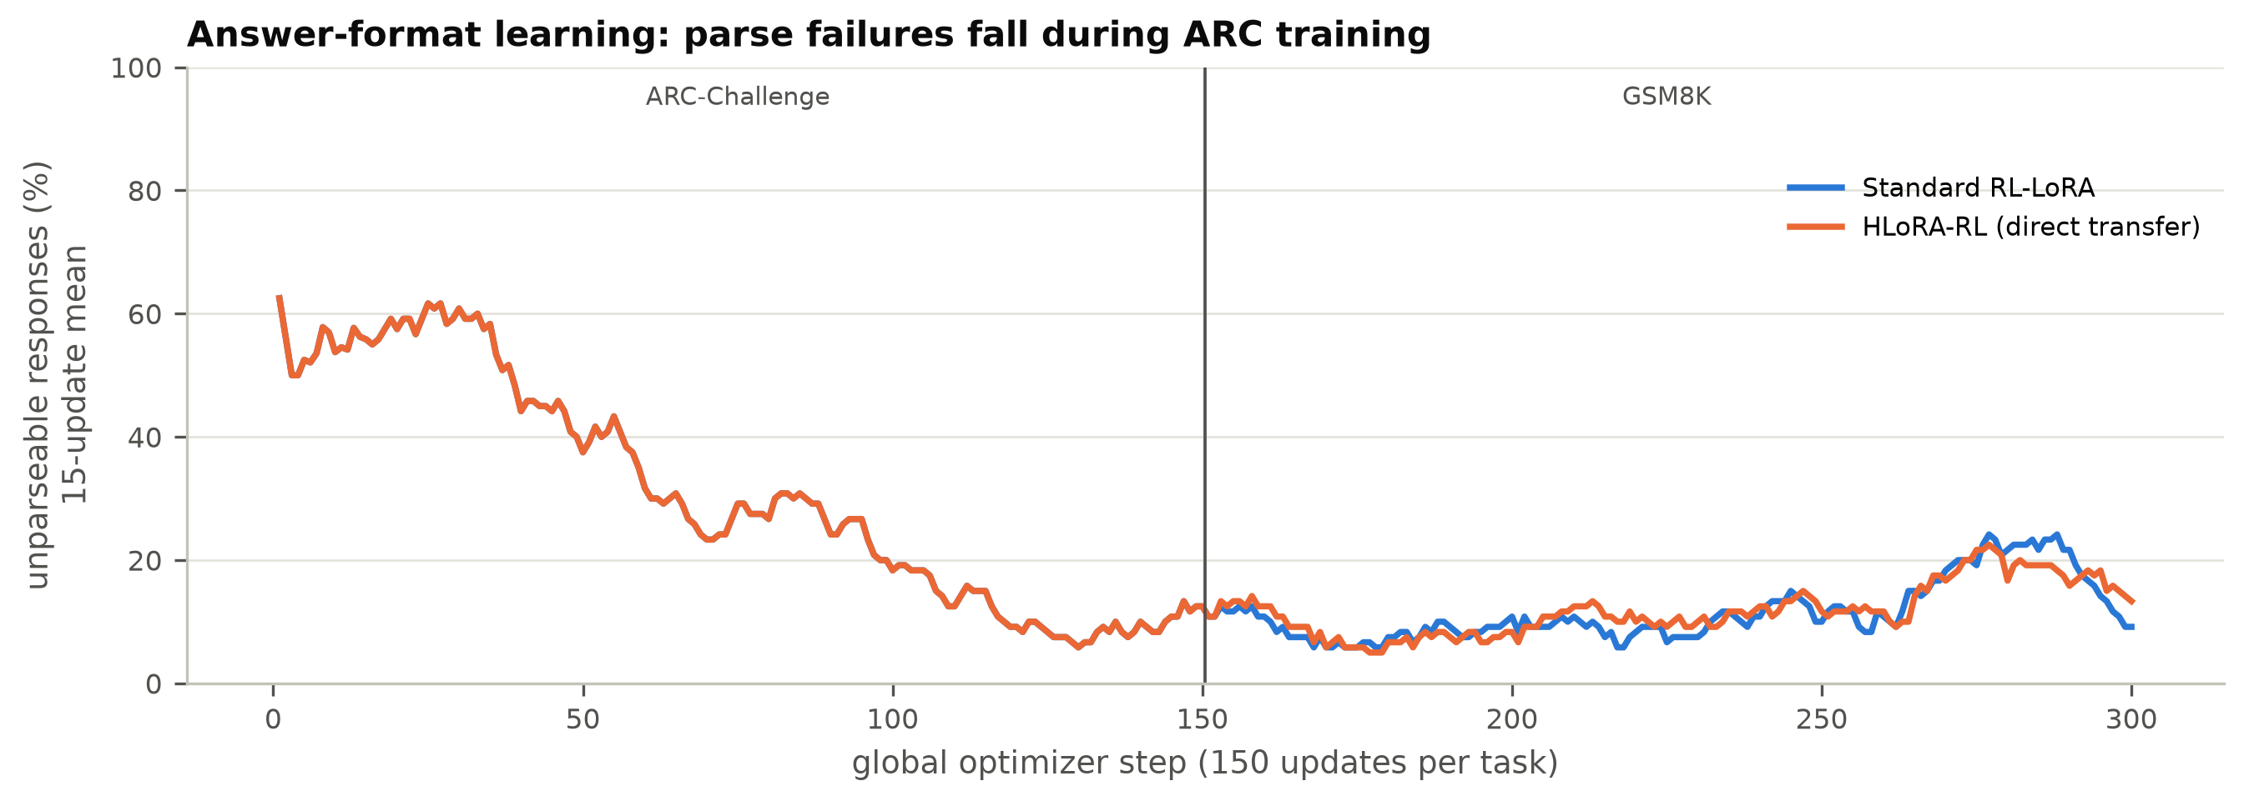
Figure 6.6: Fraction of unparseable training responses (15-update moving mean) at 150 updates per task.

6.5 General Capabilities
Figure 6.7 and Table 6.5 report the capability suite for the 150-update runs. Held-out perplexity was essentially unchanged (20.80 for the frozen model versus 20.83 and 20.77 after task 2). IFEval strict accuracy fell from 15.6% to 10.9% (RL-LoRA) and 14.1% (HLoRA-RL). These changes are within the Wilson intervals at n = 64. Across all eight runs, perplexity changed by at most +3.52%, in the 500-update GSM8K → ARC run, and by less than ±0.2% in all four ARC-first runs (Figure 6.8).
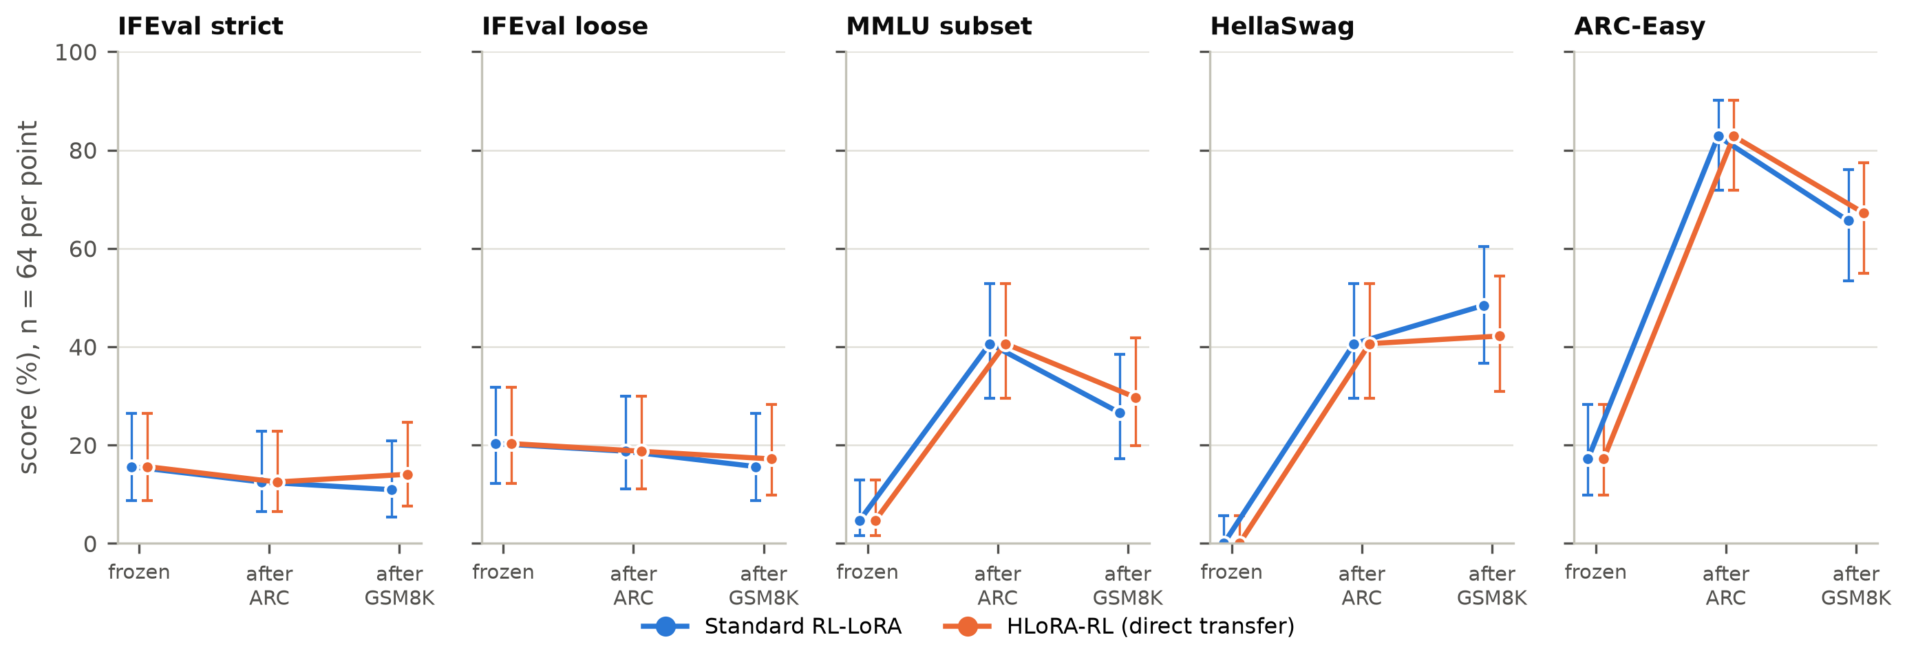
Figure 6.7: General-capability suite for the 150-update ARC → GSM8K runs (n = 64 per point, Wilson 95% intervals).
Table 6.5: General-capability suite for the 150-update ARC -> GSM8K pilots (n = 64 per metric; percent except perplexity).
Capability | Frozen model | After ARC (both methods) | After GSM8K: RL-LoRA | After GSM8K: HLoRA-RL
IFEval strict | 15.6 | 12.5 | 10.9 | 14.1
IFEval loose | 20.3 | 18.8 | 15.6 | 17.2
MMLU subset | 4.7 | 40.6 | 26.6 | 29.7
HellaSwag | 0.0 | 40.6 | 48.4 | 42.2
ARC-Easy | 17.2 | 82.8 | 65.6 | 67.2
WikiText-2 PPL | 20.80 | 20.80 | 20.83 | 20.77
Note: Scores come from generative evaluation with at most 64 greedy tokens and strict option-label parsing. The low frozen-model scores on MMLU, HellaSwag, and ARC-Easy mainly reflect answer-format failures, so the gains after ARC training measure format transfer as much as knowledge.
The multiple-choice capabilities must be interpreted with care. The frozen instruction model scored only 4.7% on MMLU, 0.0% on HellaSwag, and 17.2% on ARC-Easy. This is far below the known ability of Qwen2.5-1.5B-Instruct, and the gap arises because our evaluation is generative. It allows at most 64 greedy tokens and accepts only an unambiguous option label, and the frozen model usually answers with an explanation that either never states a single label or is cut off. After ARC-Challenge training, which rewards ending with a label, MMLU rose to 40.6%, HellaSwag to 40.6%, and ARC-Easy to 82.8%. The 500-update GSM8K → ARC run shows the same effect in reverse. After GSM8K training, which rewards numeric answers, ARC-Easy fell from 14.1% to 3.9%. After ARC-Challenge training it rose to 89.8%. These swings measure answer-format transfer at least as much as knowledge. They must not be read as the RL training "improving MMLU by 36 points", and differences between methods in these benchmarks at n = 64 are not significant. Following our protocol, the final study will report both the absolute score and the change from the frozen model, and will add a log-likelihood-based multiple-choice evaluation that does not depend on answer format.
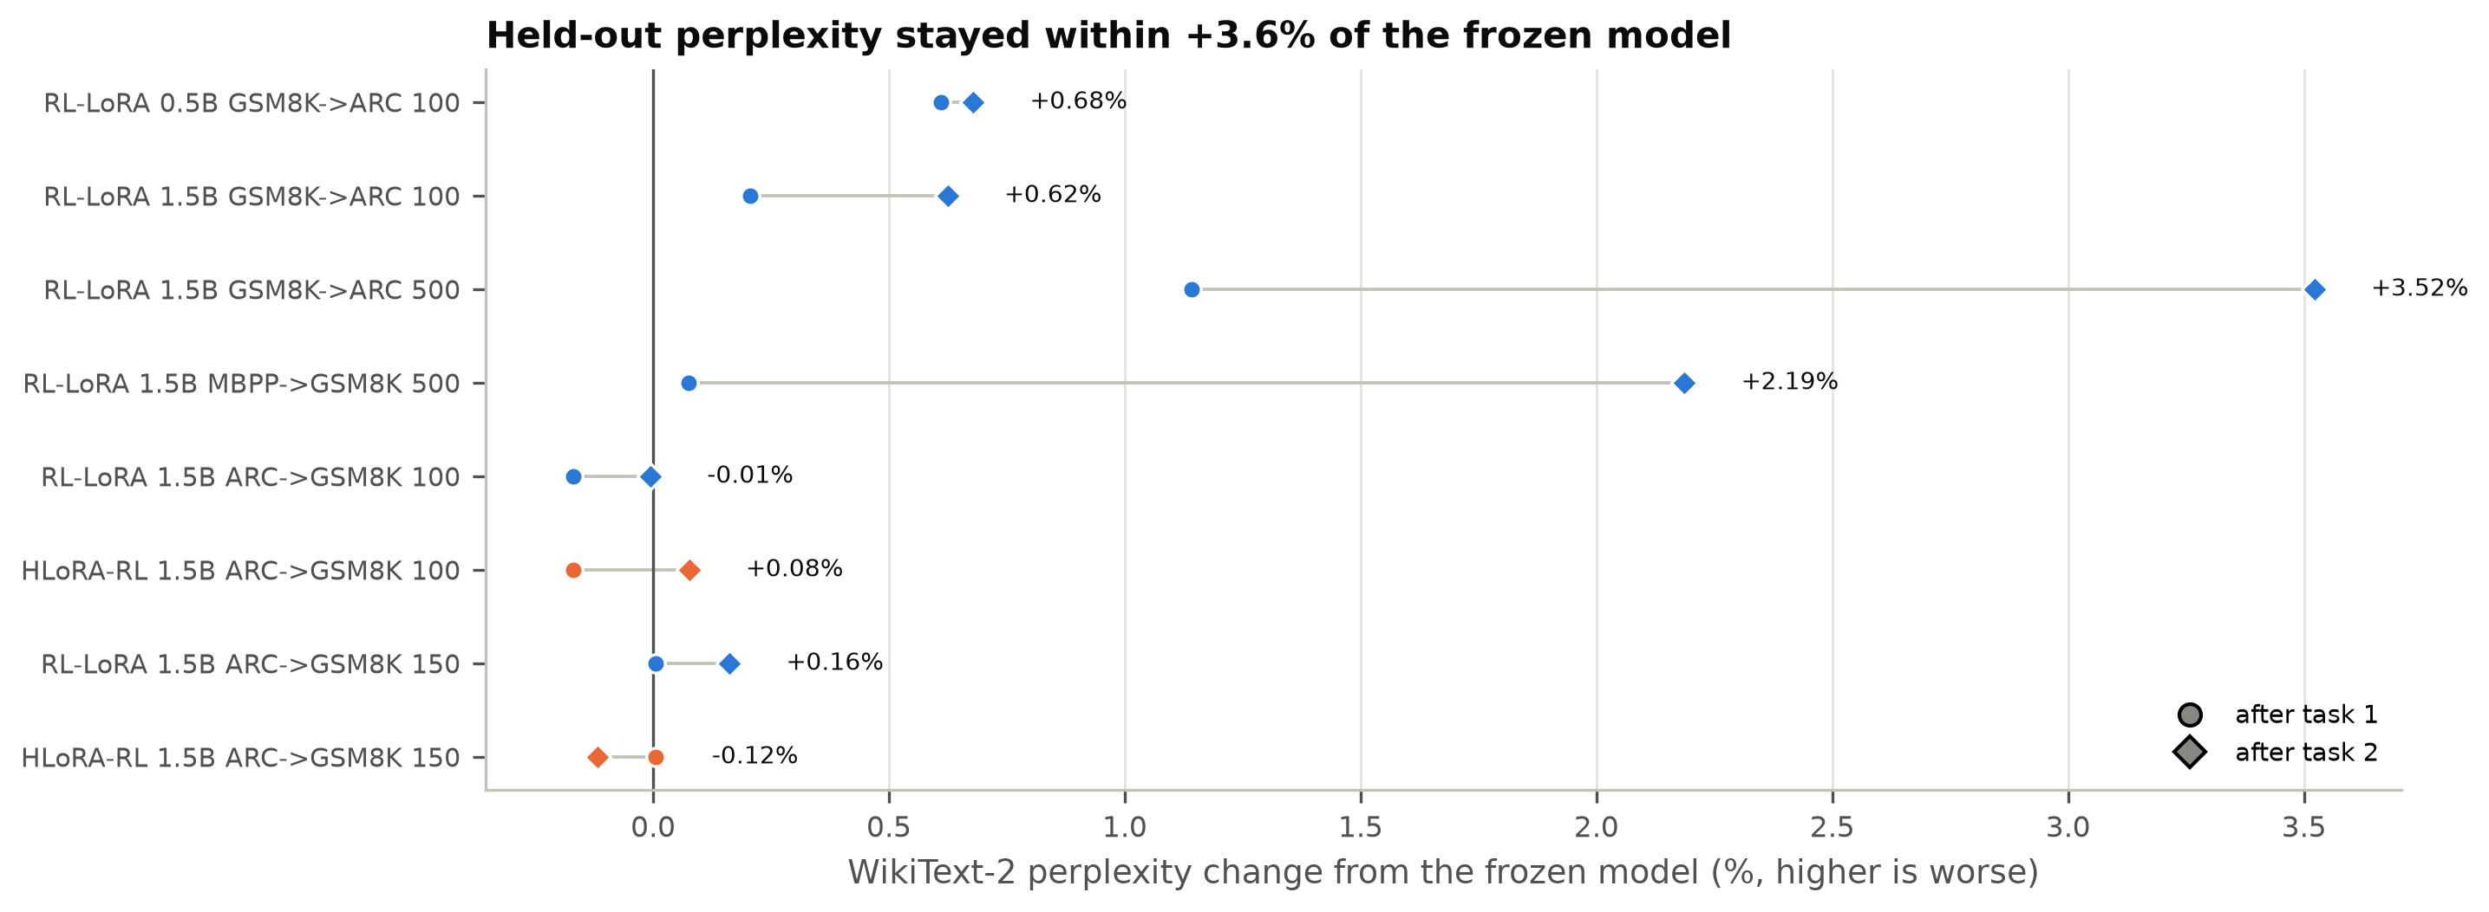
Figure 6.8: WikiText-2 perplexity change from the frozen model after task 1 and task 2 in all eight runs.

6.6 Mechanism Diagnostics of the Direct HLoRA Transfer
If HLoRA-RL's GSM8K advantage came from protecting ARC-relevant directions and leaving other directions free, the protection should be spread over the modules that matter for ARC-Challenge, and it should be strong enough to change the update. The diagnostics show neither.
Importance is concentrated in v_proj but broad. After ARC-Challenge training, the dense importance norms ‖Ω_{l}‖₂ of the 112 modules ranged from 385 to 11,729 (Figure 6.9). The largest values were in the value projections, especially in layers 0, 2, 3, and 17. Between 57% and 65% of the importance elements of each module were nonzero after ARC-Challenge, and 76-87% after GSM8K, so the path integral does assign importance across the whole adapter.
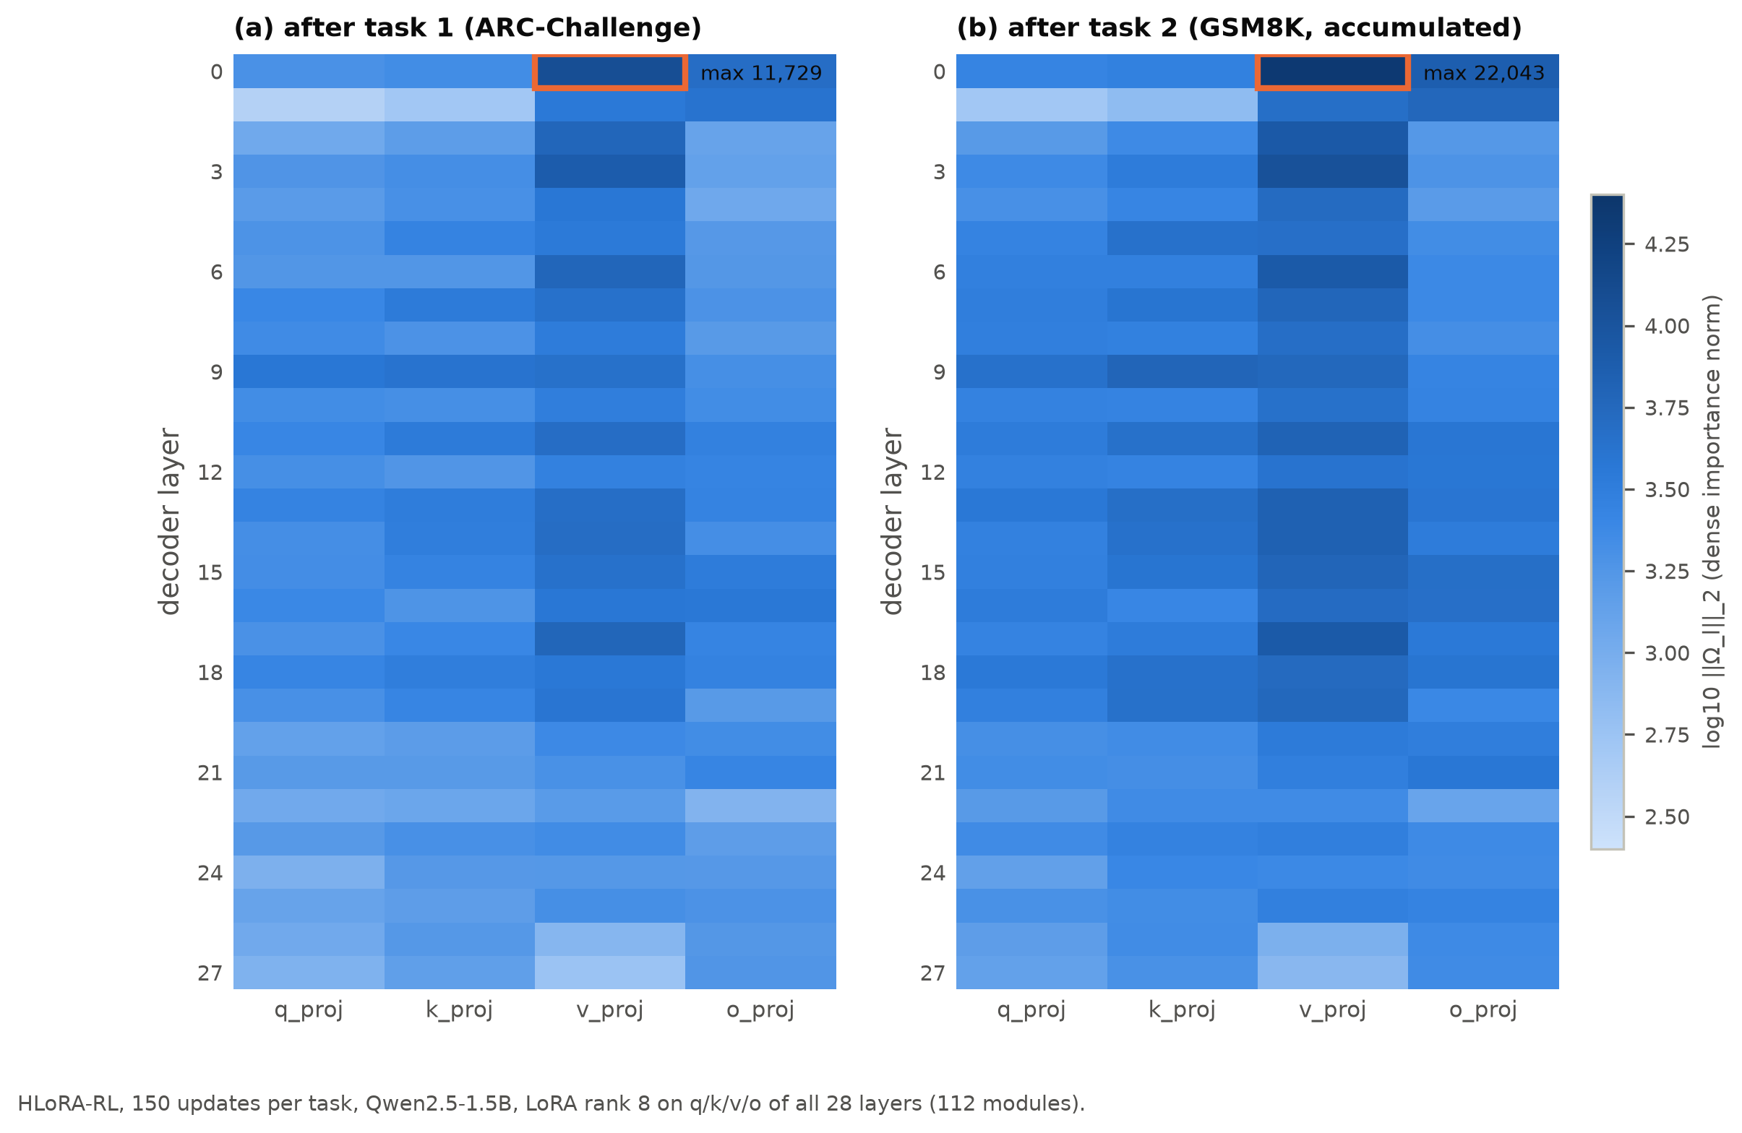
Figure 6.9: Dense path-integral importance norms per layer and projection in HLoRA-RL (150 updates per task) after (a) ARC-Challenge and (b) GSM8K.
The static layer coefficients collapse to one module. The coefficients are a softmax over these raw norms. The largest norm (layer-0 v_proj, 11,729) exceeds the second (layer-3 v_proj, 7,719) by 4,010, and e⁻⁴⁰¹⁰ is exactly zero in floating point. Layer-0 v_proj therefore receives coefficient 1 and the other 111 modules receive exactly 0. This held in all four consolidations of both budgets (Figure 6.10). The effective number of protected modules (the inverse of the sum of squared coefficients) is 1.0. By contrast, normalizing by the sum of norms would protect about 82 effective modules, and a softmax of standardized norms about 2. The direct transfer of the HLoRA layer weighting is therefore degenerate at this scale of importance values. In practice HLoRA-RL is "RL-LoRA plus a penalty on one module".
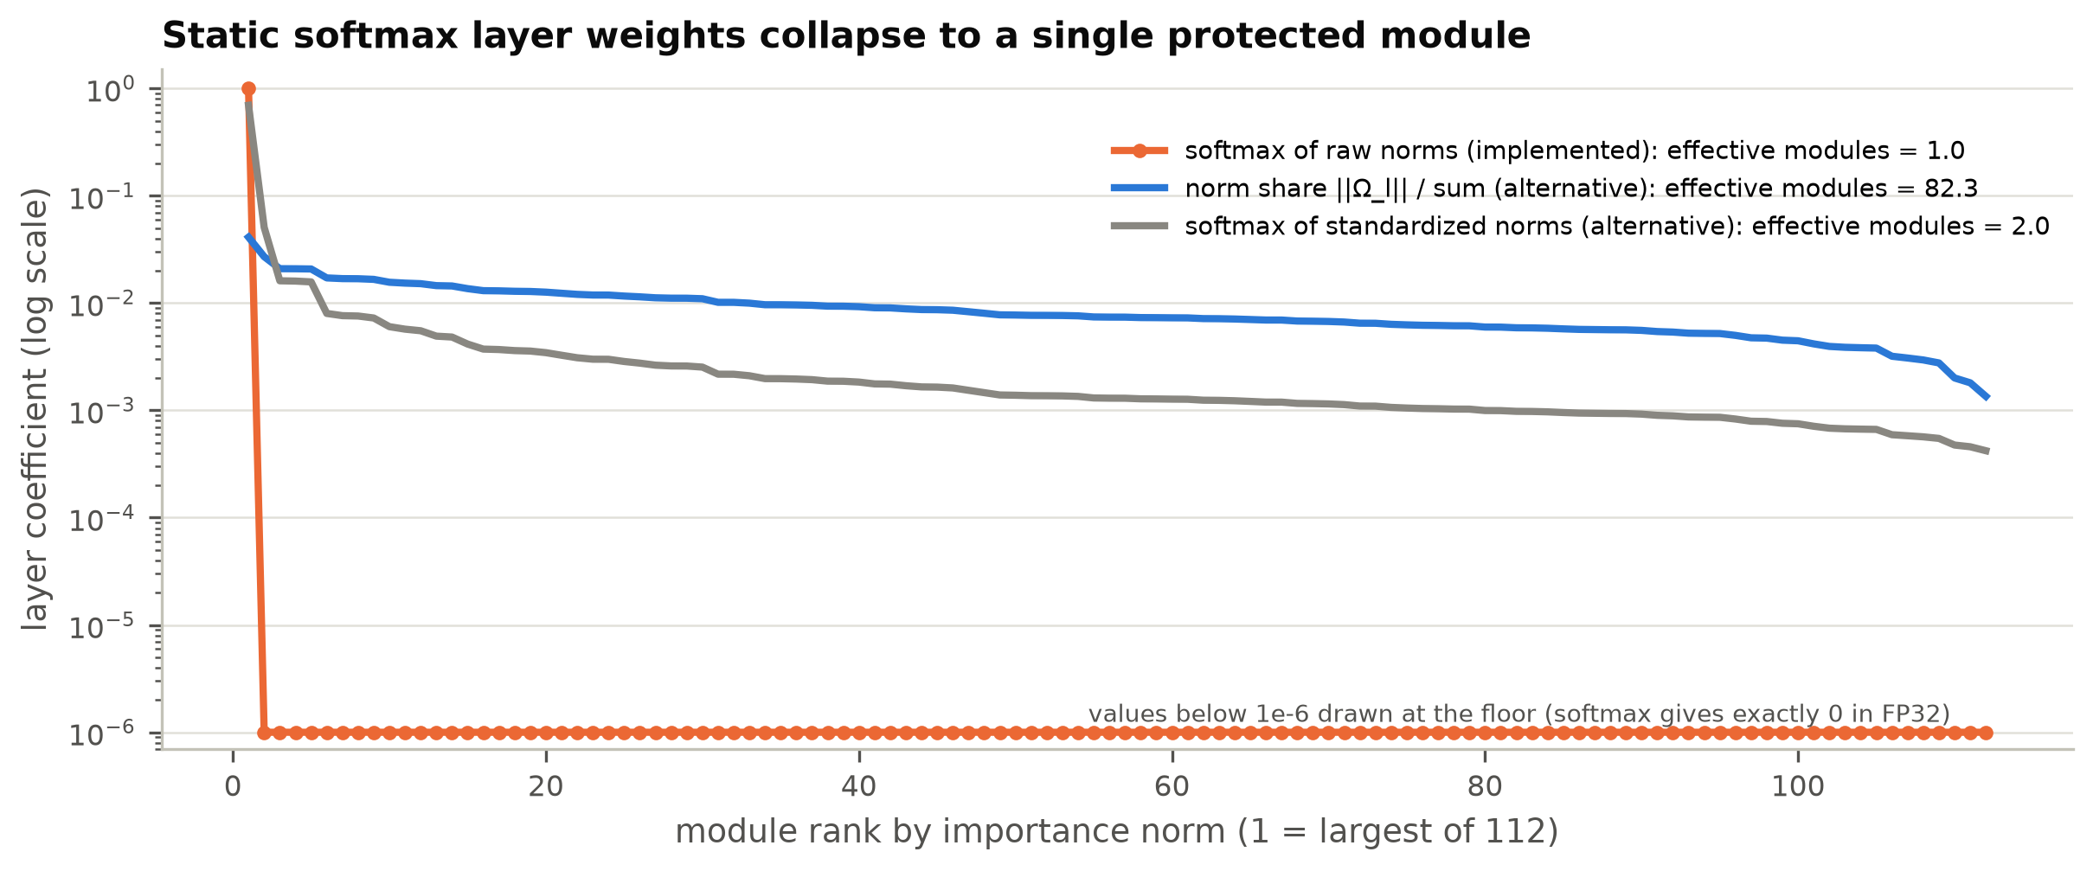
Figure 6.10: Layer coefficients sorted by importance norm: the implemented softmax of raw norms (one-hot) compared with two non-degenerate normalizations.
The penalty is small. During GSM8K training, the penalty averaged 2.5 × 10⁻⁵ (100 updates) and 5.2 × 10⁻⁵ (150 updates), with a maximum of 1.1 × 10⁻⁴. On updates with a non-zero RL loss, the mean absolute RL loss was about 2 × 10⁻⁴ to 4 × 10⁻⁴ (Figure 6.11). The penalty is thus roughly an order of magnitude smaller than the RL loss. On the many updates where the RL loss is exactly zero, however, it is the only source of gradient, and it acts only on layer-0 v_proj.
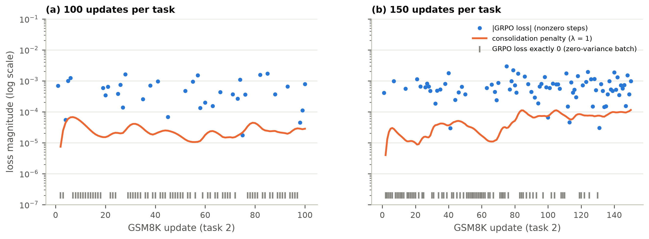
Figure 6.11: Magnitude of the consolidation penalty and of the GRPO loss during GSM8K training. Ticks mark updates whose GRPO loss was exactly zero.
The runs diverge from the second GSM8K update. Because the training runs are deterministic, the two methods can be compared step by step (Figure 6.12). All task-1 updates and the first GSM8K update are identical. At that first update the adapter still equals the reference, so both the penalty and its gradient are zero. From the second GSM8K update on (global step 102 or 152), the penalty gradient on layer-0 v_proj changes the parameters slightly. Temperature-1 sampling then produces different responses, and the two trajectories evolve independently. Their cumulative training rewards stayed close for most of task 2 and separated only in the last 30 updates of the 150-update run.
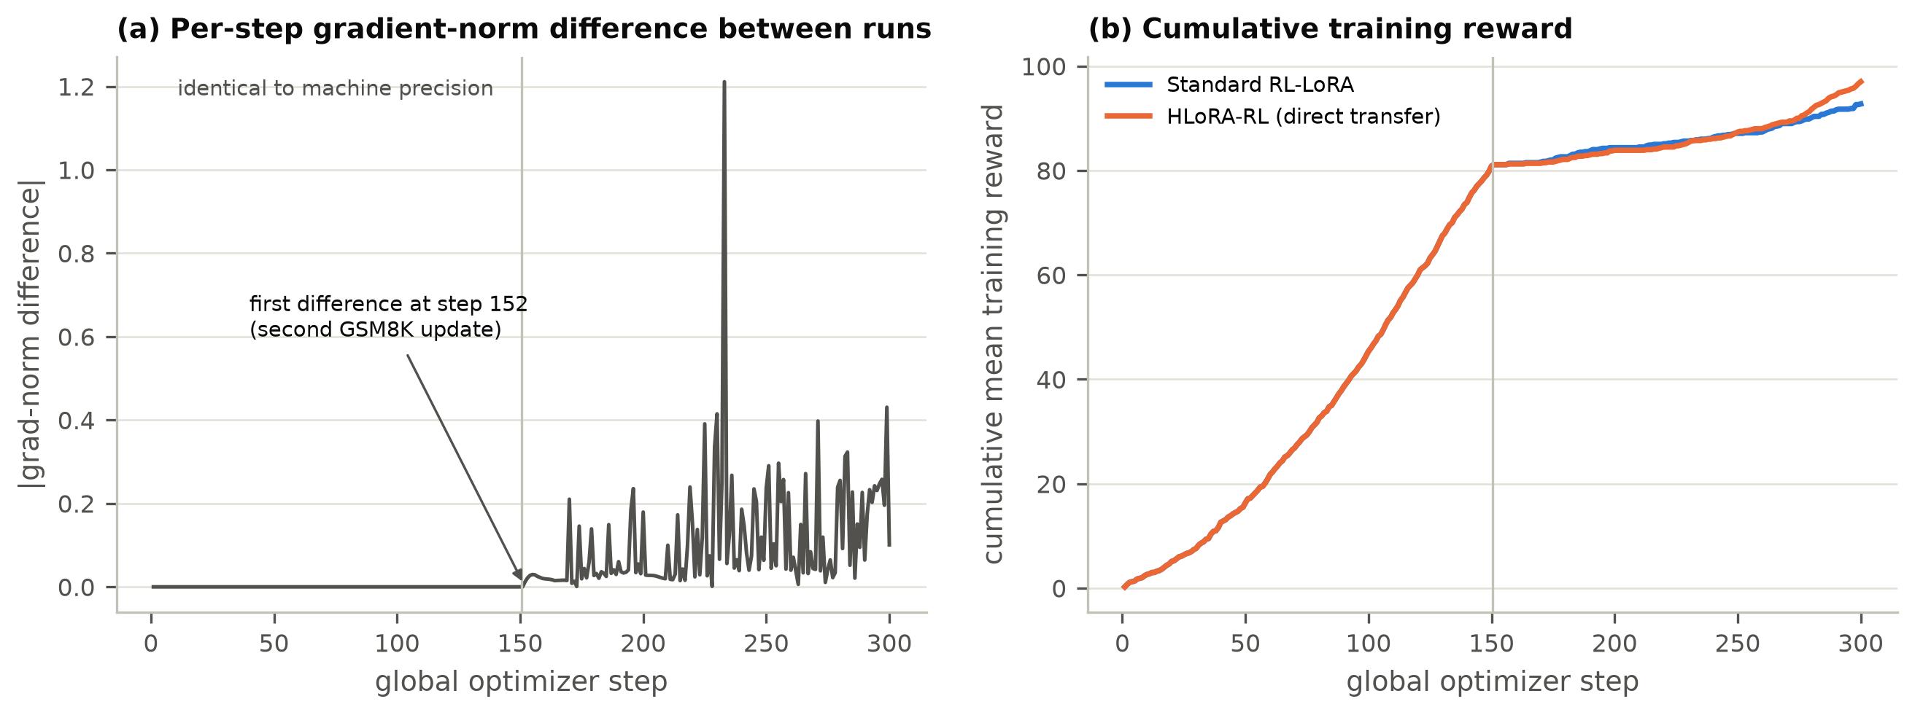
Figure 6.12: (a) Absolute difference of per-step gradient norms between the two 150-update runs; (b) cumulative training reward.
Taken together, these diagnostics suggest that the GSM8K difference reflects the sensitivity of sparse-reward RL to small perturbations of the trajectory, rather than protection of task-1 directions. A single seed cannot separate these explanations, so the plasticity result is treated as unconfirmed. It may be a genuine regularization effect, for example because the penalty prevents the adapter from settling while the RL gradient is zero, or it may be a favourable draw. Replication over at least three seeds is required, together with a control that adds an equally small, unrelated perturbation.
A second observation from code review. The captured effective gradient multiplies the output-gradient-times-input product by the LoRA scale s = α/r. Since the dense update ΔW = sBA already contains s, the captured quantity is s·∂L/∂ΔW rather than ∂L/∂ΔW. This is a uniform factor of two for all modules. It does not change importance rankings or the one-hot softmax outcome, and it is equivalent to doubling λ. It will be corrected and covered by a finite-difference test before Phase 4, which requires the scale to be applied exactly once.

6.7 Efficiency and Persistent State
Figure 6.13 and Table 6.6 summarize the cost. With the 1.5B model, an update (eight rollouts of up to 128 tokens, reward scoring, and one AdamW step) took about 50-52 seconds, at about 20 generated tokens per second. The 500-update runs averaged 52-60 seconds per update. Part of the slowdown in the interrupted MBPP → GSM8K source run was traced to host memory pressure (Section 3.7). Dense HLoRA-RL importance added only 2.2% to the step time (51.8 versus 50.6 seconds). It raised peak GPU allocation from 12.2 to 14.1 GB, close to the 16 GB limit, and process memory from 3.4 to 6.1 GB.
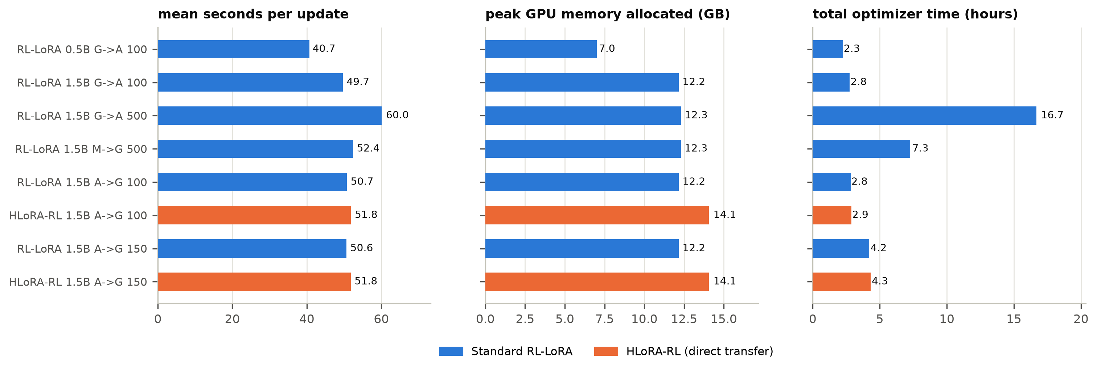
Figure 6.13: Compute profile of all runs: mean time per update, peak GPU memory allocated, and total optimizer time.
Table 6.6: Compute and persistent-state cost on the RTX 4070 Ti SUPER (Qwen2.5-1.5B unless noted).
Quantity | Standard RL-LoRA | HLoRA-RL (dense) | RAHC-LoRA target (rank-1)
Mean seconds per update (150/task) | 50.6 | 51.8 | to be measured
Peak GPU memory allocated (GB) | 12.16 | 14.06 | to be measured
Peak process RSS (GB) | 3.40 | 6.15 | to be measured
Trainable LoRA parameters | 2,179,072 | 2,179,072 | 2,179,072
Importance values stored | 0 | 154,140,672 | 272,384
Importance bytes (FP32) | 0 | 616.6 MB | 1.09 MB
Reference LoRA factors (FP32) | 0 | 8.72 MB | 8.72 MB

The persistent state shows the motivation for factorization most clearly (Figure 6.14). The dense importance of HLoRA-RL holds 154.1 million FP32 values (616.6 MB), 71 times the size of the rank-8 adapter it protects (8.7 MB). The rank-one state planned for RAHC-LoRA holds 272,384 values (1.09 MB), 566 times smaller than the dense state and smaller than the adapter itself.
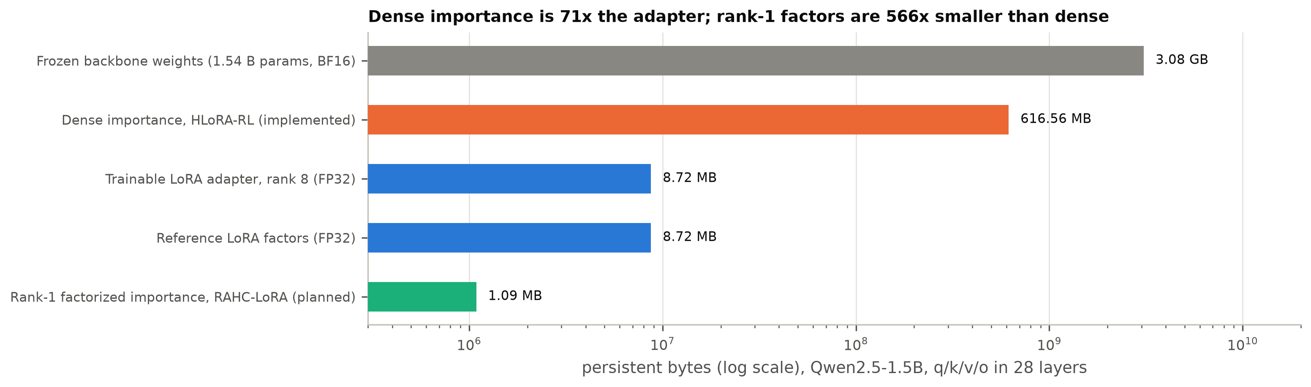
Figure 6.14: Persistent state for Qwen2.5-1.5B (log scale): the frozen backbone, dense importance (implemented), the adapter and its reference, and rank-one importance (planned).

6.8 Discussion

6.8.1 Why the baseline did not forget
Three factors explain the absence of a forgetting signal. First, weak first tasks: GSM8K at 100 updates and MBPP at 500 updates stayed close to their floors, so they had almost nothing to lose. Second, sparse rewards: most prompt groups on the hard tasks produced no gradient, so the adapter moved little. Third, the conservative nature of on-policy GRPO: the sampled KL per update stayed around 10⁻³ nats per token, and recent work finds that on-policy RL favours solutions close to the starting policy and therefore forgets less than SFT [17], [18]. Our ARC-first results agree with this: ARC-Challenge, learned to 83%, lost at most 3 points during 150 GSM8K updates.
This is itself a useful finding for the thesis. It means that a stream on which the baseline demonstrably forgets must be constructed deliberately. The next pilot will use the full four-task streams, longer budgets on each task, tasks whose answer formats conflict (numeric versus option label versus code), and a higher learning rate or LoRA rank if needed, as the protocol allows. It will check the continuation rule before any method comparison. If a sufficiently strong forgetting signal cannot be produced, the protocol provides for validating the mechanism on a continual-control benchmark instead [66].

6.8.2 Interpreting the plasticity difference
The largest effect observed is on plasticity, not stability. HLoRA-RL learned GSM8K much better than RL-LoRA in both budgets, with strong evaluation-level significance. Among the GSM8K responses that could be parsed, HLoRA-RL answered 35% correctly at 150 updates (21 of 60), compared with 4% (2 of 53) for RL-LoRA, so the difference is not only in answer format. However, the training rewards of the two runs were similar for most of task 2, and the runs diverged only because of a tiny, single-module penalty. The evidence therefore supports a cautious conclusion: small changes to the optimization trajectory can produce large differences in held-out GSM8K accuracy after a short, sparse-reward RL phase. Any claim that consolidation improves plasticity requires multi-seed replication. This is consistent with the well-known seed sensitivity of deep RL [67], [68].

6.8.3 Implications for the design of RAHC-LoRA
The pilots confirm four design decisions and motivate one correction.
- Effective-weight importance works mechanically. Hooks on the target layers capture dense effective gradients, and the path integral with the observed AdamW movement is finite, nonnegative after clamping, and broadly distributed.
- Dense state is too expensive to keep. Importance costs 71 times the adapter and uses most of the remaining GPU headroom, which supports rank-one factorization.
- Layer coefficients must not be a softmax of raw norms. Norms in the thousands make any unscaled softmax one-hot. RAHC-LoRA's conflict-aware coefficients are rescaled to a mean of one and clipped (Section 4.3), which prevents this collapse by construction. A static-coefficient ablation should use a non-degenerate normalization.
- Behavioural protection is needed. Parameter distance did not predict retention here, and recent work identifies drift on old-task inputs as the key quantity [19]. The anchor KL measures exactly this.
- Correction: apply the LoRA scale exactly once in the effective gradient, verified by a finite-difference test.

6.8.4 What the capability suite measures
The capability results show that general language modelling (perplexity) was preserved in every run and that instruction following (IFEval) changed by amounts within noise. They also show that generative multiple-choice evaluation with a short token cap largely measures answer format [27]. For the final study, log-likelihood-based multiple-choice scoring, a longer evaluation budget, and larger evaluation samples (all 1,172 ARC-Challenge and 1,319 GSM8K test items) will be used for the headline comparisons, with the current generative scores kept as a secondary, format-sensitive measure.

6.9 Threats to Validity
Internal validity. All pilots use one training seed, so seed-to-seed variance is unknown, and the paired tests describe only evaluation-sample uncertainty. The ARC-first order was chosen after the Phase 2 results and is not one of the three pre-registered orders. Its results are exploratory. Evaluation used 64 or 128 examples per task, and the 64-token evaluation cap is shorter than the 128-token training budget. The effective-gradient scale factor noted above changes the penalty strength by a constant factor.
Construct validity. Generative multiple-choice scores mix knowledge with answer format, and low scores of the frozen model on MMLU and HellaSwag reflect format rather than ability. A low anchor KL (in future runs) will not by itself prove retention, which is why held-out old-task scores remain the primary evidence.
Reward validity. While preparing Appendix C we found that the multiple-choice parser accepts a hedged answer. "Answer: A or B" is scored as label A, because only labels that follow an explicit marker are compared, and a second explicit marker ("Answer: A. Final answer: B") is correctly rejected as ambiguous. A policy could in principle learn to exploit this. We have no evidence that it happened in the pilots, since generated text is stored only as hashes, but the parser will be tightened, with new rejection tests, before the main study.
External validity. Results come from two-task streams, models of 0.5B and 1.5B parameters, and rank-8 adapters on attention projections only. They may not hold for four-task streams, larger models, other RL algorithms, or LoRA on MLP layers.
Conclusion validity. The HLoRA-RL results evaluate the direct transfer baseline, not RAHC-LoRA. No statement in this chapter supports or refutes the primary hypothesis H1, which cannot be tested until a stream with measurable baseline forgetting exists and the RAHC-LoRA components are implemented.

6.10 Summary of Findings
Table 6.7 summarizes the findings against the research questions. In brief, the platform is validated and reproducible. Standard RL-LoRA did not forget measurably on any tested stream, so the pilot continuation rule is not met and the stream must be redesigned. The direct HLoRA-to-RL baseline showed no retention benefit, a large but unconfirmed single-seed plasticity difference, and a degenerate layer weighting. The planned rank-one state reduces persistent importance storage by a factor of 566.
Table 6.7: Summary of findings against the research questions and hypotheses.
Question / hypothesis | Evidence in P2 | Status
Does standard RL-LoRA forget measurably on the chosen streams? | Forgetting -1.30 to +3.12 pp in six streams; max possible loss < 10 pp in three | Not yet: stream must be redesigned (harder conflict, longer budgets, 4-task streams)
H1: consolidation reduces forgetting vs RL-LoRA | ARC forgetting 1.56 vs 0.00 pp (100) and 3.12 vs 3.12 pp (150) | Not supported and not testable: no forgetting signal
Does consolidation preserve plasticity? | GSM8K 15.6 vs 1.6% (p = 0.004) and 32.8 vs 3.1% (p = 4e-6), one seed | Promising but unconfirmed; mechanism unclear (runs diverge from step 2 of task 2)
Is the direct HLoRA transfer well behaved in RL? | softmax layer weights one-hot on 1 of 112 modules; penalty 1e-5 to 1e-4 | No: motivates normalized, conflict-aware coefficients
Are general capabilities preserved? | perplexity within +/-0.2% (ARC-first) and <= +3.5% overall; IFEval -1.6 to -4.7 pp | Largely preserved; IFEval change within noise at n = 64
Is persistent state bounded? | dense 616.6 MB vs 1.09 MB rank-1 (566x) | Motivates Phase 5 factorization
Engineering reproducibility | 59 tests; 1e-7 resume; bit-identical task 1; SHA-256 checkpoints | Established

Chapter 7: Conclusion and Future Work

7.1 Conclusion
This thesis addresses catastrophic forgetting in continual RL post-training of an LLM with one frozen backbone and one shared LoRA adapter. Building on the P1 literature review, the P2 stage made three advances.
First, it specified RAHC-LoRA, a method that protects the gauge-invariant effective update ΔW = (α/r)BA. RAHC-LoRA estimates Hessian-free importance from the gradient of the clipped-advantage RL objective and the observed optimizer step, and stores that importance as mass-preserving rank-one factors with a Gram-form penalty. It preserves old behaviour through a fixed-budget anchor memory with a compact top-k KL, gates protection by the conflict between current and anchor gradients, and keeps anchor drift within a budget with a bounded dual controller.
Second, it built and validated a reproducible research platform. The platform includes four verifiable RL tasks with strict data isolation and an IFEval overlap audit, a network-disabled sandbox for generated code, the official IFEval scorer, full performance matrices, and atomic, hashed, resumable checkpoints. It is tested by 59 automated tests and has recovered a real interrupted run.
Third, it ran eight GPU pilots with a standard RL-LoRA baseline and a direct HLoRA-to-RL baseline. Standard RL-LoRA did not forget measurably on any tested stream (−1.30 to +3.12 points), so the pre-registered continuation rule is not met and the stream must be redesigned before a method comparison. The direct HLoRA transfer did not reduce forgetting on ARC-Challenge → GSM8K. It learned GSM8K much better in a single seed (32.8% versus 3.1%), but its layer weighting collapsed onto one of 112 modules and the two runs diverged from the second GSM8K update, so this plasticity difference cannot yet be attributed to consolidation. Dense importance required 616.6 MB, compared with 1.09 MB for the planned rank-one state.
The honest conclusion of P2 is that the research question remains open. The platform is ready to answer it. The baseline is calibrated, with measured reward sparsity, learning speed, and forgetting behaviour. The pilots also produced concrete, evidence-based corrections to the design.

7.2 Contributions
- A complete, testable specification of RAHC-LoRA and of its baselines, ablations, metrics, statistical plan, and decision rules.
- An open, reproducible continual-RL platform for LLMs with isolated verifiable rewards and full continual-learning evaluation.
- A project-owned GRPO baseline with documented semantics and a direct HLoRA-to-RL baseline with effective-weight importance from the observed AdamW movement.
- Empirical evidence that sequential RL-LoRA on the tested streams forgets little, together with an explanation of why: weak first tasks, sparse rewards, and conservative on-policy updates.
- Diagnosis of two design flaws of the direct transfer: softmax collapse of the layer coefficients, and a duplicated LoRA scale in the captured gradient. The diagnosis also identifies trajectory divergence as an alternative explanation of the single-seed plasticity difference.

7.3 Limitations
- The RAHC-LoRA components beyond the dense HLoRA-to-RL baseline (Phases 4-7) are specified but not yet implemented, so the primary hypothesis has not been tested.
- All pilots used one training seed, two-task streams, and 64-128 evaluation examples per task.
- The ARC-first stream was chosen after the Phase 2 results and is exploratory.
- The generative capability evaluation is sensitive to answer format and to the 64-token cap.
- The supervised HLoRA reproduction on SciQ, PiQA, MedMCQA, and The Pile has not yet been run.
- Compute limits the backbone to 1.5B parameters on the available 16 GB GPU.

7.4 Future Work: Plan for the Final Thesis
The final thesis stage will proceed through the remaining phases, each with an exit gate.
- Complete Phase 3. Fix the effective-gradient scale and add a finite-difference test. Tighten the multiple-choice parser so that hedged answers are rejected. Run the supervised HLoRA reproduction on SciQ [50], PiQA [51], MedMCQA [52], and a fixed subset of The Pile [49]. Add a non-degenerate static-coefficient variant.
- Redesign the forgetting benchmark. Use the pre-registered four-task orders with longer budgets. Check the continuation rule on standard RL-LoRA before any method comparison. Add log-likelihood multiple-choice scoring and use the full held-out test splits.
- Phases 4-7. Implement reward-aware importance with the rescaling-invariance and sensitivity tests, the rank-one factorization with dense-versus-Gram agreement tests, the fixed-budget anchor memory with compact KL and a controlled destructive-update test, and the conflict gate and dual controller with synthetic aligned and conflicting gradients.
- Phase 8 pilot. Compare RL-LoRA, replay, HLoRA-RL, and RAHC-LoRA on at least two orders with three seeds, and apply the continuation rule.
- Phase 9 main study. Run three orders with three seeds, all required baselines (including KL to the initial policy, balanced replay, EWC-LoRA, O-LoRA, and joint multi-task RL as an upper reference) and all ablations. Report paired statistics, efficiency, and every negative result.
- Extensions, if time permits. Evaluate larger backbones (3B) on rented hardware, LoRA on MLP layers, and higher-rank nonnegative factorization.

7.5 Expected Final Claim
If the final study succeeds, the thesis will make a bounded claim of the form:
Under the evaluated model scale, task sequences, and fixed memory budget, RAHC-LoRA reduced measured continual-RL forgetting while preserving new-task learning, with lower persistent importance storage than dense parameter-consolidation methods.
If it does not succeed, the thesis will report which component failed and why, for example that behavioural KL explains most of the retention or that reward-aware importance is too noisy under policy gradients. It will do so with the same rigour. Either outcome answers the research question.

Bibliography
[1] A. Vaswani et al., "Attention Is All You Need," in Advances in Neural Information Processing Systems (NeurIPS), 2017.
[2] T. B. Brown et al., "Language Models are Few-Shot Learners," in Advances in Neural Information Processing Systems (NeurIPS), 2020.
[3] L. Ouyang et al., "Training Language Models to Follow Instructions with Human Feedback," in Advances in Neural Information Processing Systems (NeurIPS), 2022.
[4] P. F. Christiano, J. Leike, T. B. Brown, M. Martic, S. Legg, and D. Amodei, "Deep Reinforcement Learning from Human Preferences," in Advances in Neural Information Processing Systems (NeurIPS), 2017.
[5] D. M. Ziegler et al., "Fine-Tuning Language Models from Human Preferences," arXiv:1909.08593, 2019.
[6] J. Schulman, F. Wolski, P. Dhariwal, A. Radford, and O. Klimov, "Proximal Policy Optimization Algorithms," arXiv:1707.06347, 2017.
[7] N. Lambert et al., "Tülu 3: Pushing Frontiers in Open Language Model Post-Training," arXiv:2411.15124, 2024.
[8] DeepSeek-AI, "DeepSeek-R1: Incentivizing Reasoning Capability in LLMs via Reinforcement Learning," arXiv:2501.12948, 2025.
[9] Z. Shao et al., "DeepSeekMath: Pushing the Limits of Mathematical Reasoning in Open Language Models," arXiv:2402.03300, 2024.
[10] E. J. Hu, Y. Shen, P. Wallis, Z. Allen-Zhu, Y. Li, S. Wang, L. Wang, and W. Chen, "LoRA: Low-Rank Adaptation of Large Language Models," in International Conference on Learning Representations (ICLR), 2022.
[11] G. I. Parisi, R. Kemker, J. L. Part, C. Kanan, and S. Wermter, "Continual Lifelong Learning with Neural Networks: A Review," Neural Networks, vol. 113, pp. 54–71, 2019.
[12] L. Wang, X. Zhang, H. Su, and J. Zhu, "A Comprehensive Survey of Continual Learning: Theory, Method and Application," IEEE Transactions on Pattern Analysis and Machine Intelligence, vol. 46, no. 8, pp. 5362–5383, 2024.
[13] M. McCloskey and N. J. Cohen, "Catastrophic Interference in Connectionist Networks: The Sequential Learning Problem," Psychology of Learning and Motivation, vol. 24, pp. 109–165, 1989.
[14] R. M. French, "Catastrophic Forgetting in Connectionist Networks," Trends in Cognitive Sciences, vol. 3, no. 4, pp. 128–135, 1999.
[15] Y. Luo, Z. Yang, F. Meng, Y. Li, J. Zhou, and Y. Zhang, "An Empirical Study of Catastrophic Forgetting in Large Language Models During Continual Fine-tuning," arXiv:2308.08747, 2023.
[16] D. Kalajdzievski, "Scaling Laws for Forgetting When Fine-Tuning Large Language Models," arXiv:2401.05605, 2024.
[17] I. Shenfeld, J. Pari, and P. Agrawal, "RL's Razor: Why Online Reinforcement Learning Forgets Less," arXiv:2509.04259, 2025.
[18] S. Lai et al., "Reinforcement Fine-Tuning Naturally Mitigates Forgetting in Continual Post-Training," arXiv:2507.05386, 2025.
[19] M.-L. Luo et al., "RL Forgets! Towards Continual Policy Optimization," arXiv:2607.04364, 2026.
[20] S. Song, H. Xu, J. Ma, S. Li, L. Peng, Q. Wan, X. Liu, and J. Yu, "How to Alleviate Catastrophic Forgetting in LLMs Finetuning? Hierarchical Layer-Wise and Element-Wise Regularization," arXiv:2501.13669, 2025.
[21] X. Wang, T. Chen, Q. Ge, H. Xia, R. Bao, R. Zheng, Q. Zhang, T. Gui, and X. Huang, "Orthogonal Subspace Learning for Language Model Continual Learning," in Findings of the Association for Computational Linguistics: EMNLP 2023, 2023.
[22] Y.-S. Liang and W.-J. Li, "InfLoRA: Interference-Free Low-Rank Adaptation for Continual Learning," in Proceedings of the IEEE/CVF Conference on Computer Vision and Pattern Recognition (CVPR), 2024.
[23] D. Rolnick, A. Ahuja, J. Schwarz, T. Lillicrap, and G. Wayne, "Experience Replay for Continual Learning," in Advances in Neural Information Processing Systems (NeurIPS), 2019.
[24] J. Kirkpatrick et al., "Overcoming Catastrophic Forgetting in Neural Networks," Proceedings of the National Academy of Sciences, vol. 114, no. 13, pp. 3521–3526, 2017.
[25] F. Zenke, B. Poole, and S. Ganguli, "Continual Learning Through Synaptic Intelligence," in Proceedings of the 34th International Conference on Machine Learning (ICML), pp. 3987–3995, 2017.
[26] I. Loshchilov and F. Hutter, "Decoupled Weight Decay Regularization," in International Conference on Learning Representations (ICLR), 2019.
[27] J. Zheng, X. Cai, S. Qiu, and Q. Ma, "Spurious Forgetting in Continual Learning of Language Models," in International Conference on Learning Representations (ICLR), 2025.
[28] S. Kotha, J. M. Springer, and A. Raghunathan, "Understanding Catastrophic Forgetting in Language Models via Implicit Inference," in International Conference on Learning Representations (ICLR), 2024.
[29] R. Rafailov et al., "Direct Preference Optimization: Your Language Model is Secretly a Reward Model," in Advances in Neural Information Processing Systems (NeurIPS), 2023.
[30] N. Houlsby et al., "Parameter-Efficient Transfer Learning for NLP," in Proceedings of the 36th International Conference on Machine Learning (ICML), 2019.
[31] Q. Zhang et al., "Adaptive Budget Allocation for Parameter-Efficient Fine-Tuning," in International Conference on Learning Representations (ICLR), 2023.
[32] S. Hayou, N. Ghosh, and B. Yu, "LoRA+: Efficient Low Rank Adaptation of Large Models," in Proceedings of the 41st International Conference on Machine Learning (ICML), 2024.
[33] S.-Y. Liu et al., "DoRA: Weight-Decomposed Low-Rank Adaptation," in Proceedings of the 41st International Conference on Machine Learning (ICML), 2024.
[34] D. Biderman et al., "LoRA Learns Less and Forgets Less," Transactions on Machine Learning Research, 2024.
[35] R. J. Williams, "Simple Statistical Gradient-Following Algorithms for Connectionist Reinforcement Learning," Machine Learning, vol. 8, pp. 229–256, 1992.
[36] M. Biesialska, K. Biesialska, and M. R. Costa-jussà, "Continual Lifelong Learning in Natural Language Processing: A Survey," in Proceedings of the 28th International Conference on Computational Linguistics (COLING), pp. 6523–6541, 2020.
[37] T. Wu, L. Luo, Y.-F. Li, S. Pan, T.-T. Vu, and G. Haffari, "Continual Learning for Large Language Models: A Survey," arXiv:2402.01364, 2024.
[38] H. Shi et al., "Continual Learning of Large Language Models: A Comprehensive Survey," arXiv:2404.16789, 2024.
[39] D. Lopez-Paz and M. Ranzato, "Gradient Episodic Memory for Continual Learning," in Advances in Neural Information Processing Systems (NeurIPS), 2017.
[40] A. Chaudhry, M. Ranzato, M. Rohrbach, and M. Elhoseiny, "Efficient Lifelong Learning with A-GEM," in International Conference on Learning Representations (ICLR), 2019.
[41] R. Aljundi, F. Babiloni, M. Elhoseiny, M. Rohrbach, and T. Tuytelaars, "Memory Aware Synapses: Learning What (Not) to Forget," in Proceedings of the European Conference on Computer Vision (ECCV), 2018.
[42] H. Ritter, A. Botev, and D. Barber, "Online Structured Laplace Approximations for Overcoming Catastrophic Forgetting," in Advances in Neural Information Processing Systems (NeurIPS), 2018.
[43] J. Martens and R. Grosse, "Optimizing Neural Networks with Kronecker-Factored Approximate Curvature," in Proceedings of the 32nd International Conference on Machine Learning (ICML), 2015.
[44] J. Martens, "Deep Learning via Hessian-Free Optimization," in Proceedings of the 27th International Conference on Machine Learning (ICML), 2010.
[45] T. Scialom, T. Chakrabarty, and S. Muresan, "Fine-tuned Language Models are Continual Learners," in Proceedings of the Conference on Empirical Methods in Natural Language Processing (EMNLP), 2022.
[46] K. Gupta et al., "Continual Pre-Training of Large Language Models: How to (Re)warm Your Model?," arXiv:2308.04014, 2023.
[47] J. Schwarz et al., "Progress & Compress: A Scalable Framework for Continual Learning," in Proceedings of the 35th International Conference on Machine Learning (ICML), 2018.
[48] S. Chen, Y. Hou, Y. Cui, W. Che, T. Liu, and X. Yu, "Recall and Learn: Fine-tuning Deep Pretrained Language Models with Less Forgetting," in Proceedings of the Conference on Empirical Methods in Natural Language Processing (EMNLP), pp. 7870–7881, 2020.
[49] L. Gao et al., "The Pile: An 800GB Dataset of Diverse Text for Language Modeling," arXiv:2101.00027, 2020.
[50] J. Welbl, N. F. Liu, and M. Gardner, "Crowdsourcing Multiple Choice Science Questions," in Proceedings of the 3rd Workshop on Noisy User-generated Text (W-NUT), 2017.
[51] Y. Bisk, R. Zellers, R. Le Bras, J. Gao, and Y. Choi, "PIQA: Reasoning about Physical Commonsense in Natural Language," in Proceedings of the AAAI Conference on Artificial Intelligence, 2020.
[52] A. Pal, L. K. Umapathi, and M. Sankarasubbu, "MedMCQA: A Large-scale Multi-Subject Multi-Choice Dataset for Medical Domain Question Answering," in Proceedings of the Conference on Health, Inference, and Learning (CHIL), 2022.
[53] Y. Zheng, Y. Zhang, J. van de Weijer, G. M. van de Ven, S. Du, X. Zhang, and Z. Tian, "Revisiting Weight Regularization for Low-Rank Continual Learning," in International Conference on Learning Representations (ICLR), 2026, arXiv:2602.17559.
[54] F.-K. Sun, C.-H. Ho, and H.-Y. Lee, "LAMOL: Language Modeling for Lifelong Language Learning," in International Conference on Learning Representations (ICLR), 2020.
[55] C. de Masson d'Autume, S. Ruder, L. Kong, and D. Yogatama, "Episodic Memory in Lifelong Language Learning," in Advances in Neural Information Processing Systems (NeurIPS), 2019.
[56] J. Huang et al., "Mitigating Catastrophic Forgetting in Large Language Models with Self-Synthesized Rehearsal," in Proceedings of the 62nd Annual Meeting of the Association for Computational Linguistics (ACL), 2024.
[57] Z. Li and D. Hoiem, "Learning without Forgetting," IEEE Transactions on Pattern Analysis and Machine Intelligence, vol. 40, no. 12, pp. 2935–2947, 2018.
[58] G. Hinton, O. Vinyals, and J. Dean, "Distilling the Knowledge in a Neural Network," arXiv:1503.02531, 2015.
[59] W. Ren, X. Li, L. Wang, T. Zhao, and W. Qin, "Analyzing and Reducing Catastrophic Forgetting in Parameter Efficient Tuning," arXiv:2402.18865, 2024.
[60] A. A. Rusu et al., "Progressive Neural Networks," arXiv:1606.04671, 2016.
[61] T. Yu, S. Kumar, A. Gupta, S. Levine, K. Hausman, and C. Finn, "Gradient Surgery for Multi-Task Learning," in Advances in Neural Information Processing Systems (NeurIPS), 2020.
[62] Y. Wang et al., "Geometry Conflict: Explaining and Controlling Forgetting in LLM Continual Post-Training," arXiv:2605.09608, 2026.
[63] S. Mukherjee, L. Yuan, D. Hakkani-Tür, and H. Peng, "Reinforcement Learning Finetunes Small Subnetworks in Large Language Models," arXiv:2505.11711, 2025.
[64] K. Khetarpal, M. Riemer, I. Rish, and D. Precup, "Towards Continual Reinforcement Learning: A Review and Perspectives," Journal of Artificial Intelligence Research, vol. 75, pp. 1401–1476, 2022.
[65] C. Kaplanis, M. Shanahan, and C. Clopath, "Policy Consolidation for Continual Reinforcement Learning," in Proceedings of the 36th International Conference on Machine Learning (ICML), 2019.
[66] M. Wołczyk, M. Zając, R. Pascanu, Ł. Kuciński, and P. Miłoś, "Continual World: A Robotic Benchmark for Continual Reinforcement Learning," in Advances in Neural Information Processing Systems (NeurIPS), 2021.
[67] P. Henderson, R. Islam, P. Bachman, J. Pineau, D. Precup, and D. Meger, "Deep Reinforcement Learning that Matters," in Proceedings of the AAAI Conference on Artificial Intelligence, 2018.
[68] R. Agarwal, M. Schwarzer, P. S. Castro, A. Courville, and M. G. Bellemare, "Deep Reinforcement Learning at the Edge of the Statistical Precipice," in Advances in Neural Information Processing Systems (NeurIPS), 2021.
[69] E. Altman, Constrained Markov Decision Processes. Chapman and Hall/CRC, 1999.
[70] A. Stooke, J. Achiam, and P. Abbeel, "Responsive Safety in Reinforcement Learning by PID Lagrangian Methods," in Proceedings of the 37th International Conference on Machine Learning (ICML), 2020.
[71] R. Dror, G. Baumer, S. Shlomov, and R. Reichart, "The Hitchhiker's Guide to Testing Statistical Significance in Natural Language Processing," in Proceedings of the 56th Annual Meeting of the Association for Computational Linguistics (ACL), 2018.
[72] Y. Benjamini and Y. Hochberg, "Controlling the False Discovery Rate: A Practical and Powerful Approach to Multiple Testing," Journal of the Royal Statistical Society: Series B, vol. 57, no. 1, pp. 289–300, 1995.
[73] D. D. Lee and H. S. Seung, "Learning the Parts of Objects by Non-Negative Matrix Factorization," Nature, vol. 401, pp. 788–791, 1999.
[74] J. S. Vitter, "Random Sampling with a Reservoir," ACM Transactions on Mathematical Software, vol. 11, no. 1, pp. 37–57, 1985.
[75] T. F. Gonzalez, "Clustering to Minimize the Maximum Intercluster Distance," Theoretical Computer Science, vol. 38, pp. 293–306, 1985.
[76] J. Zhou et al., "Instruction-Following Evaluation for Large Language Models," arXiv:2311.07911, 2023.
[77] D. Hendrycks, C. Burns, S. Basart, A. Zou, M. Mazeika, D. Song, and J. Steinhardt, "Measuring Massive Multitask Language Understanding," in International Conference on Learning Representations (ICLR), 2021.
[78] R. Zellers, A. Holtzman, Y. Bisk, A. Farhadi, and Y. Choi, "HellaSwag: Can a Machine Really Finish Your Sentence?," in Proceedings of the 57th Annual Meeting of the Association for Computational Linguistics (ACL), 2019.
[79] P. Clark et al., "Think You Have Solved Question Answering? Try ARC, the AI2 Reasoning Challenge," arXiv:1803.05457, 2018.
[80] S. Merity, C. Xiong, J. Bradbury, and R. Socher, "Pointer Sentinel Mixture Models," in International Conference on Learning Representations (ICLR), 2017.
[81] B. Efron and R. J. Tibshirani, An Introduction to the Bootstrap. Chapman and Hall, 1993.
[82] E. B. Wilson, "Probable Inference, the Law of Succession, and Statistical Inference," Journal of the American Statistical Association, vol. 22, no. 158, pp. 209–212, 1927.
[83] Q. McNemar, "Note on the Sampling Error of the Difference Between Correlated Proportions or Percentages," Psychometrika, vol. 12, no. 2, pp. 153–157, 1947.
[84] K. Cobbe et al., "Training Verifiers to Solve Math Word Problems," arXiv:2110.14168, 2021.
[85] J. Austin et al., "Program Synthesis with Large Language Models," arXiv:2108.07732, 2021.
[86] Q. Team, "Qwen2.5 Technical Report," arXiv:2412.15115, 2024.

Appendix A: Reproduction Commands
All commands run from the repository root in the Conda gpu-env (Python 3.11, CUDA PyTorch). The CPU checks also run in the Python 3.12 validation environment.
A.1 Environment and quality checks
python -m pip install -e ".[dev]"
python -m rahc_lora.cli doctor
ruff format --check .
ruff check .
mypy src/rahc_lora
pytest -q # 59 passed in 12.5 s (CPU)

A.2 Data preparation (manifests and IFEval overlap audit only)
python -m rahc_lora.cli prepare-data
# cache-only repeat: set HF_HUB_OFFLINE=1 and HF_DATASETS_OFFLINE=1 first

A.3 Standard RL-LoRA, 1.5B, GSM8K -> ARC-Challenge, 500 updates per task
python -m rahc_lora.cli train --run-id phase2-pilot-duration-500-gpu-128-20260924 \
experiment=pilot_two_task model=confirmation method=rl_lora task_stream=order_1 seed=1 \
launcher=single_gpu general_capabilities.enabled=true \
general_capabilities.ifeval_scorer_repository=.cache/upstream/google-research-ifeval-sparse \
general_capabilities.ifeval_nltk_data_dir=.cache/rahc_lora/nltk_data \
general_capabilities.max_examples_per_capability=128 general_capabilities.max_new_tokens=64 \
experiment.max_steps_per_task=500 experiment.task_limit=2 \
experiment.evaluation_max_examples_per_task=128 rollout.max_response_tokens=128

A.4 ARC-Challenge -> GSM8K comparison, 150 updates per task (run once per method)
python -m rahc_lora.cli train --run-id phase3-scaled-hlora-arc-gsm-150 \
experiment=pilot_two_task model=confirmation task_stream=order_arc_first seed=1 \
launcher=single_gpu general_capabilities.enabled=true \
general_capabilities.ifeval_scorer_repository=.cache/upstream/google-research-ifeval-sparse \
general_capabilities.ifeval_nltk_data_dir=.cache/rahc_lora/nltk_data \
general_capabilities.max_examples_per_capability=64 general_capabilities.max_new_tokens=64 \
experiment.max_steps_per_task=150 experiment.task_limit=2 \
experiment.evaluation_max_examples_per_task=64 rollout.max_response_tokens=128 \
method=hlora_rl method.parameter_regularization_lambda=1.0
# baseline: same overrides with method=rl_lora and --run-id phase3-scaled-baseline-arc-gsm-150

A.5 Resume from a verified task-boundary checkpoint
python -m rahc_lora.cli train --run-id <new-run-id> \
--resume outputs/runs/pilot_two_task/rl_lora/order_2/1/phase2-pilot-order2-duration-500-gpu-128-20260925/checkpoints/task-01-step-00000500 \
<identical scientific overrides>

A.6 Regenerate every number, figure and table of this thesis from the raw runs
python Thesis_Paper/source/analyze_runs.py # -> Thesis_Paper/data/results_summary.json
python Thesis_Paper/source/make_diagrams.py # -> Thesis_Paper/figures/fig_1..5_*.png
python Thesis_Paper/source/make_charts.py # -> Thesis_Paper/figures/fig_6_*.png
python Thesis_Paper/source/build_document.py # -> tables/*.png, data/document_model.json
node Thesis_Paper/source/build_docx.js # -> Thesis_Paper/*.docx and chapters/*.docx

Appendix B: Key Configuration Listings
B.1 configs/method/rl_lora.yaml (standard baseline; all retention components off)
name: rl_lora
use_anchor_kl: false
use_parameter_consolidation: false
use_reward_aware_importance: false
use_factorized_importance: false
use_conflict_gate: false
use_dual_controller: false
lora: {rank: 8, alpha: 16.0, dropout: 0.0, target_modules: [q_proj, k_proj, v_proj, o_proj]}
importance: {ema_beta: 0.99, epsilon: 1.0e-8, clip_quantile: 0.995, accumulator_dtype: float32}
anchor_memory: {enabled: false, capacity: 0, batch_size: 16, top_k_logits: 32}
conflict: {zero_norm_threshold: 1.0e-12, coefficient_clip: 5.0}
functional_controller: {initial_lambda: 0.0, dual_lr: 0.001, target_kl: 0.02, ema_beta: 0.95,
max_lambda: 10.0, saturation_patience: 100}
parameter_regularization_lambda: 0.0

B.2 configs/method/hlora_rl.yaml (implemented direct HLoRA-to-RL baseline)
defaults: [rl_lora, _self_]
name: hlora_rl
use_parameter_consolidation: true
parameter_regularization_lambda: 1.0
parameter_importance_epsilon: 1.0e-8

B.3 configs/method/rahc_lora.yaml (specified; components implemented in Phases 4-7)
defaults: [rl_lora, _self_]
name: rahc_lora
use_anchor_kl: true
use_parameter_consolidation: true
use_reward_aware_importance: true
use_factorized_importance: true
use_conflict_gate: true
use_dual_controller: true
anchor_memory: {enabled: true, capacity: 512}
parameter_regularization_lambda: 1.0

B.4 Rollout, optimizer, sandbox and task-stream configuration
rollout:
prompts_per_batch: 2 group_size: 4
max_prompt_tokens: 128 max_response_tokens: 32 (128 in all pilots)
do_sample: true temperature: 1.0 top_p: 1.0
advantage_epsilon: 1e-8 advantage_clip: 5.0 policy_clip_epsilon: 0.2
optimizer:
adamw learning_rate: 1e-4 betas: [0.9, 0.999] epsilon: 1e-8
weight_decay: 0.0 max_grad_norm: 1.0 (scheduler: constant, warmup 0)
sandbox:
docker image: python:3.11.10-slim-bookworm@sha256:840e180e...
timeout 5.0 s, memory 256 MB, cpus 1.0, pids 32, output 65536 bytes
network disabled, read-only root
task streams:
order_1: [gsm8k, arc_challenge, mbpp, constraints]
order_2: [mbpp, gsm8k, constraints, arc_challenge]
order_3: [constraints, arc_challenge, gsm8k, mbpp]
order_arc_first (exploratory): [arc_challenge, gsm8k, mbpp, constraints]

Appendix C: Example Prompts and Reward Outcomes
The prompts below are produced by the project's task adapters from real training records. The rewards were computed by running the project's reward functions on the example responses shown; the responses are illustrative and were written for this appendix.
GSM8K (arithmetic reasoning). Prompt: "Solve the problem. Give your final numeric answer clearly. Problem: Natalia sold clips to 48 of her friends in April, and then she sold half as many clips in May. How many clips did Natalia sell altogether in April and May?" The reference answer ends with "#### 72".
- "In May she sold 48 / 2 = 24 clips, so altogether 48 + 24 = 72. Final answer: 72" gives reward 1.0 (parsed 72).
- "The answer is 72.0" gives reward 1.0 (exact rational comparison).
- "She sold 48 clips in April and 24 in May, so the total is" gives reward 0.0 (parsed 24, the last number). This is the typical failure when an evaluation response is cut off by the token cap.
ARC-Challenge (science reasoning). Prompt: "Choose the correct option and end with its label. Question: George wants to warm his hands quickly by rubbing them. Which skin surface will produce the most heat? A. dry palms B. wet palms C. palms covered with oil D. palms covered with lotion" (gold label A).
- "Friction is highest on dry skin. Answer: A" gives reward 1.0.
- "Dry palms create more friction, so I would pick the first option." gives reward 0.0 (parse failure, no label).
- "Answer: A. Final answer: B" is rejected as ambiguous (parse failure).
- "Either A or B could work. Answer: A or B" gives reward 1.0. This is the hedging weakness discussed in Section 6.9.
MBPP (code generation). Prompt: "Write a complete Python solution. Return only Python code; do not include tests. Problem: Write a python function to find the first repeated character in a given string." Hidden tests, executed only in the sandbox: assert first_repeated_char("abcabc") == "a"; assert first_repeated_char("abc") == None; assert first_repeated_char("123123") == "1". The reward is the fraction of the three tests that pass.
Custom verifiable constraints (template family topic_keyword_bullets, training role). Prompt: "Scenario train-1: Write a compact field note about libraries. Use exactly 2 dash-led bullet lines, and include the standalone word 'evidence' exactly once."
- "- Quiet reading rooms help focus." followed by "- Archives preserve evidence of local history." gives reward 1.0 (2 of 2 constraints satisfied).
- A three-bullet response that uses "evidence" twice gives reward 0.0 (0 of 2).

Appendix D: Reconciliation with Earlier Internal Reports
Before this thesis, several internal summaries of the pilots were written: a benchmark report, a supervisor briefing, and a poster draft. Re-deriving every number from the raw artifacts showed several discrepancies. Table D.1 lists them and states which value this thesis uses. In every case the resolved run configuration or the raw evaluation records are treated as authoritative.
Table D.1: Reconciliation of statements in earlier internal reports with the verified run artifacts.
Earlier statement | Verified value (resolved config / raw artifacts) | Consequence for this thesis
LoRA rank 16, α 32 | rank 8, α 16, scale 2.0 in every run | All text and figures use rank 8
G = 8 responses per prompt | group size 4, 2 prompts per update (8 rollouts per update) | G = 4 reported
HLoRA-RL is 'our proposed method' | HLoRA-RL is the direct HLoRA-to-RL reference baseline (ADR 0003); RAHC-LoRA components are not yet implemented | Results are labelled baseline evidence, not RAHC-LoRA results
'98% / 96.2% of science knowledge retained' | ARC forgetting 1.56 pp (100) and 3.12 pp (150), equal to or worse than RL-LoRA | Retention benefit not claimed
'10.5x learning advantage', 'breakthrough' | 32.8 vs 3.1% GSM8K on 64 examples, one seed | Reported with intervals, p-values, and seed caveat
'Zero degradation' of capabilities | IFEval strict -1.6 to -4.7 pp; perplexity +/-0.2% | Stated as 'largely preserved, within noise'
80/10/10 SHA-256 splits | hash-ranked splits preserving official validation and test sets (Table 5.1) | Exact split counts reported
Prompts truncated to 128 tokens | prompt and response budgets 128 tokens each; evaluation capped at 64 new tokens | Evaluation cap discussed as a limitation

Appendix E: Artifact Index
Every analysed run lives under outputs/runs/pilot_two_task/<method>/<order>/1/<run_id>/ and contains the files listed in Section 5.7. The runs are:
- rl_lora/order_1/1/phase2-pilot-gpu-128-20260924 (0.5B, 100 updates per task)
- rl_lora/order_1/1/phase2-pilot-confirmation-gpu-128-20260924 (1.5B, 100 updates per task)
- rl_lora/order_1/1/phase2-pilot-duration-500-gpu-128-20260924 (1.5B, 500 updates per task)
- rl_lora/order_2/1/phase2-pilot-order2-duration-500-gpu-128-20260925 (interrupted source run, preserved)
- rl_lora/order_2/1/phase2-pilot-order2-recovery-20260926 (recovered MBPP → GSM8K run)
- rl_lora/order_arc_first/1/phase3-pilot-baseline-arc-gsm-100 and hlora_rl/order_arc_first/1/phase3-pilot-hlora-arc-gsm-100
- rl_lora/order_arc_first/1/phase3-scaled-baseline-arc-gsm-150 and hlora_rl/order_arc_first/1/phase3-scaled-hlora-arc-gsm-150
Design decisions are recorded in docs/decisions/0001-task-split-construction.md, 0002-phase2-grpo-reference.md, and 0003-direct-hlora-rl-transfer.md.

