Chapter 5: Implementation and Experimental Setup
This chapter describes how the methodology was implemented: the software architecture, data collection and preprocessing, rewards and the code sandbox, the policy and GRPO trainer, the direct HLoRA-to-RL baseline, evaluation, checkpointing, and validation. It ends with the configuration of the GPU pilots and the implementation status of every phase.

5.1 System Architecture and Software Design
The platform is a Python 3.11 package, rahc_lora, with a single command-line interface (doctor, prepare-data, train) and typed Hydra configuration. The code follows a strict layered architecture (Figure 5.1). The interface layer only parses configuration and calls package functions. The orchestration layer (the ContinualTrainer, checkpointing, and run artifacts) coordinates components without implementing scientific logic. The domain layer contains the RL objective, consolidation, and evaluation. The adapter layer wraps models, tasks, and rewards, and the infrastructure layer provides validated configuration, atomic file writes, structured logging, manifests, and reproducibility utilities. Dependencies point downward only. Scientific logic such as losses, answer parsing, and forgetting metrics never lives in scripts or notebooks.
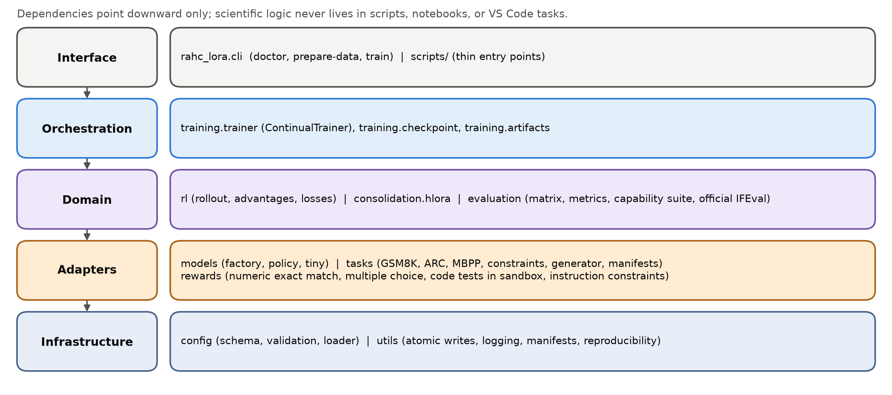
Figure 5.1: Layered software architecture of the rahc_lora package.
Configuration is composed by Hydra from groups (model, task, method, task stream, experiment, rollout, optimizer, scheduler, checkpoint, launcher, and sandbox). It is validated into immutable dataclasses and frozen when a run starts. Validation enforces, for example, that the standard method rl_lora enables no retention component, that model revisions are 40-character commit hashes, and that a requested precision is supported, with no silent fallback. The resolved configuration and its SHA-256 hash are saved with every run and checkpoint.

5.2 Data Collection and Preprocessing

5.2.1 Data sources
The continual-RL stream uses four task families, and the capability suite uses five evaluation-only datasets, all pinned to exact Hugging Face revisions (Table 5.1). GSM8K [84] provides grade-school math word problems with numeric answers. ARC-Challenge [79] provides grade-school science questions with three to five labelled options. MBPP [85], sanitized version, provides Python programming problems with hidden assert-based tests. The custom verifiable-constraints dataset is generated by the project.
Table 5.1: Pinned datasets, project roles, split sizes, and training rewards.
Dataset (revision) | Role | Train | Val. | Anchor cand. | Test / eval | Reward or metric
GSM8K main (740312a) | RL task | 5,979 | 747 | 747 | 1,319 | normalized exact final number
ARC-Challenge (210d026) | RL task | 1,007 | 299 | 112 | 1,172 | exact option label
MBPP sanitized (4bb6404) | RL task | 108 | 43 | 12 | 257 | fraction of hidden tests passed (sandbox)
Custom constraints v1.0.0 | RL task | 32 | 16 | 16 | 16 | fraction of constraints satisfied
IFEval (966cd89) | Evaluation only | - | - | - | 541 | official strict / loose scorer
MMLU, 4 subjects (c30699e) | Evaluation only | - | - | - | 623 | exact option label
HellaSwag (218ec52) | Evaluation only | - | - | - | 10,042 | exact option label
ARC-Easy (210d026) | Evaluation only | - | - | - | 2,376 | exact option label
WikiText-2 raw (b08601e) | Evaluation only | - | - | - | 2,891 | token perplexity (<= 256 tokens)
Note: Custom-constraint prompts: 0 exact and 0 normalized overlaps with the 541 official IFEval prompts. The pilots evaluate the first 64 or 128 examples of each held-out split.

5.2.2 Data cleaning and split construction
Raw records are never modified or committed. Each record receives a stable identifier, the SHA-256 hash of configured immutable identity fields (for example the GSM8K question text or the ARC item ID). Source training records are ranked by the SHA-256 of "split_seed:example_id". This makes role assignment independent of the order in which the provider returns records. Official splits are preserved where they exist. GSM8K has no validation split, so validation (10%) and anchor candidates (10%) are taken from the ranked source training split, and the official test split is the held-out test. ARC-Challenge and MBPP keep their official validation and test splits, and anchor candidates (10%) are removed from the source training split. Every trainable manifest rejects duplicate IDs and duplicate content hashes across roles, and empty roles fail loudly (Figure 5.2).
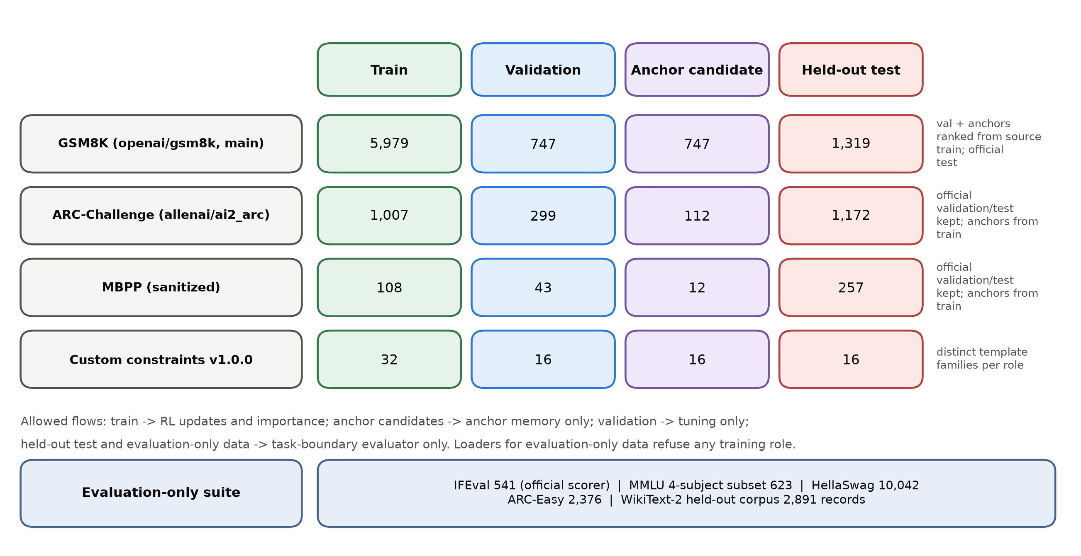
Figure 5.2: Data roles and isolation. Split sizes of the four RL tasks and the evaluation-only suite, with the flows each role is allowed to feed.

5.2.3 Data transformation: prompts and answer formats
Each task formats a fixed, versioned prompt. GSM8K uses "Solve the problem. Give your final numeric answer clearly." followed by the problem. ARC-Challenge uses "Choose the correct option and end with its label." followed by the question and labelled options. MBPP uses "Write a complete Python solution. Return only Python code; do not include tests." followed by the problem; the tests are hidden from the prompt. The capability suite uses "Select the best completion and answer with its label." for MMLU, HellaSwag, and ARC-Easy, and the official IFEval prompts unchanged. Prompts are tokenized with the pinned tokenizer and truncated to 128 tokens.

5.2.4 Custom verifiable-constraint dataset
Official IFEval must remain evaluation-only, so the constraint task uses a separate, generated dataset (version 1.0.0, seed 20260922) of 80 prompts from eight template families. The families are separated by role: topic-keyword-bullets and brief-forbidden-ending for training; summary-sections and JSON-profile for validation; steps-keyword and note-word-range for anchor candidates; and recommendation-bullets and JSON-inventory for test. Constraints include an exact bullet count, keyword counts, forbidden words, required ending phrases, word-count intervals, titled sections, and valid JSON with required fields. The reward is the fraction of constraints satisfied. Before manifests are written, every custom prompt is compared with the 541 official IFEval prompts by exact and aggressively normalized text. The checked-in audit reports zero exact and zero normalized overlaps. Any overlap would abort data preparation.

5.2.5 Summary of preprocessed data
Preparation writes only JSON manifests and the overlap audit. Each manifest records the canonical source, revision, license and citation, source-split mapping, preprocessing, prompt and reward versions, exact role membership IDs, content hashes, and per-example provenance. The run manifest of every GPU run records the SHA-256 fingerprint of each dataset manifest, so any change to the data protocol produces a visibly different run identity.

5.3 Rewards and Isolated Code Execution
All rewards are deterministic functions with a documented range of [0, 1]. Malformed or ambiguous answers receive a documented score of zero rather than a guessed interpretation. The numeric scorer extracts the final number after an explicit marker ("####", "final answer", or "answer") or, failing that, the last number in the response. It converts the number to an exact rational, handling thousands separators, currency symbols, fractions, and percentages, and compares it exactly with the reference. The multiple-choice scorer accepts one unambiguous label after a marker such as "answer:", a bare label, or an exact normalized option text. It rejects responses that name two different labels. Unit tests cover hand-written accepted, rejected, malformed, and normalization-equivalent examples for every scorer.
Generated code is executed only through an isolated Docker runner (Figure 5.3). Each response is written with its hidden tests into a read-only workspace. It runs in a new container from a digest-pinned image with no network, a read-only root file system, all capabilities dropped, no-new-privileges, user 65534, 256 MB of memory with no additional swap, one CPU, 32 processes, CPU-time and file-descriptor limits, a 5-second timeout, and a 64 KiB output cap. The container is removed afterwards. Only the test outcome leaves the sandbox. If the Docker daemon is unavailable, scoring raises an error: there is no host-execution fallback.
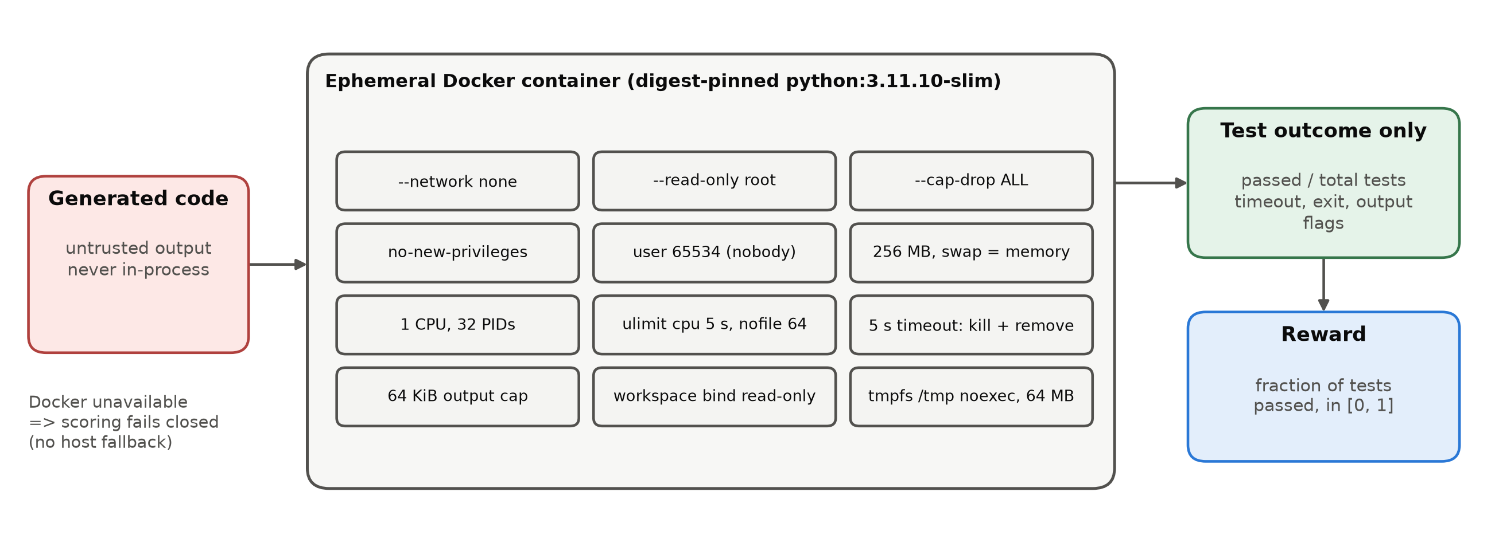
Figure 5.3: Security boundary for code rewards. Generated code runs only in an ephemeral, network-disabled, resource-limited container, and only the test outcome leaves it.

5.4 Policy, Rollouts, and the GRPO Trainer
The model factory loads the pinned causal LM (Qwen2.5-0.5B-Instruct or Qwen2.5-1.5B-Instruct [86]) in explicit BF16 with remote code disabled. It freezes every backbone parameter and attaches exactly one PEFT LoRA adapter (rank 8, α = 16, dropout 0) to the q, k, v, and o projections of every layer. For Qwen2.5-1.5B this gives 2,179,072 trainable parameters. The same closed-form count reproduces the 1,081,344 trainable parameters that the factory reported when loading Qwen2.5-0.5B on CUDA. Only LoRA tensors enter the AdamW optimizer [26], and the adapter is never reset between tasks. A CPU-only tiny model with a byte-level tokenizer shares the same policy interface and is used for deterministic tests.
Each update samples two training prompts by deterministic cycling through the current task's training split. It draws G = 4 responses per prompt with temperature 1.0, top-p 1.0, and at most 128 new tokens, storing the old log-probability of every generated token. Rewards are then normalized within each group in FP32 using the population standard deviation. Groups with a standard deviation at or below 10⁻⁸ receive exactly zero advantage, and advantages are clipped to ±5. The token-mean clipped surrogate (ε = 0.2) is optimized with one AdamW step per rollout, a learning rate of 10⁻⁴, and gradient-norm clipping at 1.0. Rewards, advantages, loss, and gradients are checked for finiteness before the optimizer is allowed to change any parameter. These semantics, which libraries leave open, are fixed in a decision record so that a dependency upgrade cannot change the objective.
Each update logs raw and normalized reward statistics, the number of zero-variance groups, the advantage and ratio clipping fractions, the gradient norm and whether it was clipped, the sampled policy KL (the mean of the old minus new log-probability, a diagnostic of step size), response length and distinct-response fraction, and reward diagnostics. The diagnostics separate parse failures from executed code that failed tests, timeouts, output-limit events, and non-zero exits. System metrics record step time, tokens per second, process memory, and peak GPU allocation.

5.5 Direct HLoRA-to-RL Implementation
The direct HLoRA-to-RL baseline (method hlora_rl) is the Phase 3 reference for consolidation. It transfers the HLoRA idea of element-wise importance with layer coefficients [20] to the shared RL trainer, with two corrections required by RL: importance uses the gradient of the real RL loss, and it uses the movement actually produced by AdamW (Figure 5.4).
During each update, forward hooks on every LoRA target layer capture the input activation (after the configured dropout) and the output gradient. From these the dense effective-weight gradient G_{l} is formed for the forward pass, without reconstructing it from factor gradients. After the optimizer step, the path integral is accumulated with the observed change of the effective update:
(5.1)

At the task boundary, negative path contributions are clamped to zero, the result is normalized by the squared total displacement over the task, and the importance is added to that of earlier tasks. Static layer coefficients are then computed as a softmax over the L2 norms of the module importances:
 | 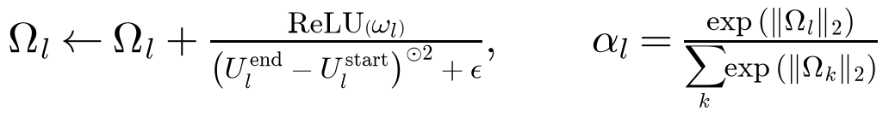 | (5.2)

During the next task, the penalty against the reference effective update is added to the GRPO loss with λ = 1:
 | 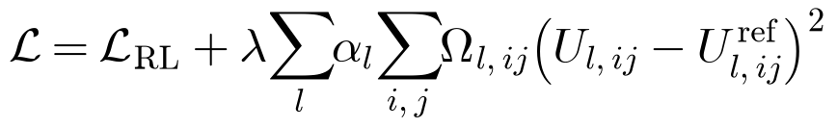 | (5.3)

Importance is stored densely on the CPU in FP32, and dense module-sized transfers happen once per update. The checkpoint stores the reference LoRA factors, the dense importance, and the layer coefficients. Reference effective updates are recomputed from the stored factors. Unit tests check that zero movement gives a zero path contribution, that the penalty against a reference matches a direct computation, and that the state survives serialization exactly. As Chapter 6 shows, this baseline behaves exactly like RL-LoRA on the first task, as required. It also reveals a weakness of the softmax coefficients, which is the main design lesson of P2.
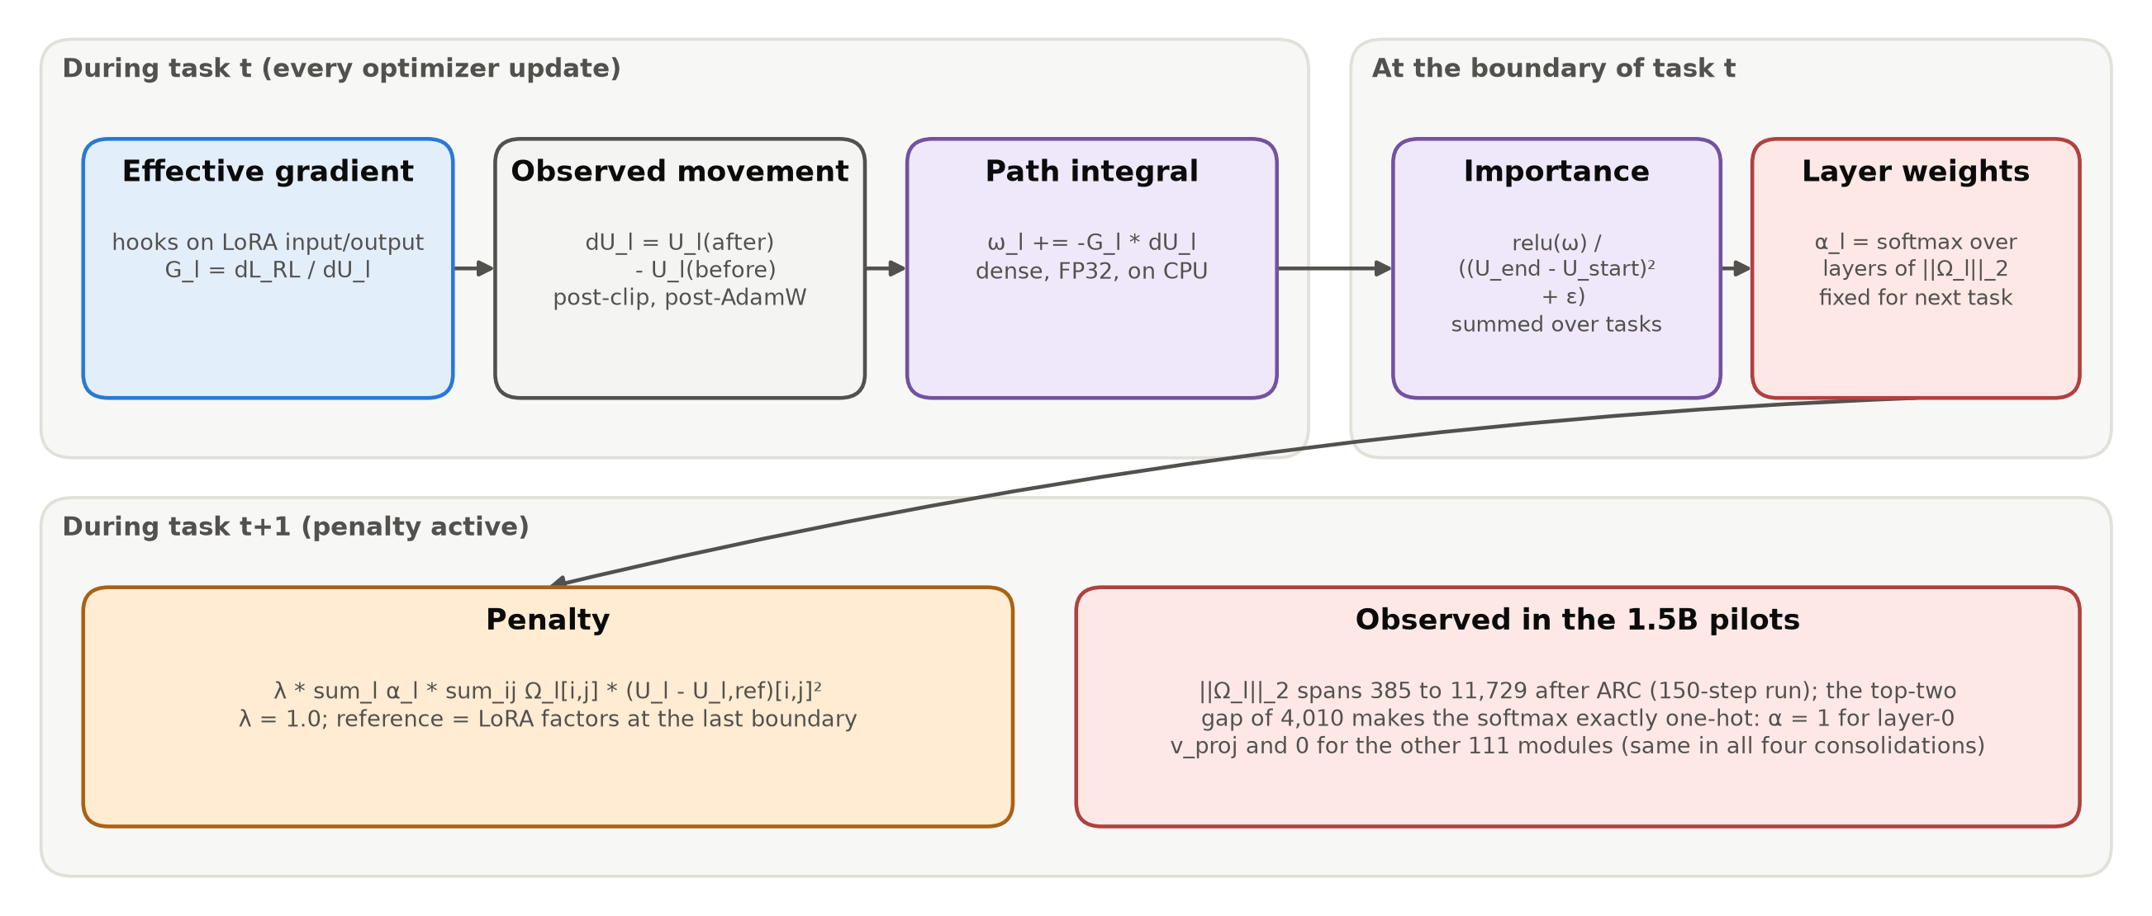
Figure 5.4: The implemented direct HLoRA-to-RL baseline, with the coefficient collapse observed in the pilots.

5.6 Evaluation Implementation
At each task boundary, the evaluator generates greedy responses (at most 64 new tokens) for the held-out test examples of every learned task. It scores them with the task's reward and writes one row of the performance matrix together with per-example records. The records contain example IDs, prompt and response hashes, rewards, and parse status, not raw text. Continual metrics are computed only from a complete matrix. Forward transfer is reported as unavailable unless the corresponding pre-learning cells were evaluated.
The capability suite is evaluated once on the frozen starting policy and after every task, and each score is stored with its signed change from the frozen baseline. IFEval is scored with the official Google Research implementation checked out at a pinned commit. Its four runtime source files and the NLTK punkt_tab resource are verified by digest before use, and there is no approximate fallback scorer. MMLU uses a fixed subset of four subjects (abstract algebra, college computer science, high-school physics, professional medicine). MMLU, HellaSwag, and ARC-Easy are scored by exact option label with the same parser as the training tasks, and perplexity is computed on non-empty WikiText-2 test records truncated to 256 tokens. The pilots evaluate the first 64 or 128 examples of each split and capability, as configured.

5.7 Checkpointing, Artifacts, and Reproducibility
Every run writes a fixed artifact layout (Figure 5.5): the resolved configuration, a schema-validated run manifest (model and tokenizer revisions, command overrides, dependency versions, hardware, and Git state when available), dataset fingerprints, structured learning and system metrics, evaluation records, the performance matrix, capability scores, layer diagnostics, the memory and checkpoint manifests, and a final summary. Checkpoints are written at every task boundary into a new directory, with the size and SHA-256 hash of every file recorded in a manifest. The latest-checkpoint pointer changes only after validation and atomic replacement succeed, and no valid checkpoint is ever overwritten. A checkpoint contains the adapter, optimizer, scheduler, task and step counters, the rollout counter and policy version, the general and rollout RNG states, the performance matrix, the capability history, and the retention state (empty for RL-LoRA, and reference factors, importance, and layer coefficients for HLoRA-RL). Resume rejects any change to the scientific configuration, the model identity, the data fingerprints, or the dependency versions.
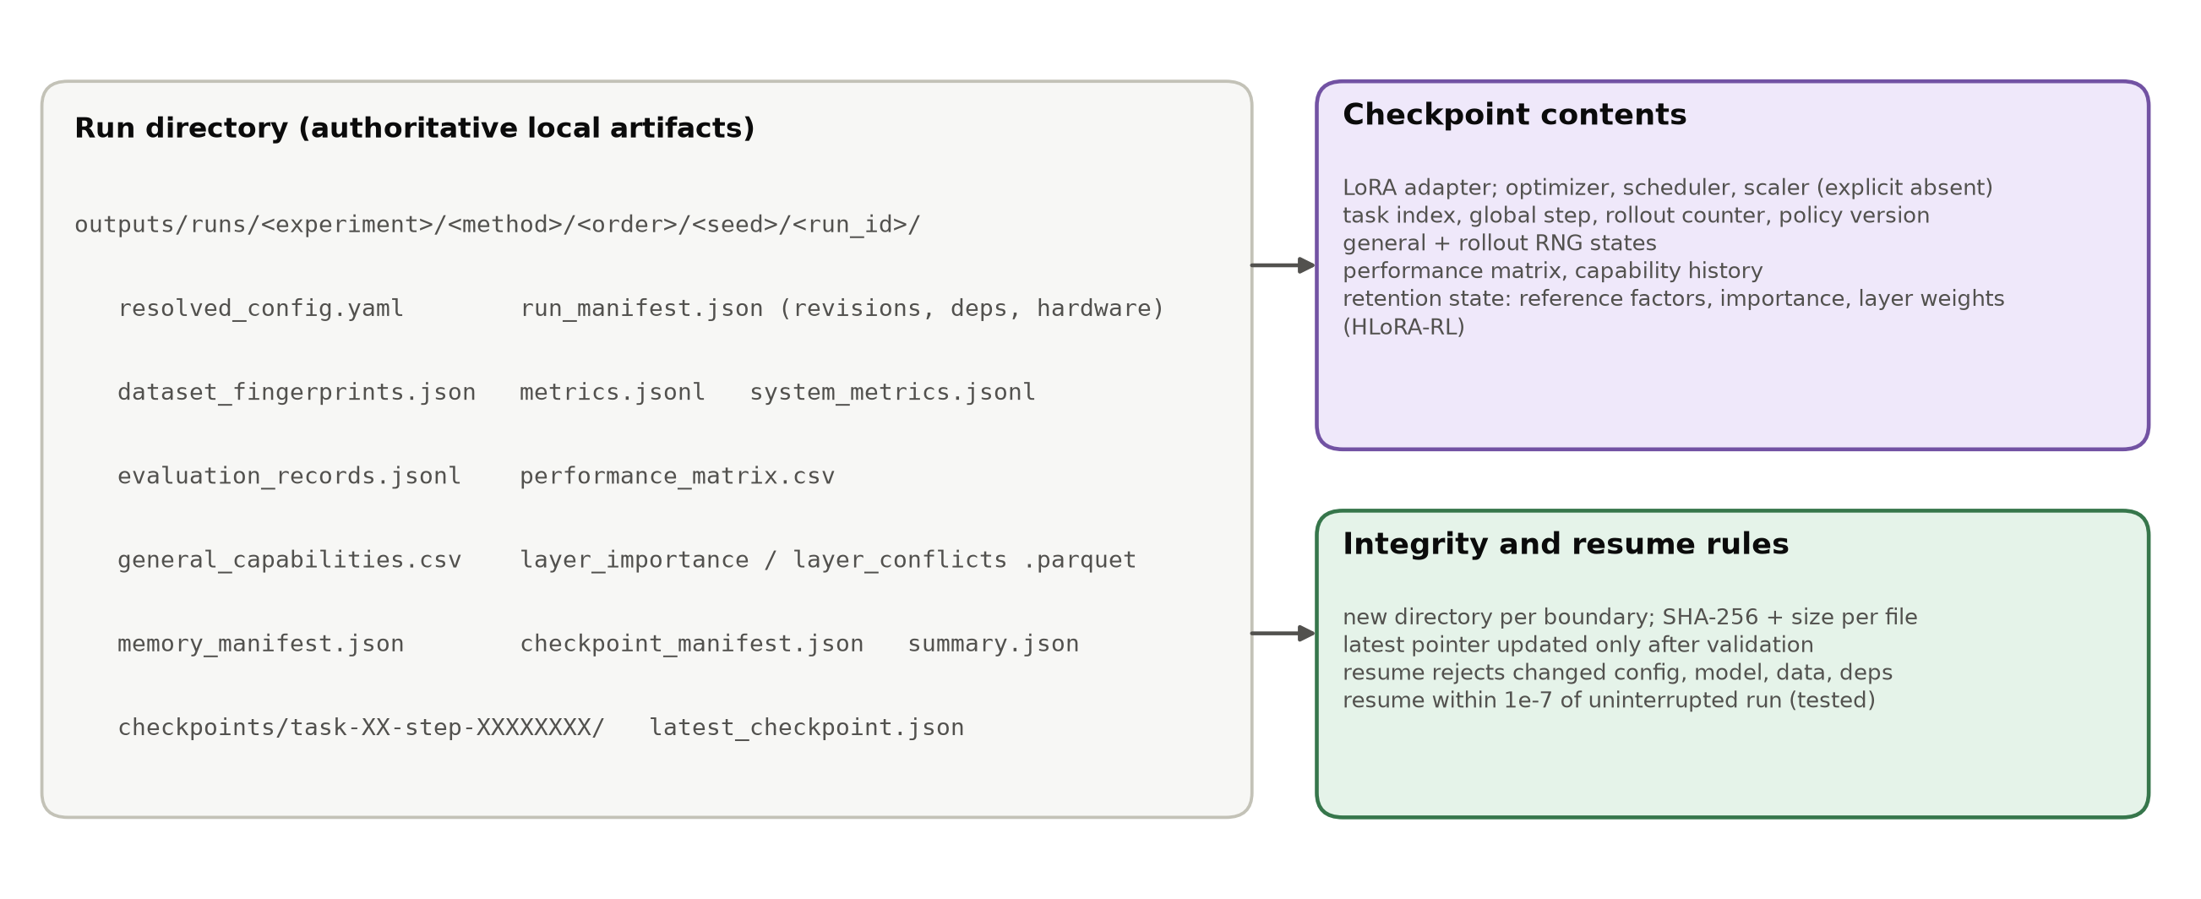
Figure 5.5: Run artifacts and checkpoint contract.
This design proved its value during P2. The 1,000-update MBPP → GSM8K pilot stopped after 918 updates, during GSM8K. Its only resumable checkpoint was the verified task-1 boundary at step 500. A recovery run restored that checkpoint under the identical configuration hash, replayed the remaining 500 GSM8K updates, and completed the final evaluation. Both the source and the recovered checkpoints pass file-membership, size, and hash validation, and the recovery provenance is recorded alongside the artifacts.

5.8 Experimental Setup
All GPU pilots share the configuration in Table 5.2. The stream design proceeded in two stages. Phase 2 tested standard RL-LoRA on the pre-registered order_1 (GSM8K → ARC-Challenge) and order_2 (MBPP → GSM8K) streams at 100 and 500 updates per task, to find out whether the baseline forgets. Because the first task was learned only weakly in these streams (Chapter 6), a stream with a strong first task, ARC-Challenge → GSM8K ("order_arc_first"), was then used to compare RL-LoRA and HLoRA-RL at 100 and 150 updates per task. Runs were executed back to back with identical seeds and settings. Table 5.3 lists every analysed run.
Table 5.2: Experimental configuration shared by all GPU pilots (values from the resolved run configurations).
Setting | Value
Backbone | Qwen2.5-1.5B-Instruct (one 0.5B pilot), BF16, frozen
Adapter | one LoRA, rank 8, α 16 (scale 2.0), dropout 0, q/k/v/o in all layers; 2,179,072 trainable parameters (1.5B)
Rollouts | 2 prompts x G = 4 responses per update (8 rollouts); temperature 1.0, top-p 1.0; <= 128 prompt and <= 128 response tokens
GRPO | population-std group normalization, zero advantage for zero-variance groups, advantage clip 5.0, ratio clip 0.2, one update per rollout
Optimizer | AdamW, lr 1e-4, betas (0.9, 0.999), no weight decay, grad-norm clip 1.0, constant schedule
Budgets | 100 or 500 updates per task (Phase 2); 100 or 150 updates per task (ARC -> GSM8K)
HLoRA-RL | λ = 1.0, epsilon = 1e-8, dense importance on CPU, static softmax layer weights
Evaluation | greedy decoding, <= 64 new tokens; 128 (Phase 2) or 64 (ARC -> GSM8K) held-out examples per task and capability
Seed / orders | seed 1; order_1 (GSM8K -> ARC), order_2 (MBPP -> GSM8K), order_arc_first (ARC -> GSM8K)

Table 5.3: Inventory of the GPU runs analysed in this report (seed 1 in every run).
Label | Model | Order | Updates / task | Eval n | Optimizer hours | Run ID
P2-A RL-LoRA | Qwen2.5-0.5B | GSM8K -> ARC | 100 | 128 | 2.3 | phase2-pilot-gpu-128-20260924
P2-B RL-LoRA | Qwen2.5-1.5B | GSM8K -> ARC | 100 | 128 | 2.8 | phase2-pilot-confirmation-gpu-128-20260924
P2-C RL-LoRA | Qwen2.5-1.5B | GSM8K -> ARC | 500 | 128 | 16.7 | phase2-pilot-duration-500-gpu-128-20260924
P2-D RL-LoRA | Qwen2.5-1.5B | MBPP -> GSM8K | 500 | 128 | 7.3 | phase2-pilot-order2-recovery-20260926
P3-A RL-LoRA | Qwen2.5-1.5B | ARC -> GSM8K | 100 | 64 | 2.8 | phase3-pilot-baseline-arc-gsm-100
P3-A HLoRA-RL | Qwen2.5-1.5B | ARC -> GSM8K | 100 | 64 | 2.9 | phase3-pilot-hlora-arc-gsm-100
P3-B RL-LoRA | Qwen2.5-1.5B | ARC -> GSM8K | 150 | 64 | 4.2 | phase3-scaled-baseline-arc-gsm-150
P3-B HLoRA-RL | Qwen2.5-1.5B | ARC -> GSM8K | 150 | 64 | 4.3 | phase3-scaled-hlora-arc-gsm-150
Note: P2-D optimizer hours cover the 500 recovered GSM8K updates; the preserved source run supplied the MBPP task and its verified step-500 checkpoint.
Two deviations from the initial pilot plan were made using training rollouts only and are documented. First, the training response budget was raised from 32 to 128 tokens after probes at 32 and 64 tokens produced no GSM8K reward. Second, the budget was extended from 100 to 500 updates per task after the 1.5B confirmation pilot showed positive GSM8K reward in only 28 of 100 training batches. Held-out scores were not used to choose either setting.

5.9 Validation and Testing
Following the rule "cheap validation before expensive validation", the platform was validated before any GPU run and re-validated afterwards (Table 5.4). The test suite contains unit tests for splits and manifests, rewards, the constraint generator and IFEval overlap, the sandbox command, GRPO advantages and loss, continual metrics, the capability suite, the official IFEval adapter, and HLoRA importance, together with integration tests for data preparation, mock two-task evaluation, and interrupted training with resume. At the time of writing all 59 tests pass in 12.5 seconds on CPU.
Table 5.4: Engineering validation evidence (cheap checks before GPU runs).
Check | Result
Unit and integration tests | 59 passed in 12.5 s (CPU, Python 3.12 venv); also 56/56 in the CUDA gpu-env at Phase 2
Frozen backbone | synthetic-reward update changes LoRA tensors; every frozen parameter bit-identical
Interrupted resume | adapter and matrix match the uninterrupted run within 1e-7 absolute tolerance
Repeat determinism | two CLI smoke runs match exactly in adapter tensors, events, summary, matrix
First-task equivalence | HLoRA-RL and RL-LoRA losses and gradient norms bit-identical for all task-1 updates
Checkpoint integrity | all files in every pilot checkpoint pass size and SHA-256 validation
Data isolation | custom constraints vs IFEval: 0 exact, 0 normalized overlaps; duplicate IDs and hashes rejected
Sandbox | Docker backend passed a generated-code check; unavailable Docker fails closed
IFEval scorer | pinned google-research checkout and NLTK punkt_tab digest verified; no fallback scorer

5.10 Implementation Status
Table 5.5 summarizes the status of each phase, established from repository evidence rather than from file names. Phases 0-2 are complete. Phase 3 is partly complete: the dense HLoRA-to-RL baseline is implemented and has been piloted, but the separate supervised HLoRA reproduction on SciQ, PiQA, MedMCQA, and a Pile subset has not yet been run. Phases 4-7, the RAHC-LoRA components specified in Chapter 4, have not been started. Their configuration switches exist and are validated, but the trainer currently accepts only the rl_lora and hlora_rl methods. It rejects the others explicitly, so no result in this thesis could come from an unimplemented component.
Table 5.5: Phase-by-phase implementation status established from repository evidence (29 September 2026).
Phase | Deliverable | Status | Evidence
0 | Scaffold, typed Hydra config, CLI, logging, manifests, tooling | Complete | doctor, ruff, mypy, pytest pass
1 | Four task adapters, generator, rewards, sandbox, matrix and metrics | Complete | hand-checked reward tests; mock two-task gate
2 | Standard RL-LoRA GRPO trainer, checkpoint/resume, capability suite | Complete | 4 GPU pilots; resume within 1e-7
3 | Direct HLoRA-to-RL baseline | Partial | dense importance + penalty implemented and piloted; supervised reproduction not yet run
4 | Reward-aware effective-weight importance | Not started | specified (Section 4.3.3)
5 | Rank-1 factorization and Gram-form penalty | Not started | specified (Section 4.3.4)
6 | Fixed anchor memory and compact KL | Not started | specified (Section 4.3.5)
7 | Conflict gate and dual controller | Not started | specified (Section 4.3.6)
8-9 | Method pilot, main study, ablations, statistics | Not started | gated by continuation rule

