
––-

“ScanSure”
Detection from Chest X-Rays Using CNN and ResNet Moels

Final Project Report Submitted to
The Department of Computer Science
Faculty of Computer and Information Technology
Jordan University of Science and Technology

In Partial Fulfillment of the Requirements for the Degree of
Bachelor of Science in Computer Science

By

Baylasan Mohammad AL-Tawallbeh (151993)
Ayham Mohammed Obeidat (157950)
Mohammad Nabil AL Heileh (152733)

Supervised by Dr. Farah Al Shanik

Spring / 2025

نموذج حقوق الملكية الفكرية لمشاريع التخرج في قسم علوم الحاسوب
يتم قراءة وتوقيع هذا النموذج من قبل الطالب المسجلين لمشاريع التخرج في قسم علوم الحاسوب
تعود حقوق الملكية الفكرية لمشاريع التخرج ونتائجها) مثل براءات الأختراع أو أي منتج قابل للتسويق) إلى جامعة العلوم والتكنولوجيا الأردنية، وتخضع هذه الحقوق إلى قوانين وأنظمة و تعليمات الجامعة المتعلقة بالملكية الفكرية وبراءات الاختراع.
بناءا على ما سبق أوافق على ما يلي:
- أن أحفظ كافة حقوق الملكية الفكرية لجامعة العلوم والتكنولوجيا الأردنية في مشروع التخرج.
- أن ألتزم بوضع اسم جامعة العلوم والتكنولوجيا األردنية و أسماء جميع الباحثين المشاركين في المشروع على أي نشرة علمية للمشروع كاملا أو لنتائجه. و يشمل ذلك النشر في المجلات و المؤتمرات العلمية عامة أو النشر على المواقع الالكترونية أو براءات الاختراع أو المسابقات العلمية.
- أن ألتزم بأسس حقوق التأليف المعتمدة في جامعة العلوم والتكنولوجيا الأردنية.
- أن أقوم بإعلام الجهة المختصة في الجامعة عن أي اختراع أو اكتشاف قد ينتج عن هذا المشروع و أن ألتزم السرية التامة في ذلك و أن أعمل من خلال الجامعة على الحصول على براءة الاختراع التي قد تنتج عن هذا المشروع.
- أن تكون جامعة العلوم والتكنولوجيا الأردنية هي المالك ألي براءة اختراع قد تنتج عن هذا المشروع و تشمل هذه الملكية حق الجامعة في إعطاء التراخيص و التسويق و البيع كمؤسسة راعية و داعمة لكافة الأنشطة البحثية. و يكون حق للطالب شمول اسمه على براءة الاختراع كأحد المخترعين، و في حال تم إعطاء تراخيص أو تسويق و بيع ألي من منتجات المشروع يمنح المخترعون بما فيهم الطالب نسبة من اإليرادات حسب تعليمات البحث العلمي في جامعة العلوم والتكنولوجيا الأردنية.
إسم الطالب محمد نبيل محمد الحيله التوقيع
إسم الطالب بيلسان محمد محمود الطوالبه التوقيع
إسم الطالب أيهم محمد محمود عبيدات التوقيع
إسم المشرف فرح الشنيك التوقيع

تاريخ ...............................

ACKNOWLEDGMENTS

We would like to take this opportunity to express our deep sense of gratitude and profound feeling of admiration of our supervisor Dr. Farah Al Shanik, for her valuable assistance and guidance during the semester.

We would also like to express our sincere gratitude to Dr. Yahya Tashtoush for his time and support.

Many thanks for their contribution to this study.

ABSTRACT
Pneumonia is a serious respiratory condition that can be life-threatening if not diagnosed and treated promptly. Traditional diagnostic methods such as chest X-ray interpretation require expert radio-logical analysis, which may not always be available, especially in resource-limited settings. This project presents an automated system for pneumonia detection using Convolution Neural Networks (CNN), a powerful deep learning technique widely used in medical image classification The system is designed to analyze chest X-ray images and classify them as either normal or showing signs of pneumonia. The CNN model is trained on publicly available datasets and integrated into a user-friendly interface that allows users to upload X-ray images, view diagnostic predictions, and download reports. The system aims to assist healthcare professionals and patients by providing fast, accurate, and consistent preliminary diagnoses. This document seeks to describe requirements such as functionalities, features, and user interfaces of an AI powered web-based platform in detail. The document also presents the behaviors and interactivity details of the website, which will be fully described with figures and diagrams.

KEYWORDS
Diagnose, X-Ray, Web-Based, Requirements, Artificial Intelligence

Table of Contents
ACKNOWLEDGMENTS..............................................................................................................3
ABSTRACT...............................................................................................................................4
LIST OF FIGURES......................................................................................................................7
LIST OF TABLES .......................................................................................................................9

CHAPTER
- INTRODUCTION....................................................................................................10
1.1 Overview........................................................................................................10
1.2 Motivation......................................................................................................11
1.3 Problem Statement.........................................................................................11
1.4 Solution..........................................................................................................11

2. REVIEW OF RELATED LITERATURE...........................................................................13
2.1 ChexNet .........................................................................................................13
2.2 qXR ................................................................................................................14
2.3 VUNO Med–Chest ..........................................................................................15
2.4 CAD4TB ..........................................................................................................16
2.5 Summery........................................................................................................17

3. ANALYSIS AND DESIGN ..........................................................................................18
2.1 Techniques we used to elicit requirements.....................................................18
3.2 Analysis of survey answers..............................................................................19
3.3 Stakeholders ...................................................................................................23
3.4 Functional requirements..................................................................................23
3.4.1 Patient’s requirements...........................................................................23
3.4.2 Doctor’s requirements............................................................................24
3.5 Non-functional requirements..........................................................................25
3.6 Unified modeling language..............................................................................26
3.6.1 Use case diagram ...................................................................................26
3.6.2 Class Diagram.........................................................................................30
3.6.3 Entity relationship diagram....................................................................31
3.6.4 Database schema ...................................................................................33
3.7 User interface design......................................................................................35
3.8 Conclusion and future work ...........................................................................39

REFERENCES ....................................................................................................................40
APPENDICIES ...................................................................................................................41
APPENDIX A: MEETING MINUTES..........................................................................42
APPENDIX B: GANTT CHART..................................................................................43
APPENDIX C: SURVEY QUESTIONS.........................................................................44
LIST OF FIGURES
FIGURE PAGE
2.1 ChexNet by Stanford.………….………………………………………………………….………13
2.2 qXR by Qure.ai.……………………………………………………….….……………….…………14
2.3 VUNO Med–Chest X-ray…………….………..……………………..……………….…………15
2.4 CAD4TB………………………………………..…………………………….……………….………….16
3.2.1 Question 1 ………………………………………..……………………….…………….………….19
3.2.2 Question 2 ………………………………………..……………………….…………….………….19
3.2.3 Question 3 ………………………………………..……………………….…………….………….20
3.2.4 Question 4 ………………………………………..……………………….…………….………….20
3.2.5 Question 5 ………………………………………..……………………….…………….………….21
3.2.6 Question 6 ………………………………………..……………………….…………….………….21
3.2.7 Question 7 ………………………………………..……………………….…………….………….22
3.6.1 Patient use case diagram ………………..……….……………….…………….…………28
3.6.2 Doctor use case diagram ………………..……….……………….…………….………….29
3.6.3 Doctor use case diagram ………………..……….……………….…………….………….30
3.6.4 ER diagram ...........................................................................................32
3.6.4 Database schema .................................................................................34
3.7.1 Homepage interface ............................................................................35
3.7.2 Doctor login interface ..........................................................................36
3.7.3 Patient login interface .........................................................................36
3.7.2 Doctor interface ..................................................................................37
3.7.2 Patient interface ..................................................................................37
3.7.2 Message interface ...............................................................................38
3.7.2 Tip interface .........................................................................................38
4.2 Gantt chart ..............................................................................................43
4.3.1 Question 1 ………………………………………..…………………….…………….………….44
4.3.2 Question 2 ………………………………………..…………………….…………….………….44
4.3.3 Question 3 ………………………………………..…………………….…………….………….44
4.3.4 Question 4 ………………………………………..…………………….…………….………….45
4.3.5 Question 5 ………………………………………..…………………….…………….………….45
4.3.6 Question 6 ………………………………………..…………………….…………….………….45
4.3.7 Question 7 ………………………………………..…………………….…………….………….46
4.3.8 Question 8 ………………………………………..…………………….…………….………….42

LIST OF TABLES
TABLE PAGE
2.1 Comparison of platforms…….…………………………………………………….…………17
3.1 Uses Case Description…….……………………………..…………………………….…………26
3.2 Future work………………….…….…………………………………………………….…………39
4.1 Meeting minutes ………….…….…………………………………………………….…………42

CHAPTER 1
INTRODUCTION
1.1 Overview
With the advancement of artificial intelligence and the increasing accessibility of medical imaging data, healthcare has seen a major transformation in how diseases are detected and diagnosed. One significant development is the application of deep learning techniques—particularly Convolutional Neural Networks (CNN)—in the analysis of chest X-ray images for early and accurate diagnosis of diseases like pneumonia.
Pneumonia is a common and potentially life-threatening respiratory infection that requires timely detection for effective treatment. However, in many regions, access to expert radiologists is limited. This project aims to bridge that gap by developing an AI-powered system that can automatically detect signs of pneumonia from chest X-ray images. The use of CNN allows the system to learn and extract critical features from medical images, providing reliable predictions.
Our project focuses on creating an efficient and user-friendly platform that enables healthcare professionals, students, or even the general public to upload chest X-ray images and receive instant diagnostic feedback. This system offers consistent performance, operates at anytime from anywhere with internet access, and supports the continuity of care, especially in under-resourced or emergency situations. We believe our solution can assist in early detection, reduce diagnosis time, and ultimately contribute to improved patient outcomes.

1.2 Motivation
Pneumonia remains one of the leading causes of death worldwide, especially among children under five and the elderly. In many countries, including Jordan, there is limited access to expert radiologists, particularly in rural or under-resourced areas. This shortage poses a serious barrier to the early and accurate diagnosis of pneumonia, often leading to delayed treatment and increased health risks.

1.3 Problem statement
Pneumonia remains a significant public health issue, particularly in low-resource settings where access to trained radiologists and diagnostic tools is limited. Despite the availability of chest X-ray imaging, accurately interpreting these images requires specialized expertise that is not always accessible, especially in rural or overcrowded healthcare systems. As a result, many pneumonia cases go undiagnosed or are detected too late, leading to increased morbidity and mortality.

1.4 Solution
we propose a smart, AI-powered platform that utilizes Convolutional Neural Networks (CNN) to analyze chest X-ray images and detect signs of pneumonia. This solution provides a fast, accurate, and accessible diagnostic aid that can support healthcare professionals in both urban and rural settings.
Our platform is designed to be user-friendly, available online 24/7, and completely free to use, ensuring that anyone with internet access can benefit from its features. Users can upload chest X-ray images, receive instant diagnostic results, and download detailed reports—all through a secure and intuitive interface. By offering consistent and reliable performance.

The Chest X-Ray Images (Pneumonia) dataset from Kaggle, created by Paul Mooney, is a widely used and publicly available dataset designed to train and evaluate models for pneumonia detection using chest X-ray images. It contains approximately 5,800 images divided into three categories: training, validation, and testing, with each further classified as either "NORMAL" (healthy lungs) or "PNEUMONIA" (infected lungs). These labeled images can be used to train a Convolutional Neural Network (CNN) model by preprocessing them—resizing, normalizing, and augmenting—to improve accuracy and generalization. Once the model is trained and evaluated, it can be integrated into the backend of a web-based pneumonia detection system. In practice, when a user uploads an X-ray image through the interface, the image is sent to the server, where the model processes it and returns a prediction along with a confidence score. This result is then displayed to the user, and additional features like downloadable reports, visual feedback, and health tips can be offered based on the prediction outcome. This dataset serves as the foundational training source to enable accurate and automated pneumonia detection within the system. [1]

For the pneumonia detection system, Python plays a central role in both building the machine learning model and developing the backend logic of the web application. Key libraries used in the project include TensorFlow for designing and training the Convolutional Neural Network (CNN) model that analyzes chest X-ray images. NumPy and Pandas are used for efficient data manipulation and preprocessing, while OpenCV and Matplotlib help with image processing and visualization. To deploy the trained model within the web app, Flask can be used to create RESTful APIs that connect the front end with the prediction engine. Additionally, libraries like scikit-learn are employed for evaluating the model's performance with metrics such as accracy, precision, and recall. Together, these Python tools and libraries enable the creation of a robust, scalable, and intelligent pneumonia detection system.

CHAPTER 2
REVIEW OF RELATED LITERATURE

2.1 ChexNet by Stanford:
Is a deep learning model developed by researchers at Stanford University in 2017 using ChestX-ray14 dataset from the NIH Clinical Center. It was designed to detect pneumonia and other chest diseases directly from chest X-ray images using a 121-layer Convolutional Neural Network (DenseNet-121). [2]
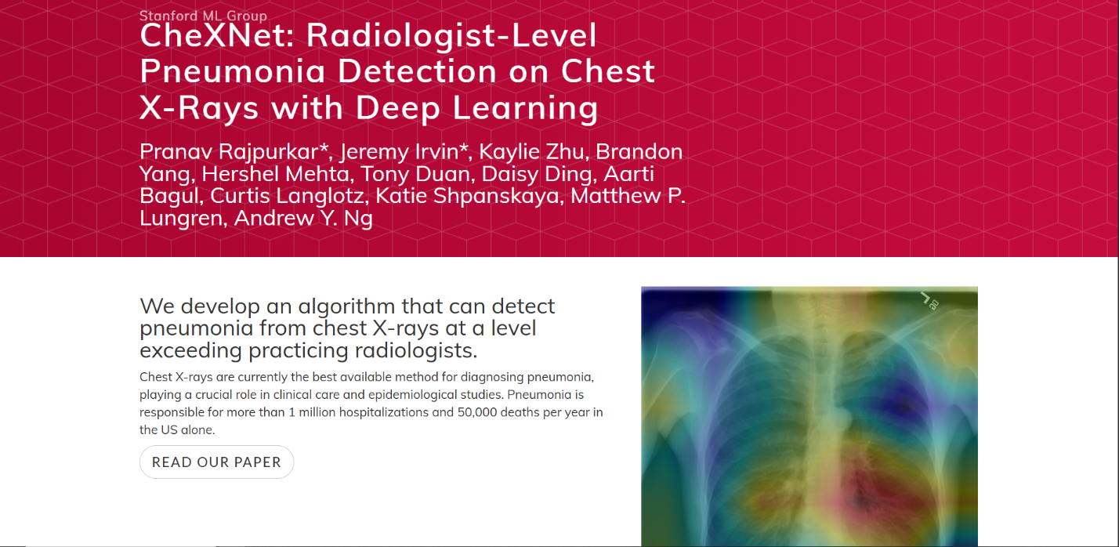
Figure 2.1 ChexNet by Stanford

CheXNet has several limitations. It lacks a user-friendly interface, requires powerful hardware, and is not easily deployable in real-world healthcare settings. As a research-focused tool, it’s not designed for public or clinical use.

2.2 qXR:
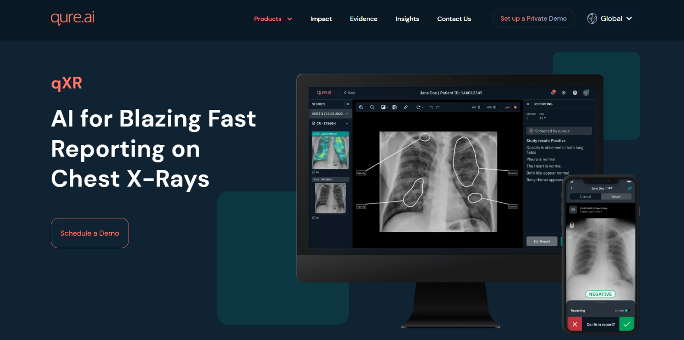
Is an AI-based diagnostic tool developed by Qure.ai using Proprietary dataset of over 2.5 million chest X-rays, sourced from hospitals worldwide that automatically interprets chest X-rays to detect a wide range of pulmonary conditions. It uses deep learning models, qXR is designed for use in clinical settings and assists radiologists by providing fast, consistent interpretations of chest X-rays. [3
Figure 2.2 qXR by Qure.ai

qXR is a commercial product, which means it requires licensing fees and is not freely accessible to the general public or small clinics with limited budgets. it is designed primarily for professional healthcare environments, which may make it less user-friendly for non-experts or educational use. Additionally, it typically functions as part of a larger hospital system or workflow, which could make deployment more complex in remote or under-resourced settings.

2.3 VUNO Med–Chest X-ray:
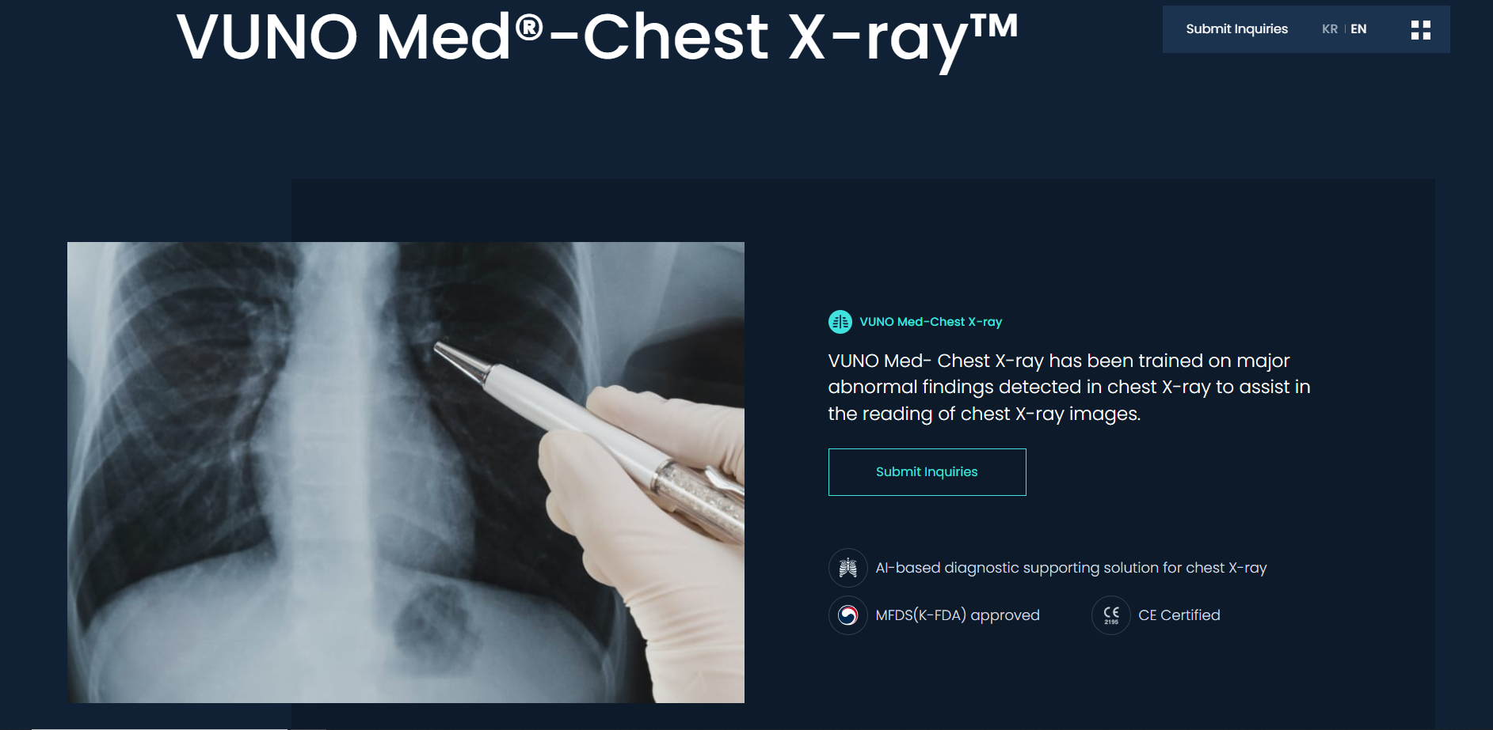
VUNO Med–Chest X-ray is an AI-powered medical imaging solution developed by VUNO Inc using PA view Chest X-rays from Korean hospitals (private medical datasets). It automatically analyzes chest X-rays to detect multiple lung conditions, including pneumonia. Designed for clinical use, it integrates with hospital systems and provides real-time diagnostic support to radiologists. The tool is FDA-cleared and CE-certified. [4]
Figure 2.3 VUNO Med–Chest X-ray

VUNO Med–Chest X-ray is a commercial solution, which means it’s not free and may be unaffordable for smaller clinics or public use. it is designed for hospital integration, requiring technical setup and trained staff, making it less accessible for use in remote or under-resourced areas.

2.4 CAD4TB:
CAD4TB (Computer-Aided Detection for Tuberculosis) is an AI-powered tool developed by Radboud University and Delft Imaging using Private dataset. It analyzes chest X-rays to detect signs of tuberculosis (TB), using deep learning to assist in early and fast diagnosis—especially in low-resource settings. CAD4TB is widely used in public health screening programs across Africa and Asia. While highly effective for TB. [5]
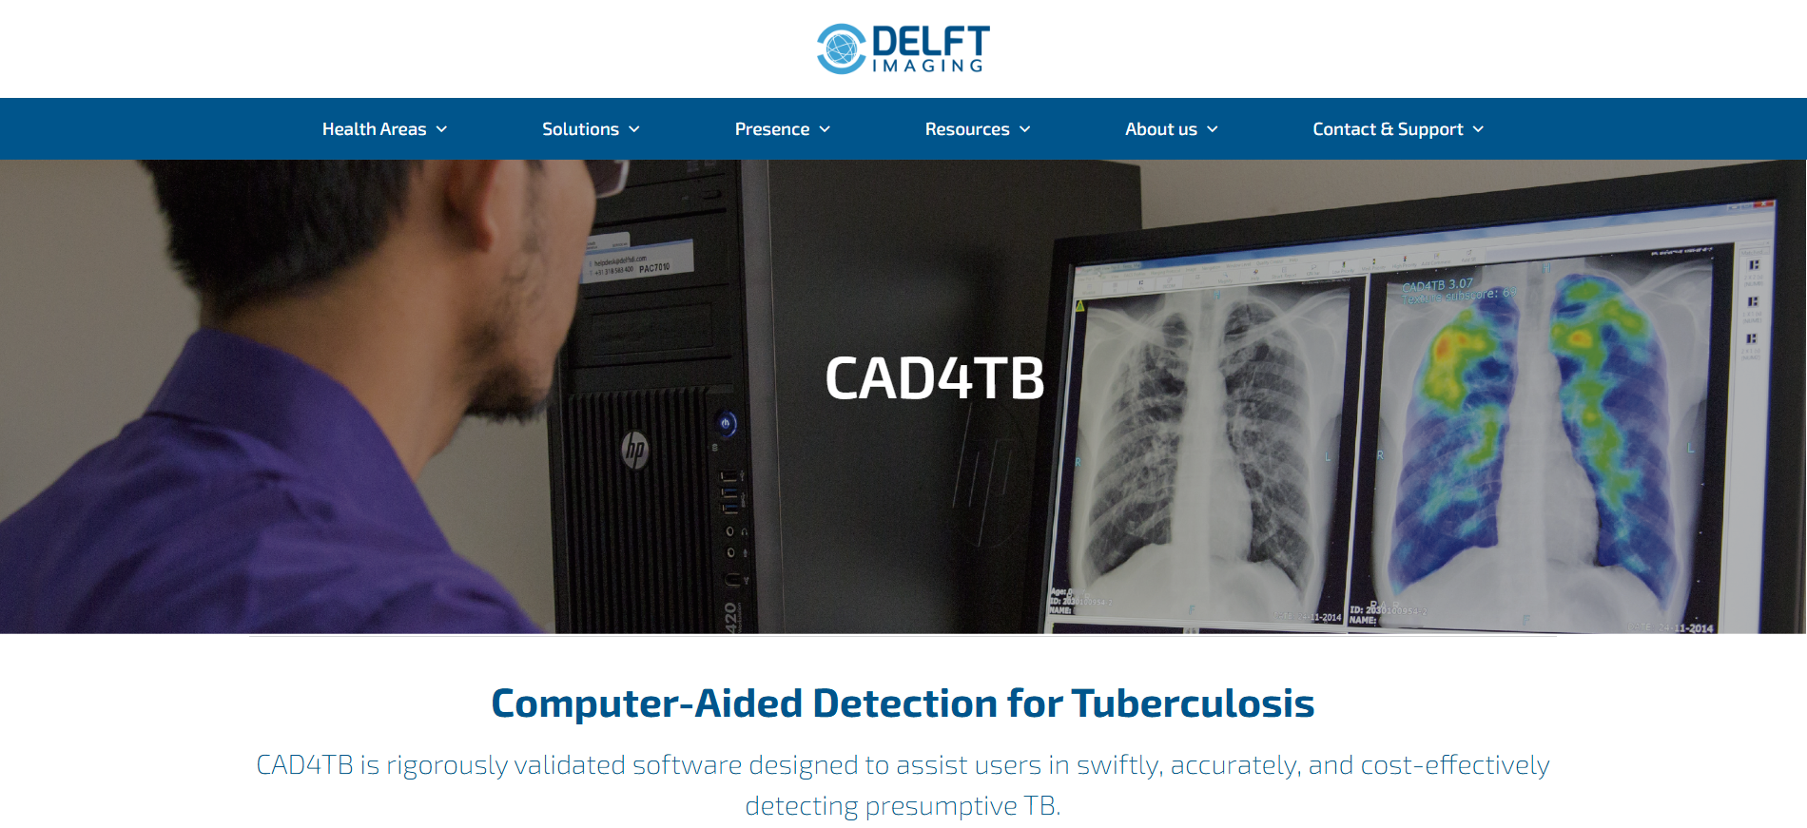
Figure 2.4 CAD4TB

CAD4TB is a well-established tool for detecting tuberculosis from chest X-rays, it has some limitations compared to our project. First, it is focused solely on tuberculosis, meaning it cannot detect pneumonia or other lung conditions, which limits its diagnostic flexibility. Second, it is a commercial tool, requiring paid licenses, which may not be suitable for widespread use in underfunded or public community settings. In contrast, our project is free, specifically designed for pneumonia detection, and is more accessible to students, doctors, and rural users with minimal technical requirements.
2.5 Summery
It is important to focus on the advantages and pros and to avoid weaknesses and drawbacks of each platform for a better experience. The following table is a summary of the platforms previously mentioned:
Project | Main Focus | Accuracy | Deployment | Internet Access Required | Real-time Feedback | Purpose | Target Users | Ease of Use
Chex Net | Pneumonia detection | ~93% | Requires local setup | Yes | No | Medical AI research | Researchers, developers | Low
qXR | Multiple chest diseases | ~91% | Integrated hospital systems | Yes | Yes | Radiology efficiency | Hospitals, healthcare professionals | Medium
VUNO Med–Chest X-ray | Multiple chest diseases | ~92% | On-premise in hospitals | Yes | Yes | Clinical decision support | Radiologists, clinicians | Low
CAD4TB | Tuberculosis detection | ~90% | Mobile/  offline systems | NO | Yes | Public health diagnostics | Health workers, NGOs | Medium
Proposed Project | Pneumonia detection | 90-95% | Web-based, lightweight | Yes | Yes | Education, outreach, screening | Students, doctors, general users | High
Table 2.5 Comparison of platforms
Chapter 3
ANALYSIS AND DESIGN
This chapter will provide a complete description of the system and its users. Then it depicts the functional and non-functional requirements collected using many strategies like brainstorming, interview, and surveys. After determining the most vital requirements, requirement analysis was adopted using many tools like use-case diagram, class diagram, ER diagram.

3.1 Techniques we used to elicit requirements
The methods we used to gather information are:
• Survey
• Focus groups (Brainstorming)

3.2 Analysis of survey answers
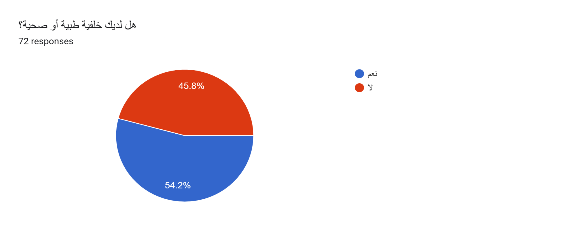
The published survey collected 72 responses
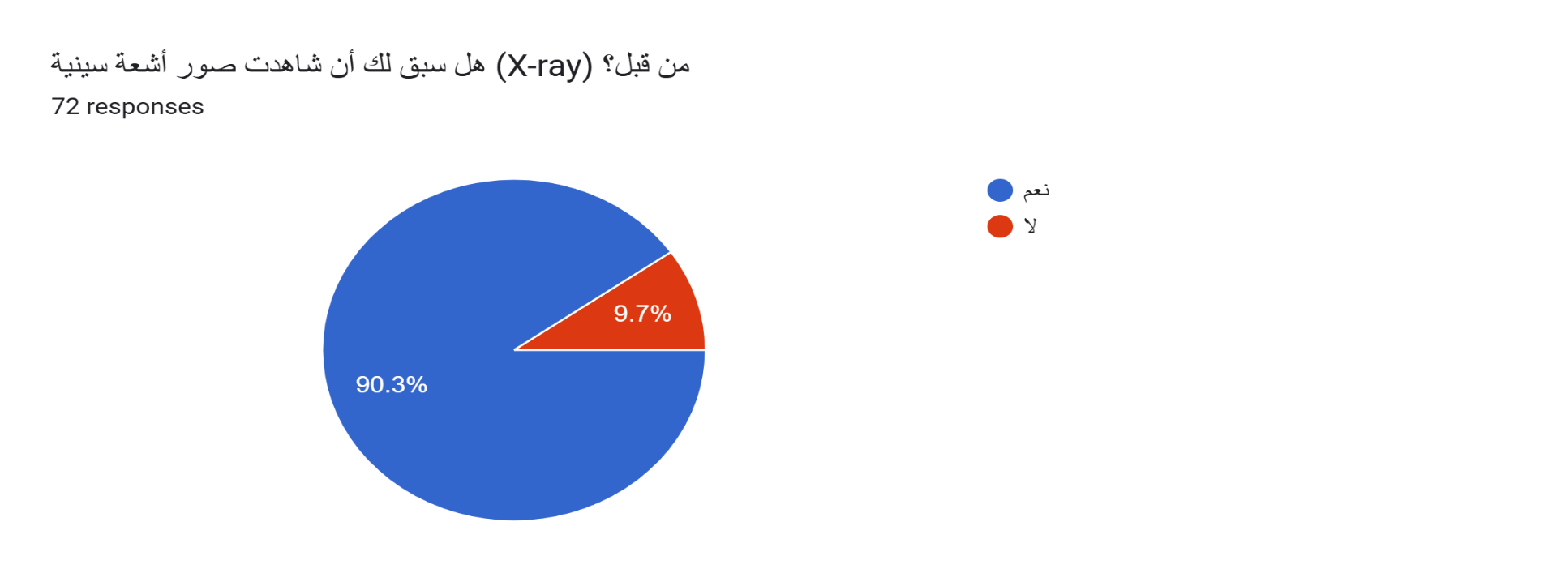
Figure 3.2.1 question 1
Figure 3.2.2 question2
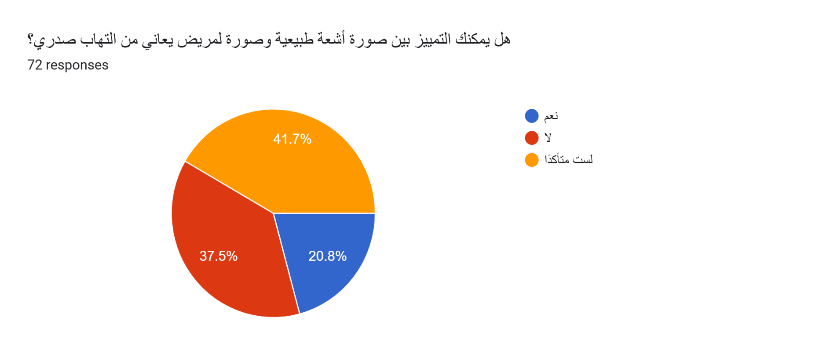
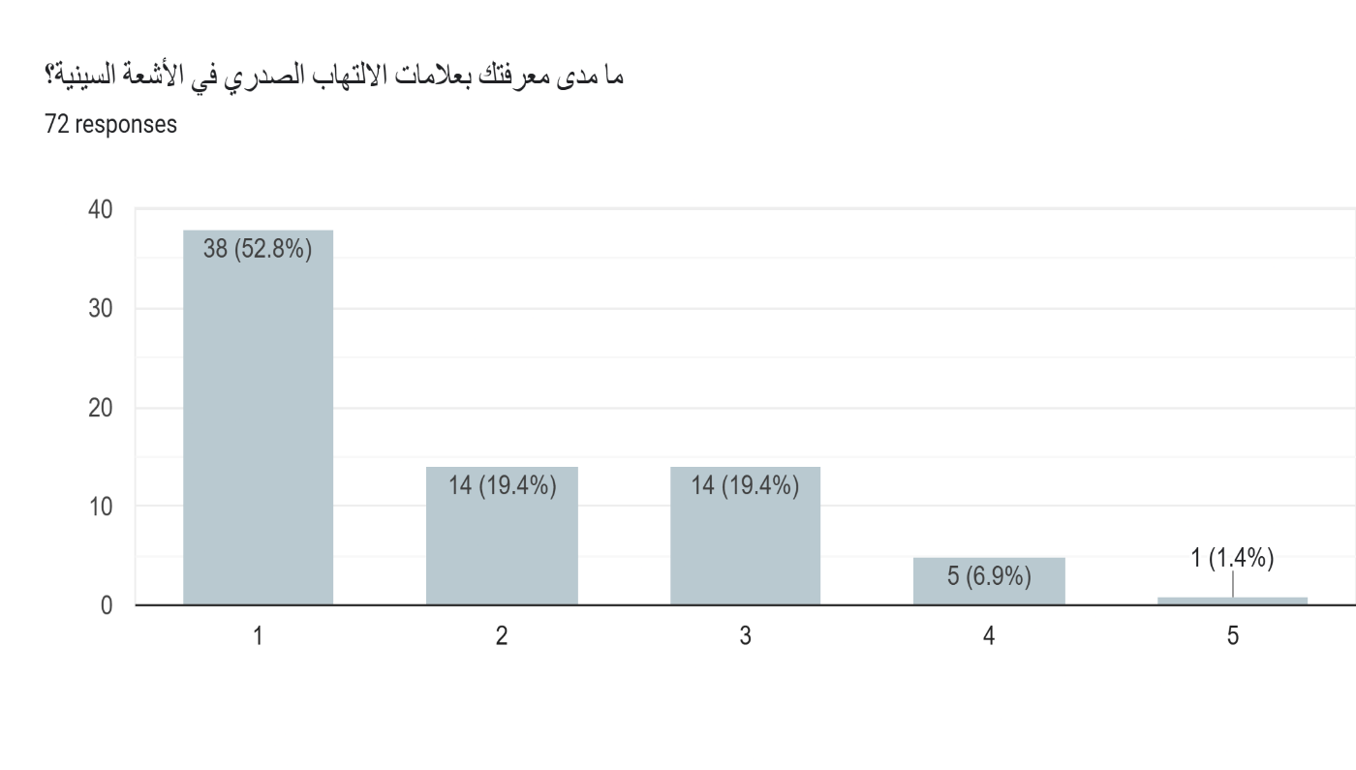
Figure 3.2.3 question 3
Figure 3.2.4 question 4

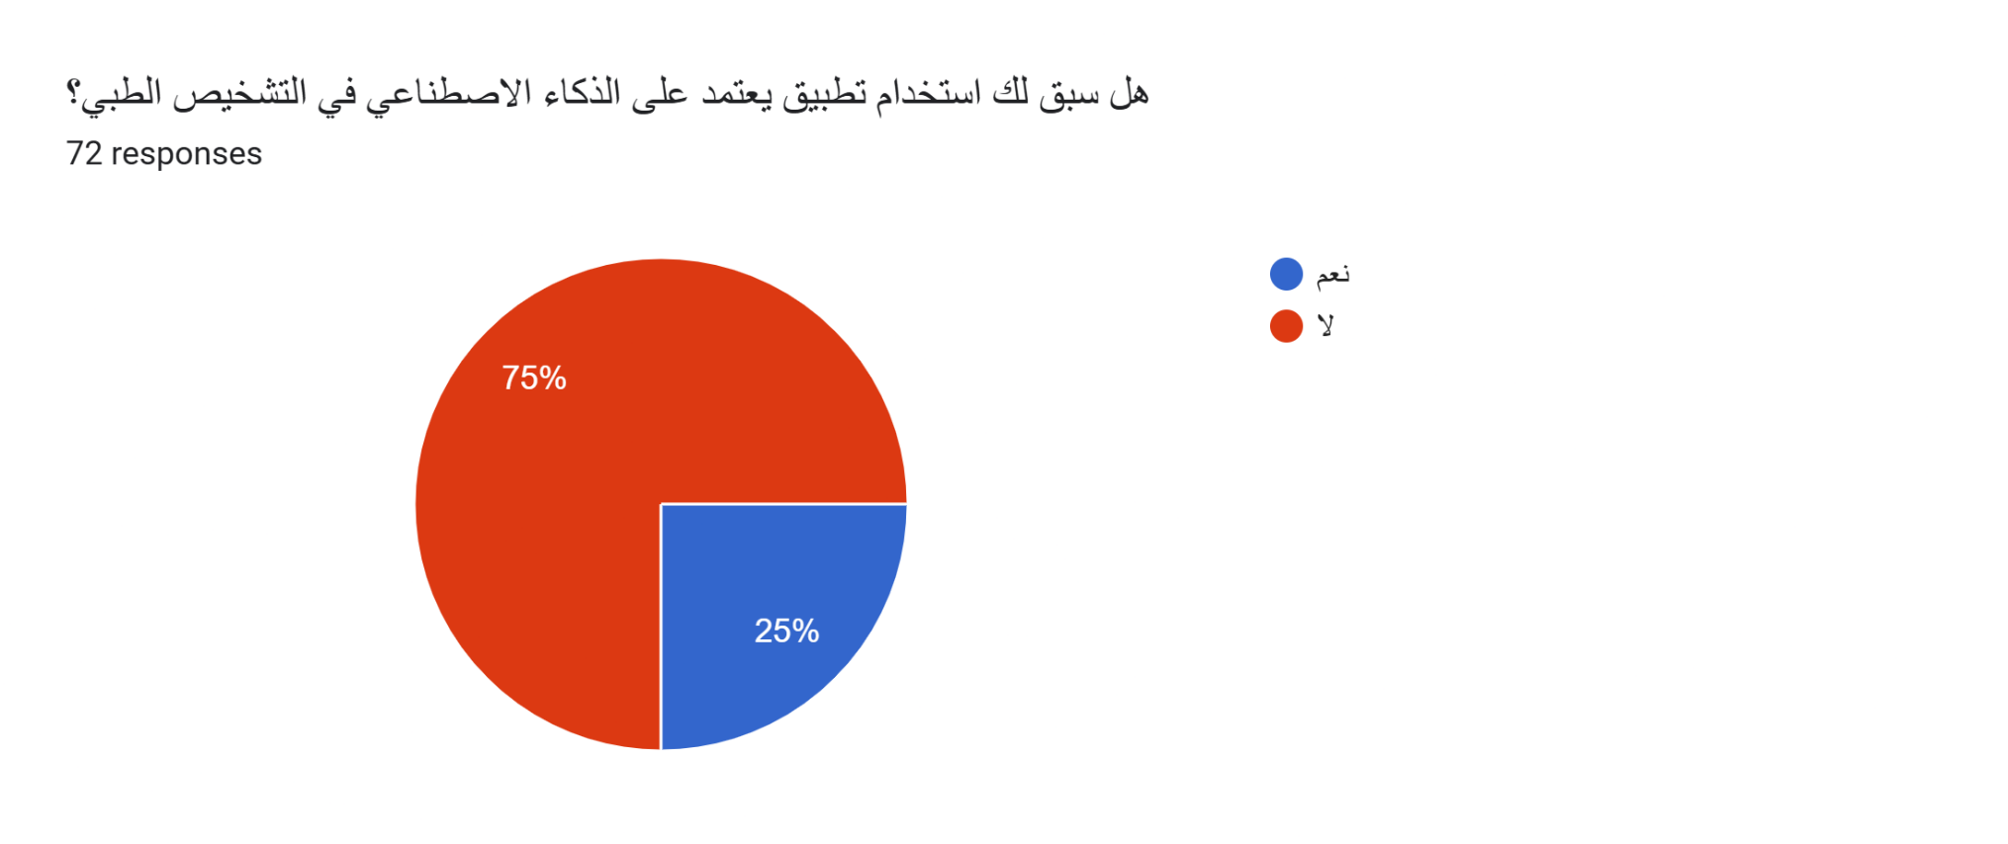
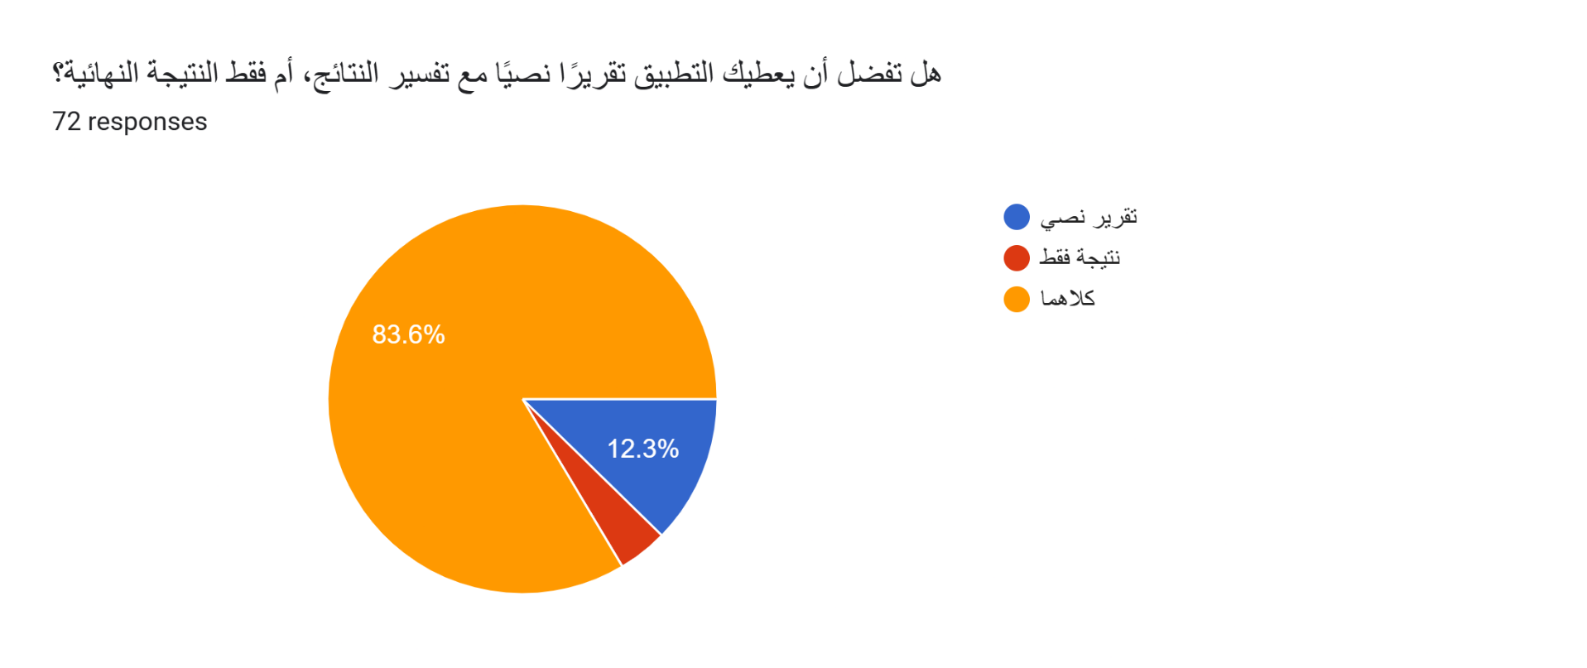
Figure 3.2.5 question 5
Figure 3.2.6 question 6
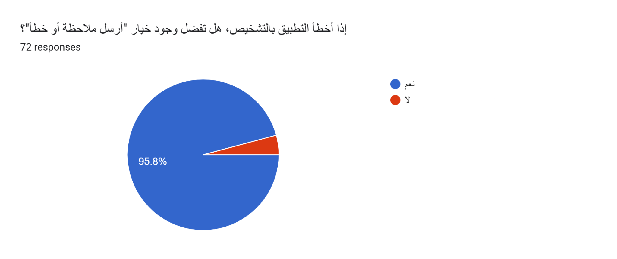
Figure 3.2.7 question 7

3.3 Stakeholder
These are the ones with a direct stake in the project. In our platform they are:
- Patients
- Doctors

3.4 Functional Requirements
Features or functions that we must implement in our website to enable users to accomplish their tasks effectively.

3.4.1 Patient’s Requirements
- Able to create personal profile.
- Able to upload X-ray images.
- Able to download the patient's diagnostic report.
- Able to request medical tips or clarifications directly from the assigned doctor.
- Able to access personal medical history and previous X-ray results.
- Able to request a comparison between new and previous images with doctor’s feedback.
- Able to write and submit overall feedback on the system and diagnosis process.

3.4.2 Doctor’s Requirements
- Able to upload X-ray images.
- Able to download patient reports.
- Able to create new folders/profiles for patients.
- Able to select patients that already have a profile.
- Able to update or edit patient folders with new results or notes.
- Able to access complete patient history and prior diagnoses.
- Able to compare newly uploaded X-rays with older patient images.
- Able to provide and save evaluations or diagnoses for each image.
- Able to respond to patient questions and provide personalized medical tips.

3.5 Non-Functional Requirements
They serve to define system attributes (also known as qualities), such as security, performance, etc. They ensure the usability and effectiveness of the entire system:

• Usability
The system must be easy to learn for both novices and users with experience from similar systems. Also, the users must feel satisfied with the system.

• Performance
The system must provide response time less than 1 second for all requests.

• Availability
The system must run 24/7 at all times.

• Security
All communications must be encrypted and also authenticated using certificates.
3.6 Unified Modeling Language

3.6.1 Use Case Diagram
The purpose of use case diagrams is to specify the context of the system and to capture the requirements of the system. Use case belongs to the behavioral diagrams family and is a list of activities or event steps that define the interactions between a role (actor) and a system to achieve a goal.

Use Case: Pneumonia Detection from Chest X-Rays
Actor: User “ID: Patient”, User “ID: Doctor”
Goal: View the Responsibilities for each Actor
Actor | Description
User “ID: Patient” | - Log In  - Create personal Profiles  - Upload X-ray Image  - View Prediction Result  - Send Messages  - Request Medical Tips  - Download Report  - Access Personal History  - Compare with Older Images  - Log Out
User “ID: Doctor” | - Log In  - Select Patient  - Create Patient Profiles  - Upload X-ray Image  - View Prediction Result  - Send Messages  - Provide Medical Tips  - Download Patient Report  - Access Patient History  - Evaluate Diagnosis Results  - Compare with Older Images  - Log Out
table 3.6.1 use case digram
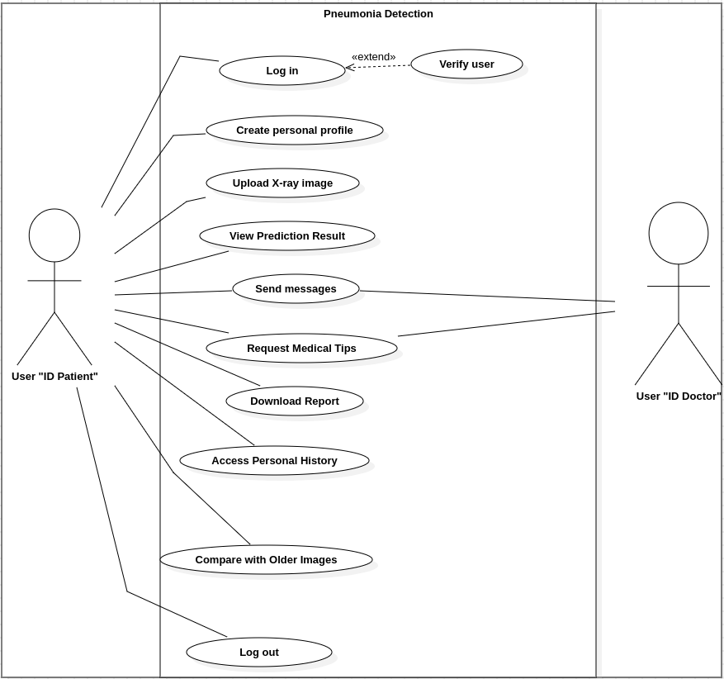Figure 3.6.1 Patient use case diagram

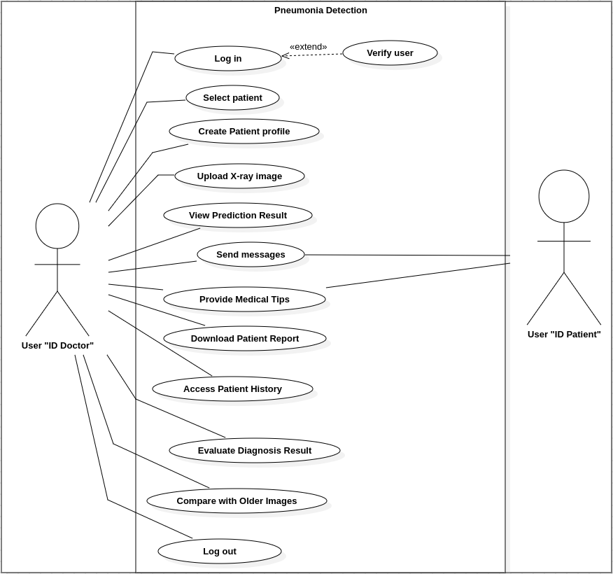Figure 3.6.2 Doctor use case diagram

3.6.2 Class Diagram
Diagrams that belong to the structural diagrams family, which are used for general conceptual modeling and describes the structure of a system by showing the system's classes, their attributes, methods, and the relationships among objects.

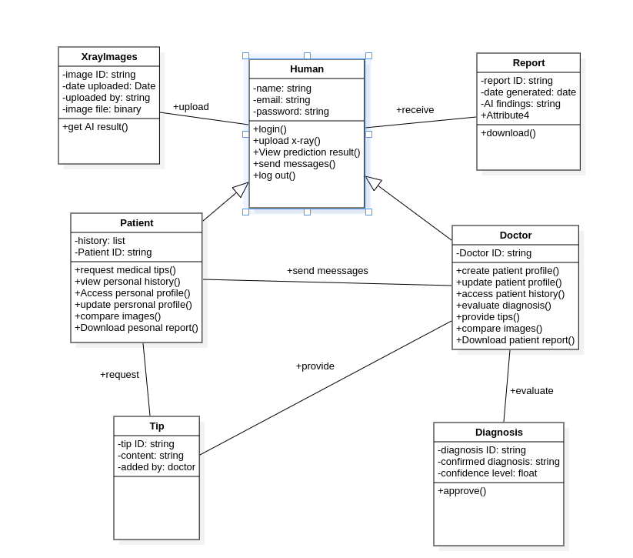
Figure 3.6.3 System Class Diagram
3.6.3 Entity Relationship Diagram
Entity Relationship Diagram, also known as ERD is a type of structural diagram for use in database design and was developed for designing relational databases in terms of concept visualization and in terms of physical database design.

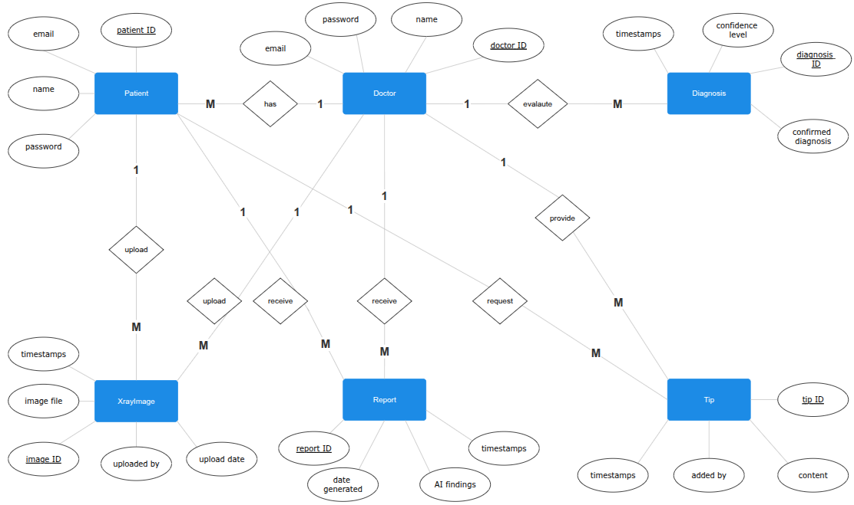



Figure 3.6.4 ER diagram
3.6.4 Database Schema

A database schema is the skeleton structure that represents the logical view of the complete database. It defines how the data is organized and how the relations among them are associated. It formulates all the constraints that are to be applied to the data. It defines its entities and the relationship among them. It’s the database designers who design the schema to assist programmers perceive the database and make it useful.

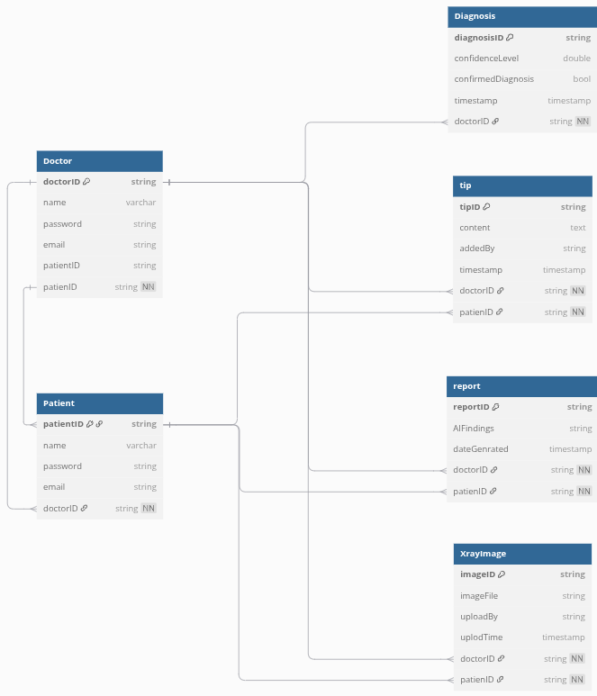
Figure 3.6.4 Database schema
3.7 User Interface Design
User interface design typically refers to the visual layout and style of the elements that a user may interact with when exploring a web site, Such as font styles, colors, and the control buttons. The interface design should not solely be engaging to potential users, however, should even be highly usable, that are easy to access and understand.

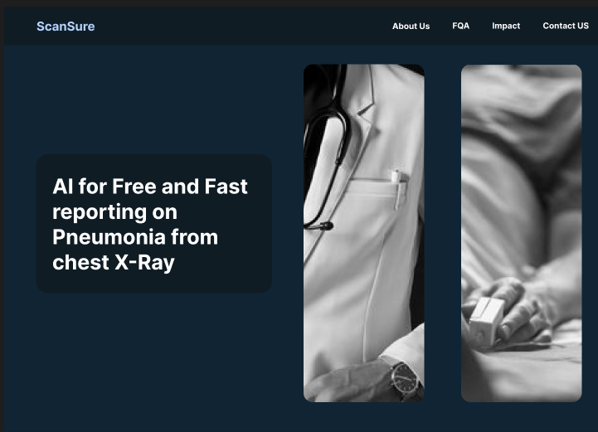
Figure 3.7.1 Homepage Interface
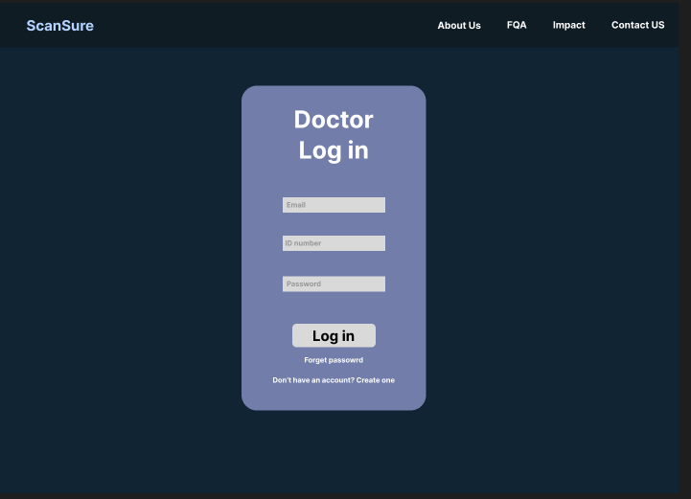
Figure 3.7.2 Doctor Login Interface
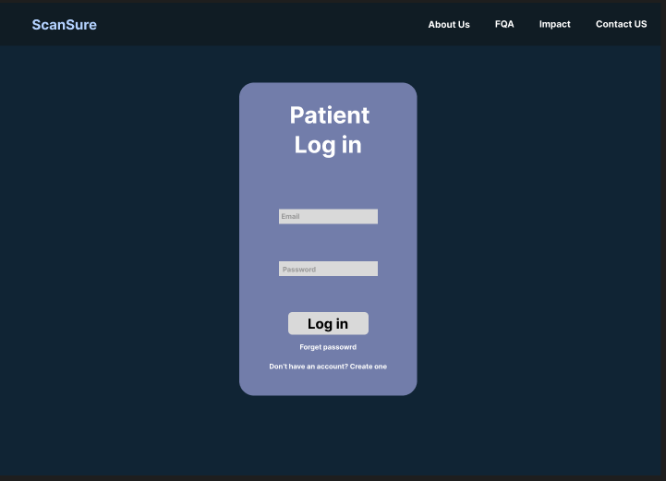
Figure 3.7.3 Patient Login Interface
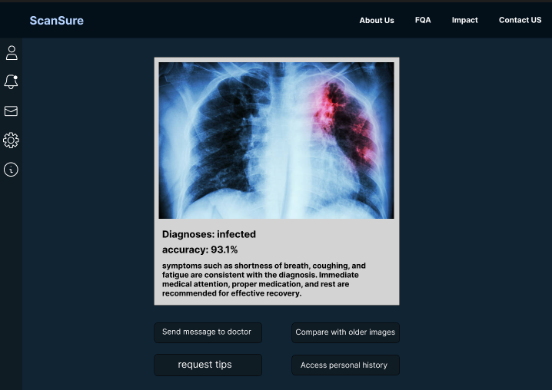
Figure 3.7.4 Patient Interface
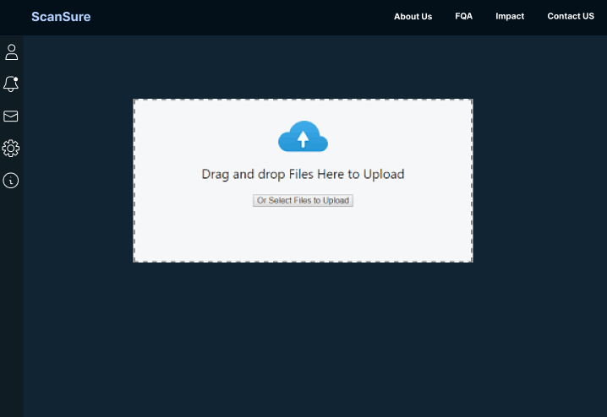
Figure 3.7.5 Doctor Interface
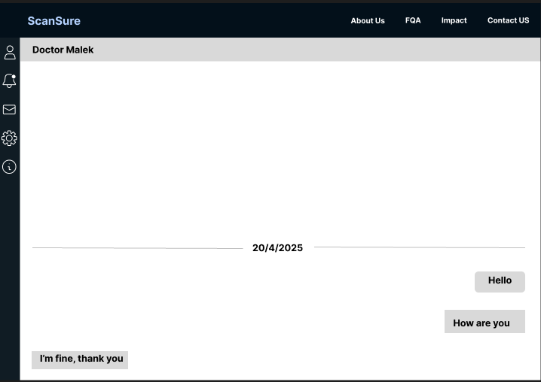
Figure 3.7.6 message Interface
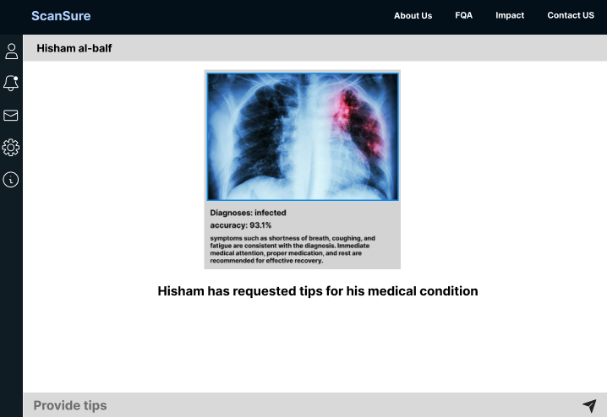
Figure 3.7.7 Tip Interface
3.8 Conclusion and Future work

The Pneumonia Detection using Convolution Neural Networks (CNN) project demonstrates the potential of artificial intelligence to enhance early diagnosis and healthcare accessibility. By leveraging deep learning and medical imaging, the system provides an efficient, accurate, and user-friendly platform for detecting pneumonia from chest X-rays. This project is designed to be freely accessible, particularly benefiting students, healthcare workers, and communities with limited medical resources. The simplicity of the interface, combined with the strength of CNN-based analysis, enables fast and reliable detection, which can support timely treatment and improve patient outcomes.

As a future work, we will finish this project by the end of Fall semester 2025. We will follow the following schedule:
TASK | START DATE | END DATE
UI/UX DESIGN | 27/9/2025 | 3/10/2025
BACKEND | 4/10/2025 | 20/11/2025
FRONTEND | 20/11/2025 | 1/12/2025
TESTING & DEBUGGING | 1/12/2025 | 10/12/2025
ANALYZE PERFORMANCE | 11/12/2025 | 18/12/2025
DEPLOYMENT | 18/12/2025 | 1/1/2026

Table 3.8 Future Work

References

- kaggle.com/datasets/paultimothymooney/chest-xray-pneumonia

- CheXNet https://stanfordmlgroup.github.io/projects/chexnet/

- qXR by Qure.ai https://www.qure.ai/product/qxr

- VUNO Med–Chest X-ray by VUNO https://www.vuno.co/en/chest

- CAD4TB https://delft.care/cad4tb/

APPENDICES

APPENDIX A
Meeting Minutes

All meetings took place on campus, to discuss our progress in each topic.
# | Date | Description
1 | 8/4/2025 | Introductory meeting with Dr. Farah and General discussion about ideas of our project
2 | 20/4/2025 | Discuss our work on chapter 1 and about the main idea of the project
3 | 13/5/2025 | Discuss our work on chapter 2 and get feedback on our purposed survey questions We also discussed the survey results
Table 4.1 Meeting minutes
APPENDIX B
Gantt Chart
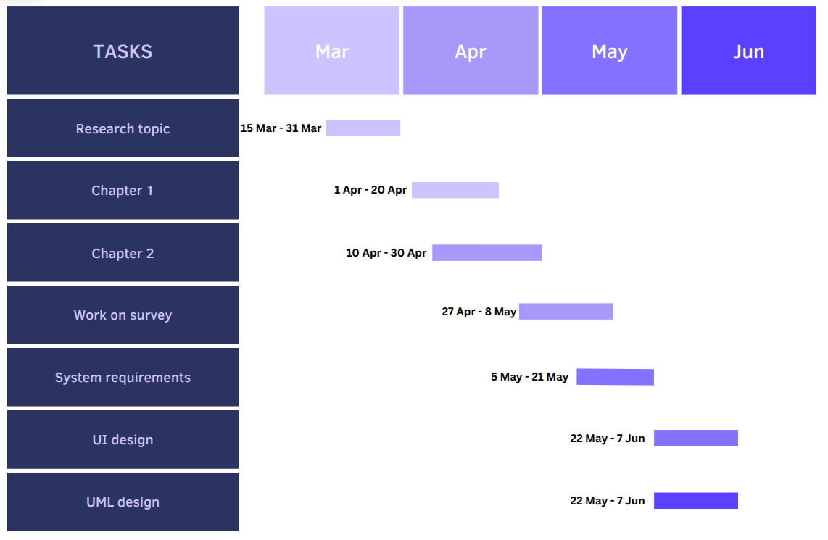
Figure 4.2 Gantt chart
APPENDIX C
Survey Questions
Figure 4.3.1 question 1
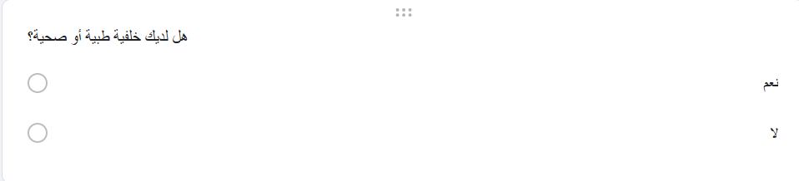
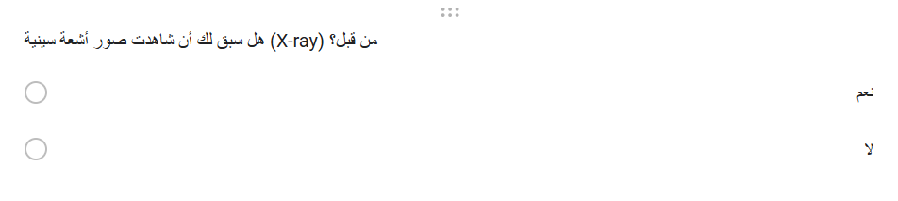
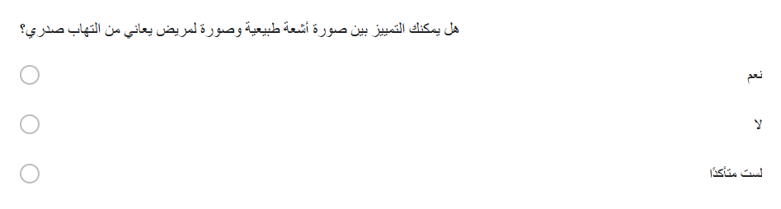
Figure 4.3.2 question 2

Figure 4.3.3 question 3
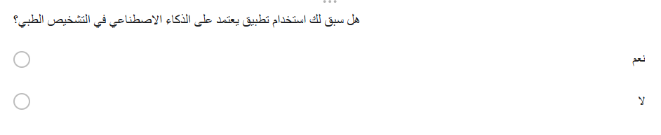
Figure 4.3.4 question 4
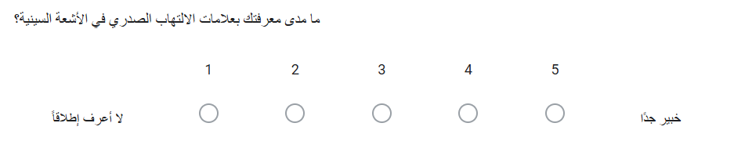
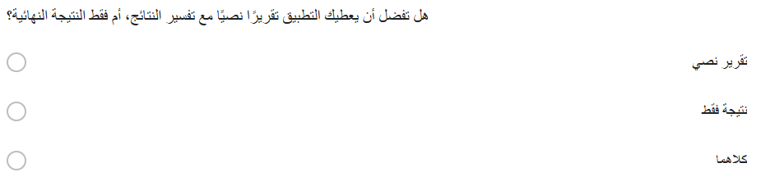
Figure 4.3.5 question 5
Figure 4.3.6 question 6

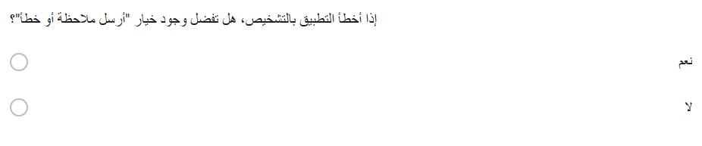
Figure 4.3.7 question 7


Figure 4.3.8 question 8

