Ayhan Okuyan

21601531

EEE321 – Lab Work #1

Introduction

This lab assignment combined the abilities of understanding discrete time signals and using an algorithmic approach to utilize the knowledge on these using MATLAB. In the assignment we were given samples of discrete cosine functions and asked to plot these functions and compare and understand how they differentiate from each other when certain parts of the functions change. For this assignment, I have written the following MATLAB code. Since, the basic instructions of all 12 signals were the same, I have written a loop based coded to iterate the same application 12 times, changing the coefficients, so that anything I would change with the algorithm would be a lot easier to change. The code is given below.

% data set of n

n = 0:127;

% frequencies and phase shifts

omega = [0.17*pi, 2.4*pi, -1.6*pi, 0.125*pi, 0.125*pi, 0.32*pi, 0.02*pi, pi, 1.02*pi, 0.98*pi, 1, 0.3];

phi = [0, 0, 0, 0, 1.4, 0, 0, 0, 0, 0, 0, 0.3];

for i = 1:12

% cosine function

xi = cos(omega(i)*n + phi(i));

% save and retrieve

savetxt = ['x',num2str(i),'[n].mat'];

save(savetxt, 'xi');

clear xi;

load(savetxt, 'xi');

% show the desired elements of the functions

a = [i, xi(7), xi(12), xi(112), xi(128)];

disp(a);

% plot the discrete function

figure();

stem(n, xi);

xlabel('n');

ystr = ['x',num2str(i),'[n]'];

ylabel(ystr);

title([ystr, ' vs n']);

grid on

axis tight

% find fundamental period

[pks,locs] = findpeaks(xi,n);

bool = 0;

for a = 2:length(pks)

if(pks(1) == pks(a))

disp([ystr, ' is periodic']);

fund_per = locs(a)-locs(1);

fp_dsp = ['Fundamental Period of ', ystr, ' is: ', num2str(fund_per)];

disp(fp_dsp);

bool = 1;

break;

end

end

if(bool == 0)

disp([ystr, 'is not periodic']);

end

bool = 0;

end

In this code, I have first created n ∈ [0, 127]. Then, I have created the ω and φ vectors which are given throughout questions 1-12. As we were required to show the value of ω (angular frequency) for each function, the values of the omega vector show exactly these frequencies, being the coefficients of n in the equation. Then for each ω and φ couple, I have created the xi[n] signal. Then, I have written the code to store the data on a different .mat file and reloaded it after clearing the workspace variable. The next phase was to show the values of xi[6], xi[11], xi[111], xi[127].

After these are done, I plotted the signals using the stem functions, which is MATLAB’s default function for plotting discrete signals. Then, the final phase was to find if the signal is periodical or not. For this, I have used the MATLAB’s findpeaks function which stores the local maximums and its locations. Then compared the peaks vector’s elements from 2nd to end with the 1st one. If there seems to be a match, relevant periodicity is printed and also by subtracting the locations of the first peak and the found one, I have found the fundamental period if it existed. This is done, not to answer the 14th question but to compare and contrast the discrepancies in between the analysis and computation.

As for the mathematical analysis of periodicity, we were asked to find if the signals are individually periodic. Then if they are, we were ought to find their fundamental periods. For that we need to find a test to conclude if the signal is periodic, beginning from the definition of periodicity of discrete functions. Note that this proof also corresponds to the answer of the 14th Question.

A discrete time signal is said to be periodic if there is an integer N such that

$$X_{i}\left[n\right]= X_{i}\left[n+N\right]$$

Then, as cosine function is the real part of a complex exponential function, we can define Xi[n] as $$X_{i}\left[n\right]= e^{jωn}$$

Then,

$$X_{i}\left[n+N\right]= e^{jω(n+N)}= e^{jωN}e^{jωn}$$

Which means that these two parts must be equal to each other.

$$e^{jωn}= e^{jωN}e^{jωn}$$

Which means that

$$e^{jωN}= 1$$

Then, we can say that the ωN should be equal to 2πk as it is the angle of the phasor.

$$ωN= 2πk, k∈Z$$

$$\frac{ω}{2π}=\frac{k}{N}$$

As k and N are both integers, the division on the right-hand side is a rational number, this means that the left-hand side of the equation should also be a rational number. This fact, consists the basis of the test to find periodicity of a discrete time function. This condition test is applied in every question as requested in Question 13. Hence, throughout the report, there is no single answer for question 13 but every single signal’s periodicity is investigated individually.

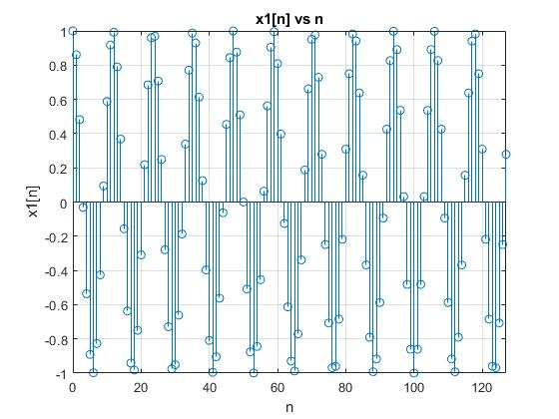

Figure 1 – x1[n] vs n

The value of ω is equal to 0.17π radians. Then the outputs on the command window for the assigned values are given as i, xi(6), xi(11), xi(111), xi(127).

1.0000 -0.9980 0.9178 -0.9178 0.2790

Then, we examine the periodicity of the signal. ω/2π = 0.17π/2π = 17/200, which is a rational number. This means that this signal is periodic. Then its fundamental period can be found by,

$$N=\frac{2π}{ω}k$$

Then, N=(200/17)*k. The smallest k integer to satisfy this turns out to be, 17 and we can see that fundamental period is 200. Then, I have looked at the MATLAB output and saw that the function is listed as not periodic as shown below. The reason for that is in the MATLAB code, I am only considering the part where n is only in [0,127]. However, as we consider the ideal limits, which is from minus infinity to plus infinity, we have calculated that the signal is periodic.

Quantization is said to be the transformation of a continuous ranged values into a finite range of discrete values. This is the procedure that happens when we transfer the ideal mathematical case to MATLAB. There is no way to store mathematical real valued data as it is as it would require an infinite amount of data space for infinite precision. Hence, we analyze the data by dividing the real valued function into an equally divided discrete function around the points of interest. Furthermore, the computer approximates the value of π to a limited precision, there is not one to one correspondence with the theoretical values and the computed values. Hence, when we describe x1[n] in MATLAB, we approximate to some precision, which is enough for most applications. However, we shouldn’t forget that the result on the MATLAB is mostly NOT equal to the real theoretical value as we lose precision.

2-

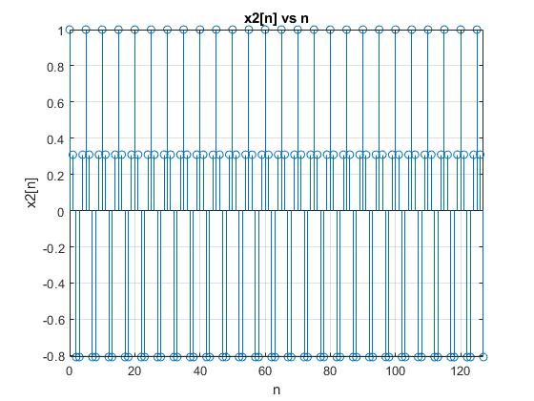

Figure 2 – x2[n] vs n

The value of ω is equal to 2.4π radians. Then the outputs on the command window for the assigned values are given as i, xi(6), xi(11), xi(111), xi(127).

2.0000 0.3090 0.3090 0.3090 -0.8090

Then, we examine the periodicity of the signal. ω/2π = 2.4π/2π = 6/5, which is a rational number. This means that this signal is periodic.

Then, N=(5/6)*k. The smallest k integer to satisfy this is 6 and we can see that fundamental period is 5. This is parallel with the MATLAB output given below.

x2[n] is periodic

Fundamental Period of x2[n] is: 5

3-

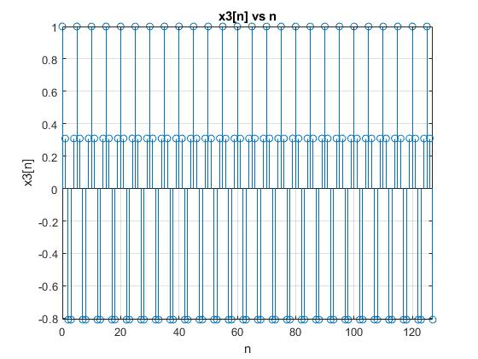

Figure 3 – x3[n] vs n

The value of ω is equal to -1.6π radians. Then the outputs on the command window for the assigned values are given as i, xi(6), xi(11), xi(111), xi(127).

3.0000 0.3090 0.3090 0.3090 -0.8090

Then, we examine the periodicity of the signal. ω/2π = (-1.6)π/2π = -4/5, which is a rational number. This means that this signal is periodic.

Then, N=|(-5/4)|*k = (5/4)*k. The smallest k integer to satisfy this is 6 and we can see that fundamental period is 5. This result is parallel with the MATLAB output given below.

x2[n] is periodic

Fundamental Period of x2[n] is: 5

As seen from the graphs, these two functions are exactly the same. In discrete signals, there are infinite number of ω values, however, the signals that are higher than π and lower than -π are recursive with the values that are in this interval. We can mathematically prove this fact like given below.

$$X_{i}\left[n\right]= X_{i}\left[n+N\right]$$

If N = 2πk, $k∈Z$ and we assume that $X_{i}\left[n\right]= e^{jωn}$ then,

$$X_{i}\left[n+2πk\right]= e^{jω(n+2πk)}= e^{jω2πk}e^{jωn}= e^{jωn}$$

The ω for one signal is -1.6π and 2.4π for the other, we can see that their difference is exactly 4π, which is a multiple of 2π, k being equal to 2 As cosine signal is the real part of a complex exponential function like above, we can investigate these functions in order to understand the cosine functions.

4 –

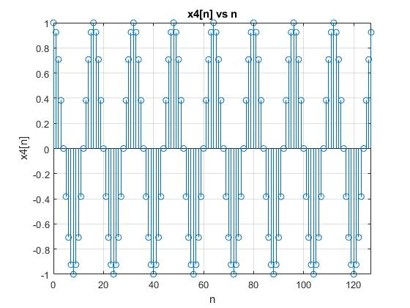

Figure 4 – x4[n] vs n

The value of ω is equal to 0.125π radians. Then the outputs on the command window for the assigned values are given as i, xi(6), xi(11), xi(111), xi(127).

4.0000 -0.7071 -0.3827 0.9239 0.9239

Then, we examine the periodicity of the signal. ω/2π = 0.125π/2π = 1/16, which is a rational number. This means that this signal is periodic.

Then, N = (16/1)*k. The smallest k integer to satisfy this is 1 and we can see that fundamental period is 16. This result is parallel with the MATLAB output given below.

x4[n] is periodic

Fundamental Period of x4[n] is: 16

5-

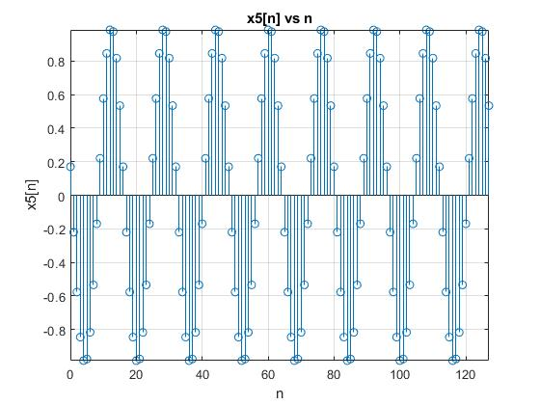

Figure 5 – x5[n] vs n

The value of ω is equal to 0.125π radians again. Then we can say that, this graph is nothing but the shifted graph of the 4th signal. Then the outputs on the command window for the assigned values are given as i, xi(6), xi(11), xi(111), xi(127).

5.0000 -0.8170 0.8454 0.5341 0.5341

Then, we examine the periodicity of the signal. ω/2π = 0.125π/2π = 1/16, which is a rational number. This means that this signal is periodic.

Then, N = (16/1)*k. The smallest k integer to satisfy this is 1 and we can see that fundamental period is 16. However, the MATLAB result is contradictory with the algebraic solution given below. This mistake is due to the fact that we use a local maximum finding algorithm to find the period. As seen from the graph the first value, which is around 0.2 is considered a local maximum in the given interval, and none of the other maxima points match with the first one, declaring the signal not periodic. This is an algorithmic mistake rather than an algebraic one.

x5[n]is not periodic

If this were a continuous function and not a discrete one, we could easily say that these two graphs were the shifted versions of each other. However, we can not state that for a discrete case. For one discrete function to be called as the shifted of another, the phase difference φ, should be an integer. As we know 1.4 is definitely not an integer, we cannot say that the 5th graph is a shifted version of the 4th. Furthermore, we can observe this fact on the graphs easily, as we see that for one waveform, the frequency sets still, but the individual data points that cover the waveform change.

6-

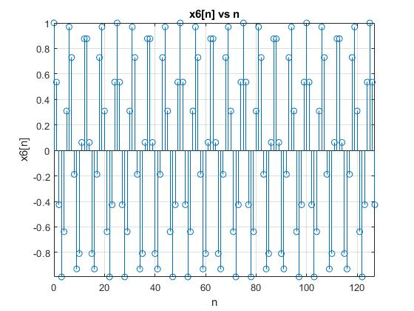

Figure 6 – x6[n] vs n

The value of ω is equal to 0.32π. Then the outputs on the command window for the assigned values are given as i, xi(6), xi(11), xi(111), xi(127).

6.0000 0.9686 0.0628 0.0628 -0.4258

Then, we examine the periodicity of the signal. ω/2π = 0.32π/2π = 4/25, which is indeed a rational number. This means that this signal is periodic.

Then, N = (25/4)*k. The smallest k integer to satisfy this is 4 and we can see that fundamental period is 25. This result is parallel with the MATLAB output given below.

x6[n] is periodic

Fundamental Period of x6[n] is: 25

7-

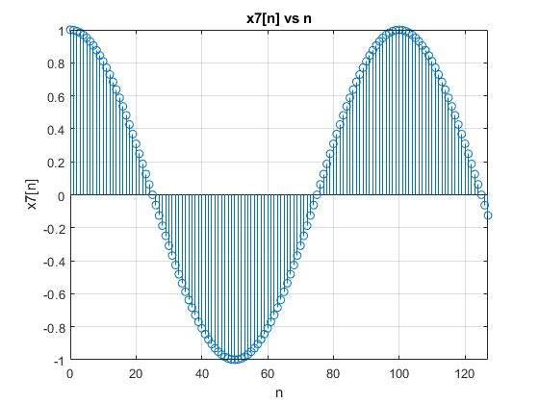

Figure 7 – x7[n] vs n

The value of ω is equal to 0.02π. Then the outputs on the command window for the assigned values are given as i, xi(6), xi(11), xi(111), xi(127).

7.0000 0.9298 0.7705 0.7705 -0.1253

Then, we examine the periodicity of the signal. ω/2π = 0.02π/2π = 1/100, which is indeed a rational number. This means that this signal is periodic.

Then, N = (100/1)*k. The smallest k integer to satisfy this is 1 and we can see that fundamental period is 100.

Again, the MATLAB result doesn’t match with the analytic solution, however, this time, the problem is based on the quantization and not MATLAB itself. MATLAB, uses a finitely precise approximation of the number pi, as there is no infinite precision in digital computers. This is called as the quantization. Hence, the values that were meant to be equal, in this case, x7(11) and x7(111) are not equal due to the incapability of a computer computing pi, hence nearly all of the trigonometric properties. The MATLAB output is given below.

x7[n]is not periodic

8-

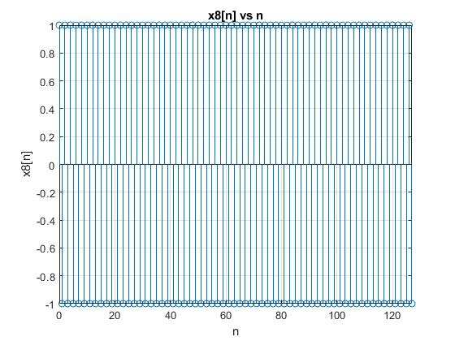

Figure 8 – x8[n] vs n

The value of ω is equal to π. Then the outputs on the command window for the assigned values are given as i, xi(6), xi(11), xi(111), xi(127).

8 1 -1 -1 -1

Then, we examine the periodicity of the signal. ω/2π = π/2π = 1/2, which is a rational number. This means that this signal is periodic.

Then, N = (2/1)*k. The smallest k integer to satisfy this is 1 and we can see that fundamental period is 2. This is also in correspondence with the MATLAB output and also the intuition. The command window output for the periodicity test is given below.

x8[n] is periodic

Fundamental Period of x8[n] is: 2

9-

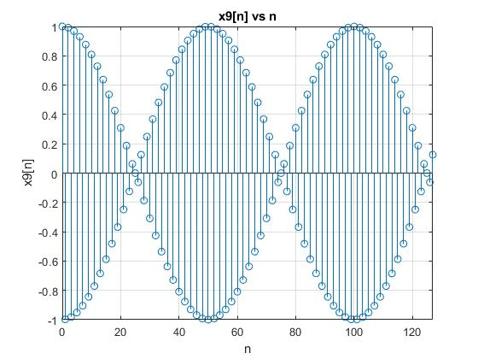

Figure 9 – x9[n] vs n

The value of ω is equal to 1.02π. Then the outputs on the command window for the assigned values are given as i, xi(6), xi(11), xi(111), xi(127).

9.0000 0.9298 -0.7705 -0.7705 0.1253

Then, we examine the periodicity of the signal. ω/2π = 1.02π/2π = 51/100, which is a rational number. This means that this signal is periodic.

Then, N = (100/51)*k. The smallest k integer to satisfy this is 51 and we can see that fundamental period is 100. However, this analytic solution, again differs from the MATLAB computed output. The reason is that the quantization here neutralizes the equality as the values are approximated with errors different from each other. MATLAB output is given below.

x9[n]is not periodic

We can state the 9th signal not as cos[1.02πn], but as cos[-0.98πn] as it is a good engineering practice to write the discrete cosine signals in the interval between -π and π. Then, we know that the 7th graph is the function cos[0.02πn]. We clearly see that the difference in the angular frequency is equal to π. The seventh graph contains only the values that are positive one half of the period and negative the other, as the samples only correspond to those values of that continuous cosine signal. However, the ninth graph’s data samples also correspond to positive and negative values one by one with 1-1 ratio. The reason for that is one graph shrinks the cos[πn] with the factor 0.02 while the other expands is with the factor 0.98.

10-

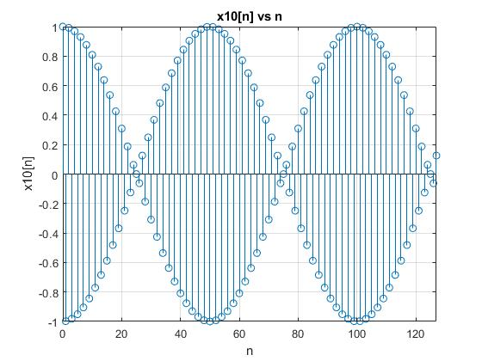

Figure 10 – x10[n] vs n

The value of ω is equal to 0.98π. Then the outputs on the command window for the assigned values are given as i, xi(6), xi(11), xi(111), xi(127).

10.0000 0.9298 -0.7705 -0.7705 0.1253

Then, we examine the periodicity of the signal. ω/2π = 0.98π/2π = 49/100, which is a rational number. This means that this signal is periodic.

Then, N = (100/49)*k. The smallest k integer to satisfy this is 49 and we can see that fundamental period is 100. However, this analytic solution, again differs from the MATLAB computed output. The reason is that the limits of our set [0,127] is not sufficient to see the periodicity. MATLAB output is given below.

x10[n]is not periodic.

To compare, we can start the discussion with the 8th signal. As the angular frequency of that signal is equal to π, it is considered the discrete cosine that has the highest ω. Then one observation is that, these two graphs are exactly the same, which is in parallel with the first claim. We can prove these by comparing two arbitrary discrete cosine signals.

Assume, x_1[n] = cos[(π+α)n] and x_2[n] = cos[(π-α)n] where α is an arbitrary constant. Then, we can add 2π to one and it shouldn’t change the signal itself.

$$x_{1}[n]=cos\left[\left(π+α\right)n\right]= cos\left[\left(π+α-2π\right)n\right]= cos\left[\left(α-π\right)n\right]$$

$$cos\left[\left(α-π\right)n\right]= cos\left[-\left(π-α\right)n\right]= cos\left[\left(π-α\right)n\right]=x_{2}[n]$$

Hence, we can say that these two discrete cosines are only equal to each other. Then we can see investigate the periodicity of one. In the case we are asked about, we can simply exchange α in the proof with 0.02π. This results with the fact that both of the functions are periodic and have period of 100 samples as expected. Hence, we can say that the frequency of these signals = 1/100 = 0.01 rd. Then, we can look at the frequency of the 8th signal which is cos[πn]. As its period is 2 samples. The frequency is ½ = 0.5 rd. Hence, we can say that the 8th signal has higher frequency than both of the other graphs by far.

11-

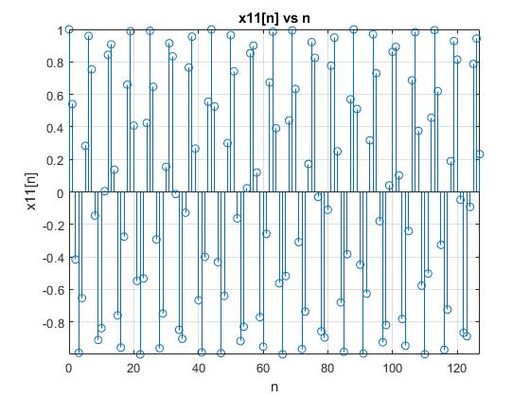

Figure 11 – x11[n] vs n

The value of ω is equal to 1. Then the outputs on the command window for the assigned values are given as i, xi(6), xi(11), xi(111), xi(127).

11.0000 0.9602 0.0044 -0.5025 0.2324

Then, we examine the periodicity of the signal. ω/2π = 1/2π , which is definitely not a rational number. This means that this signal is not periodic. Then we cannot find any period. This result is also in correspondence with the MATLAB approach.

x11[n]is not periodic.

12-

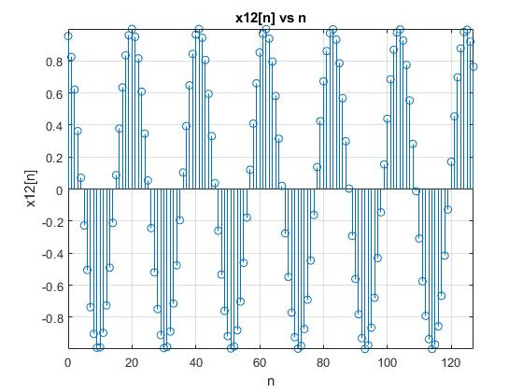

Figure 12 – x12[n] vs n

The value of ω is equal to 0.3. Then the outputs on the command window for the assigned values are given as i, xi(6), xi(11), xi(111), xi(127).

12.0000 -0.5048 -0.8968 -0.5756 0.7643

Then, we examine the periodicity of the signal. ω/2π = 3/20π, which is also not a rational number. This means that this signal is not periodic even though it looks like periodic on the first glance. Then we cannot find any period. This result is also in correspondence with the MATLAB approach.

x12[n]is not periodic.

15-

In comparison, we can easily say that each continuous cosine signal is periodic. And period is always given by 2π/ω. Basically, the period of a continuous cosine signal is the difference between two maximums or two minimums. However, the concept of periodicity in discrete cosine signals differ by the continuous case a lot. For any discrete cosine to be periodic, the number ω/2π should be a rational number as explained earlier in the report. In this case the period is not defined as the difference between two peaks but instead it is described as the difference between two repeating points at different periods. This is hardly achieved as out of infinite possible choices of ω, only the ones that are real multiples of π can be considered periodic. Hence, we usually say that nearly none of the discrete cosine signals are periodic as the infinity that we can use is much limited compared to the ω values that can be used in the continuous case. Also, while the period (T) of a continuous cosine can be any number, the period of the discrete case (N) should be an integer at all costs.