**MATLAB CODE**

choice = input('Enter question number:');

% 1st number for question number and 2nd number for the part of the

% question. Ex: 13 responds to question 1 part c.

if choice == 11

a_1 = convolve(@res1,@inp1,10);

figure()

stem([0:29], a_1(41:70));

xlabel('n');

ylabel('y1[n]');

grid on

axis tight

title('y1[n] vs n');

disp(a_1(41:70));

elseif choice == 12

b_1 = convolve(@res1,@inp2,16);

figure()

stem([0:29],b_1(41:70));

xlabel('n');

ylabel('y2[n]');

grid on

axis tight

title('y2[n] vs n');

disp(b_1(41:70));

elseif choice == 13

c_1_Re = convolve(@res1,@inp3Re,16);

c_1_Im = convolve(@res1,@inp3Im,16);

figure()

subplot(2,1,1);

stem([0:29],c_1_Re(41:70));

xlabel('n');

ylabel('Re(y3[n])');

grid on

axis tight

title('Re(y3[n]) vs n');

subplot(2,1,2);

stem([0:29],c_1_Im(41:70),'r');

xlabel('n');

ylabel('Im(y3[n])');

grid on

axis tight

title('Im(y3[n]) vs n');

disp(c_1_Re(41:70));

disp(c_1_Im(41:70));

elseif choice == 14

d_1 = convolve(@res1,@inp4,16);

figure()

stem([0:29],d_1(41:70));

xlabel('n');

ylabel('y4[n]');

grid on

axis tight

title('y4[n] vs n');

disp(d_1(41:70));

elseif choice == 15

e_1 = convolve(@res1,@inp5,16);

figure()

stem([0:29],e_1(41:70));

xlabel('n');

ylabel('y5[n]');

grid on

axis tight

title('y5[n] vs n');

disp(e_1(41:70));

elseif choice == 16

f_1_Re = convolve(@res1,@inp6Re,16);

f_1_Im = convolve(@res1,@inp6Im,16);

figure()

subplot(2,1,1);

stem([0:29],f_1_Re(41:70));

xlabel('n');

ylabel('Re(y6[n])');

grid on

axis tight

title('Re(y6[n]) vs n');

subplot(2,1,2);

stem([0:29],f_1_Im(41:70),'r');

xlabel('n');

ylabel('Im(y6[n])');

grid on

axis tight

title('Im(y6[n]) vs n');

disp(f_1_Re(41:70));

disp(f_1_Im(41:70));

elseif choice == 21

a_2 = convolve(@res2,@inp1,10);

figure()

stem([0:29],a_2(41:70));

xlabel('n');

ylabel('y''1[n]');

grid on

axis tight

title('y''1[n] vs n');

disp(a_2(41:70));

elseif choice == 22

b_2 = convolve(@res2,@inp2,16);

figure()

stem([0:29],b_2(41:70));

xlabel('n');

ylabel('y''2[n]');

grid on

axis tight

title('y''2[n] vs n');

disp(b_2(41:70));

elseif choice == 23

c_2_Re = convolve(@res2,@inp3Re,16);

c_2_Im = convolve(@res2,@inp3Im,16);

figure()

subplot(2,1,1);

stem([0:29],c_2_Re(41:70));

xlabel('n');

ylabel('Re(y3[n])');

grid on

axis tight

title('Re(y''3[n]) vs n');

subplot(2,1,2);

stem([0:29],c_1_Im(41:70),'r');

xlabel('n');

ylabel('Im(y''3[n])');

grid on

axis tight

title('Im(y3[n]) vs n');

disp(c_2_Im(41:70));

disp(c_2_Re(41:70));

elseif choice == 24

d_2 = convolve(@res2,@inp4,16);

figure()

stem([0:29],d_2(41:70));

xlabel('n');

ylabel('y''4[n]');

grid on

axis tight

title('y''4[n] vs n');

disp(d_2(41:70));

elseif choice == 25

e_2 = convolve(@res2,@inp5,16);

figure()

stem([0:29],e_2(41:70));

xlabel('n');

ylabel('y''5[n]');

grid on

axis tight

title('y5''[n] vs n');

disp(e_2(41:70));

elseif choice == 26

f_2_Re = convolve(@res2,@inp6Re,16);

f_2_Im = convolve(@res2,@inp6Im,16);

figure()

subplot(2,1,1);

stem([0:29],f_2_Re(41:70));

xlabel('n');

ylabel('Re(y''6[n])');

grid on

axis tight

title('Re(y''6[n]) vs n');

subplot(2,1,2);

stem([0:29],f_2_Im(41:70),'r');

xlabel('n');

ylabel('Im(y''6[n])');

grid on

axis tight

title('Im(y''6[n]) vs n');

disp(f_2_Re(41:70));

disp(f_2_Im(41:70));

end

function out = convolve(response,input_fcn,interval)

out = zeros(1,81);

for n=-40:40

value_temp = zeros(1,33);

for k = -1*(interval):interval

value_temp(k+17) = input_fcn(k)* response(n-k);

end

out(n+41) = sum(value_temp);

end

end

function out_us = u_s(k)

if(k>=0)

out_us = 1;

else

out_us = 0;

end

end

function h1 = res1(k)

h1 = u_s(k-2).*(1/2).^k;

end

function h2 = res2(k)

h2 = u_s(k-2).*3.*(1/2)^k + u_s(k-7).*(1/2)^(k-5);

end

function x1 = inp1(k)

if(k>=0 && k<=10)

x1 = -1;

else

x1 = 0;

end

end

function x2 = inp2(k)

if(k>=0 && k<=5)

x2 = -1;

elseif(k>=6 && k<=10)

x2 = 1;

elseif(k>=11 && k<=16)

x2 = 2;

else

x2 = 0;

end

end

function x3 = inp3Re(k)

if(k>=4 && k<=16)

x3 = cos(2*k/3);

else

x3 = 0;

end

end

function x3 = inp3Im(k)

if(k>=4 && k<=16)

x3 = sin(2*k/3);

else

x3 = 0;

end

end

function x4 = inp4(k)

if(k>=4 && k<=16)

x4 = sin(2*k/3);

else

x4 = 0;

end

end

function x5 = inp5(k)

if(k>=4 && k<=16)

x5 = cos(2*k/3);

else

x5 = 0;

end

end

function x6 = inp6Re(k)

x6 = real(2.*inp1(k) -3i.*inp2(k));

end

function x6 = inp6Im(k)

x6 = imag(2.*inp1(k) -3i.*inp2(k));

end

**MATLAB OUTPUTS**

**QUESTION 1**

**PART A**

Columns 1 through 14

0 0 -0.2500 -0.3750 -0.4375 -0.4688 -0.4844 -0.4922 -0.4961 -0.4980 -0.4990 -0.4995 -0.4998 -0.2499

Columns 15 through 28

-0.1249 -0.0625 -0.0312 -0.0156 -0.0078 -0.0039 -0.0020 -0.0010 -0.0005 -0.0002 -0.0001 -0.0001 -0.0000 -0.0000

Columns 29 through 30

-0.0000 -0.0000

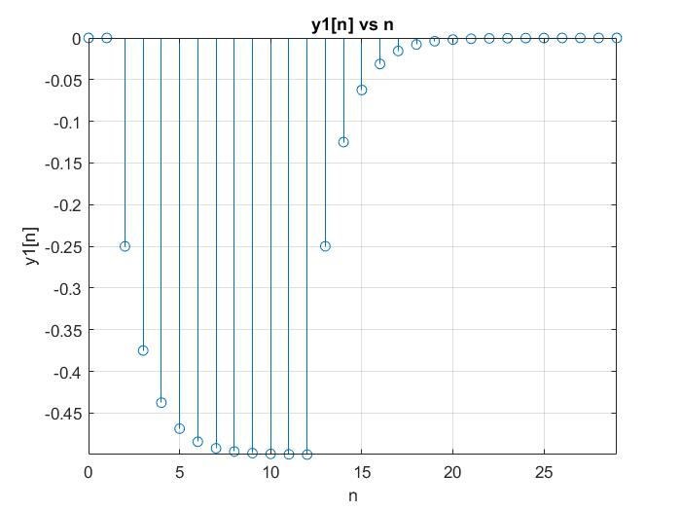

**PART B**

Columns 1 through 6

0 0 -0.2500 -0.3750 -0.4375 -0.4688

Columns 7 through 12

-0.4844 -0.4922 0.0039 0.2520 0.3760 0.4380

Columns 13 through 18

0.4690 0.7345 0.8672 0.9336 0.9668 0.9834

Columns 19 through 24

0.9917 0.4959 0.2479 0.1240 0.0620 0.0310

Columns 25 through 30

0.0155 0.0077 0.0039 0.0019 0.0010 0.0005

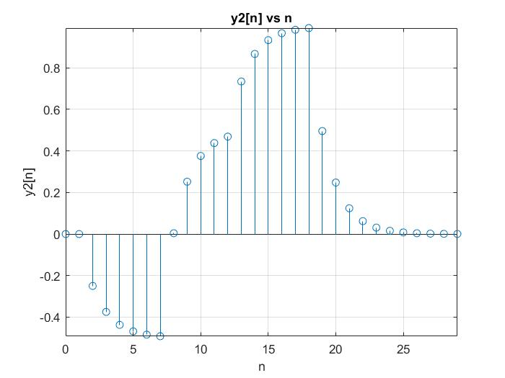

**PART 3**

**Real Part**

Columns 1 through 6

0 0 0 0 0 0

Columns 7 through 12

-0.2223 -0.3566 -0.3417 -0.1823 0.0543 0.2672

Columns 13 through 18

0.3654 0.3071 0.1172 -0.1230 -0.3104 -0.3650

Columns 19 through 24

-0.2632 -0.1316 -0.0658 -0.0329 -0.0165 -0.0082

Columns 25 through 30

-0.0041 -0.0021 -0.0010 -0.0005 -0.0003 -0.0001

**Imaginary Part**

Columns 1 through 6

0 0 0 0 0 0

Columns 7 through 12

0.1143 0.0095 -0.1844 -0.3420 -0.3743 -0.2570

Columns 13 through 18

-0.0350 0.1994 0.3470 0.3454 0.1955 -0.0382

Columns 19 through 24

-0.2557 -0.1279 -0.0639 -0.0320 -0.0160 -0.0080

Columns 25 through 30

-0.0040 -0.0020 -0.0010 -0.0005 -0.0002 -0.0001

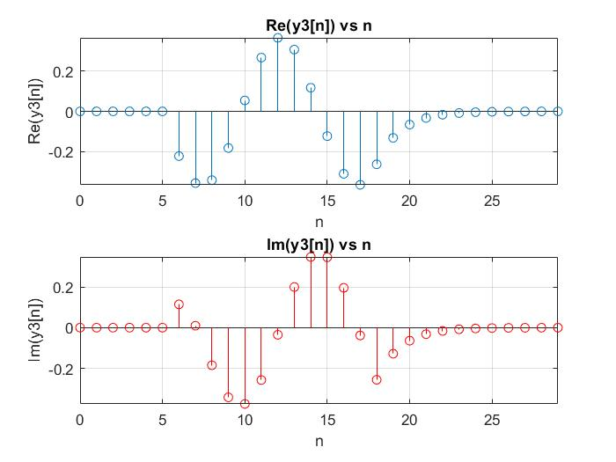

**PART D**

Columns 1 through 6

0 0 0 0 0 0

Columns 7 through 12

0.1143 0.0095 -0.1844 -0.3420 -0.3743 -0.2570

Columns 13 through 18

-0.0350 0.1994 0.3470 0.3454 0.1955 -0.0382

Columns 19 through 24

-0.2557 -0.1279 -0.0639 -0.0320 -0.0160 -0.0080

Columns 25 through 30

-0.0040 -0.0020 -0.0010 -0.0005 -0.0002 -0.0001

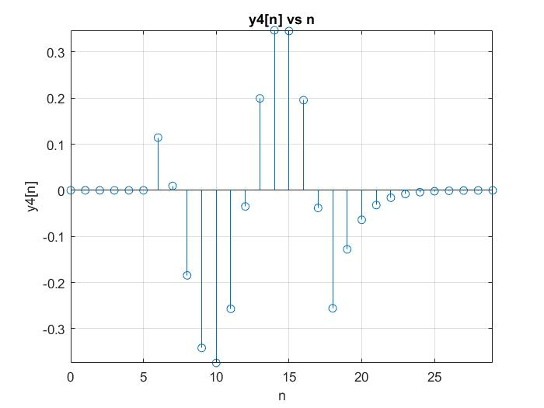

**PART E**

Columns 1 through 6

0 0 0 0 0 0

Columns 7 through 12

-0.2223 -0.3566 -0.3417 -0.1823 0.0543 0.2672

Columns 13 through 18

0.3654 0.3071 0.1172 -0.1230 -0.3104 -0.3650

Columns 19 through 24

-0.2632 -0.1316 -0.0658 -0.0329 -0.0165 -0.0082

Columns 25 through 30

-0.0041 -0.0021 -0.0010 -0.0005 -0.0003 -0.0001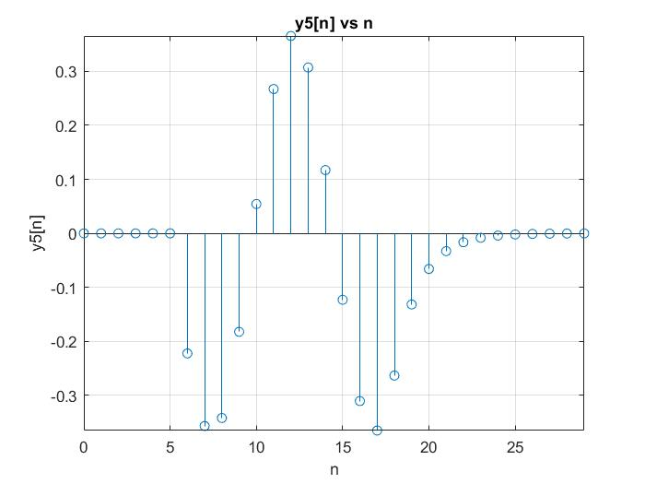

**PART F**

**REAL PART**

Columns 1 through 6

0 0 -0.5000 -0.7500 -0.8750 -0.9375

Columns 7 through 12

-0.9688 -0.9844 -0.9922 -0.9961 -0.9980 -0.9990

Columns 13 through 18

-0.9995 -0.4998 -0.2499 -0.1249 -0.0625 -0.0312

Columns 19 through 24

-0.0156 -0.0078 -0.0039 -0.0020 -0.0010 -0.0005

Columns 25 through 30

-0.0002 -0.0001 -0.0001 -0.0000 -0.0000 -0.0000

**IMAGINARY PART**

Columns 1 through 6

0 0 0.7500 1.1250 1.3125 1.4063

Columns 7 through 12

1.4531 1.4766 -0.0117 -0.7559 -1.1279 -1.3140

Columns 13 through 18

-1.4070 -2.2035 -2.6017 -2.8009 -2.9004 -2.9502

Columns 19 through 24

-2.9751 -1.4876 -0.7438 -0.3719 -0.1859 -0.0930

Columns 25 through 30

-0.0465 -0.0232 -0.0116 -0.0058 -0.0029 -0.0015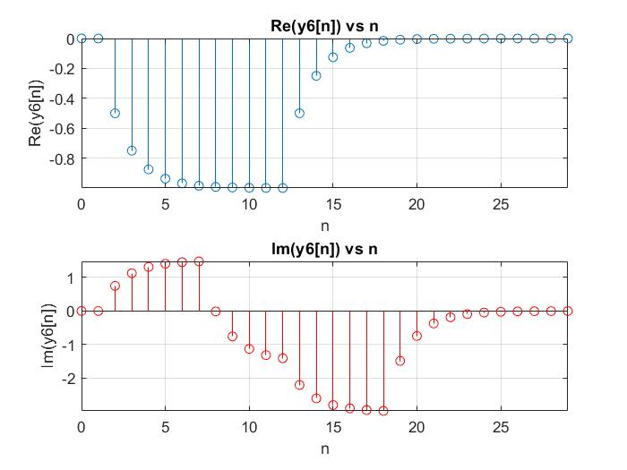

**QUESTION 2**

**PART A**

Columns 1 through 6

0 0 -0.7500 -1.1250 -1.3125 -1.4063

Columns 7 through 12

-1.4531 -1.7266 -1.8633 -1.9316 -1.9658 -1.9829

Columns 13 through 18

-1.9915 -1.2457 -0.8729 -0.6864 -0.5932 -0.5466

Columns 19 through 24

-0.2733 -0.1367 -0.0683 -0.0342 -0.0171 -0.0085

Columns 25 through 30

-0.0043 -0.0021 -0.0011 -0.0005 -0.0003 -0.0001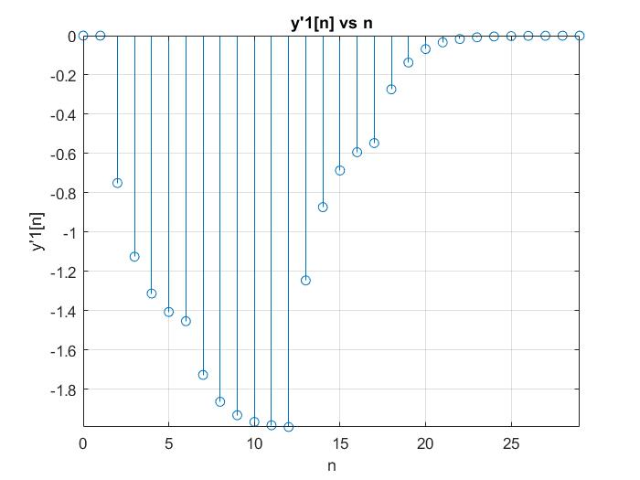

**PART B**

Columns 1 through 6

0 0 -0.7500 -1.1250 -1.3125 -1.4063

Columns 7 through 12

-1.4531 -1.7266 -0.3633 0.3184 0.6592 0.8296

Columns 13 through 18

0.9148 2.2074 2.8537 3.1768 3.3384 3.4192

Columns 19 through 24

3.7096 2.3548 1.6774 1.3387 1.1694 1.0847

Columns 25 through 30

0.5423 0.2712 0.1356 0.0678 0.0339 0.0169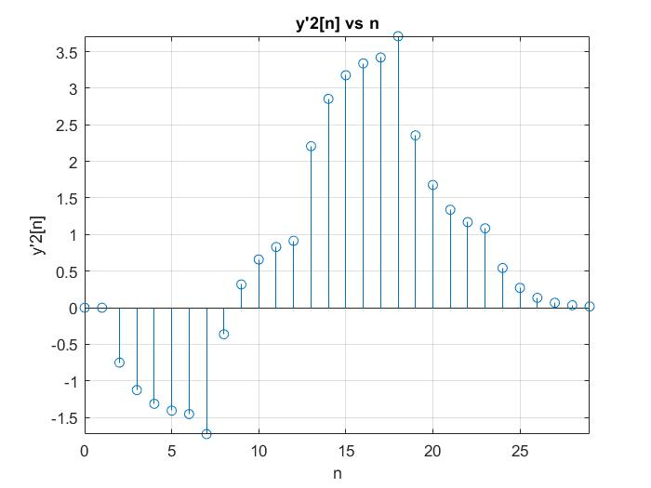

**PART C**

**REAL PART**

Columns 1 through 6

0 0 0 0 0 0

Columns 7 through 12

0.3430 0.0286 -0.5533 -1.0259 -1.1229 -0.6567

Columns 13 through 18

-0.0954 0.4137 0.6991 0.6619 0.3296 -0.1497

Columns 19 through 24

-0.5678 -0.0365 0.1536 0.0996 -0.0862 -0.2797

Columns 25 through 30

-0.1398 -0.0699 -0.0350 -0.0175 -0.0087 -0.0044

**IMAGINARY PART**

Columns 1 through 6

0 0 0 0 0 0

Columns 7 through 12

-0.6670 -1.0698 -1.0251 -0.5468 0.1629 0.5793

Columns 13 through 18

0.7397 0.5795 0.1692 -0.3145 -0.6641 -0.7295

Columns 19 through 24

-0.4827 -0.2777 -0.3204 -0.4091 -0.4143 -0.2879

Columns 25 through 30

-0.1440 -0.0720 -0.0360 -0.0180 -0.0090 -0.0045

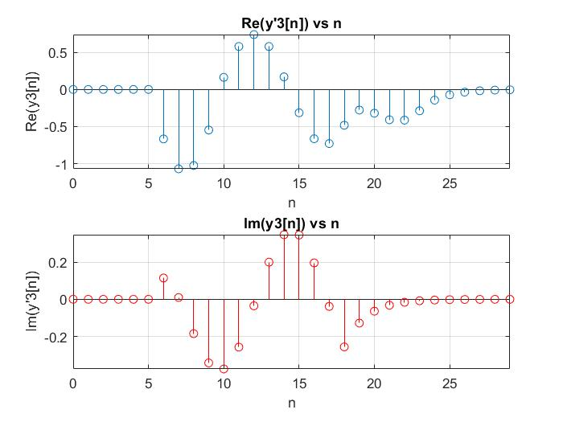

**PART D**

Columns 1 through 6

0 0 0 0 0 0

Columns 7 through 12

0.3430 0.0286 -0.5533 -1.0259 -1.1229 -0.6567

Columns 13 through 18

-0.0954 0.4137 0.6991 0.6619 0.3296 -0.1497

Columns 19 through 24

-0.5678 -0.0365 0.1536 0.0996 -0.0862 -0.2797

Columns 25 through 30

-0.1398 -0.0699 -0.0350 -0.0175 -0.0087 -0.0044

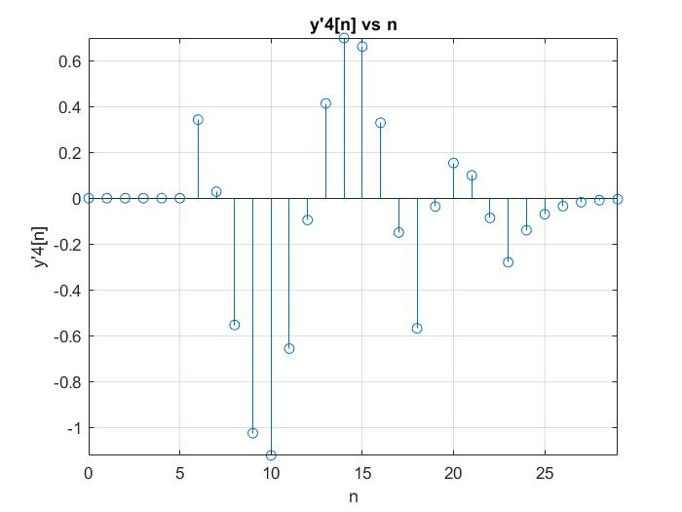

**PART E**

Columns 1 through 6

0 0 0 0 0 0

Columns 7 through 12

-0.6670 -1.0698 -1.0251 -0.5468 0.1629 0.5793

Columns 13 through 18

0.7397 0.5795 0.1692 -0.3145 -0.6641 -0.7295

Columns 19 through 24

-0.4827 -0.2777 -0.3204 -0.4091 -0.4143 -0.2879

Columns 25 through 30

-0.1440 -0.0720 -0.0360 -0.0180 -0.0090 -0.0045

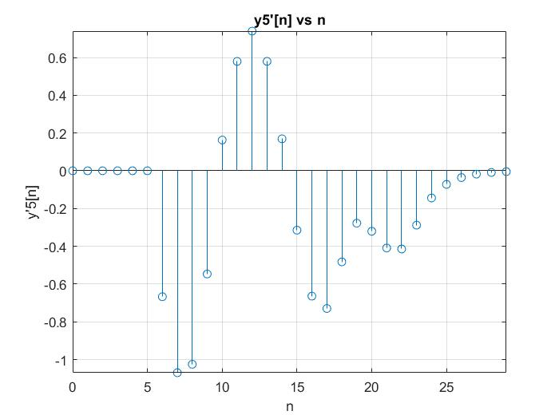

**PART F**

**REAL PART**

Columns 1 through 6

0 0 -1.5000 -2.2500 -2.6250 -2.8125

Columns 7 through 12

-2.9063 -3.4531 -3.7266 -3.8633 -3.9316 -3.9658

Columns 13 through 18

-3.9829 -2.4915 -1.7457 -1.3729 -1.1864 -1.0932

Columns 19 through 24

-0.5466 -0.2733 -0.1367 -0.0683 -0.0342 -0.0171

Columns 25 through 30

-0.0085 -0.0043 -0.0021 -0.0011 -0.0005 -0.0003

**IMAGINARY PART**

Columns 1 through 6

0 0 2.2500 3.3750 3.9375 4.2188

Columns 7 through 12

4.3594 5.1797 1.0898 -0.9551 -1.9775 -2.4888

Columns 13 through 18

-2.7444 -6.6222 -8.5611 -9.5305 -10.0153 -10.2576

Columns 19 through 24

-11.1288 -7.0644 -5.0322 -4.0161 -3.5081 -3.2540

Columns 25 through 30

-1.6270 -0.8135 -0.4068 -0.2034 -0.1017 -0.0508

