**Lab Work 3**

Appendix A - Graphs

Q1

Function

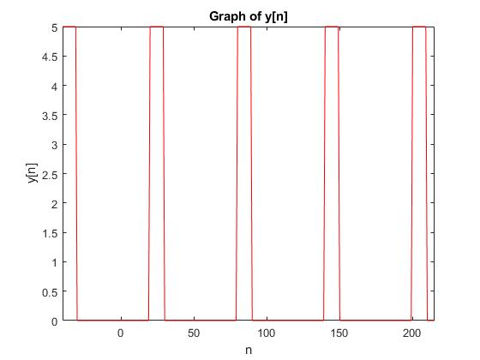

FSE Approximations

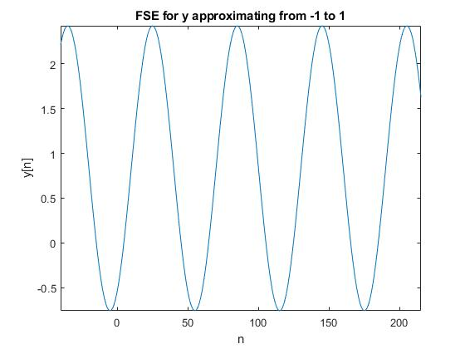

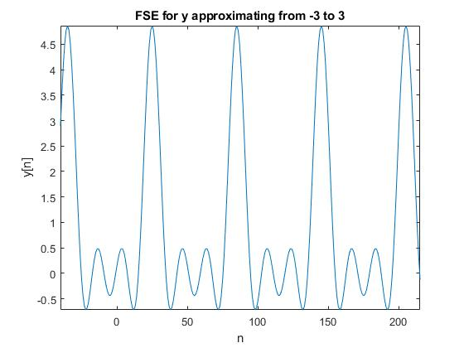

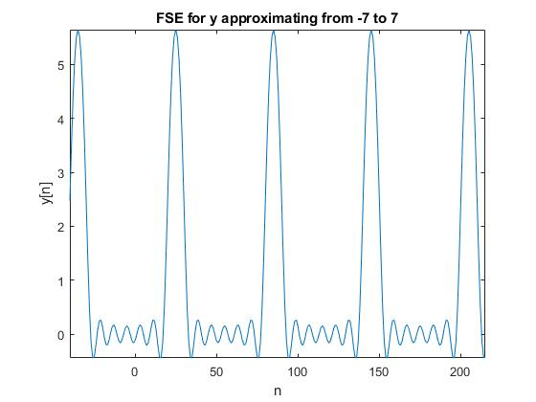

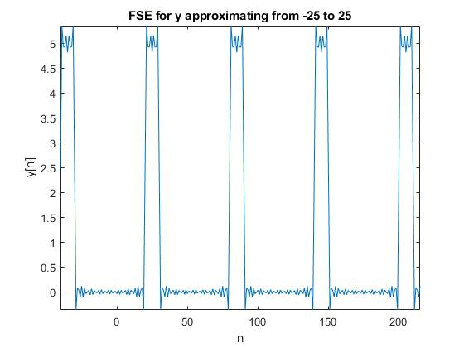

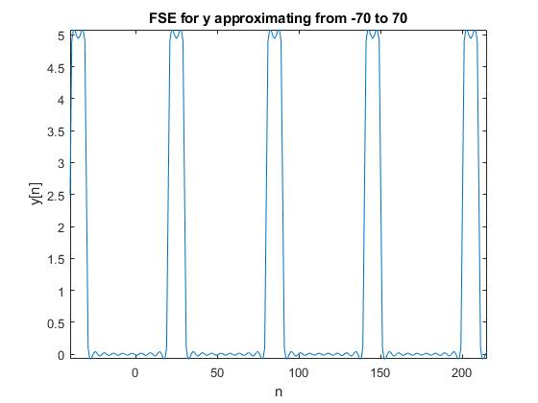

Harmonics

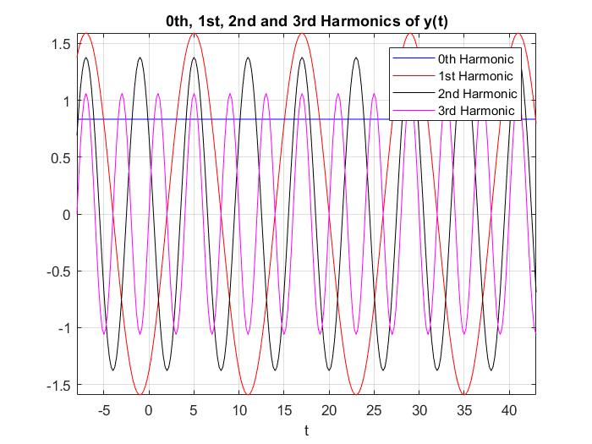

**Question 2**

**Function**

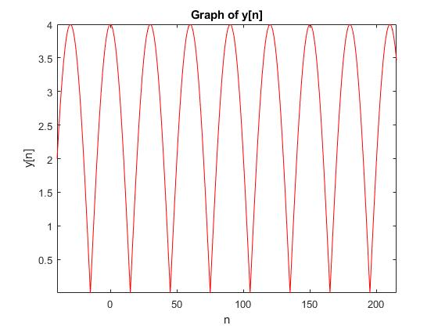

**FSE Approximations**

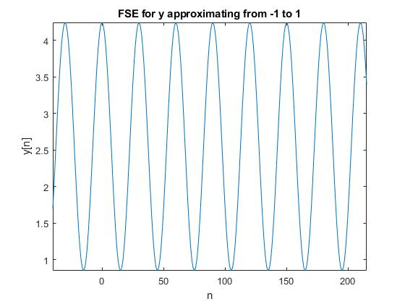

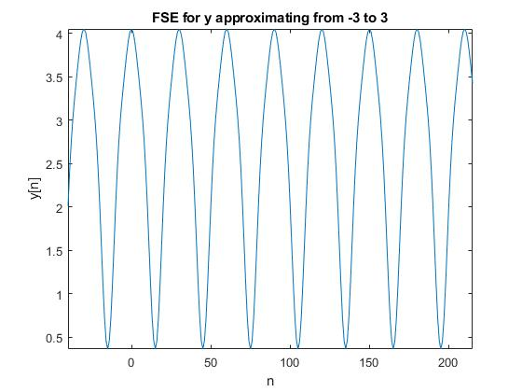

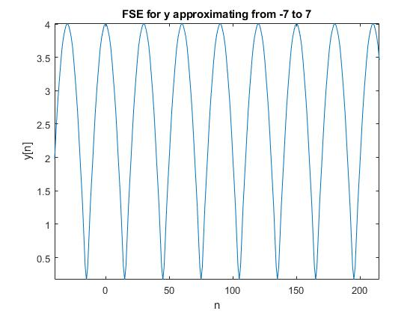

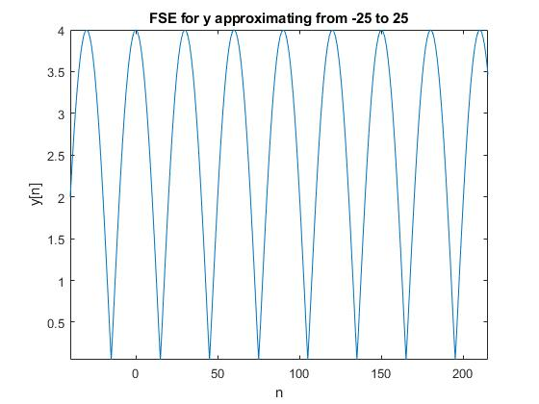

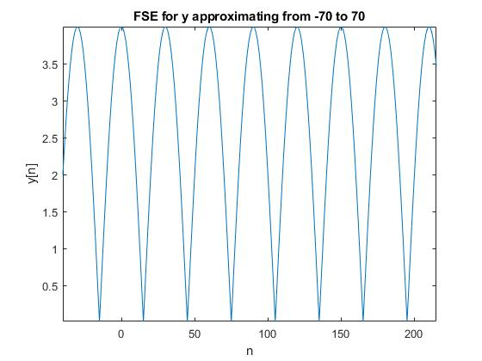

**Harmonics**

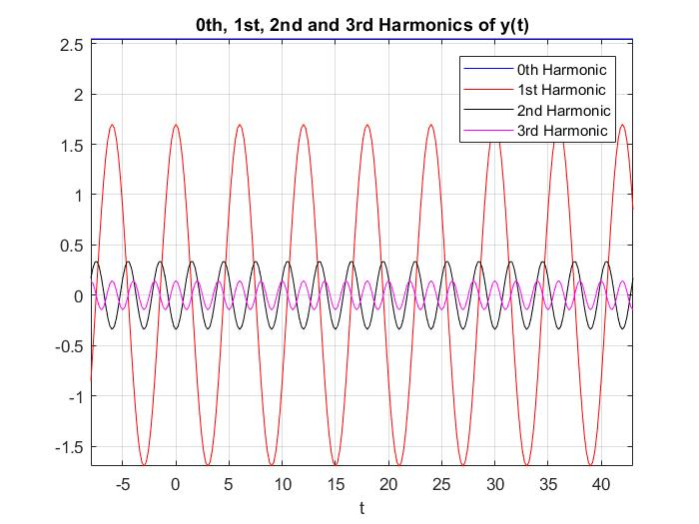

**Question 3**

**Function**

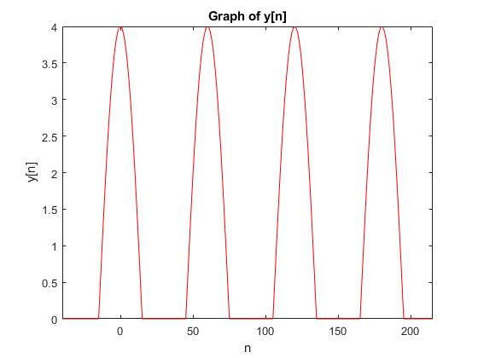

**FSE Approximations**

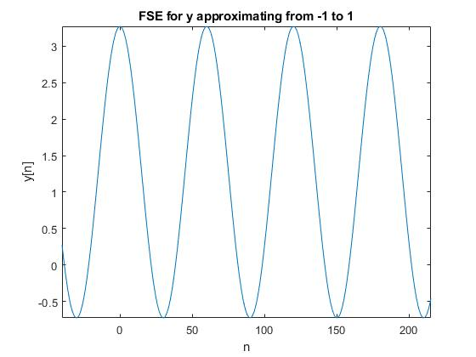

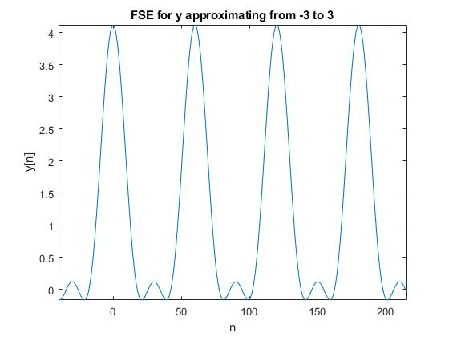

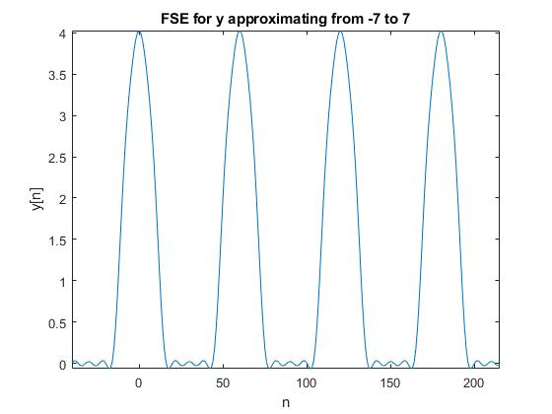

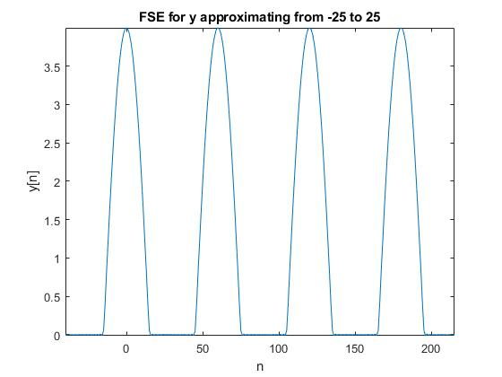

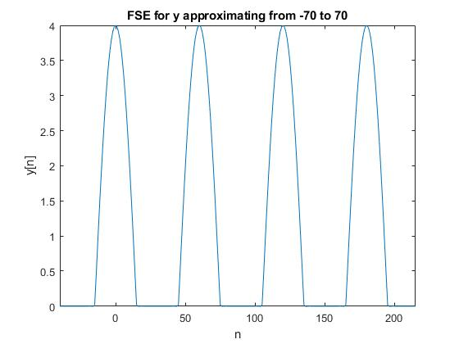

**Harmonics**

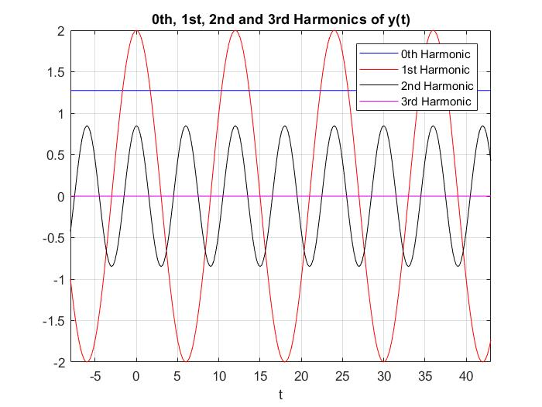

**Appendix B - MATLAB Code**

%% Q1

% Part A

% Defining parameters for discrete function y_n

prd = 12;

t_s = 0.2;

n = -40:215;

nt_s = t_s .* n;

% Define anonymous periodic function y_t

y_t = @(nt_s) 0.*(0<=mod(nt_s,prd) & mod(nt_s,prd)<4)...

+ 5.*(4<=mod(nt_s,prd) & mod(nt_s,prd)<6)...

+ 0.*(6<=mod(nt_s,prd) & mod(nt_s,prd)<12);

% Discretizing

y_n = y_t(nt_s);

% Plot a section of y_n

plot(n,y_n,'r');

axis tight

title('Graph of y[n]');

ylabel('y[n]');

xlabel('n');

% Part D

% Finding and plotting the ak weights of the expansion

%figure();

k_lim = 70;

a_k1_array = a_k1(k_lim);

%stem(-k_lim:k_lim, a_k1_array);

% Approximating and plotting the FSE

figure();

plot(n, fourier_ser(nt_s,prd,a_k1_array, k_lim));

title('FSE for y approximating from -70 to 70');

xlabel('n');

ylabel('y[n]');

axis tight

% Part I

% Plot the harmonics

figure();

plot(nt_s, kth_harmonic(nt_s, 0, a_k1_array, prd, k_lim),'b');

hold on

plot(nt_s, kth_harmonic(nt_s, 1, a_k1_array, prd, k_lim),'r');

hold on

plot(nt_s, kth_harmonic(nt_s, 2, a_k1_array, prd, k_lim),'k');

hold on

plot(nt_s, kth_harmonic(nt_s, 3, a_k1_array, prd, k_lim),'m');

title('0th, 1st, 2nd and 3rd Harmonics of y(t)');

xlabel('t');

axis tight

grid on

legend('0th Harmonic','1st Harmonic','2nd Harmonic','3rd Harmonic');

hold off

% Part E,F,G,H

for r = [25, 7, 3, 1]

%figure();

k_lim = r;

a_k1_array = a_k1(k_lim);

%stem(-k_lim:k_lim, a_k1_array);

figure();

plot(n, fourier_ser(nt_s,prd,a_k1_array, k_lim));

title(['FSE for y approximating from -', num2str(r), ' to ', num2str(r)]);

xlabel('n');

ylabel('y[n]');

axis tight

end

%% Q2

% Part A

% Defining parameters for discrete function y_n

prd = 6;

t_s = 0.2;

n = -40:215;

nt_s = t_s .* n;

% Define anonymous periodic function y_t

y_t = @(nt_s) abs(4*cos(pi*nt_s/6));

y_n = y_t(nt_s);

% Plot a section of y_n

figure();

plot(n,y_n,'r');

title('Graph of y[n]');

ylabel('y[n]');

xlabel('n');

axis tight

% Part D

% Finding and plotting the ak weights of the expansion

%figure();

k_lim = 70;

a_k2_array = a_k2(k_lim);

%stem(-k_lim:k_lim, a_k2_array);

% Approximating and plotting the FSE

figure();

plot(n, fourier_ser(nt_s,prd,a_k2_array, k_lim));

title('FSE for y approximating from -70 to 70');

xlabel('n');

ylabel('y[n]');

axis tight

% Part I

% Plot the harmonics

figure();

plot(nt_s, kth_harmonic(nt_s, 0, a_k2_array, prd, k_lim),'b');

hold on

plot(nt_s, kth_harmonic(nt_s, 1, a_k2_array, prd, k_lim),'r');

hold on

plot(nt_s, kth_harmonic(nt_s, 2, a_k2_array, prd, k_lim),'k');

hold on

plot(nt_s, kth_harmonic(nt_s, 3, a_k2_array, prd, k_lim),'m');

title('0th, 1st, 2nd and 3rd Harmonics of y(t)');

xlabel('t');

axis tight

grid on

legend('0th Harmonic','1st Harmonic','2nd Harmonic','3rd Harmonic');

hold off

% Part E,F,G,H

for r = [25, 7, 3, 1]

%figure();

k_lim = r;

a_k2_array = a_k2(k_lim);

%stem(-k_lim:k_lim, a_k2_array);

figure();

plot(n, fourier_ser(nt_s,prd,a_k2_array, k_lim));

title(['FSE for y approximating from -', num2str(r), ' to ', num2str(r)]);

xlabel('n');

axis tight

ylabel('y[n]');

end

%% Q3

% Part A

% Defining parameters for discrete function y_n

prd = 12;

t_s = 0.2;

n = -40:215;

nt_s = t_s .* n;

% Define anonymous periodic function y_t

y_t = @(nt_s) abs(4*cos(pi*nt_s/6)).*(0<=mod(nt_s,prd) & mod(nt_s,prd)<3)...

+ abs(4*cos(pi*nt_s/6)).*(9<=mod(nt_s,prd) & mod(nt_s,prd)<12)...

+ 0.*(3<=mod(nt_s,prd) & mod(nt_s,prd)<9);

% Discretizing

y_n = y_t(nt_s);

% Plot a section of y_n

figure()

plot(n,y_n,'r');

ylabel('y[n]');

xlabel('n');

title('Graph of y[n]');

axis tight

% Part D

% Finding and plotting the ak weights of the expansion

%figure();

k_lim = 70;

a_k3_array = a_k3(k_lim)

%stem(-k_lim:k_lim, a_k3_array);

% Approximating and plotting the FSE

figure();

plot(n, fourier_ser(nt_s,prd,a_k3_array, k_lim));

title('FSE for y approximating from -70 to 70');

xlabel('n');

axis tight

ylabel('y[n]');

% Part I

% Plot the harmonics

figure();

plot(nt_s, kth_harmonic(nt_s, 0, a_k3_array, prd, k_lim),'b');

hold on

plot(nt_s, kth_harmonic(nt_s, 1, a_k3_array, prd, k_lim),'r');

hold on

plot(nt_s, kth_harmonic(nt_s, 2, a_k3_array, prd, k_lim),'k');

hold on

plot(nt_s, kth_harmonic(nt_s, 3, a_k3_array, prd, k_lim),'m');

title('0th, 1st, 2nd and 3rd Harmonics of y(t)');

xlabel('t');

axis tight

grid on

legend('0th Harmonic','1st Harmonic','2nd Harmonic','3rd Harmonic');

hold off

% Part E,F,G,H

for r = [25, 7, 3, 1]

%figure();

k_lim = r;

a_k3_array = a_k3(k_lim);

%stem(-k_lim:k_lim, a_k3_array);

figure();

plot(n, fourier_ser(nt_s,prd,a_k3_array, k_lim));

title(['FSE for y approximating from -', num2str(r), ' to ', num2str(r)]);

xlabel('n');

ylabel('y[n]');

axis tight

end

%% Functions

function out = a_k1(k_lim)

out = zeros(0,k_lim);

k_rng = -1*k_lim:k_lim;

for k = k_rng

if(k==0)

temp = 5/6;

else

%temp = (5/6)*exp(-i*k*(pi/6))*(sin(k*pi/6)/(k*pi/6));

temp = ((5*i)/(2*pi*k)) * (exp(-i*k*pi) - exp(-i*(2/3)*pi*k));

end

out(k+k_lim+1) = temp;

end

end

function out = a_k2(k_lim)

out = zeros(0,k_lim);

k_rng = -1*k_lim:k_lim;

for k = k_rng

if(k==1/2)

temp = 8*i/(3*pi);

elseif(k==-1/2)

temp = 8*i/(3*pi);

else

temp = 8*cos(pi*k) / (pi*(1-4*k^2));

end

out(k+k_lim+1) = temp;

end

end

function out = a_k3(k_lim)

out = zeros(0,k_lim);

k_rng = -1*k_lim:k_lim;

for k = k_rng

if(k==1)

temp = 1;

elseif(k==-1)

temp = 1;

else

temp = (-4*cos(pi*k/ 2)) / (pi*(k^2-1));

end

out(k+k_lim+1) = temp;

end

end

function out = fourier_ser(nt_s,period, a_k, rng)

out = 0;

for ind = -rng:rng

out = out + a_k(ind+rng+1).* exp(i*(2*pi/period).*ind.*nt_s);

end

end

function out = kth_harmonic(nt_s, k, a_k, period, rng)

if k == 0

out = a_k(rng+k+1).* exp(i*(2*pi/period).*k.*nt_s);

else

out = a_k(rng+k+1).* exp(i*(2*pi/period).*k.*nt_s)...

+ a_k(rng-k+1).* exp(-i*(2*pi/period).*k.*nt_s);

end

end