Medical Laboratory Report

Patient Information
- Patient Name: John Doe
- Date of Birth: Jul 18, 2025
- Patient ID: 123456789
- Referring Physician: Dr. Martin Philips
- Collection Date: Jul 11, 2025
- Report Date: Jul 12, 2025

Clinical Summary
This report details the results of a routine blood panel ordered for a comprehensive health assessment. The patient presented with no specific complaints at the time of sample collection. The tests were performed to establish baseline values and screen for any potential abnormalities.

Hematology Results
The hematology panel provides an overview of the patient's blood components.

Test Name | Result | Reference Range | Unit | Interpretation
White Blood Cell Count | 7.2 | 4.0 - 10.0 | x10^9/L | Normal
Red Blood Cell Count | 4.8 | 4.2 - 5.4 | x10^12/L | Normal
Hemoglobin | 14.5 | 13.0 - 17.0 | g/dL | Normal
Hematocrit | 42.1 | 38.0 - 50.0 | % | Normal
Platelet Count | 250 | 150 - 400 | x10^9/L | Normal

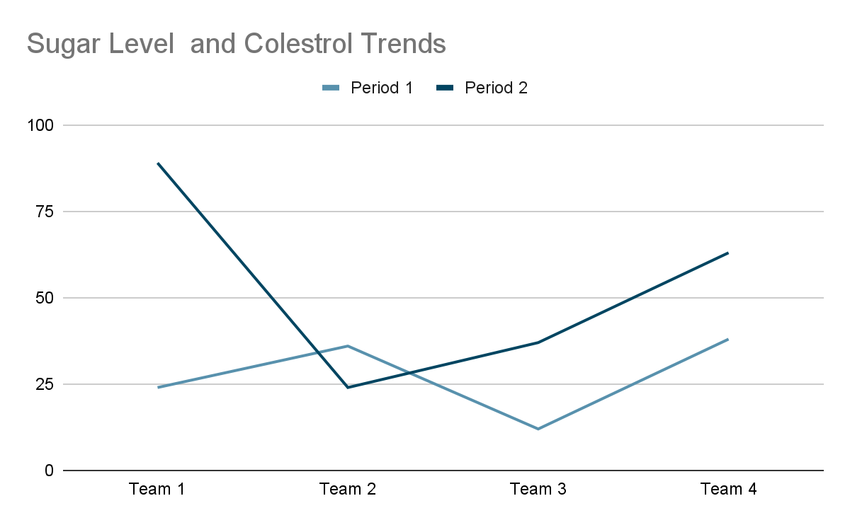

Chemistry Panel Results
The chemistry panel assesses various substances in the blood to provide information about organ function and metabolic status.

Test Name | Result | Reference Range | Unit | Interpretation
Glucose (Fasting) | 95 | 70 - 99 | mg/dL | Normal
Blood Urea Nitrogen (BUN) | 15 | 7 - 20 | mg/dL | Normal
Creatinine | 0.9 | 0.6 - 1.2 | mg/dL | Normal
Sodium | 140 | 135 - 145 | mmol/L | Normal
Potassium | 4.2 | 3.5 - 5.0 | mmol/L | Normal
Total Cholesterol | 180 | < 200 | mg/dL | Optimal
LDL Cholesterol | 100 | < 100 | mg/dL | Optimal
HDL Cholesterol | 55 | > 40 | mg/dL | Good
Triglycerides | 120 | < 150 | mg/dL | Normal

[A line graph showing the trend of glucose levels over time, if multiple readings were available. Otherwise, a pie chart showing the distribution of different cholesterol types.]

Urinalysis Results
A microscopic and chemical examination of the urine sample.

- Color: Yellow
- Clarity: Clear
- Specific Gravity: 1.015
- pH: 6.0
- Protein: Negative
- Glucose: Negative
- Ketones: Negative
- Blood: Negative
- Nitrite: Negative
- Leukocyte Esterase: Negative

Conclusion and Recommendations
All tested parameters are within normal reference ranges, indicating good general health at the time of testing. No significant abnormalities were detected in this routine panel.

It is recommended to continue regular check-ups as advised by your physician. This report should be interpreted in conjunction with the patient's clinical history and other relevant diagnostic findings. If you have any questions, please consult with your referring physician.

Further information regarding these tests can be found in the accompanying File.

