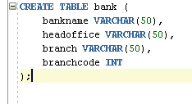

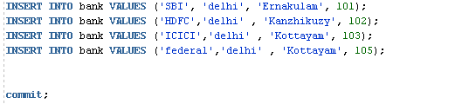

select *from bank;

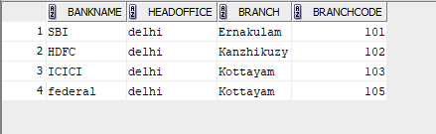

INSERT INTO bank VALUES ('AXIS', 'delhi', 'Aluva', 104);
savepoint sp1;
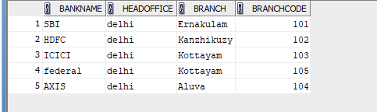



select *from bank;
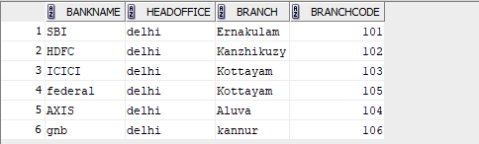

rollback to sp2;
select *from bank;

rollback to sp1;


select *from bank;

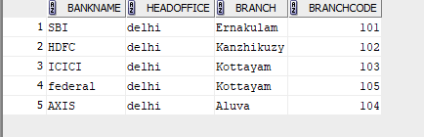
grant select on student to c24csa29;
select * from c24csa29.student;



revoke select on bank from c24csa29;

