Yin Hinton

Signals Systems and Transforms – Prof R Cliver

September 13, 2021

Lab 2 Report



Section 2

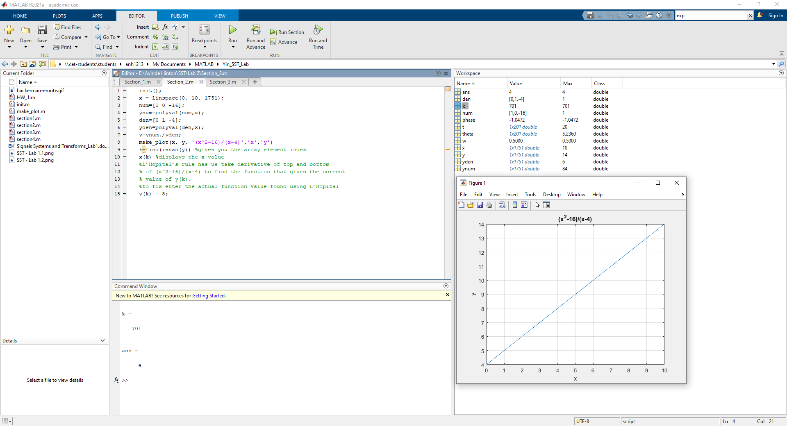

init();

x = linspace(0, 10, 1751);

num=[1 0 -16];

ynum=polyval(num,x);

den=[0 1 -4];

yden=polyval(den,x);

y=ynum./yden;

make_plot(x, y, '(x^2-16)/(x-4)','x','y')

k=find(isnan(y)) %gives you the array element index

x(k) %displays the x value

%L’Hopital’s rule has us take derivative of top and bottom

% of (x^2-16)/(x-4) to find the function that gives the correct

% value of y(k).

%to fix enter the actual function value found using L’Hopital

y(k) = 8;

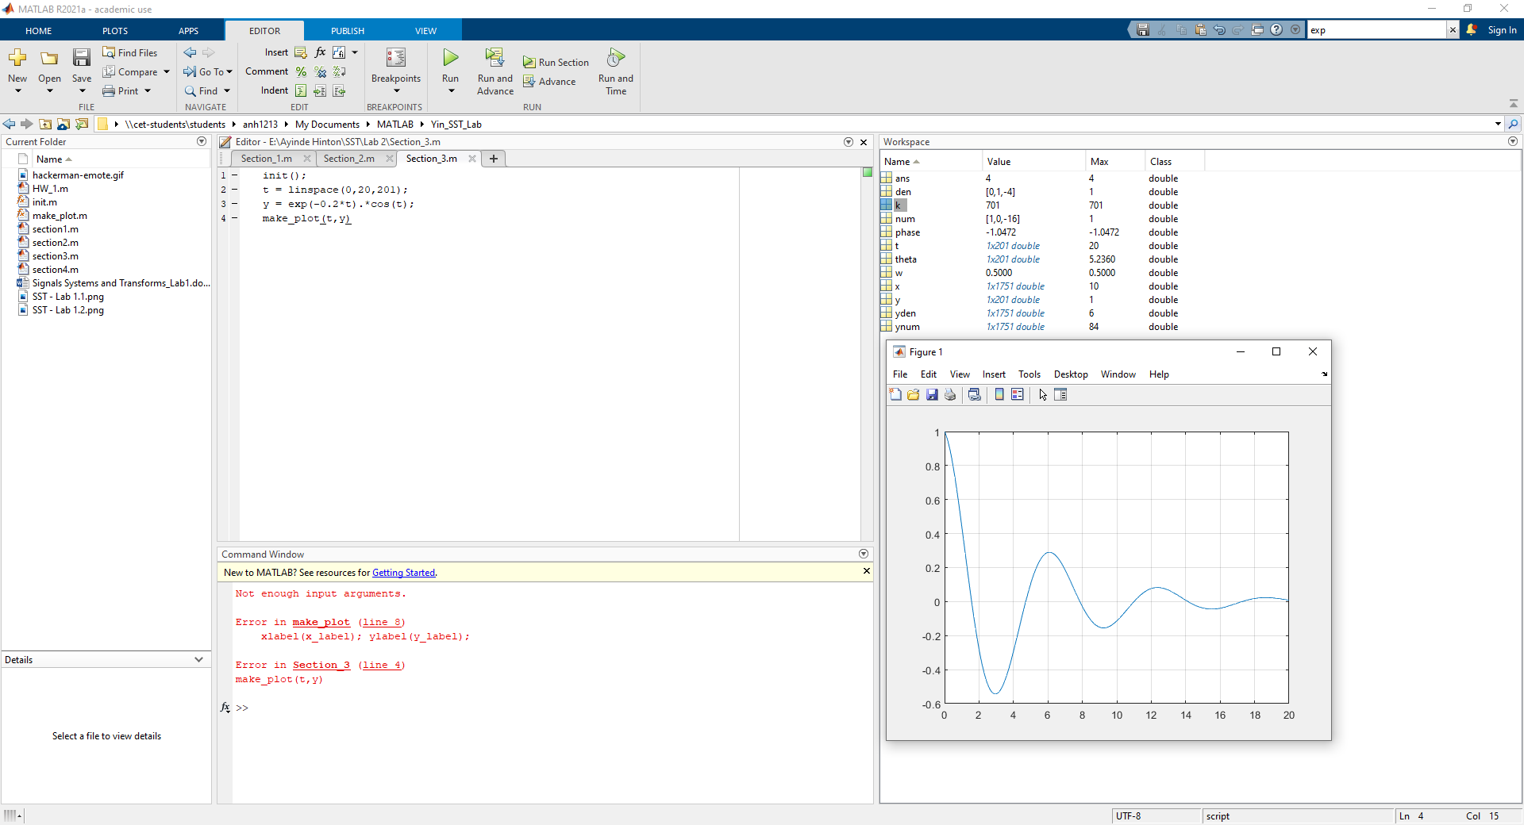Section 3

Sign Offs

