Yin Hinton

SST Lab 4

October 4, 2021



Daniels response to Mr. Miyagi’s impulse was to get up and keep fighting

Section 1

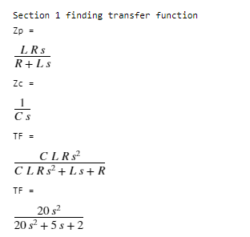

Section 2

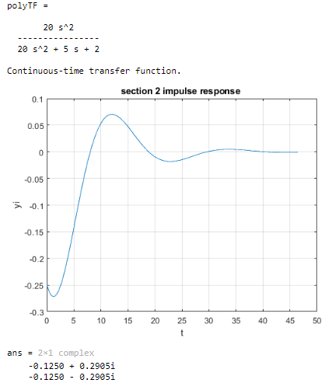

System stabilizes to zero around 40 time units in

the roots also say that the system is stable because they fall on the left hand side of a Cartesian plane

Routh-Hurwitz method also confirms that system is stable because all denominator coefficients are positive