Subject ID: MVI002R004

Date: 20170124

Visit ID: Visit8

Test Name: RotaryChair MotionMod LHRH Sinusoids 100dps

Test Condition: 0.1Hz

Raw Filename: SESSION-2017Jan24-140946.txt

**Cycle Averages**

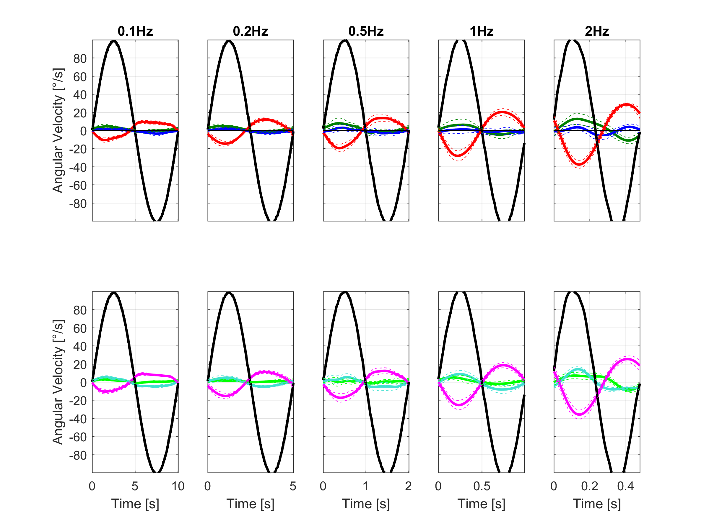

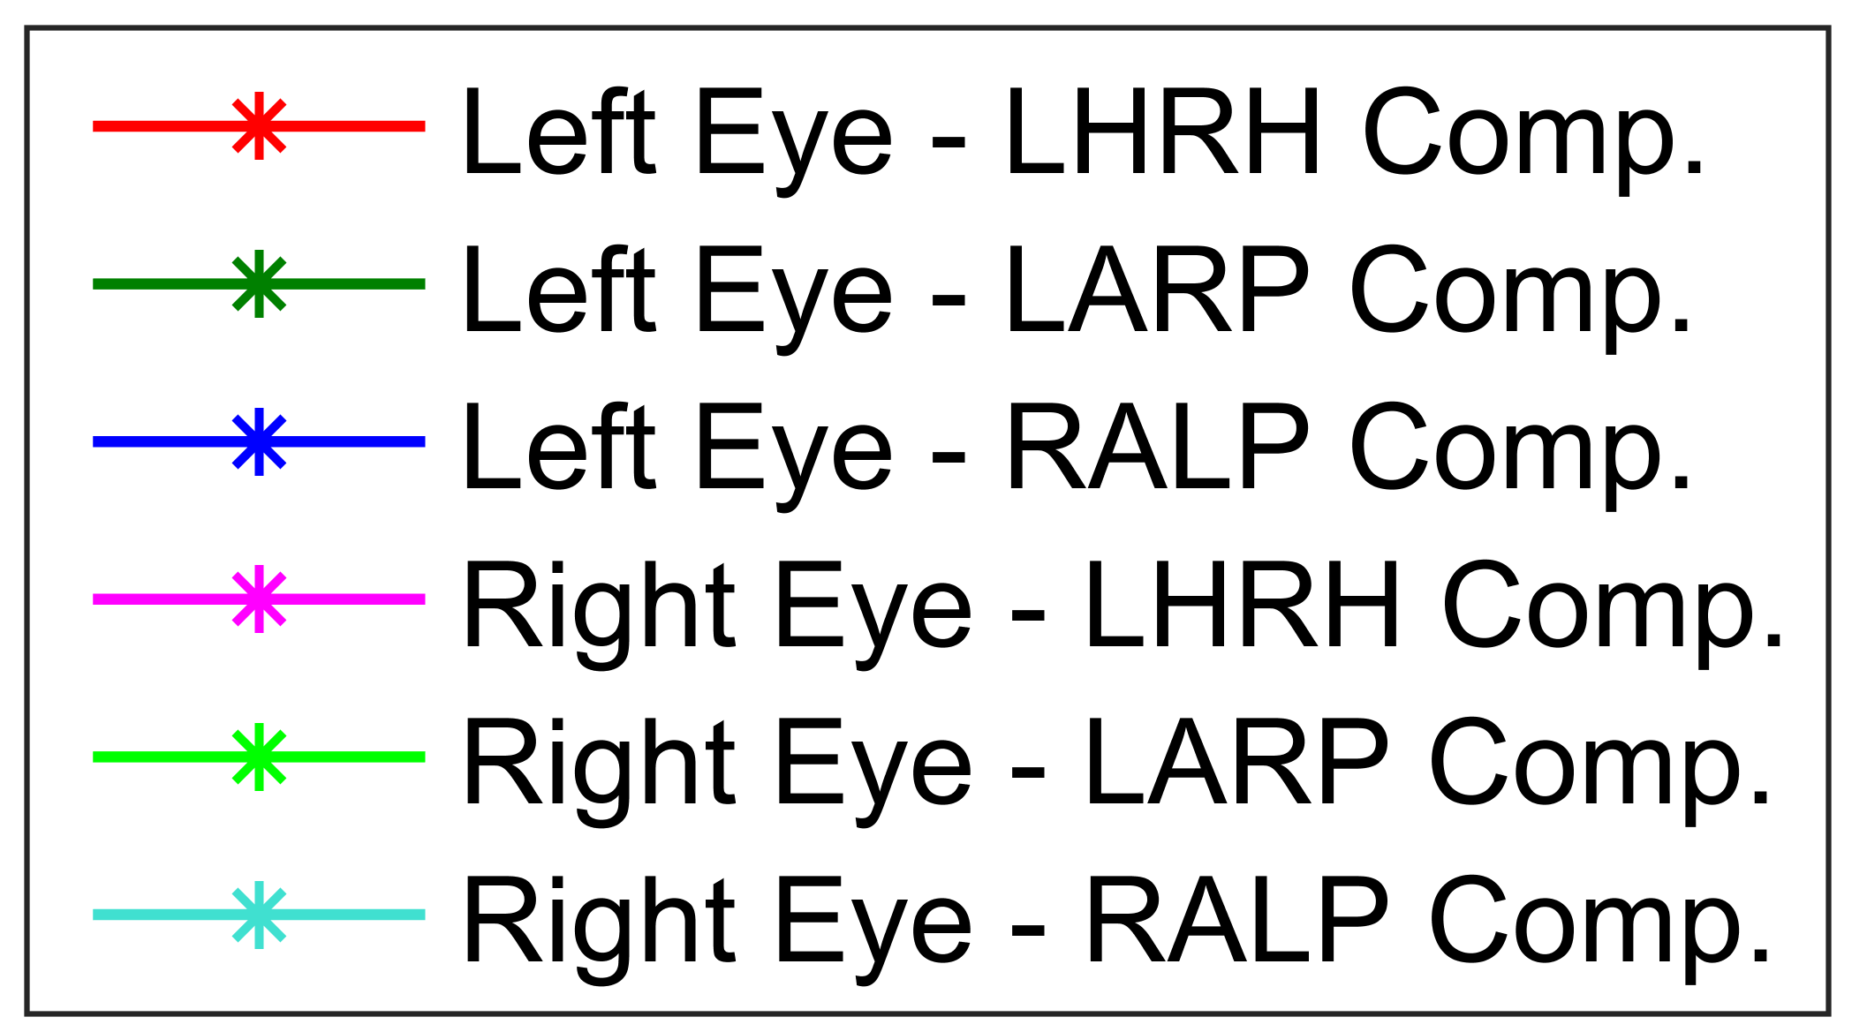

**Results**

LHRH

|  |  |  |  |  |  |  |  |  |  |  |  |  |
| --- | --- | --- | --- | --- | --- | --- | --- | --- | --- | --- | --- | --- |
| **Test Condition** | **LE : +LHRH Peak Amp. [deg/s]** | **LE : +LHRH STD [deg/s]** | **LE : +LHRH # of cycles** | **RE : +LHRH Peak Amp. [deg/s]** | **RE : +LHRH STD [deg/s]** | **RE : +LHRH # of cycles** | **LE : -LHRH Peak Amp. [deg/s]** | **LE : -LHRH STD [deg/s]** | **LE : -LHRH # of cycles** | **RE : -LHRH Peak Amp. [deg/s]** | **RE : -LHRH STD [deg/s]** | **RE : -LHRH # of cycles** |
| **0.1Hz** | -10.7 | 2.3 | 10.0 | -10.5 | 2.6 | 10.0 | 9.5 | 1.7 | 10.0 | 9.0 | 1.8 | 10.0 |
| **0.2Hz** | -14.6 | 2.6 | 14.0 | -15.3 | 3.0 | 14.0 | 12.1 | 1.6 | 14.0 | 11.2 | 1.7 | 14.0 |
| **0.5Hz** | -19.6 | 3.9 | 16.0 | -17.4 | 4.8 | 16.0 | 13.6 | 3.5 | 16.0 | 12.4 | 3.3 | 16.0 |
| **1Hz** | -28.1 | 5.7 | 22.0 | -25.4 | 5.1 | 22.0 | 20.3 | 3.6 | 22.0 | 18.6 | 2.9 | 22.0 |
| **2Hz** | -37.7 | 4.1 | 21.0 | -36.0 | 5.0 | 21.0 | 28.6 | 1.8 | 21.0 | 25.4 | 3.2 | 21.0 |

LARP

|  |  |  |  |  |  |  |  |  |  |  |  |  |
| --- | --- | --- | --- | --- | --- | --- | --- | --- | --- | --- | --- | --- |
| **Test Condition** | **LE : +LARP Peak Amp. [deg/s]** | **LE : +LARP STD [deg/s]** | **LE : +LARP # of cycles** | **RE : +LARP Peak Amp. [deg/s]** | **RE : +LARP STD [deg/s]** | **RE : +LARP # of cycles** | **LE : -LARP Peak Amp. [deg/s]** | **LE : -LARP STD [deg/s]** | **LE : -LARP # of cycles** | **RE : -LARP Peak Amp. [deg/s]** | **RE : -LARP STD [deg/s]** | **RE : -LARP # of cycles** |
| **0.1Hz** | 4.4 | 2.1 | 10.0 | 2.9 | 1.5 | 10.0 | -1.6 | 1.4 | 10.0 | -0.6 | 0.8 | 10.0 |
| **0.2Hz** | 4.7 | 1.3 | 14.0 | 1.6 | 1.5 | 14.0 | -1.2 | 1.3 | 14.0 | 0.3 | 0.9 | 14.0 |
| **0.5Hz** | 7.8 | 6.0 | 16.0 | 0.1 | 3.4 | 16.0 | -1.2 | 2.7 | 16.0 | 0.5 | 2.3 | 16.0 |
| **1Hz** | 5.9 | 6.3 | 22.0 | 4.6 | 2.9 | 22.0 | -4.6 | 4.7 | 22.0 | -1.8 | 2.8 | 22.0 |
| **2Hz** | 12.6 | 6.3 | 21.0 | 6.9 | 3.5 | 21.0 | -10.8 | 3.4 | 21.0 | -9.2 | 2.0 | 21.0 |

RALP

|  |  |  |  |  |  |  |  |  |  |  |  |  |
| --- | --- | --- | --- | --- | --- | --- | --- | --- | --- | --- | --- | --- |
| **Test Condition** | **LE : +RALP Peak Amp. [deg/s]** | **LE : +RALP STD [deg/s]** | **LE : +RALP # of cycles** | **RE : +RALP Peak Amp. [deg/s]** | **RE : +RALP STD [deg/s]** | **RE : +RALP # of cycles** | **LE : -RALP Peak Amp. [deg/s]** | **LE : -RALP STD [deg/s]** | **LE : -RALP # of cycles** | **RE : -RALP Peak Amp. [deg/s]** | **RE : -RALP STD [deg/s]** | **RE : -RALP # of cycles** |
| **0.1Hz** | 1.4 | 1.0 | 10.0 | 5.3 | 1.7 | 10.0 | -1.5 | 1.2 | 10.0 | -4.6 | 1.1 | 10.0 |
| **0.2Hz** | 2.0 | 1.3 | 14.0 | 4.8 | 1.9 | 14.0 | -2.8 | 1.6 | 14.0 | -5.1 | 1.3 | 14.0 |
| **0.5Hz** | 2.7 | 3.4 | 16.0 | 3.8 | 3.7 | 16.0 | -3.1 | 2.7 | 16.0 | -5.0 | 4.4 | 16.0 |
| **1Hz** | 0.8 | 4.5 | 22.0 | 8.7 | 3.9 | 22.0 | -0.8 | 3.3 | 22.0 | -8.2 | 4.4 | 22.0 |
| **2Hz** | 3.4 | 3.0 | 21.0 | 14.2 | 3.0 | 21.0 | 3.4 | 2.6 | 21.0 | -6.9 | 2.3 | 21.0 |