Technical architecture
Python for the language engine and API, one TypeScript app for web and mobile, and a versioned lexicon file as the shared contract between them.

1. Stack decisions
Per the Oct 26 decision, each component starts with the simplest thing that works and names its upgrade, so nothing has to be redesigned to improve it.
Component | Start with | Why | Upgrade path
Engine language | Python 3.12, packaged as hv | Every Indic NLP library used here is Python | Port hot paths (normalize, key, lookup) to TypeScript for offline grading
API | FastAPI + Pydantic v2, served by Uvicorn | Typed request/response models generate the OpenAPI spec the app consumes | Split model inference into its own service when load requires
Lexicon store | Read-only SQLite file built offline, versioned, loaded per worker | Fast indexed lookups, one file to ship and diff | Same schema in Postgres if editors need live curation
App data | Postgres 16 via Supabase (also provides auth and file storage) | One managed service covers users, cards, logs and audio | Self-hosted Postgres; keep SQL portable
Translation | IndicTrans2 distilled 200M, both directions, via Hugging Face transformers + IndicTransToolkit (model card; toolkit) | MIT-licensed, strong Hindi quality, CPU-capable | INT8 ONNX or CTranslate2 builds (ONNX packages); 1B model on GPU
Transliteration fallback | ai4bharat-transliteration XlitEngine, Hindi, beam 10 with rescoring (PyPI) | Ranked Devanagari candidates for unseen words | CTranslate2 build that drops the Fairseq dependency (HF)
Token language ID | English wordlist + lexicon membership + character n-gram classifier | No model download; handles homographs with context | IndicLID (MIT; has a hin_Latn class) for sentence-level calls (IndicLID)
Sentence reranking | KenLM 5-gram trained on normalized Hindi Wikipedia text from Dakshina | Small, fast, well understood | Small transformer LM
Schwa deletion | Ohala rule + curated lists | Works day one | Arora et al. classifier
Script normalization | Own normalizer following section 4 of the spec | No heavy build tooling | Nisaba (Apache 2.0) via its Python bindings
Scheduler | py-fsrs on server; ts-fsrs on device | Same algorithm both sides | Per-learner parameter optimization
TTS | Indic Parler-TTS, audio pre-generated for every lexicon word and phrase, stored as Opus (model) | Apache 2.0; named Hindi voices give voice variety for perception drills | Native-speaker recordings for the core 500 words
App | Expo (React Native) + TypeScript, one codebase for iOS, Android and web | Matches the web-and-mobile decision with one team | Native modules only if audio latency demands
Fonts | Noto Sans Devanagari, bundled | Consistent conjunct rendering on all platforms
Hosting | Docker image on a single managed VM or container host | Models load once at startup | Autoscaled container service; GPU node for MT
Observability | Sentry for errors, structured JSON logs, OpenTelemetry traces | Find slow pipeline stages | Dashboards per ambiguity class
Memory planning estimate: a 200M-parameter model in 32-bit floats needs roughly 0.8 GB, so two directions need about 1.6 GB before INT8 quantization. Measure this in Phase 2 rather than trusting the estimate.

2. System diagram
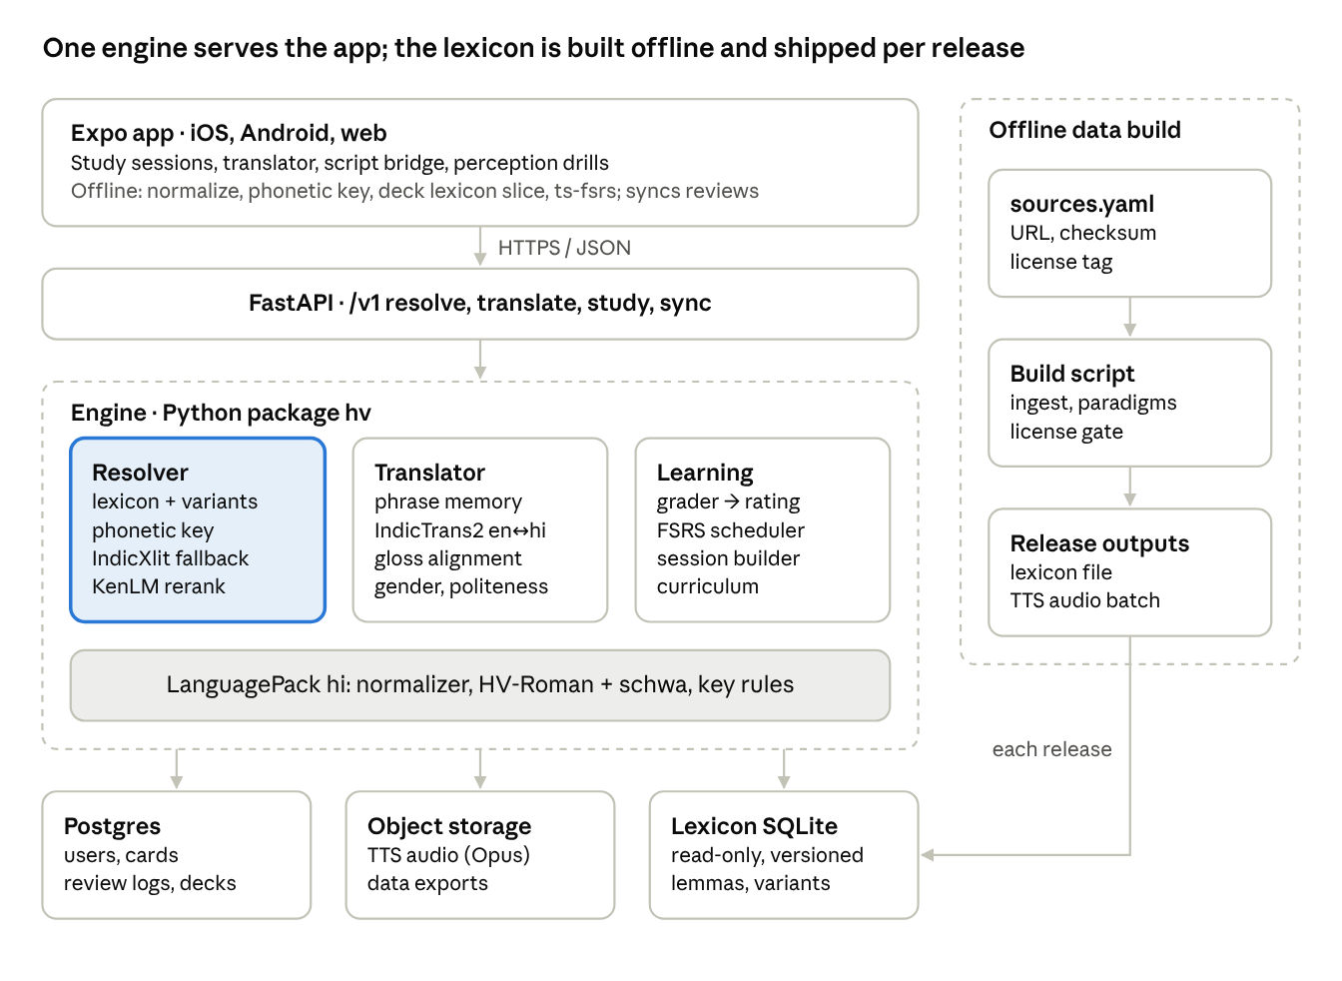
The resolver is highlighted because every other part depends on it: translation, grading and the offline app all start by resolving romanized text to Devanagari. All Hindi-specific rules live in the LanguagePack band, so a second language replaces that band only.

3. Core interfaces
All language-specific behavior sits behind one LanguagePack protocol; the resolver, translator and learning code never mention Hindi. Adding a language means writing a new pack, not editing the pipeline.
from dataclasses import dataclass, field
from typing import Protocol, Sequence
@dataclass(frozen=True)
class Token:
text: str # as typed
norm: str # Latin-normalized
start: int; end: int # offsets into the original input
lang: str # "hi" | "en" | "num" | "punct"
lang_conf: float
@dataclass(frozen=True)
class Candidate:
native: str # storage-form Devanagari
lemma_id: int | None
canonical: str # HV-Roman of this surface form
source: str # "canonical" | "variant" | "key" | "edit" | "xlit"
score: float
@dataclass
class Resolution:
tokens: list[Token]
best: list[Candidate | None] # one per token; None = pass-through
alternatives: list[list[Candidate]]
confidence: list[float]
class LanguagePack(Protocol):
code: str # "hi"
mt_code: str # "hin_Deva" (IndicTrans2 tag)
scheme_version: str # "hv-roman 1.0.0"
def normalize_native(self, s: str) -> str: ...
def match_key_native(self, s: str) -> str: ...
def normalize_latin(self, s: str) -> str: ...
def phonetic_key(self, latin: str) -> str: ...
def to_canonical(self, native_word: str) -> str: ...
def to_precise(self, native_word: str) -> str: ...
def edit_costs(self) -> dict[tuple[str, str], float]: ...
def lexicon_path(self) -> str: ...
def tts_voices(self) -> Sequence[str]: ...
class Resolver:
def __init__(self, pack: LanguagePack, lexicon, lm, xlit, langid): ...
def resolve(self, text: str) -> Resolution: ...
class Translator:
def to_english(self, res: Resolution) -> "Translation": ...
def from_english(self, text: str, *, speaker_gender: str,
politeness: str) -> "Translation": ...
class Grader:
def grade(self, card, answer: str, latency_ms: int) -> "Grade": ...
Contract tests run against every pack: normalization is idempotent, to_canonical round-trips through the resolver for every lexicon entry, and phonetic_key maps every listed variant of a lemma to keys that include the lemma's candidates.

4. API specification
A versioned JSON API under /v1; FastAPI generates the OpenAPI document, and the app's TypeScript client is generated from it so the two cannot drift.
Method + path | Purpose | Key fields
POST /v1/resolve | Romanized text → Devanagari candidates per token | text, lang
POST /v1/translate | Either direction, with gloss and respelling notes | text, direction (rom_to_en, en_to_rom), lang, speaker_gender, politeness
POST /v1/romanize | Devanagari → canonical + precise | text
GET /v1/lexicon/{lemma_id} | Entry, forms, glosses, audio URLs
GET /v1/lexicon/search | Look up by English, any spelling, or Devanagari | q
GET /v1/study/session | Due cards + new items for today | limit_new
POST /v1/study/review | Grade an answer, update FSRS, return feedback | card_id, answer, latency_ms, client_review_id
POST /v1/study/sync | Upload reviews done offline | reviews[] (idempotent by client_review_id)
POST /v1/decks/{deck_id}/items | Save a translated sentence or word to a deck | text, native, source
GET /v1/progress | Known words, retention, script stage
GET /v1/me/export | Full data export
DELETE /v1/me | Account and data deletion

Example: POST /v1/translate
// request
{ "text": "mera phone kharab h", "direction": "rom_to_en", "lang": "hi" }
// response
{
"english": "My phone is broken.",
"native": "मेरा फ़ोन ख़राब है",
"canonical": "mera phone kharaab hai",
"tokens": [
{ "text": "mera", "lang": "hi", "native": "मेरा", "canonical": "mera", "gloss": "my (m.)", "confidence": 0.97, "respelled": false },
{ "text": "phone", "lang": "en", "native": "फ़ोन", "canonical": "phone", "gloss": "phone", "confidence": 0.99, "respelled": false },
{ "text": "kharab", "lang": "hi", "native": "ख़राब", "canonical": "kharaab", "gloss": "broken, bad", "confidence": 0.93, "respelled": true },
{ "text": "h", "lang": "hi", "native": "है", "canonical": "hai", "gloss": "is", "confidence": 0.88, "respelled": true }
],
"alternatives": [],
"engine": { "scheme": "hv-roman 1.0.0", "lexicon": "2026.11.0", "mt": "indictrans2-indic-en-dist-200M" }
}
Errors use RFC 9457 problem+json. Every response carries the scheme, lexicon and model versions so any reported mistake can be reproduced exactly.

5. Budgets, offline behavior, security and privacy
These are proposed targets for a single CPU server; Phase 2 measures them and either meets them or revises them in this table.
Operation | p95 target | Where it runs
Romanize a sentence (Devanagari → HV-Roman) | 5 ms | Server and device
Resolve a 10-word romanized sentence | 50 ms (lexicon path), 250 ms with IndicXlit fallback | Server
Translate a 15-word sentence | 800 ms on CPU | Server
Grade a study answer | 30 ms | Device (offline) and server
App cold start to first card | 2 s on a mid-range phone | Device
Lexicon download for offline use | under 15 MB compressed for A1–A2 words, variants and paradigms | Device

Offline behavior
- Studying works fully offline: the app holds the learner's deck slice of the lexicon, a TypeScript port of normalization, phonetic key and lookup, and ts-fsrs.
- Reviews done offline are queued with a client-generated id and synced idempotently; the server's FSRS replays them in timestamp order and is the source of truth.
- Translation and free-text resolution need the network; the UI says so instead of failing silently.

Security and privacy
- Translation text is not stored by default; review logs store the learner's answer because grading quality depends on it, and this is stated in the privacy notice.
- Learner identifiers in analytics are pseudonymous; raw answers are excluded from analytics exports.
- Export and delete endpoints exist from the first public release.
- Rate limiting on /translate and /resolve per account and per IP, since they run the expensive models.
- If the app may be used by people under 13 (or the local age of digital consent), get legal review before launch; the default plan is an age gate.

6. Extending beyond Hindi
The Hindi design generalizes in two tiers: other Indic languages reuse almost every resource, while other script families reuse the architecture but need new data, new rules and often a different translation model.

What every new LanguagePack must supply
- A written canonical romanization spec in the format of the Linguistics tab, reviewed by a native speaker and a linguist.
- A native-script normalizer and match key.
- A variant source: attested romanizations (lexicon pairs) plus rule-generated alternations.
- A word frequency list and a monolingual corpus for the language model.
- A translation model with that language and English.
- TTS voices, and a gold test set of romanized sentences.

By script family
Family | Examples | Reusable resources | Language-specific work
Other Brahmic (Indic) | Bengali, Marathi, Punjabi, Gujarati, Tamil, Telugu | Dakshina covers 12 South Asian languages (repo); Aksharantar covers 21; IndicXlit, IndicTrans2 (22 languages), IndicLID, Indic Parler-TTS; Nisaba normalization | Schwa behaves differently (Bengali keeps medial schwas Hindi deletes); Marathi shares Devanagari, so the pack needs a language tag, not just a script
Perso-Arabic | Urdu, Sindhi, Kashmiri | Dakshina (Urdu, Sindhi), IndicTrans2 | Short vowels usually unwritten, so the canonical romanization needs vowel prediction from the lexicon; right-to-left UI
Cyrillic, Greek | Russian, Ukrainian, Greek | uroman as a baseline candidate generator (uroman) | Mostly alphabetic, so romanization is closer to letter mapping; stress is unwritten
Arabic, Hebrew | Arabic, Hebrew | uroman baseline | Unwritten vowels as for Urdu; Arabic chat alphabet uses digits for letters (3, 7), so the Latin normalizer must keep digits inside words
CJK | Mandarin, Japanese, Korean | Established standards (pinyin, Hepburn, Revised Romanization) can serve as the canonical scheme | Word segmentation; tones (Mandarin) and kanji readings need a dictionary, not character rules
uroman's own documentation says a romanizer is not a full transliterator (uroman); use it to propose candidates and test coverage, never as the taught standard.
Translation outside IndicTrans2's 22 languages needs a separate model choice, to be made when the second family is scoped.

