**CHECKINOUT USER MANUAL**

**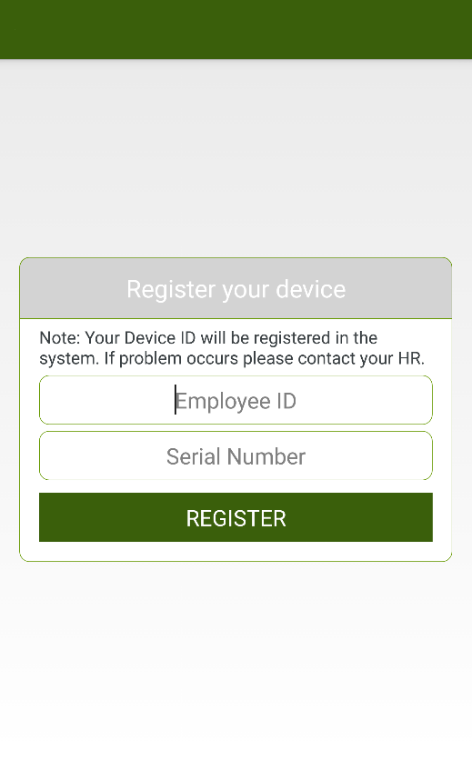*REGISTER DEVICE***

Each user is required to register their device with its employee id for app first time use. If the user already registered. This screen will not appear anymore.

To register your device, input your employee id of the user and the serial number of the company. Click on the register button to send the registration data to server.

Type your Employee ID

Type your Company Serial

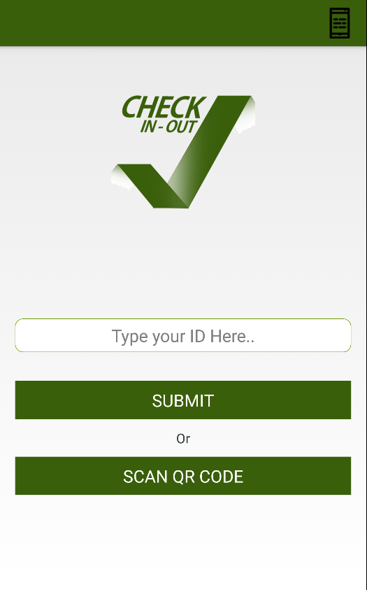***LOGIN SCREEN***

After you registered your device to the server, it will be approved in the backend part of the system. Once the user is approved, you can now login your attendance.

To login you can:

Type the employee id in the input field

Submit Employee ID

Scan your assigned QR code located at the back of your id.

Scan QR Code

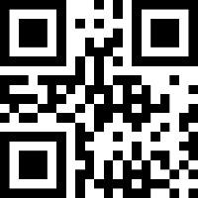

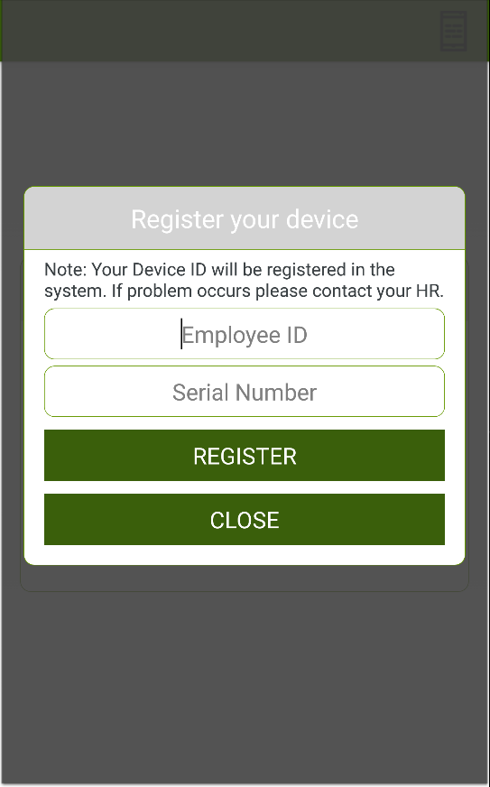***RE-REGISTER DEVICE***



Re-Register Device Icon

You can change the employee id of the device by clicking the gear icon located at the top right of the screen of your phone. You can re-register your employee id to a device by using this function.

To re-register device, click on the gear icon. Input your employee id and the serial number of your company.

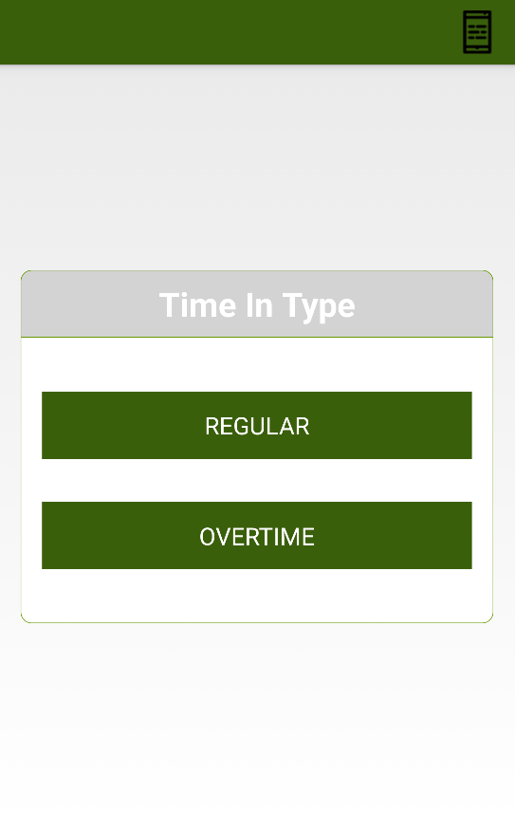***LOGIN TYPE SCREEN***

You can choose what type of attendance you want to log on to.

Click on the “Regular” button to log in a regular attendance.

Regular Attendance

Click on the “Overtime” button to log in an overtime attendance.

Overtime Attendance

***HOME SCREEN – PERSONAL STATUS***

Pay Slip

Log Out

*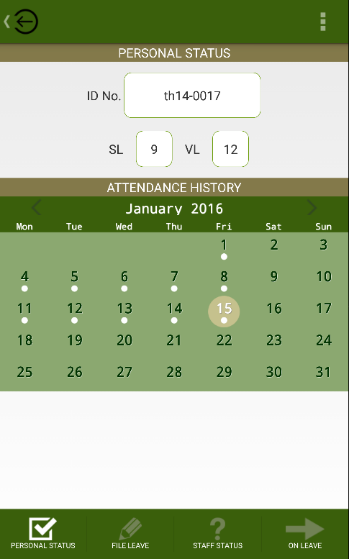Home Screen*

**Personal Status, File Leave, Staff Status and On Leave Tabs**

*Logging Out:*

To log out press the icon on the upper left side of the screen.

*Personal Status*

Once you’ve successfully logged in, you will see your employee id, remaining vacation and sick leave. In the calendar, you will see the current date marked and the indicator in the date if you have login data in that date. It is marked with a white dot below the number. To see the full detail of your log in status, press the date you want to check. (Note: if there is no white dot on the date, it means that it has no data.)

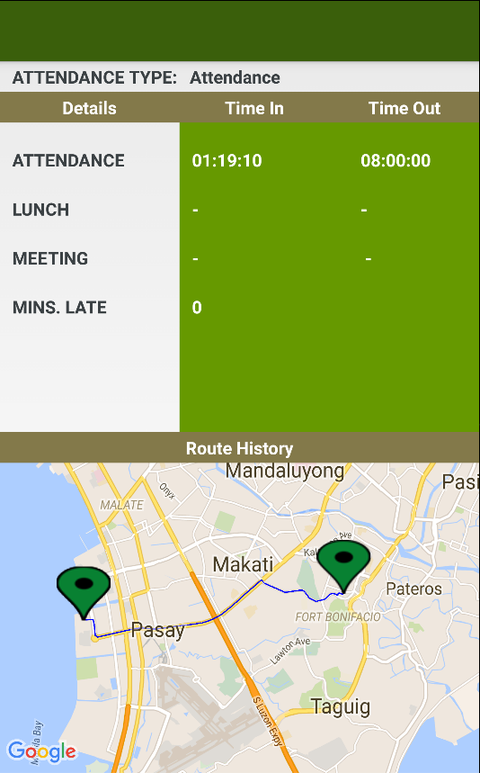

On Leave

Staff Status

File Leave

Personal Status

***PERSONAL STATUS DETAIL***

Once you’ve clicked on the date desired, you will see the following:

* Type of attendance you logged
* Time in and out of the attendance, lunch and meeting
* Minutes of late the employee incur.
* Location or the Route History of the user where they have logged.

Locations where the employee went

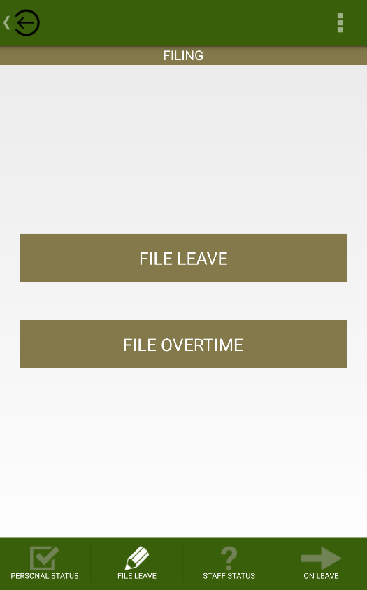***FILING***

In the filing page, you can file a leave or file an overtime.

To file a leave, click on the “File Leave” button.

File Leave

To file an overtime, click on the “File Overtime” button.

On Leave

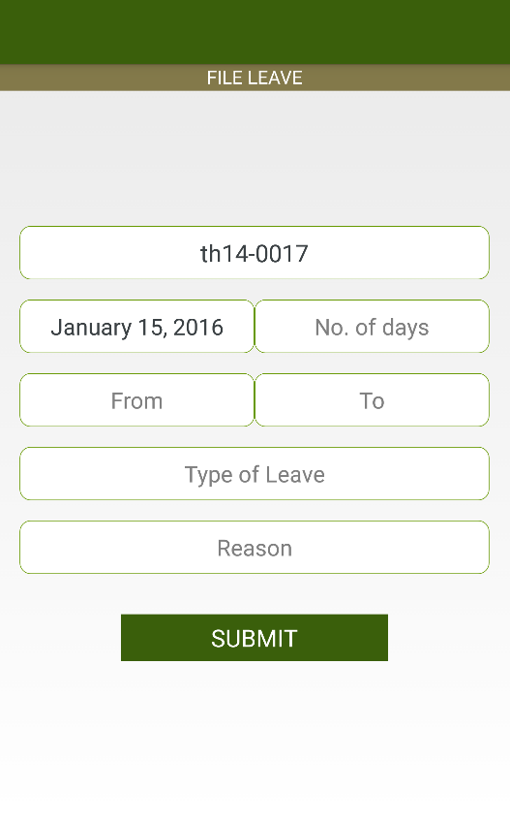***FILE LEAVE***

In this screen, you can file a leave by inputting the following:

* No. of days
* Date of Leave From
* Date of Leave To
* Type of Leave
* Reason of Leave

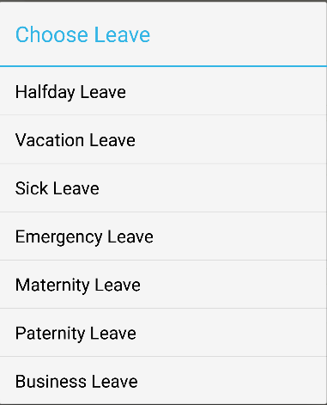

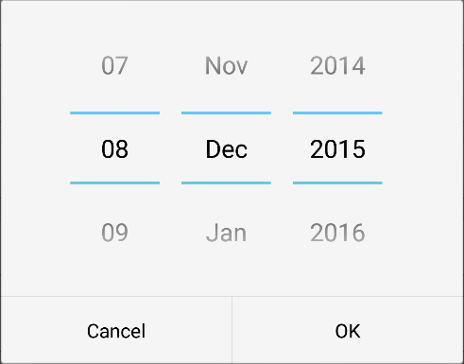

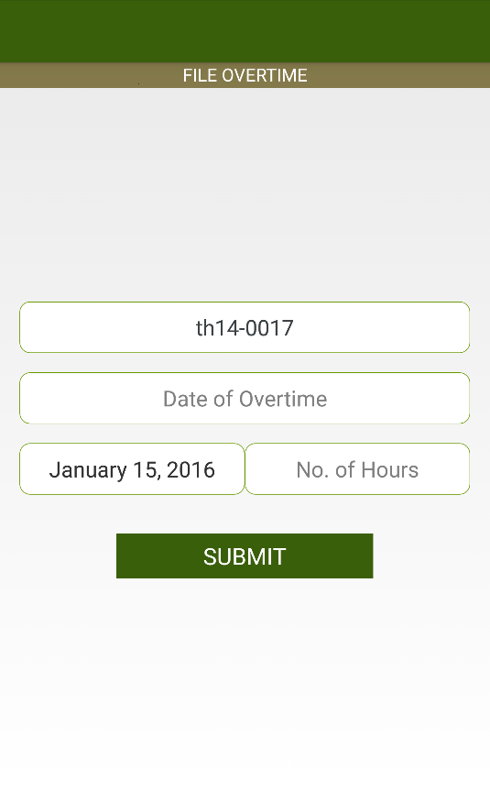***FILE OVERTIME***

In this screen, you can file an overtime by inputting the following:

* Date of the overtime
* Number of hours of the overtime



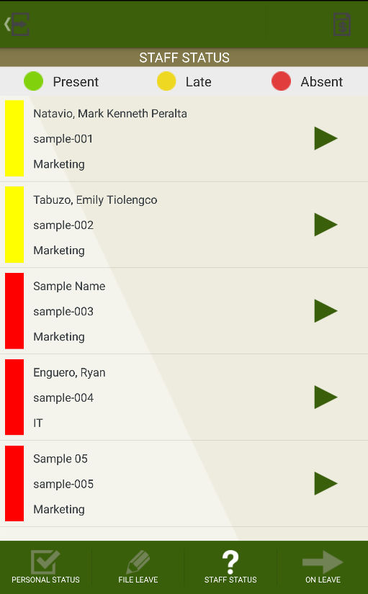***STAFF STATUS***

This screen lets you view the current status of your employees. You will see whether the employee is present, late or absent. Each status is color coded: green color for present, yellow color for late and red color for absent.

Click on the list of the chosen employee and there the time-in, time-out and the location of the user is indicated in the view.

Employee

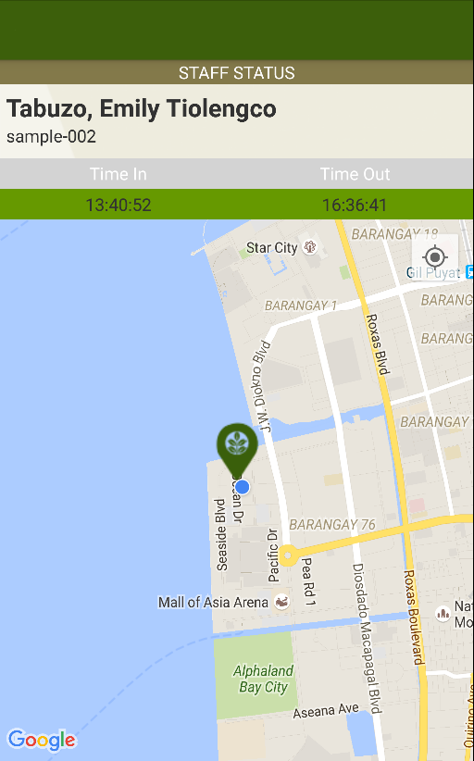***STAFF STATUS DETAIL***

On this screen, you will see the detail of the status of the employee. The following is indicated in this screen:

* name of the employee and employee id
* time in and out
* location where he or she logged

Time Out

Time In

Location

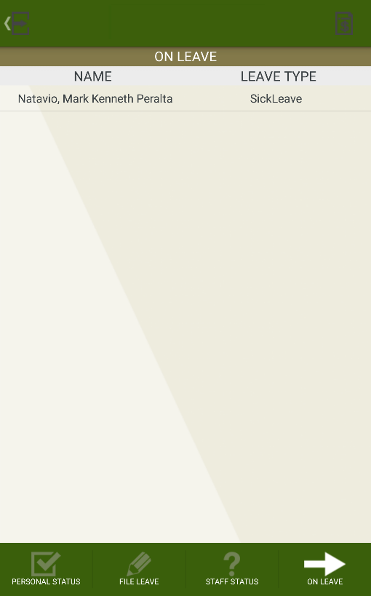***ON LEAVE***

This module lets you view the employees who filed a leave on a certain number of days. This will let you know what type of leave the employee took for that day.

Click on the list and there it will show you the complete detail of the kind of leave the employee has taken.

Leave Type

Employee Name

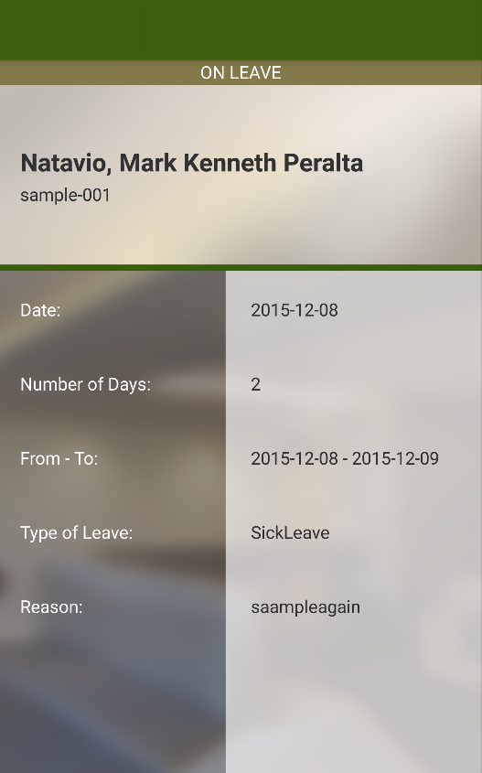***ON LEAVE DETAIL***

On this screen, you will see the detail of the leave filed by the employee. The following is indicated in this screen:

* Employee Name
* Employee ID
* Date filed
* Number of days leave
* Date of leave from and to
* Type of leave
* Reason of leave

Additional Features:

* For Managers Account
* A notification will pop up whenever an employee logged in the system.

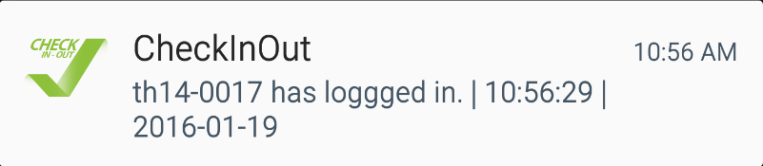

* Personal status, file leave, staff status and on leave tab will appear.

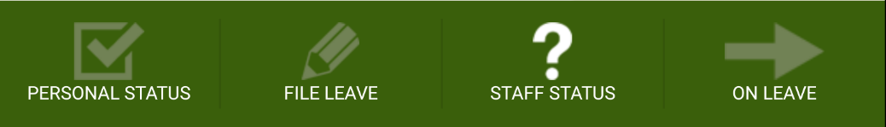

* For Employee Account
* Only the personal status and file leave tab will appear in the employees account.

