Gift Voucher Code Cracking

Running executable server:
Had to chmod to allow permissions for it to be executed..
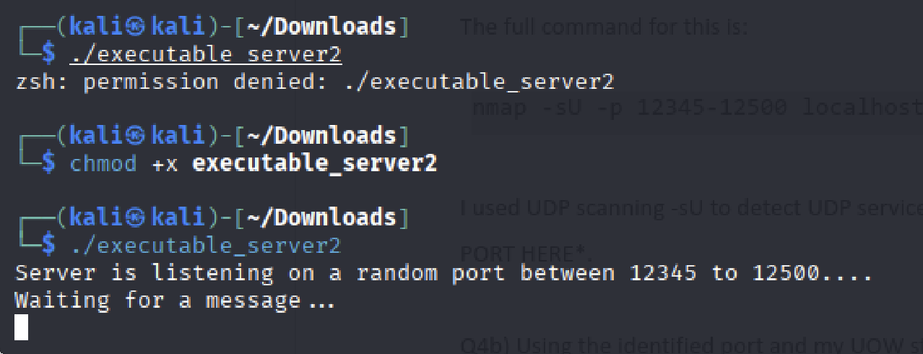

Q4a) Port Scanning with Nmap
To identify the open port between 12345 and 12500, I used nmap with the -sU flag for UDP scanning and I specified the port range using flag -p with ports 12345-12500.
The full command for this is:
nmap -sU -p 12345-12500 localhost
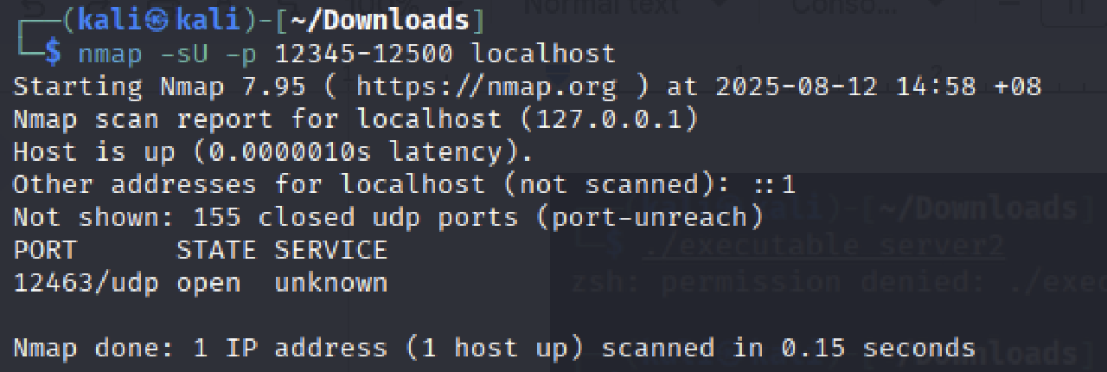
I used UDP scanning -sU to detect UDP services and the scan showed that the open port was 12463.

Q4b) Retrieving Voucher Code
Using the identified port and my UOW student ID, 1035289, I retrieved the voucher code using netcat and the -u flag for UDP communication.
The command I used was:
echo "1035289" | nc -u localhost 12463
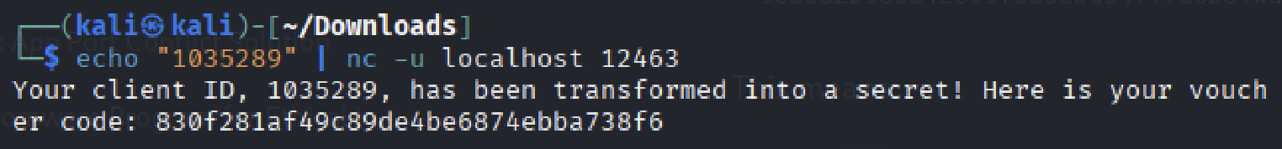
After running this command, the server responded with the voucher code which is 830f281af49c89de4be6874ebba738f6.

Q4c) Cracking the Hash using Hashcat
To find the two-alphabet character from A and the two-symbol character from B that the server used to generate a gift voucher code I used Crunch and Hashcat. Since the format of the voucher code is VoucherCode=MD5(A||ClientID||B), I first generated all possible combinations of two-alphabet characters and all possible combinations of two-symbol characters. I generated these combinations using Crunch and wrote the output into a text file for A and B each.
The commands for generating the two lists of possible combinations are as follows:
Generating possible alphabet list: crunch 2 2 abcdefghijklmnopqrstuvwxyz -o A_list.txt
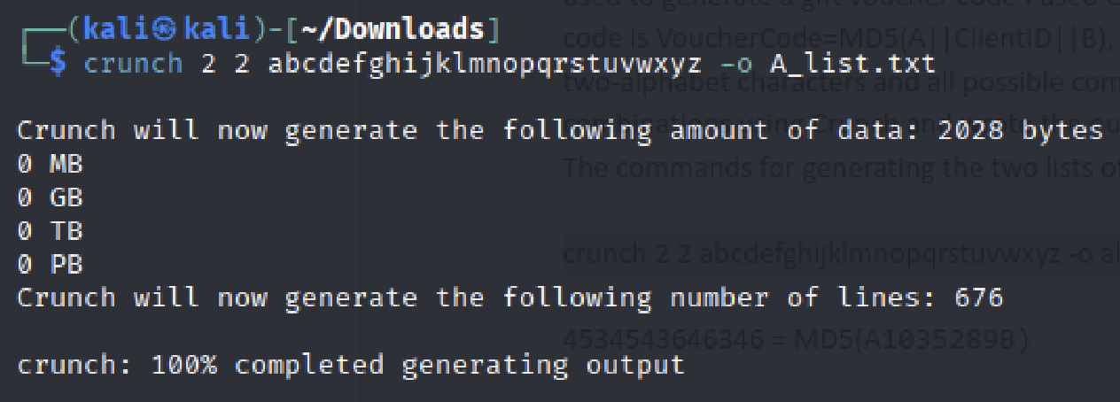
Generating all possible symbols list: crunch 2 2 '!@#$%^&*()_+-=[]{};:'"'""'"',./<>?' -o B_list.txt
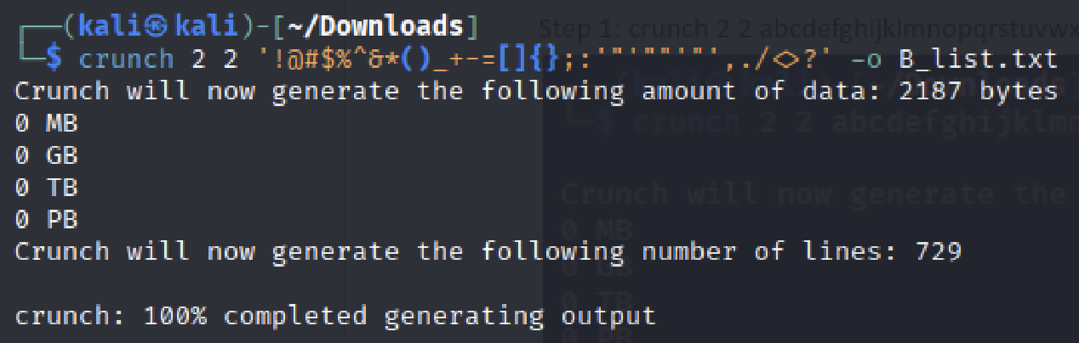

Creating a file called target_vouchercode.txt to prepare for Hashcat command: echo "830f281af49c89de4be6874ebba738f6" > target_vouchercode.txt
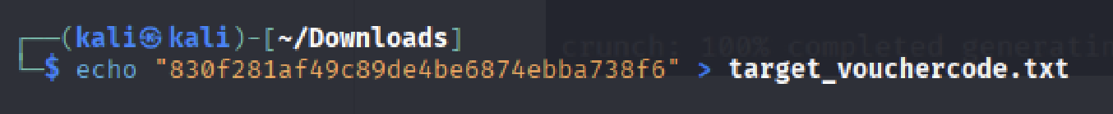
Generating all possible concatenations of A+ “1035289” +B by processing values from A_list.txt and B_list.txt, and storing the results into combined.txt :
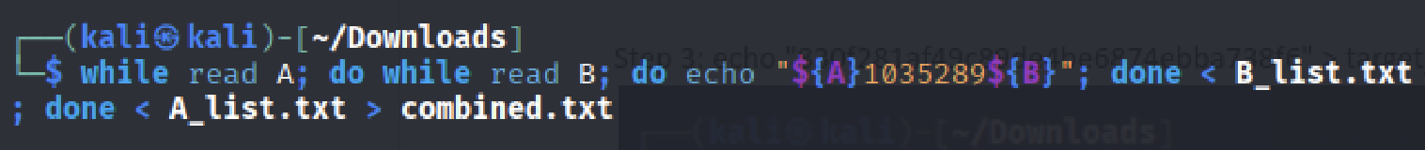

Executing Hashcat command: hashcat -m 0 target_vouchercode.txt combined.txt --force
- -m 0: -m flag is to specify the hash type and 0 specifies that it is MD5
- target_vouchercode.txt: file that contains the target MD5 hash
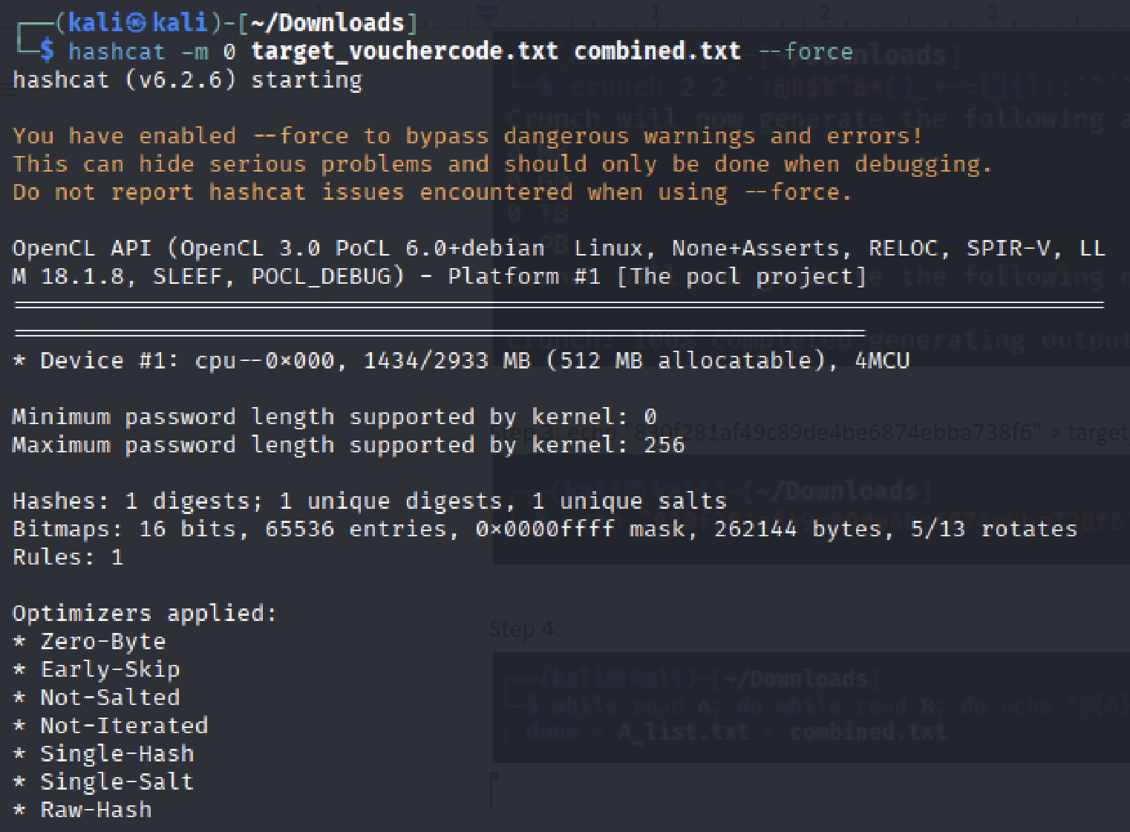
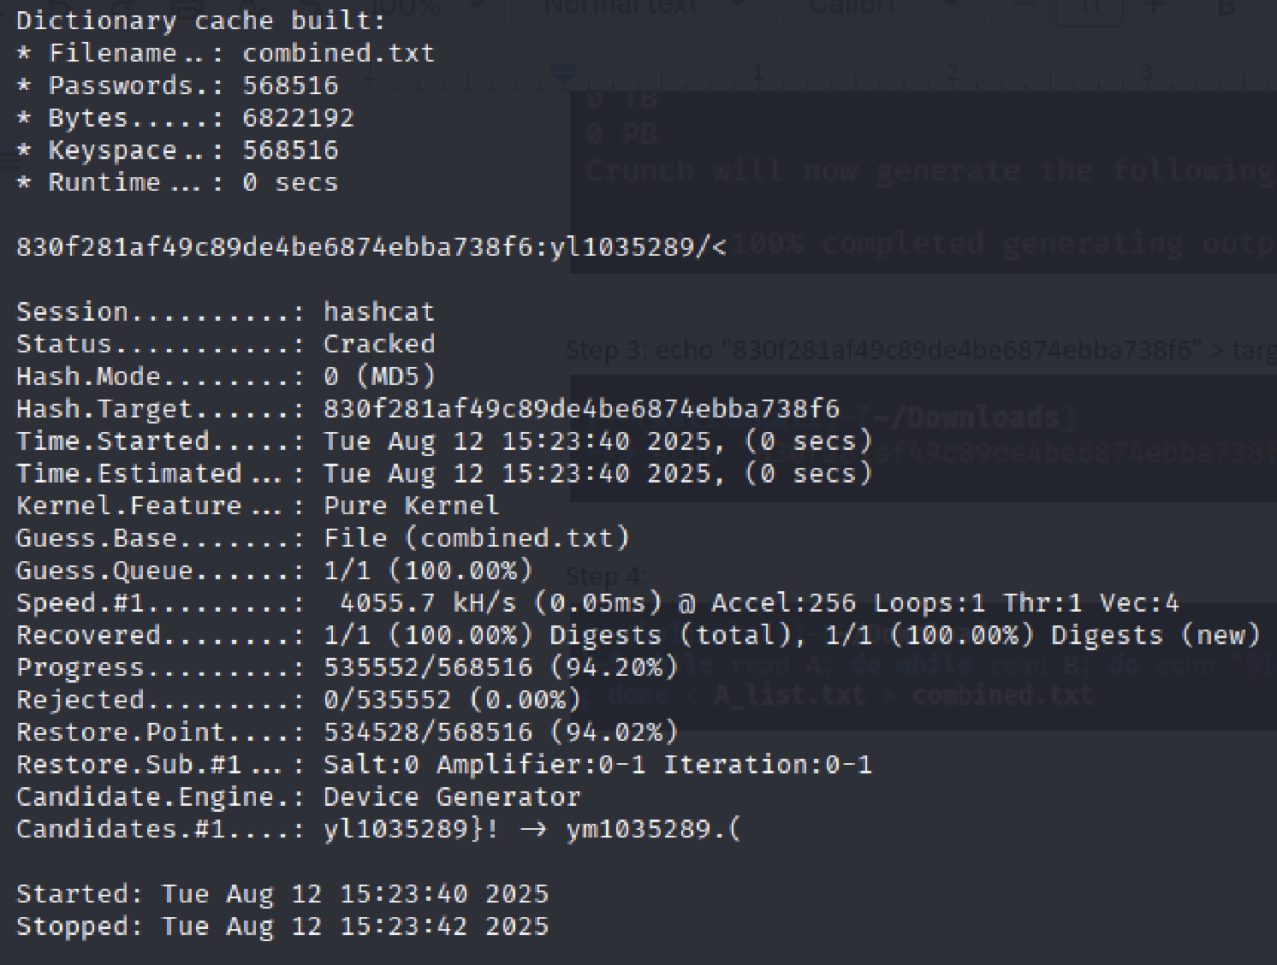
From the hashcat command, we can see that it cracked the hash and resulted in yl1035289/<
To confirm that yl1035289/< is the correct input to generate the gift voucher code, I ran the following command which resulted in the same hash that I retrieved in Qn 4b.
echo -n "yl1035289/<" | md5sum
