Code Snippets
Lines 1 - 46
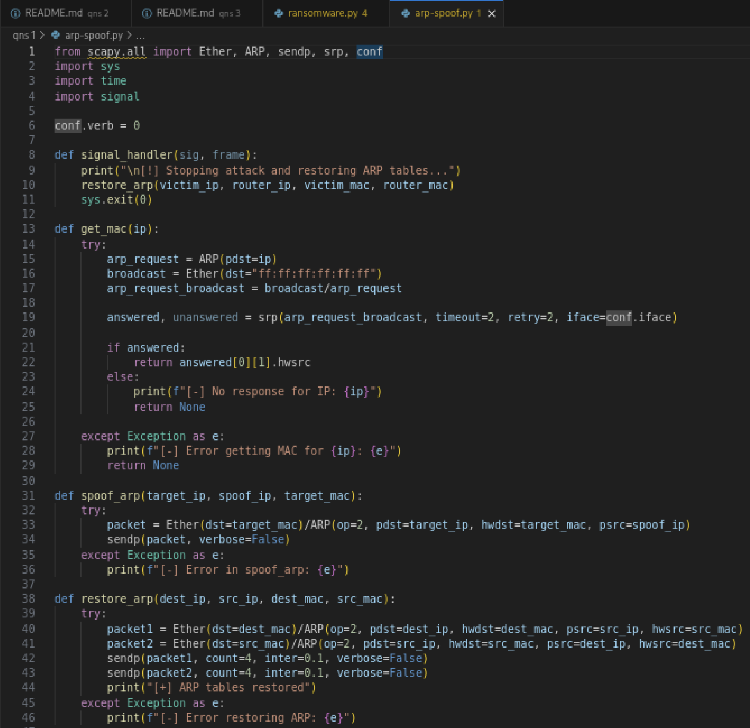

Lines 47 - 91
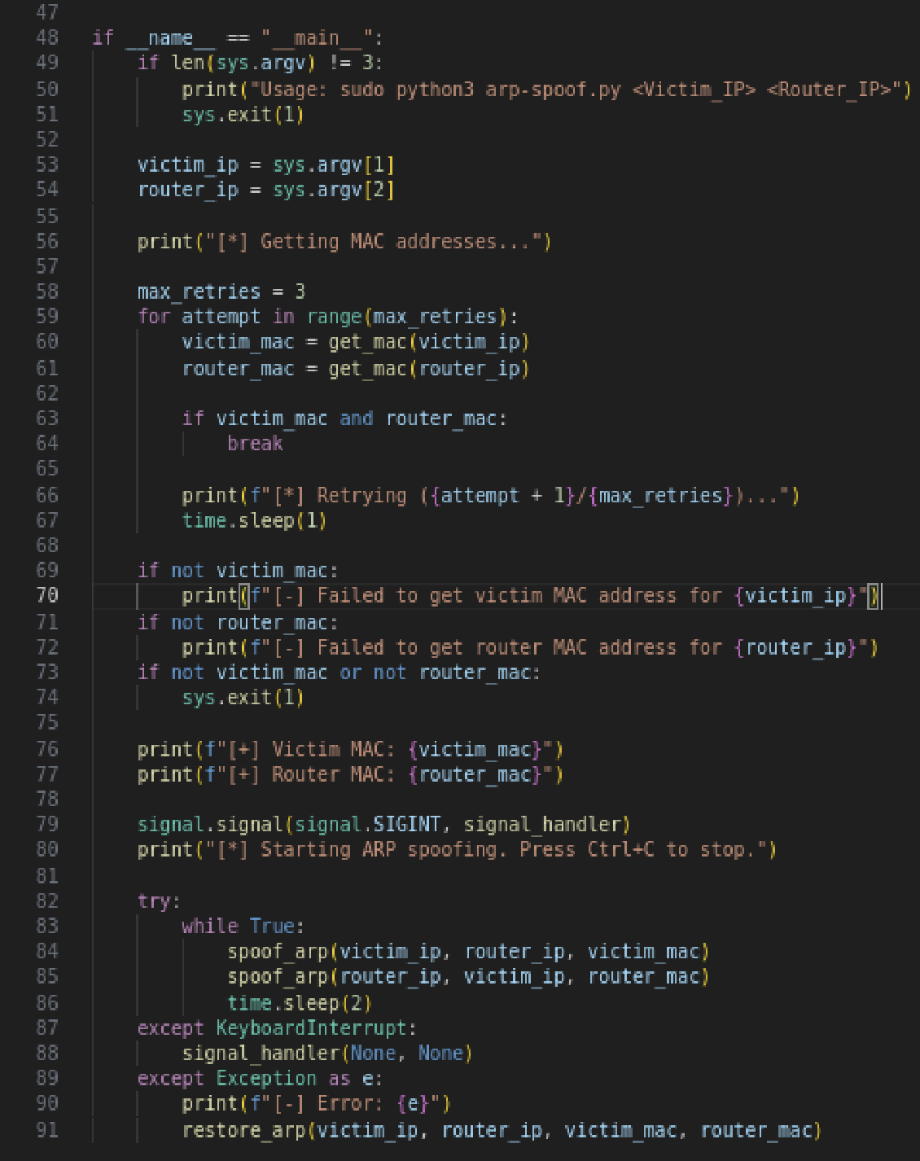
- Code will perform ARP spoofing attack to intercept traffic between victim and router
- get_mac(ip) will send ARP request to get MAC address of meta2’s ip, using scapy to send packets, and will return MAC if response is received
- spoof_arp(target_ip, spoof_ip, target_mac) will send fake ARP reply to trick target into associating spoof_ip with attacker’s MAC
- When a user enters the command sudo python3 arp-spoof.py <victim ip> <router ip>, it takes the IPs as arguments. The program will retry 3 times if no response/no connection to the IPs

Terminal Outputs

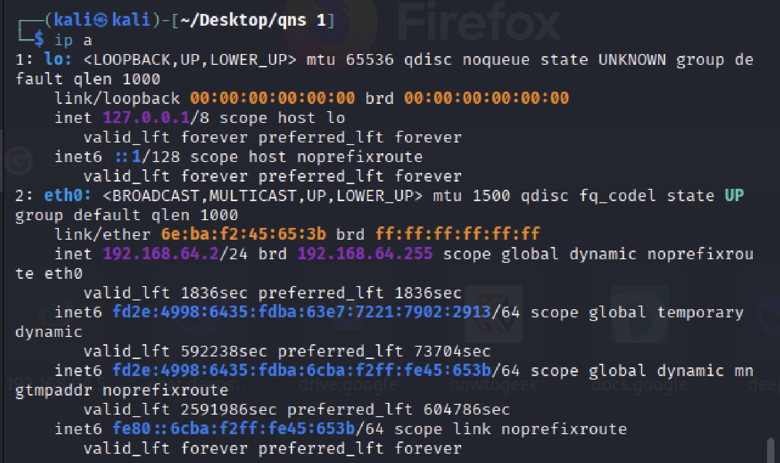

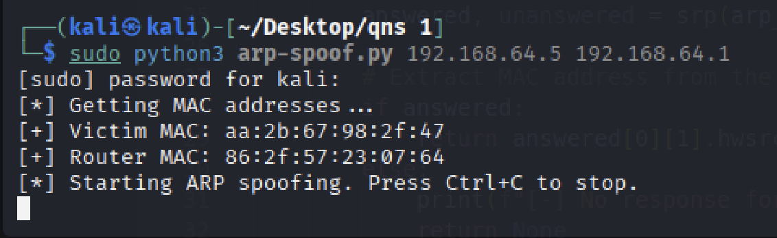
- Note that the MAC of Kali VM (Attacker) is 6e:ba:f2:45:65:3b to check if the spoofing is successful later

- Code got the MAC of victim and router using get_mac()
- When spoofing starts, the loop will send spoofed ARP replies to the victim and to the router, where the router’s IP will be the attackers MAC from the victim’s pov

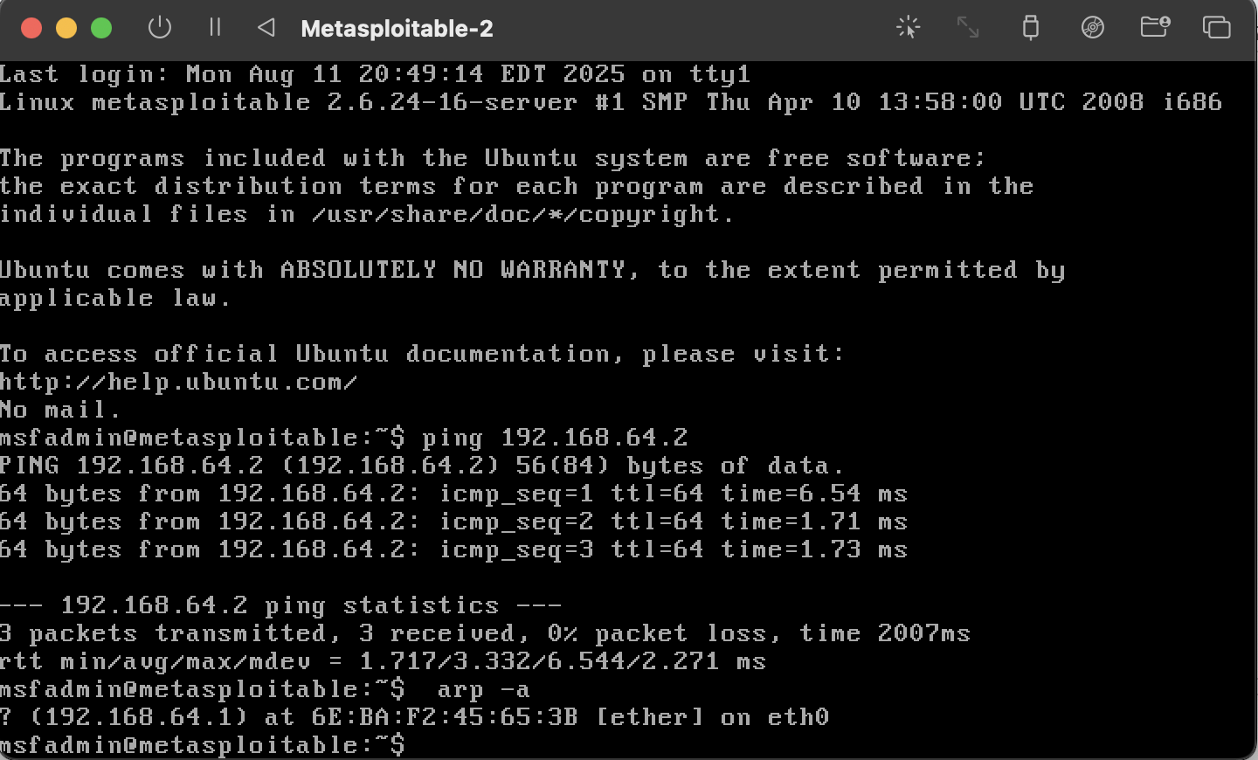

- From the meta2’s terminal above, note that it displayed the Router’s IP with the Kali VM’s MAC
- This signifies that the spoofing is successful

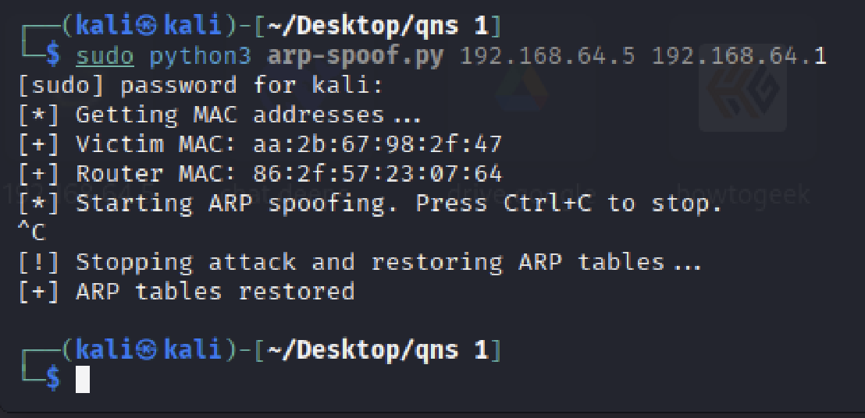
- User presses Ctrl+C to stop the spoofing, and program will stop the attack and restore the ARP tables

