Code Snippet
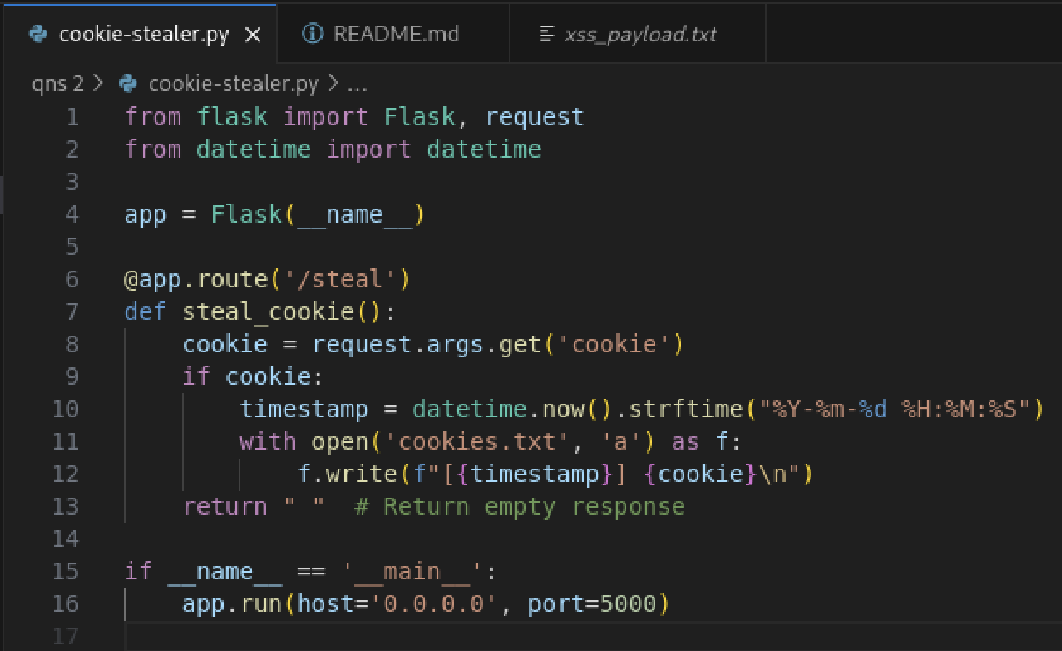
- Code creates a flask server listening on port 5000
- /steal is an endpoint that will capture the cookies sent via the URL parameters, then logs them to cookies.txt with timestamps

Javascript Code for payload
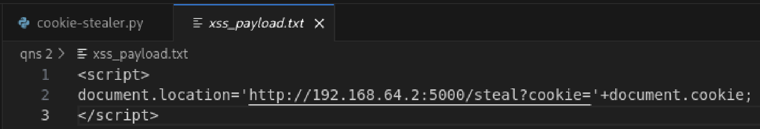
- XSS payload is to be injected into the meta2’s DVWA’s vulnerable “What’s your name” field
- The payload will execute automatically when the page loads
- document.cookie property will access all cookies for the current site which is DVWA, and appends them to the attacker’s URL as a parameter

Terminal Outputs
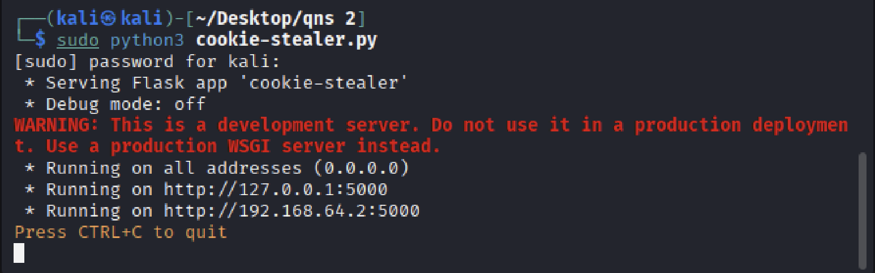
- When users first run the code, they will be greeted by this output
- User goes to DVWA with the meta2’s ip
- Inject the payload into the “What’s your name” field
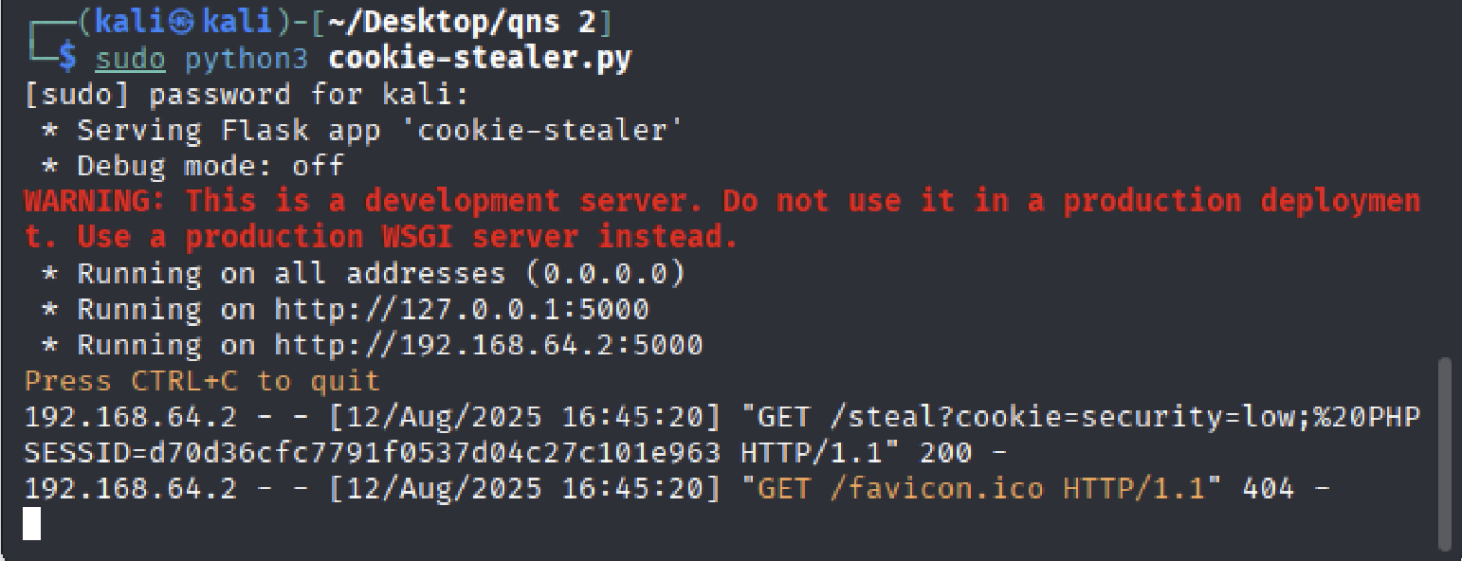
- Once there is a successful cookie capture, the program will extract the cookie from the URL parameters
- The browser will try to load a favicon, which is a blank page

Cookie.txt output
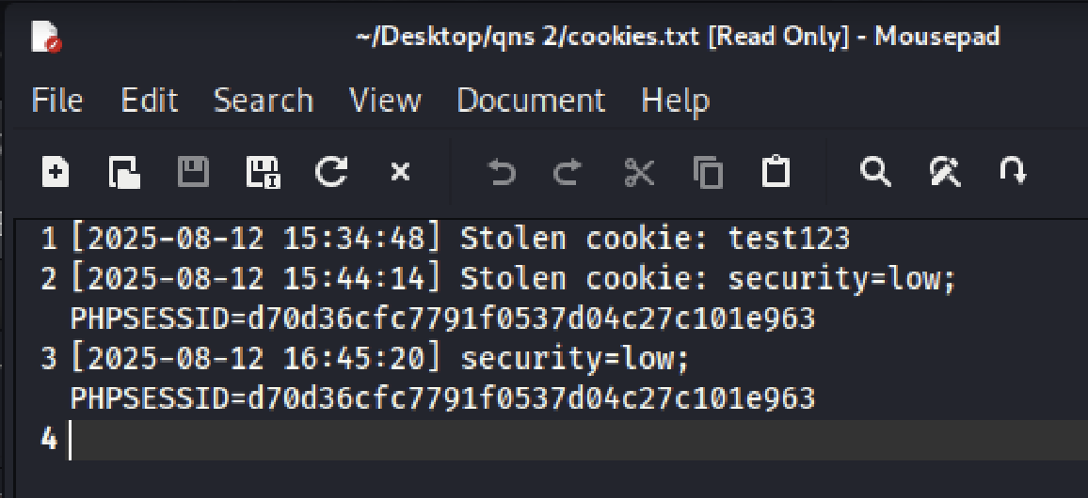
- cookie.txt will be updated with the latest cookie stolen with timestamps

