Code Snippets

Lines 1 - 63
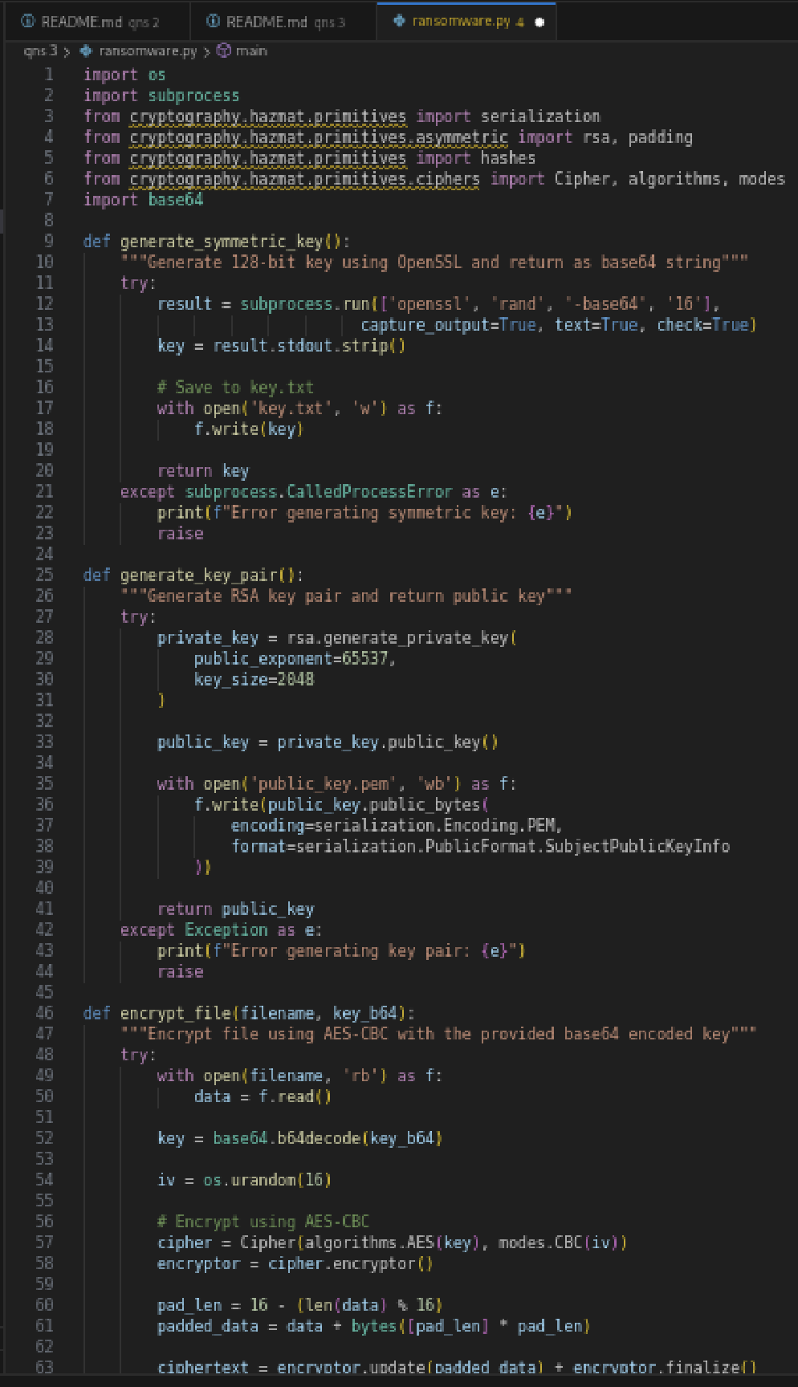
Lines 64 - 95
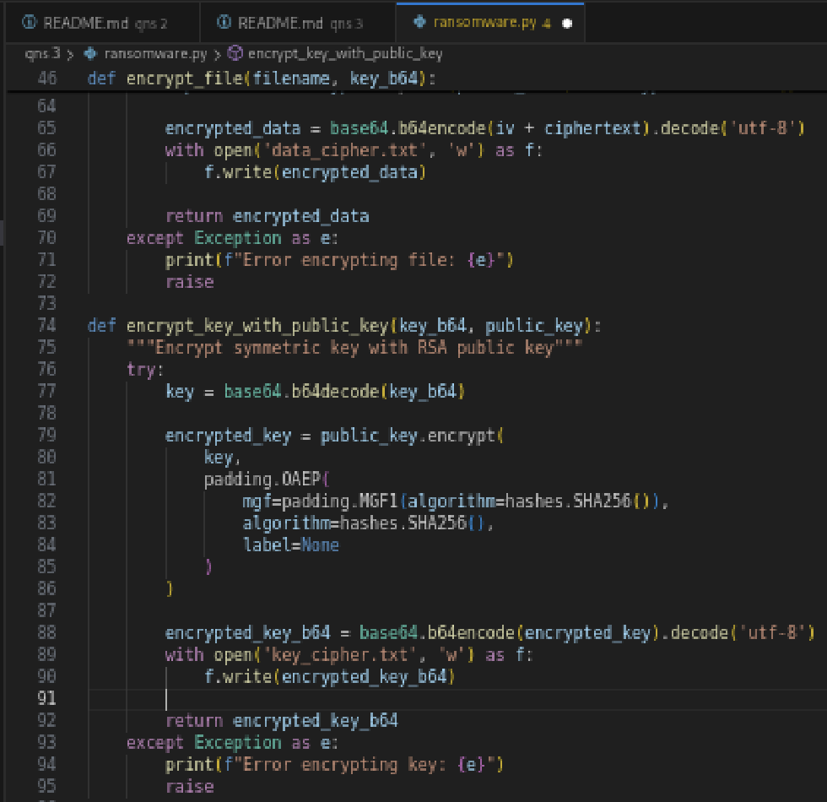

Lines 96 - 132
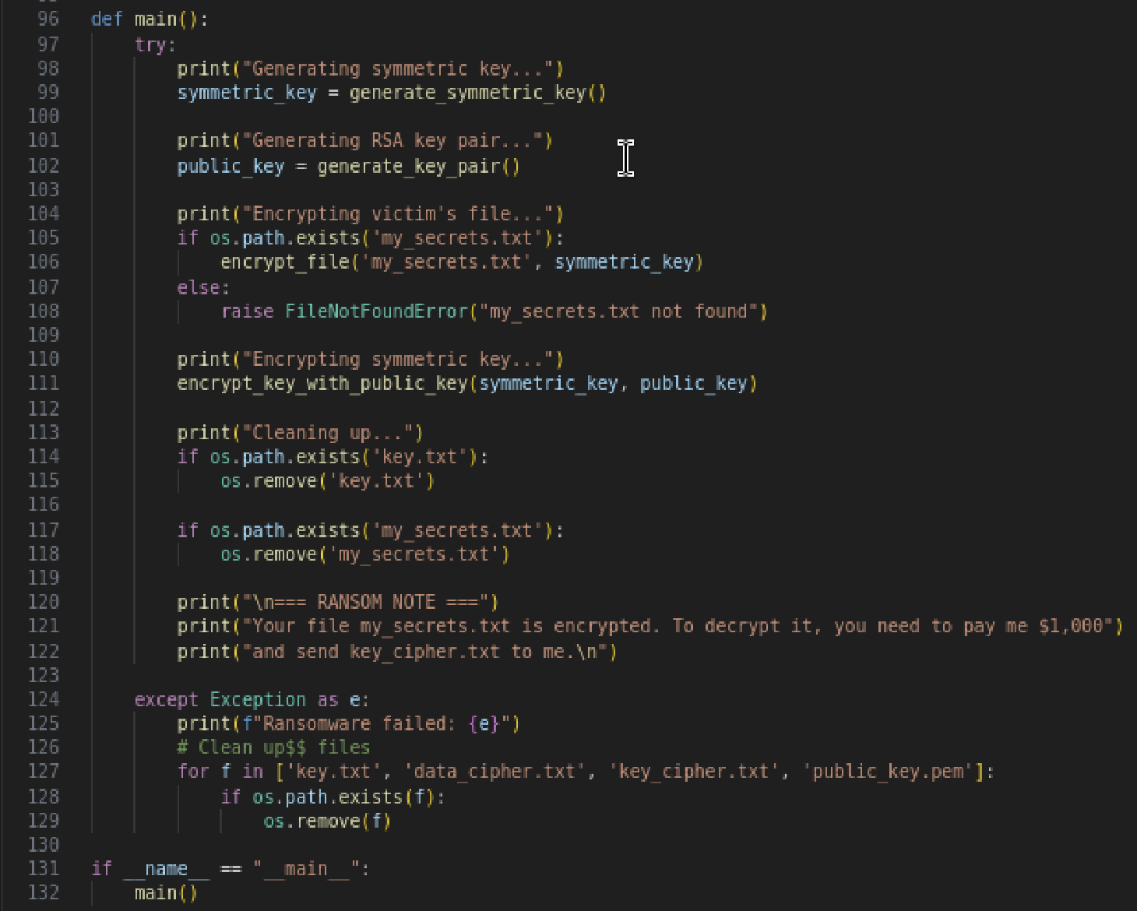
- Code will encrypt the victim’s file and demands a ransom be paid for decryption
- It uses openssl rand -base64 16 to create a 128 bit AES key, and saves it as key.txt temporarily
- Victim’s file is encrypted using AES-CBC with symmetric key, and saved as data_cipher.txt
- AES key is encrypted with RSA public key, and saved as key_cipher.txt
- Program will cleanup and delete key.txt and my_secrets.txt
- Ransom will be displayed

Terminal Outputs

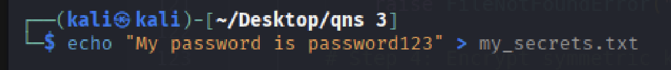
- Create my_secrets.txt for the attacker to encrypt later
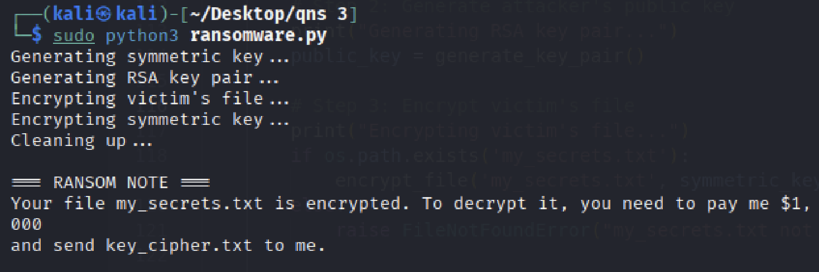
- Once my_secrets.txt is created, the program is able to locate it and encrypt the file
- The ransom note is then displayed, demanding the victim to pay the ransom in order to decrypt it and get the information back
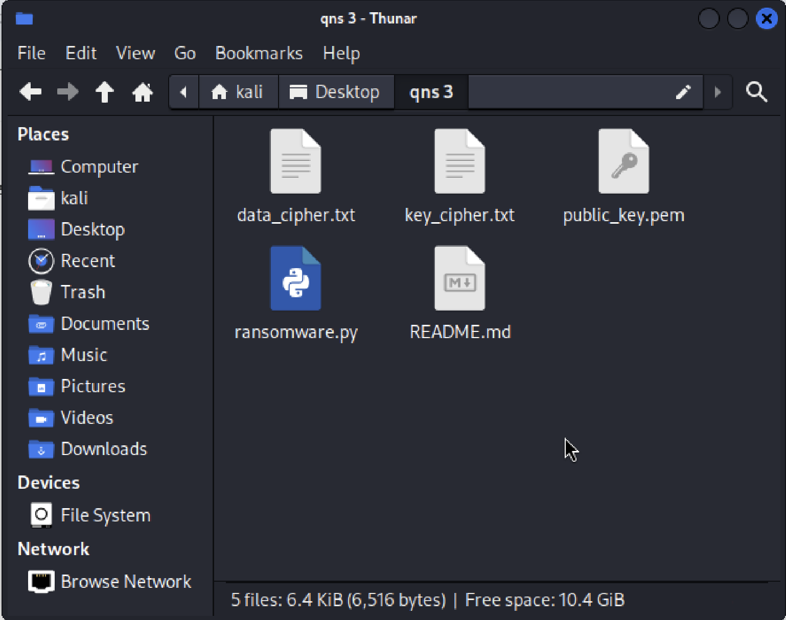
- data_cipher.txt and key_cipher.txt created and stored in the same directory

