Liberator IPT Release Rev 3 SW Native Conversion
Design Notes 5/24/13

Rev 3 Updates
Conversion error with trigger spring fixed
Hammer pin added
Conversion Notes

.380 barrel (threaded) - Status : Complete
- Case Rim Fillet broken in import. Readded in SW model but only on one corner

Geometry Check

Inventor Mass Properties
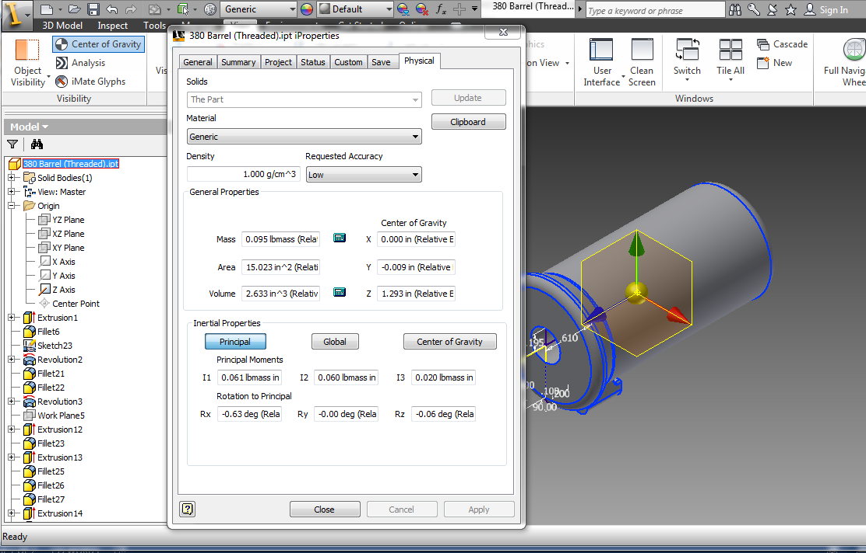

Solidworks Mass Properties
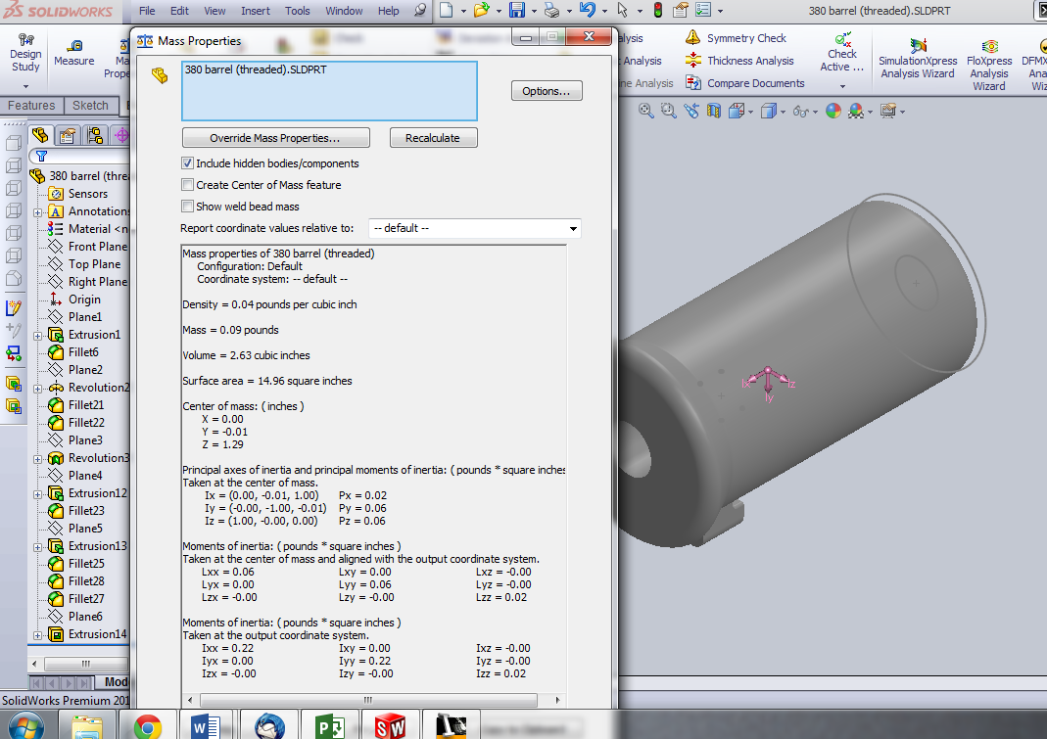

Bottom Cover - Status : Complete
- Simple Part, No check needed

Geometry Check

Inventor Mass Properties

Solidworks Mass Properties

Firing Pin Bushing - Status : Complete
- Simple Part, No check needed

Geometry Check

Inventor Mass Properties

Solidworks Mass Properties

Frame - Status : Complete
2 Inch fillet and .125 fillet broken. Remodeled completely for Solidworks
Trigger cutout two way extrusion missing during import. Fixed in SW model
Barrel Lock
Mass properties still not close enough. Revisit and verify

Geometry Check

Inventor Mass Properties
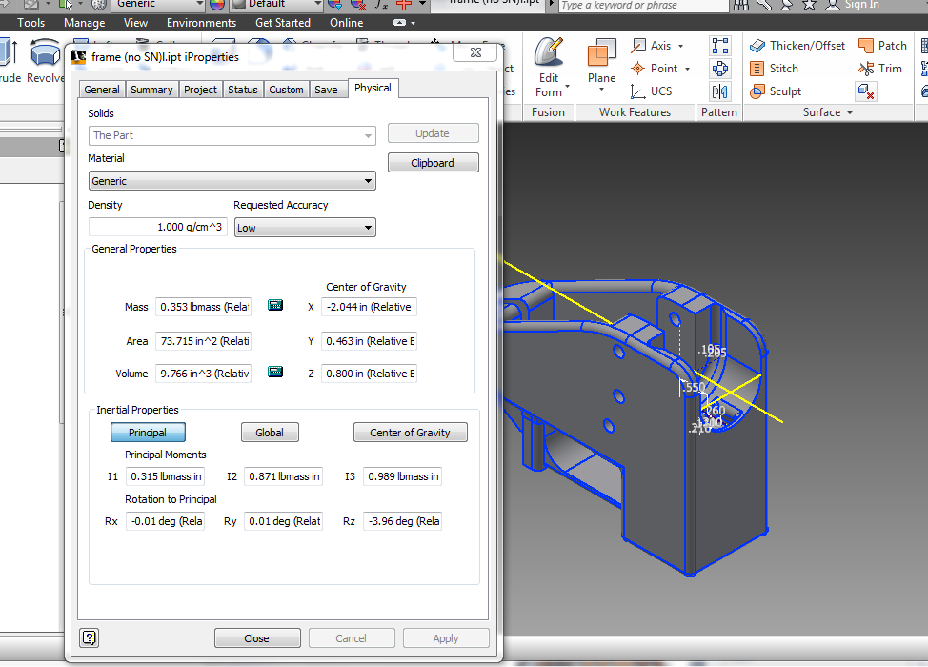

Solidworks Mass Properties
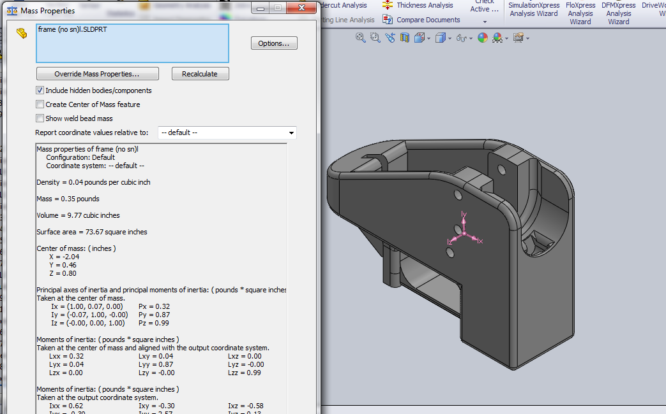

Frame Pin - Status : Complete
- Simple Part, No check needed

Geometry Check

Inventor Mass Properties

Grip Pin - Status : Complete
- Changed length from 1.60 in to .875 in

Geometry Check

Inventor Mass Properties

Solidworks Mass Properties

Grip - Status : Complete
- Import miserably failed. Complete remodel from scratch

Geometry Check

Inventor Mass Properties
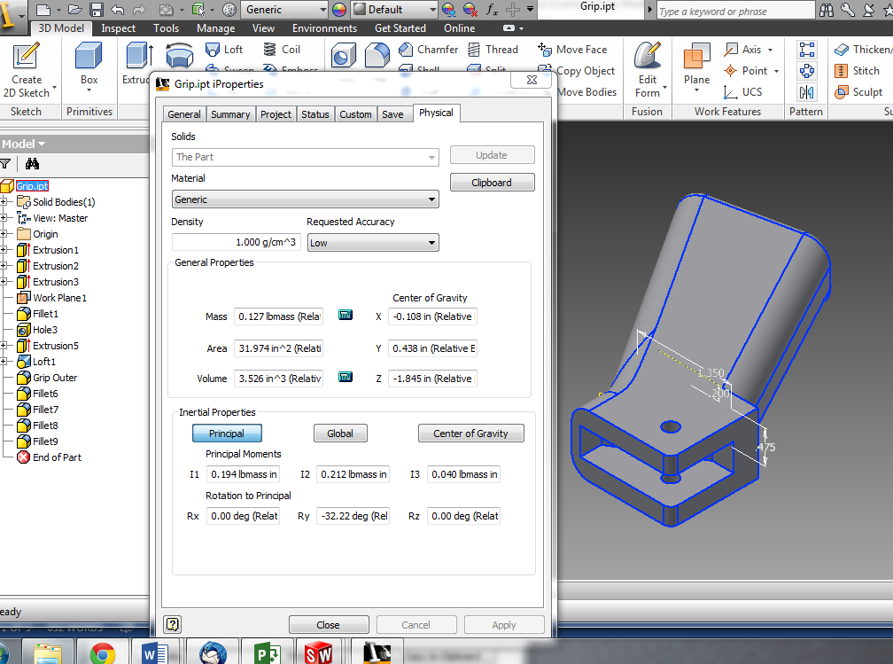

Solidworks Mass Properties
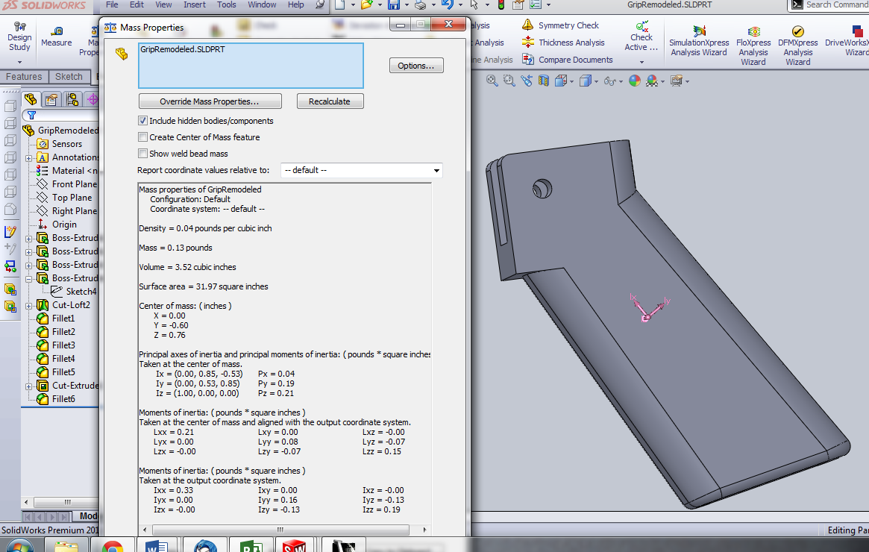

Hammer Body - Status : Complete
- Hammer Hole Missing, Remodeled
- Some extrusions broken, Remodeled
- Mass properties check out
- Check hammer hole position

Geometry Check

Inventor Mass Properties
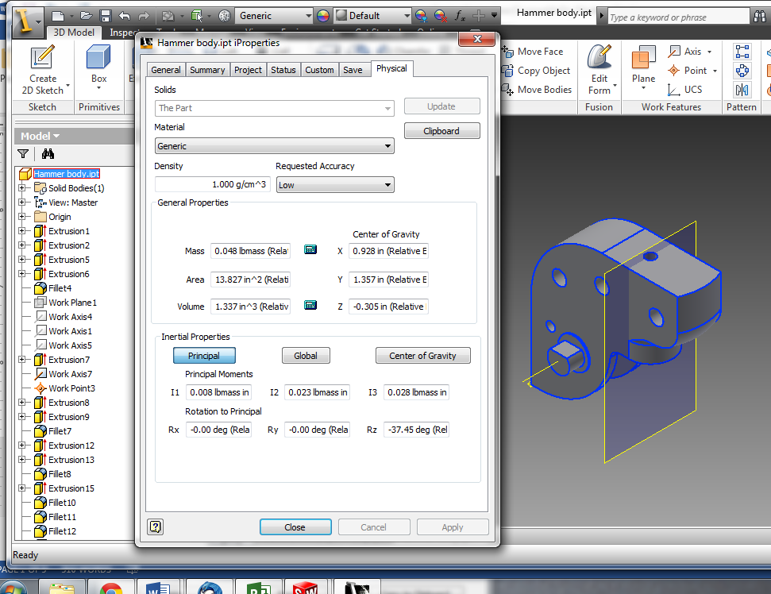

Solidworks Mass Properties
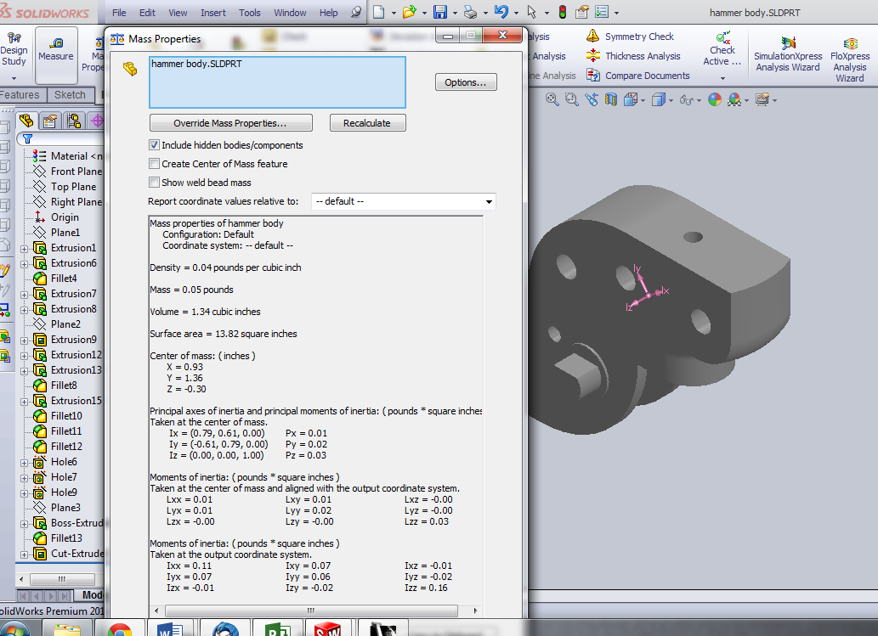

Spring - Status : Complete
- Complete remodel
- Based on DWG generated from Inventor

Geometry Check

Inventor Mass Properties
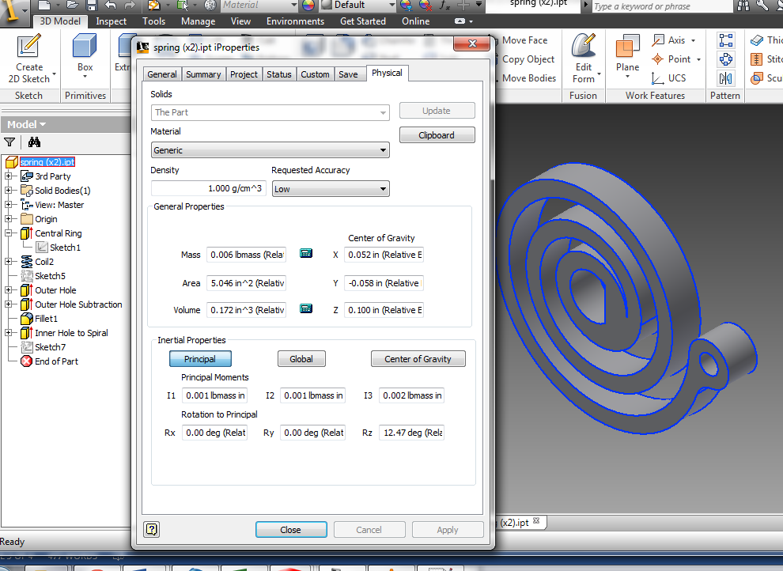

Solidworks Mass Properties
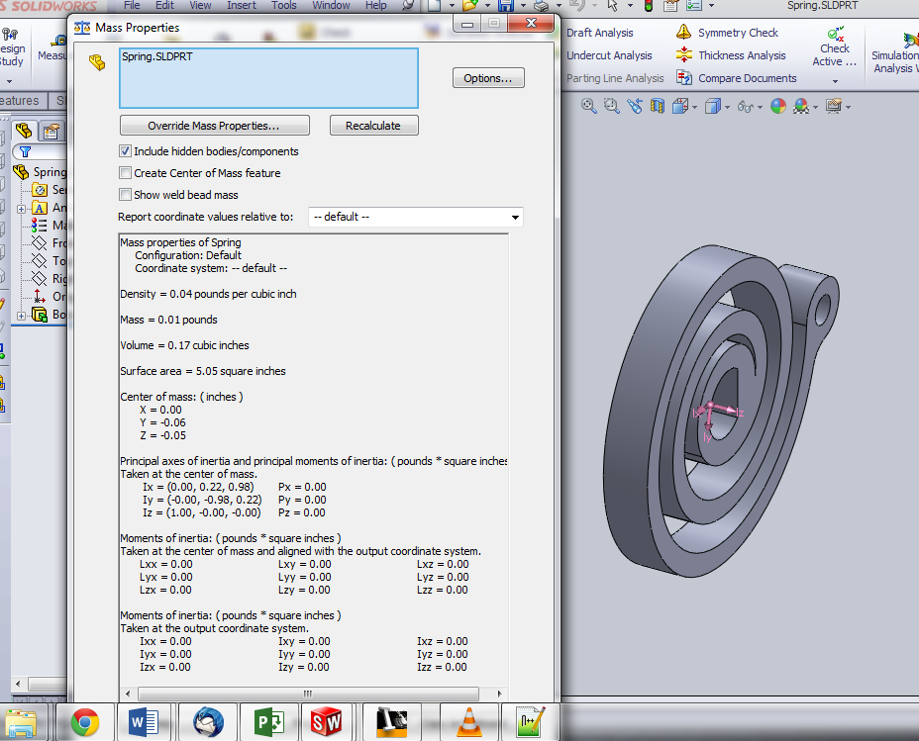

Spring Connecting Rod Bushing - Status : Complete
- Simple Part, No check needed

Geometry Check

Inventor Mass Properties

Solidworks Mass Properties

Trigger Spring - Status : Complete
- Clean Import

Geometry Check

Inventor Mass Properties
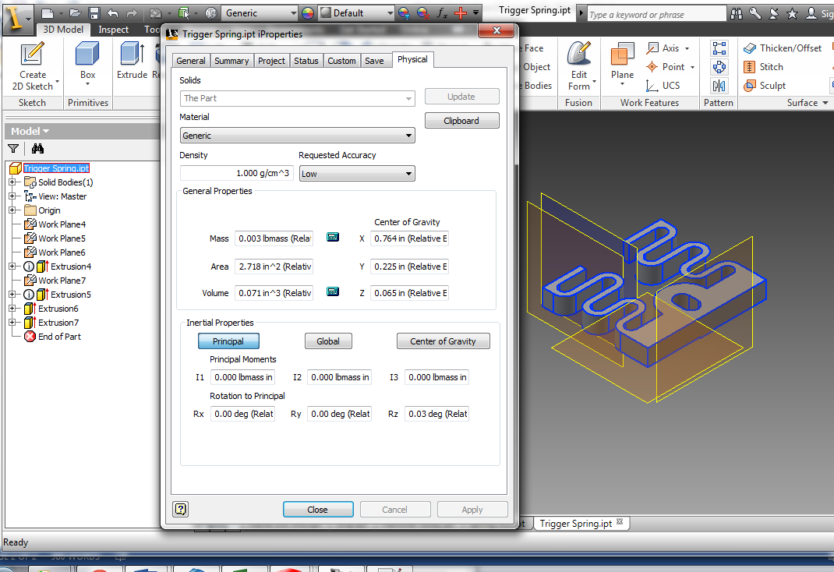

Solidworks Mass Properties 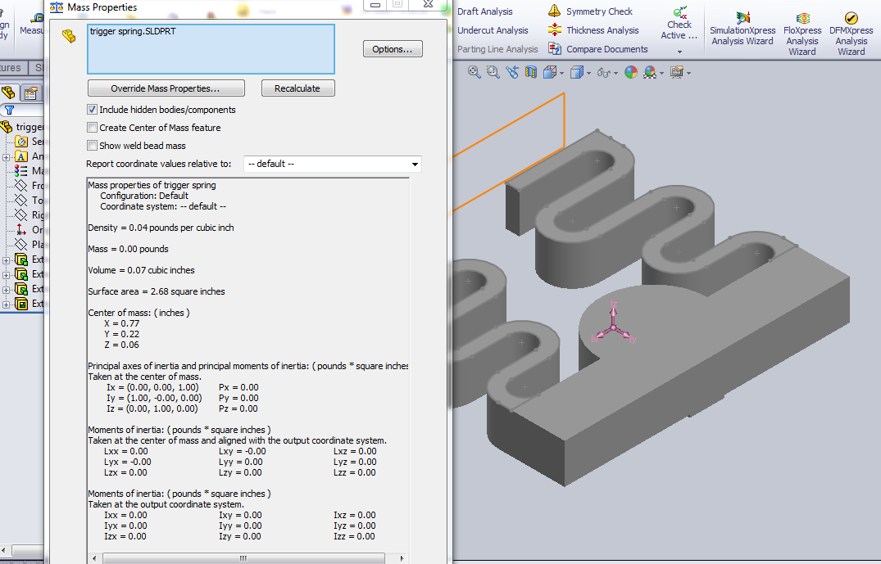 Spring Connecting Rod Bushing Status : Complete
- Simple Part, No check needed

Geometry Check

Inventor Mass Properties

Solidworks Mass Properties

Trigger - Status : Complete
- Fillets Broken on import

Geometry Check

Inventor Mass Properties
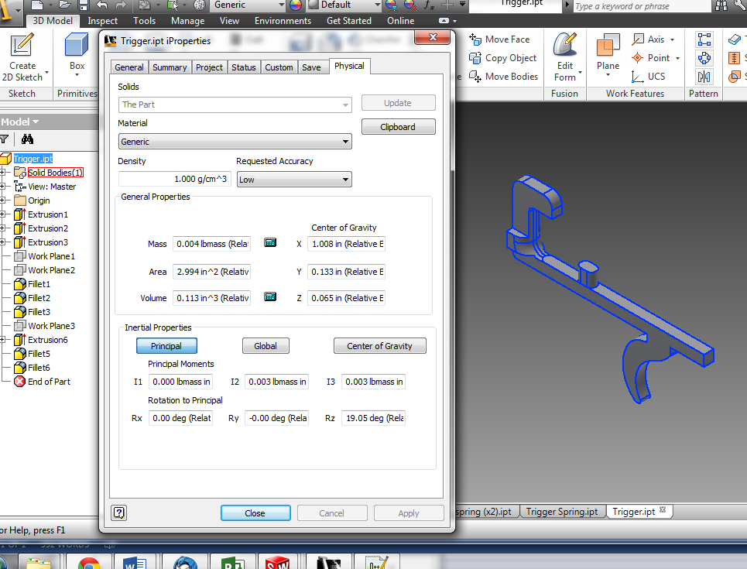

Solidworks Mass Properties
