Tfinal= 0.1
For each T:
all searchers are applied one by one
a searcher selected in random order

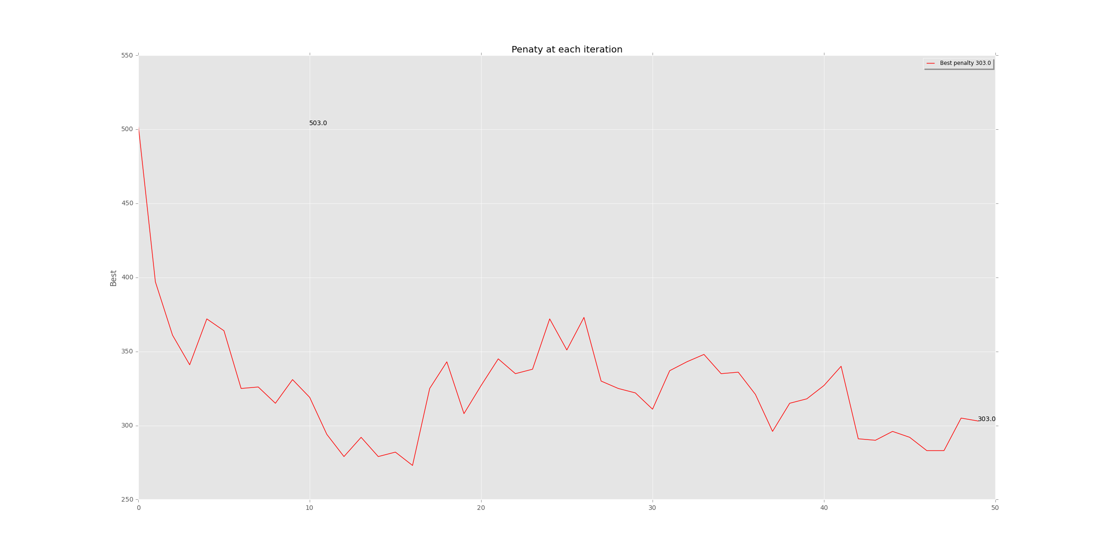

Tfinal= 0.01
For each T:
all searchers are applied one by one
a searcher selected in random order
Total running time is 681 seconds

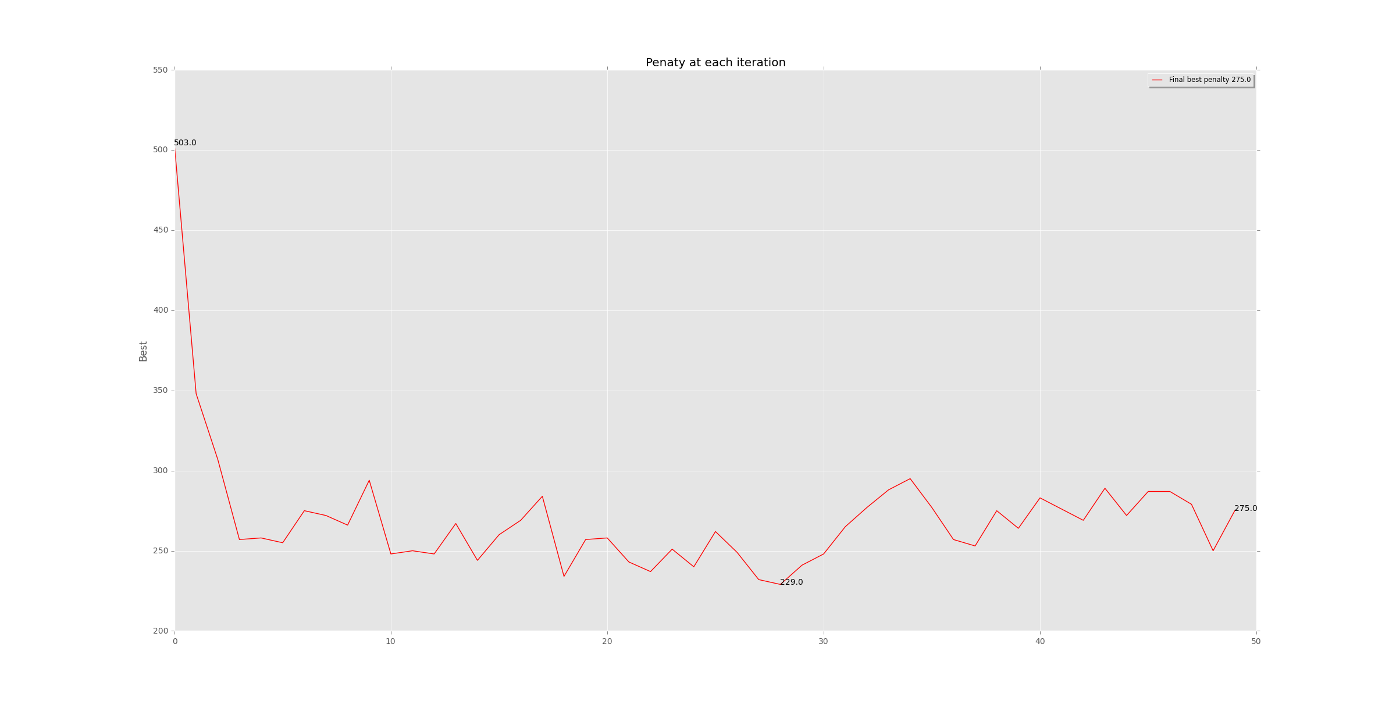

Tfinal= 0.01
For each T:
only one searcher is applied which is selected randomly

