Exercise 2: Scrabble
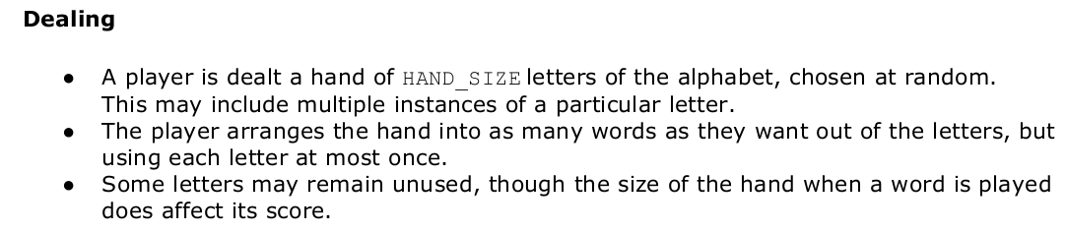
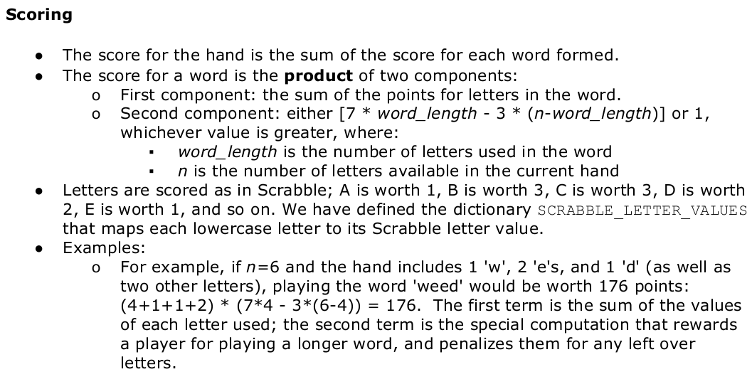
Step1 – Getting Started
- Download and extract zip files.
- Run ps3.py, without making any modifications to it, in order to ensure that everything is set up correctly. The code loads a list of valid words from a file and then calls the play_game function. If everything is okay, after a small delay, you should see the following printed out:

Loading word list from file…
83667 words loaded. play_game not yet implemented.

- This problem set is structured so that you will write a number of modular functions and then glue them together to form the complete game. Instead of waiting until the entire game is ready, you should test each function you write, individually, before moving on. This approach is known as unit testing, and it will help you debug your code

- Several test functions have been provided to get you started. As you make progress on the
problem set, run test_ps3.py to check your work so far. If your code passes the unit tests you will see a SUCCESS message; otherwise you will see a FAILURE message.

Step 2 – The Code
- Scoring: Implement a function that calculates the score for a single word. Fill in the code for “get_word_score” in ps3.py according to the function specifications.

Testing: If this function is implemented correctly, and you run test_ps3.py, the test_get_word_score() tests will pass. You should also test your implementation of
get_word_score yourself, using some reasonable English words. Note that the wildcard tests
will crash due to a KeyError. This is fine for now - you will fix this later.

- Converting words into dictionary representation: Function “get_frequency_dict” has already been implemented. When given a string of letters as an input, it returns a dictionary where the keys are letters and the values are the number of times that letter is represented in the input string. For example:
>> get_frequency_dict("hello")
{'h': 1, 'e': 1, 'l': 2, 'o': 1}

- Displaying a hand: Given a hand represented as a dictionary, we want to display it in a user-friendly way. We have provided the implementation for this in the “display_hand” function. Take a few minutes right now to read through this function carefully and understand what it does and how it works.
- Generating a random hand: The hand a player is dealt is a set of letters chosen at random. We provide you with a function that generates a random hand, “deal_hand” . The function takes as input a positive integer n , and returns a new dictionary representing a hand of n lowercase letters. Again, take a few minutes to read through this function carefully and understand what it does and how it works.

- Removing letters from a hand (you implement this!): The player starts with a full hand of n letters. As the player spells out words, letters from the set are used up. For example, the player could start with the following hand: a, q, l, m, u, i, l. The player could choose to play the word quail. This would leave the following letters in the player's hand: l, m. You will now write a function that takes a hand and a word as inputs, uses letters from that hand to spell the word, and returns a new hand containing only the remaining letters. Your function should not modify the input hand. For example:
>> hand = {'a':1, 'q':1, 'l':2, 'm':1, 'u':1, 'i':1}
>> display_hand(hand)
a q l l m u i
>> new_hand = update_hand(hand, 'quail')
>> new_hand
{'l': 1, 'm': 1}
>> display_hand(new_hand)
l m
>> display_hand(hand)
a q l l m u i
- Valid words: At this point, we have not written any code to verify that a word given by a player obeys the rules of the game. A valid word is in the word list (we ignore the case of words here) and it is composed entirely of letters from the current hand. Implement the “is_valid_word” function according to its specifications.

Testing: Make sure the “test_is_valid_word” tests pass. You should also test your implementation with some reasonable inputs.

- Wildcards: We want to allow hands to contain wildcard letters, which will be denoted by an asterisk (*). Wildcards can only replace vowels. Each hand dealt should initially contain exactly one wildcard as one of its letters. The player does not receive any points for using the wildcard (unlike all the other letters), though it does count as a used or unused letter when scoring. During the game, a player wishing to use a wildcard should enter "*" (without quotes) instead of the intended letter. The word-validation code should not make any assumptions about what the intended vowel should be, but should verify that at least one valid word can be made with the wildcard as a vowel in the desired position.

Example #1: A valid word made without the wildcard
Current Hand: c o w s * z
Enter word, or "!!" to indicate that you are finished: cows
"cows" earned 198 points. Total: 198 points
Current Hand: * z
Enter word, or "!!" to indicate that you are finished: !!
Total score: 198 points

Example #2: A valid word made using the wildcard
Current Hand: c o w s * z
Enter word, or "!!" to indicate that you are finished: c*ws
"c*ws" earned 176 points. Total: 176 points
Current Hand: o z
Enter word, or "!!" to indicate that you are finished: !!
Total score: 176 points

- Playing a hand: We are now ready to begin writing the code that interacts with the player. Implement the “play_hand” function. This function allows the user to play out a single hand. You'll first need to implement the helper function “calculate_handlen” , which can be done in under five lines of code. To end the hand early, the player must type " !! " (two exclamation points).
Note that after the line # BEGIN PSEUDOCODE there is a bunch of, well, pseudocode! This is to help guide you in writing your function.

Testing: Try out your implementation as if you were playing the game: run your program and call the play_hand function from your shell with a hand and the word_list. Note: Your output should match the examples below. You should not print extraneous " None " messages.

Example #1
Current Hand: a j e f * r x
Enter word, or "!!" to indicate that you are finished: jar
"jar" earned 90 points. Total: 90 points
Current Hand: * f x e
Enter word, or "!!" to indicate that you are finished: f*x
"f*x" earned 216 points. Total: 306 points
Current Hand: e
Enter word, or "!!" to indicate that you are finished: !!
Total score: 306 points

Example #2
Current Hand: a c f i * t x
Enter word, or "!!" to indicate that you are finished: fix
"fix" earned 117 points. Total: 117 points
Current Hand: a c t *
Enter word, or "!!" to indicate that you are finished: ac
That is not a valid word. Please choose another word.
Current Hand: t *
Enter word, or "!!" to indicate that you are finished: *t
"*t" earned 14 points. Total: 131 points
Ran out of letters. Total score: 131 points

- Playing a game: A game consists of playing multiple hands. We need to implement two final functions to complete our wordgame. Implement the substitute_hand and play_game functions according to their specifications. For the game, you should use the HAND_SIZE constant to determine the number of letters in a hand. Do not assume that there will always be 7 letters in a hand! Our goal is to keep the code modular - if you want to try playing your word game with 10 letters or 4 letters you will be able to do it by simply changing the value of HAND_SIZE !

Testing: Try out this implementation as if you were playing the game. Try out different values for HAND_SIZE with your program, and be sure that you can play the word game with different hand sizes by modifying only the variable HAND_SIZE.

