Consumer-to-shop Clothes Retrieval Benchmark

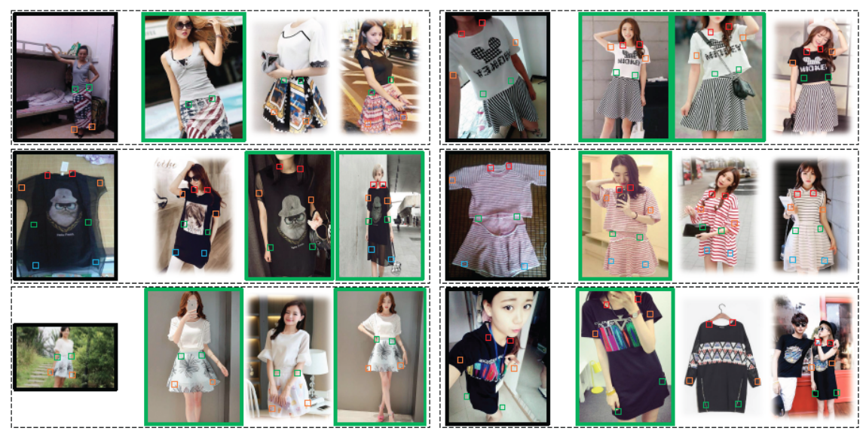
By defition;
- 33,881 number of clothing items; 239,557 number of consumer/shop clothes images, and 195,540 cross-domain pairs.
- Each image is annotated by bounding box, clothing type and source type.

Images folder:
 |  | # items
CLOTHING | Blouse | 231
CLOTHING | Coat | 7
CLOTHING | Jeans | 275
CLOTHING | Pants | 656
CLOTHING | Polo_Shirt | 656
CLOTHING | Summer_Wear | 90
CLOTHING | Tank_Top | 27
CLOTHING | T_Shirt | 1023
DRESSES | Dress | 2695
DRESSES | Lace_Dress | 28
DRESSES | Skirt | 381
DRESSES | Sleeveless_Dress | 16
DRESSES | Suspenders_Skirt | 22
TOPS | Blouse | 203
TOPS | Chiffon | 523
TOPS | Coat | 2433
TOPS | Lace_Shirt | 1411
TOPS | Summer_Wear | 10801
TOPS | Tank_Top | 1164
TOPS | T_Shirt | 5354
TROUSERS | Leggings | 2215
TROUSERS | Pants | 2196
TROUSERS | Summer_Wear | 3514

4 COARSE CATEGORIES; AS A TOTAL THERE ARE 23 C ATEGORIES IN THIS BENCHMARK!

---------------images:----------------------------------------
239,557 consumer-to-shop clothes images (195,540 cross-domain pairs).

Notes:
1. The long side of images are resized to 300;
2. The aspect ratios of original images are kept unchanged.

--------------- list_items_consumer2shop.txt -------------- THIS FILE IS NOT USEFUL I THINK!
First Row: number of items
Rest of the Rows: <item id>

Head:
33881
id_00000001
id_00000002
id_00000003
id_00000004

=========================
ATTRIBUTE LABELS
=========================
--------------- list_attr_cloth.txt --------------
First Row: number of attributes
Second Row: entry names

Rest of the Rows: <attribute name (Chinese)> <attribute name (English)> <attribute type>

Head:
303
attribute_name (Chinese) attribute_name (English) attribute_type (1 to 18)
常规款（51-65cm） Regular length (51-65cm) 1
常规款（55-65cm） Regular length (55-65cm) 1
中长款（大于65cm） Regular to long (longer than 65cm) 1

--------------- list_attr_type.txt --------------
First Row: number of attribute types
Second Row: entry names

Rest of the Rows: <attribute type (Chinese)> <attribute type (English)>

Head:
18
attribute_type (Chinese) attribute_type (English)
衣长 length of upper-body clothes
裤型 type of trousers

--------------- list_attr_items.txt --------------
First Row: number of items
Second Row: entry names

Rest of the Rows: <item id> <attribute labels>

Head:
33881
item_id attribute_labels
id_00006282 -1 -1 -1 -1 -1 -1 -1 -1 -1 -1 -1 -1 -1 -1 -1 -1 -1 -1 1 -1 -1 -1 -1 -1 -1 -1 -1 -1 -1 -1 -1 -1 -1 -1 -1 -1 -1 -1 -1 -1 -1 -1 -1 -1 -1 -1 -1 -1 -1 -1 -1 -1 -1 -1 -1 -1 -1 -1 -1 -1 -1 -1 -1 -1 -1 -1 -1 -1 -1 -1 -1 -1 -1 -1 -1 -1 -1 -1 -1 1 -1 -1 -1 -1 -1 -1 -1 -1 -1 -1 -1 -1 -1 -1 -1 -1 -1 -1 -1 -1 -1 -1 -1 -1 -1 -1 -1 -1 -1 -1 -1 -1 -1 -1 -1 1 -1 -1 -1 -1 -1 -1 -1 -1 1 -1 -1 -1 -1 -1 -1 -1 -1 -1 -1 1 -1 -1 -1 -1 -1 1 -1 -1 -1 -1 -1 -1 -1 -1 -1 -1 -1 -1 -1 -1 -1 -1 -1 -1 -1 -1 -1 -1 -1 -1 -1 -1 -1 -1 -1 -1 -1 -1 -1 -1 -1 -1 -1 -1 -1 -1 -1 -1 -1 -1 1 -1 -1 -1 -1 -1 -1 -1 -1 -1 -1 -1 -1 -1 -1 -1 -1 -1 -1 -1 -1 -1 -1 -1 -1 -1 -1 -1 -1 -1 -1 -1 -1 -1 -1 -1 -1 -1 -1 -1 -1 -1 -1 -1 -1 -1 -1 -1 -1 -1 -1 -1 -1 1 -1 -1 -1 -1 -1 1 -1 -1 -1 -1 -1 -1 -1 -1 -1 1 -1 -1 -1 -1 -1 -1 -1 -1 -1 -1 -1 -1 -1 -1 -1 -1 -1 -1 -1 -1 -1 -1 -1 -1 -1 -1 -1 -1 -1 -1 -1 -1 -1 -1 -1 -1 1 -1 -1 -1 -1 -1 -1 -1 -1 -1 -1

1. The order of attribute labels accords with the order of attribute names;
2. In attribute labels, "1" represents positive while "-1" represents negative, '0' represents unknown;
3. Attribute prediction is treated as a multi-label tagging problem.
---------------------------------------------------

=========================
BBOX LABELS
=========================
------------ list_bbox_consumer2shop.txt ------------
First Row: number of images
Second Row: entry names

Rest of the Rows: <image name> <clothes type> <source type> <bbox location>

Head:
239557
image_name clothes_type source_type x_1 y_1 x_2 y_2
img/CLOTHING/Polo_Shirt/id_00006282/shop_01.jpg 1 1 001 039 200 292
img/CLOTHING/Polo_Shirt/id_00006282/comsumer_01.jpg 1 2 001 001 223 300
img/CLOTHING/Polo_Shirt/id_00006282/comsumer_02.jpg 1 2 001 001 169 230

Notes:
1. The order of bbox labels accords with the order of entry names;
2. In clothes type, "1" represents upper-body clothes, "2" represents lower-body clothes, "3" represents full-body clothes;
3. In source type, "1" represents shop image, "2" represents consumer image;
4. In bbox location, "x_1" and "y_1" represent the upper left point coordinate of bounding box, "x_2" and "y_2" represent the lower right point coordinate of bounding box.
---------------------------------------------------

=========================
LANDMARK LABELS
=========================
------------ list_landmarks_consumer2shop.txt ------------
First Row: number of images
Second Row: entry names
Rest of the Rows: <image name> <clothes type> <variation type> [<landmark visibility 1> <landmark location x_1> <landmark location y_1>, ... <landmark visibility 8> <landmark location x_8> <landmark location y_8>]
Head:
239557
image_name clothes_type variation_type landmark_visibility_1 landmark_location_x_1 landmark_location_y_1 landmark_visibility_2 landmark_location_x_2 landmark_location_y_2 landmark_visibility_3 landmark_location_x_3 landmark_location_y_3 landmark_visibility_4 landmark_location_x_4 landmark_location_y_4 landmark_visibility_5 landmark_location_x_5 landmark_location_y_5 landmark_visibility_6 landmark_location_x_6 landmark_location_y_6 landmark_visibility_7 landmark_location_x_7 landmark_location_y_7 landmark_visibility_8 landmark_location_x_8 landmark_location_y_8
img/CLOTHING/Polo_Shirt/id_00006282/shop_01.jpg 1 1 0 082 062 0 126 061 0 030 144 0 170 146 0 048 270 0 153 270

Notes:
1. The order of landmark labels accords with the order of entry names;
2. In clothes type, "1" represents upper-body clothes, "2" represents lower-body clothes, "3" represents full-body clothes. Upper-body clothes possess six fahsion landmarks, lower-body clothes possess four fashion landmarks, full-body clothes possess eight fashion landmarks;
3. In variation type, "1" represents normal pose, "2" represents medium pose, "3" represents large pose, "4" represents medium zoom-in, "5" represents large zoom-in;
4. In landmark visibility state, "0" represents visible, "1" represents invisible/occluded, "2" represents truncated/cut-off;
5. For upper-body clothes, landmark annotations are listed in the order of ["left collar", "right collar", "left sleeve", "right sleeve", "left hem", "right hem"]; For lower-body clothes, landmark annotations are listed in the order of ["left waistline", "right waistline", "left hem", "right hem"]; For upper-body clothes, landmark annotations are listed in the order of ["left collar", "right collar", "left sleeve", "right sleeve", "left waistline", "right waistline", "left hem", "right hem"].
---------------------------------------------------

=========================
EVALUATION PARTITIONS
=========================
------------- list_eval_partition.txt -------------

First Row: number of images
Second Row: entry names

Rest of the Rows: <image pair name 1> <image pair name 2> <item id> <evaluation status>

Head:
195540
image_pair_name_1 image_pair_name_2 item_id evaluation_status
img/TOPS/T_Shirt/id_00000001/comsumer_01.jpg img/TOPS/T_Shirt/id_00000001/shop_02.jpg id_00000001 test
img/TOPS/T_Shirt/id_00000001/comsumer_02.jpg img/TOPS/T_Shirt/id_00000001/shop_01.jpg id_00000001 test
img/TOPS/T_Shirt/id_00000001/comsumer_03.jpg img/TOPS/T_Shirt/id_00000001/shop_01.jpg id_00000001 test

---------------------------------------------------

=========================
IMAGE DATASET
=========================
Attributes: 303 attributes each with
attribute id
attribute name
attribute type: 1/2/.../18

Image properties:
file_name: img/TOPS/T_Shirt/id_00000001/comsumer_01.jpg
label: item id Taken from folder names
main_category: CLOTHING/TOPS.. Taken from folder names
lower_category: Blouse/Coat...Taken from folder names
cloth_type: 1/2/3 Created using list_landmarks_consumer2shop.txt
source_type: 1/2 Created using list_landmarks_consumer2shop.txt
variation type: 1/2/3/4/5 Created using list_landmarks_consumer2shop.txt
bbox_x_y: x_1 y_1 x_2 y_2 Created using list_bbox_consumer2shop.txt
landmarks: list of size 3*8= 24. Meaningful with cloth_type attribute. Created using list_landmarks_consumer2shop.txt
attributes: two options:
- a vector of size 303 Created using list_attr_items.txt
- a list that holds only valid attributes Created using list_attr_items.txt
Keep data for attribute types valid for this image? We might need?

Data Cleaning:
Step 1: Go through all item folders in 4 main categories; removen an item if:
- No image in that folder
- 2 images in that folder
- No shop images in a folder
Step 2: Are there any duplicate items? Same id number in another category. This should be wrong?

Train/Valid/Test: Her categoriden (23’ ten) itemların %10 (round up) valid; %10 (round up) test olarak ayrılacak.

