**Goal:** By the end of this exercise, you should have rough sketches for several (4-6) possible project proposal ideas. The goal is NOT for you to come up with finished products in this exercise. It is to generate many ideas in a structured way without judging them yet (these do not have to be “good” ideas). You should use these as inspiration for your actual project proposals. This exercise strongly depends on the 4 papers you have read but you can definitely expand this to other papers you have read.

**Important:** you do not have to limit yourself to these ideas! Feel free to come up with something completely different! This is just to help get the ball rolling ☺

STEP 1 – in group (15 min)

We will start with a “Reizwortanalyse”. This is a typical creative technique to come up with new, innovative ideas. Here is how you do it:

The topic is: What is a novel and feasible research question (in the area of cognitive psychology)?

1. Next, you randomly pick a word from this list:
2. TV
3. Suitcase
4. Basketball
5. Doctor
6. Ship
7. Sun
8. Necklace
9. Tulip
10. Hedgehog
11. Computer
12. Ladder
13. Mouth
14. Zebra
15. Vacation
16. Tee
17. Bucket
18. Spoon
19. Phone
20. Politician
21. Bike
22. Pepper
23. Zoo
24. Dog
25. Bottle
26. Knive
27. Radio
28. Now, think of 4-6 things that relate to this word. IMPORTANT: these things don’t have to have anything to do with research questions, experiments, etc. The goal is to simply come up with concepts/words/properties that are related to this specific word. Don’t think too hard about these, just write down the first things that come to mind (see example below). I know this seems random at first, but trust me it’s part of the process ;)
29. Now, try to think of connections between each of the things you came up with and the topic: **novel research questions**. Here is an example of what this can look like:

Figure 1. First, I came up with 4 concepts that came to mind when I thought about "Shower". Then, I wrote down ideas that were related both to these concepts as well as psychological research. Please note, that your ideas do not have to be finished research questions. It is totally fine if they are just very rough ideas.

1. Repeat this for overall 4 of the random words (pick a random one from the list each time).

STEP 2 – Morphological matrix, in group (30 – 60 min)

Hopefully, you have already come up with some rough ideas. Now, we will use a creative technique from engineering: Morphological matrix. The technique is usually used to come up with new products by first analyzing and decomposing a product into its main components and then recombining these into novel products. Let’s expand this to our topic: coming up with experiments.

First, we need to decompose “experiment” into its main components. To keep things simple, we will choose the following components: Topic, Paradigm/Task, DVs, IVs

1. For each component, write down all possible variations you can think of. This should be based on the papers you read, but you can expand this to other papers you have read before and even the research questions you came up with in Part 1. Below, there is an example of how this could look like just for the shower example:

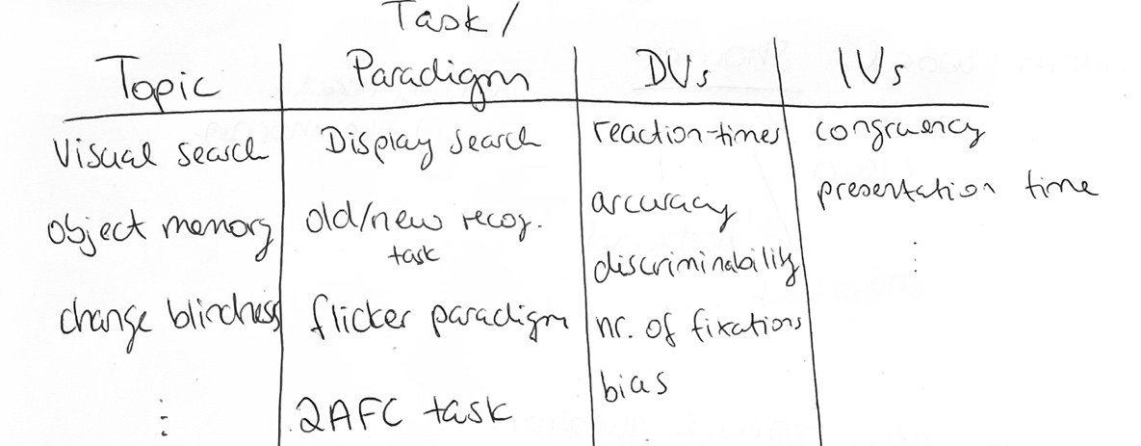

Use the table below to come up with your own, based on the papers and the ideas you have come up with so far. (You can obviously reuse things from the example above).

|  |  |  |  |
| --- | --- | --- | --- |
| Topic | Task / Paradigm | DVs | IVs |
|  |  |  |  |
|  |  |  |  |
|  |  |  |  |
|  |  |  |  |
|  |  |  |  |
|  |  |  |  |
|  |  |  |  |

1. Now, recombine variations to form rough designs of novel experiments. These don’t have to make sense yet. The idea is, that you take these as inspirations to work on your 3 proposals. Try to come up with 6 new combinations first without judging them. Remember, this is about the “generating ideas” part, not about coming up with anything fully fleshed out.

1. Now, as a group, chose the 3-4 most promising sketches and use these to come up with your final research proposals. Hope this helped a little to get the ball rolling!