# mysql权限

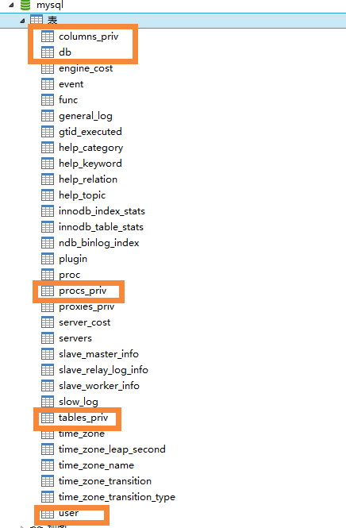

mysql的权限信息基本保持在user/db/tables\_priv/proces\_priv/columns\_priv这几张表里面.mysql服务器在启动的时候将这些表的内容读到内存中，并基于授权表的内存副本对访问控制做出决定。

如果要查看给定账户具有的权限，使用show grants语句

Show grants for ‘joe’@’home.example.com’

当您运行连接到服务器的客户端程序时，MySQL访问控制涉及两个阶段：

阶段1：服务器根据您的身份接受或拒绝连接，以及您是否可以通过提供正确的密码来验证您的身份。

阶段2：假设您可以连接，服务器会检查您发出的每条语句，以确定您是否有足够的权限执行它。例如，如果尝试从数据库中的表中选择行或从数据库中删除表，则服务器会验证您是否具有select该表的drop权限或数据库的权限

user:用户账户，全局权限和其他非特权列

db:数据库级别的权限

tables\_priv :表级特权

Columns\_priv:列级权限

Procs\_priv:存储过程和功能特权

Proxies\_priv:代理用户权限

每张表都包含范围字段和特权字段

范围字段：例如

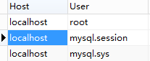

user表的host和user字段，适用于认证对应的用户与对应的主机相连

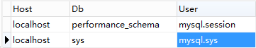

db表认证来自于对应的用户与对应的主机相连，并且是连接某个具体的数据库时候的权限

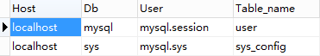

table\_priv表认证某个具体的表的访问权限



Columns\_priv表认证某个具体的列字段的访问权限



Procs\_priv.

特权字段：

| **GRANT的时候用的名称** | **数据库中的字段** | **上下文解释** |
| --- | --- | --- |
| [ALL [PRIVILEGES]](https://dev.mysql.com/doc/refman/5.7/en/privileges-provided.html" \l "priv_all) | “ 所有权限 ”的同义词 | 所有权限 |
| [ALTER](https://dev.mysql.com/doc/refman/5.7/en/privileges-provided.html" \l "priv_alter) | Alter\_priv | 可以修改表格 |
| [ALTER ROUTINE](https://dev.mysql.com/doc/refman/5.7/en/privileges-provided.html" \l "priv_alter-routine) | Alter\_routine\_priv |  |
| [CREATE](https://dev.mysql.com/doc/refman/5.7/en/privileges-provided.html" \l "priv_create) | Create\_priv | 新建数据库，表或索引 |
| [CREATE ROUTINE](https://dev.mysql.com/doc/refman/5.7/en/privileges-provided.html" \l "priv_create-routine) | Create\_routine\_priv |  |
| [CREATE TABLESPACE](https://dev.mysql.com/doc/refman/5.7/en/privileges-provided.html" \l "priv_create-tablespace) | Create\_tablespace\_priv | 更改删除表空间和日志组 |
| [CREATE TEMPORARY TABLES](https://dev.mysql.com/doc/refman/5.7/en/privileges-provided.html" \l "priv_create-temporary-tables) | Create\_tmp\_table\_priv | 创建临时表 |
| [CREATE USER](https://dev.mysql.com/doc/refman/5.7/en/privileges-provided.html" \l "priv_create-user) | Create\_user\_priv | 增删改查用户 |
| [CREATE VIEW](https://dev.mysql.com/doc/refman/5.7/en/privileges-provided.html" \l "priv_create-view) | Create\_view\_priv | 查看用户信息 |
| [DELETE](https://dev.mysql.com/doc/refman/5.7/en/privileges-provided.html" \l "priv_delete) | Delete\_priv | 删除表 |
| [DROP](https://dev.mysql.com/doc/refman/5.7/en/privileges-provided.html" \l "priv_drop) | Drop\_priv | 删除数据库表格或视图 |
| [EVENT](https://dev.mysql.com/doc/refman/5.7/en/privileges-provided.html" \l "priv_event) | Event\_priv | 创建，修改删除事件 |
| [EXECUTE](https://dev.mysql.com/doc/refman/5.7/en/privileges-provided.html" \l "priv_execute) | Execute\_priv | 执行过程和函数必须 |
| [FILE](https://dev.mysql.com/doc/refman/5.7/en/privileges-provided.html" \l "priv_file) | File\_priv | 服务器主机上的文件访问 |
| [GRANT OPTION](https://dev.mysql.com/doc/refman/5.7/en/privileges-provided.html" \l "priv_grant-option) | Grant\_priv | 从其他用户中删除自己的 |
| [INDEX](https://dev.mysql.com/doc/refman/5.7/en/privileges-provided.html" \l "priv_index) | Index\_priv | 创建和删除索引 |
| [INSERT](https://dev.mysql.com/doc/refman/5.7/en/privileges-provided.html" \l "priv_insert) | Insert\_priv | 插入数据 |
| [LOCK TABLES](https://dev.mysql.com/doc/refman/5.7/en/privileges-provided.html" \l "priv_lock-tables) | Lock\_tables\_priv | 锁定select操作 |
| [PROCESS](https://dev.mysql.com/doc/refman/5.7/en/privileges-provided.html" \l "priv_process) | Process\_priv | 显示服务器内执行线程 |
| [PROXY](https://dev.mysql.com/doc/refman/5.7/en/privileges-provided.html" \l "priv_proxy) | 见proxies\_priv表格 | 代理用户 |
| [REFERENCES](https://dev.mysql.com/doc/refman/5.7/en/privileges-provided.html" \l "priv_references) | References\_priv | 外键约束 |
| [RELOAD](https://dev.mysql.com/doc/refman/5.7/en/privileges-provided.html" \l "priv_reload) | Reload\_priv | 重载特权 |
| [REPLICATION CLIENT](https://dev.mysql.com/doc/refman/5.7/en/privileges-provided.html" \l "priv_replication-client) | Repl\_client\_priv |  |
| [REPLICATION SLAVE](https://dev.mysql.com/doc/refman/5.7/en/privileges-provided.html" \l "priv_replication-slave) | Repl\_slave\_priv | 从属与主服务器连接 |
| [SELECT](https://dev.mysql.com/doc/refman/5.7/en/privileges-provided.html" \l "priv_select) | Select\_priv | 显示表或列 |
| [SHOW DATABASES](https://dev.mysql.com/doc/refman/5.7/en/privileges-provided.html" \l "priv_show-databases) | Show\_db\_priv | 查看数据库 |
| [SHOW VIEW](https://dev.mysql.com/doc/refman/5.7/en/privileges-provided.html" \l "priv_show-view) | Show\_view\_priv | 查看视图 |
| [SHUTDOWN](https://dev.mysql.com/doc/refman/5.7/en/privileges-provided.html" \l "priv_shutdown) | Shutdown\_priv |  |
| [SUPER](https://dev.mysql.com/doc/refman/5.7/en/privileges-provided.html" \l "priv_super) | Super\_priv | 可以理解为高级操作 |
| [TRIGGER](https://dev.mysql.com/doc/refman/5.7/en/privileges-provided.html" \l "priv_trigger) | Trigger\_priv | 触发操作 |
| [UPDATE](https://dev.mysql.com/doc/refman/5.7/en/privileges-provided.html" \l "priv_update) | Update\_priv | 更新表或列 |
| [USAGE](https://dev.mysql.com/doc/refman/5.7/en/privileges-provided.html" \l "priv_usage) | “ 没有权限 ”的同义词 | 服务器管理 |

CREATE\_USER创建用户

CREATE USER 'jeffrey'@'localhost' IDENTIFIED BY 'password';

CREATE\_USER在mysql.user表中会创建一个新行。行中会记录在声明中指定的属性，为指定的为默认值

1. 身份验证选项

一般都是INDENTIFIED BY PASSWORD ‘hash\_string’或者是INDENTIFIED WITH auth\_plugin AS ‘hash\_string’

1. SSL/TLS选项
2. 资源限制
3. 密码管理
4. 账户锁定

首次创建的账户没有特权，要分配权限，使用GRANT语句.

GRANT 特权 on 数据库 TO ‘用户名’@’主机’

DROP USER 'jeffrey'@'localhost'; 删除用户