Pixel & Pose


Session 2025 – 2029
Submitted by:
Ayma Harris (2025-CS-329) Zunaira Javed (2025-CS-303) Hadia (2025-CS-305)
Project Supervisor:
Prof. Ashir Kamal

Course:
CSC-100L Application of Information and Technologies

Contents
Pixel & Pose 2
1. Introduction 2
2. Objectives 2
3. Tools Used 2
4. Web Page Application 2
Home Page 2
About Page 3
Services Page 3
Contact Page 4
5. Database Tables (Theoretical) 4
Database Objectives 4
Database Tables 4
Purpose: 5
Purpose 5
Purpose 6
Entity Relationship Description (ERD – Textual) 6
Relationships: 6
6. SQL Queries 6
INSERT Queries 7
SELECT Query 7
UPDATE Query 8
DELETE Query 8
7. Canva Designs 8
8. GitHub Link 10
9. Conclusion 10

Pixel & Pose

Introduction
Pixel & Pose is a photography studio website designed to showcase professional photography services, including portraits, events, and product photography.
The project combines HTML and CSS for the website, SQL for database design, and Canva for visual assets such as logo, banner, and a social media poster.

Objectives
- To design a visually appealing photography website
- To create four main pages: Home, About, Services, and Contact
- To implement a contact form for customer inquiries
- To design a theoretical database using SQL
- To create basic visual assets (logo, banner, poster) using Canva
- To document the project clearly and upload it on GitHub

Tools Used
- HTML5 – For website structure
- CSS – For styling, layout, and responsiveness
- SQL (theoretical) – For database design and queries
- Canva – For creating logo, website banner, and social media poster
- VS Code / Code Editor – For writing and testing code
- GitHub – For project upload and version control

Web Page Application

Home Page
- Features a banner image at the top
- Left section: Studio name, tagline, and introduction
- Right section: Vertical image of photography work
- Sidebar navigation for smooth scrolling between pages
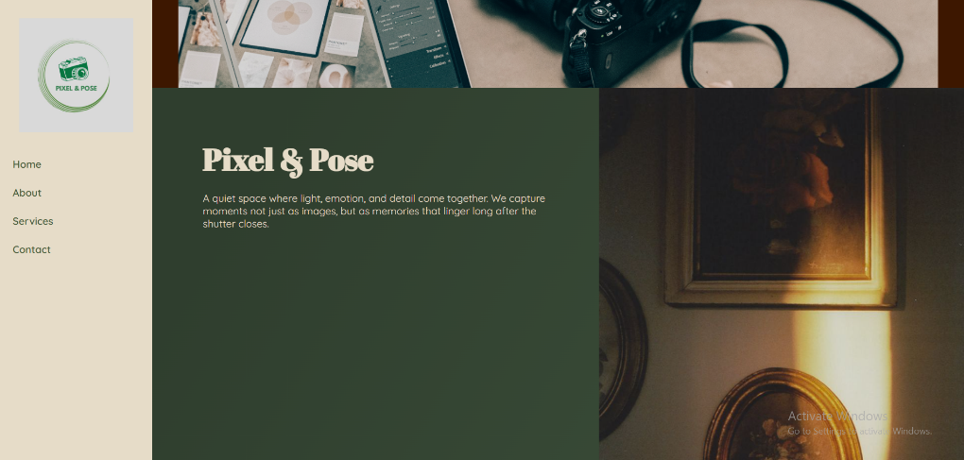

About Page
- Left section: Studio description and philosophy
- Small images below text to show examples of work
- Right section: Vertical image with slight offset for visual appeal
- Styled using flexbox for alignment
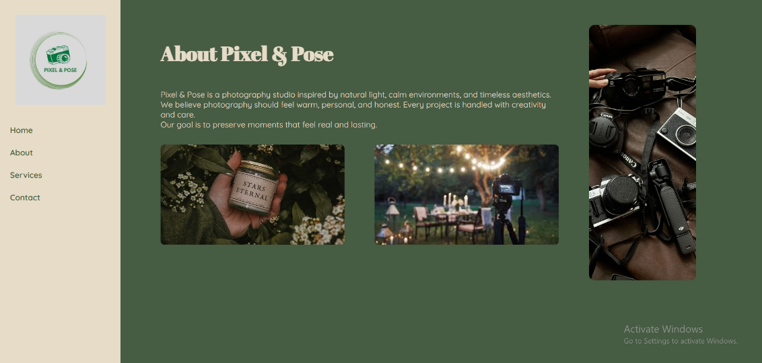

Services Page
- Highlights three main services:
  - Portrait Photography
  - Event Photography
  - Product Photography
- Each service presented in a card layout
- Styled with hover effects for interactivity
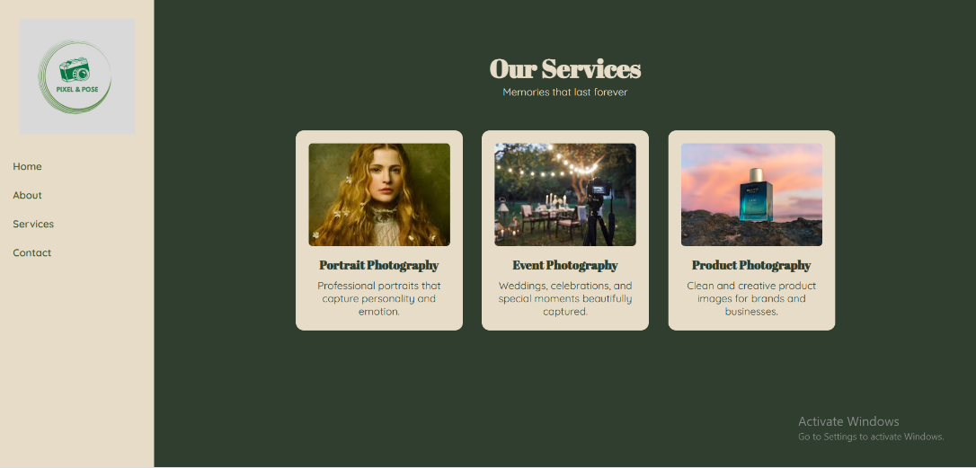

Contact Page
- Includes a form for user inquiries
- Fields: Name, Email, Phone, Message
- Submit button styled to match the website color theme
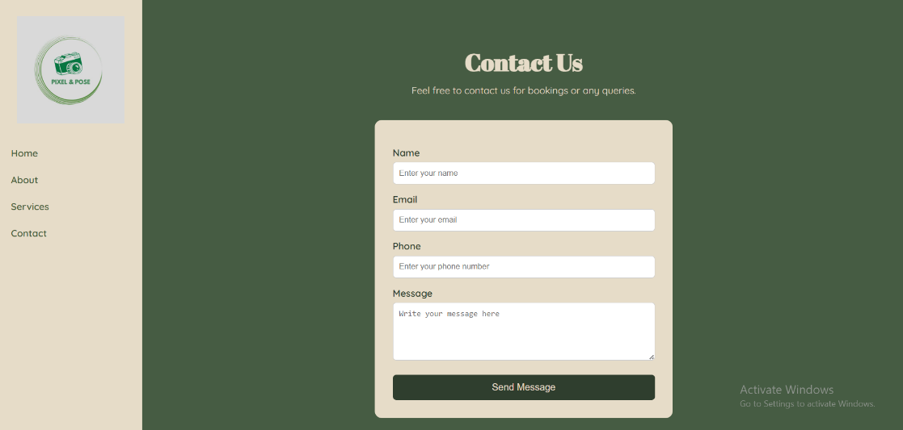

Database Tables (Theoretical)

Database Objectives
The database is designed to store photography services, customer details, and customer inquiries in a structured and organized manner.

Database Tables

Table 1: Services
Field Name | Data Type | Description
service_id | INT (Primary Key) | Unique identifier for each service
service_name | VARCHAR(100) | Name of the photography service
description | TEXT | Details of the service
price | DECIMAL(10,2) | Price of the service

Purpose:
Stores photography services shown on the Services page.
Table 2: Customers
Field Name | Data Type | Description
customer_id | INT (Primary Key) | Unique identifier for each customer
name | VARCHAR(100) | Customer’s full name
email | VARCHAR(100) | Customer’s email address
phone | VARCHAR(20) | Customer’s phone number

Purpose:
Stores customer information submitted through the Contact page.
Table 3: Contact Queries
Field Name | Data Type | Description
query_id | INT (Primary Key) | Unique identifier for each query
customer_id | INT (Foreign Key) | References Customers(customer_id)
service_id | INT (Foreign Key) | References Services(service_id)
message | TEXT | Customer’s message
query_date | DATE | Date when the inquiry was submitted

Purpose:
Connects customers with services they inquire about.

Entity Relationship Description (ERD – Textual)
The Pixel & Pose database consists of three main entities:
Services, Customers, and Contact_Queries.
- The Contact_Queries entity represents inquiries submitted by customers. It contains foreign keys customer_id and service_id, which reference the Customers and Services tables respectively.

Relationships:
- One-to-Many relationship between Services and Contact_Queries
- One service can be associated with multiple contact queries, but each contact query is linked to only one service.
- One-to-Many relationship between Customers and Contact_Queries One customer can submit multiple contact queries, but each contact query belongs to only one customer.

SQL Queries
CREATE TABLE Services (
service_id INT PRIMARY KEY AUTO_INCREMENT,
service_name VARCHAR(100) NOT NULL, description TEXT,
price DECIMAL(10,2)

);

CREATE TABLE Customers (
customer_id INT PRIMARY KEY AUTO_INCREMENT,
name VARCHAR (100) NOT NULL,
email VARCHAR (100) NOT NULL,
phone VARCHAR (20)
);

CREATE TABLE Contact_Queries (
query_id INT PRIMARY KEY AUTO_INCREMENT,
customer_id INT,
service_id INT,
message TEXT,
query_date DATE,
FOREIGN KEY (customer_id) REFERENCES Customers(customer_id),
FOREIGN KEY (service_id) REFERENCES Services(service_id)
);

INSERT Queries
INSERT INTO Services (service_name, description, price)
VALUES ('Portrait Photography', 'Professional indoor and outdoor portraits', 15000);

INSERT INTO Customers (name, email, phone)
VALUES ('Ayesha Khan', 'ayesha@gmail.com', '03001234567');

INSERT INTO Contact_Queries (customer_id, service_id, message, query_date)
VALUES (1, 1, 'I want to book a portrait session.', '2026-01-15')

SELECT Query
SELECT Customers.name, Services.service_name, Contact_Queries.query_date
FROM Contact_Queries
JOIN Customers ON Contact_Queries.customer_id = Customers.customer_id JOIN Services ON Contact_Queries.service_id = Services.service_id

UPDATE Query
UPDATE Services SET price = 18000
WHERE service_id = 1;

DELETE Query
DELETE FROM Contact_Queries
WHERE query_id = 1;

Canva Designs
All designs were made using Canva, maintaining the website’s color theme and aesthetics.
- Website Banner: • LOGO:


- Social Media Poster:


GitHub Link
- Project uploaded to GitHub
- README.md file.
link:
https://github.com/ayma212678/Pixel-Pose-website-project

Conclusion
The Pixel & Pose Photography Website is a complete project combining frontend development, database design, and basic graphic design.
- The website is user-friendly and visually appealing
- Database structure allows efficient data management
- Canva assets provide professional branding
- Project has been documented and uploaded on GitHub for version control and sharing

