

School of Computing and Mathematical Sciences

CO7201 Individual Project

Interim Report

A Hybrid Fraud Detection System: Combining Rule-based and Deep Learning Approaches with Explainable AI

Aymaan Baig Mohammed
Abm18@student.le.ac.uk
249047986

Project Supervisor: VLADIMIROVA, TANYA
Principal Marker: LAU, NEWMAN

Word Count: 2030
24/07/2026

DECLARATION
All sentences or passages quoted in this report, or computer code of any form whatsoever used and/or submitted at any stages, which are taken from other people’s work have been specifically acknowledged by clear citation of the source, specifying author, work, date and page(s). Any part of my own written work, or software coding, which is substantially based upon other people’s work, is duly accompanied by clear citation of the source, specifying author, work, date and page(s). I understand that failure to do this amounts to plagiarism and will be considered grounds for failure in this module and the degree examination as a whole.

Name: Aymaan Baig Mohammed
Date: 24/07/2026

Contents
I. Project Progress 3
I.1. Completed Tasks 3
I.2. Ongoing Tasks 4
I.3. Pending Tasks 4
II. Challenges and How I Solved Them 5
IV. Deviations from the Planned Project 5
V. Updated Project Plan 6
VI. Appendix — Results 8
A. XGBoost — Confusion Matrix 8
B. MLP — Confusion Matrix 8
C. XGBoost — ROC Curve 8
D. XGBoost vs MLP — Precision-Recall Comparison 9

I. Project Progress
This project builds a system that spots fraud in credit card transactions. It uses two machine learning models and gives a plain-English explanation for every transaction it flags. The goal is to catch fraud while keeping false alarms low. It also has to explain each decision so an analyst can trust it.
The work is on track. All the essential machine learning tasks are done before the interim deadline. The table below shows where each task stands.
No | Task | Status
1 | Data preparation: split, SMOTE, feature scaling | Complete
2 | XGBoost model training and evaluation | Complete
3 | MLP model training and evaluation | Complete
4 | Precision-recall comparison of both models | Complete
5 | SHAP explanation layer for both models | Complete
6 | Plain-English explanations for flagged transactions | Complete
7 | Rule engine service (velocity, location, amount rules) | Ongoing
8 | Hybrid pipeline joining rules and models | Pending
9 | Analyst dashboard (React) | Pending
10 | Adjustable threshold, filter and sort, model comparison view | Pending
11 | Explanation history and PDF export | Pending
12 | Full system testing, final report, and viva | Pending
Table 1 Task Status Overview

I.1. Completed Tasks
a. Data preparation
The data was split 80/20 into training and test using scikit-learn. Fraud is rare here, about 1 in every 578 transactions, so I used the stratify option to keep the same fraud rate in both sets.
To fix the imbalance I used SMOTE on the training set only. The test set keeps its real fraud rate so the results show what the model would actually face. Amount and time were much bigger than the other columns, so StandardScaler brought them down to the same scale, fitted on training data only. Everything was saved as pickle files so both models load the same data.
b. XGBoost model
I wrote a training script that loads the pickle files from the data preparation step. I ran it four times with different settings, changing the number of trees, the tree depth and the learning rate each time. I did this by hand rather than with GridSearchCV, because GridSearchCV on 450,000 rows would have taken far too long for only four runs.
I compared the four runs and picked the best by F1 score. Going from depth 4 to depth 6 made the biggest difference. Dropping the learning rate to 0.05 made things worse, so I left it at 0.1.
I then evaluated the best model on the test set. It wrongly flags only 1 in 2000 genuine transactions and catches 85 of the 98 fraud cases. I saved the model as a pickle file and saved a confusion matrix and an ROC curve as evidence.
c. MLP model
I wrote a second training script following the same structure as the XGBoost one. It loads the same pickle files and uses the same split and the same measures.
I ran four combinations, changing the number of layers, how many neurons in each, and the regularisation strength. I turned on early_stopping so training stops once the model stops improving. Two layers of 100 and 50 neurons came out best.
The MLP ended up close to XGBoost but slightly behind. Same false positive rate, but it caught 84 fraud cases against XGBoost's 85, and it was a little worse at telling fraud from genuine overall. I then drew both models on one precision-recall chart. XGBoost sits just above the MLP for most of it.
d. SHAP explanation layer
I wrote shap/explainer.py to work out which features pushed each flagged transaction toward fraud and which pushed it away.
I started with TreeExplainer on XGBoost, but it failed on the model. XGBoost has its own built-in way of producing the same values, so I used that instead. For the MLP I used KernelExplainer with a 100-row background sample. It works but it is slow, about a minute for three transactions, so in the final pipeline I will only run it on a small sample.
I checked the output on 100 test transactions. The top features it picked out were ones that also showed up as highly correlated with fraud back in the first week.
The transaction features have no real names because the bank hid them for privacy. So the explanations can say which feature mattered and how much, but not what it actually means.
e. Plain-English explanations
The raw SHAP output is just a list of numbers, which an analyst cannot read. I wrote a function that sorts the top features for a flagged transaction and writes one short sentence for each.
Each sentence names the feature, says whether it pushed toward fraud or away from it, and how strongly. I set three strength levels based on the size of the value. The same function works for both models because it only needs the values and the feature names.

I.2. Ongoing Tasks
I am now building the rule engine. This is a separate service that checks each transaction against simple rules before the models even run. There are three rules. One checks how many transactions come from the same user in a short time. One checks for an unusual location. One checks for an unusually large amount. All the rule settings live in a config file so they can be changed without touching the code.

I.3. Pending Tasks
The tasks still left are:
- The hybrid pipeline that joins the rule engine and the models into one decision per transaction.
- The analyst dashboard that shows flagged transactions, their scores, the rules they triggered, and the plain-English explanation.
- Extra dashboard features like an adjustable threshold, filtering and sorting, and a side-by-side view of both models.
- Explanation history stored in a database, and a PDF export option.
- Full system testing, the final report, and the viva.

II. Challenges and How I Solved Them
This section covers the main problems I ran into so far and how I fixed them.
a. The project setup was wrong at the start
Problem: I typed the package names into pyproject.toml by hand. uv does not read a file I edit myself. It writes the lockfile only when I add packages through it. So my file and the lockfile did not match.
Solution: I deleted the file and ran uv init again. Then I added every package with uv add. Now uv writes both files itself and they stay in sync.
b. pytest could not read the pickle files
Problem: My first test run failed. pytest was using the system Python, not the project venv. The pandas versions did not match so it could not load the pickle files.
Solution: I ran uv add --dev pytest so pytest installs inside the venv. I also rewrote the tests to read a small JSON file instead of the pickle files. Now version differences do not matter.
c. SHAP would not install
Problem: Installing SHAP took a few tries. I installed the latest version first and it failed to build. So I tried an older version. That one installed but crashed as soon as I imported it. I tried another version after that. It installed and imported fine, but then TreeExplainer failed when I ran it on the XGBoost model. Each version I tried broke at a different point.
Solution: I stopped trying to make TreeExplainer work. XGBoost has its own built-in way of producing the same values, so I used that instead. For the MLP I used KernelExplainer from SHAP, which did work. Both models now produce explanations.
d. The two models give SHAP values on different scales
Problem: The XGBoost values are much bigger than the MLP ones. At first this looked like a bug.
Solution: It is not a bug. The two methods measure on different scales. So I cannot compare the raw numbers between models. I can only compare which features come out on top for each.

IV. Deviations from the Planned Project
The project mostly followed the original plan. A few small changes were needed along the way. None of them changed the goal or the final results. I list them here so they are clear.
a. Explanation method for XGBoost
The plan was to use SHAP for both models. For XGBoost this did not work. SHAP kept clashing with the other tools in the project. So I used XGBoost's own built-in method instead. It gives the same values through a different path so the results are not affected.
b. Hyperparameter search by hand
The plan allowed GridSearchCV to find the best model settings. I tested a small set of settings by hand instead. The training set is very large and GridSearchCV would have taken far too long for the few settings I needed to try. The hand search was quicker and still found a strong model.
c. SHAP values are on different scales
I did not plan for this. The two models produce SHAP values on different scales. This means I cannot compare the raw numbers between them. I can only compare which features rank at the top for each model. I have noted this as a limit for the final report.

V. Updated Project Plan
The project runs over twelve weeks. All the essential machine learning tasks are complete. I am currently in Phase 2, building the rule engine (shown in yellow).
No | Task | W1 | W2 | W3 | W4 | W5 | W6 | W7 | W8 | W9 | W10 | W11 | W12
Phase 1 — Machine Learning Core (Essential)
1 | Data preparation and balancing
2 | XGBoost model
3 | MLP model
4 | SHAP explanation layer
5 | Plain-English explanations
Phase 2 — Rules and Pipeline (Essential)
6 | Rule engine service
7 | Hybrid pipeline
Phase 3 — Dashboard and Features (Recommended)
8 | Analyst dashboard
9 | Threshold, filter, sort, model comparison
Phase 4 — Optional and Polish
10 | Explanation history and PDF export
11 | Full system testing and bug fixes
Final Submission and Viva
12 | Final report and viva
Table 2 Updated Project Plan
Overall, the project is on track and will be finished on schedule.

VI. Appendix — Results

A. XGBoost — Confusion Matrix
Out of every real fraud case, the model caught most of them and missed only a few. It wrongly flagged only a very small number of genuine transactions.
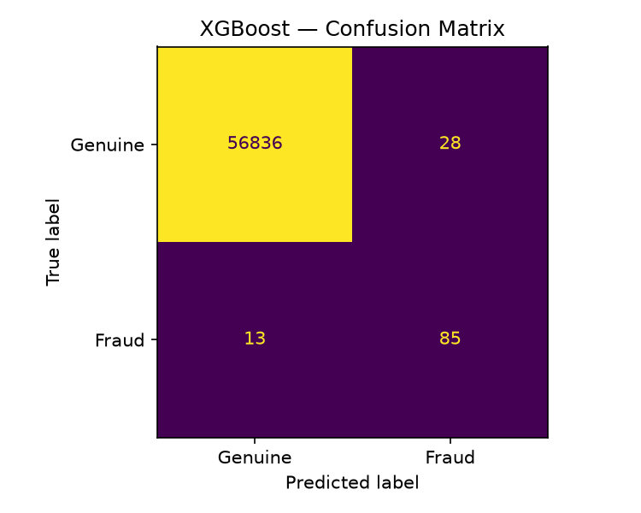
Figure 1 XGBoost Confusion Matrix

B. MLP — Confusion Matrix
The MLP result is very close to XGBoost. It caught one fewer fraud case and raised one more false alarm.
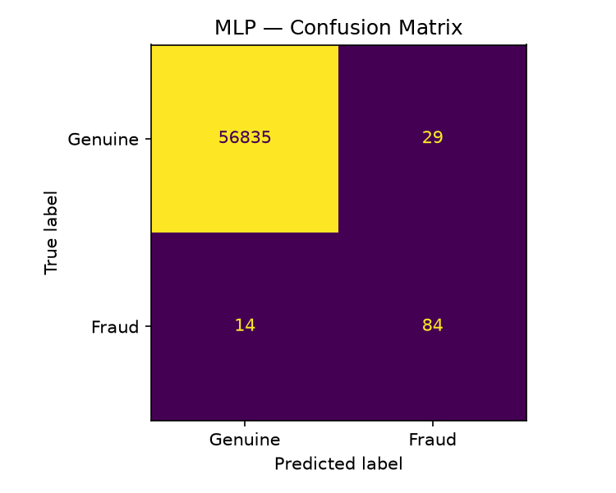
Figure 2 MLP Confusion Matrix

C. XGBoost — ROC Curve
The curve rises sharply toward the top-left corner. This means the model catches most fraud while keeping false alarms very low. A perfect model would reach the top-left corner exactly.
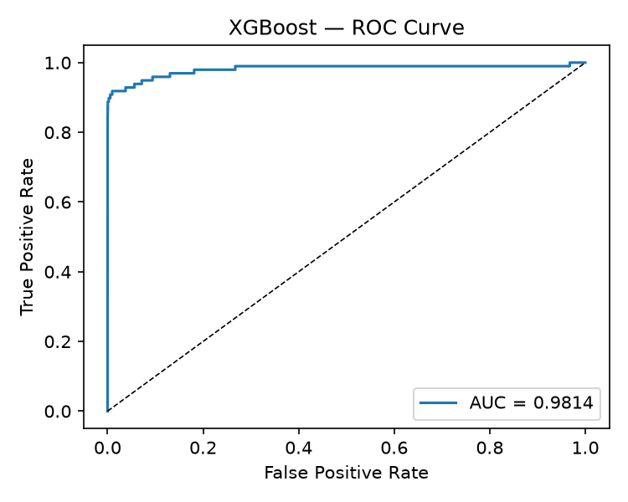
Figure 3 XGBoost ROC Curve

D. XGBoost vs MLP — Precision-Recall Comparison
Both models are drawn on the same axes so the difference is easy to see. XGBoost sits slightly above the MLP across most of the chart. This shows XGBoost is the stronger model on this data, though the gap is small.
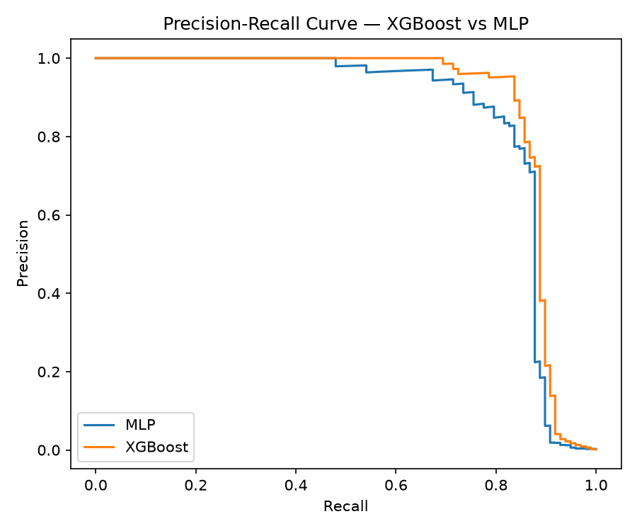
Figure 4 Precision-Recall Comparison — XGBoost vs MLP

